Table S1. Characteristics of study subjects.
Patient ID | Gender | GAge | Weight | Mode of Delivery | Diet | PROM |  | Days of Antibiotics | Days of Antacids | Days of Fortification | DOL NEC | DOL Samples
Case 1 | M | 24 | 616 | CS | MOM |  | No | 5 | 0 | 9 | 45 | 8, 15, 24,30, 36
Case 2 | M | 25 | 641 | SVD | MOM,DHM |  | No | 31 | 12 | 4 | 50 | 5,19, 42
Case 3 | M | 25 | 680 | CS | MOM,DHM |  | No | 2 | 0 | 1 | 24 | 9,16
Case 4 | M | 26 | 516 | CS | MOM,DHM |  | No | 4 | 9 | 3 | 35 | 13, 26
Case 5 | F | 27 | 1026 | CS | MOM |  | Yes | 2 | 0 | 8 | 38 | 14, 21, 28
Control 1 | M | 23 | 570 | CS | DHM,FM |  | No | 36 | 6 | 10 | X | 29, 40
Control 2 | M | 24 | 646 | SVD | MOM,DHM |  | No | 38 | 23 | 31 | X | 13, 20, 33, 43, 48
Control 3 | M | 25 | 485 | CS | MOM |  | No | 0 | 8 | 0 | X | 1, 19
Control 4 | M | 26 | 860 | CS | MOM,DHM |  | No | 5 | 11 | 14 | X | 28, 35
Control 5 | F | 27 | 756 | CS | MOM |  | No | 3 | 0 | 21 | X | 17, 32, 36

GAge: Gestational age in weeks; Weight: Birth weight in g; Mode of Delivery: Cesarean (CS) or Spontaneous vaginal delivery (SVD); Diet: Mother’s own milk (MOM), donor human milk (DHM) or Elecare formula (FM); PROM: Prolonged rupture of membranes; Days of antibiotic/antacids/fortification: Cumulative days of exposure prior to NEC diagnosis or equivalent chronologic ages in controls; DOL NEC: Day of life that the infant developed NEC; DOL Samples: Day of life of sample acquisition.

Table S2.

Hierarchical linear regression with outcome: Operational Taxonomic Units (OTUs)
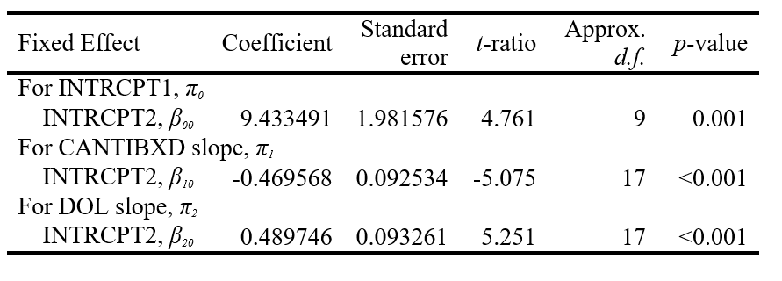
Hierarchical linear regression with outcome: Operational Taxonomic Units (OTUs). Adjusted mean OTU count was 9.4 on DOL 1. Cumulative days of antibiotic exposure was associated with a decrease in OTU count of 0.47 for each prior day of antibiotic therapy at the day of sample collection. Stool OTU count increased by 0.49 for each DOL within the range studied. Clinical factors not associated with OTU count were: NEC, cumulative days of fortification, cumulative days of antacids, exposure to donor human milk (DHM), and exposure to broad-spectrum antibiotics on the day of sample collection.

Table S3.

Hierarchical linear regression with outcome: Simpson Diversity Index (SDI)
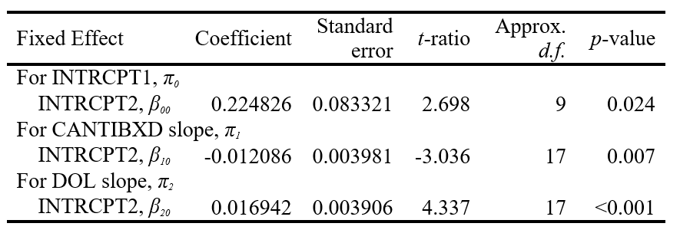
Hierarchical linear regression with outcome: Simpson Diversity Index (SDI). Adjusted mean SDI was 0.22 on DOL 1. Cumulative antibiotic exposure was associated with a decrease in SDI of 0.012 for each prior day of antibiotic therapy at the day of sample collection. Stool SDI increased by 0.017 for each DOL within the range studied. Clinical factors not associated with SDI were: NEC, cumulative days of fortification, cumulative days of antacids, exposure to DHM, and exposure to broad-spectrum antibiotics on the day of sample collection.

Table S4. Indicator Species Analysis.
Phyla | Family or Genus | Subjects | Indicator Value | Mean | S.Dev | P-Value
Proteobacteria | f. Enterobacteriaceae | Cases | 85 | 60.9 | 11.30 | 0.01*
Proteobacteria | g. Trabulsiella | Cases | 80 | 54.6 | 9.48 | 0.01*
Firmicutes | g. Veillonella | Controls | 76 | 43.9 | 12.69 | 0.01*
Firmicutes | g. Enterococcus | Controls | 84 | 63.7 | 12.40 | 0.03*
Abbreviations: f: Family, g: Genus, S.Dev: Standard deviation. * P ≤ 0.05.

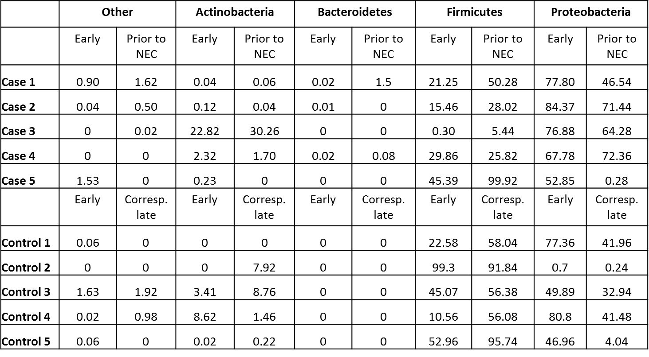
Table S5: Percentages of phyla identified in early fecal samples and those collected most proximal to the development of NEC or corresponding (Corresp.) time points in controls.

Table S6.

Hierarchical linear regression with outcome: Gammaproteobacteria
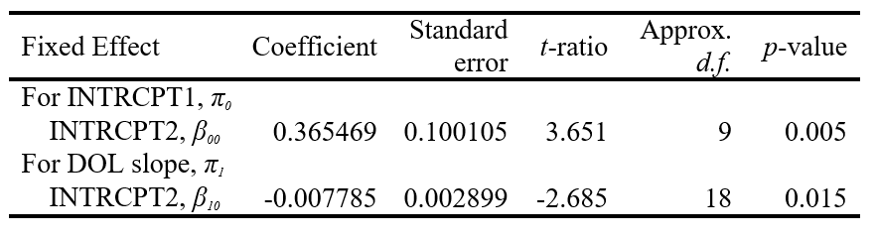
Hierarchical linear regression with outcome: Gammaproteobacteria. Adjusted mean proportion of Gammaproteobacteria was 0.37 on DOL1, and decreased by 0.008 for each DOL within the range tested, however this association did not remain significant after controlling for false discovery rate. Clinical factors not associated this outcome were: Cumulative days of fortification, cumulative days of antibiotics, cumulative days of antacids, exposure to DHM, and exposure to broad-spectrum antibiotics on the day of sample collection.

Table S7.
Hierarchical linear regression with outcome: Clostridia 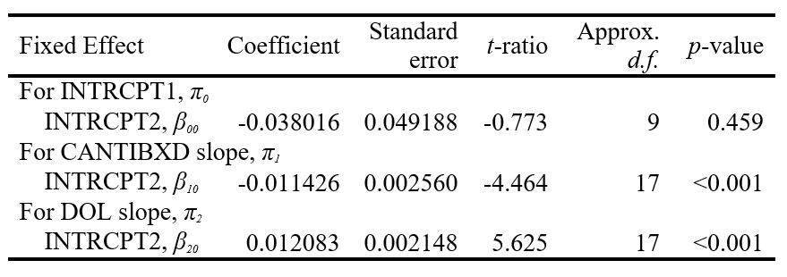
Hierarchical linear regression with outcome: Clostridia. Adjusted mean proportion of Clostridia was -0.04 on DOL1. Cumulative antibiotic exposure was associated with a decrease of 0.011 for each prior day of antibiotic therapy at the day of sample collection. The proportion of Clostridia increased by 0.012 for each DOL within the range tested. Clinical factors not associated with this outcome were: Cumulative days of fortification, cumulative days of antacids, exposure to DHM, and exposure to broad-spectrum antibiotics on the day of sample collection.

Table S8.

Hierarchical linear regression with outcome: Bacillii
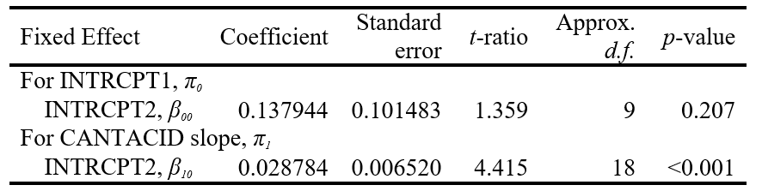
Hierarchical linear regression with outcome: Bacilli. Adjusted mean proportion of Bacilli was 0.14 on DOL 1, and increased by 0.029 for each prior day of antacid therapy at the day of sample collection. Clinical factors not associated with this outcome were: DOL, cumulative days of fortification, cumulative days of antibiotics, exposure to DHM, and exposure to broad spectrum antibiotics on day of sample collection.

