Standard Operating Procedure (SOP): A Portable Imaging System for Microhymenoptera

Carolyn Trietsch, István Mikó
Frost Entomological Museum (PSUC)
The Pennsylvania State University
July 2018

This standard operating procedure is for an imaging system consisting of a Canon EOS 70D camera mounted on an Olympus CX41 microscope, with an Olympus UPlanFLN 4× UIS2 objective and Olympus LMPlanFLN (10×/0.25; 20×/0.40 and 50×/0.50) UIS2 objectives. This system is connected to a computer (Mac or PC, desktop or laptop) with Canon EOS Utility software to adjust, capture and save images (Fig. 1).

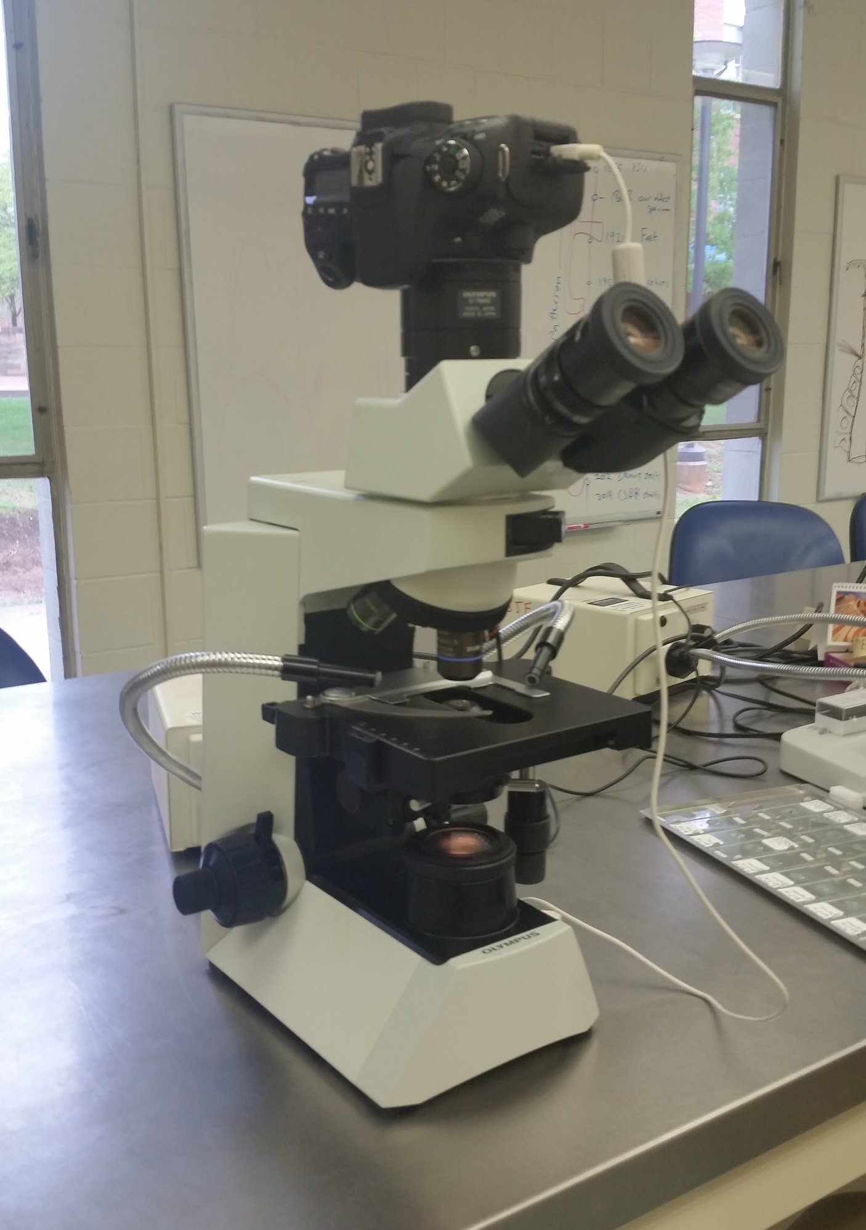
Figure 1. The portable imaging system, consisting of a Canon EOS 70D camera mounted on an Olympus CX41 microscope.

This system is ideal for imaging insect specimens that are 2mm and smaller, thought it can also be used to image specific morphological structures on larger insect specimens. The system can be packed into a Pelican Air 1535 Case (Pelican Products, Inc., Torrance, CA) for travel, and is small enough to be carried on an airplane.

Computer Software

Images are taken remotely on a computer attached to the system using EOS Utility software. This software is included with the purchase of the camera, and can also be downloaded online at: https://www.usa.canon.com/internet/portal/us/home/support/self-help-center/eos-utility

Notes on Assembly And Disassembly of System

The most expensive pieces of this system are the microscope objectives, so exercise extra care when removing and attaching the objectives. Take your time with assembling and disassembling the microscope. Don’t rush!

Tips for Assembling the System:
- Inspect all lenses and objectives for fingerprints so that the quality of your images won’t suffer.
- When attaching the objectives, the objective sequence should be 4X, 10X, 20X, 50X. This is important since the length of each objective increases with magnification.

Tips for Disassembling the System:
- After removing the objectives, be sure to attach the plastic cover caps back onto the holes. This prevents dust from getting inside the system and impacting the quality of the images.

Recommended Pictures

It is ideal to image habitus pictures of pinned, point-mounted, or card-mounted specimens with lower magnification (4X or 10X). We recommend using higher magnification (20X and 50X) to image important morphological features of dissected or slide-mounted specimens.

Preparing The Specimens for Imaging

For pinned and point-mounted specimens:
- Remove the labels from the pin, arrange separately with a ruler, and take an image with a phone camera or other camera to have a record (or transcribe at a later date). Be mindful that some labels may be double sided--check just in case.
- Use a seperate stereomicroscope to position your specimens. Position the specimen pin on a glass slide using molding clay (Sculpey, Polyform Products Company, Elk Grove Village, Illinois, USA).
  - In cases where the insect pin must be upright to image the specimen, sculpt a triangle of clay that extends off of the edge of the slide. Put the slide over a unit tray, then push the pin through the clay triangle. Adjust the height of the pin.
- Cut the solid end off of a critical point drying cylinder to create a hollow cylinder. Carefully place the critical point drying cylinder around the specimen to diffuse light around the specimen. Be careful not to touch or hit the specimen with the cylinder.
  - It’s better to have the specimen located near the bottom of the cylinder-- this will give you the best light diffusion.
- Place the slide and specimen on the stage carefully.
  - Always make sure there are no objectives in the way-- switch to the space where there is no objective.
  - For the dorsal picture or any picture where the pin needs to be upright, make sure that the specimen and cylinder are facing towards you. Be very careful when placing the slide and specimen down on the stage: you don’t want the pin to hit anything underneath the stage and risk moving and damaging the specimen.
- Use a seperate light source to illuminate the specimen. We recommend dual fiber optic goose neck lights.

For slides:
- Place the entire slide next to a ruler and use a phone camera or other camera to capture the entire slide.
- Place the slide on the stage, and use the lighting built into the microscope for the best images.

Camera and Save Settings
- The camera should be set to Manual mode and Video mode.
- Hit the folder icon to choose where to save your images to for that specimen. We recommend creating a seperate folder for each image stack.
- The ISO on the computer should be set to 100. At higher settings, the final image may appear grainy.
- The ratio should always be 1/40.
- Go to Live View to adjust the white balance.
- Click on the magnifying glass on the bottom of the screen to see what the final resolution of the picture will be.

Taking Images
- Before taking any images, make sure that the camera and the microscope focus are the same.
  - Focus on a particular structure on the screen, then focus on the same structure using the microscope. This is particularly important when taking image stacks because if the computer shows the top of a specimen but the microscope and camera show the middle, your image stack will be from the middle onwards, and the quality of your final stacked image will suffer.
- Position the computer on one side of the microscope so you can click capture and take images with your dominant hand. Look through the microscope as you image.
- Once your image is in focus and your lighting is optimal, either take a single image or for larger specimens, take a manual image stack.
- To take a manual image stack:
  - Start at the top of the specimen, take a picture, adjust the microscope slightly down through the specimen, take another picture and repeat until you get to the bottom of the specimen or the image is out of focus.
    - If the increment between each image is too large, your final image will not have good resolution.
    - At higher magnifications, make sure to use smaller increments between taking pictures.

Use software such as Zerene stacker (we used Zerene Stacker 1.04 Build T201706041920) to align and stack your images into a final image that can be used for publication.

Further reading on specimen lighting:

Mikó, I., & Deans, A. R. (2013, August 16). A small trick for better lighting. Hamuli, 4(2), 17–18.

