PEGylated self-assembled enzyme-responsive nanoparticles for effective targeted therapy against lung tumors

Fangyuan Guo, Jiangqing Wu, Wenchao Wu, Dongxue Huang, Qinying Yan, Qingliang Yang, Ying Gao, Gensheng Yang*
College of Pharmaceutical Science, Zhejiang University of Technology, Hangzhou 310014, China

Author list with email address:
Fangyuan Guo guofy.2008@hotmail.com
Jiangqing Wu 751529082@qq.com
Wenchao Wu 1508445025@qq.com
Dongxue Huang 1178156772@qq.com
Qinying Yan yqy@zjut.edu.cn
Qingliang Yang qyang@zjut.edu.cn
Ying Gao 22357418@qq.com

Corresponding author:
Dr. Gensheng Yang
Postal address: College of Pharmaceutical Science, ZJUT
#18 Chaowang Road, Hangzhou, 310032, PR China
Tel: 86-571-88871077
Fax:86-571-88320913
Email: yanggs@zjut.edu.cn

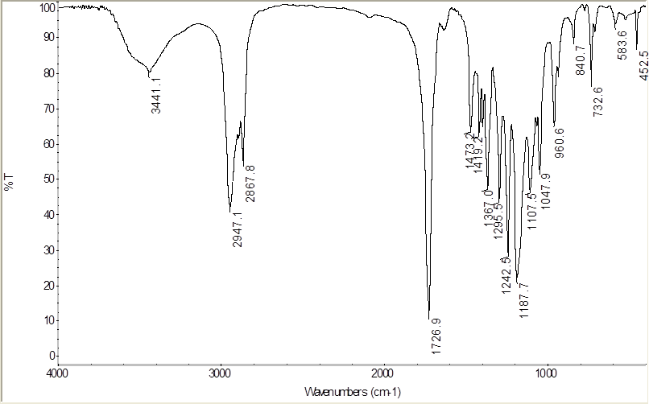
S1 The FT-IR of mPEG-PCL
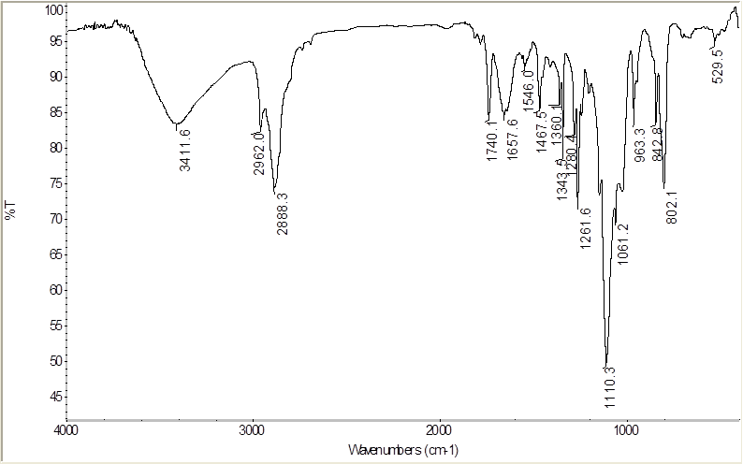
S2 The FT-IR of mPEG-Peptide
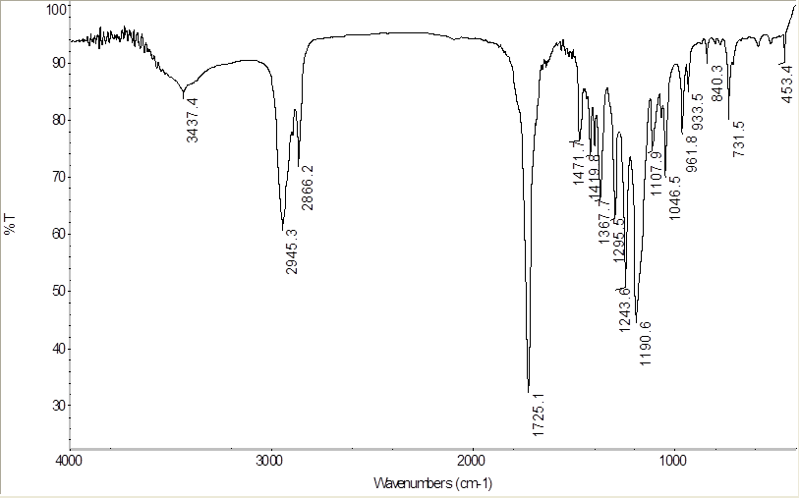
S3 The FT-IR of PCL-NH₂

