Synthesis, Characterization, Spectroscopy, X-ray structure and Gaussian hybrid computational investigation of (−)-(S)-1-[2-(benzenesulfonamido)-3-phenylpropanoyl]-4-[(4-methyl)phenyl]thiosemicarbazide
SIBEL DEMIR KANMAZALP,*^{,a} EYÜP BAŞARAN,^{b} AYŞEGÜL KARAKÜÇÜK-IYIDOĞAN,^{b} EMINE ELÇIN ORUÇ-EMRE,^{b} FATIH ŞEN,^{c} necmI dege,^{d}
ªTechnical Sciences, Gaziantep University, 27310, Gaziantep, Turkey
^{b}Department of Chemistry, Faculty of Science and Arts, Gaziantep University, 27310, Gaziantep, Turkey
^{c}Kilis 7 Aralık University, Vocational High School of Health Services, Department of Opticianry, 79000-Kilis, Turkey
^{d}Department of Physics, Faculty of Arts and Sciences, Ondokuz Mayıs University, TR-55139 Kurupelit-Samsun, Turkey
Email: sibeld@gantep.edu.tr
Supplemental Materials

Figure S 1 The calculated [DFT/B3LYP/6-31G(d, p) and DFT/B3LYP/6-31G+(d, p) levels] and experimental FT-IR spectra of the title compound (cm⁻¹).

Figure S2 Correlation graphic of calculated and experimental vibrational frequencies of title compound (cm⁻¹).

Figure S 3 a) ¹H-NMR and b) ¹³C-NMR spectra of the title compound.

a)
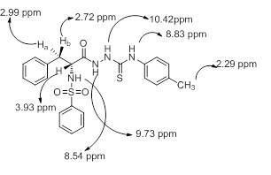
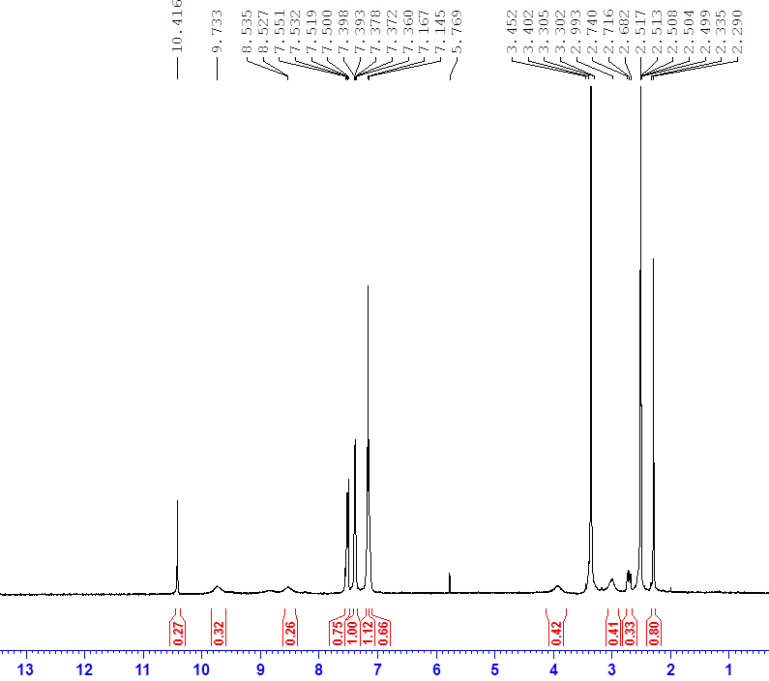
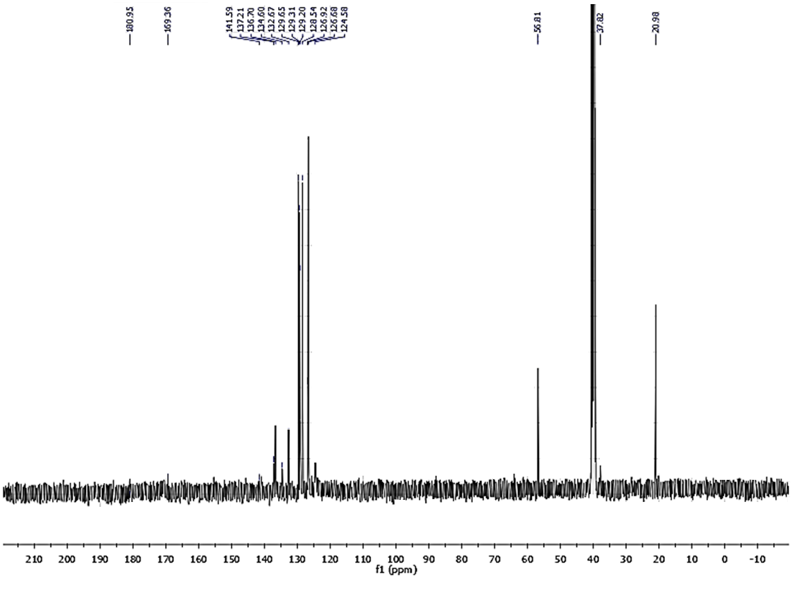
b)
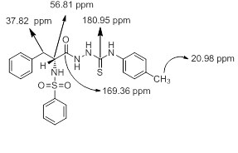
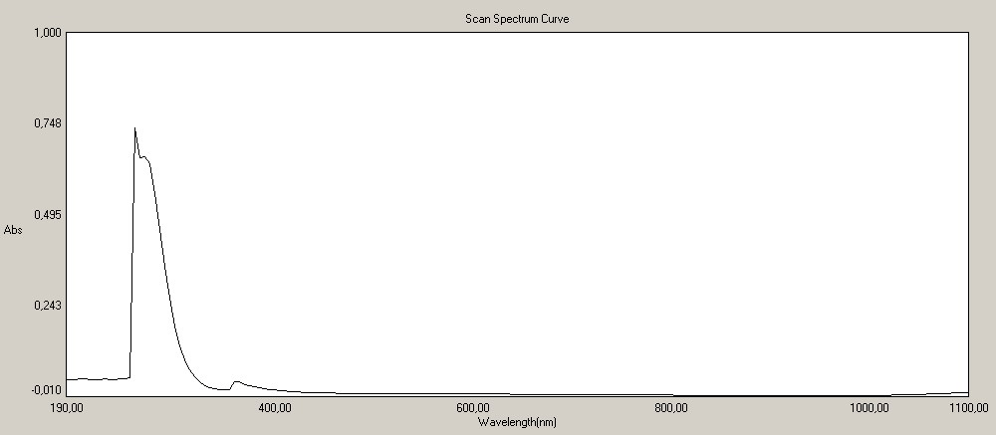

Figure S 4 Experimental UV-Vis spectra of the title compound.

