The catalytic activity of alkali metal alkoxides and titanium alkoxides in the hydrosilylation of unfunctionalized olefins

Xiaoling Yanga, Ying Baia*, Jiayun Lia, Yu Liua, Jiajian Penga*, Tianbo Lib, Rui Langb and Botao Qiaob

aKey Laboratory of Organosilicon Chemistry and Material Technology of Ministry of Education, Hangzhou Normal University, Hangzhou 311121, China

bDalian Institute of Chemical Physics, Chinese Academy of Sciences, Dalian 116011, China

E-mail: jjpeng@hznu.edu.cn

**Supplemental Materials**

2.tiff

**Figure S 1** 29Si NMR spectrum of Cp2TiCl2、LiO*t*Bu、Ph2SiH2 reaction mixture

2.tiff

**Figure S 2** 29Si NMR spectrum of Ti(OEt)4+ Ph2SiH2  reaction mixture

 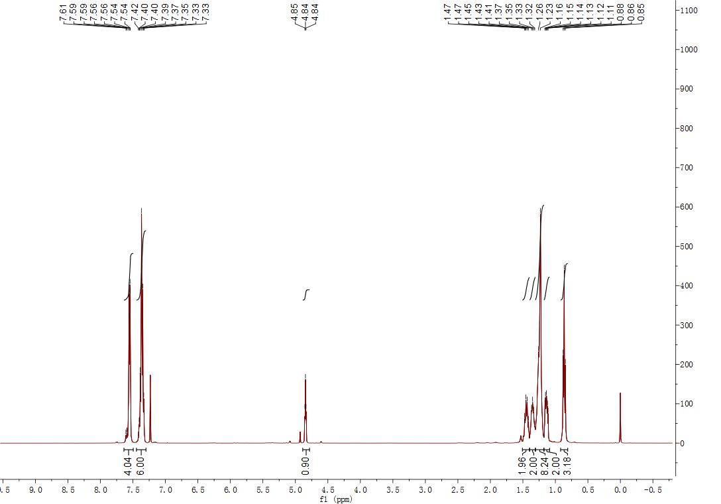

**Figure S 3**: 1H NMR of hydrosilylation production of Ph2SiH2 and 1-octene

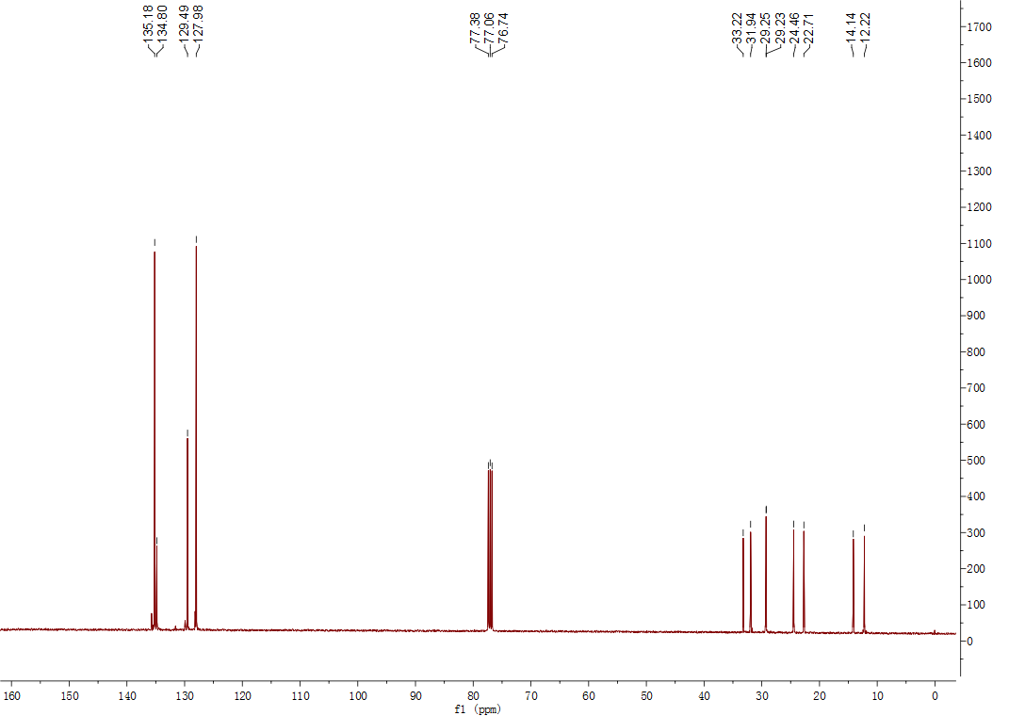

**Figure S 4**: 13C NMR of hydrosilylation production of Ph2SiH2 and 1-octene