Solvent-free Zn(OTf)₂-catalyzed dehydrative cross coupling of propargyl alcohols with diarylphosphine oxides to afford allenylphosphine oxides
Jianlin Yangª, Ming Zhangª, Chao Dongª, Li-Biao Han^{b}, Ruwei Shen^{a,}*
ª State Key Laboratory of Materials-Oriented Chemical Engineering, College of Chemical Engineering, Nanjing Tech University, Nanjing 210009, China
^{b} National Institute of Advanced Industrial Science & Technology (AIST), Tsukuba, Ibaraki, 305-8565, Japan
Email: shenrw@njtech.edu.cn
Supplemental Materials

General Information. All reactions were performed under dry N₂ atmosphere. Anhydrous solvents were distilled prior to use: THF was distilled from sodium using benzophenone as the indicator; MeCN, DCM and DMF were distilled from CaH₂. Propargyl alcohols 1 were prepared following known method.¹Diarylphosphine oxides 2 were purchased from commercial sources or prepared following known method.² Flash chromatography was performed on silica gel using petroleum ether and EtOAc as eluent. ¹H (400 MHz), ¹³C (100 MHz) and ³¹P NMR (162 MHz) spectra were recorded on a Bruke Ascend(TM) 400 MHz NMR spectrometer in CDCl₃. Chemical shifts (ppm) were recorded with tetramethylsilane (TMS) as the internal reference standard. Chemical shifts are expressed in ppm and J values are given in Hz. HRMS analysis of the products (ESI-TOF) was performed at the Analytical Center of State Key Laboratory of Materials-Oriented Chemical Engineering at Nanjing Tech University, China.

Competition experiment
Reaction of 1a, 1g and 2a
An oven-dried Schlenk tube containing a Teflon-coated stir bar was charged with Zn(OTf)₂ (7.3 mg, 10 mol %), 1a (38.1 mg, 0.2 mmol), 1g (38.0 mg, 0.2 mmol) and 2a (40.8 mg, 0.2 mmol). The Schlenk tube was sealed and then evacuated and backfilled with N₂ (3 cycles). The Schlenk tube was sealed and immersed in an oil bath which was heated to 100 ºC for 12 h. The reaction mixture was disolved in DCM, transfered into a round-bottom flask and concentrated under reduced pressure. The catalyst was removed by passing the reside through a very short silica chromatography to afford a mixture of the products. The mixture was dissolved in CDCl₃ and the ³¹P NMR spectra was recorded (Figure S<1>). Based on the ³¹P NMR spectra, the ratio of 3a (δ 29.40 ppm) to 3g (δ 29.65 ppm) and the combined yields were calculated: 3a/3g = 1.42/1, total NMR yield: >98%.

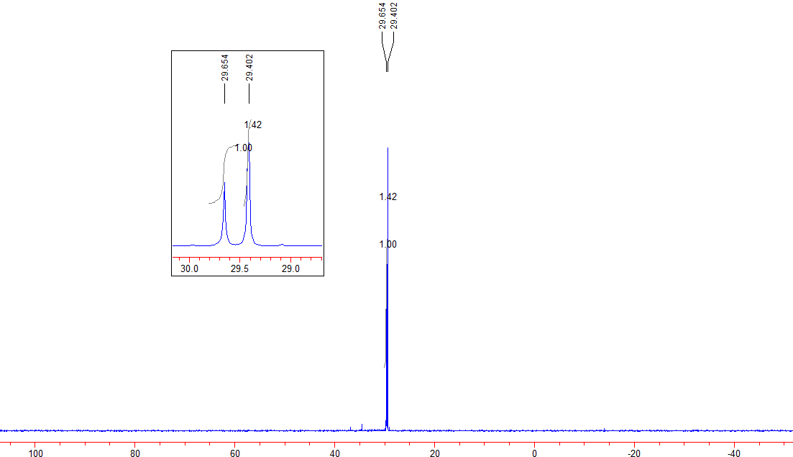
Figure S 1: ³¹P NMR of the crude reaction mixture

General procedure for the Zn(OTf)₂-catalyzed dehydrative reaction of propargyl alcohols with diarylphosphine oxide
An oven-dried Schlenk tube containing a Teflon-coated stir bar was charged with Zn(OTf)₂ (0.1 equiv), propagylic alcohol 1 (2.0 equiv) and diarylphosphine oxide (1.0 equiv). The Schlenk tube was sealed and then evacuated and backfilled with N₂ (3 cycles). The Schlenk tube was sealed and immersed in an oil bath which was heated to 100 ºC. After the reaction was heated for 12 h, the mixture was dissolved in DCM and transferred into a round-bottom flask. Removal of the solvent under vacuum left a slurry residue, which was purified by flash chromatography on silica (petroleum ether/ethyl acetate 3/1 to 1/1) to afford the product 3.

Characterization data of the products 3
(4,4-dimethyl-1-phenylpenta-1,2-dien-3-yl)diphenylphosphine oxide (3a): 69.2 mg (yield 93%), prepared from 75.4 mg of 1a (0.4 mmol) and 40.4 mg of 2a (0.2 mmol). Known compound.³ ¹H NMR (CDCl₃, 400 MHz): δ = 7.78–7.73 (m, 2H), 7.66–7.60 (m, 2H), 7.52–7.48 (m, 1H), 7.45–7.40 (m, 2H), 7.30–7.15 (m, 6H), 7.00 (d, J = 8.0 Hz, 2H), 6.02 (d, J = 11.2 Hz, 1H), 1.34 (s, 9H). ³¹P NMR (CDCl₃, 162 MHz): δ = 29.2.
(1-(4-chlorophenyl)-4,4-dimethylpenta-1,2-dien-3-yl)diphenylphosphine oxide (3b): 76.8 mg (yield 95%), prepared from 89.1 mg of 1b (0.4 mmol) and 40.7 mg of 2a (0.2 mmol). Known compound.³ ¹H NMR (CDCl₃, 400 MHz): δ = 7.79–7.74 (m, 2H), 7.63–7.58 (m, 2H), 7.52–7.42 (m, 3H), 7.31–7.29 (m, 1H), 7.23–7.17 (m, 4H), 6.90 (d, J = 8.0 Hz, 2H), 5.98 (d, J = 11.2 Hz, 1H), 1.33 (s, 9H). ³¹P NMR (CDCl₃, 162 MHz): δ = 29.0.
(1-(4-fluorophenyl)-4,4-dimethylpenta-1,2-dien-3-yl)diphenylphosphine oxide (3c): 73.3 mg (yield 94%), prepared from 83.2 mg of 1c (0.4 mmol) and 40.5 mg of 2a (0.2 mmol). Known compound.³ ¹H NMR (CDCl₃, 400 MHz): δ = 7.80–7.75 (m, 2H), 7.62–7.57 (m, 2H), 7.54–7.42 (m, 3H), 7.30–7.26 (m, 1H), 7.22–7.18 (m, 2H), 6.95–6.88 (m, 4H), 6.00 (d, J = 11.2 Hz, 1H), 1.33 (s, 9H). ³¹P NMR (CDCl₃, 162 MHz): δ = 29.3.
(1-(4-bromophenyl)-4,4-dimethylpenta-1,2-dien-3-yl)diphenylphosphine oxide (3d): 85.7 mg (yield 95%), prepared from 107.2 mg of 1d (0.4 mmol) and 40.4 mg of 2a (0.2 mmol). This is a known compound.³ ¹H NMR (CDCl₃, 400 MHz): δ = 7.79–7.74 (m, 2H), 7.63–7.58 (m, 2H), 7.54–7.42 (m, 3H), 7.34–7.29 (m, 3H), 7.25–7.20 (m, 2H), 6.84 (d, J = 7.6 Hz, 2H), 5.96 (d, J = 11.2 Hz, 1H), 1.32 (s, 9H). ³¹P NMR (CDCl₃, 162 MHz): δ = 29.2.

(1-(2-chlorophenyl)-4,4-dimethylpenta-1,2-dien-3-yl)diphenylphosphine oxide (3e): 66.0 mg (yield 81%), prepared from 89.5 mg of 1f (0.4 mmol) and 40.6 mg of 2a (0.2 mmol). This is a known compound.³ ¹H NMR (CDCl₃, 400 MHz): δ = 7.82–7.77 (m, 2H), 7.60–7.52 (m, 3H), 7.49–7.45 (m, 2H), 7.29–7.16 (m, 4H), 7.14–7.06 (m, 3H), 6.46 (d, J = 11.2 Hz, 1H), 1.34 (s, 9H). ³¹P NMR (CDCl₃, 162 MHz): δ = 29.1.
diphenyl(1-phenylhepta-1,2-dien-3-yl)phosphine oxide (3g): 54.9 mg (yield 74%), prepared from 75.5 mg of 1g (0.4 mmol) and 40.4 mg of 2a (0.2 mmol). This is a known compound.³ ¹H NMR (CDCl₃, 400 MHz): δ = 7.78–7.69 (m, 4H), 7.52–7.48 (m, 1H), 7.43–7.31 (m, 5H), 7.28–7.24 (m, 2H), 7.21–7.17 (m, 1H), 7.09-7.07 (m, 2H), 6.11 (dt, J₁ = 11.2 Hz, J₂ = 3.2 Hz, 1H), 2.50–2.30 (m, 2H), 1.60–1.51 (m, 2H), 1.37–1.31 (m, 2H), 0.84 (t, J = 7.2 Hz, 3H). ³¹P NMR (CDCl₃, 162 MHz): δ = 29.5.
(1-(4-fluorophenyl)hepta-1,2-dien-3-yl)diphenylphosphine oxide (3h): 55.9 mg (yield 72%), prepared from 83.2 mg of 1h (0.4 mmol) and 40.4 mg of 2a (0.2 mmol). This is a known compound.³ ¹H NMR (CDCl₃, 400 MHz): δ = 7.79–7.74 (m, 2H), 7.71–7.66 (m, 2H), 7.54–7.50 (m, 1H), 7.46–7.39 (m, 3H), 7.35–7.30 (m, 2H), 7.05–7.02 (m, 2H), 6.97–6.92 (m, 2H), 6.09 (dt, J₁ = 10.8 Hz, J₂ = 3.2 Hz, 1H), 2.50–2.29 (m, 2H), 1.59–1.50 (m, 2H), 1.37–1.31 (m, 2H), 0.84 (t, J = 7.4 Hz, 3H). ³¹P NMR (CDCl₃, 162 MHz): δ = 29.6.
diphenyl(1-(4-(trifluoromethyl)phenyl)hepta-1,2-dien-3-yl)phosphine oxide (3i): 41.5 mg (yield 47%), prepared from 102.8 mg of 1i (0.4 mmol) and 40.5 mg of 2a (0.2 mmol). This is a known compound.³ ¹H NMR (CDCl₃, 400 MHz): δ = 7.79–7.66 (m, 4H), 7.53–7.40 (m, 6H), 7.36-7.32 (m, 2H), 7.16 (d, J = 8.0 Hz, 2H), 6.13 (dt, J₁ = 9.2 Hz, J₂ = 3.2 Hz, 1H), 2.52–2.31 (m, 2H), 1.59–1.50 (m, 2H), 1.37–1.32 (m, 2H), 0.84 (t, J = 7.6 Hz, 3H). ³¹P NMR (CDCl₃, 162 MHz): δ = 29.6.
(4,4-dimethyl-1,1-diphenylpenta-1,2-dien-3-yl)diphenylphosphine oxide (3k): 85.2 mg (yield 95%), prepared from 105.6 mg of 1k (0.4 mmol) and 40.5 mg of 2a (0.2 mmol). This is a known compound.³ ¹H NMR (CDCl₃, 400 MHz): δ = 7.61–7.56 (m, 4H), 7.40–7.36 (m, 2H), 7.28–7.26 (m, 10H), 6.97–6.94 (m, 4H), 1.35 (s, 9H). ³¹P NMR (CDCl₃, 162 MHz): δ = 29.0.
(1,1-diphenylhepta-1,2-dien-3-yl)diphenylphosphine oxide (3l): 59.8 mg (yield 67%), prepared from 105.5 mg of 1l (0.4 mmol) and 40.2 mg of 2a (0.2 mmol). This is a known compound.³ ¹H NMR (CDCl₃, 400 MHz): δ = 7.66–7.61 (m, 4H), 7.46–7.42 (m, 2H), 7.34–7.26 (m, 10H), 6.99–6.97 (m, 4H), 2.47–2.41 (m, 2H), 1.67–1.59 (m, 2H), 1.35–1.31 (m, 2H), 0.83 (t, J = 7.4 Hz, 3H). ³¹P NMR (CDCl₃, 162 MHz): δ = 29.9.
cyclohexylidene-3,3-dimethylbut-1-en-2-yl)diphenylphosphine oxide (3m): 19.1 mg (yield 26%), prepared from 72.2 mg of 1m (0.4 mmol) and 40.4 mg of 2a (0.2 mmol). This is a known compound.³ ¹H NMR (CDCl₃, 400 MHz): δ = 7.71–7.66 (m, 4H), 7.49–7.40 (m, 6H), 2.00–1.93 (m, 2H), 1.77–1.70 (m, 2H), 1.44–1.37 (m, 2H), 1.34–1.26 (m, 2H), 1.21 (s, 9H), 1.10–1.02 (m, 2H). ³¹P NMR (CDCl₃, 162 MHz): δ = 31.6.
(1,3-diphenylpropa-1,2-dien-1-yl)diphenylphosphine oxide (3n): 15.7 mg (yield 20%), prepared from 83.7 mg of 1n (0.4 mmol) and 40.6 mg of 2a (0.2 mmol). This is a known compound.³ ¹H NMR (CDCl₃, 400 MHz): δ = 7.80–7.72 (m, 4H), 7.68 (d, J = 8.0 Hz, 2H), 7.48–7.44 (m, 1H), 7.39–7.21 (m, 11H), 7.12 (d, J = 7.6 Hz, 2H), 6.29 (d, J = 10.8 Hz, 1H). ³¹P NMR (CDCl₃, 162 MHz): δ = 29.7.

(1-cyclopropyl-3-phenylpropa-1,2-dien-1-yl)diphenylphosphine oxide (3o): 26.5 mg (yield 37%), prepared from 68.9 mg of 1o (0.4 mmol) and 40.4 mg of 2a (0.2 mmol). This is a known compound.³ ¹H NMR (CDCl₃, 400 MHz): δ = 7.81–7.73 (m, 4H), 7.51–7.48 (m, 1H), 7.43–7.32 (m, 5H), 7.27–7.17 (m, 3H), 7.05 (d, J = 8.0 Hz, 2H), 6.16 (dd, J₁ = 10.8 Hz, J₂ = 1.2 Hz, 1H), 1.66–1.57 (m, 1H), 0.90–0.79 (m, 2H), 0.65–0.57 (m, 2H). ³¹P NMR (CDCl₃, 162 MHz): δ = 29.8.
(4,4-dimethyl-1-phenylpenta-1,2-dien-3-yl)di-p-tolylphosphine oxide (3p): 63.5 mg (yield 79%), prepared from 75.4 mg of 1a (0.4 mmol) and 46.1 mg of 2b (0.2 mmol). This is a known compound.³ ¹H NMR (CDCl₃, 400 MHz): δ = 7.62 (dd, J₁ = 11.6 Hz, J₂ = 8.0 Hz, 2H), 7.50 (dd, J₁ = 12.0 Hz, J₂ = 8.0 Hz, 2H), 7.24–7.17 (m, 5H), 7.01–7.99 (m, 4H), 6.00 (d, J = 10.8 Hz, 1H), 2.38 (s, 3H), 2.21 (s, 3H), 1.33 (s, 9H). ³¹P NMR (CDCl₃, 162 MHz): δ = 29.5.
(4,4-dimethyl-1-phenylpenta-1,2-dien-3-yl)bis(4-fluorophenyl)phosphine oxide (3q): 76.5 mg (yield 85%), prepared from 82.8 mg of 1a (0.44 mmol) and 52.4 mg of 2c (0.22 mmol). This is a known compound.³ ¹H NMR (CDCl₃, 400 MHz): δ = 7.77–7.71 (m, 2H), 7.63–7.57 (m, 2H), 7.27–7.20 (m, 3H), 7.16–7.11 (m, 2H), 7.00 (d, J = 8.0 Hz, 2H), 6.92-6.87 (m, 2H), 6.05 (d, J = 11.6 Hz, 1H), 1.33 (s, 9 H). ³¹P NMR (CDCl₃, 162 MHz): δ = 27.8.
(4,4-dimethyl-1-phenylpenta-1,2-dien-3-yl)bis(4-methoxyphenyl)phosphine oxide (3r): 77.5 mg (yield 90%), prepared from 75.2 mg of 1a (0.4 mmol) and 52.5 mg of 2d (0.2 mmol). This is a known compound.³ ¹H NMR (CDCl₃, 400 MHz): δ = 7.65 (dd, J₁ = 11.6 Hz, J₂ = 8.8 Hz, 2H), 7.53 (dd, J₁ = 11.6 Hz, J₂ = 8.8 Hz, 2H), 7.25–7.15 (m, 3H), 7.01 (d, J = 8.0 Hz, 2H), 6.93 (dd, J₁ = 8.8 Hz, J₂ = 2.0 Hz, 2H), 6.69 (dd, J₁ = 8.8 Hz, J₂ = 2.4 Hz, 2H), 6.00 (d, J = 11.2 Hz, 1H), 3.83 (s, 3H) 3.67 (s, 3H), 1.33 (s, 9 H). ³¹P NMR (CDCl₃, 162 MHz): δ = 29.8.
bis(3-chlorophenyl)(4,4-dimethyl-1-phenylpenta-1,2-dien-3-yl)phosphine oxide (3s): 75.2 mg (yield 82%), prepared from 75.3 mg of 1a (0.4 mmol) and 54.2 mg of 2e (0.2 mmol). This is a known compound.³ ¹H NMR (CDCl₃, 400 MHz): δ = 7.74 (dt, J₁ = 12.0 Hz, J₂= 1.6 Hz, 1H), 7.64–7.56 (m, 2H), 7.51–7.36 (m, 3H), 7.29–7.13 (m, 5H), 7.03 (d, J = 8.0 Hz, 1H), 6.11 (d, J = 11.2 Hz, 1H), 1.34 (s, 9H). ³¹P NMR (CDCl₃, 162 MHz): δ = 27.3.
(4,4-dimethyl-1-phenylpenta-1,2-dien-3-yl)bis(4-methoxyphenyl)phosphine oxide (3t): 63.9 mg (yield 82%), prepared from 75.4 mg of 1a (0.4 mmol) and 44.0 mg of 2f (0.2 mmol). ¹H NMR (CDCl₃, 400 MHz): δ = 7.79-7.57 (m, 4H), 7.54-7.31 (m, 2H), 7.26–7.17 (m, 4H), 7.13-7.08 (m, 1H), 7.03-6.98 (m, 2H), 6.89-6.84 (m, 1H), 6.06-6.01 (m, 1H), 1.34 (s, 4.5H), 1.33 (s, 4.5H). ³¹P NMR (CDCl₃, 162 MHz): δ = 29.13, 29.08. HRMS (ESI-TOF): m/z = 391.1618, calcd for C₂₅H₂₅FOP [MH⁺] 391.1627.
(4,4-dimethyl-1-phenylpenta-1,2-dien-3-yl)bis(4-methoxyphenyl)phosphine oxide (3u): 67.8 mg (yield 84%), prepared from 75.5 mg of 1a (0.4 mmol) and 46.4 mg of 2g (0.2 mmol). ¹H NMR (CDCl₃, 400 MHz): δ = 7.77-7.39 (m, 6H), 7.25-7.161 (m, 4H), 7.02–6.93 (m, 3H), 6.72-6.69 (m, 1H), 6.03-5.99 (m, 1H), 3.84 (s, 1.5H), 3.68 (s, 1.5), 1.33 (s, 9 H). ³¹P NMR (CDCl₃, 162 MHz): δ = 30.1, 29.9. HRMS (ESI-TOF): m/z = 403.1819, calcd for C₂₆H₂₈O₂P [MH⁺] 403.1827.

Reference:
- J. Y. Kang, B. T. Connell, J. Org. Chem. 2011, 76, 2379.
- R. Shen, B. Luo, J. Yang, L. Zhang and L.-B. Han, Chem. Commun. 2016, 52, 6451.
- (a) G. Hu, C. Shan, W. Chen, P. Xu, Y. Gao and Y. Zhao, Org. Lett. 2016, 18, 6066; (b) J. Yang, M. Zhang, K. Qiu, L. Wang, J. Yu, Z. Xia, R. Shen, L.-B. Han, Adv. Syn. Catal. 2017, 359, 4417.

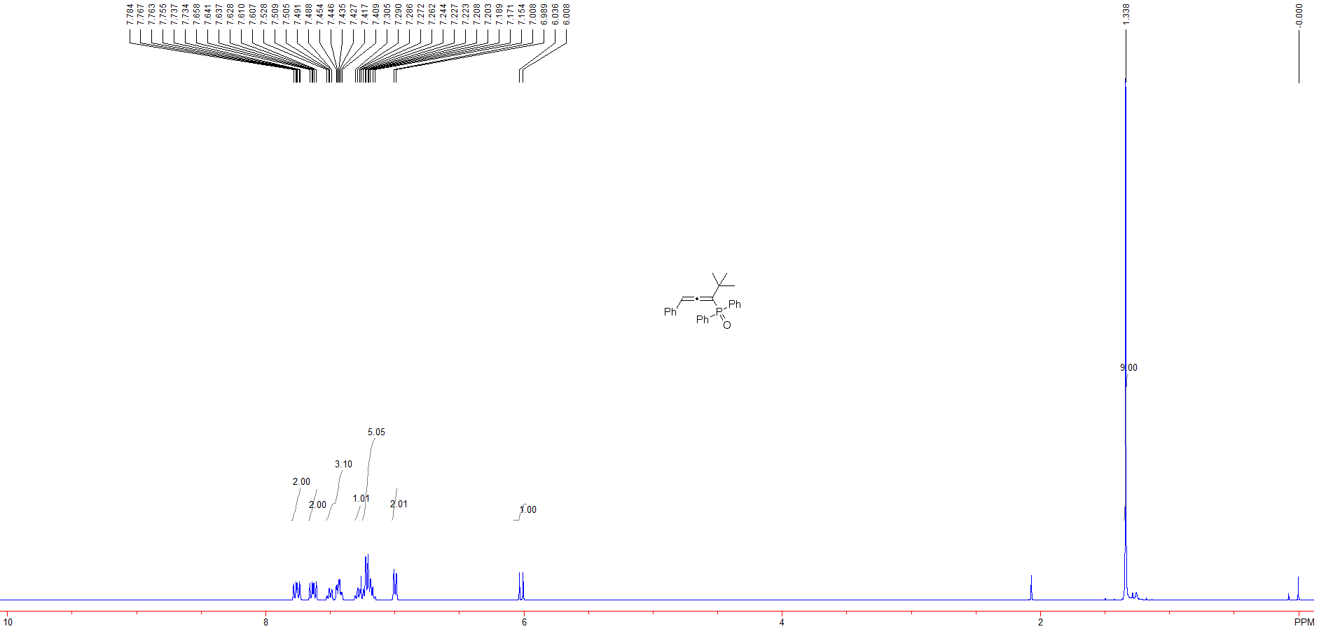
Figure S 2: ¹H NMR spectra of (4,4-dimethyl-1-phenylpenta-1,2-dien-3-yl)diphenylphosphine oxide (3a)

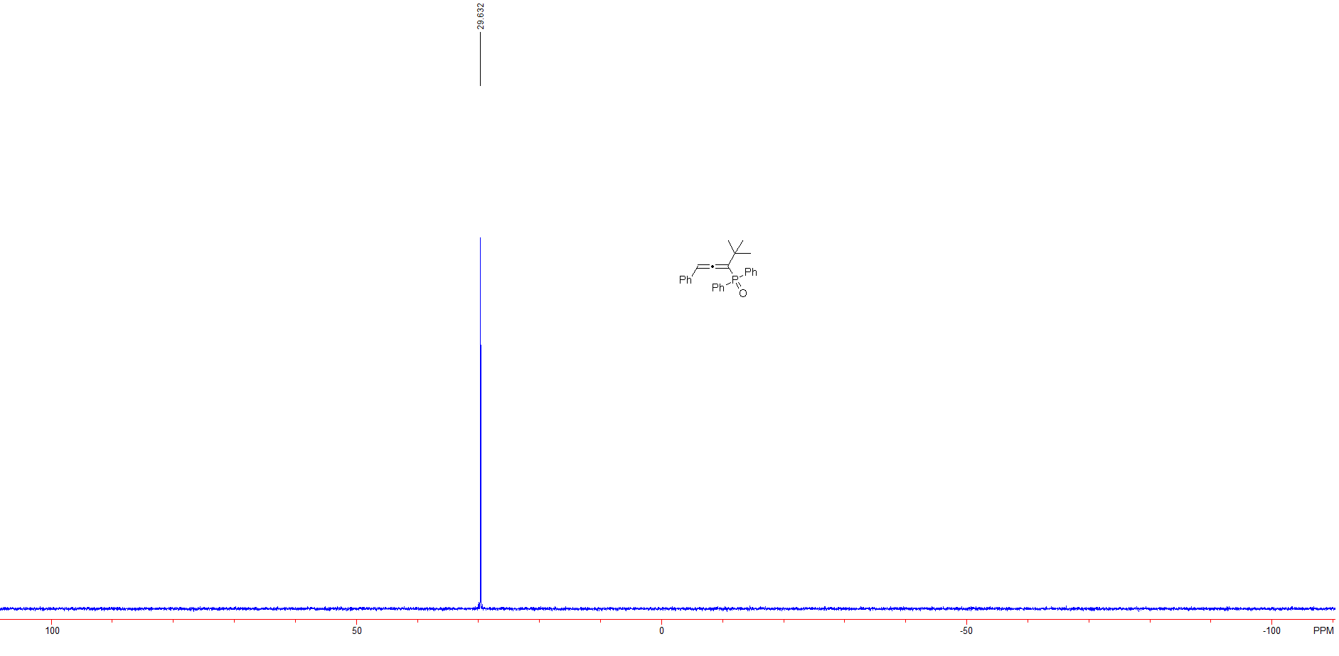

Figure S 3: ³¹P NMR spectra of (4,4-dimethyl-1-phenylpenta-1,2-dien-3-yl)diphenylphosphine oxide (3a)

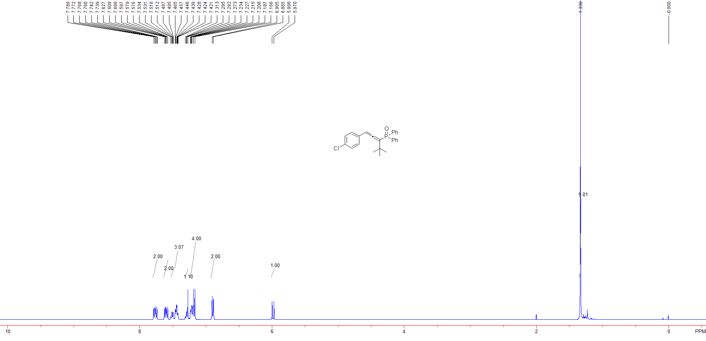

Figure S 4: ¹H NMR spectra of (1-(4-chlorophenyl)-4,4-dimethylpenta-1,2-dien-3-yl)diphenylphosphine oxide (3b)

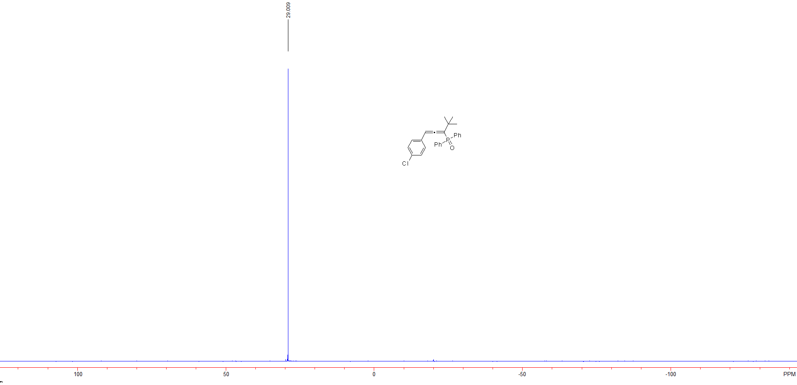

Figure S 5: ³¹P NMR spectra of (1-(4-chlorophenyl)-4,4-dimethylpenta-1,2-dien-3-yl)diphenylphosphine oxide (3b)

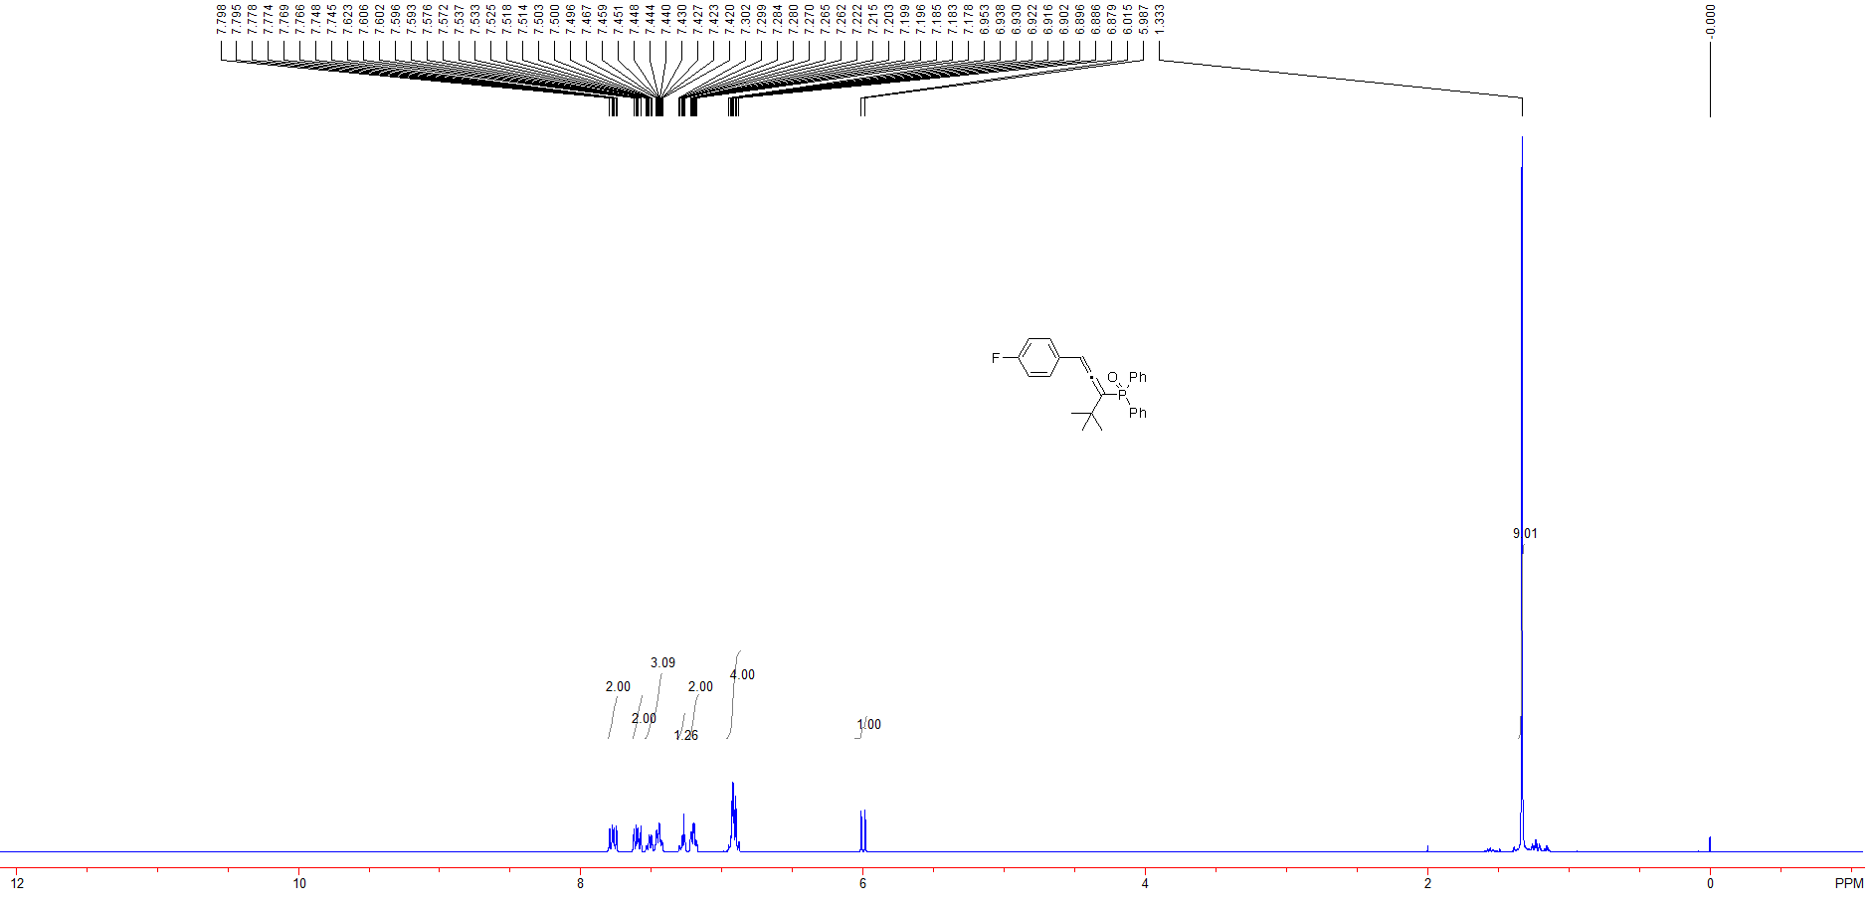

Figure S 6: ¹H NMR spectra of (1-(4-fluorophenyl)-4,4-dimethylpenta-1,2-dien-3-yl)diphenylphosphine oxide (3c)

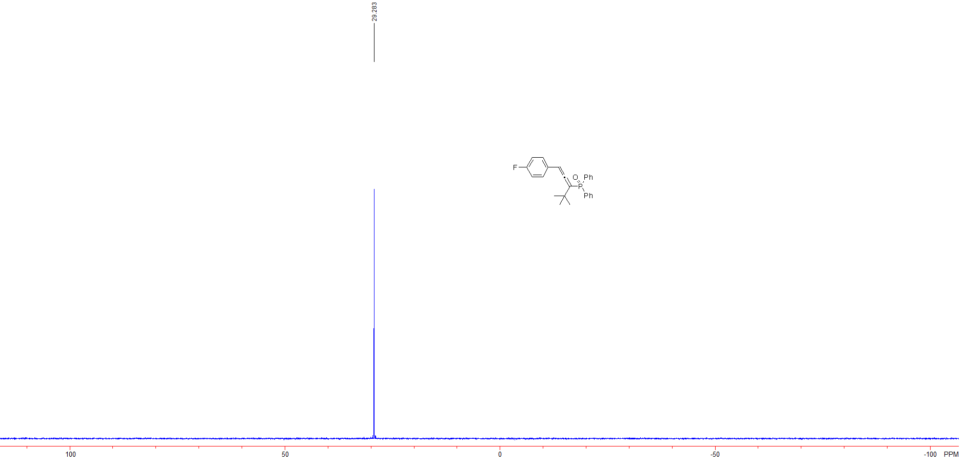

Figure S 7: ³¹P NMR spectra of (1-(4-fluorophenyl)-4,4-dimethylpenta-1,2-dien-3-yl)diphenylphosphine oxide (3c)

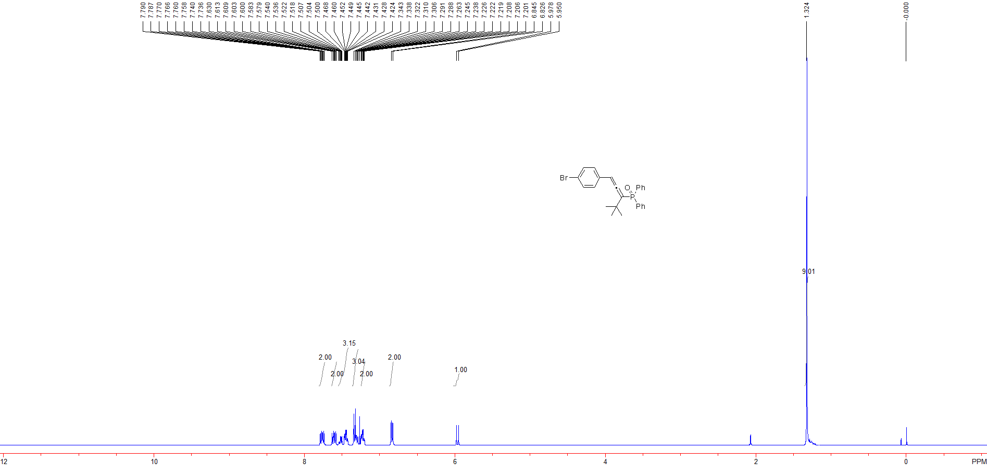

Figure S 8: ¹H NMR spectra of (1-(4-bromophenyl)-4,4-dimethylpenta-1,2-dien-3-yl)diphenylphosphine oxide (3d)

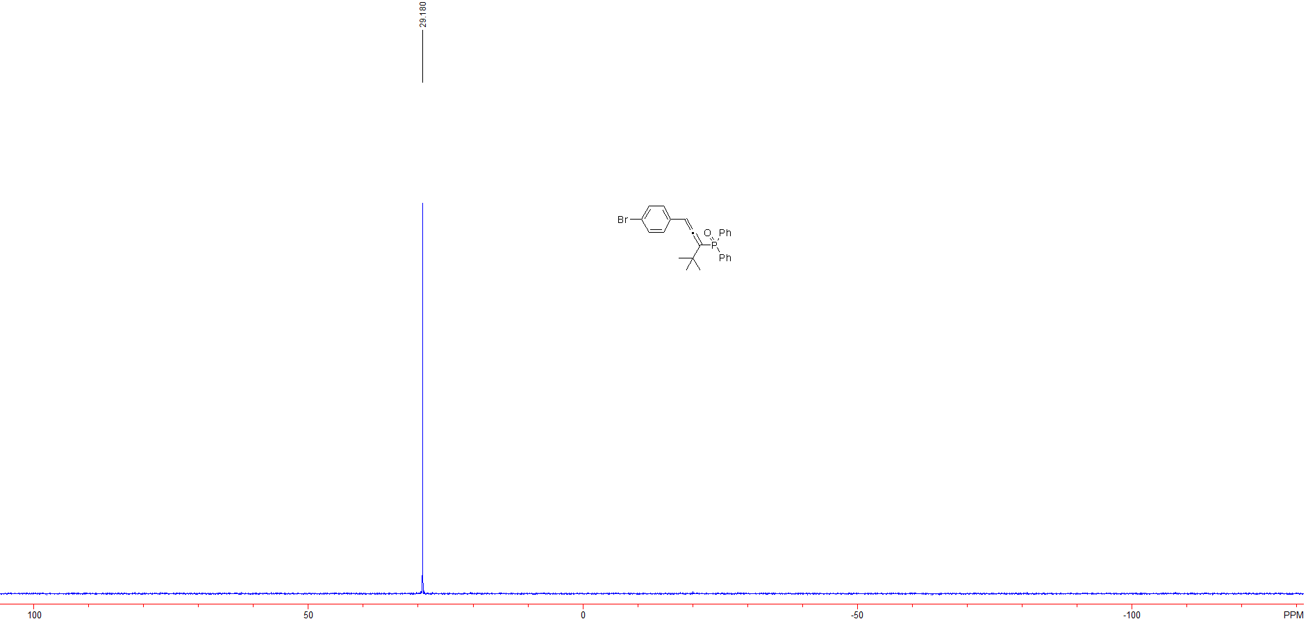

Figure S 9: ³¹P NMR spectra of (1-(4-bromophenyl)-4,4-dimethylpenta-1,2-dien-3-yl)diphenylphosphine oxide (3d)

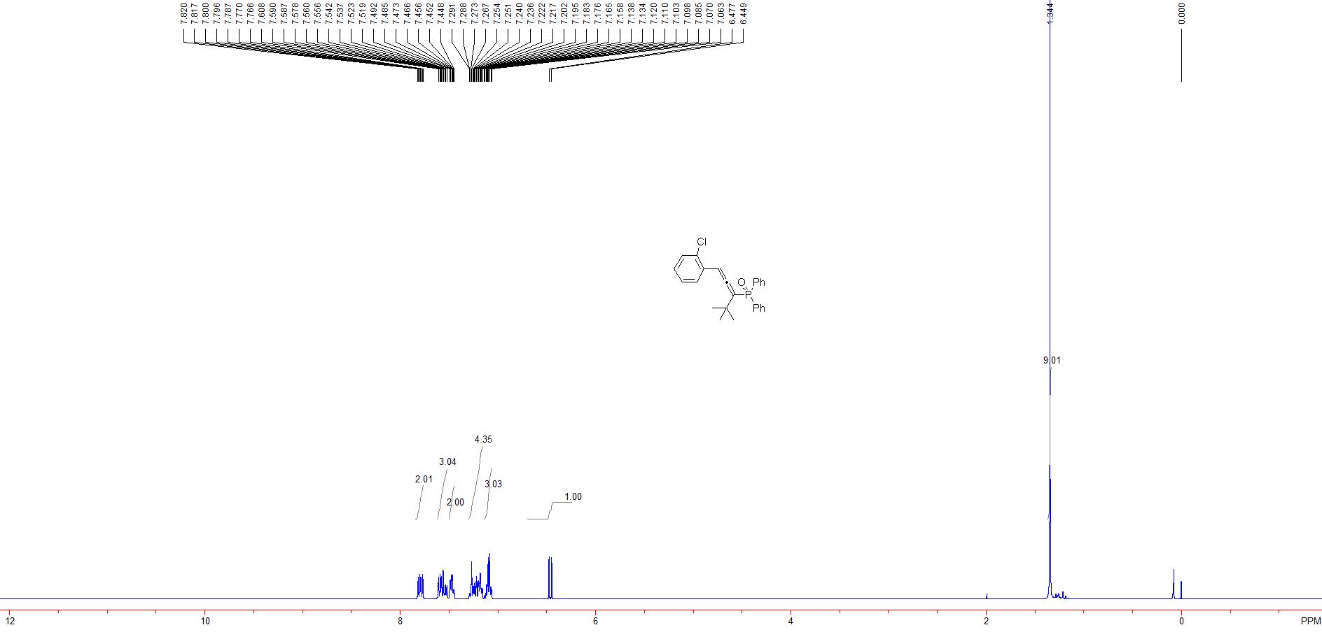

Figure S 10: ¹H NMR spectra of (1-(2-chlorophenyl)-4,4-dimethylpenta-1,2-dien-3-yl)diphenylphosphine oxide (3e)

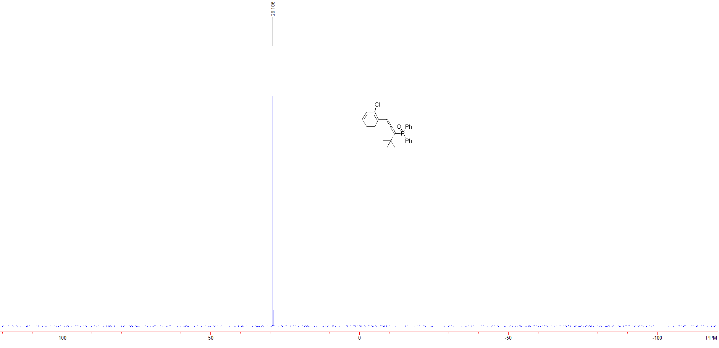

Figure S 11: ³¹P NMR spectra of (1-(2-chlorophenyl)-4,4-dimethylpenta-1,2-dien-3-yl)diphenylphosphine oxide (3e)

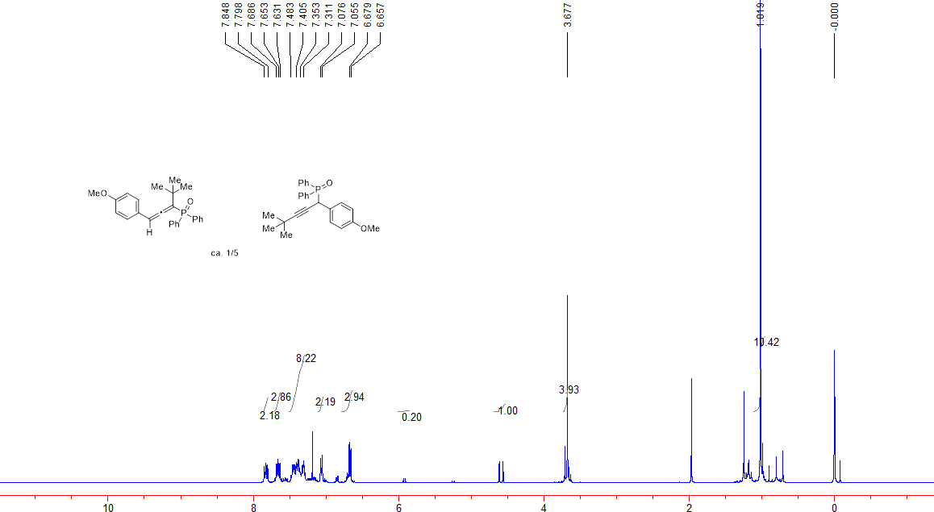

Figure S 12: ¹H NMR spectra of the mixture of (1-(4-methoxyphenyl)-4,4-dimethylpenta-1,2-dien-3-yl)diphenylphosphineoxide(3f)and(1-(4-methoxyphenyl)-4,4-dimethylpent-2-yn-1-yl)diphenylphosphine oxide (3f’)

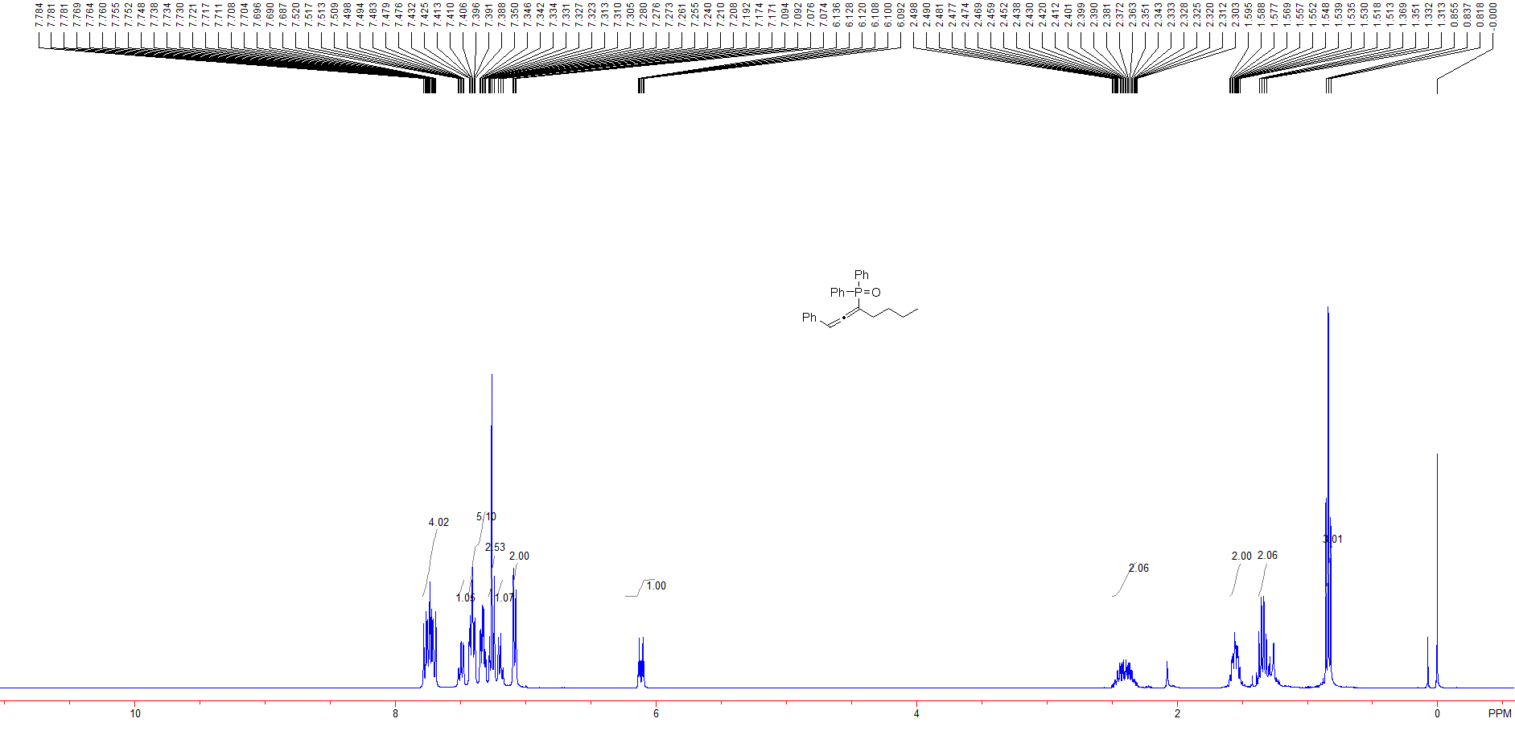

Figure S 13: ¹H NMR spectra of diphenyl(1-phenylhepta-1,2-dien-3-yl)phosphine oxide (3g)

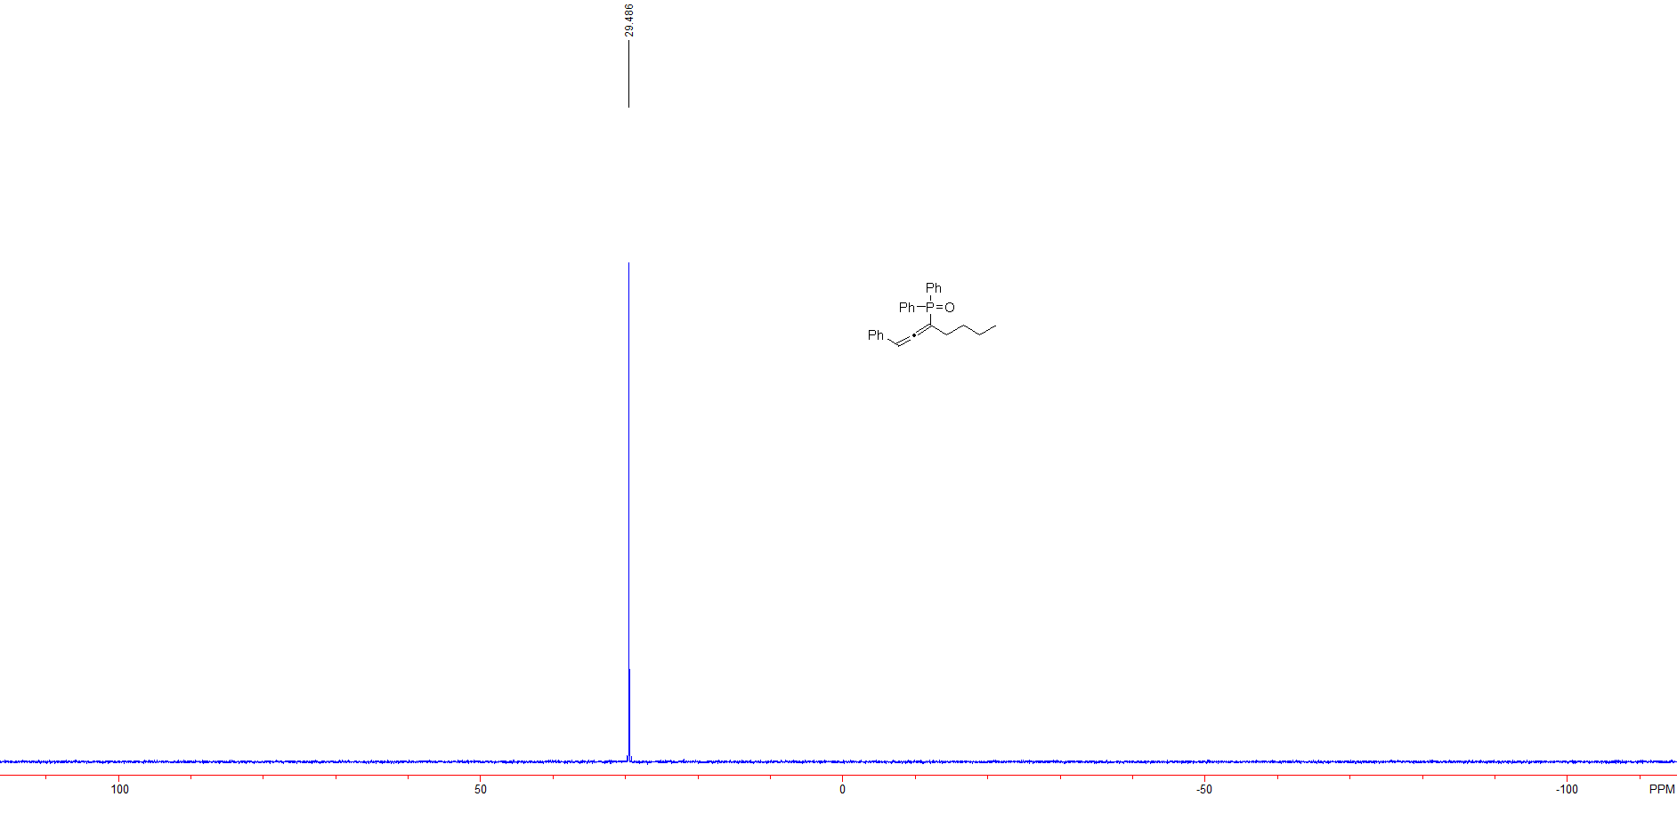

Figure S 14: ³¹P NMR spectra of diphenyl(1-phenylhepta-1,2-dien-3-yl)phosphine oxide (3g)

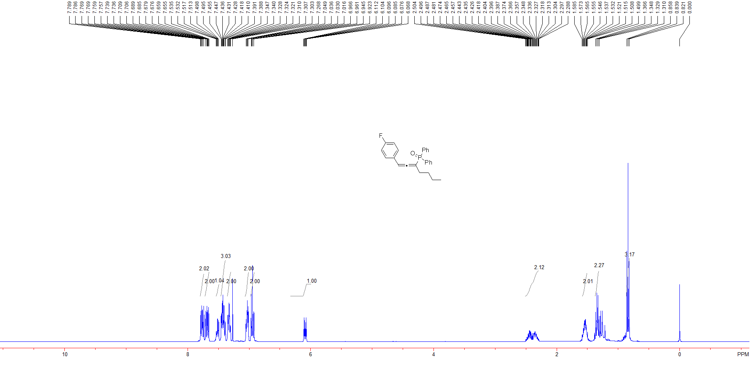

Figure S 15: ¹H NMR spectra of (1-(4-fluorophenyl)hepta-1,2-dien-3-yl)diphenylphosphine oxide (3h)

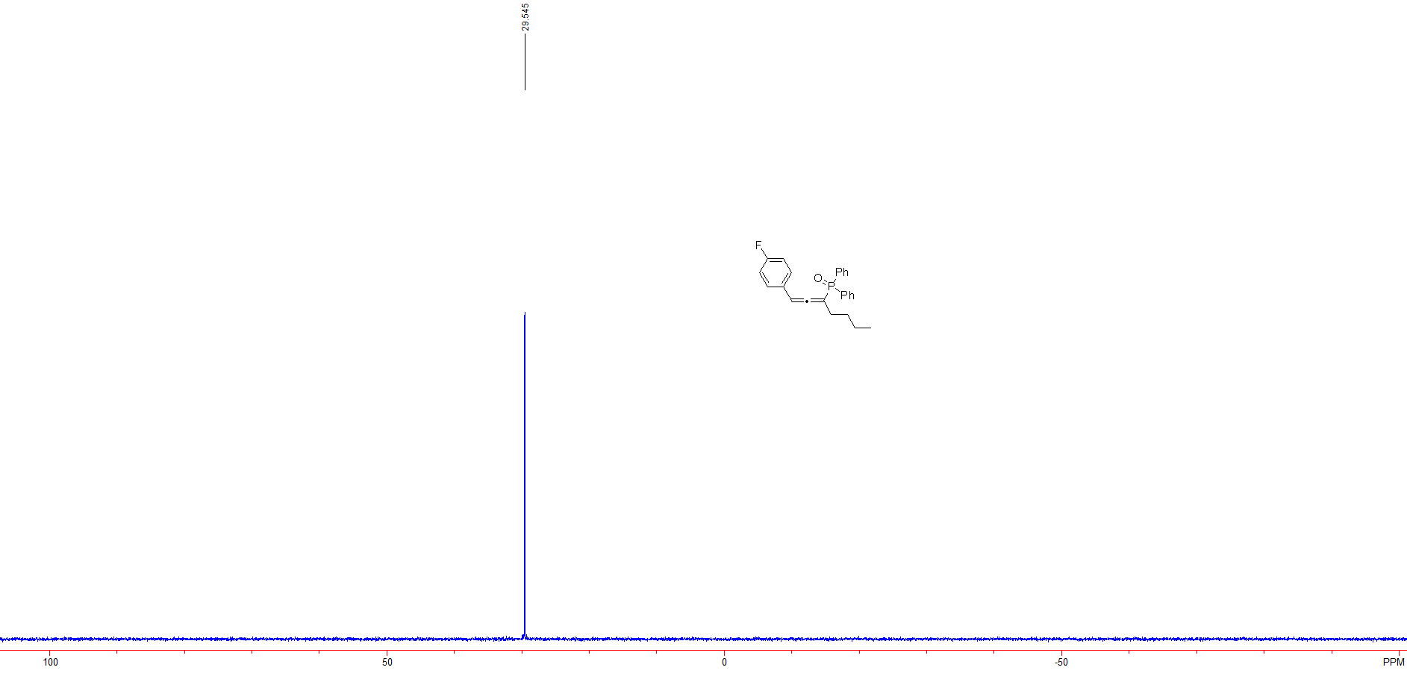

Figure S 16: ³¹P NMR spectra of (1-(4-fluorophenyl)hepta-1,2-dien-3-yl)diphenylphosphine oxide (3h)

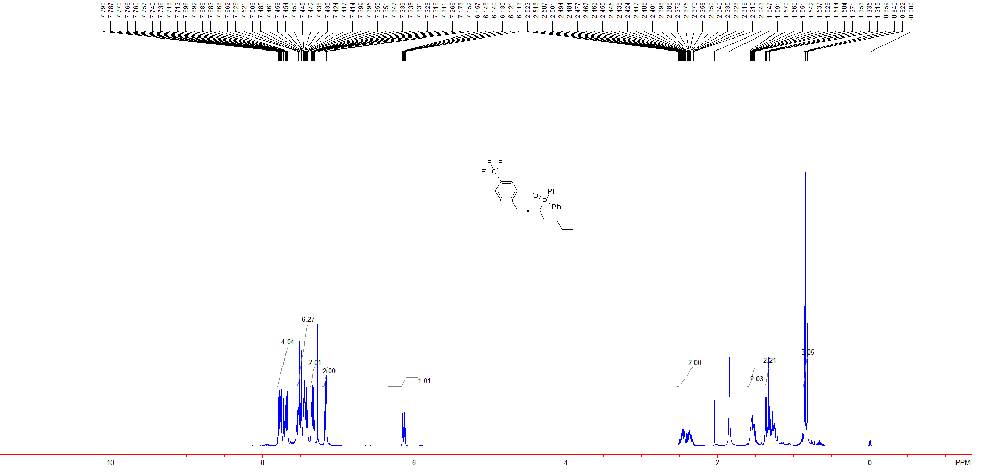

Figure S 17: ¹H NMR spectra of diphenyl(1-(4-(trifluoromethyl)phenyl)hepta-1,2-dien-3-yl)phosphine oxide (3i)

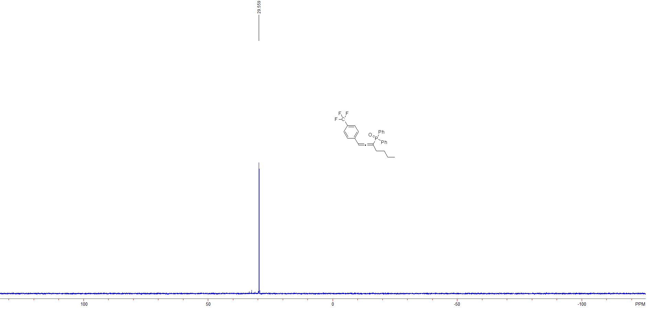

Figure S 18: ³¹P NMR spectra of diphenyl(1-(4-(trifluoromethyl)phenyl)hepta-1,2-dien-3-yl)phosphine oxide (3i)

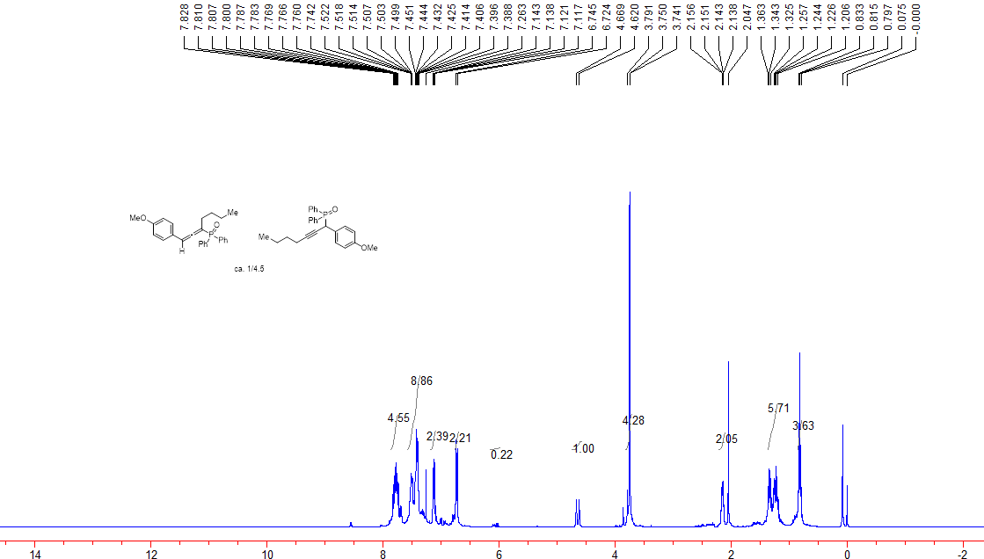

Figure S 19: ¹H NMR spectra of the mixture of (1-(4-methoxyphenyl)hepta-1,2-dien-3-yl)diphenylphosphine oxide (3j) and (1-(4-methoxyphenyl)hepta-1,2-dien-3-yl)diphenylphosphine oxide (3j’)

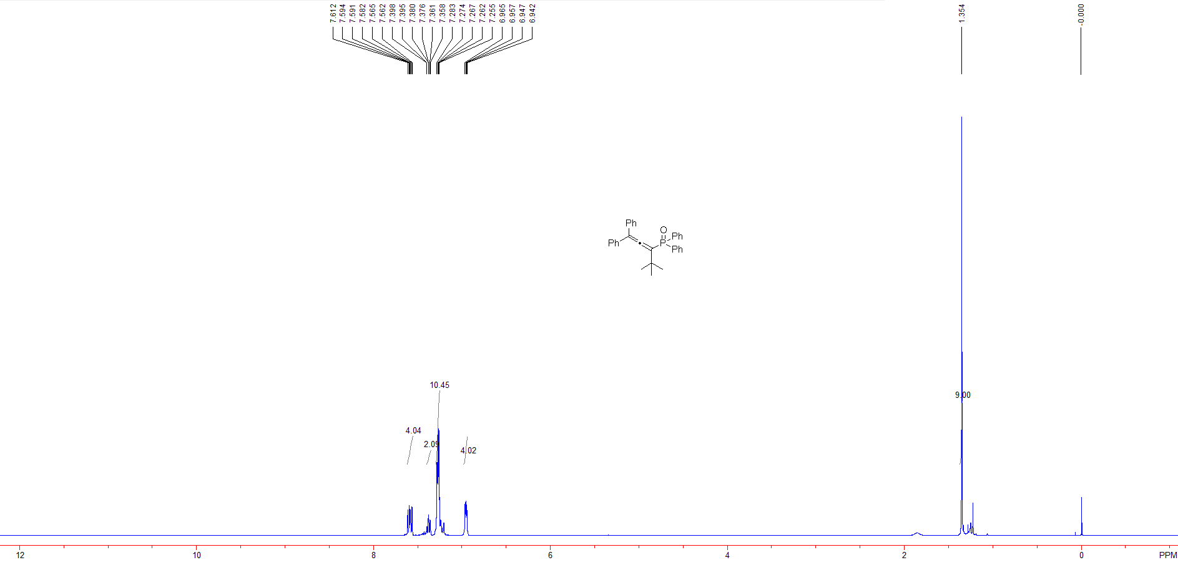

Figure S 20: ¹H NMR spectra of (4,4-dimethyl-1,1-diphenylpenta-1,2-dien-3-yl)diphenylphosphine oxide (3k)

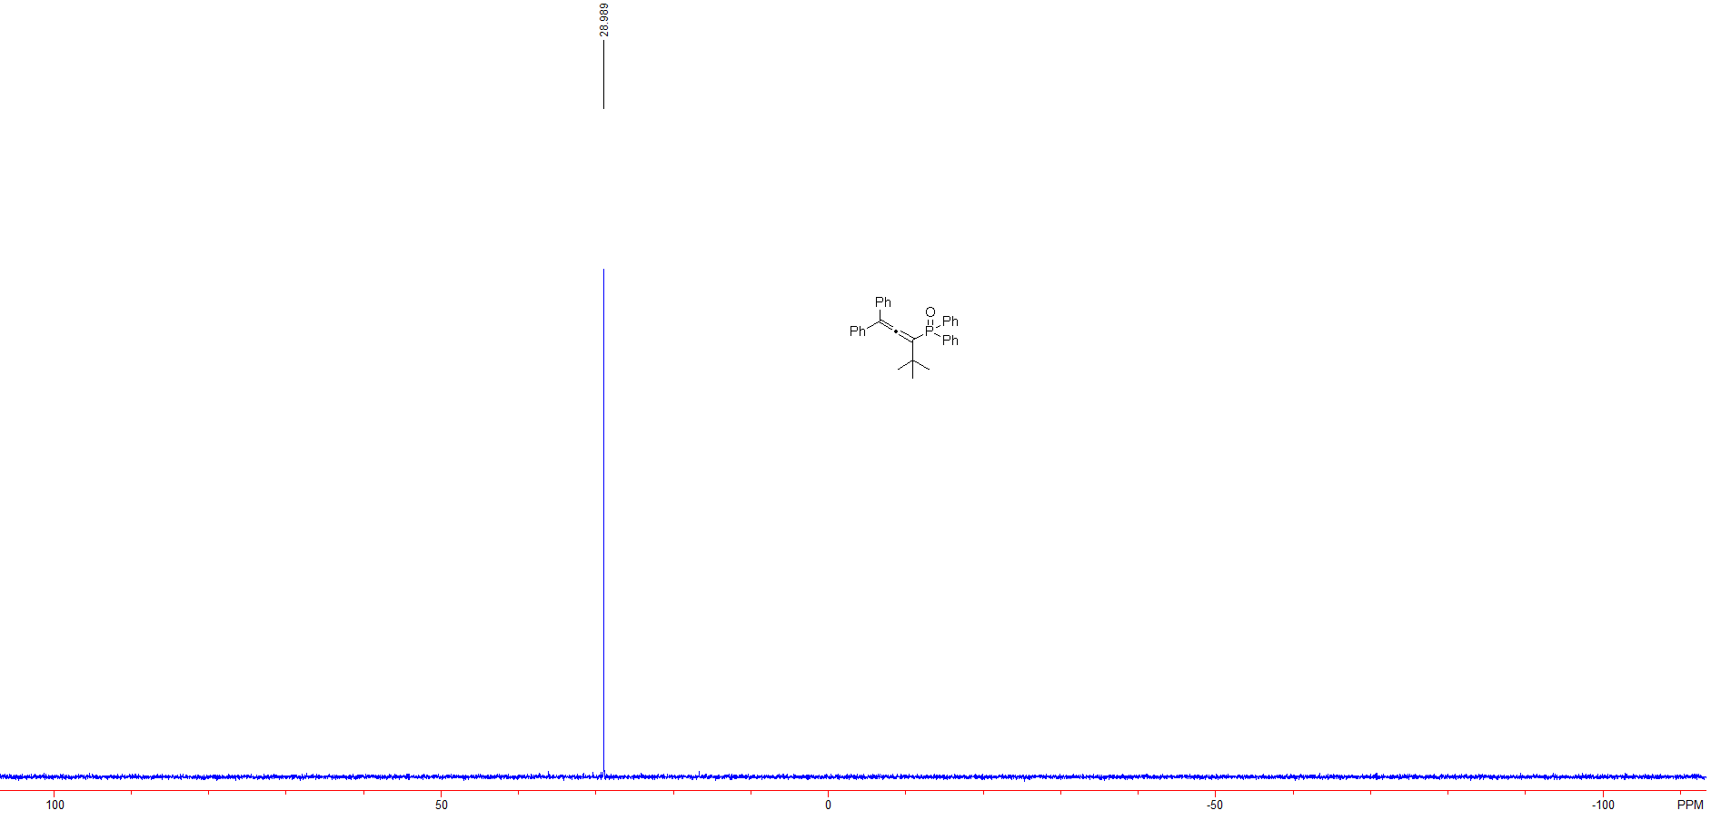

Figure S 21: ³¹P NMR spectra of (4,4-dimethyl-1,1-diphenylpenta-1,2-dien-3-yl)diphenylphosphine oxide (3k)

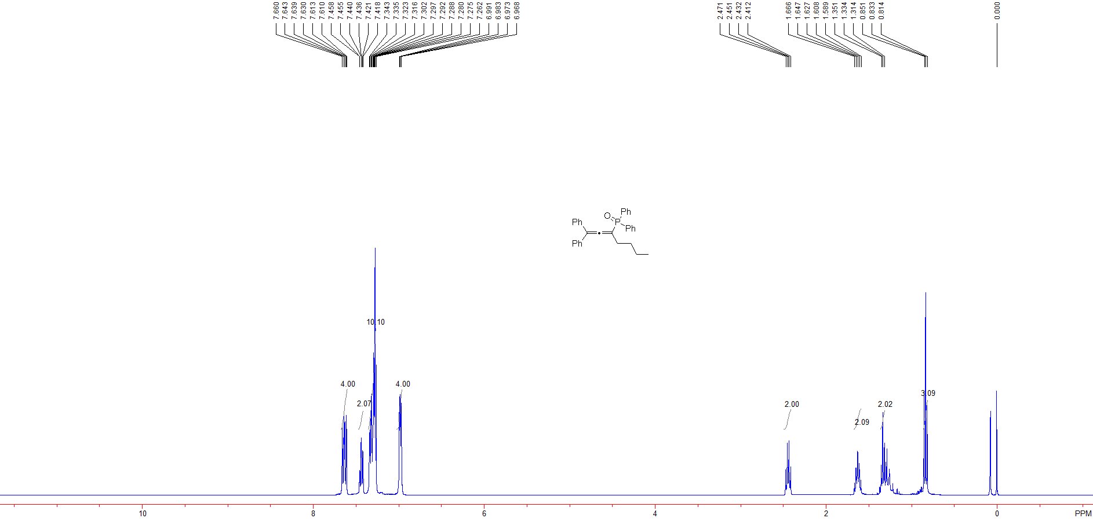

Figure S 22: ¹H NMR spectra of (1,1-diphenylhepta-1,2-dien-3-yl)diphenylphosphine oxide (3l)

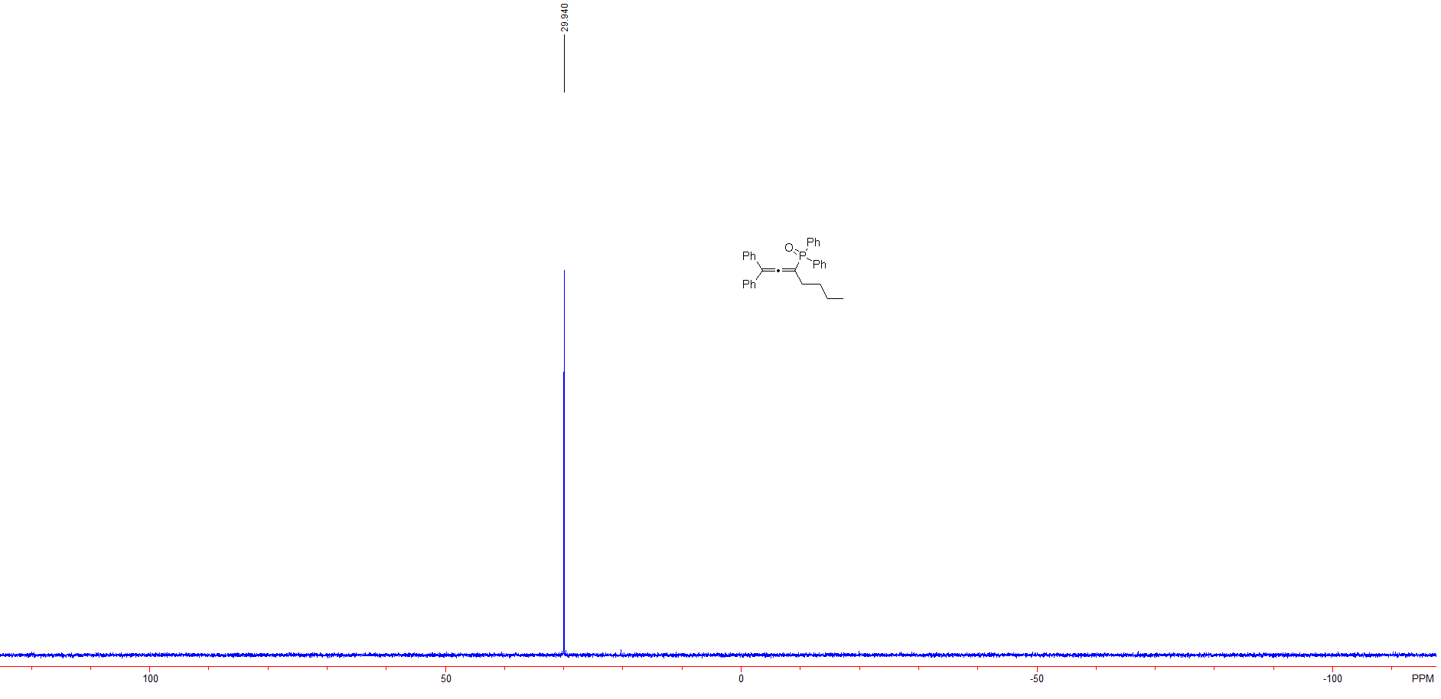

Figure S 23: ³¹P NMR spectra of (1,1-diphenylhepta-1,2-dien-3-yl)diphenylphosphine oxide (3l)

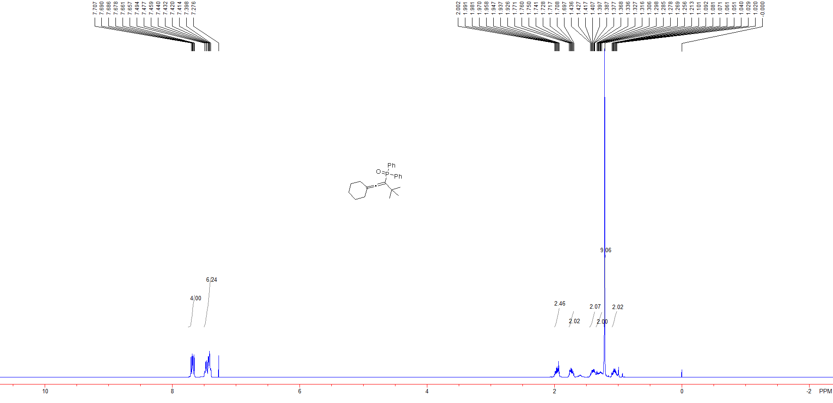

Figure S 24: ¹H NMR spectra of (1-cyclohexylidene-3,3-dimethylbut-1-en-2-yl)diphenylphosphine oxide (3m)

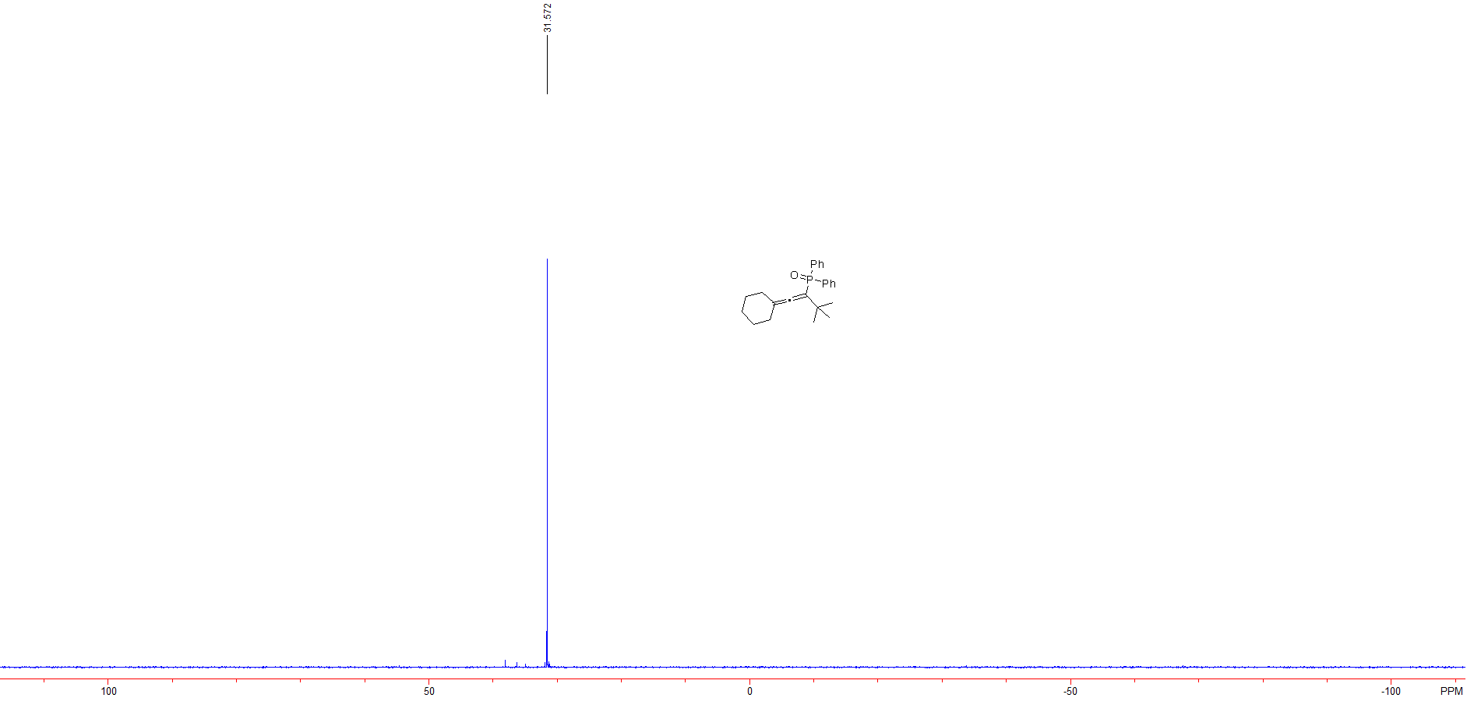

Figure S 25: ³¹P NMR spectra of (1-cyclohexylidene-3,3-dimethylbut-1-en-2-yl)diphenylphosphine oxide (3m)

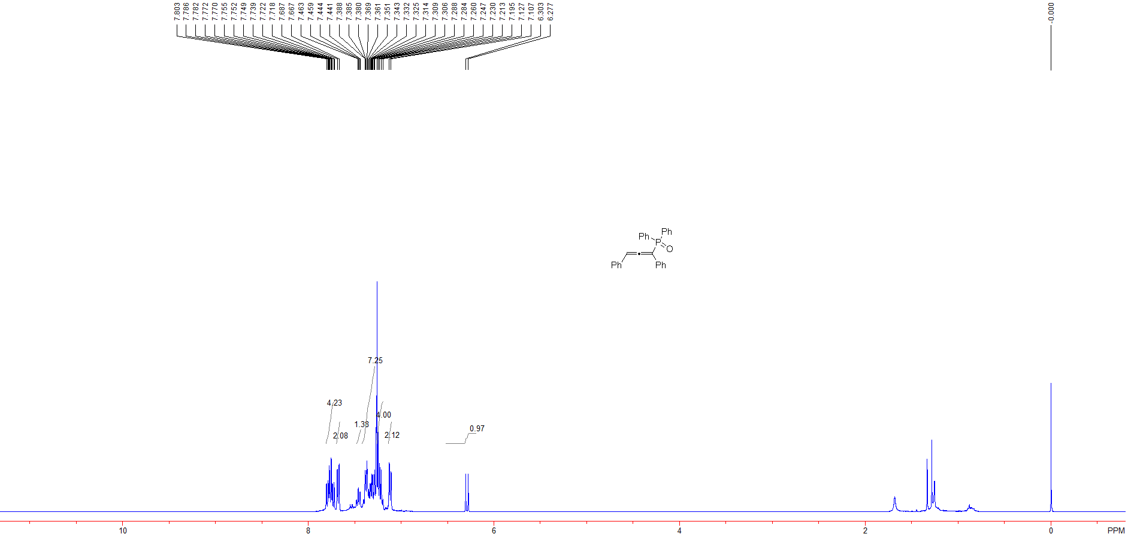

Figure S 26: ¹H NMR spectra of (1,3-diphenylpropa-1,2-dien-1-yl)diphenylphosphine oxide (3n)

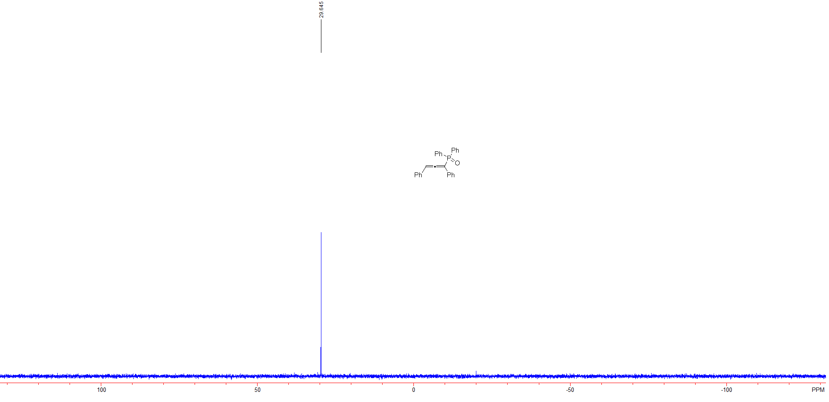

Figure S 27: ³¹P NMR spectra of (1,3-diphenylpropa-1,2-dien-1-yl)diphenylphosphine oxide (3n)

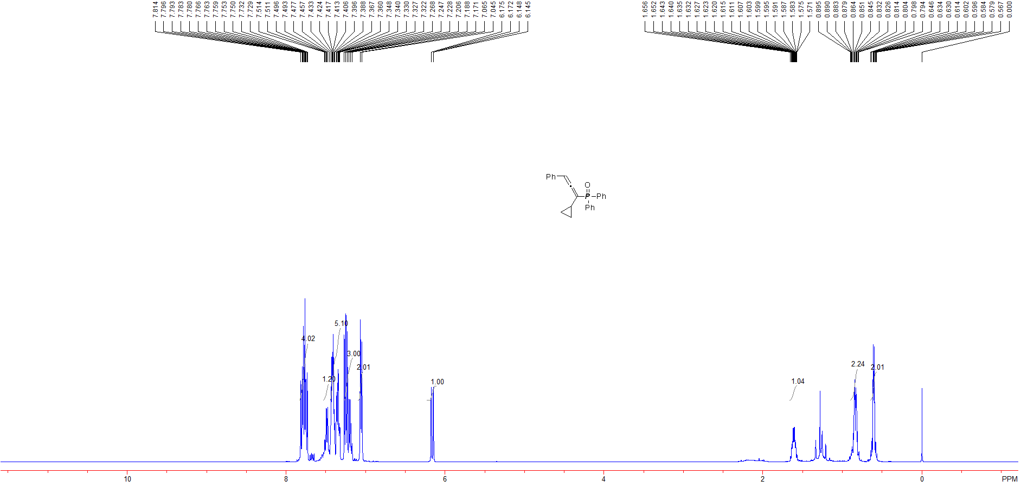

Figure S 28: ¹H NMR spectra of (1-cyclopropyl-3-phenylpropa-1,2-dien-1-yl)diphenylphosphine oxide (3o)

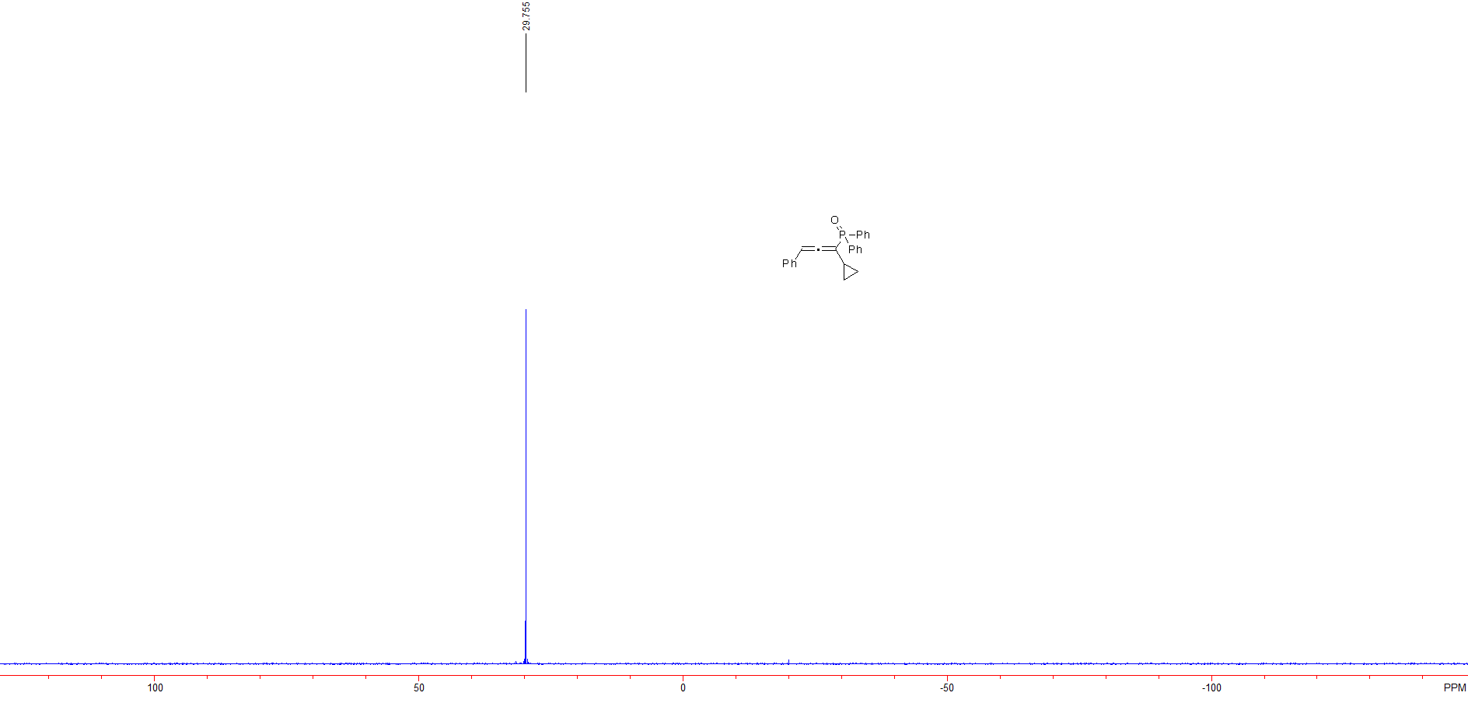

Figure S 29: ³¹P NMR spectra of (1-cyclopropyl-3-phenylpropa-1,2-dien-1-yl)diphenylphosphine oxide (3o)

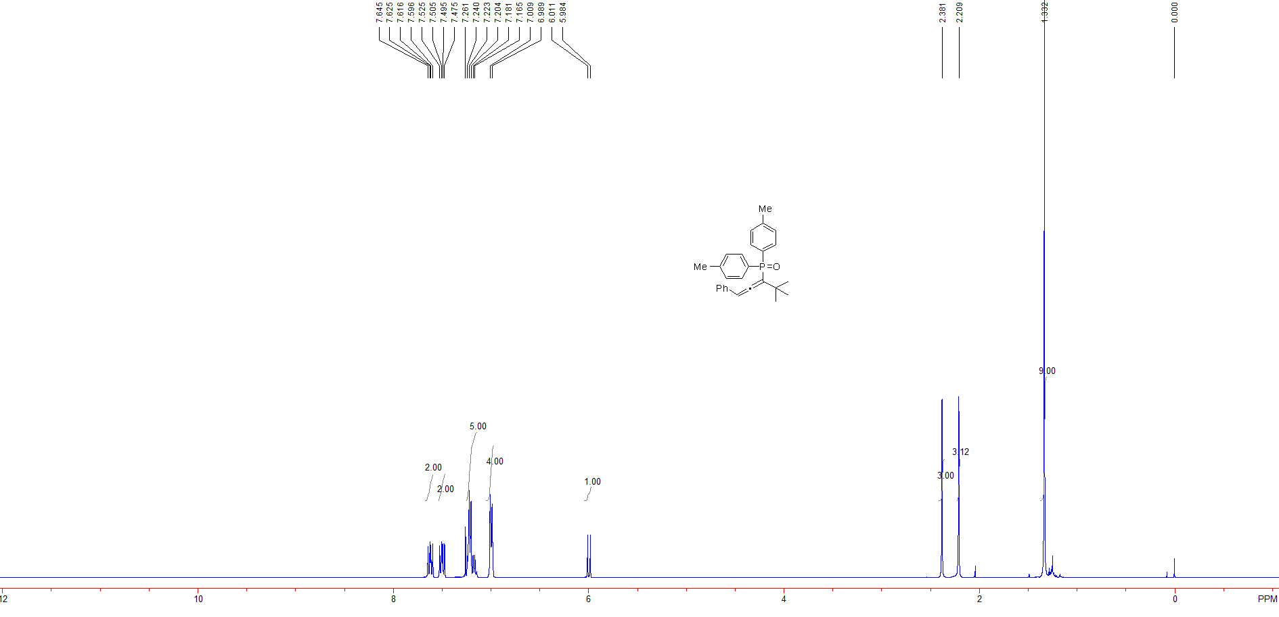

Figure S 30: ¹H NMR spectra of (4,4-dimethyl-1-phenylpenta-1,2-dien-3-yl)di-p-tolylphosphine oxide (3p)

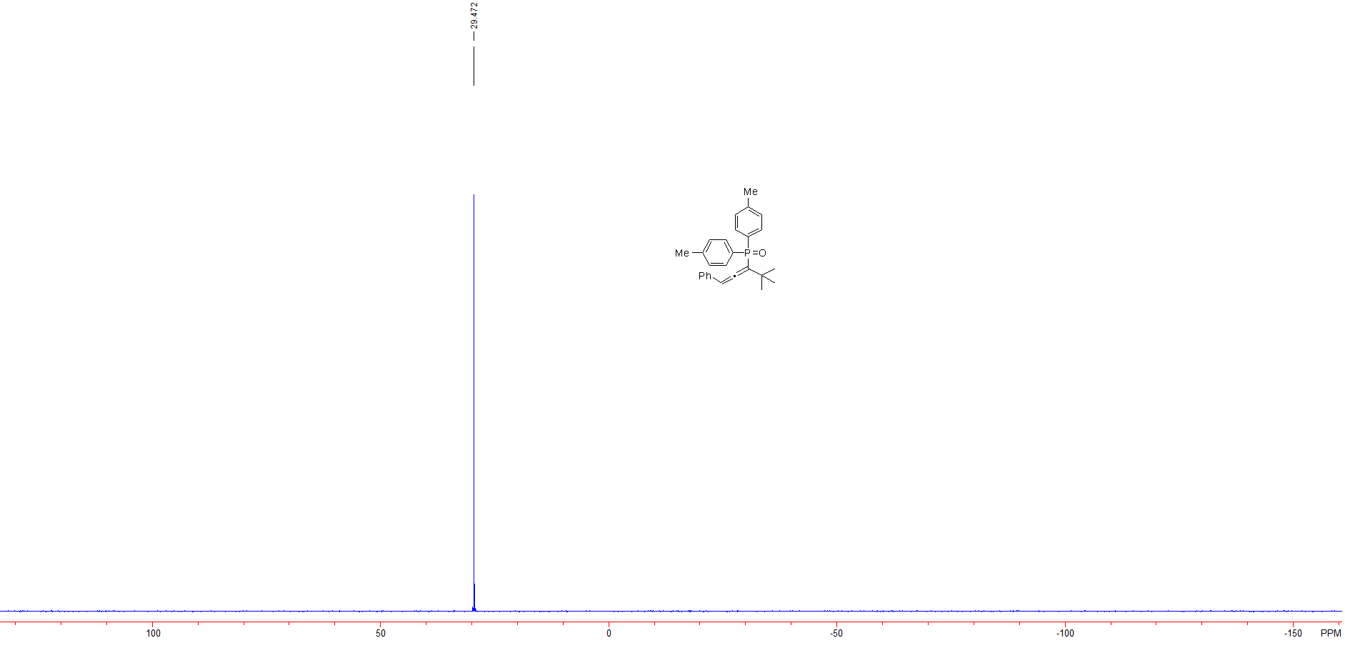

Figure S 31: ³¹P NMR spectra of (4,4-dimethyl-1-phenylpenta-1,2-dien-3-yl)di-p-tolylphosphine oxide (3p)

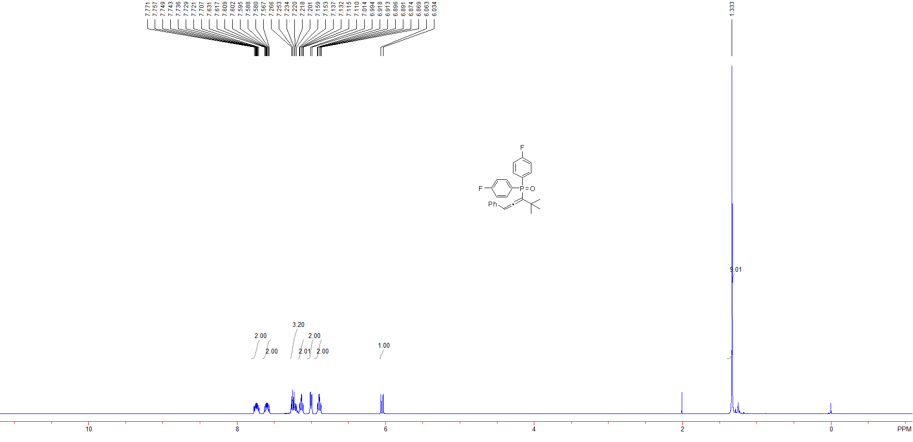

Figure S 32: ¹H NMR spectra of (4,4-dimethyl-1-phenylpenta-1,2-dien-3-yl)bis(4-fluorophenyl)phosphine oxide (3q)

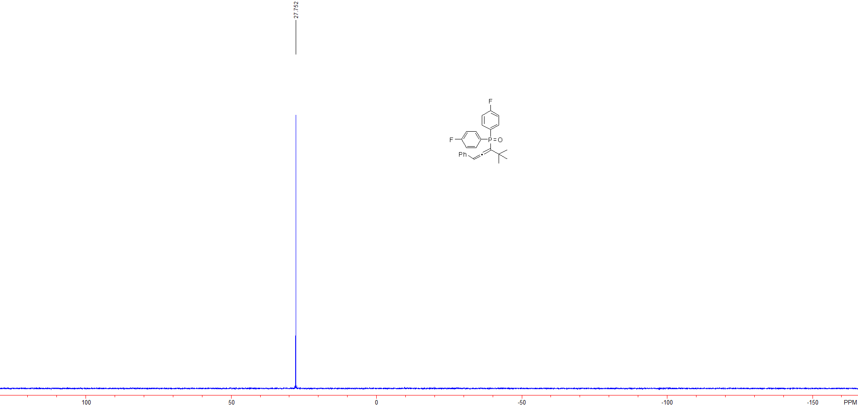

Figure S 33: ³¹P NMR spectra of (4,4-dimethyl-1-phenylpenta-1,2-dien-3-yl)bis(4-fluorophenyl)phosphine oxide (3q)

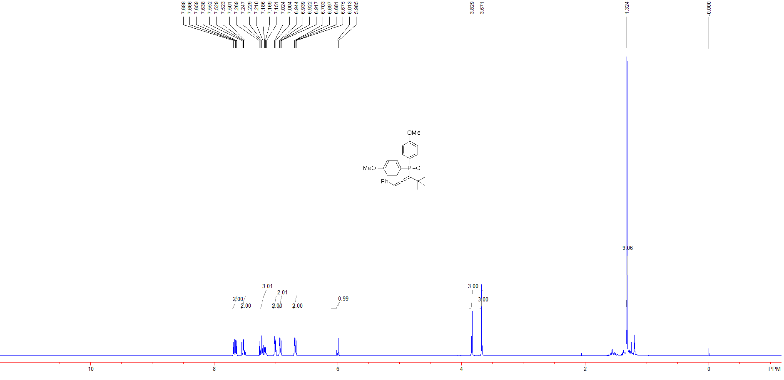

Figure S 34: ¹H NMR spectra of (4,4-dimethyl-1-phenylpenta-1,2-dien-3-yl)bis(4-methoxyphenyl)phosphine oxide (3r)

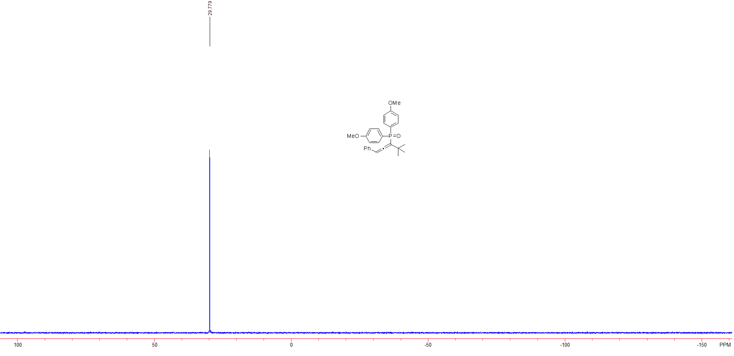

Figure S 35: ³¹P NMR spectra of (4,4-dimethyl-1-phenylpenta-1,2-dien-3-yl)bis(4-methoxyphenyl)phosphine oxide (3r)

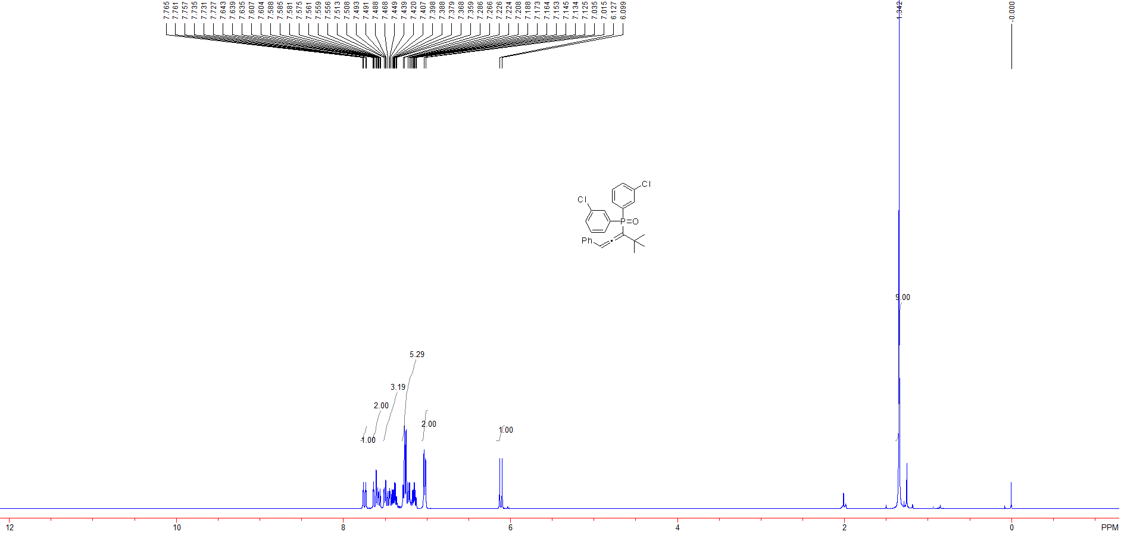

Figure S 36: ¹H NMR spectra of bis(3-chlorophenyl)(4,4-dimethyl-1-phenylpenta-1,2-dien-3-yl)phosphine oxide (3s)

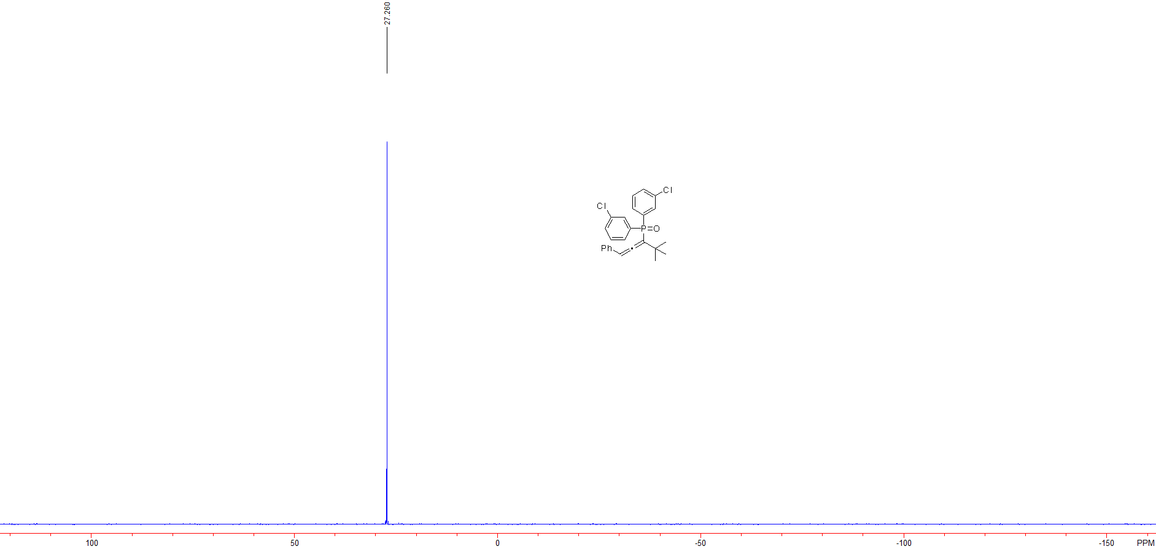

Figure S 37: ³¹P NMR spectra of bis(3-chlorophenyl)(4,4-dimethyl-1-phenylpenta-1,2-dien-3-yl)phosphine oxide (3s)

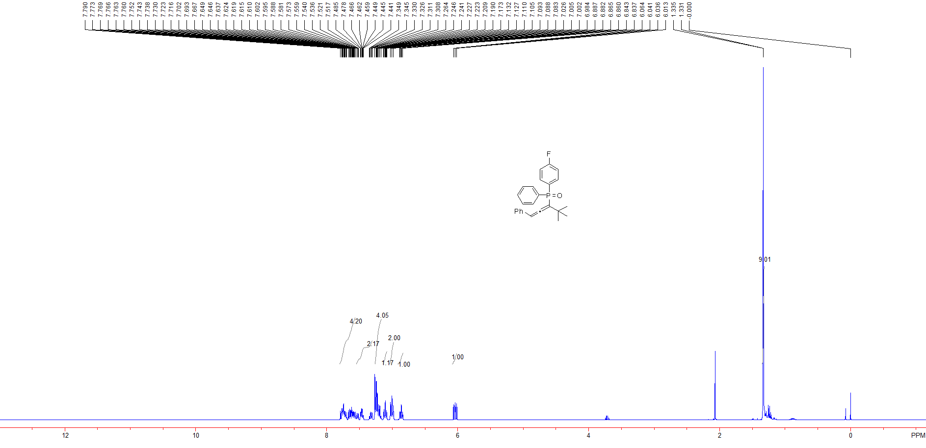

Figure S 38: ¹H NMR spectra of (4,4-dimethyl-1-phenylpenta-1,2-dien-3-yl)(4-fluorophenyl)(phenyl) phosphine oxide (3t)

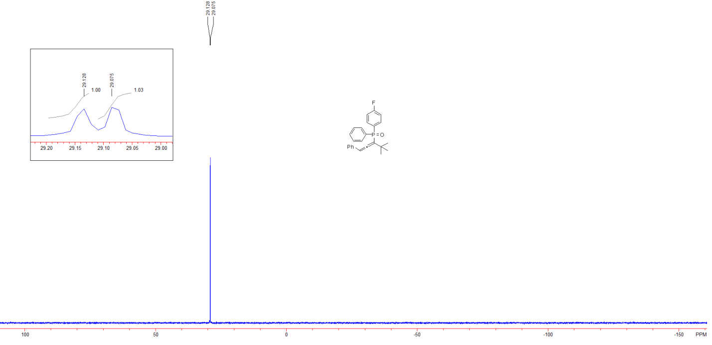

Figure S 39: ³¹P NMR spectra of (4,4-dimethyl-1-phenylpenta-1,2-dien-3-yl)(4-fluorophenyl)(phenyl) phosphine oxide (3t)

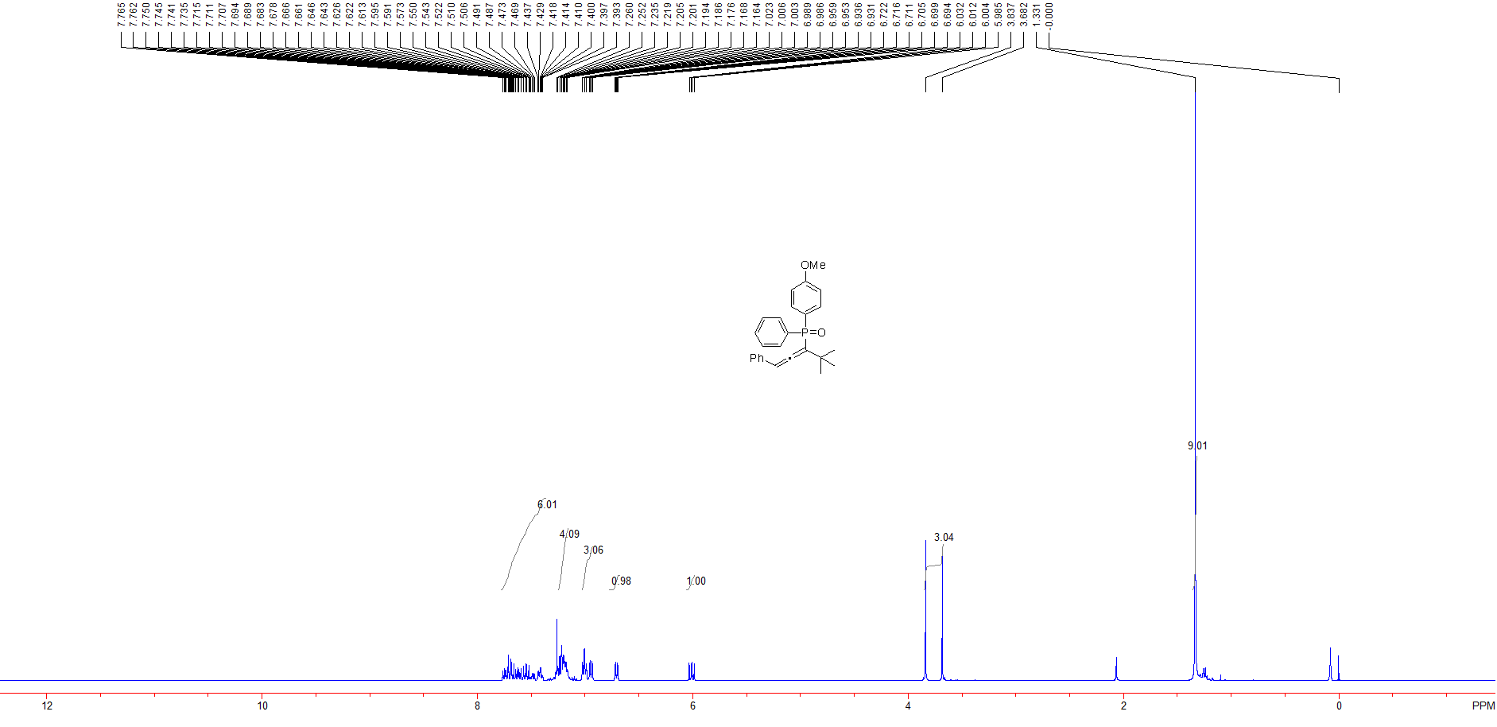

Figure S 40: ¹H NMR spectra of (4,4-dimethyl-1-phenylpenta-1,2-dien-3-yl)(4-methoxyphenyl)(phenyl) phosphine oxide (3u)

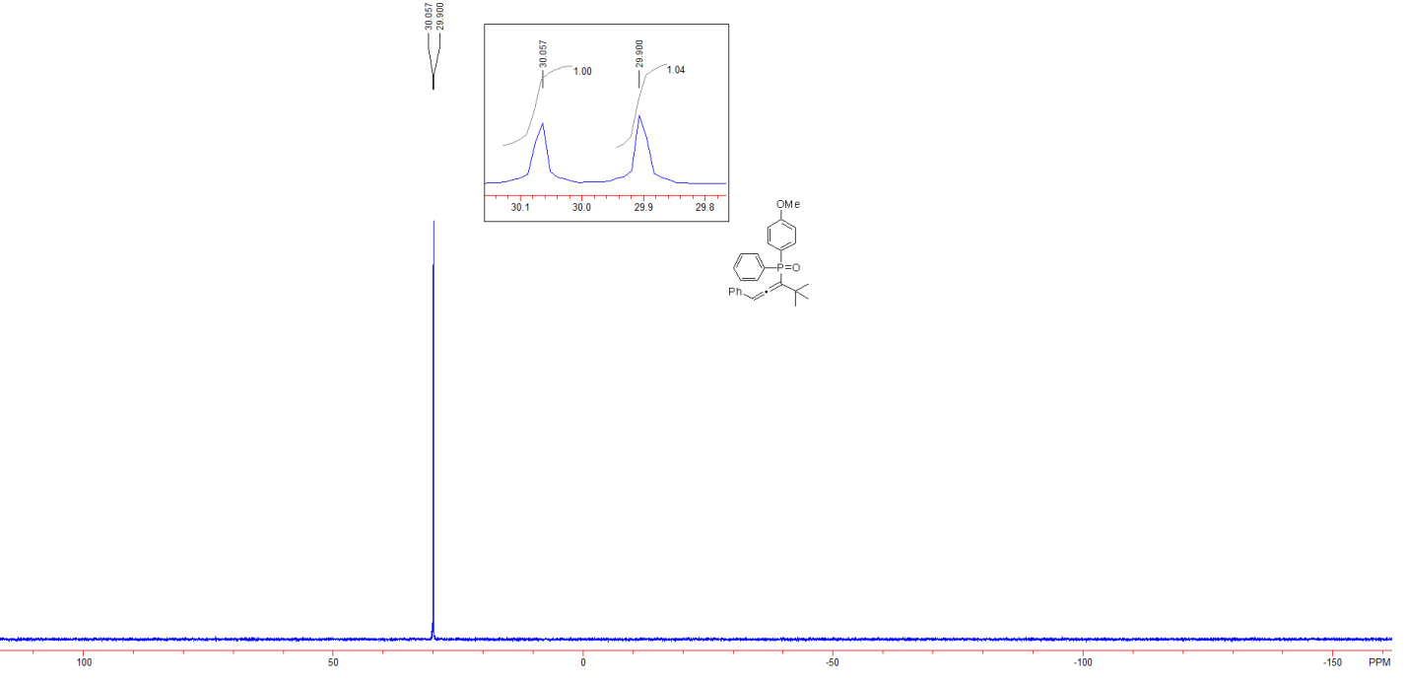

Figure S 41: ³¹P NMR spectra of (4,4-dimethyl-1-phenylpenta-1,2-dien-3-yl)(4-methoxyphenyl)(phenyl) phosphine oxide (3u)

