Synthesis and anticancer activity of some novel diethyl {(chromonyl/pyrazolyl)[(4-oxo-2-phenyl-quinazolin-3(4H)-yl)amino]methyl}phosphonates
Mohammed A. Assiri^{a,b}, Tarik E. Ali^{c}*, Mamdouh M. Ali^{d} and I. S. Yahia^{e,f}
ªAdvanced Materials and Green Chemistry, Chemistry Department, Faculty of Science, King Khalid University, Abha, Saudi Arabia.
^{b}Research Center for Advanced Materials Science (RCAMS), King Khalid University, Abha, Saudi Arabia.
^{c}Department of Chemistry, Faculty of Education, Ain Shams University, Roxy, Cairo, Egypt
^{d}Department of Biochemistry, Division of Genetic Engineering and Biotechnology, National Research Centre, Dokki, Giza, Egypt.
^{e}Advanced Functional Materials & Optoelectronic Laboratory, Department of Physics, Faculty of Science, King Khalid University, Abha, Saudi Arabia.
^{f}Nanoscience Laboratory for Environmental and Bio-medical Applications, Semiconductor Lab., Department of Physics, Faculty of Education, Ain Shams University, Roxy, Cairo, Egypt.
Email: tarik_elsayed1975@yahoo.com

Supplemental Materials
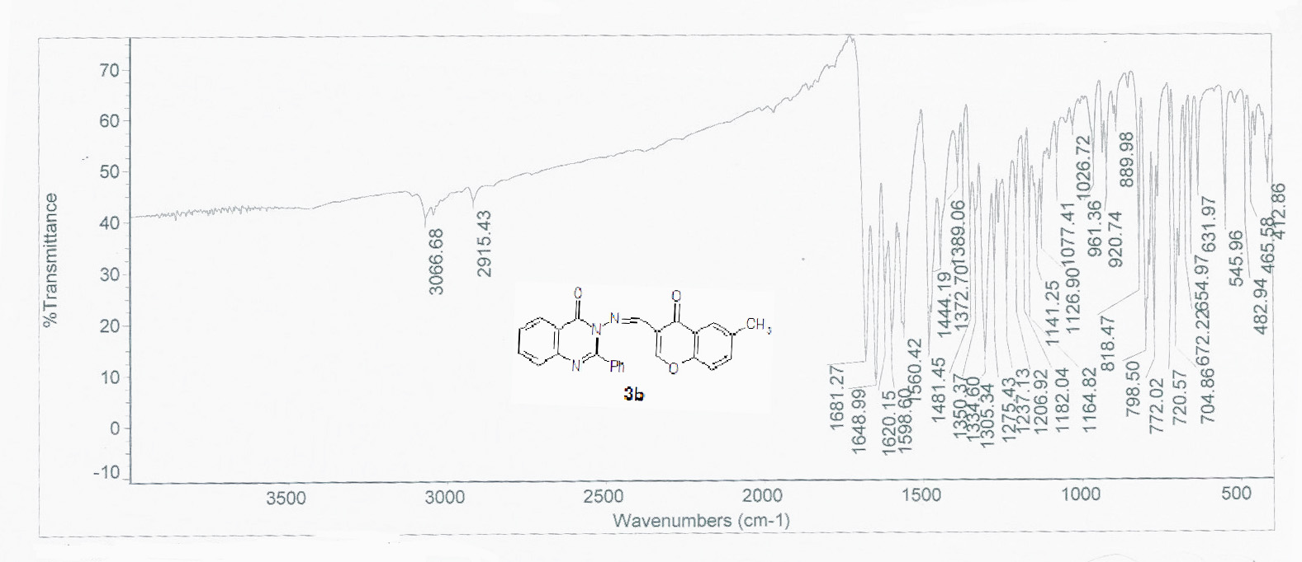
Figure S 1: The IR spectrum of compound 3b
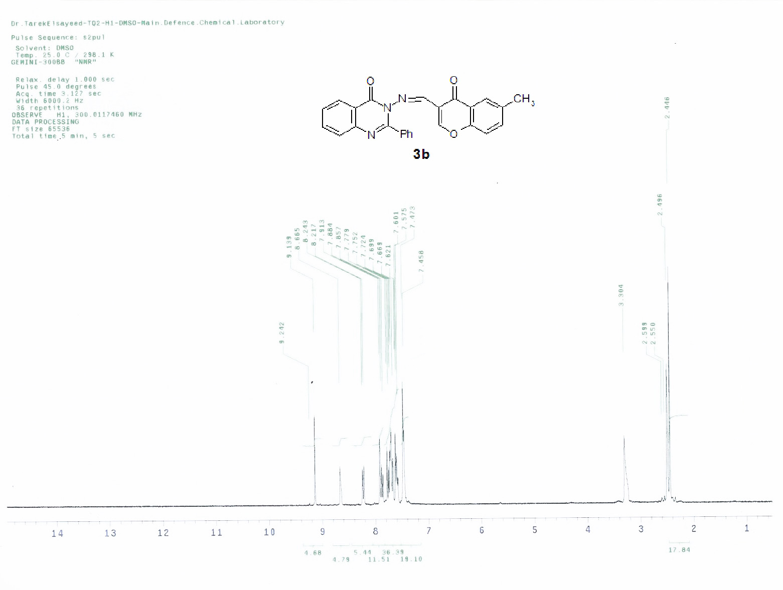
Figure S 2: The ¹H-NMR spectrum of compound 3b.
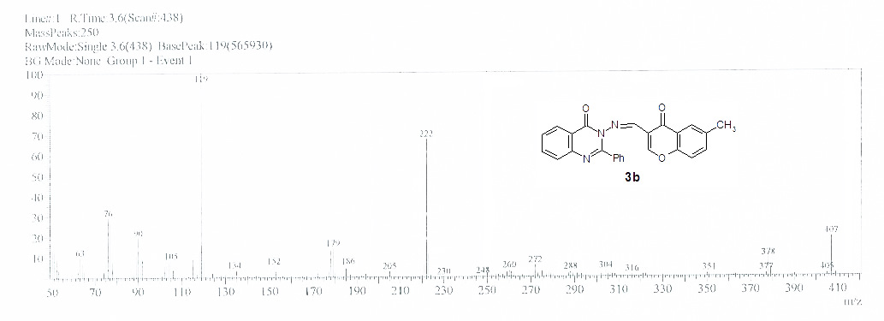
Figure S 3: The mass spectrum of compound 3b
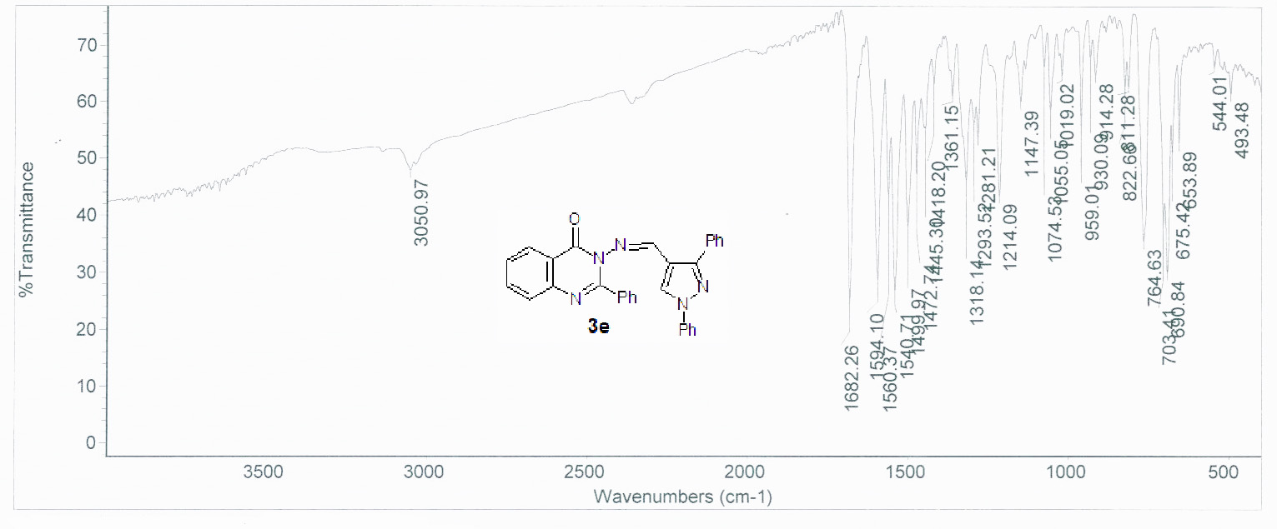
Figure S 4: The IR spectrum of compound 3e
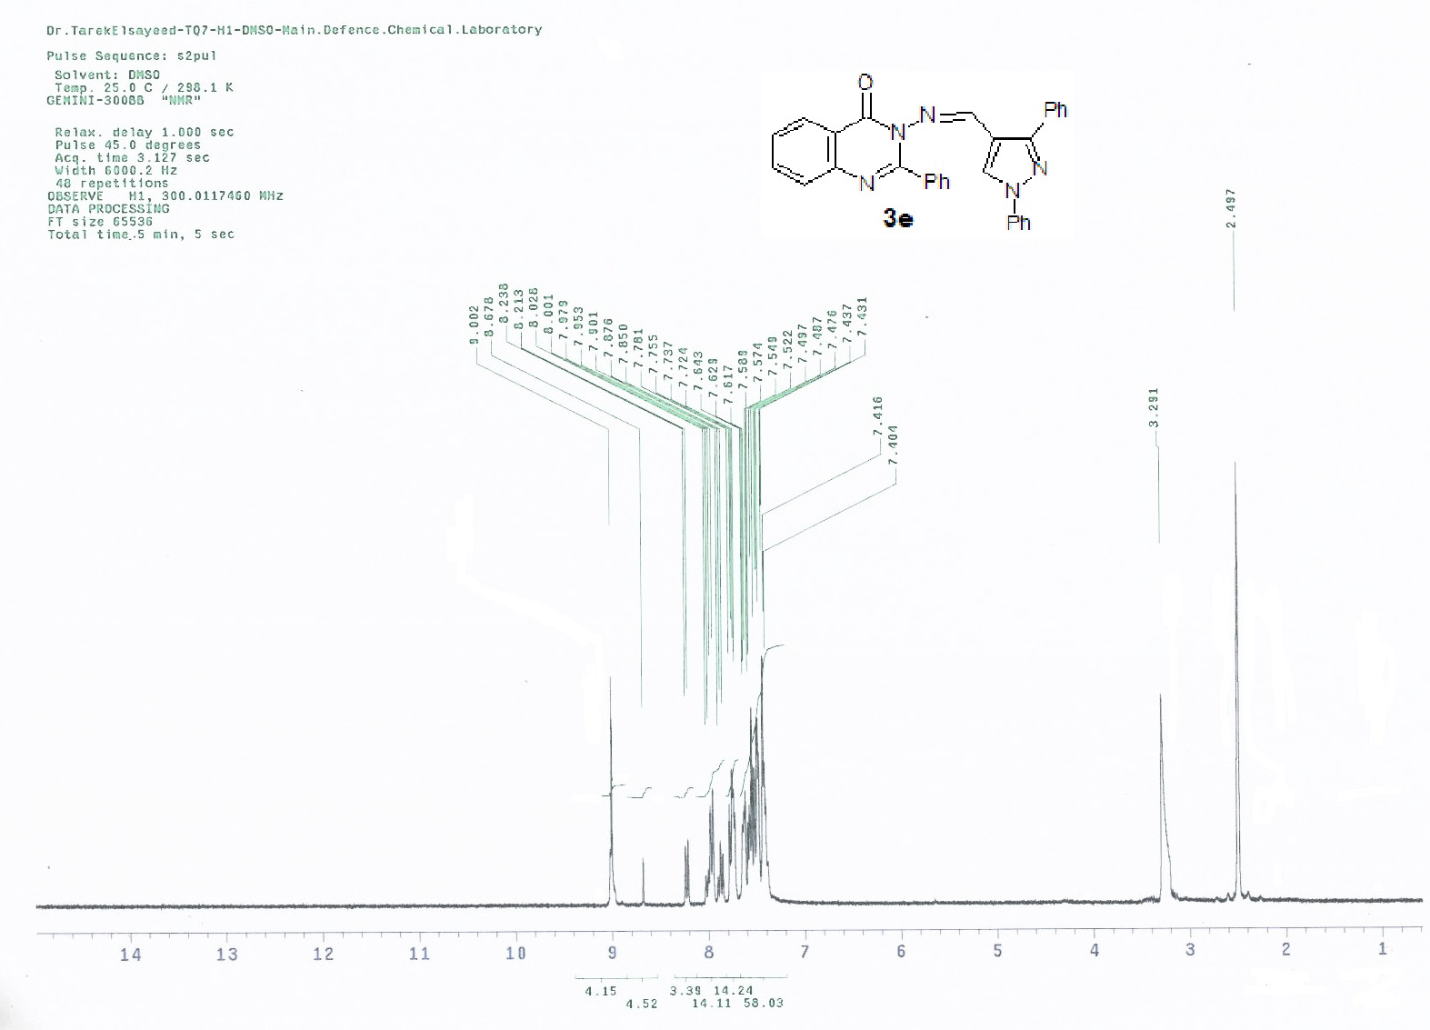
Figure S 5: The ¹H-NMR spectrum of compound 3e

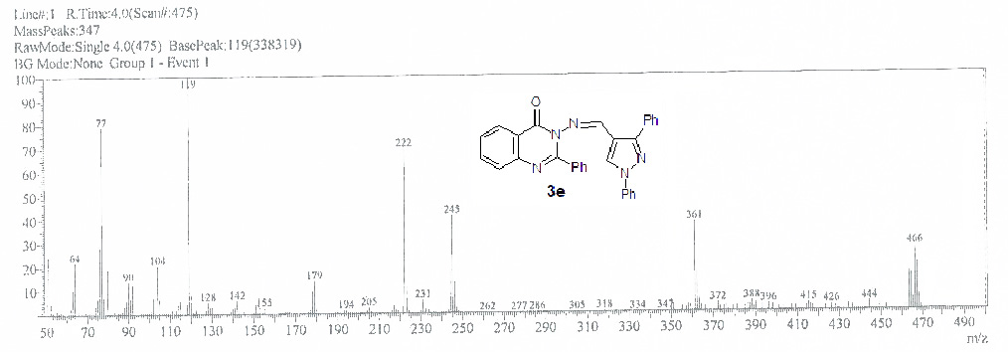
Figure S 6: The mass spectrum of compound 3e

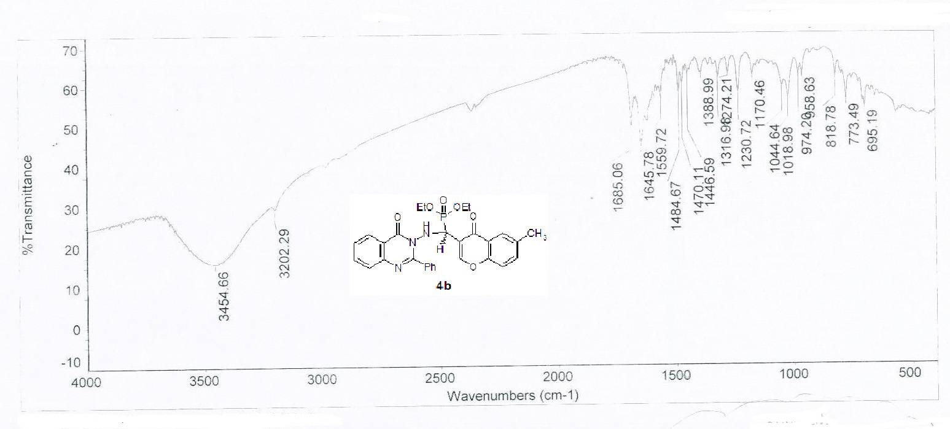
Figure S 7: The IR spectrum of compound 4b
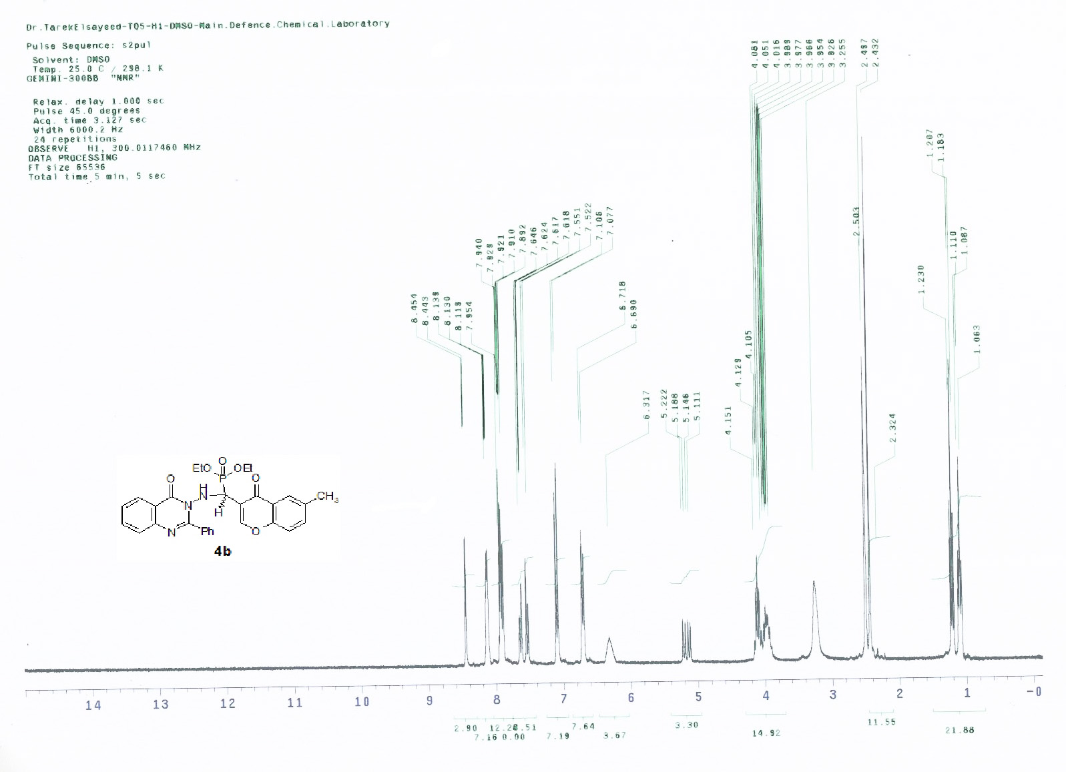
Figure S 8: The ¹H-NMR spectrum of compound 4b
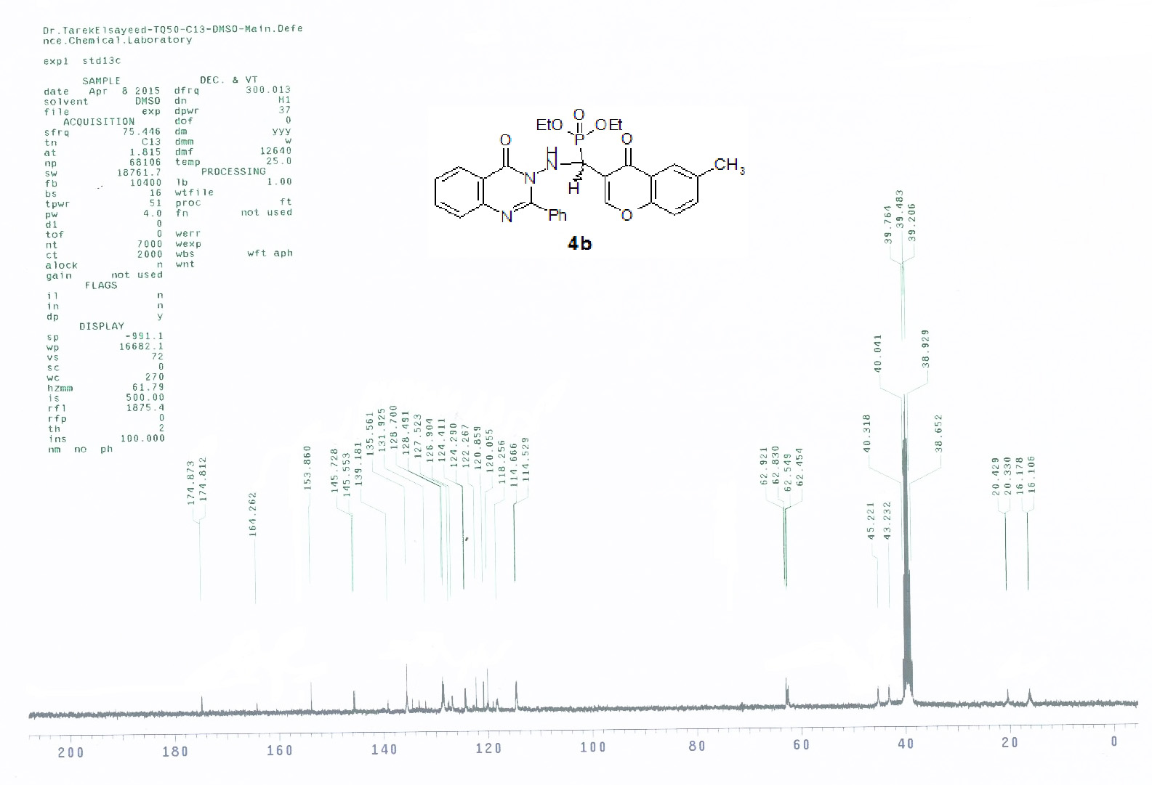
Figure S 9: The ¹³C-NMR spectrum of compound 4b

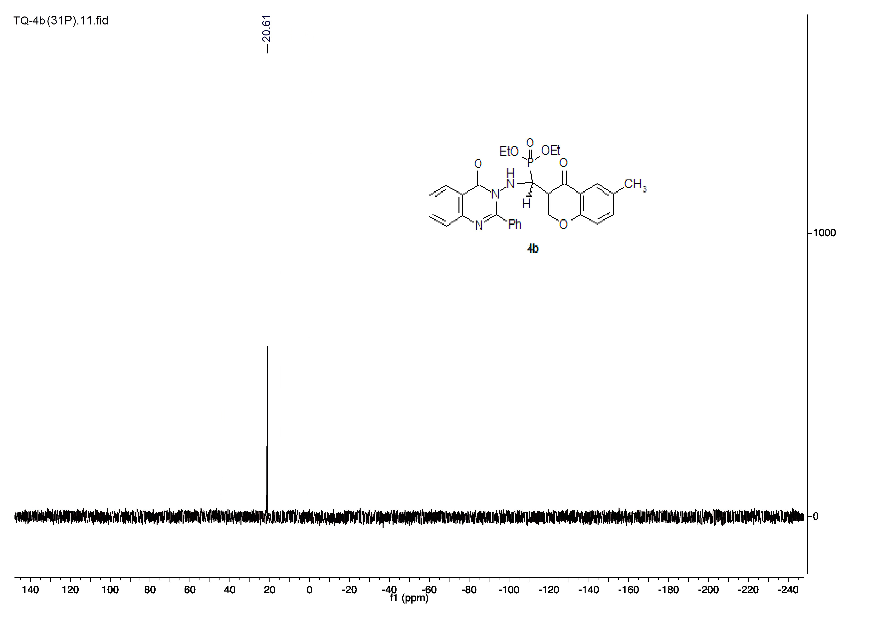
Figure S 10: The ³¹P-NMR spectrum of compound 4b
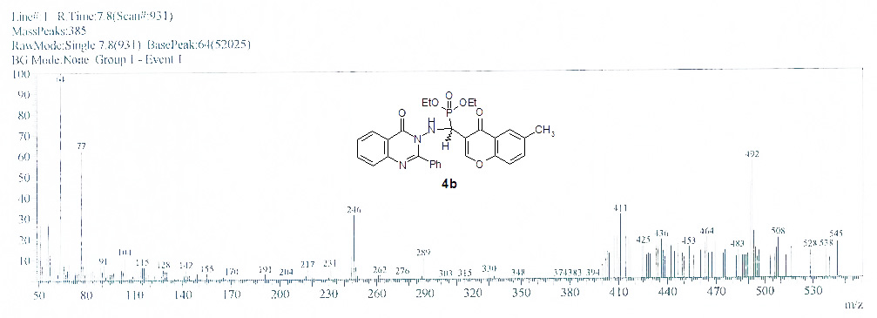
Figure S 11: The mass spectrum of compound 4b

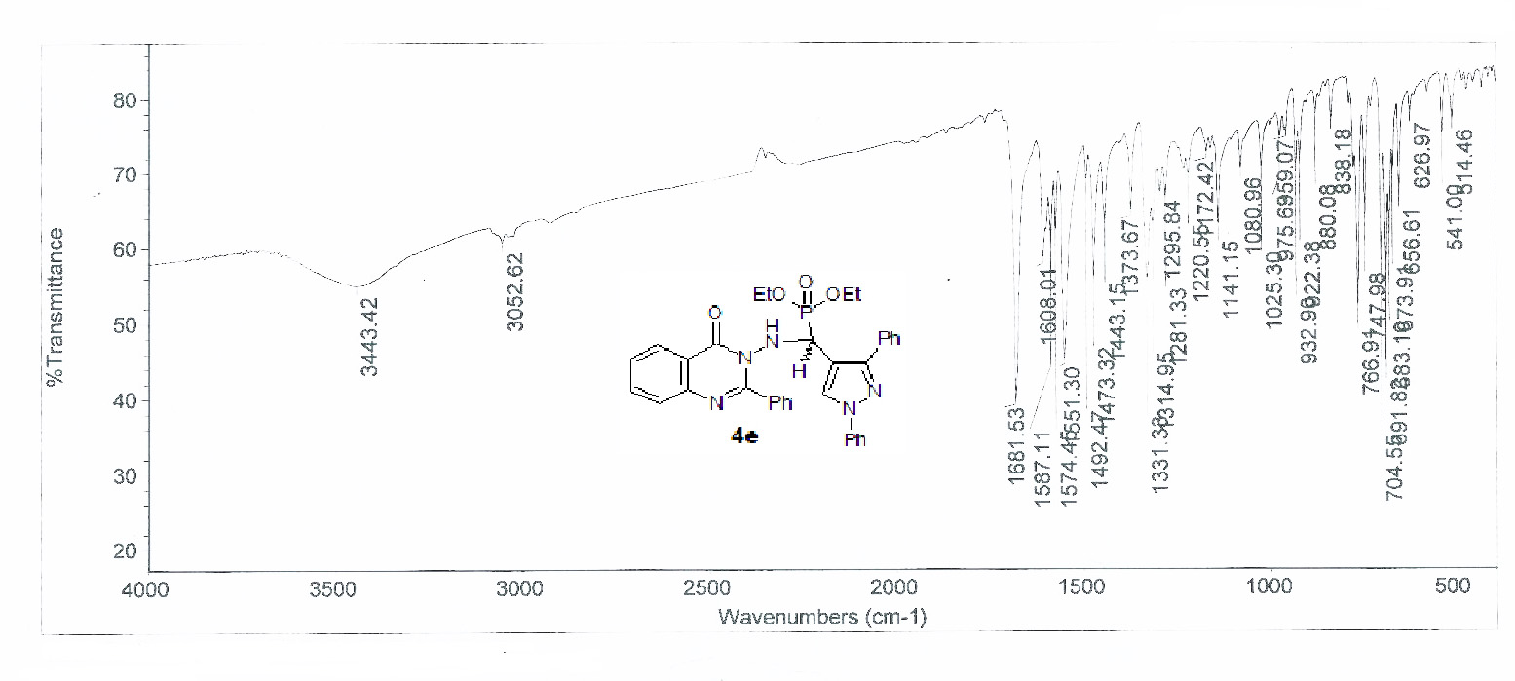
Figure S 12: The IR spectrum of compound 4e

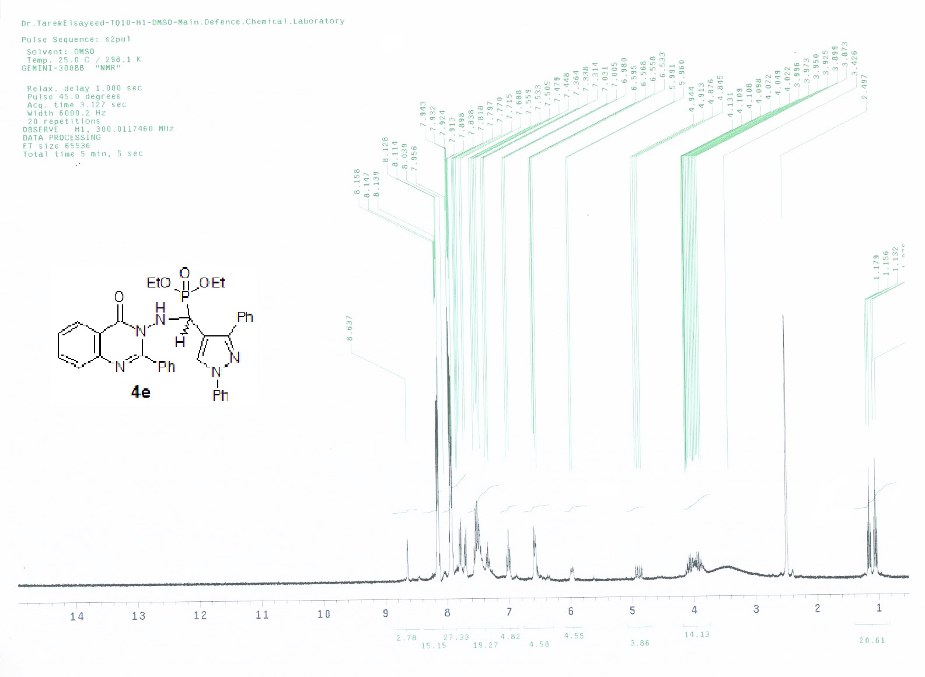
Figure S 13: The ¹H-NMR spectrum of compound 4e.
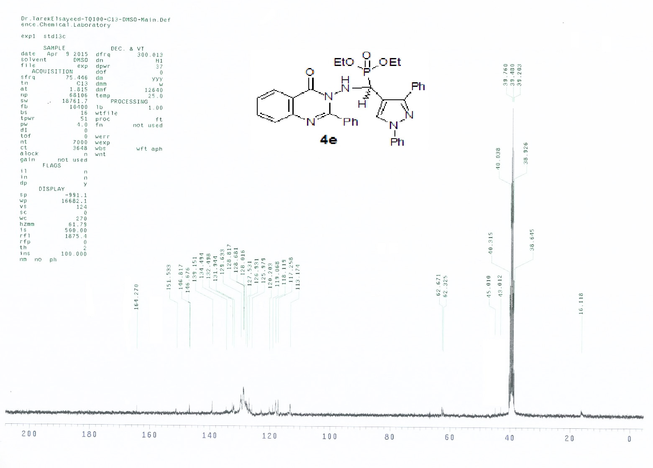Figure S 14: The ¹³C-NMR spectrum of compound 4e

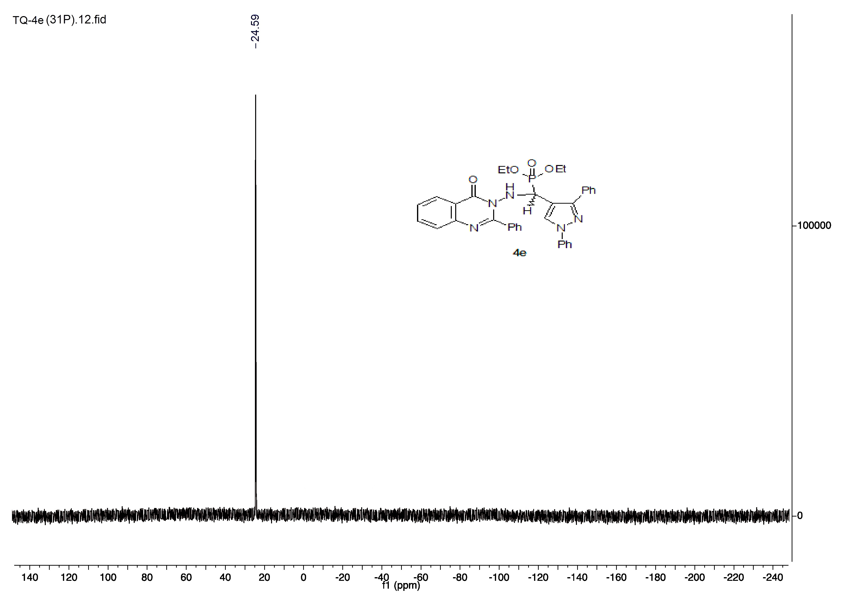
Figure S 15: The ³¹P-NMR spectrum of compound 4e
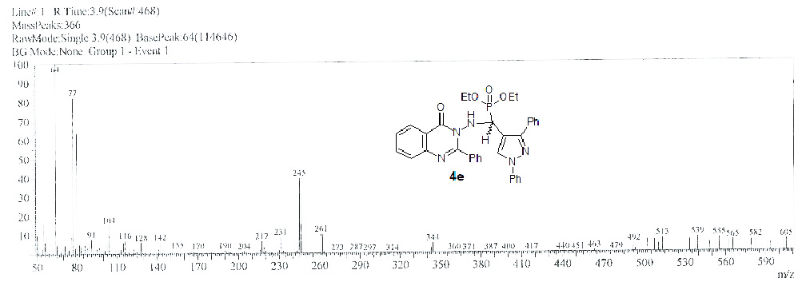
Figure S 16: The mass spectrum of compound 4e

