Design, synthesis, and toward a side-ring optimization of tricyclic thieno[2,3-d]pyrimidin-4(3H)-ones and their effect on melanin synthesis in murine B16 cells
Li Fei Nie ^{a, b}, Khurshed Bozorov ^{a, c}, Guozheng Huang ^{a,}, Jiangyu Zhao ª, Chao Niu ª, Haji A. Aisa ^{a, *}
ª Key Laboratory of Plant Resources and Chemistry in Arid Regions, State Key Laboratory Basis of Xinjiang Indigenous Medicinal Plants Resource Utilization, Xinjiang Technical Institute of Physics and Chemistry, Chinese Academy of Sciences, South Beijing Rd 40-1, Urumqi, 830011, P. R. China
^{b} University of Chinese Academy of Sciences, Yuquan Rd 19 A, Beijing, 100049, P.R.China
^{c} Institute of the Chemistry of Plant Substances, Academy of Sciences of Uzbekistan, Mirzo Ulugbek str. 77, Tashkent, 100170, Uzbekistan
E-mail: haji@ms.xjb.ac.cn
Supplemental Materials
2-Methyl-3-nitrothieno[2,3-d]dihydropyrrolo[1,2-a]pyrimidin-4-one (6). Yield: 85%, white solid, mp 175-177 °С. ¹Н NMR (400 MHz, CDCl₃) δ: 4.21 (t, J=7.5 Hz, 2H), 3.28 (td, J=8.4 Hz, J=4.0 Hz, 2H), 2.31 – 2.37 (m, 2H), 2.14 (s, 3H). ¹³C NMR (100 MHz, CDCl₃) δ 187.41, 186.03, 171.84, 154.47, 107.91, 96.5, 47.50, 33.70, 21.61, 18.83.
2-Methyl-3-nitrothieno[2,3-d]tetrahydroazepino[1,2-a]pyrimidin-4-one (7). Yield: 86%, white solid, mp 117-119 °С. ¹Н NMR (400 MHz, CDCl₃) δ: 4.36 (t, J=4.8 Hz, 2H), 3.10 (t, J=5.6 Hz, 2H), 2.15 (s, 3H), 1.89 – 1.93 (m, 6H). ¹³C NMR (100 MHz, CDCl₃) δ 186.5, 184.8, 172.0, 155.3, 106.9, 96.2, 42.8, 38.2, 29.4, 26.5, 23.9, 21.6.
Figure S 1. Biologically relevant thieno[2,3-d]pyrimidine scaffolds.

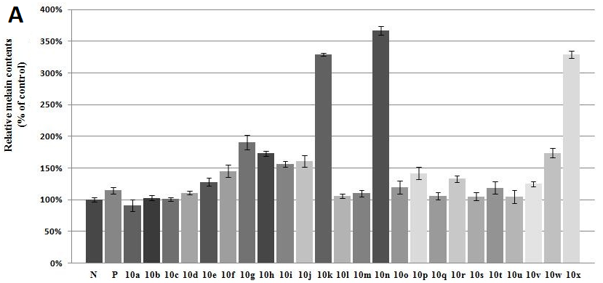
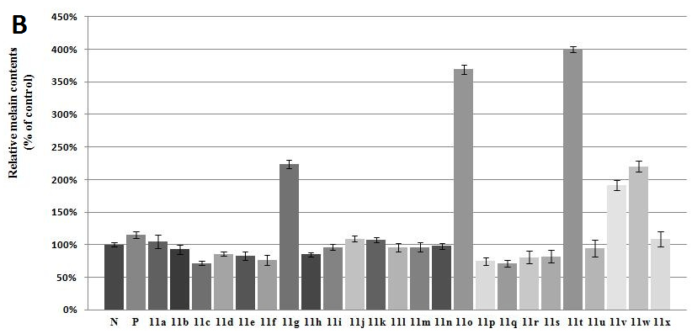
Figure S 2. Stimulation of melanin content of B16 cells by compounds 10a-x (A) and 11a-x (B). N means negative control; P means positive control (8-MOP); The B16 cells were treated with 50 µM of selected samples for 48 h. After that, melanin content was measured directly. The data are the mean ± SD (bars) of three experiments in duplicate.

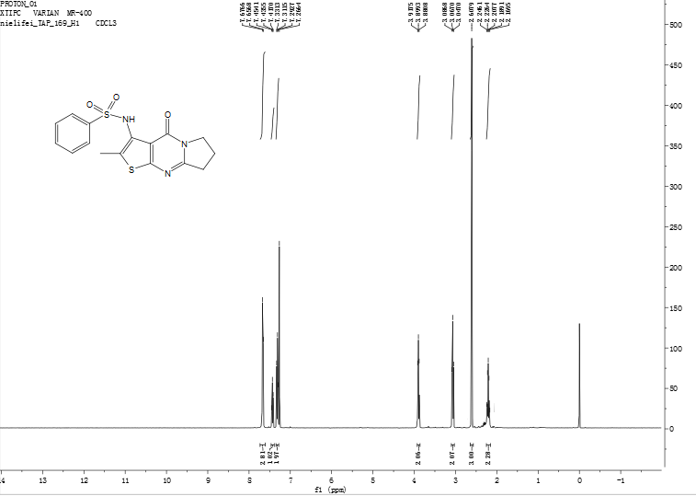
Figure S 3: ¹H NMR spectrum of compound 10a
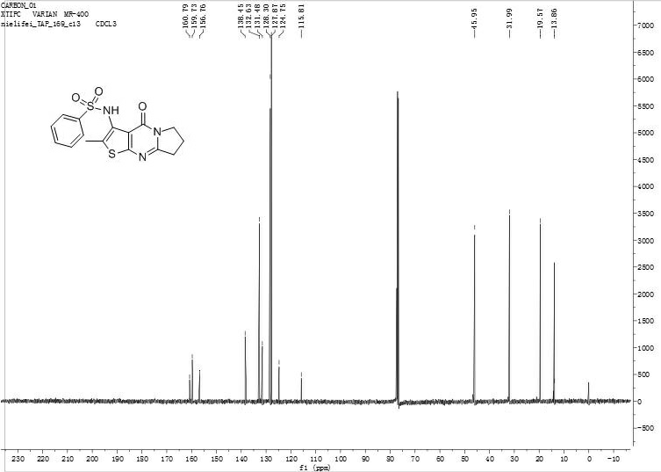
Figure S 4: ¹³C NMR spectrum of compound 10a
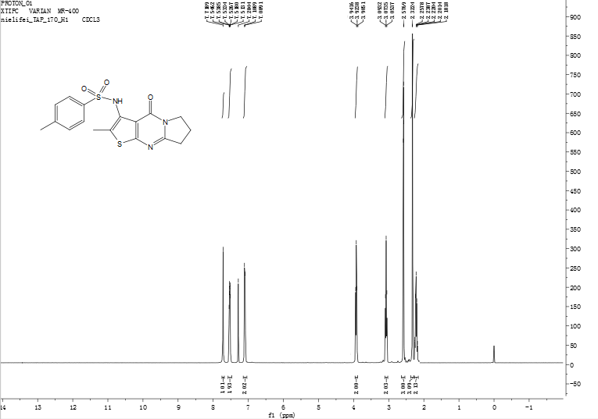
Figure S 5: ¹H NMR spectrum of compound 10b

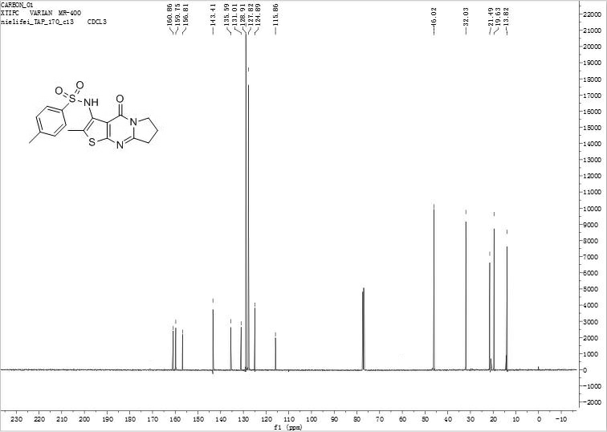
Figure S 6: ¹³C NMR spectrum of compound 10b
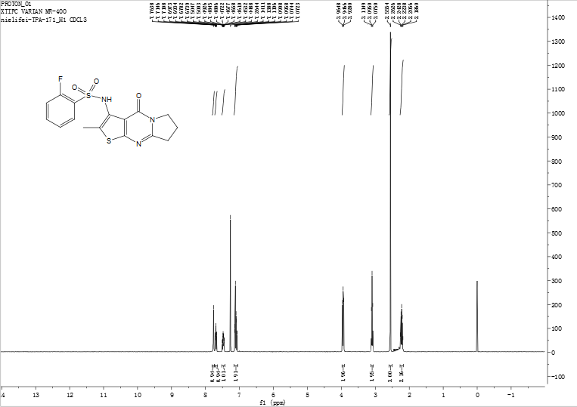
Figure S 7: ¹H NMR spectrum of compound 10c
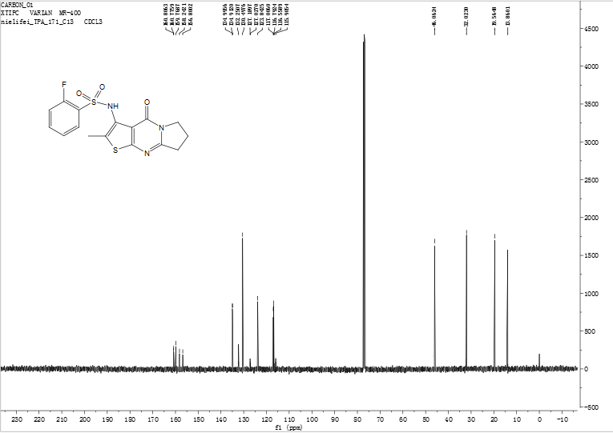
Figure S 8: ¹³C NMR spectrum of compound 10c
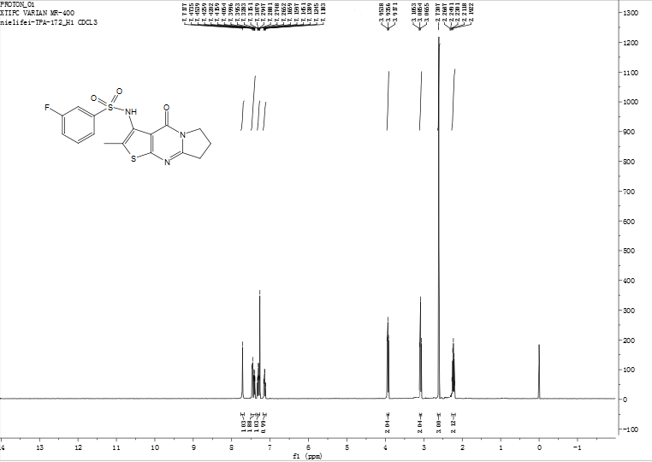
Figure S 9: ¹H NMR spectrum of compound 10d
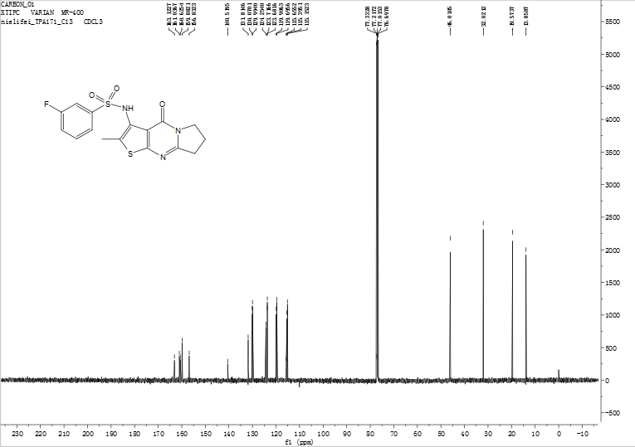
Figure S 10: ¹³C NMR spectrum of compound 10d
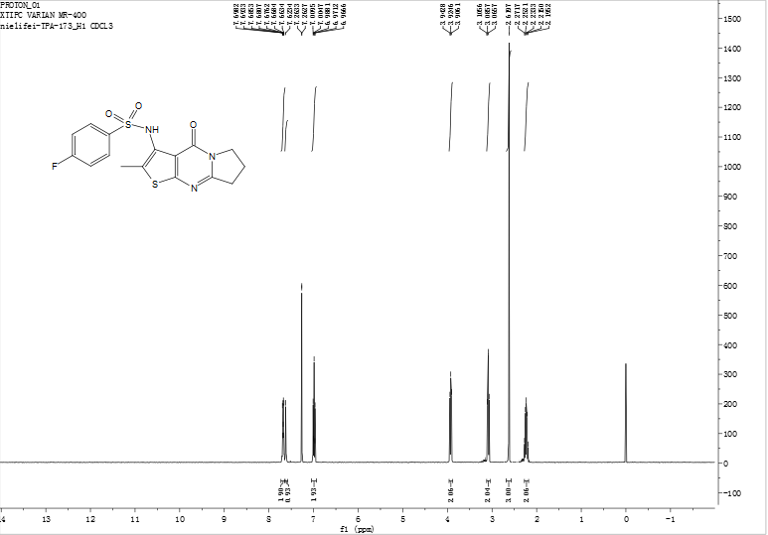
Figure S 11: ¹H NMR spectrum of compound 10e
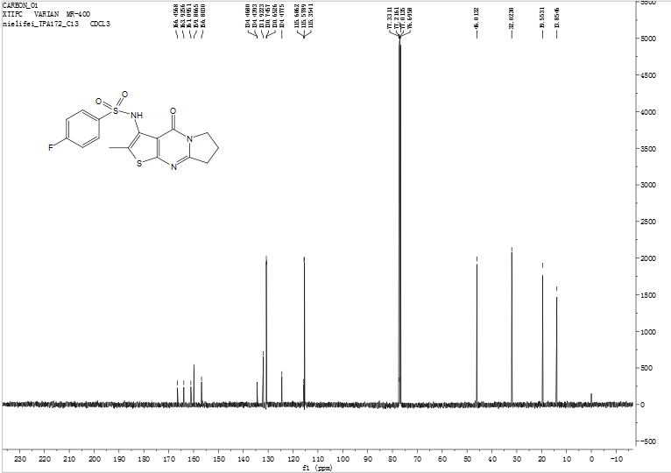
Figure S 12: ¹³C NMR spectrum of compound 10e

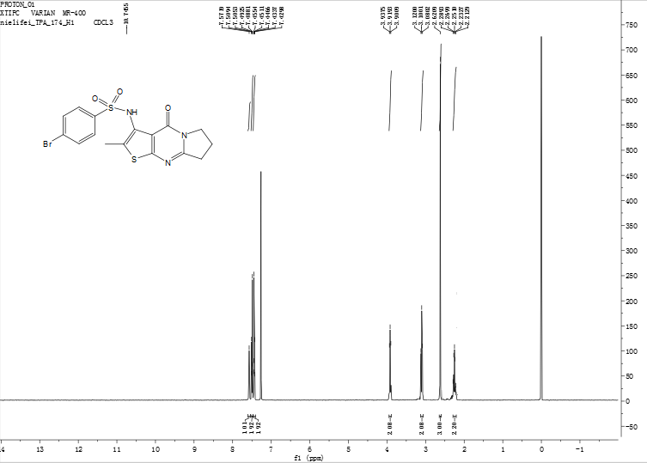
Figure S 13: ¹H NMR spectrum of compound 10f
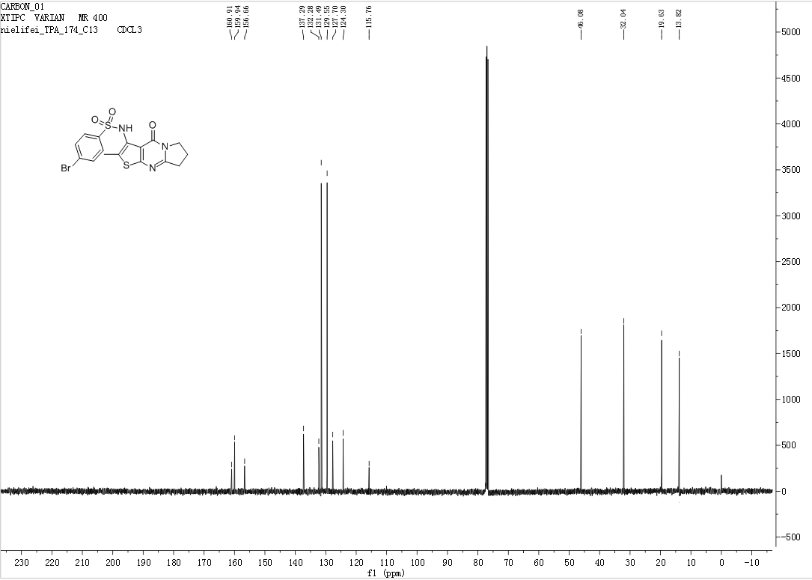
Figure S 14: ¹³C NMR spectrum of compound 10f
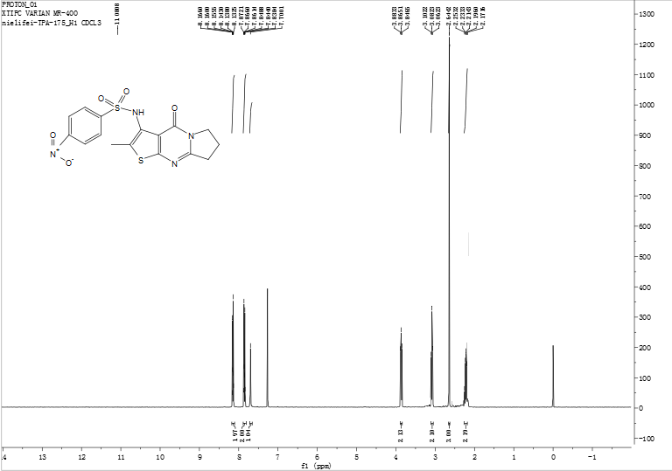
Figure S 15: ¹H NMR spectrum of compound 10g
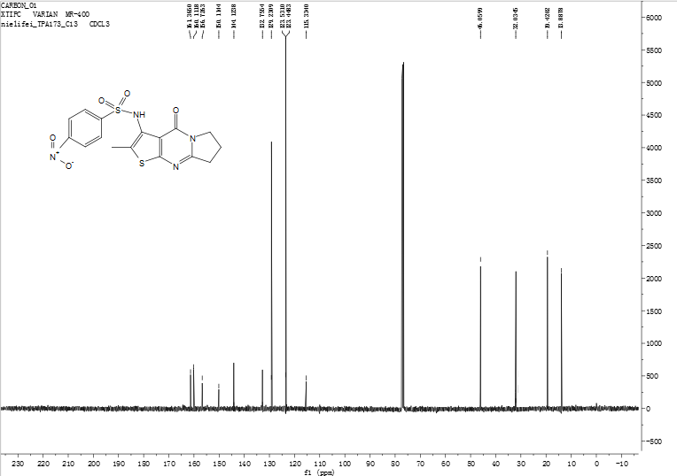
Figure S 16: ¹³C NMR spectrum of compound 10g
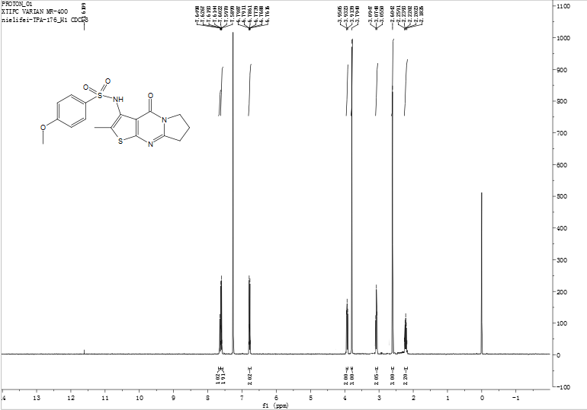
Figure S 17: ¹H NMR spectrum of compound 10h
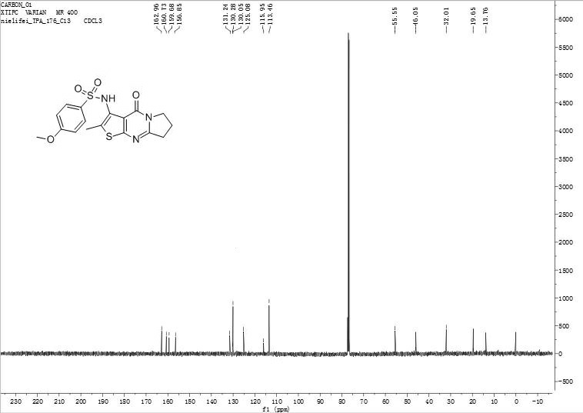
Figure S 18: ¹³C NMR spectrum of compound 10h
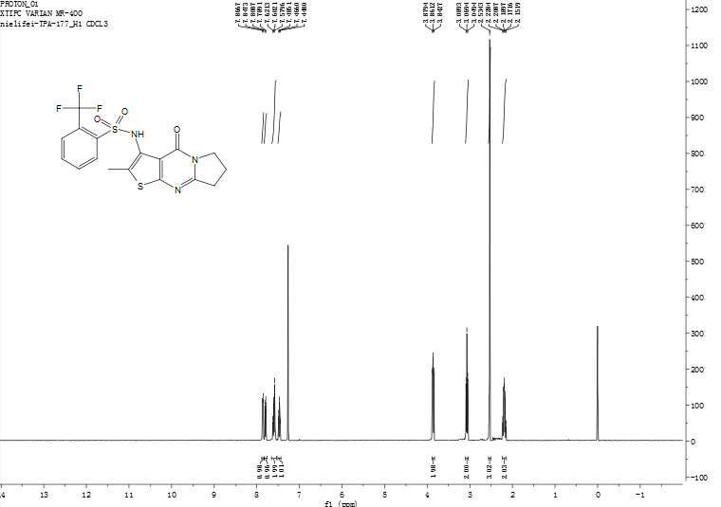
Figure S 19: ¹H NMR spectrum of compound 10i
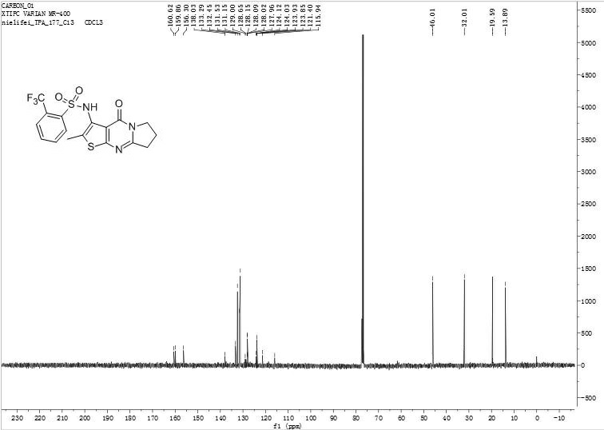
Figure S 20: ¹³C NMR spectrum of compound 10i
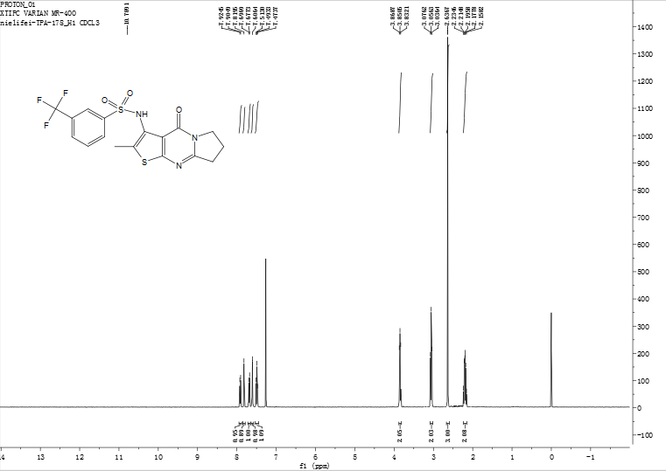
Figure S 21: ¹H NMR spectrum of compound 10j
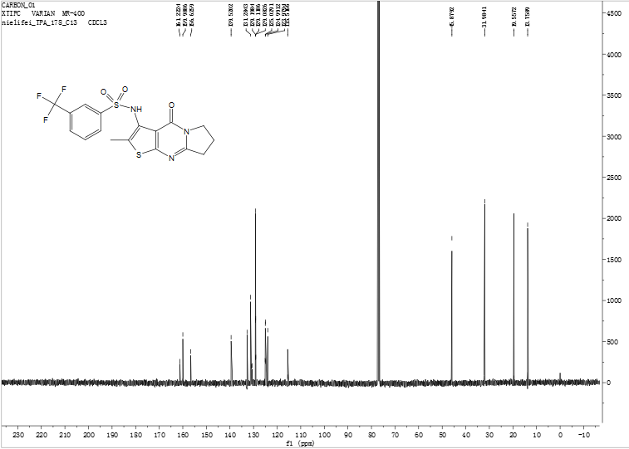
Figure S 22: ¹³C NMR spectrum of compound 10j
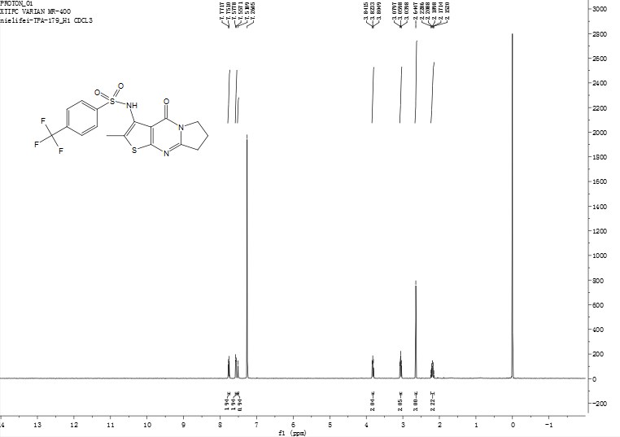
Figure S 23: ¹H NMR spectrum of compound 10k
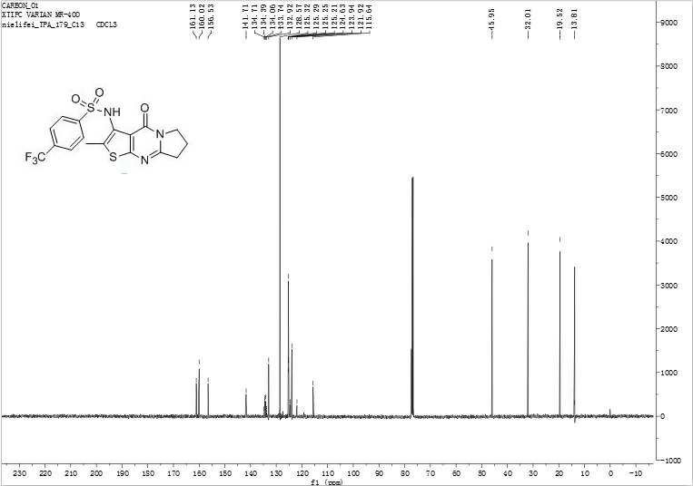
Figure S 24: ¹³C NMR spectrum of compound 10k
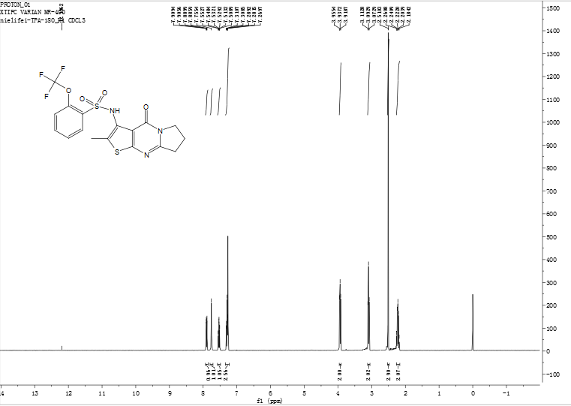
Figure S 25: ¹H NMR spectrum of compound 10l
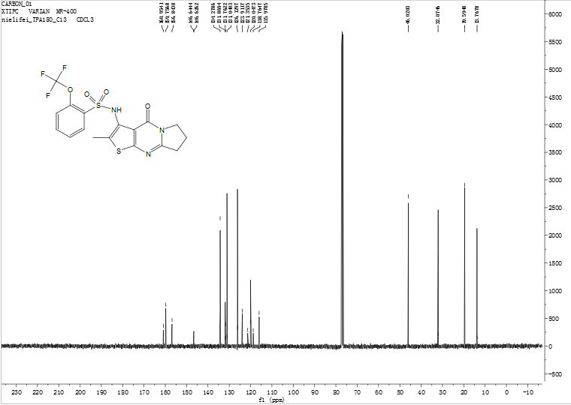
Figure S 26: ¹³C NMR spectrum of compound 10l
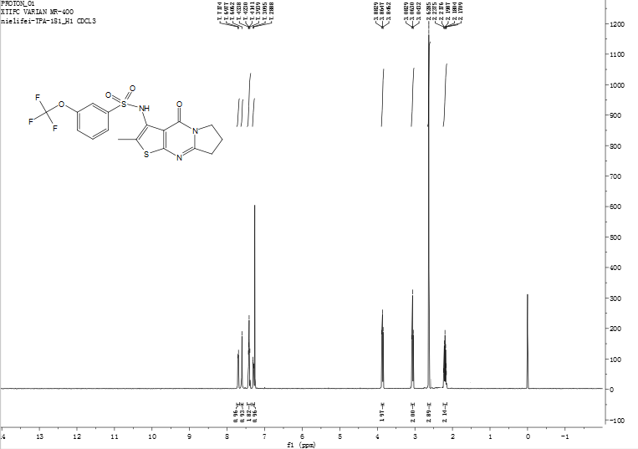
Figure S 27: ¹H NMR spectrum of compound 10m
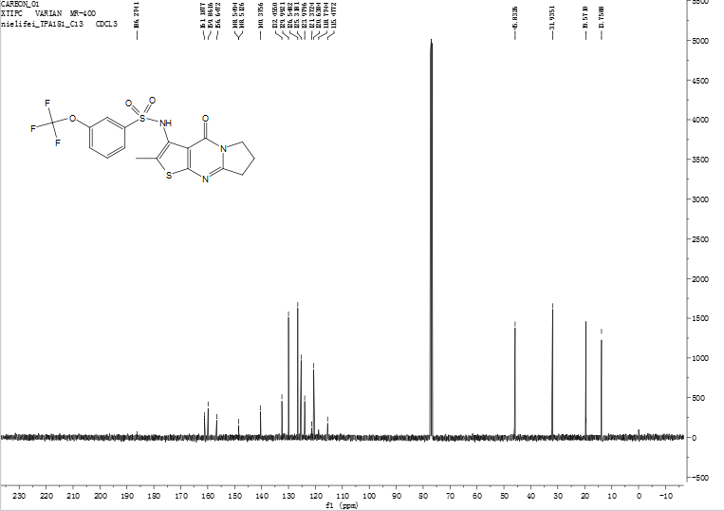
Figure S 28: ¹³C NMR spectrum of compound 10m
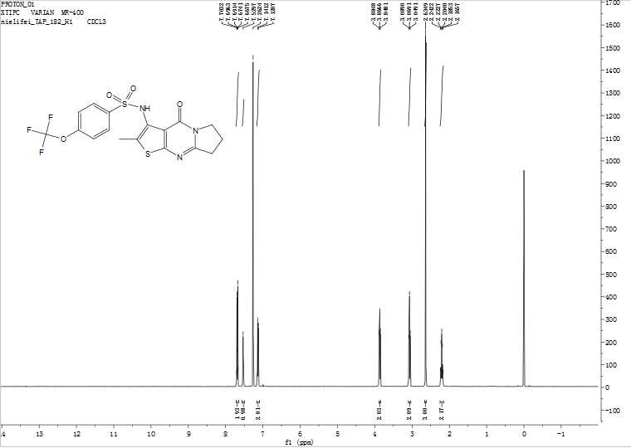
Figure S 29: ¹H NMR spectrum of compound 10n
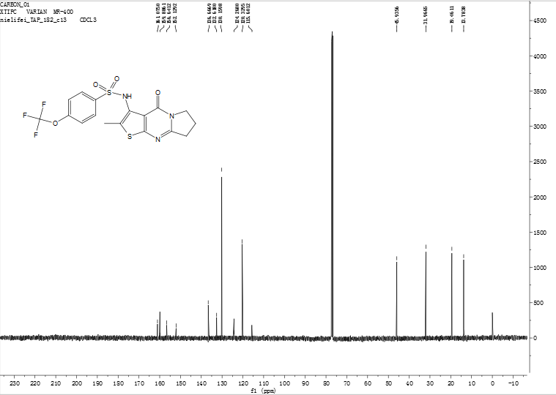
Figure S 30: ¹³C NMR spectrum of compound 10n
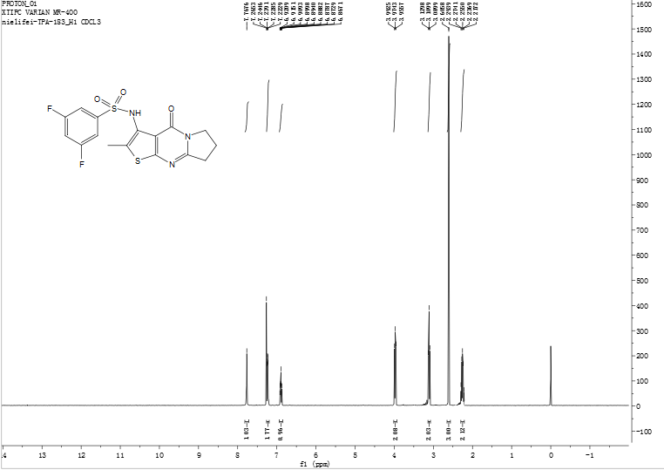
Figure S 31: ¹H NMR spectrum of compound 10o
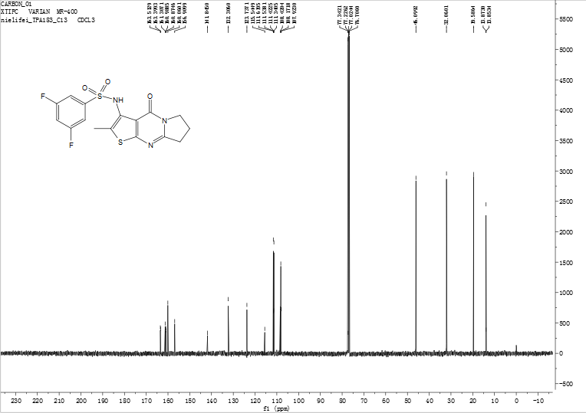
Figure S 32: ¹³C NMR spectrum of compound 10o
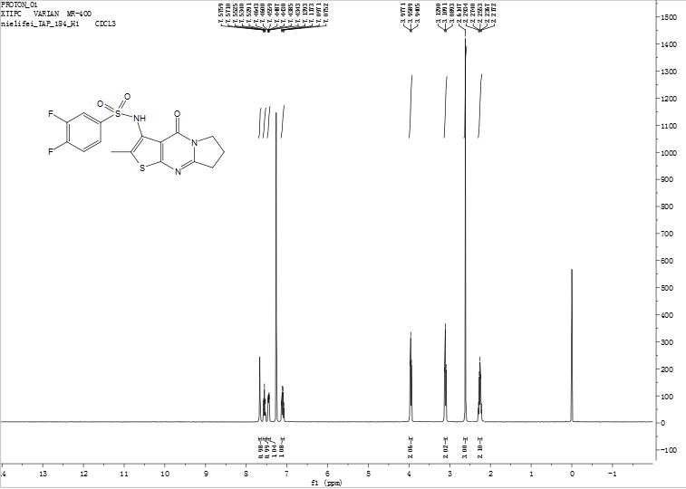
Figure S 33: ¹H NMR spectrum of compound 10p
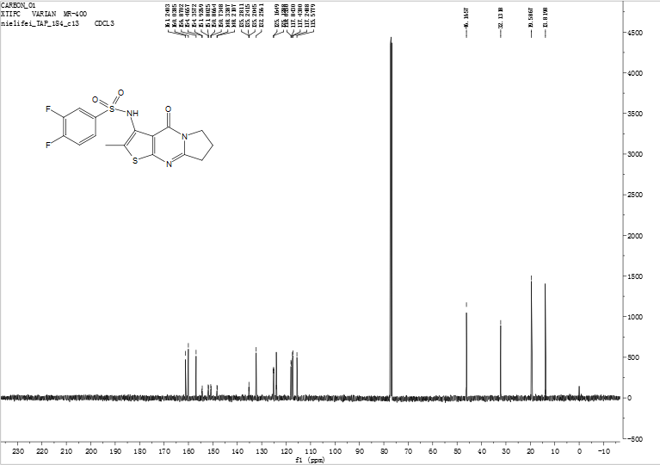
Figure S 34: ¹³C NMR spectrum of compound 10p
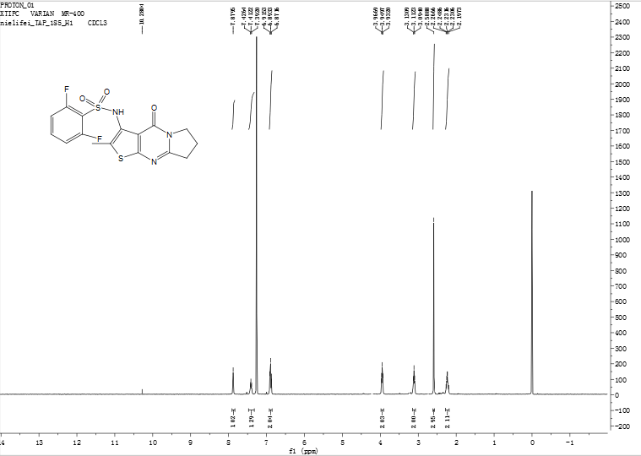
Figure S 35: ¹H NMR spectrum of compound 10q
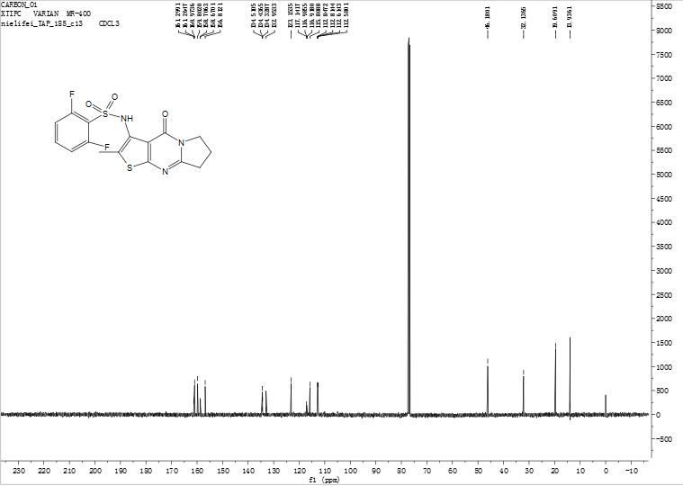
Figure S 36: ¹³C NMR spectrum of compound 10q
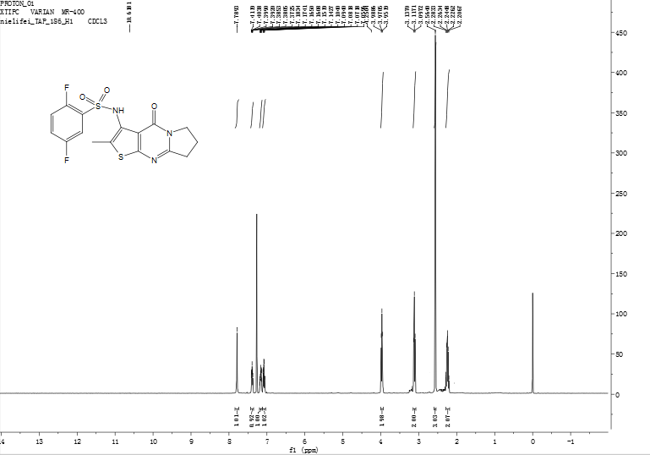
Figure S 37: ¹H NMR spectrum of compound 10r
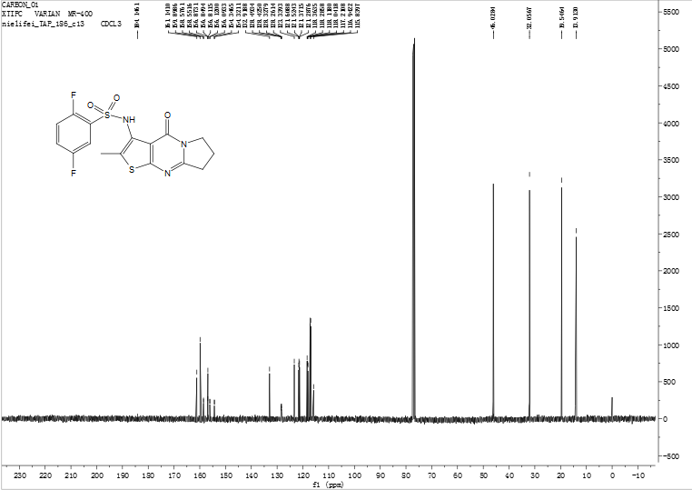
Figure S 38: ¹³C NMR spectrum of compound 10r
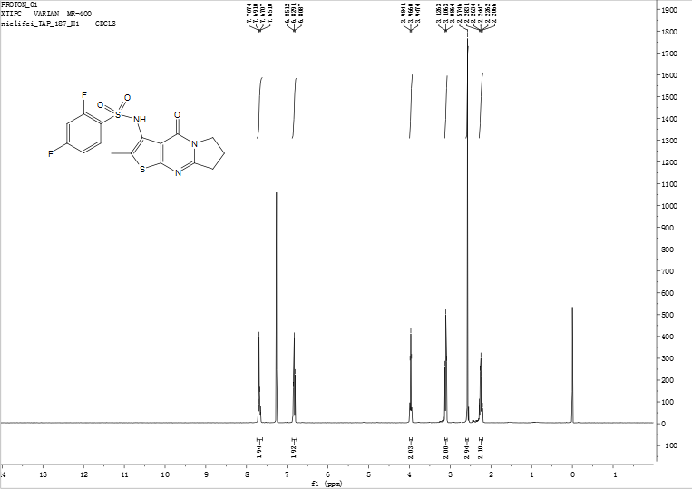
Figure S 39: ¹H NMR spectrum of compound 10s
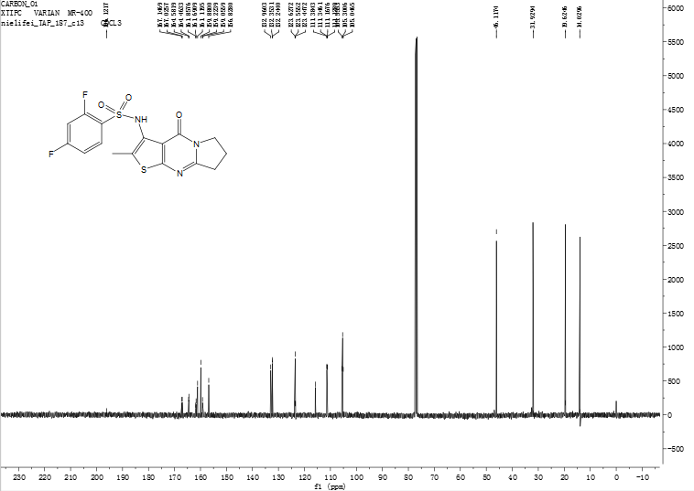
Figure S 40: ¹³C NMR spectrum of compound 10s
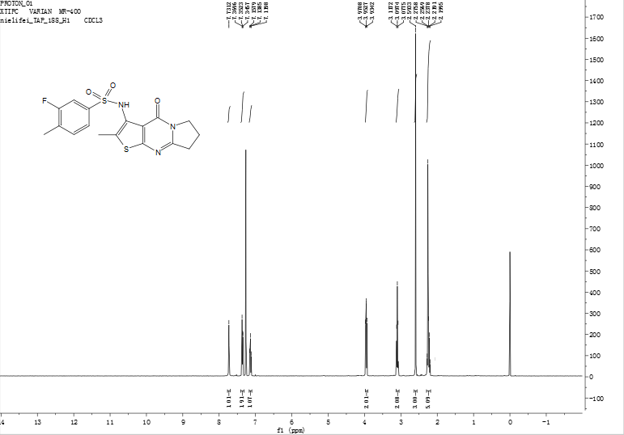
Figure S 41: ¹H NMR spectrum of compound 10t
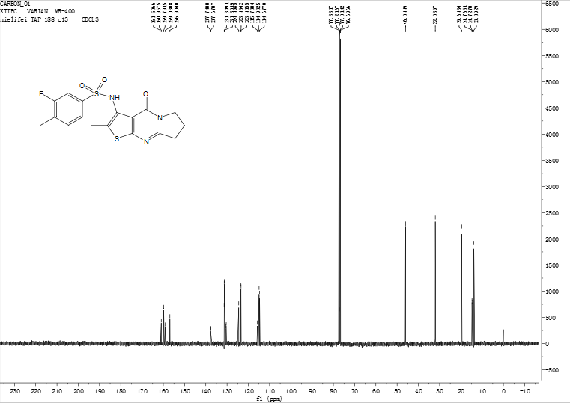
Figure S 42: ¹³C NMR spectrum of compound 10t
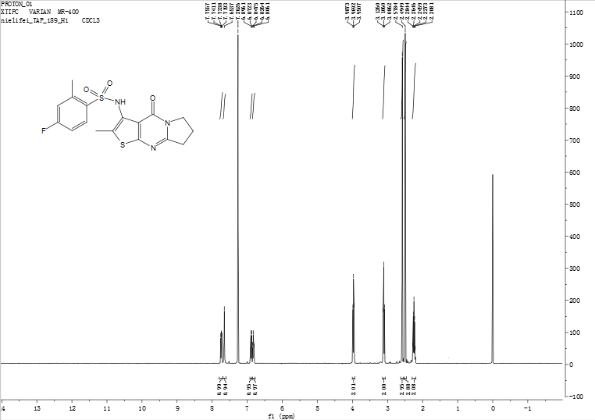
Figure S 43: ¹H NMR spectrum of compound 10u
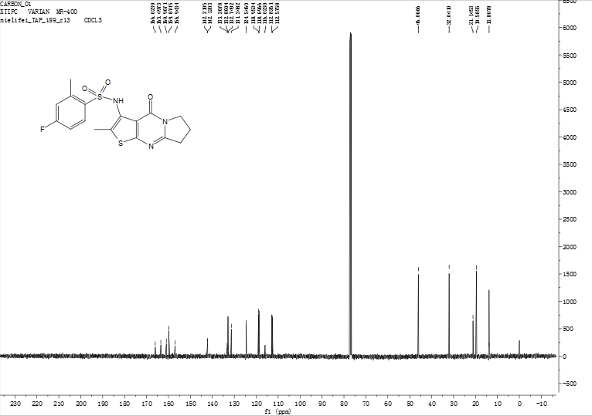
Figure S 44: ¹³C NMR spectrum of compound 10u
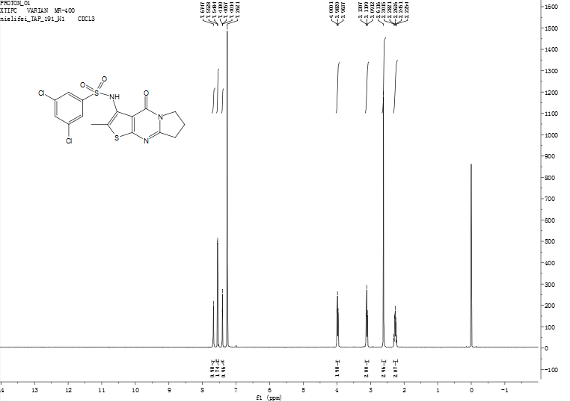
Figure S 45: ¹H NMR spectrum of compound 10w
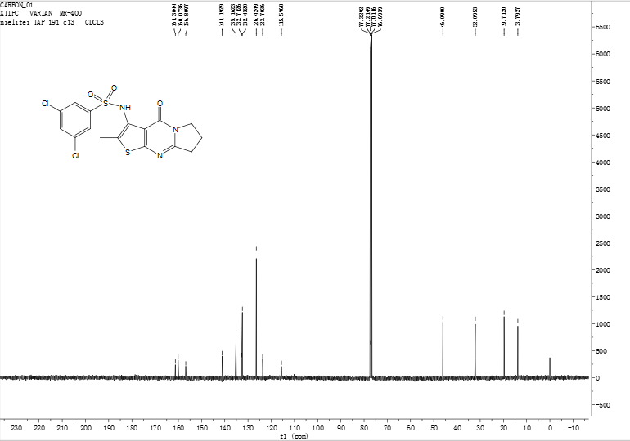
Figure S 46: ¹³C NMR spectrum of compound 10w
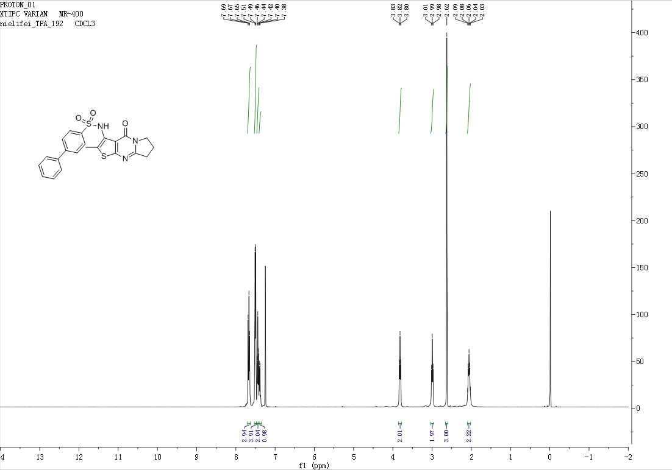
Figure S 47: ¹H NMR spectrum of compound 10x
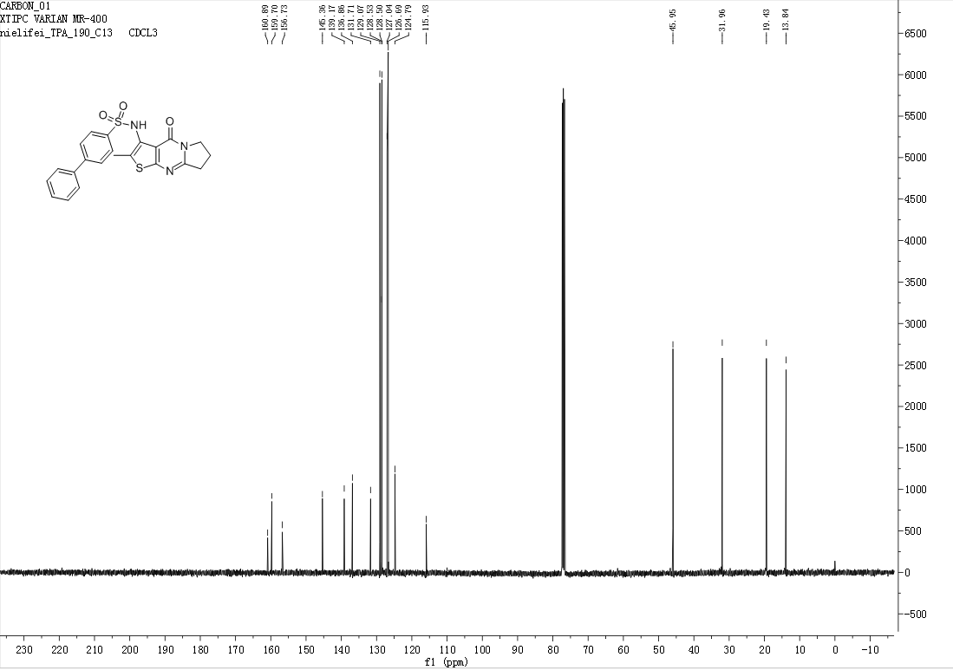
Figure S 48: ¹³C NMR spectrum of compound 10x

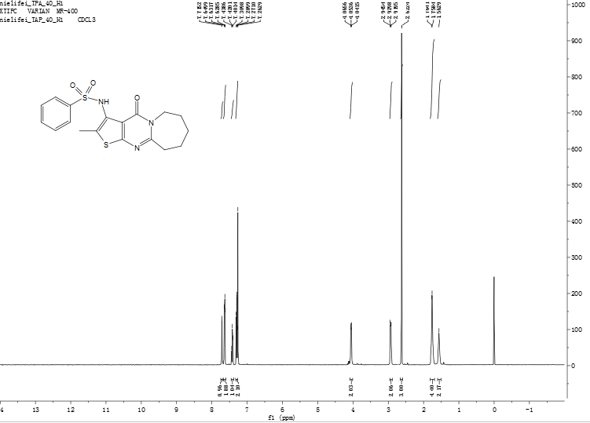
Figure S 49: ¹H NMR spectrum of compound 11a
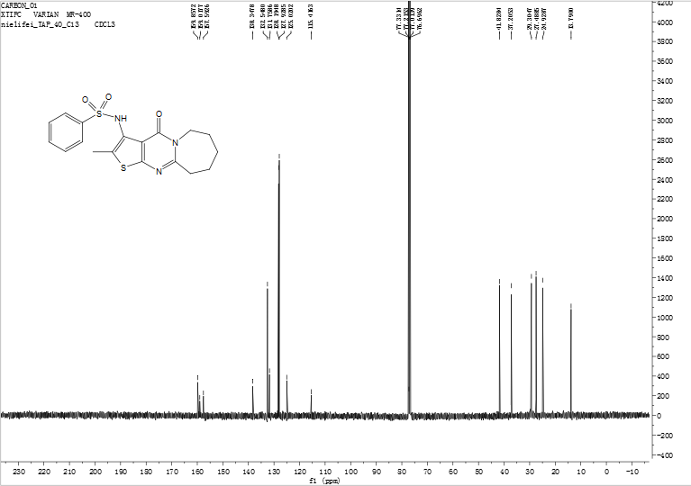
Figure S 50: ¹³C NMR spectrum of compound 11a
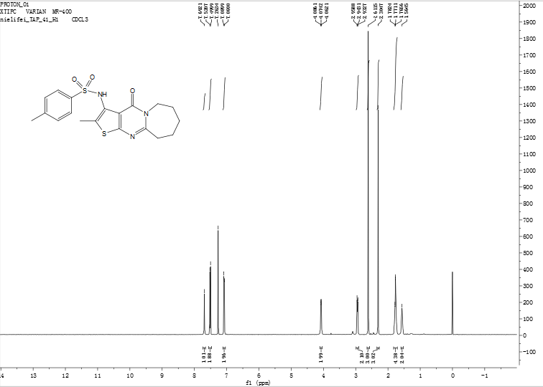
Figure S 51: ¹H NMR spectrum of compound 11b
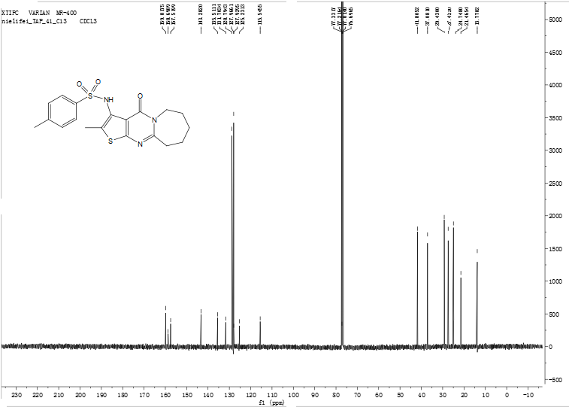
Figure S 52: ¹³C NMR spectrum of compound 11b
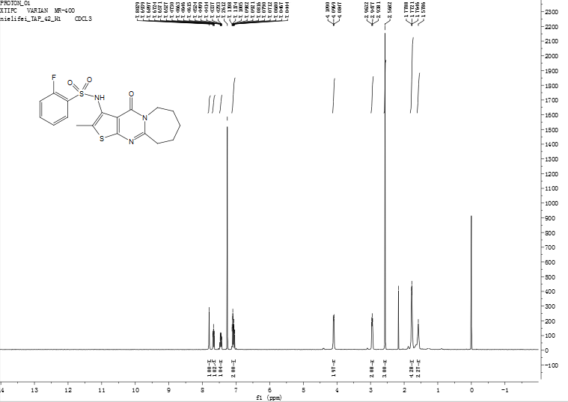
Figure S 53: ¹H NMR spectrum of compound 11c
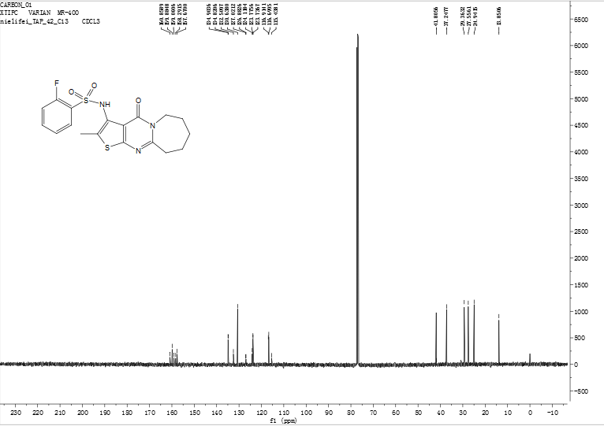
Figure S 54: ¹³C NMR spectrum of compound 11c
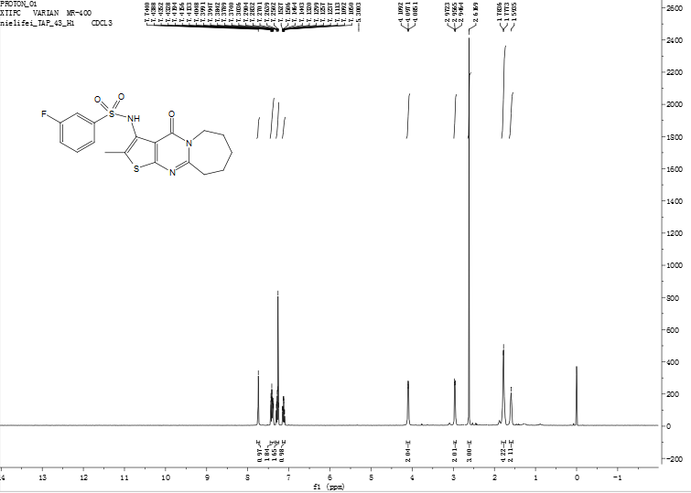
Figure S 55: ¹H NMR spectrum of compound 11d
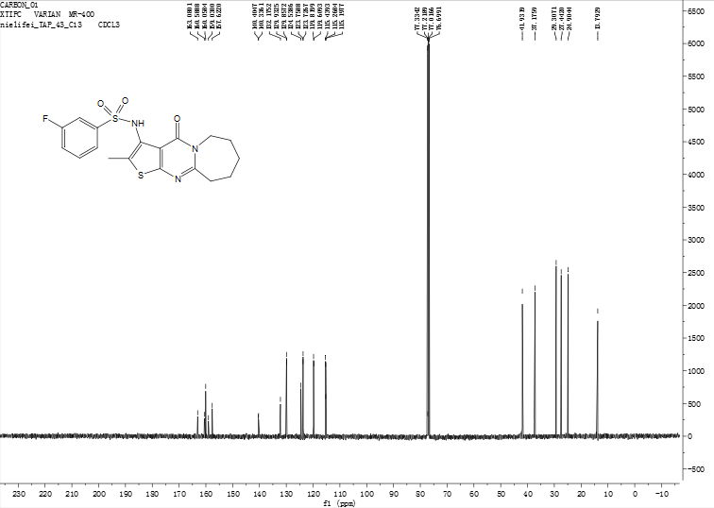
Figure S 56: ¹³C NMR spectrum of compound 11d
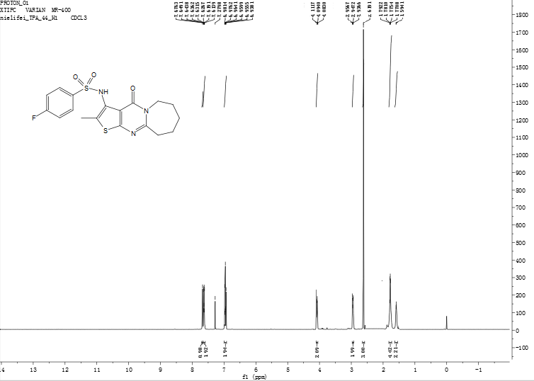
Figure S 57: ¹H NMR spectrum of compound 11e
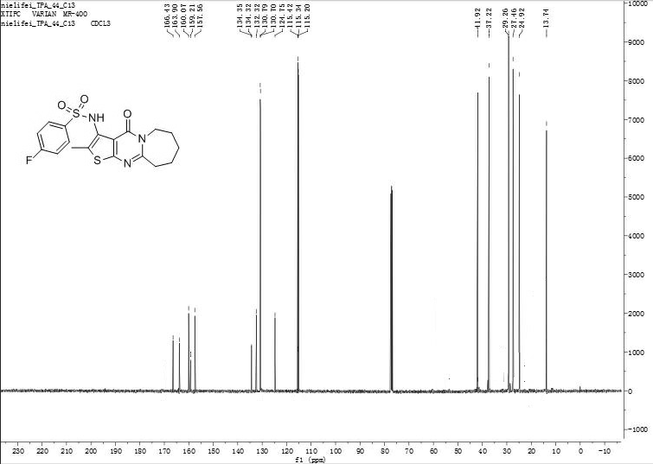
Figure S 58: ¹³C NMR spectrum of compound 11e
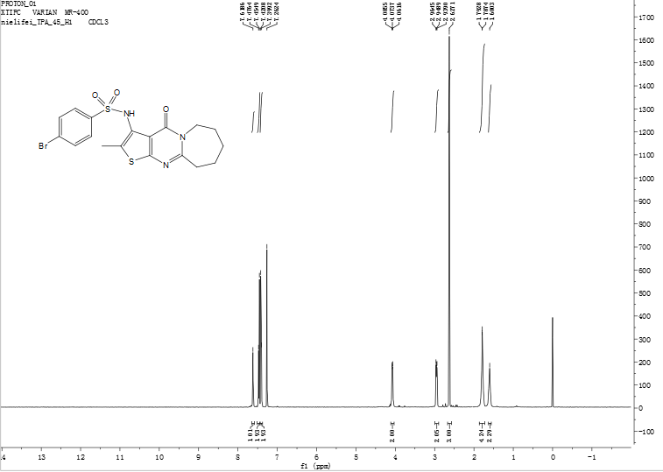
Figure S 59: ¹H NMR spectrum of compound 11f
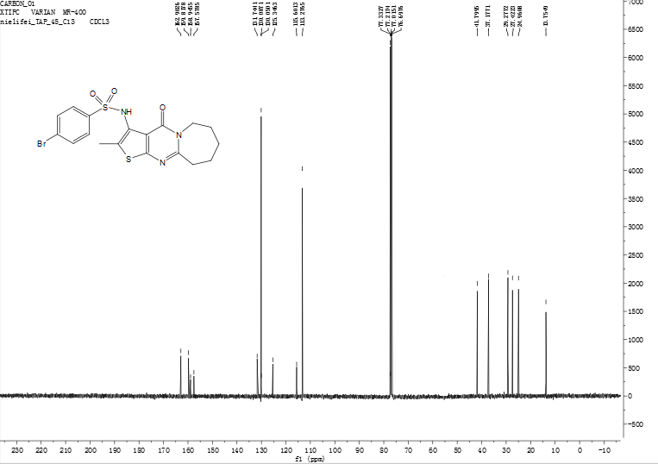
Figure S 60: ¹³C NMR spectrum of compound 11f
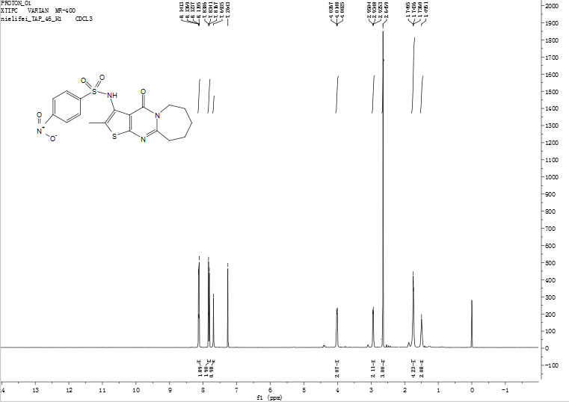
Figure S 61: ¹H NMR spectrum of compound 11g
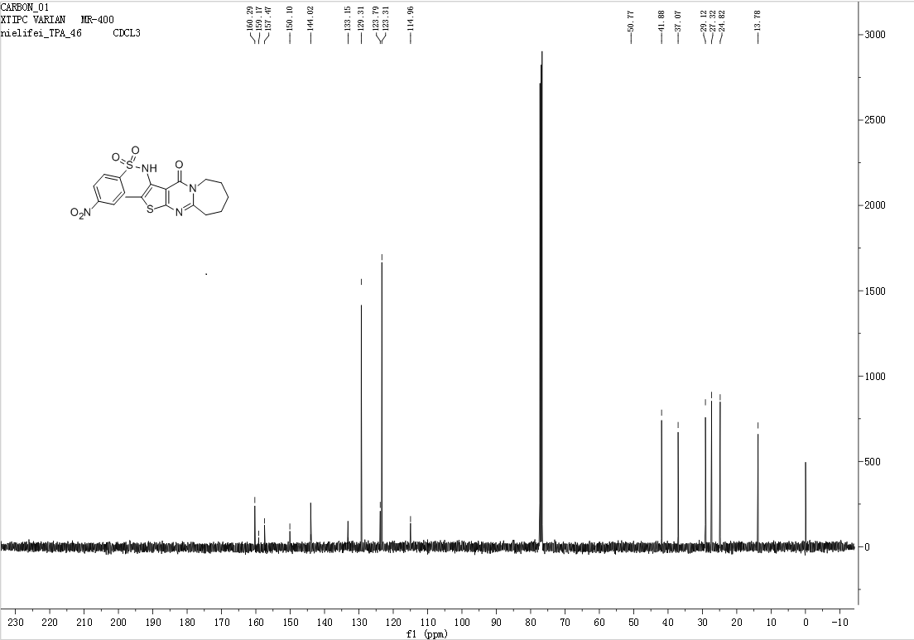
Figure S 62: ¹³C NMR spectrum of compound 11g
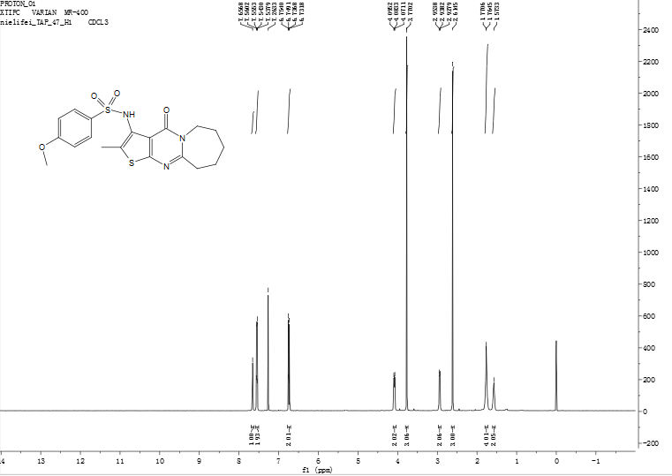
Figure S 63: ¹H NMR spectrum of compound 11h
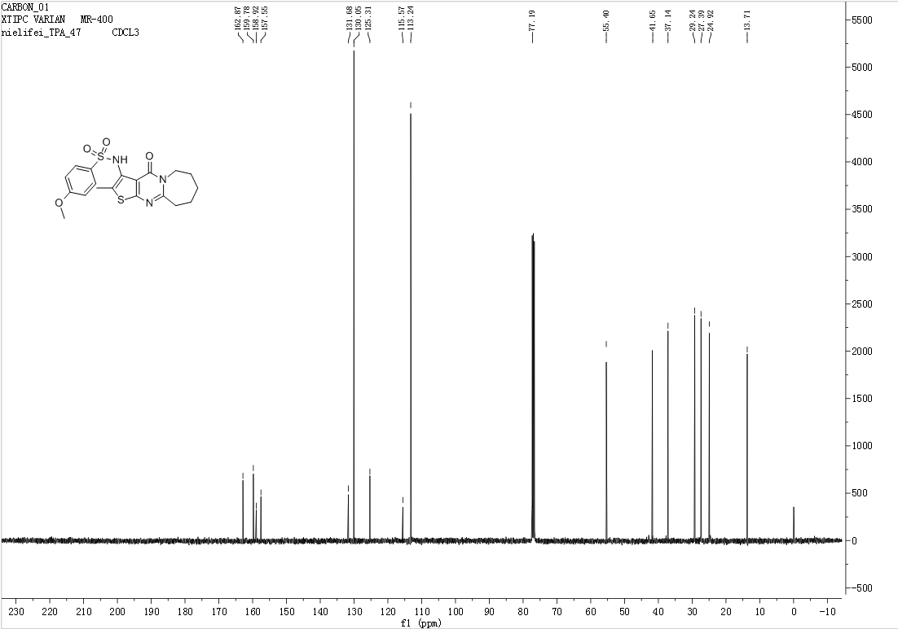
Figure S 64: ¹³C NMR spectrum of compound 11h
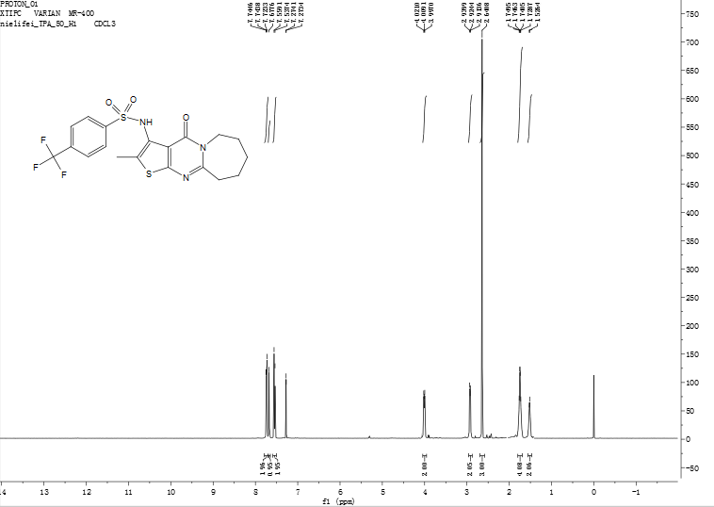
Figure S 65: ¹H NMR spectrum of compound 11k
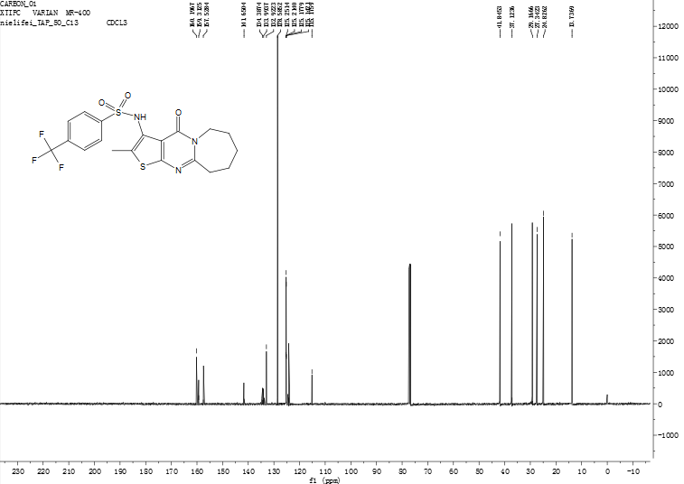
Figure S 66: ¹³C NMR spectrum of compound 11k
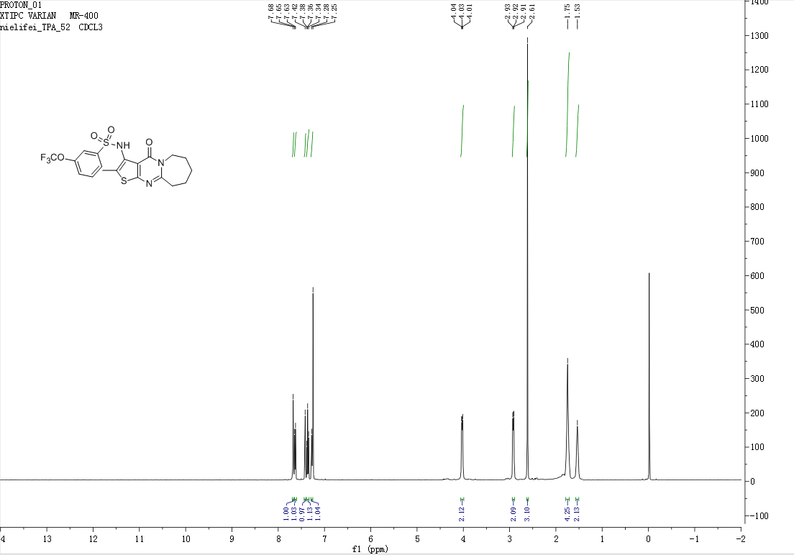
Figure S 67: ¹H NMR spectrum of compound 11m
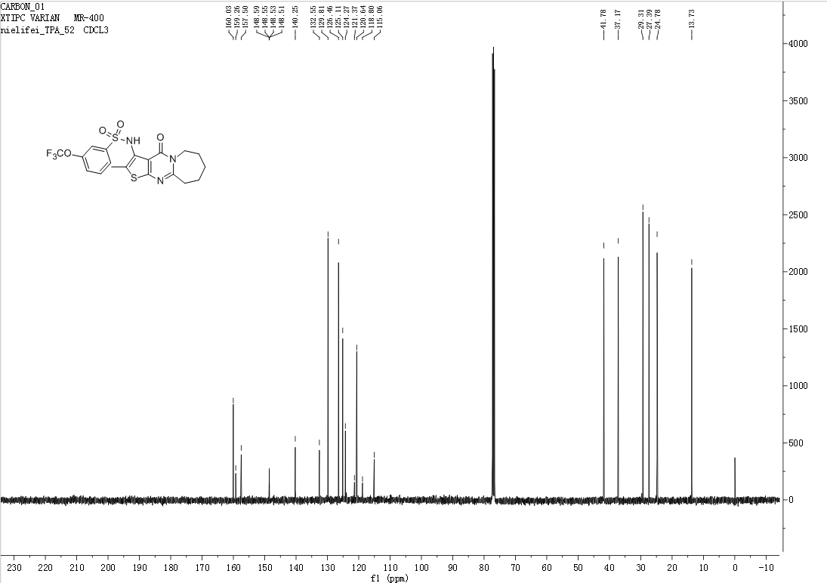
Figure S 68: ¹³C NMR spectrum of compound 11m
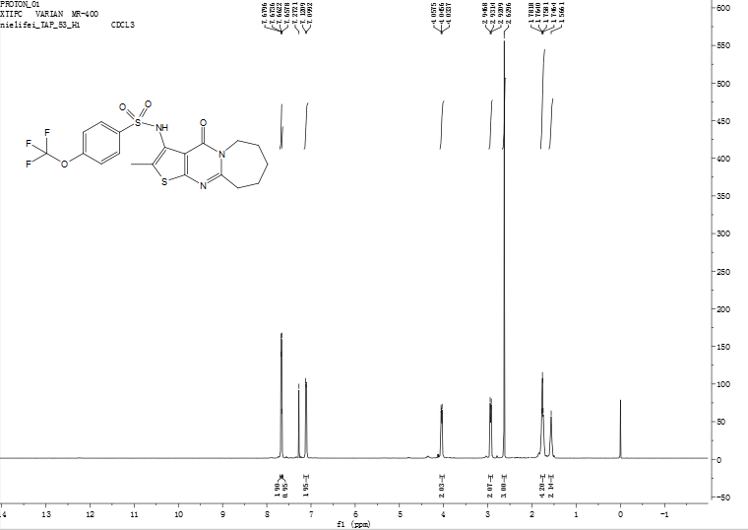
Figure S 69: ¹H NMR spectrum of compound 11n
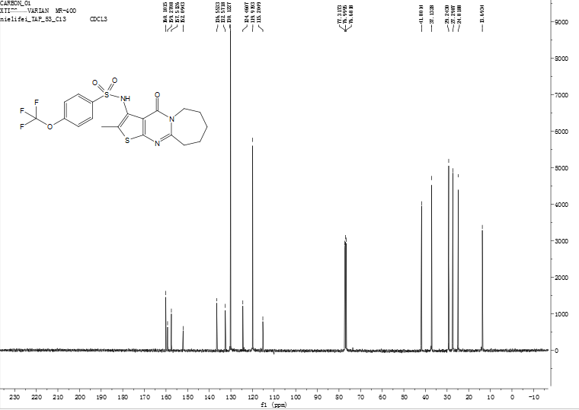
Figure S 70: ¹³C NMR spectrum of compound 11n
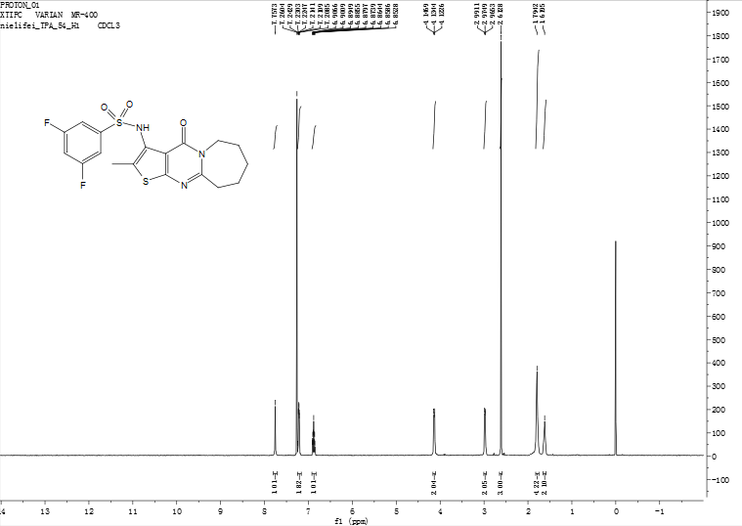
Figure S 71: ¹H NMR spectrum of compound 11o

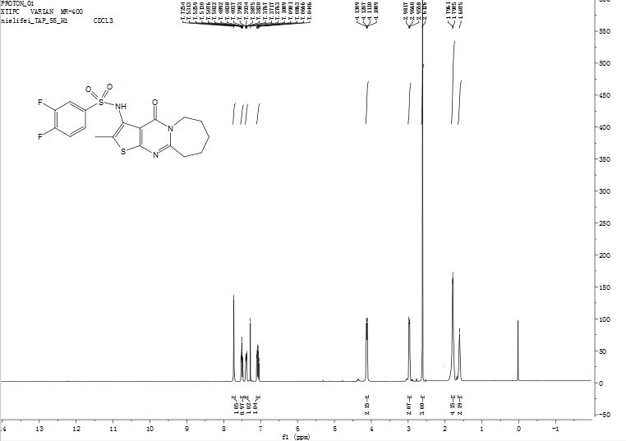
Figure S 72: ¹H NMR spectrum of compound 11p
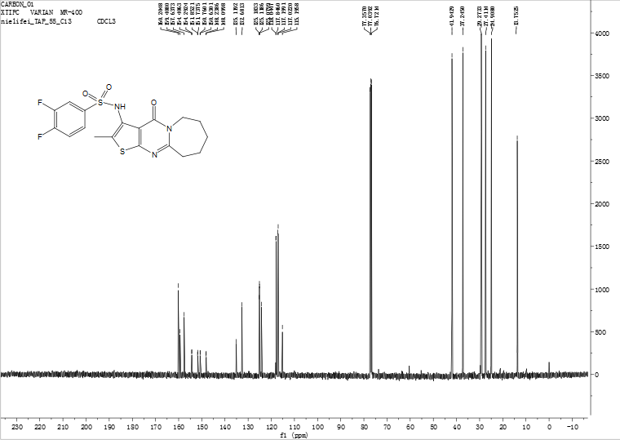
Figure S 73: ¹³C NMR spectrum of compound 11p
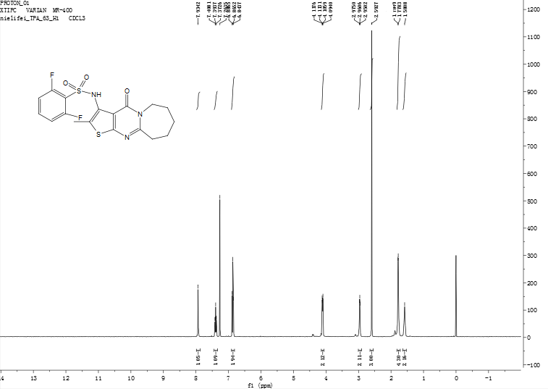
Figure S 74: ¹H NMR spectrum of compound 11q
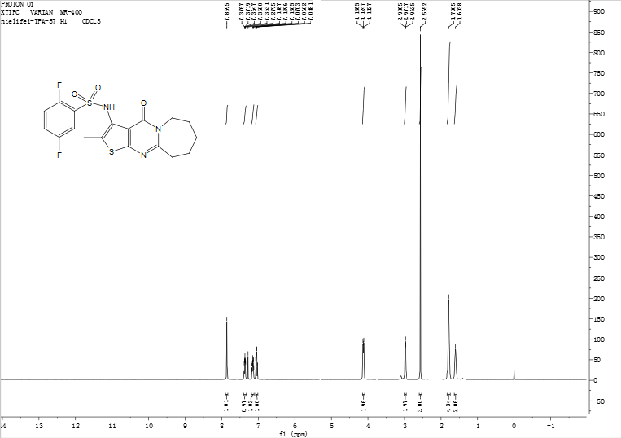
Figure S 75: ¹H NMR spectrum of compound 11r

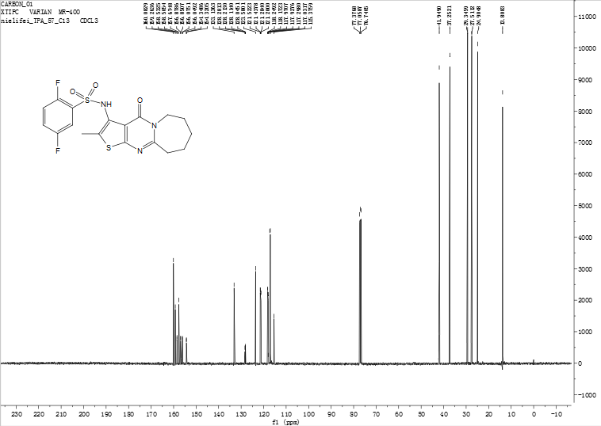
Figure S 76: ¹³C NMR spectrum of compound 11r
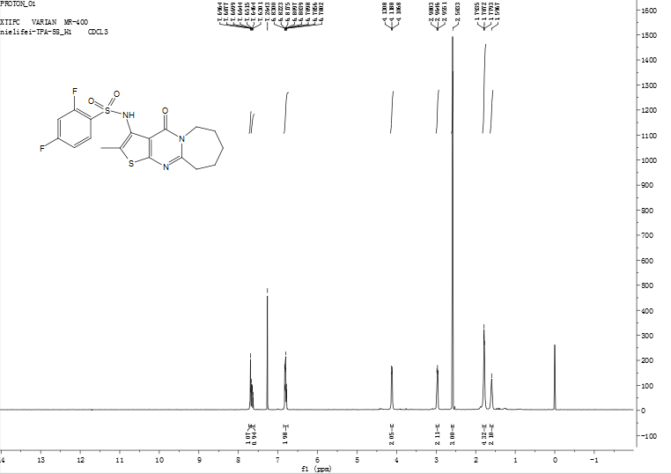
Figure S 77: ¹H NMR spectrum of compound 11s

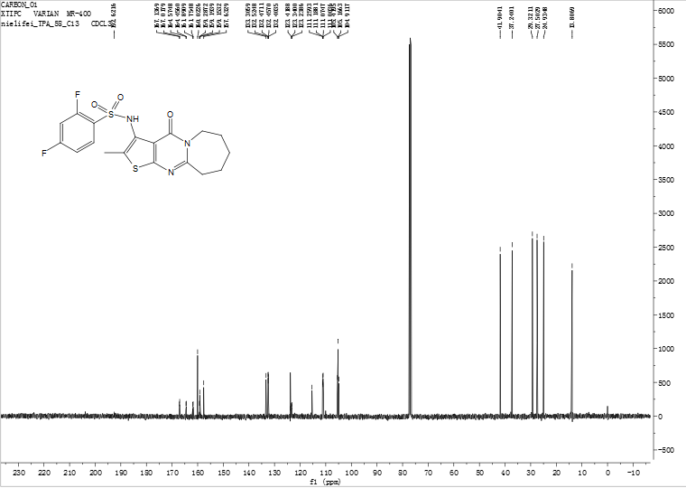
Figure S 78: ¹³C NMR spectrum of compound 11s
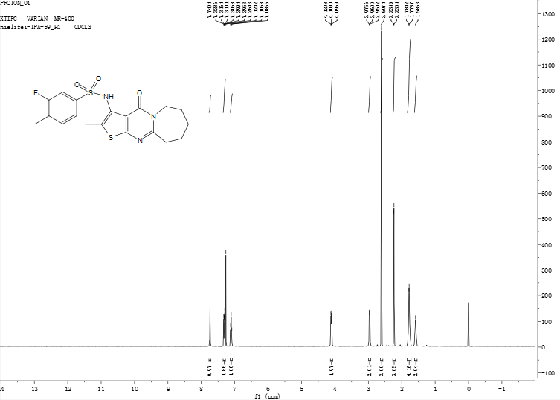
Figure S 79: ¹H NMR spectrum of compound 11t

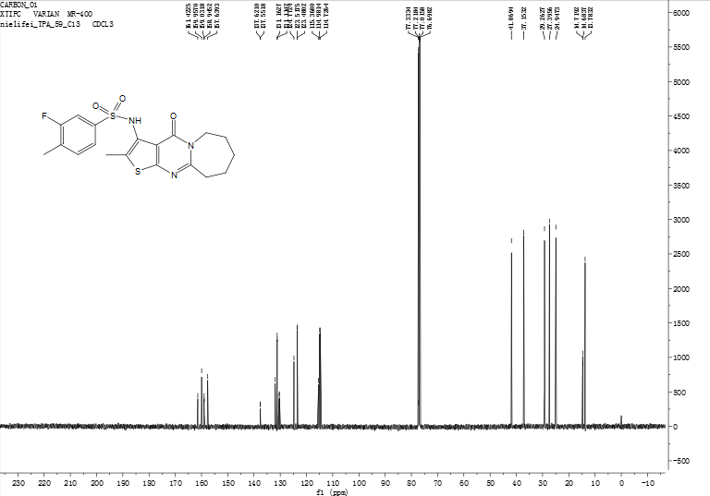
Figure S 80: ¹³C NMR spectrum of compound 11t
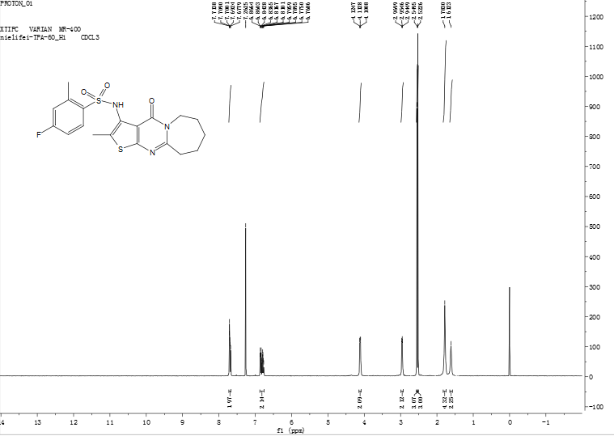
Figure S 81: ¹H NMR spectrum of compound 11u

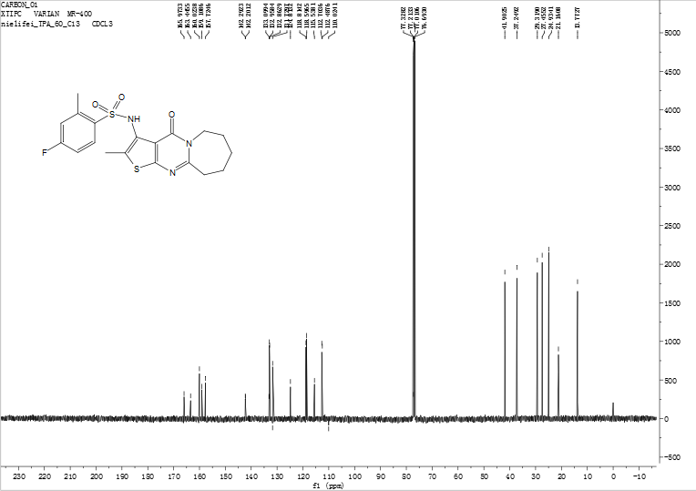
Figure S 82: ¹³C NMR spectrum of compound 11u
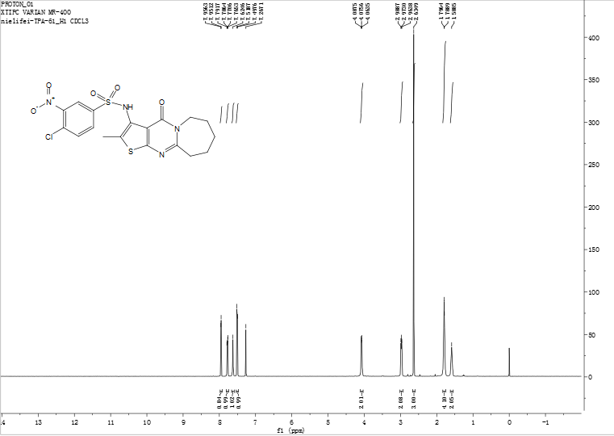
Figure S 83: ¹H NMR spectrum of compound 11v

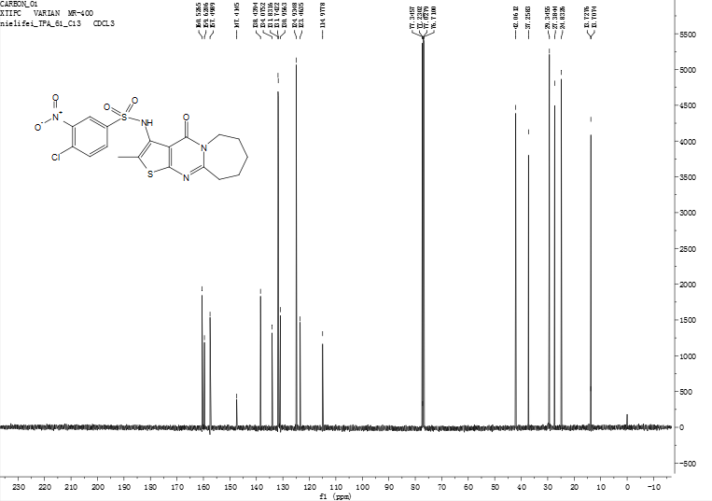
Figure S 84: ¹³C NMR spectrum of compound 11v
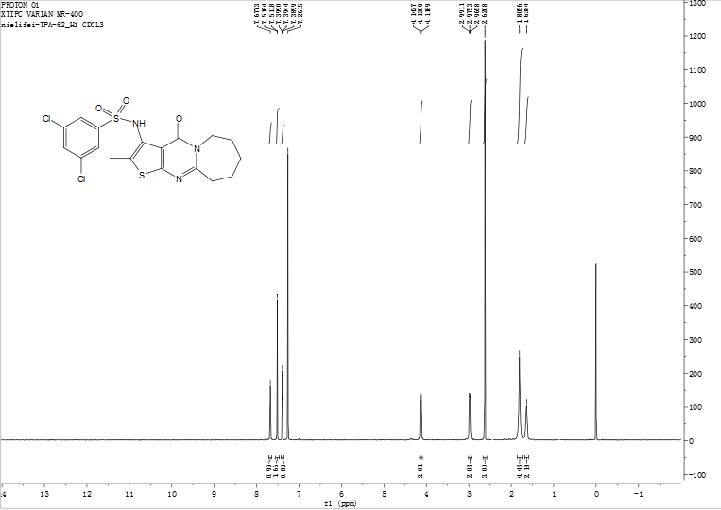
Figure S 85: ¹H NMR spectrum of compound 11w

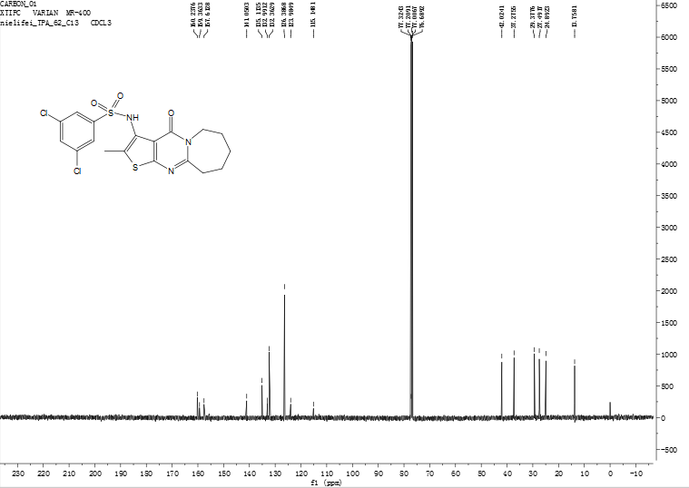
Figure S 86: ¹³C NMR spectrum of compound 11w
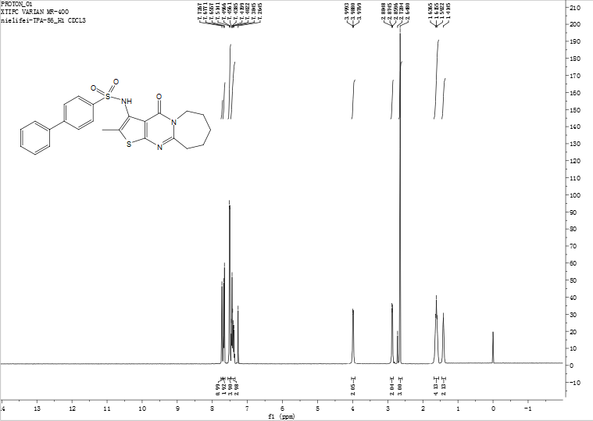
Figure S 87: ¹H NMR spectrum of compound 11x

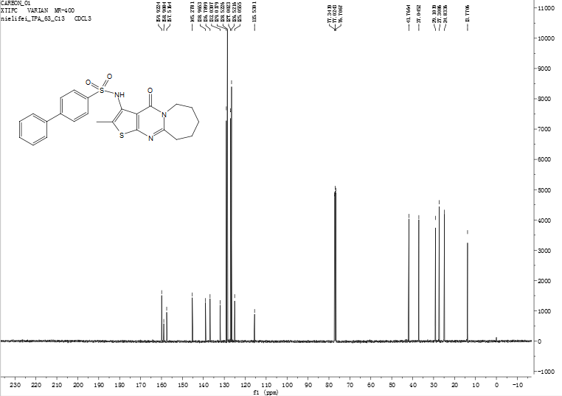
Figure S 88: ¹³C NMR spectrum of compound 11x

