APPENDIX

Table A1. Injury summary, AIS code and notes for six cases with thoracolumbar fractures.
Case Vehicle | AIS Code | Spine Injury Description | Injury Notes
2006 Chevrolet Silverado | 650434.3  650634.3 | T12 compression fracture  L1 compression fracture | Burst fracture, 50% major compression at T12 superior, 25% at L1 inferior region
2007 Toyota  Solara | 650418.2  650432.2  650632.2 | T1,T2,T3,T4,T6,T8 compression fractures  T5 spinous process fracture  L1 and L2 compression fracture | T1-T3 superior endplate, vertebral body fractures; minor compression deformity at T2-T6, T8 and L1 levels
2007 Toyota  Corolla | 650634.3 | L4 endplate fracture | Anterior-superior endplate of L4 acute, compression fracture, slight wedging
2006 Chevrolet Malibu | 650632.2  650620.2 | L1 compression fracture  L1-L2 transverse process fracture | Minor compression fracture, L1 vertebral body, inferior L1 and L2 transverse process fracture
2006 Chevrolet Cobalt | 650632.2 | L1 and L3 compression fractures | Cranial endplate fracture, mild compression of L1, ventral compression fracture of L3
2012 Ford  Escape | 650632.2 | L3 compression fractures | Inferior/lower burst fracture of L3, minor compression

Table A2. Occupant positioning parameters for 11 reconstructed cases. Intervals indicate the range for the corresponding DOE for cases with thoracolumbar fractures.
Case | Seat Track Position (mm) |  | Seatback Angle  (°) |  | D-Ring Height  (mm) |  | Steering Column Position (mm) |  | Steering Column Angle (°)
Cavalier | 120 |  | 15 |  | 0 |  | 0 |  | 24
Camry | 0 |  | 12 |  | 0 |  | 0 |  | 5
Silverado | 0 | [-50,75] | 12 | [0,35] | NA |  | 0 | [-10,10] | 21 | [11.3,36.7]
Lexus | 100 |  | 15 |  | 75 |  | 0 |  | 25
Hummer | 10 |  | 15 |  | 50 |  | 0 |  | 9.7
Solara | -80 | [-120,25] | 5 | [-3,25] | 25 | [0,75] | 0 | [-22.5,22] | 25 | [17.2,33.3]
Corolla | -75 | [-40,125] | 10 | [-5,35] | 25 | [-10,85] | 25 | [-30,30] | 29.1 | [25.5,29.1]
Civic | 0 |  | 10 |  | 75 |  | 0 |  | 24
Malibu | 0 | [-75,75] | 16 | [0,35] | 0 | [0,100] | 0 | [-26,26] | 23 | [20.7,25]
Cobalt | 65 | [-40,130] | 12 | [0,33] | 75 | [0,100] | 0 | [-30,30] | 20 | [18,22]
Escape | 65 | [-40,130] | 12 | [0,33] | 75 | [0,100] | 0 | [-30,30] | 20 | [18,22]

Figure A1. THUMS thoracolumbar spine local coordinate systems and cross-section instrumentation.

Figure A2. Age adjustment factor as a function of occupant age for age-adjusted lumbar spine index.

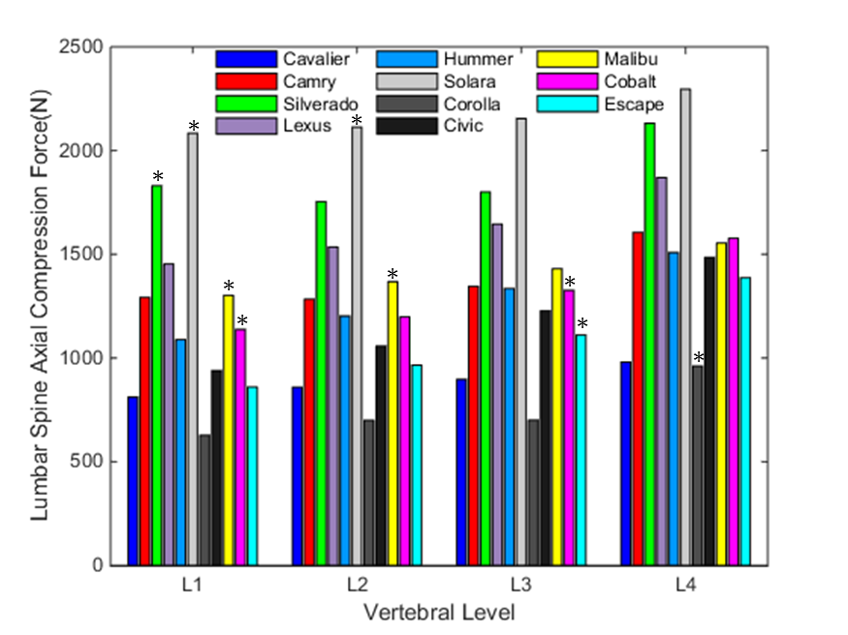
Figure A3. Lumbar spine axial compression force of 11 reconstructed baseline cases. Asterisks indicate lumbar spine fractures.

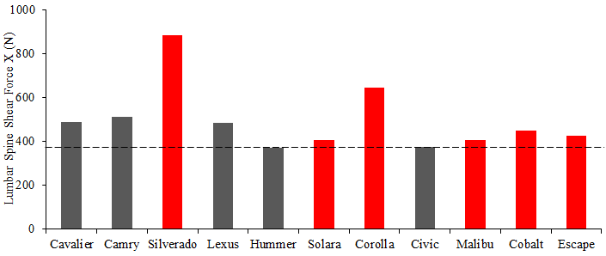Figure A4. Average L1-L4 vertebrae shear force $Fx$ of 11 reconstructed cases (threshold: 373.2 N, sensitivity: 1.00, specificity: 0.40, TP: 6, FP: 3, TN: 2, FN: 0). Red bars indicate cases with lumbar spine fractures.

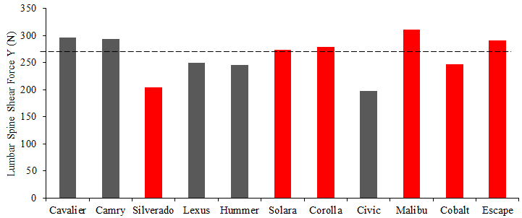Figure A5. Average L1-L4 vertebrae shear force $Fy$ of 11 reconstructed cases (threshold: 273.4 N, sensitivity: 0.67, specificity: 0.60, TP: 4, FP: 2, TN: 3, FN: 2). Red bars indicate cases with lumbar spine fractures.

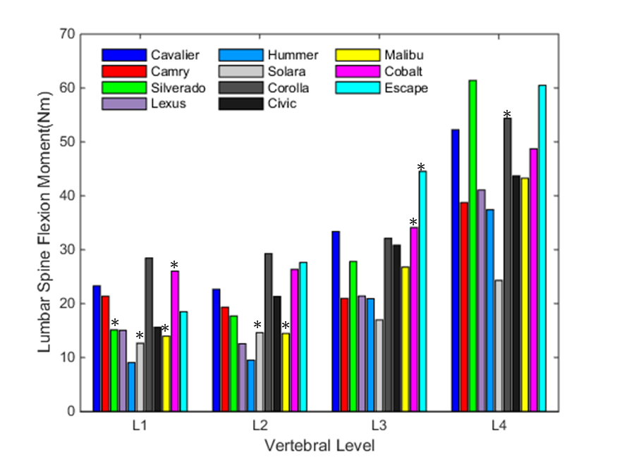
Figure A6. Lumbar spine flexion moment $My$ of 11 reconstructed baseline cases. Asterisks indicate lumbar spine fractures.

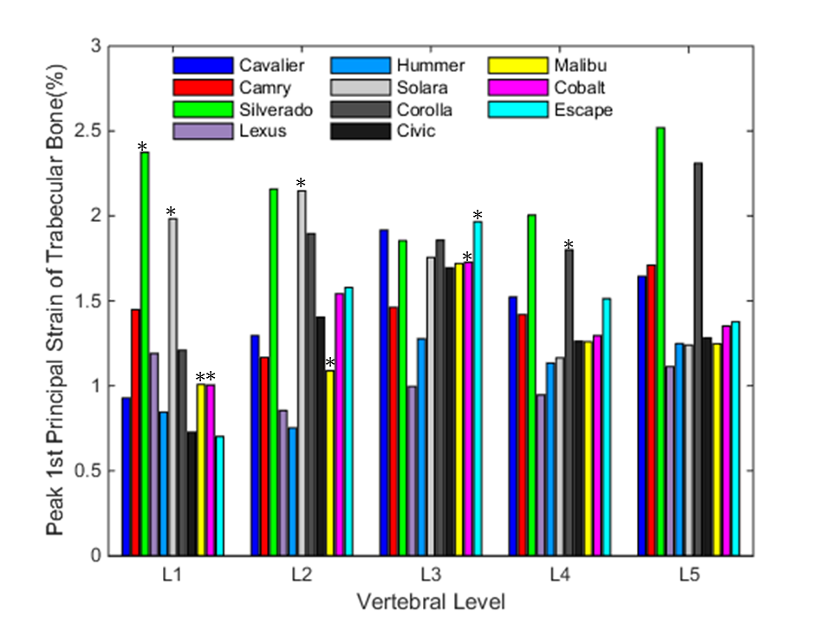
Figure A7. Maximum principal strain of trabecular bone in the vertebrae. Asterisks indicate lumbar spine fractures.

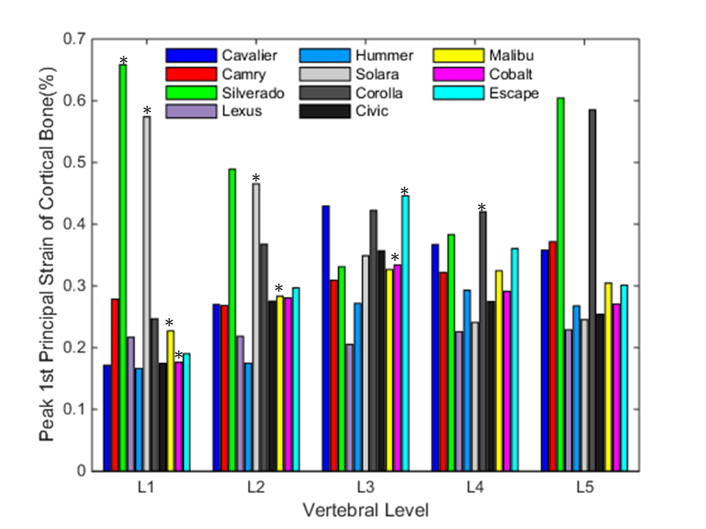
Figure A8. Maximum principal strain of cortical bone in the vertebrae. Asterisks indicate lumbar spine fractures.

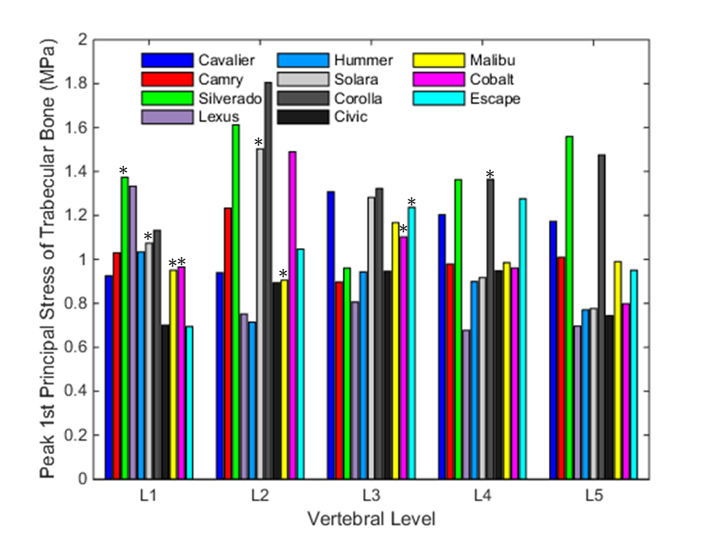
Figure A9. Maximum principal stress of trabecular bone in the vertebrae. Asterisks indicate lumbar spine fractures.
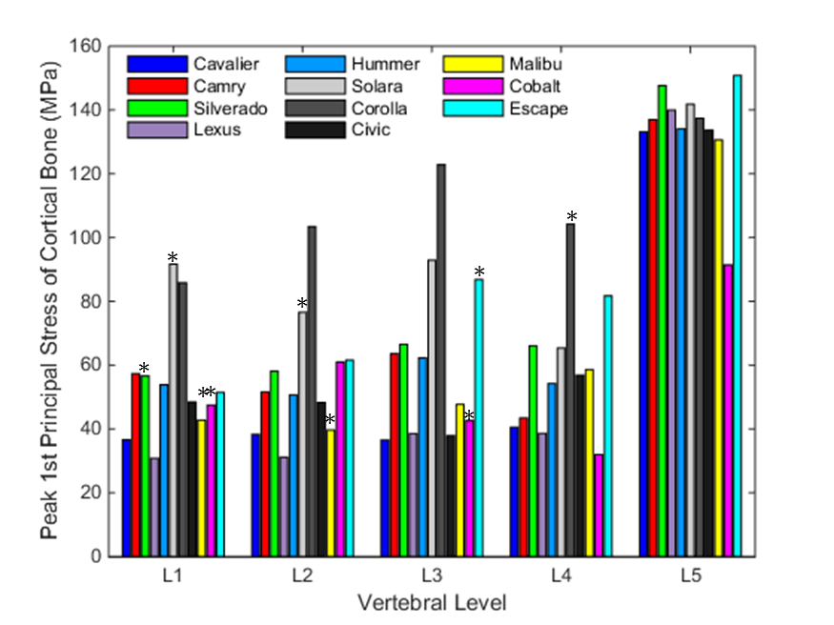
Figure A10. Maximum principal stress of cortical bone in the vertebrae. Asterisks indicate lumbar spine fractures.

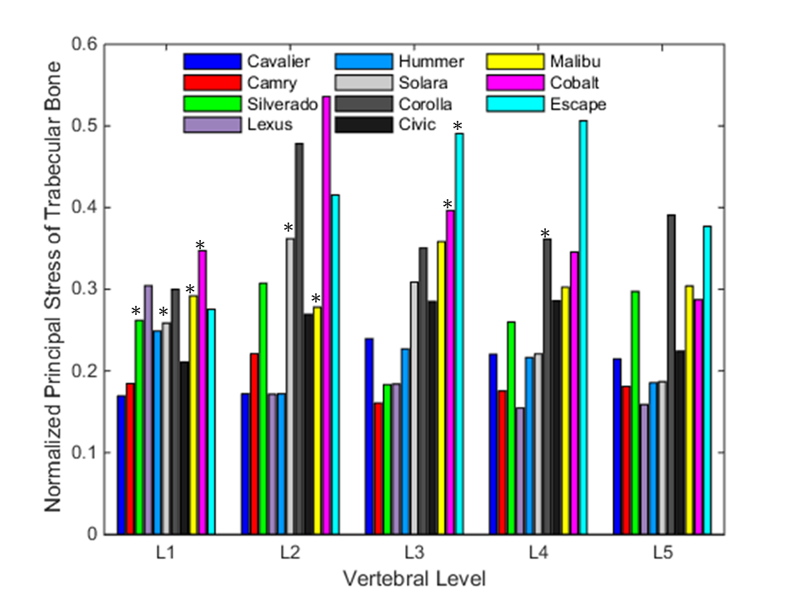
Figure A11. Age-normalized maximum principal stress of trabecular bone in the vertebrae. Age-normalized maximum principal stress was derived from peak principal stress divided by age-adjusted yield stress from Eqn. 7. Asterisks indicate lumbar spine fractures.

Table A3. Linear regression models (y=A+B*x) of spine response (y) versus occupant positioning parameters (x) for cases with thoracolumbar fractures.
Cobalt | D-Ring Height  (mm) |  | Seat Track Position  (mm) |  | Seatback Angle  (degree) |  | Column Telescoping (mm) |  | Column Angle  (degree)
Parameters | A | B | A | B | A | B | A | B | A | B
L1 Axial  Force (N) | -1727.76 | +1.45 | -1710.25 | +1.18 | -1568.59 | -5.23 | -1655.69 | -2.56 | -1559.88 | -4.76
 | (R²_{adj} <0.01) |  | (R²_{adj} =0.02) |  | (R²_{adj} <0.01) |  | (R²_{adj} <0.01) |  | (R²_{adj} <0.01)
L1 Flexion Moment (Nm) | +28.26 | -0.03 | +26.74 | +0.01 | +23.85 | +0.18 | +26.92 | +0.09 | +15.76 | +0.56
 | (R²_{adj} =0.02) |  | (R²_{adj} <0.01) |  | (R²_{adj} =0.12) |  | (R²_{adj} =0.09) |  | (R²_{adj} <0.01)
L3 Axial  Force (N) | -1955.38 | +1.35 | -1903.28 | +0.33 | -1642.53 | -14.83 | -1888.49 | -2.98 | -1975.74 | +4.38
 | (R²_{adj} <0.01) |  | (R²_{adj} <0.01) |  | (R²_{adj} =0.10) |  | (R²_{adj} <0.01) |  | (R²_{adj} <0.01)
L3 Flexion Moment (Nm) | +38.06 | -0.01 | +38.18 | -0.01 | +27.80 | +0.60 | +3771 | +0.15 | +26.48 | +0.56
 | (R²_{adj} <0.01) |  | (R²_{adj} <0.01) |  | (R²_{adj} =0.52) |  | (R²_{adj} =0.11) |  | (R²_{adj} <0.01)
Corolla | D-Ring Height  (mm) |  | Seat Track Position  (mm) |  | Seatback Angle  (degree) |  | Column Telescoping (mm) |  | Column Angle  (degree)
Parameters | A | B | A | B | A | B | A | B | A | B
L4 Axial  Force (N) | -1622.49 | -0.70 | -1475.47 | +4.50 | -914.49 | -48.79 | -1645.56 | -3.45 | -848.36 | -29.23
 | (R²_{adj} <0.01) |  | (R²_{adj} =0.11) |  | (R²_{adj} =0.68) |  | (R²_{adj} <0.01) |  | (R²_{adj} <0.01)
L4 Flexion Moment (Nm) | +55.27 | -0.02 | +56.17 | +0.04 | +29.49 | +1.67 | +54.54 | +0.12 | +41.73 | +0.47
 | (R²_{adj} <0.01) |  | (R²_{adj} <0.01) |  | (R²_{adj} =0.89) |  | (R²_{adj} <0.01) |  | (R²_{adj} <0.01)
Escape | D-Ring Height  (mm) |  | Seat Track Position  (mm) |  | Seatback Angle  (degree) |  | Column Telescoping (mm) |  | Column Angle  (degree)
Parameters | A | B | A | B | A | B | A | B | A | B
L3 Axial  Force (N) | -1238.63 | +2.47 | -1356.93 | +5.13 | -704.21 | -19.95 | -1145.29 | -1.81 | -1024.79 | -4.42
 | (R²_{adj} =0.01) |  | (R²_{adj} =0.54) |  | (R²_{adj} =0.24) |  | (R²_{adj} <0.01) |  | (R²_{adj} <0.01)
L3 Flexion Moment (Nm) | +46.47 | -0.02 | +44.55 | +0.03 | +28.07 | +0.80 | +45.83 | -0.05 | +31.51 | +0.52
 | (R²_{adj} <0.01) |  | (R²_{adj} =0.03) |  | (R²_{adj} =0.82) |  | (R²_{adj} <0.01) |  | (R²_{adj} <0.01)
Malibu | D-Ring Height  (mm) |  | Seat Track Position  (mm) |  | Seatback Angle  (degree) |  | Column Telescoping (mm) |  | Column Angle  (degree)
Parameters | A | B | A | B | A | B | A | B | A | B
L1 Axial  Force (N) | -1570.52 | +0.70 | -1540.67 | +1.94 | -1154.95 | -21.18 | -1537.18 | -3.99 | -2030.90 | +21.71
 | (R²_{adj} <0.01) |  | (R²_{adj} =0.05) |  | (R²_{adj} =0.35) |  | (R²_{adj} =0.02) |  | (R²_{adj} <0.01)
L1 Flexion Moment (Nm) | +14.03 | -0.01 | +13.63 | +0.09 | +9.77 | +0.23 | +13.87 | -0.02 | +8.62 | +0.23
 | (R²_{adj} <0.01) |  | (R²_{adj} =0.58) |  | (R²_{adj} =0.20) |  | (R²_{adj} <0.01) |  | (R²_{adj} <0.01)
L2 Axial  Force (N) | -1625.82 | +0.68 | -1596.30 | +1.81 | -1171.18 | -23.39 | -1593.22 | -4.02 | -2061.45 | +20.59
 | (R²_{adj} <0.01) |  | (R²_{adj} =0.04) |  | (R²_{adj} =0.39) |  | (R²_{adj} =0.02) |  | (R²_{adj} <0.01)
L2 Flexion Moment (Nm) | +16.94 | -0.01 | +16.73 | +0.07 | +9.46 | +0.42 | +16.97 | +0.07 | +18.33 | -0.06
 | (R²_{adj} <0.01) |  | (R²_{adj} =0.26) |  | (R²_{adj} =0.50) |  | (R²_{adj} =0.02) |  | (R²_{adj} <0.01)
Silverado | D-Ring Height  (mm) |  | Seat Track Position  (mm) |  | Seatback Angle  (degree) |  | Column Telescoping (mm) |  | Column Angle  (degree)
Parameters | A | B | A | B | A | B | A | B | A | B
T12 Axial  Force (N) | ‒ | ‒ | -2148.56 | +3.91 | -1345.83 | -42.09 | -2105.18 | -10.71 | -1511.66 | -24.46
 |  |  | (R²_{adj} =0.05) |  | (R²_{adj} =0.49) |  | (R²_{adj} <0.01) |  | (R²_{adj} =0.09)
T12 Flexion Moment (Nm) | ‒ | ‒ | +15.37 | +0.10 | +10.72 | +0.32 | +16.52 | +0.12 | +13.07 | +0.14
 |  |  | (R²_{adj} =0.40) |  | (R²_{adj} =0.27) |  | (R²_{adj} <0.01) |  | (R²_{adj} =0.02)
L1 Axial  Force (N) | ‒ | ‒ | -2168.27 | +4.29 | -1337.40 | -43.42 | -2120.71 | -10.70 | -1513.17 | -25.04
 |  |  | (R²_{adj} =0.06) |  | (R²_{adj} =0.49) |  | (R²_{adj} <0.01) |  | (R²_{adj} =0.09)
L1 Flexion Moment (Nm) | ‒ | ‒ | +18.28 | +0.13 | +13.66 | +0.34 | +19.75 | +0.17 | +16.95 | +0.12
 |  |  | (R²_{adj} =0.47) |  | (R²_{adj} =0.22) |  | (R²_{adj} =0.01) |  | (R²_{adj} <0.01)
Solara | D-Ring Height  (mm) |  | Seat Track Position  (mm) |  | Seatback Angle  (degree) |  | Column Telescoping (mm) |  | Column Angle  (degree)
Parameters | A | B | A | B | A | B | A | B | A | B
T1-T4 Axial  Force (N) | -558.41 | +0.11 | -530.65 | +0.54 | -538.88 | -1.41 | -554.51 | -0.29 | -405.84 | -5.93
 | (R²_{adj} <0.01) |  | (R²_{adj} =0.03) |  | (R²_{adj} <0.01) |  | (R²_{adj} <0.01) |  | (R²_{adj} =0.06)
T1-T4 Flexion Moment (Nm) | +7.70 | -0.01 | +6.67 | -0.02 | +9.29 | -0.15 | +7.59 | -0.05 | +8.50 | -0.04
 | (R²_{adj} <0.01) |  | (R²_{adj} =0.06) |  | (R²_{adj} =0.12) |  | (R²_{adj} =0.03) |  | (R²_{adj} <0.01)
T5-T8 Axial  Force (N) | -894.49 | -0.09 | -758.14 | +3.17 | -1078.17 | +13.64 | -898.69 | -2.45 | -730.02 | -6.70
 | (R²_{adj} <0.01) |  | (R²_{adj} =0.25) |  | (R²_{adj} =0.16) |  | (R²_{adj} <0.01) |  | (R²_{adj} <0.01)
T5-T8 Flexion Moment (Nm) | +8.84 | -0.03 | +6.02 | -0.04 | +11.56 | -0.34 | +7.85 | +0.03 | +8.34 | -0.02
 | (R²_{adj} =0.01) |  | (R²_{adj} =0.17) |  | (R²_{adj} =0.42) |  | (R²_{adj} <0.01) |  | (R²_{adj} <0.01)
L1 Axial  Force (N) | -1506.07 | +0.79 | -1162.80 | +7.13 | -1651.01 | +15.83 | -1478.37 | -5.12 | -1235.76 | -9.62
 | (R²_{adj} <0.01) |  | (R²_{adj} =0.55) |  | (R²_{adj} =0.09) |  | (R²_{adj} =0.02) |  | (R²_{adj} <0.01)
L1 Flexion Moment (Nm) | +20.46 | +0.02 | +25.50 | +0.10 | +14.48 | +0.60 | +21.15 | +0.13 | +18.82 | +0.09
 | (R²_{adj} <0.01) |  | (R²_{adj} =0.36) |  | (R²_{adj} =0.47) |  | (R²_{adj} =0.06) |  | (R²_{adj} <0.01)
L2 Axial  Force (N) | -1559.50 | +0.84 | -1230.53 | +6.77 | -1689.05 | +14.58 | -1530.19 | -5.15 | -1291.57 | -9.46
 | (R²_{adj} <0.01) |  | (R²_{adj} =0.52) |  | (R²_{adj} =0.08) |  | (R²_{adj} =0.02) |  | (R²_{adj} <0.01)
L2 Flexion Moment (Nm) | +21.80 | +0.03 | +27.41 | +0.10 | +15.31 | +0.71 | +23.14 | +0.18 | +21.99 | +0.04
 | (R²_{adj} <0.01) |  | (R²_{adj} =0.28) |  | (R²_{adj} =0.54) |  | (R²_{adj} =0.09) |  | (R²_{adj} <0.01)
*All linear regressions followed the form y= A+B*x, where A is the intercept (1st column), B is the slope (2nd column). Adjusted R-squared indicated the goodness of fit, and shaded regions indicated strong linear correlation (R²_{adj}>0.50).
*Spine force and moment followed SAE J211 polarity: tension (+), compression (-), flexion (+), extension (-).

T= 0 ms | T=30 ms | T = 60 ms | T = 90 ms
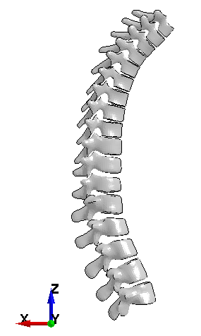 | 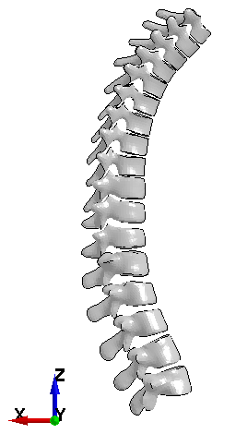 | 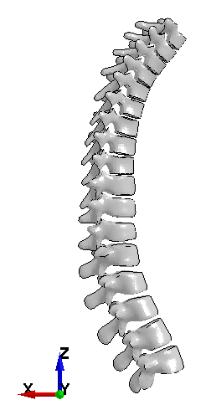 | 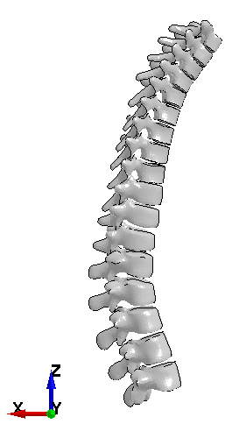
T = 120 ms | T = 150 ms | T = 180 ms
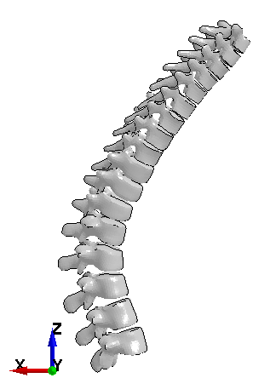 | 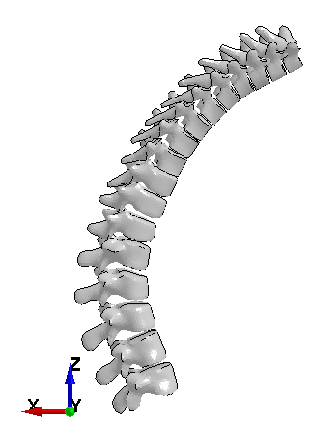 | 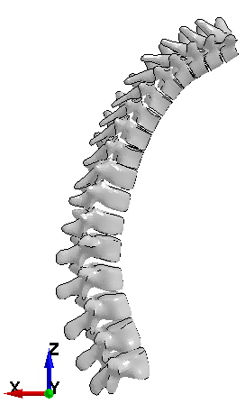
Figure A12. Example of thoracolumbar spine motion throughout the crash event for the Cobalt baseline case, with the L5 vertebral level set as reference for trace.

