SUPPLEMENTAL INFORMATION

a membrane fusion protein, YKT6, regulates epithelial cell migration via microRNA-mediated suppression of junctional adhesion molecule A

Nayden G. Naydenov^{1,2}, Supriya Joshi¹, Alex Feygin¹, Siddharth Saini³, Larisa Litovchick³, and Andrei I. Ivanov^{1,2*}
¹ Department of Inflammation and Immunity, Lerner Research Institute of Cleveland Clinic Foundation, Cleveland, OH 44195; ²Department of Human and Molecular Genetics, Virginia Commonwealth University, Richmond, VA 23298; ³Department of Medicine, Virginia Commonwealth University, Richmond, VA 23298

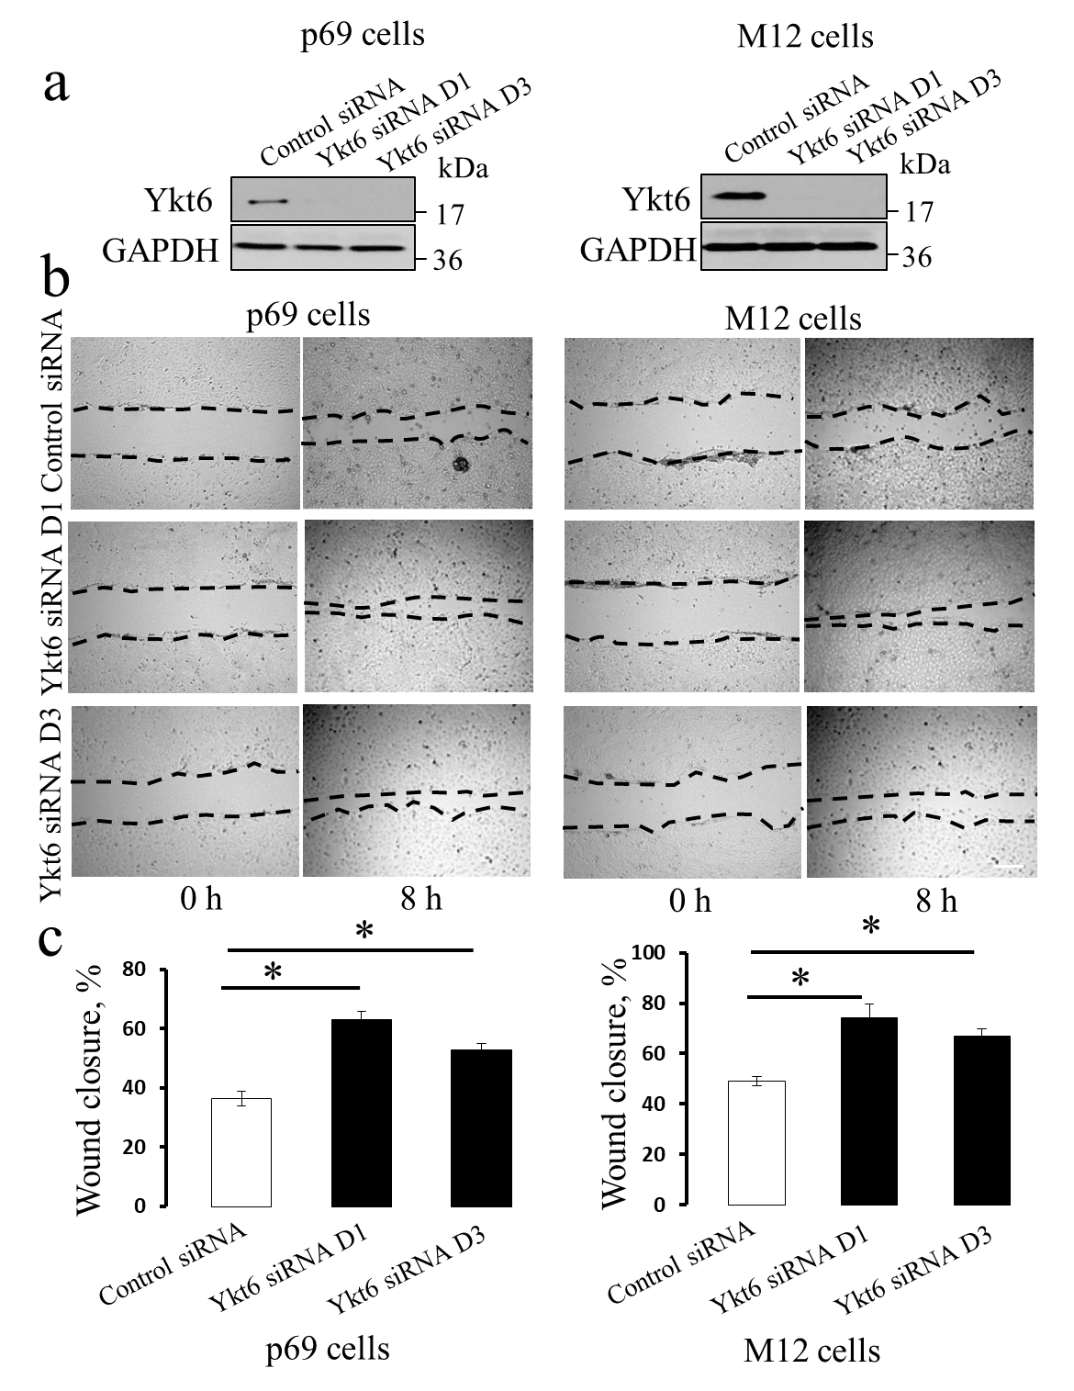

Supplemental Figure 1: Ykt6 depletion increases the motility of different prostate epithelial cells.
p69 and M17 prostate epithelial cells were transfected with either control siRNA or Ykt6-specific siRNA SmartPool. (a) Immunoblotting analysis displays the efficiency of Ykt6 knockdown on day 4 post-transfection. (b) Representative images of wound healing in p69 and M17 cell monolayers transfected with either control, or two Ykt6-specific, siRNAs. (c) Quantitation of wound closure during 8 h of cell migration. Data are presented as mean ± SE (n = 3); *P<0.01. Scale bar, 200 µm.

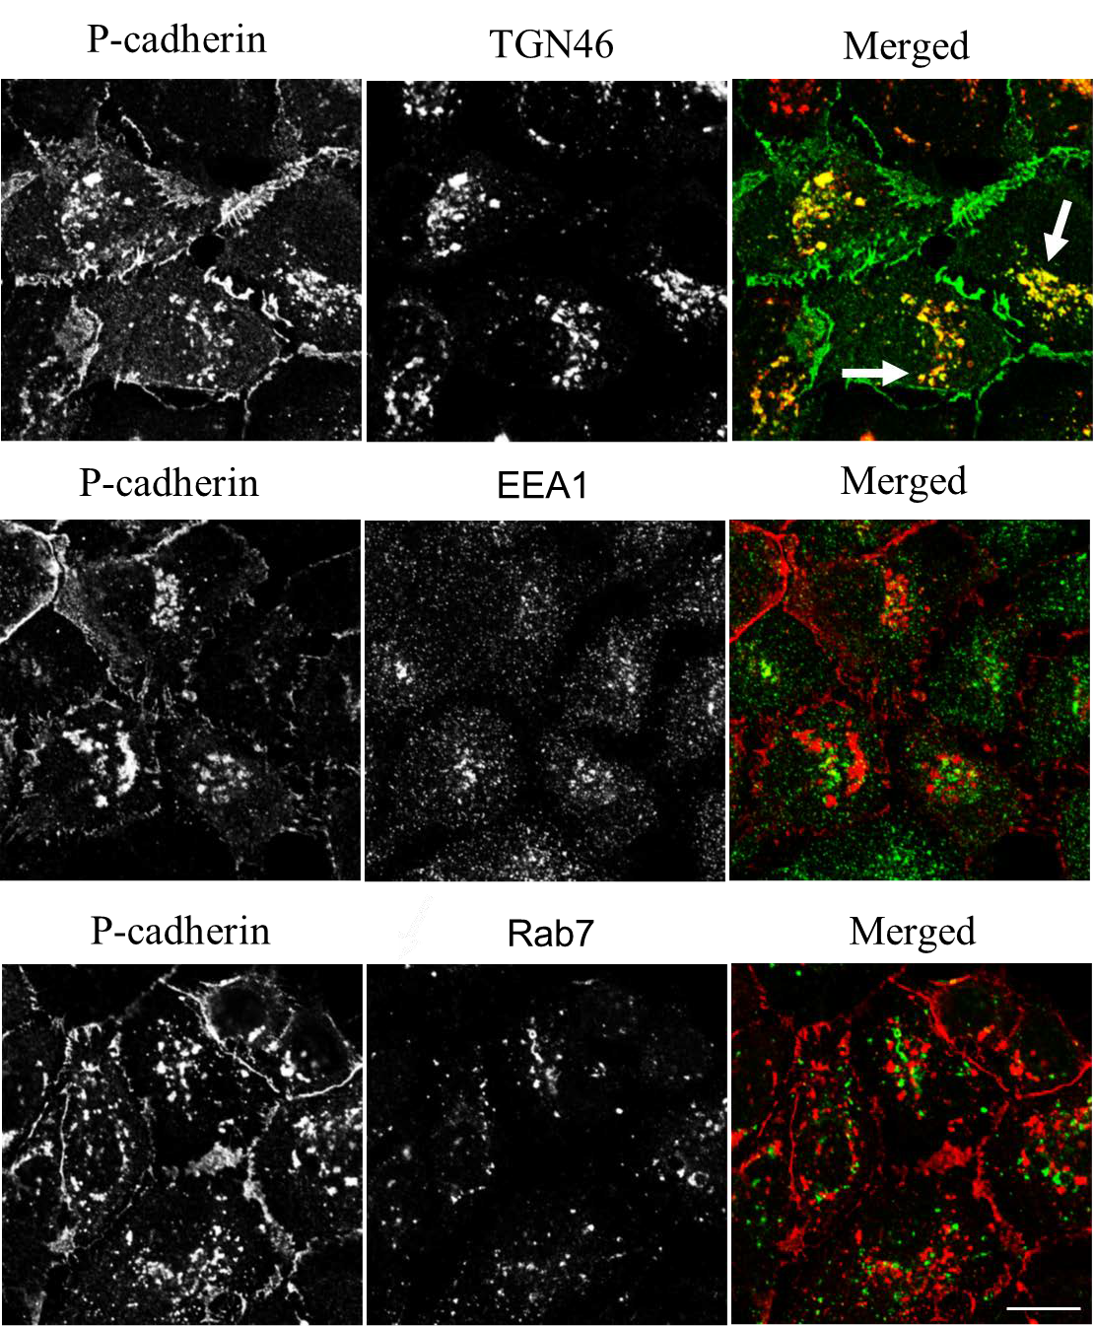

Supplemental Figure 2: Ykt6 knockdown results in the accumulation of P-cadherin in TGN46-positive intracellular compartments.
DU145 cells were transfected with Ykt6-specific siRNA D1 and, on day 4 post-transfection, were subjected to dual immunolabeling with antibodies to the following proteins: (upper images), P- cadherin (green)-TGN46 (red); (middle images), P-cadherin (red)-EEA1 (green) and (lower images), P-cadherin (red)-Rab7 (green). Arrows indicate the marked colocalization of P-cadherin and TGN46 in the perinuclear compartment of Ykt6-depleted cells. Scale bar, 20 µm.

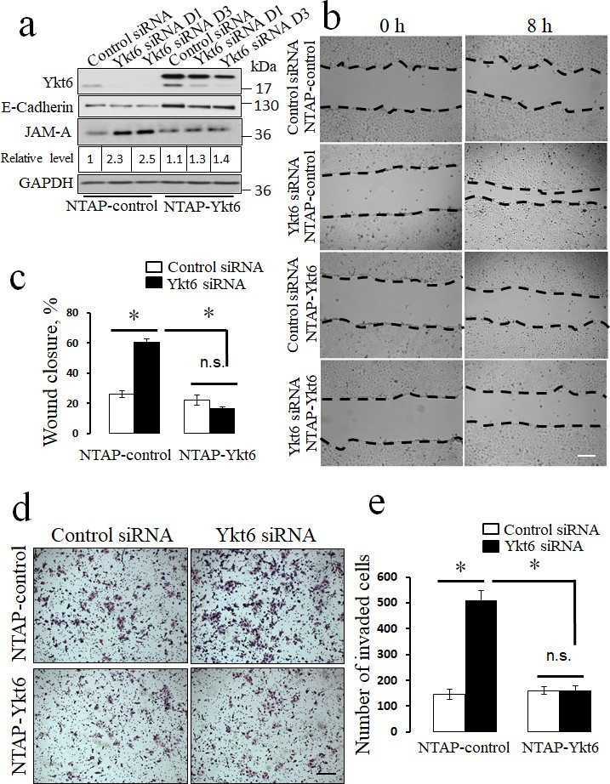

Supplemental Figure 3: Overexpression of Ykt6 rescues the effects of Ykt6 knockdown on JAM-A level and the motility of prostate epithelial cells.
DU145 cells stably expressing His-tagged Ykt6 (NTAP-Ykt6), or a control vector (NTAP- Control), were transfected with either control siRNA or Ykt6 siRNA D1. (a) Expression of Ykt6, E-cadherin, and JAM-A in these cells was determined by immunoblotting. Cell migration was examined using wound healing (b,c) and Matrigel invasion (d,e) assays. Data are presented as mean ± SE (n = 3); *P<0.01. Scale bars, 200 µm.

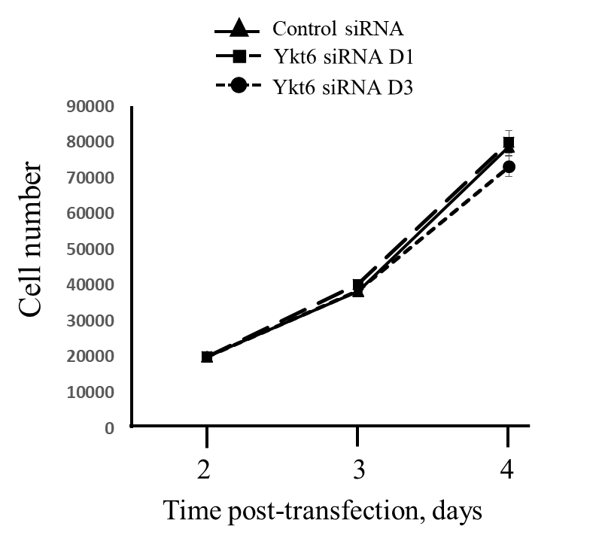

Supplemental Figure 4: Loss of Ykt6 does not affect the epithelial cell proliferation.
Cell proliferation analysis of actively dividing control and Ykt6-depleted DU145 cells was performed on days 3 and 4 post-transfection, by counting the cells using hemocytometer. Data are presented as mean ± SE (n = 4).

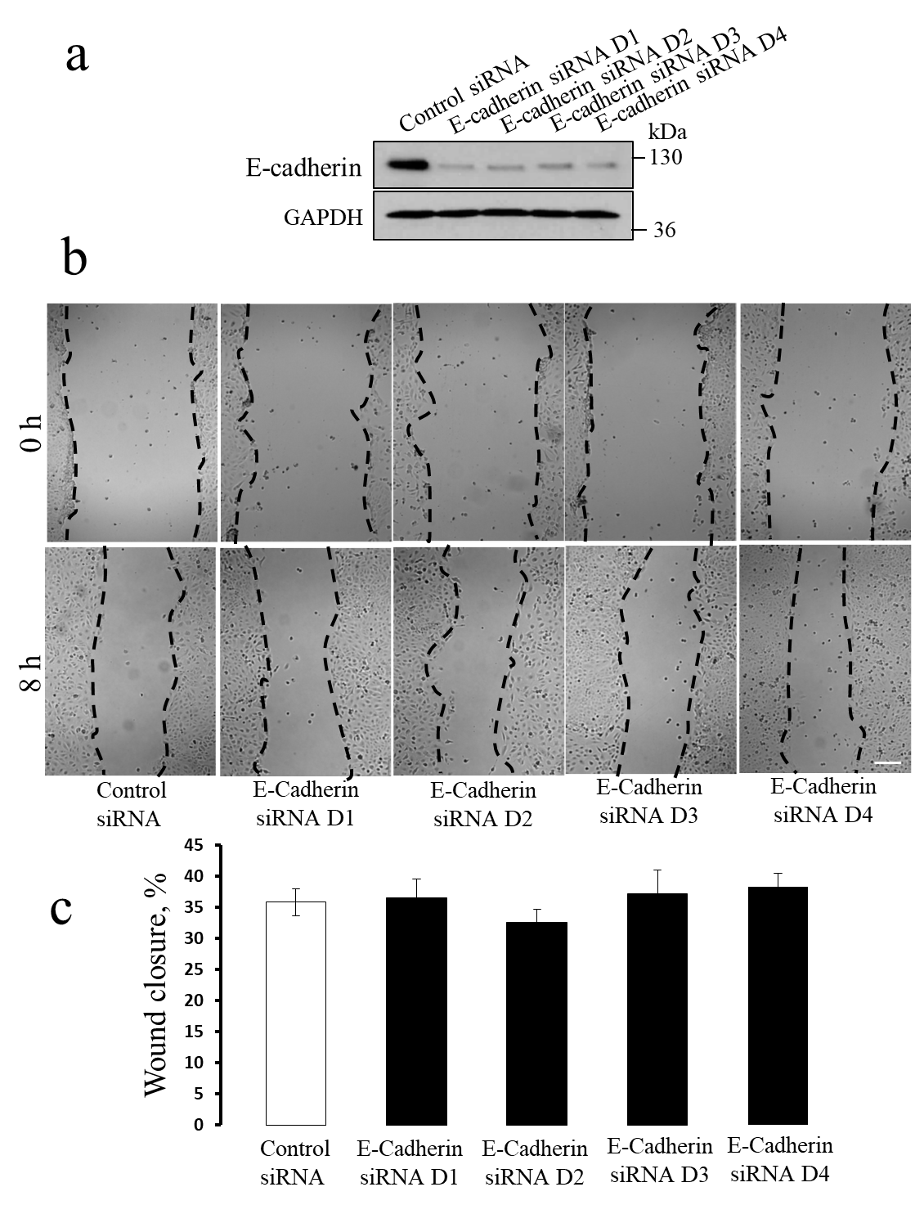

Supplemental. Figure 5: Knockdown of E-cadherin does not affect the collective migration of Du145 cell monolayers.
DU145 cells were transfected with either control siRNA or four E-cadherin-specific siRNA duplexes (D1-D4). (a) Immunoblotting analysis shows the efficiency of E-cadherin knockdown on day 4 post-transfection. (b) Representative images of wound healing of control and E- cadherin-depleted cell monolayers. (c) Quantitation of wound closure during 8 h of cell migration. Scale bar, 200 µm.

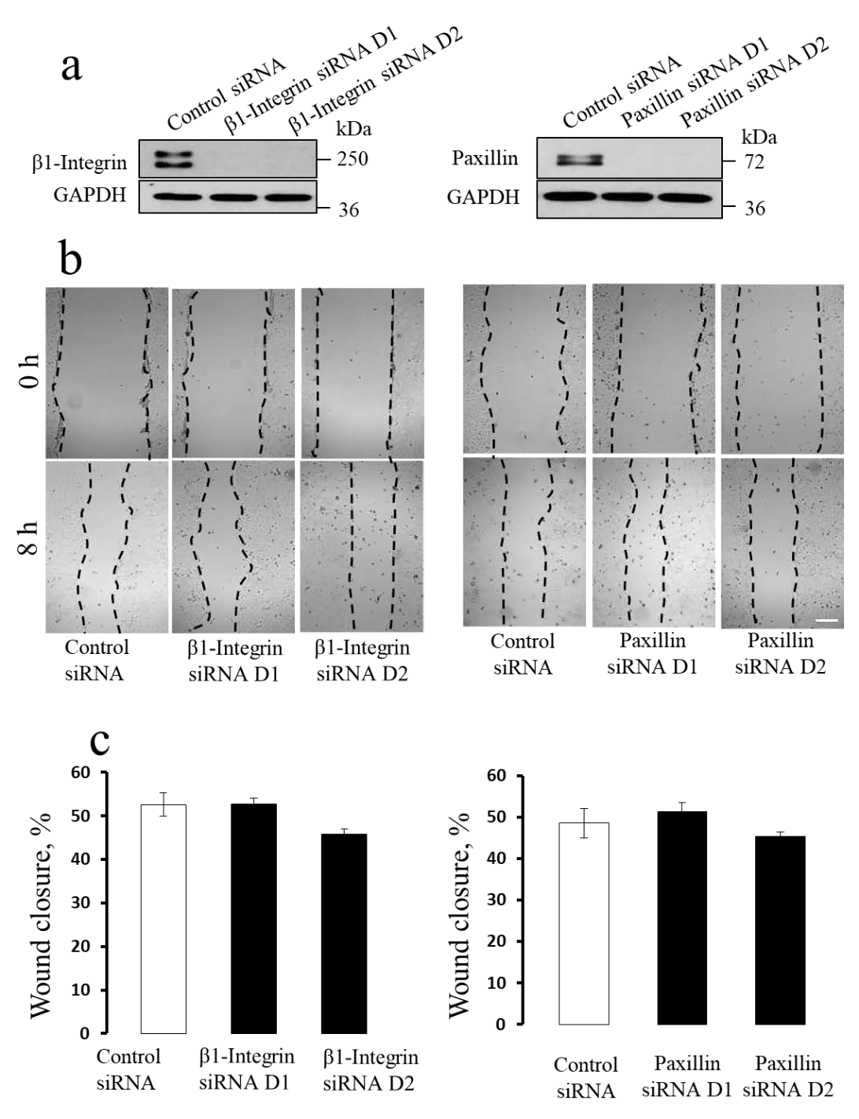

Supplemental Figure 6: Depletion of either β1-integrin or paxillin does not recapitulate the effects of YKT6 knockdown on DU145 cell motility.
DU145 cells were transfected with either control siRNA, β1-integrin-specific siRNAs D1 and D2, or paxillin-specific siRNAs D1 and D2. (a) Immunoblotting analysis shows the efficiency of β1- integrin and paxillin knockdown on day 4 post-transfection. (b) Representative images of wound healing of control monolayers and of β1-integrin or paxillin-depleted cell monolayers. (c) Quantitation of wound closure during 8 h of cell migration. Scale bar, 200 µm.

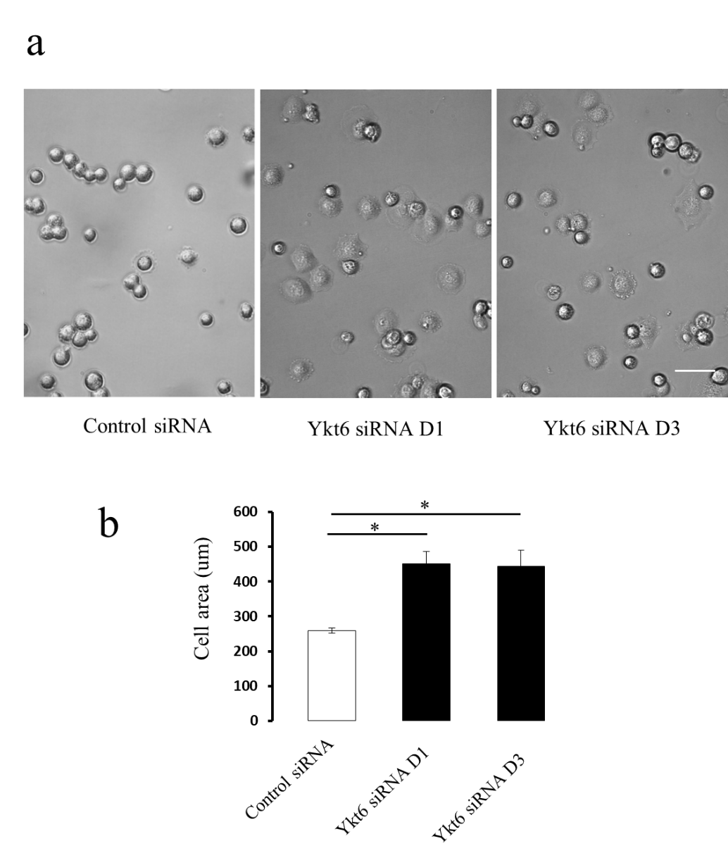

Supplemental Figure 7: Ykt6 depletion accelerates the spreading of epithelial cells.
DU145 cells were transfected with either control or Ykt6-specific siRNAs and, on day 4 post- transfection, were subjected to a cell spreading assay as described in the Methods section. Representative images (a) and quantitation analysis of the cell area (b) of control and Ykt6- depleted DU145 cells after 1 h spreading on collagen I ECM. Data are presented as mean ± SE (n
= 50); *P<0.01. Scale bar, 20 µm.

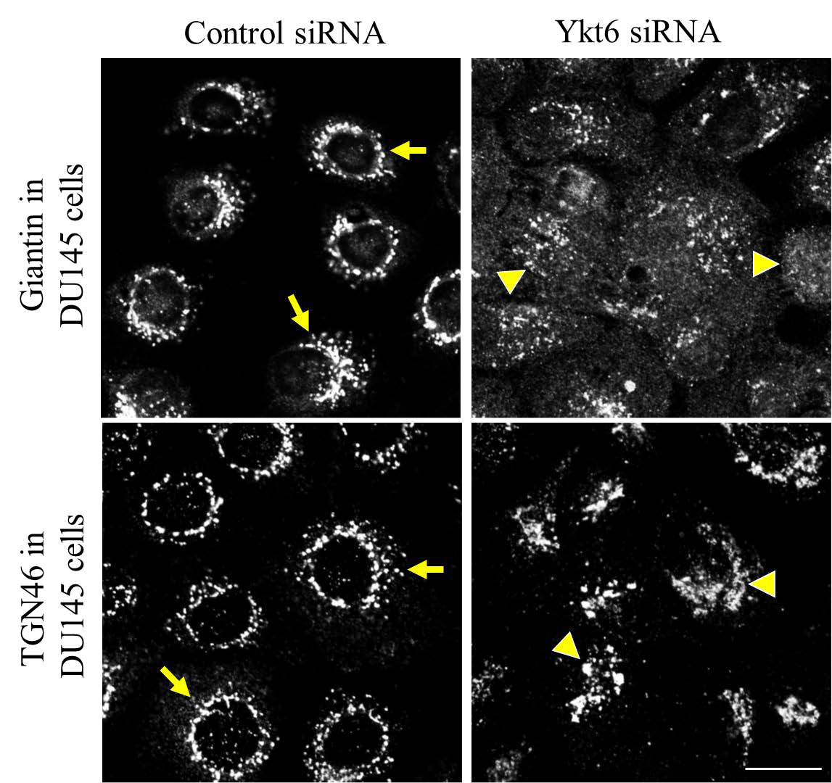

Supplemental Figure 8: Loss of Ykt6 disrupts organization of the Golgi in DU145 cells. DU145 cells were transfected with either control siRNA or Ykt6-specific siRNA D1. On day 4 post-transfection, cells were fixed and immunolabeled for two different markers of the Golgi complex, Giantin and TGN46. Arrows point to Golgi organization in control cells. Arrowheads indicate altered localization of Golgi markers in Ykt6-depleted cells. Images shown are representative of 3 independent experiments with multiple images taken per slide. Scale bar, 20
µm.

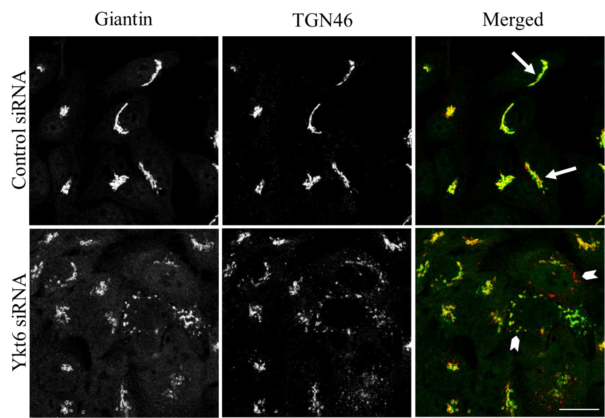

Supplemental Figure 9: Depletion of Ykt6 disrupts compact Golgi structure in HeLa cells. HeLa cells were transfected with either control siRNA or Ykt6-specific siRNA D1. On day 4 post- transfection, cells were subjected to dual immunolabeling with Golgi markers Giantin (green) and TGN46 (red). Arrows point to the compact Golgi complex in control cells. Arrowheads indicate the marked fragmentation of the Golgi in Ykt6-depleted HeLa cells. Images shown are representative of 3 independent experiments with multiple images taken per slide. Scale bar, 20
µm.

Loss of Ykt6
?
AJ/TJ
Disassembly
Disruption of ER- Golgi trafficking

?
mir145A
Jam-A
Rap1 GTP
Rac1 GTP
Cell spreading

Supplemental Figure 10: A schematic diagram describing molecular events that mediate accelerated motility and disrupted cell-cell adhesions of Ykt6-depleted epithelial cells.

Cell motility
The diagram outlines the proposed signaling cascade, which is activated by Ykt6 depletion and results in increased migration and invasion of epithelial cells, as well as in disassembly of epithelial junctions.

