Supporting information

Acceleration of the corrosion reaction of magnesium by Fenton reagents

GUY BEN HAMU*, DROR SHAMIR, MOSHE ZOHAR and ARIELA BURG*

S-1 - pH results during the immersion.
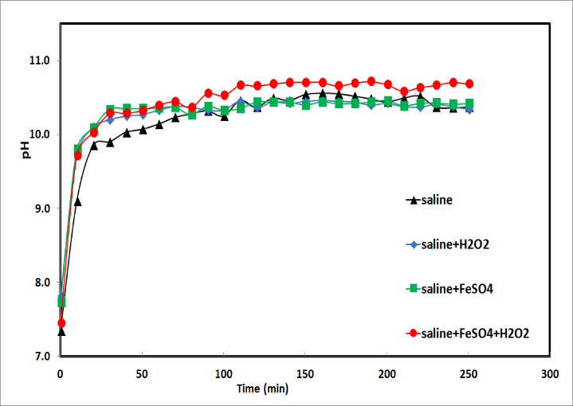
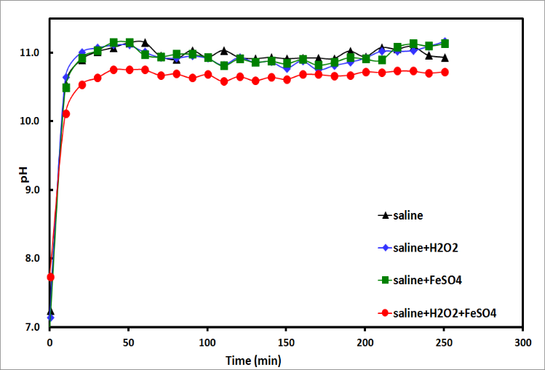
Figure S-1. pH values of the study solutions during immersion of a. Pure Mg, b. ZK60 in the following solutions: 0.90% NaCl, 0.90% NaCl, 3.0×10⁻⁴M H₂O₂, 0.90% NaCl, 3.0×10⁻⁵M FeSO₄, 0.90% NaCl, 3.0×10⁻⁴ M H₂O₂, 3.0×10⁻⁵ M FeSO₄) at 25 °C.
b. ZK60
a. Pure Mg

S-2 – Hydrogen and Oxygen concentrations during the immersion (detected by gas chromatograph).
Table S-1. Hydrogen and oxygen concentrations during the immersion.
480 min | 480 min | 30 min | 30 min | 2 min | 2 min | Time
C(H₂) ppm | C(O₂)ppm | C(H₂) ppm | C(O₂) ppm | C(H₂) ppm | C(O₂) ppm
32.36 | 1.65 | 4.68 | 1> | 1.21 | 1> | Pure Mg Saline
41.69 | 2.02 | 9.33 | 1> | 1.89 | 1> | Pure Mg Saline + reagents
29.74 | 1.72 | 3.54 | 1> | 1.01 | 1> | ZK60Saline
40.05 | 1.98 | 4.23 | 1> | 1.12 | 1> | ZK60Saline + reagents

S-3 - Auger electron spectroscopy results:

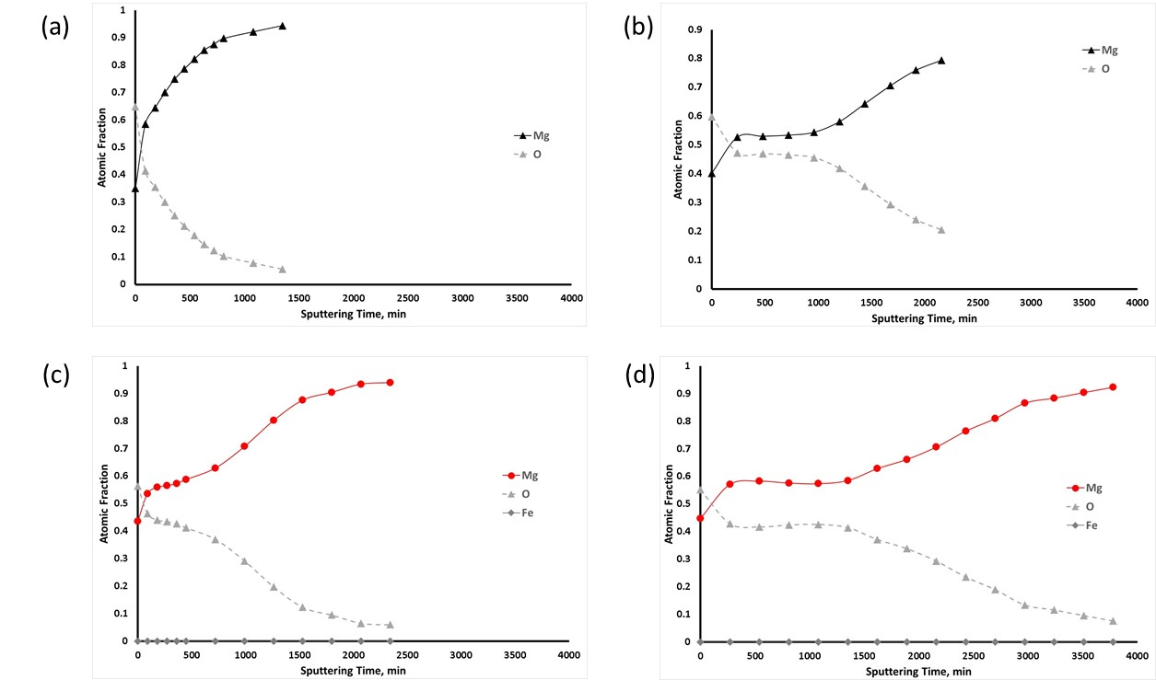
Figure S-2. Variation of oxidation characterization vs. sputtering time of pure Mg after 5 min (a, c) and 1 h (b, d) of immersion in saline (a, b) and in saline + Fenton reagents (c, d) by AES.

