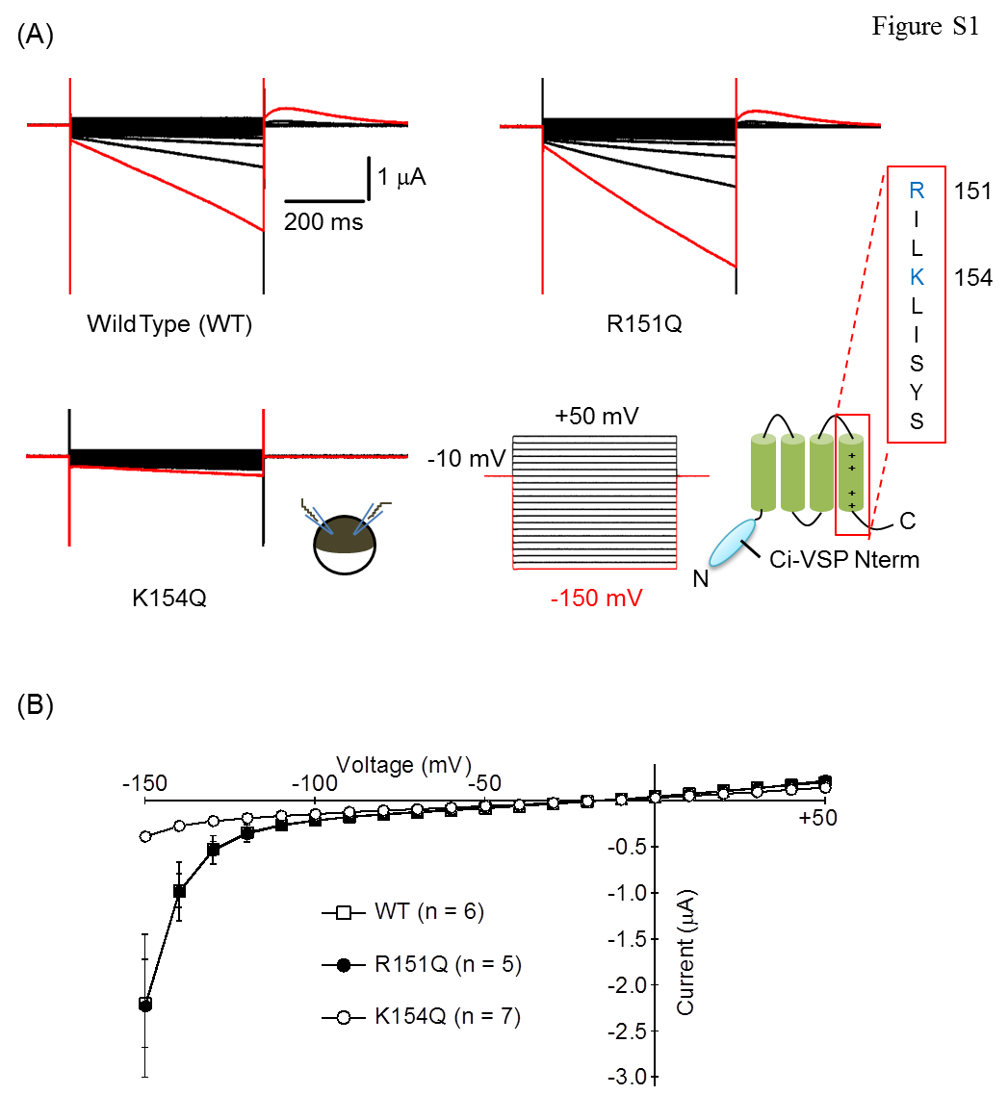
Figure S1. Inward currents were reduced by a mutation in the S4 segment.
(A) Representative current traces from Xenopus oocytes expressing the WT, R151Q or K154Q of the MT-mCS3 VSD. Voltage steps were from +50 mV to -150 mV by 10 mV decrement (Right lower). Holding potential (Vh) was at -10 mV. The current evoked by a step pulse to -150 mV is colored by red.
(B) Current-Voltage (I-V) relationships of the recordings (mean ± SEM).

