Supplemental Table S1A. Other gene expression differences in the hypothalamus of females across treatment groups. Data shown as mean, with lower and upper 95% confidence intervals shown in parenthesis.
Brain Region | Transcript | EE  Fold Change* | BPA  Fold Change | p-value**  Vehicle vs. EE*** | p-value  Vehicle vs. BPA | p-value  EE vs. BPA
Hypothalamus | Dnmt3a | 1.44 (0.38, 5.51) | 1.40 (0.37, 5.32) | 0.599 | 0.624 | 0.970
 | Avp | 0.87 (0.33, 2.32) | 0.85 (0.32, 2.25) | 0.784 | 0.747 | 0.964
 | Ar | 0.74 (0.18, 3.11) | 0.57 (0.14, 2.39) | 0.683 | 0.450 | 0.732
 | Oxt | 1.47 (0.31, 7.01) | 0.74 (0.16, 3.47) | 0.634 | 0.700 | 0.393
*Fold change refers to the gene expression level relative to that in the vehicle control group using the 2^{-ΔΔCT} method.
**Statistical significance was determined using the ΔCT values

Supplemental Table S1B. Other gene expression differences in the hypothalamus of males across treatment groups. Data shown as mean, with lower and upper 95% confidence intervals shown in parenthesis.
Brain Region | Transcript | EE  Fold Change | BPA  Fold Change* | p-value**  Vehicle vs. EE*** | p-value  Vehicle vs. BPA | p-value  EE vs. BPA
Hypothalamus | Dnmt3a | 0.28 (0.07, 1.07) | 0.46 (0.12, 1.75) | 0.071 | 0.262 | 0.470
 | Avp | 0.38 (0.14, 1.02) | 0.65 (0.25, 1.72) | 0.064 | 0.392 | 0.299
 | Ar | 0.16 (0.04, 0.67) | 0.41 (0.10, 1.71) | 0.018 | 0.229 | 0.205
 | Oxt | 0.31 (0.07, 1.49) | 0.31 (0.07, 1.45) | 0.154 | 0.146 | 0.986
*Fold change refers to the gene expression level relative to that in the vehicle control group using the 2^{-ΔΔCT} method.
**Statistical significance was determined using the ΔCT values

Supplemental Table S2. Comparison of hypothalamic gene expression differences between females and males within the same treatment group.
Brain Region | Transcript | Female vs. Male *
 |  | p-value **
 |  | Control Females vs. Control Males *** | EE Females vs. EE males | BPA females vs. BPA males
Hypothalamus | Dnmt3a | 0.015 (M > F) | 0.813 | 0.522
 | Dnmt3b | 0.0001 (M > F) | 0.902 | 0.623
 | Dnmt1 | 0.0001 (M > F) | 0.833 | 0.030 (M > F)
 | Esr1 | 0.002 (M > F) | 0.015 (F > M) | 0.417
 | Esr2 | 0.0001 (M > F) | 0.193 | 0.112
 | Avp | 0.410 | 0.284 | 0.877
 | Ar | 0.014 (M > F) | 0.943 | 0.051 (M > F)
 | Otr | 0.0001 (M > F) | 0.224 | 0.133
 | Oxt | 0.090 | 0.470 | 0.778
 | Bdnf | 0.0001 (M > F) | 0.167 | 0.253
* F, female; M, male; >, higher expression (lower ΔCT) than the other sex
** Statistical significance was determined using the ΔCT values
***Comparisons with a significant difference (p < 0.05) are highlighted in grey and in bold, while those with p < 0.06 are highlighted in italic

Supplemental Table S3. Primer sequences used for gene expression and bisulfite sequencing analyses.
Gene | Direction | Primer Sequence (5’ 3’) | Amplicon Size
For gene expression
Rpl19 | Forward | AGCACATCCACAAACTGAAGGCAG | 168 bp
 | Reverse | TACAGACACGAGGGACGCTTCATT
Dnmt3a | Forward | TTCAGCAAAGTGAGGACC AT | 121 bp
 | Reverse | GGACAGGGAAGCCAAACA
Avp | Forward | CCTCACCTCTGCCTGCTACTT | 442 bp
 | Reverse | GGGGGCGATGGCTCAGTAGAC
Ar | Forward | GTAGAGCAAGACTGGAGAG | 89 bp
 | Reverse | GACGAAGAAGTTGAAGTAGAC
Dnmt3b | Forward | TGTGCAGAGTCCATTGCTGTAGGA | 104 bp
 | Reverse | GCTTCCGCCAATCACCAAGTCAAA
Esr2 | Forward | AGGATGTACCACCGAATGCCAAGT | 63 bp
 | Reverse | TCCAAGTGGGCAAGGAGACAGAAA
Dnmt1 | Forward | AAGCCAGCTATGCGACTTGGAAAC | 121 bp
 | Reverse | ACAACCGTTGGCTTTCTGAGTGAG
Esr1 | Forward | GATGGTCAGTGCCTTATTGGATGC | 453 bp
 | Reverse | GCAGGTTCATCATGCGGAATCGA
Otr | Forward | CGATTGCTGGGCGGTCTT | 143 bp
 | Reverse | CCGCCGCTGCCGTCTTGA
Oxt | Forward | gaggagaactacctgccctc | 170 bp
 | Reverse | ggtatcatcacaaagcgggc
Bdnf | Forward | TGGCTGACACTTTTGAGCAC | 161 bp
 | Reverse | TTCCTCCAGCAGAAAGAGCA
For bisulfite sequencing
Bdnf | Forward | TGGAAAGGGTTTTATTAATATGTGAT | 450 bp
 | Reverse | ACCAAAAATCTATTCCAACCTACAC
Dnmt3b | Forward | GGGAGGGATTTTAAATTTTTTT | 664 bp
 | Reverse | AACACTAAATCCTAAAAACAACCTCTACT
Esr1 | Forward | TAGTTTAAGATGTTTATGGAGAGGGTTTT | 661 bp
 | Reverse | TAAATCTAACTCTCCCACAAAATAACTAC

Supplemental Table S4. Summary of male and female offspring and litters tested in the study.
Treatment group | Total number of offspring (Number of litters)
 | Males | Females | Males and Females
Vehicle Control | 5 (5) | 5 (5) | 10 (8)
EE | 5 (5) | 5 (5) | 10 (9)
BPA | 5 (5) | 5 (5) | 10 (8)

Supplemental Figure Legends
Supplemental Figure S1. Gene expression differences in the hypothalamus of female and male rats developmentally exposed to BPA or EE. (A) Dnmt3b expression in females. (B) Dnmt3b expression in males. (C) Dnmt1 expression in females. (D) Dnmt1 expression in males. (E) Bdnf expression in females. (F) Bdnf expression in males. P values are shown in the individual panels. Fold change refers to the gene expression level relative to that in the vehicle control group using the 2^{-ΔΔCT} method. Statistical significance was determined using the ΔCT values. The graphs depict the mean ± upper and lower 95% confidence interval.

Supplemental Figure S2. Additional gene expression differences in the hypothalamus of female and male rats developmentally exposed to BPA or EE. (A) Esr1 expression in females. (B) Esr1 expression in males. (C) Esr2 expression in females. (D) Esr2 expression in males. (E) Otr expression in females. (F) Otr expression in males. P value differences are shown in the individual panels. Fold change refers to the gene expression level relative to that in the vehicle control group using the 2^{-ΔΔCT} method. Statistical significance was determined using the ΔCT values. The graphs depict the mean ± upper and lower 95% confidence interval.

Supplemental Figure S3. Effect of treatment with 5-aza-cytidine on the expression of (A) Bdnf, (B) Esr1, and (C) Dnmt3b in rat prostate epithelial cell lines by qPCR. A normal prostate epithelial cell line NbE-1 (left), and a cancerous rat prostate epithelial cell line AIT (right) were treated with DMSO (Veh), or 0.5 µM or 1 µM 5-aza-2-deoxycytidine, a DNA methylation inhibitor, every two days for 8 days. Since the expression level of Bdnf was very low in AIT cells, it was not shown in this figure. Data are expressed as mean ± SEM. **p<0.01 and ***p<0.001 vs Vehicle by One-way ANOVA and Tukey’s multiple test comparison.

Supplemental Figure S4. Effect of early-life exposure to EE and BPA on the methylation and expression of Dnmt3b in the adult rat hypothalamus. (A) Schematic diagram showing the presence of a CG-rich region (green) at the promoter region of Dnmt3b, which spans over the exon 1. Figure with annotation modified from UCSC Genome Browser. TSS, transcription start site. Region used for primer design (300 bp upstream and 300bp downstream of the CG-rich region) is highlighted with a red line. (B) Primer design using MethPrimer. The blue highlighted region under the curve indicates the CG-rich region within the sequence used for primer design. A blue line indicates the target region for bisulfite sequencing. Methylation pattern of the CG-rich region for Dnmt3b in the hypothalamus of (C) females and males, (D) females, and (E) males with early-life exposure to vehicle control (white), 0.5 μg EE/kg BW (EE; orange), and 2500 μg BPA /kg BW (BPA; violet). Data are expressed as mean ± SEM. Each circle represents the average % methylation of each corresponding CG site from 5-7 individual colonies. (N=5 males and N=5 females per group). For methylation analysis, *p<0.05 vs Vehicle by Two-way ANOVA and Tukey’s multiple test comparison. Gene expression levels are expressed as gene expression level in treatment groups relative to the control group using the 2^{-ΔΔCT} method. For the gene expression graphs, *p<0.05; p<0.0001.

Supplemental Figure S5. Effect of early-life exposure to EE and BPA on the methylation and expression of Esr1 in the adult rat hypothalamus. (A) Schematic diagram showing the presence of a CG-rich region (green) within exon1 of Esr1. Figure with annotation modified from UCSC Genome Browser. Region used for primer design (1,000 bp upstream and 1,000bp downstream of the CG-rich region) is highlighted with a red line. (B) Primer design using MethPrimer. The blue highlighted region under the curve indicates the CG-rich region within the sequence used for primer design. A blue line indicates the target region for bisulfite sequencing. Methylation pattern of the CG-rich region for Esr1 in the hypothalamus of (C) females and males, (D) females, and (E) males with early-life exposure to vehicle control (white), 0.5 μg EE/kg BW (EE; orange), and 2500 μg BPA /kg BW (BPA; violet). Data expressed as mean ± SEM. Each circle represents the average % methylation of each corresponding CG site from 6-7 individual colonies. (N=5 males and N=5 females per group). For methylation analysis, ªp<0.05, EE vs Vehicle, and ^{b}p<0.05, BPA vs Veh, and ^{c}p<0.05, EE/BPA vs Vehicle, by Two-way ANOVA and Tukey’s multiple test comparison. Gene expression levels are expressed as gene expression level in treatment groups relative to the control group using the 2^{-ΔΔCT} method. For the gene expression graphs, *p<0.05.

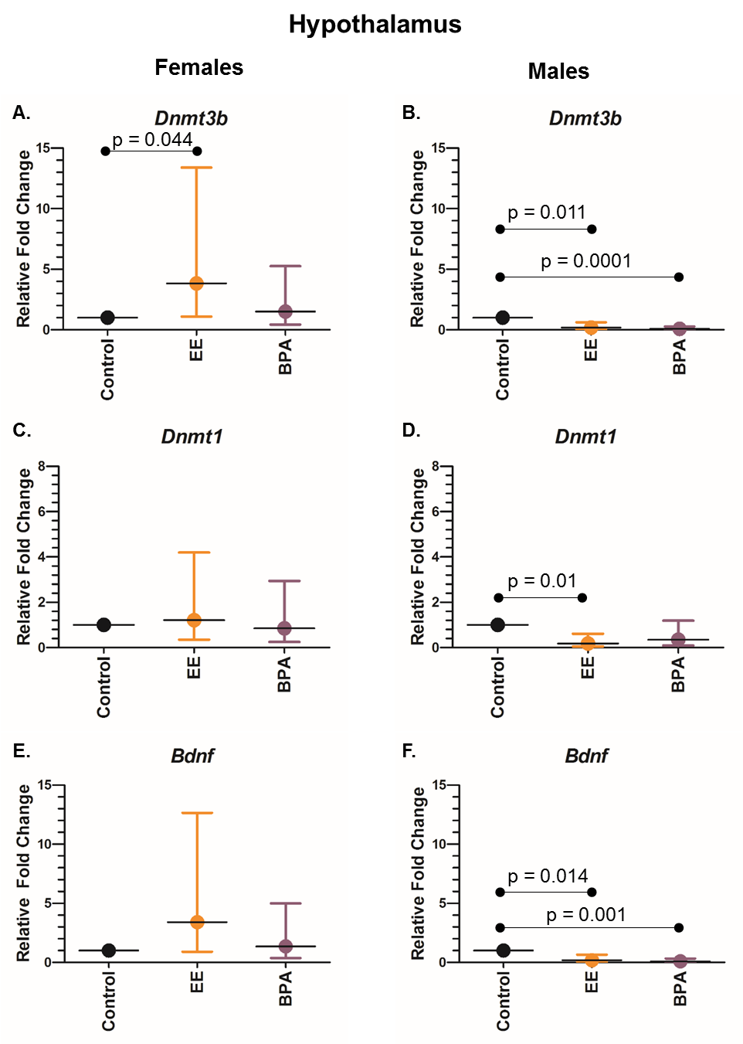
Supplemental Figure S1
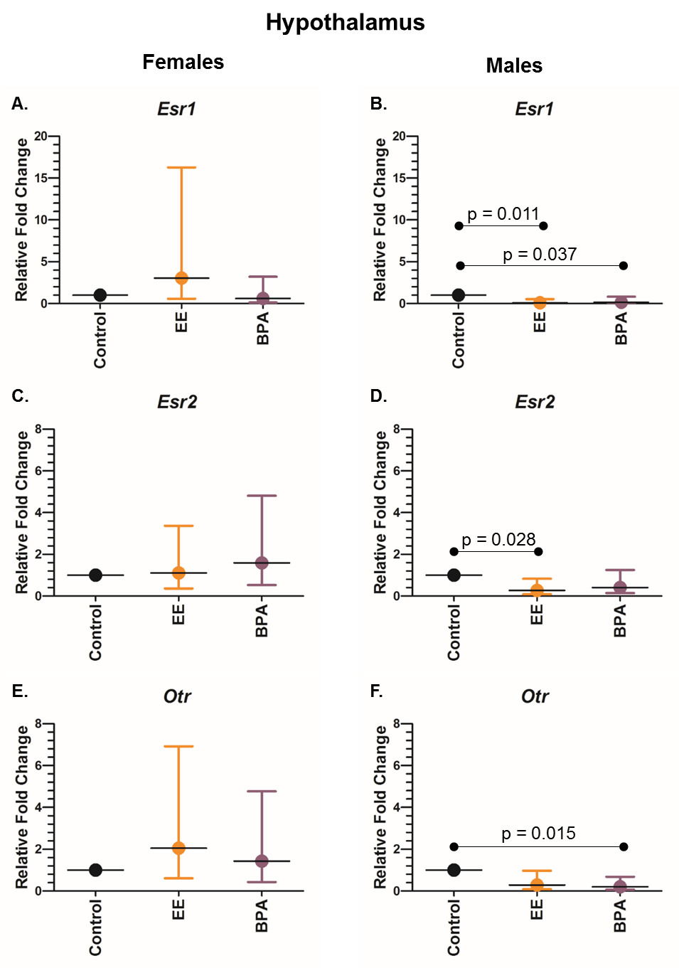
Supplemental Figure S2
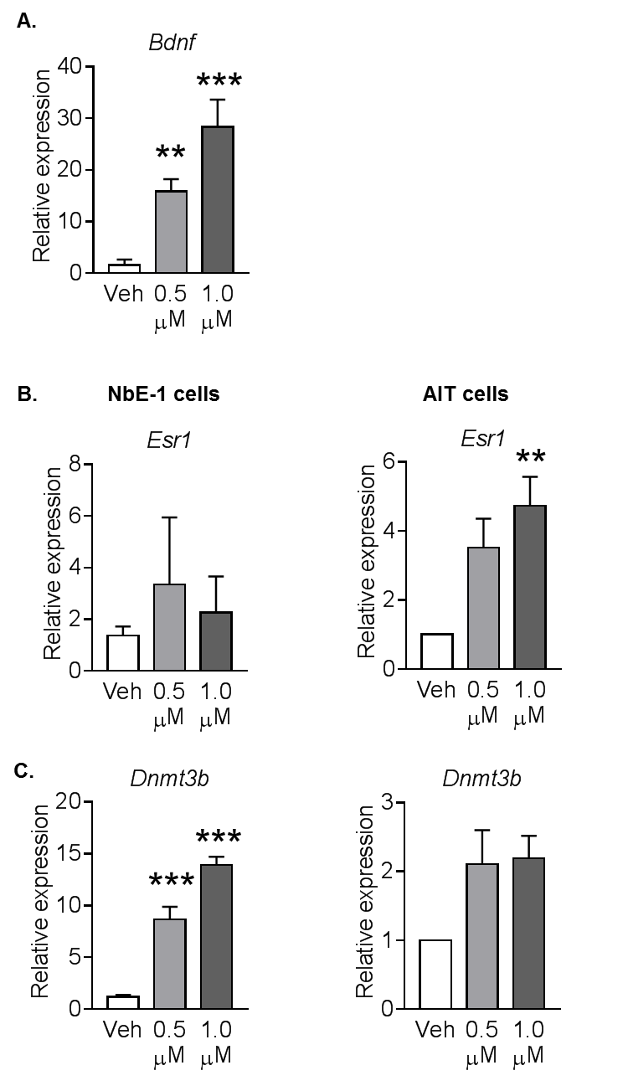
Supplemental Figure S3

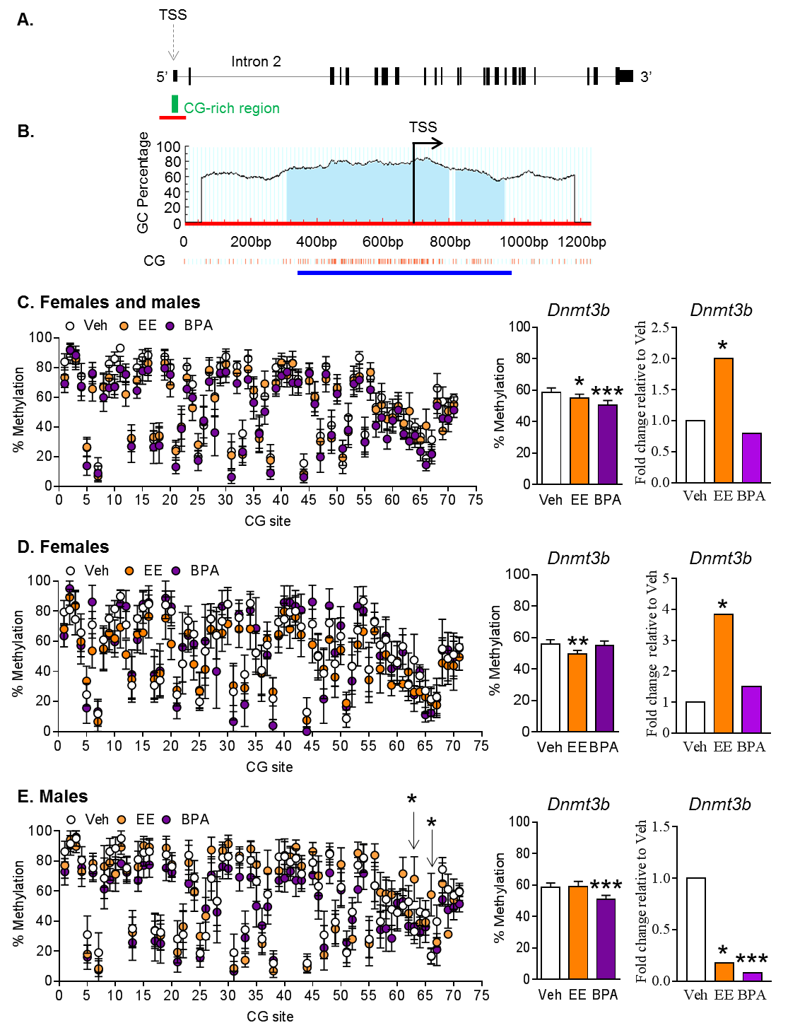
Supplemental Figure S4
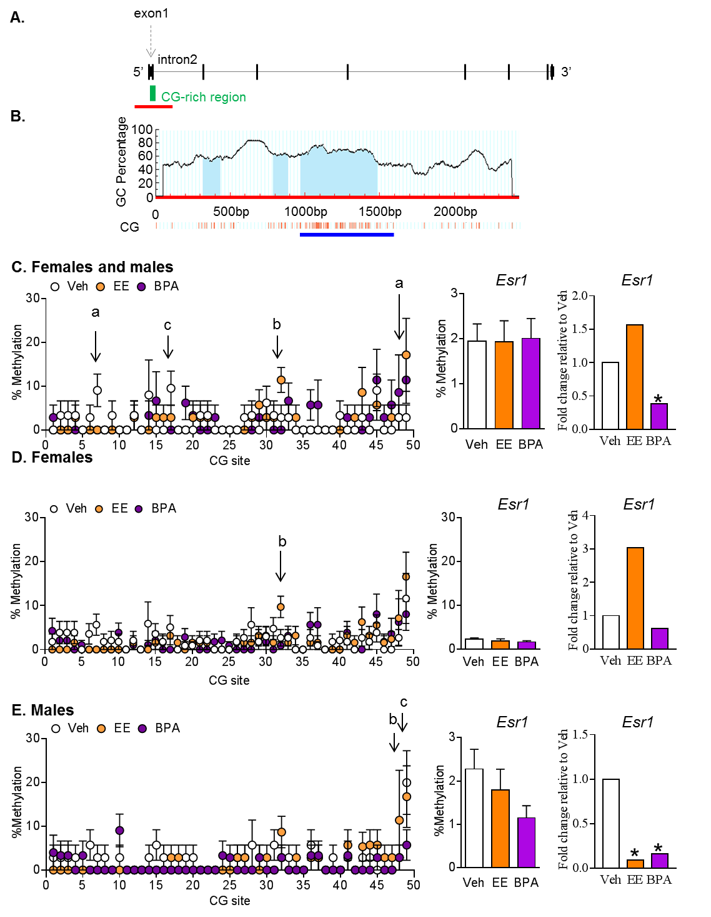
Supplemental Figure S5

