Resolution of racemic Vigabatrin using tartaric acid
Kishore Karumanchi,* Senthil Kumar Natarajan, Krishna Murthy V R Moturu, Ramadas Chavakula, Raghu Babu Korupolu and Kishore Babu Bonige

S.No | Content | Page. No
1 | (S)-Vigabatrin (¹H NMR,¹³C NMR, HRMS, SOR, IR) | 2-7
2 | (R)-Vigabatrin (¹H NMR, SOR, IR) | 8-11
3 | Vigabatrin-L-tartarate(¹H NMR, SOR, IR) | 12-15
4 | Vigabatrin-D-tartarate(¹H NMR, SOR, IR) | 16-19

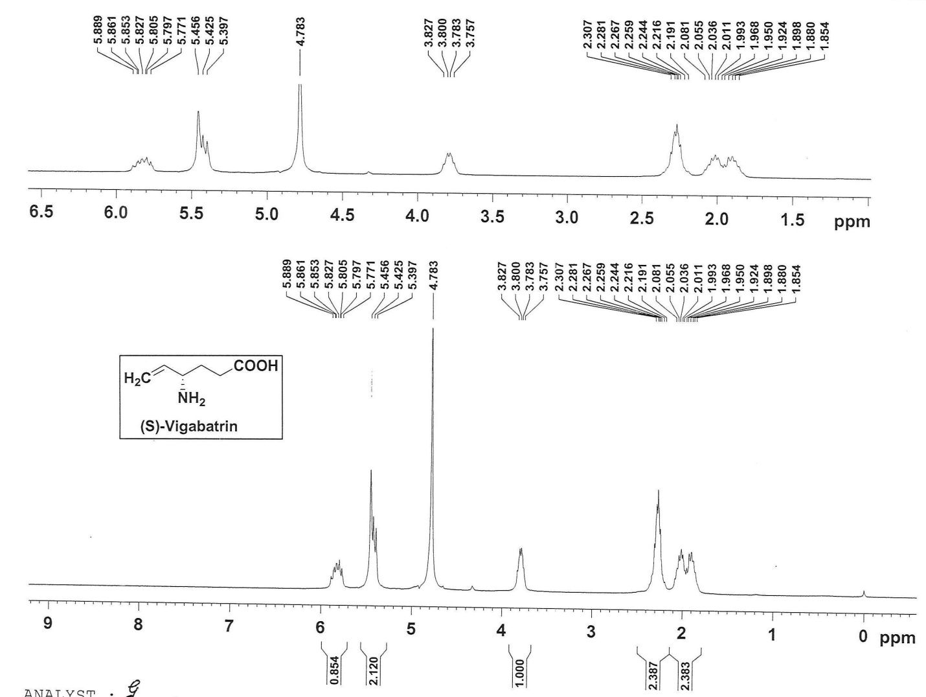

¹H NMR spectrum of compound 2

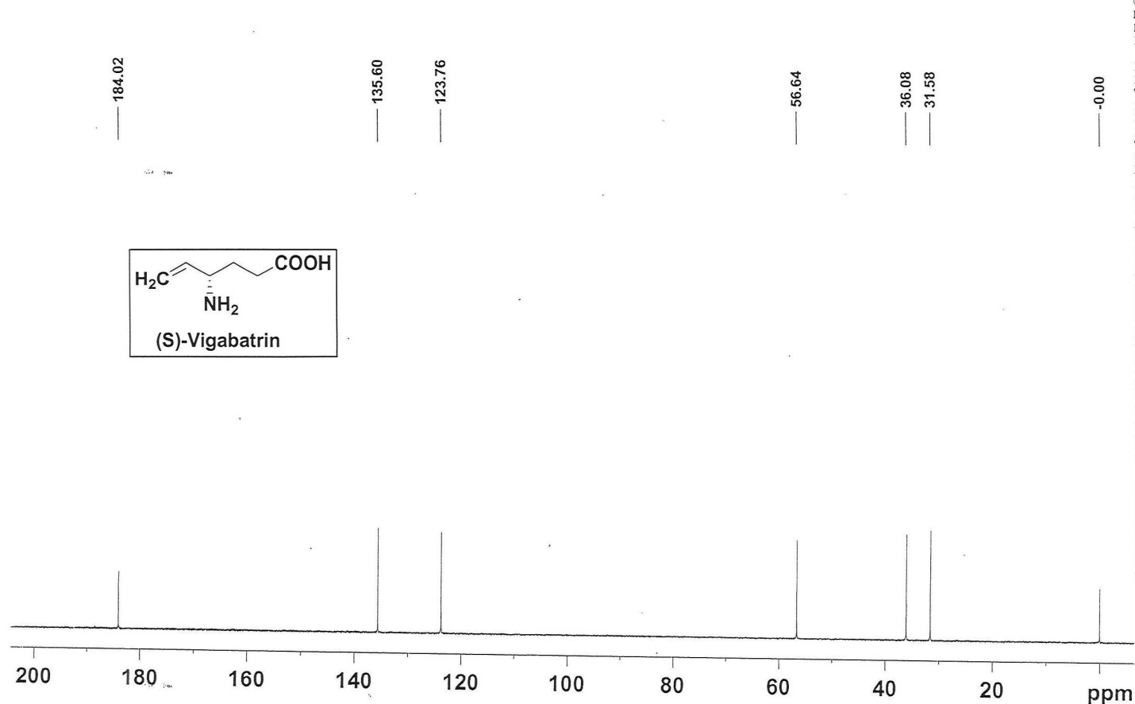
¹³C NMR spectrum of compound 2

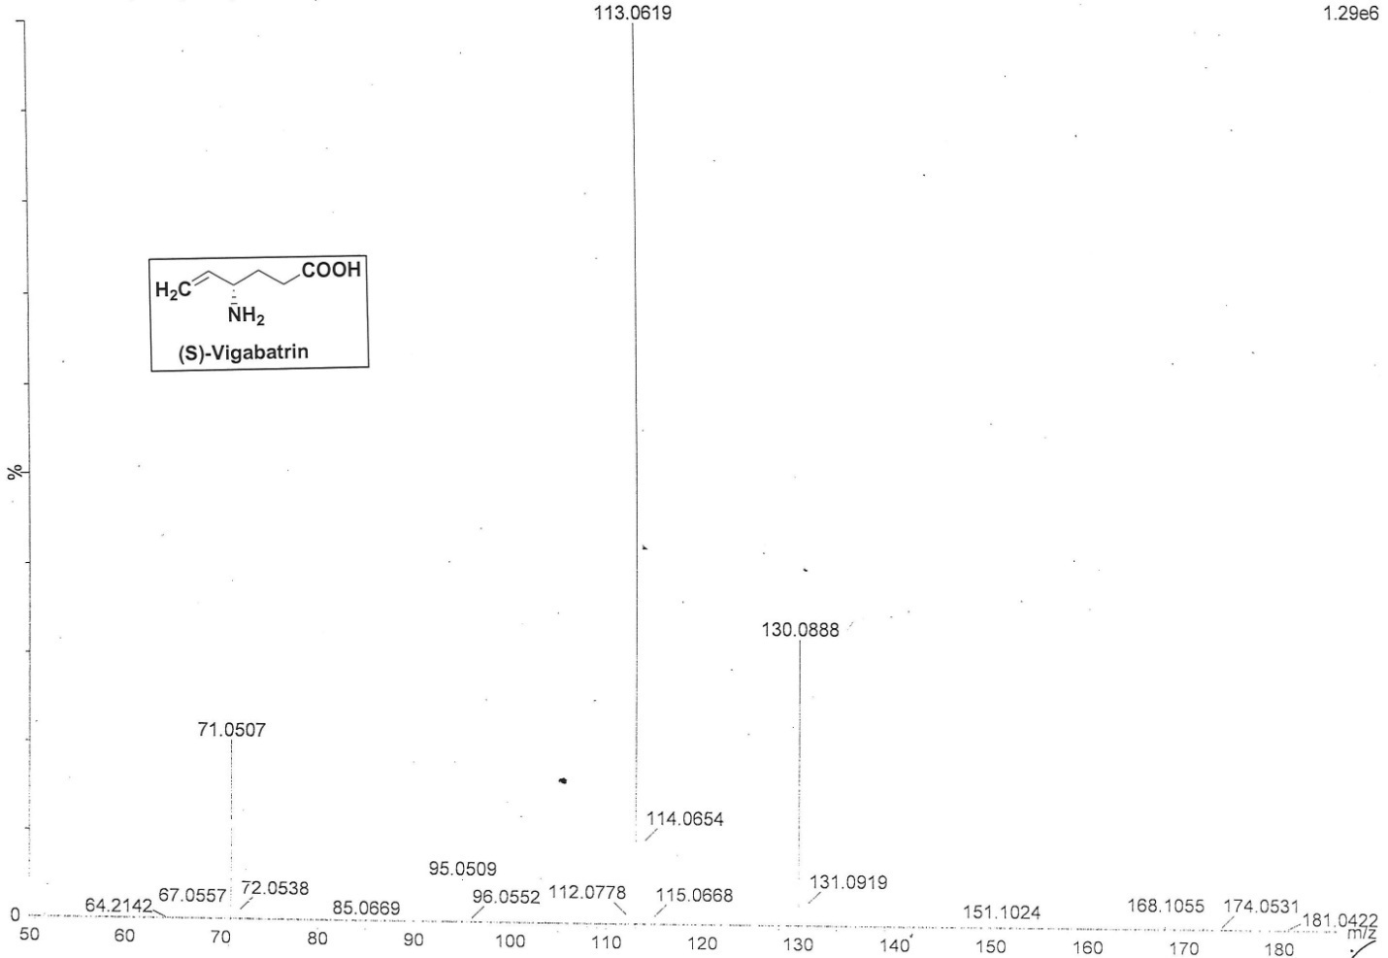

HRMS of compound 2

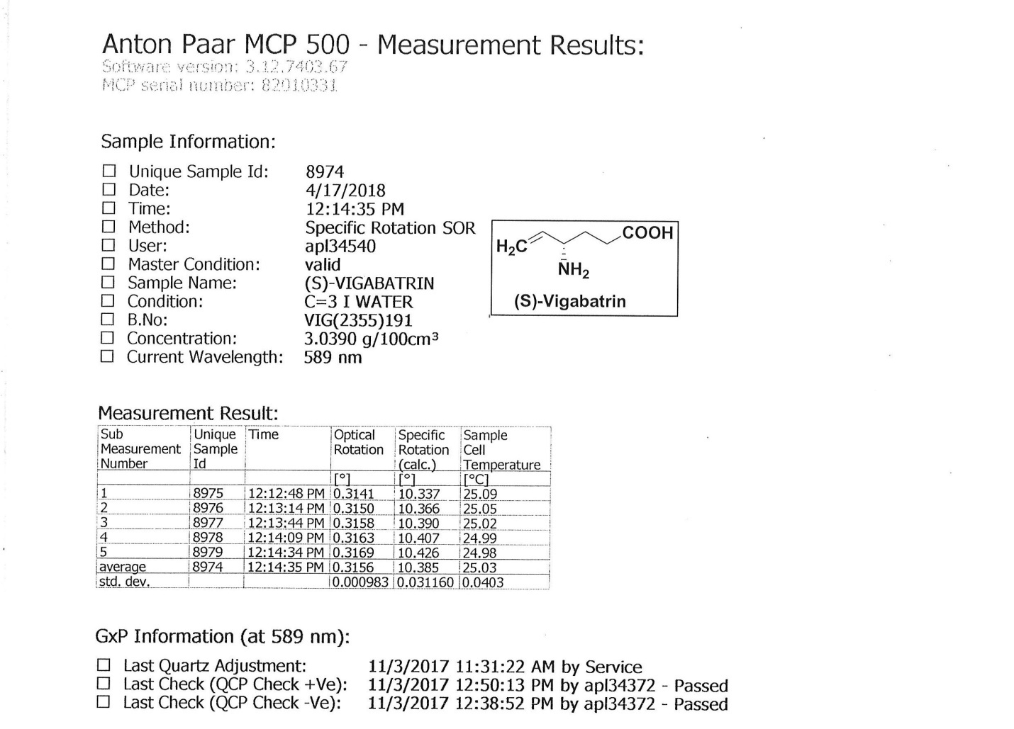

Specific Optical Rotation (SOR) of compound 2
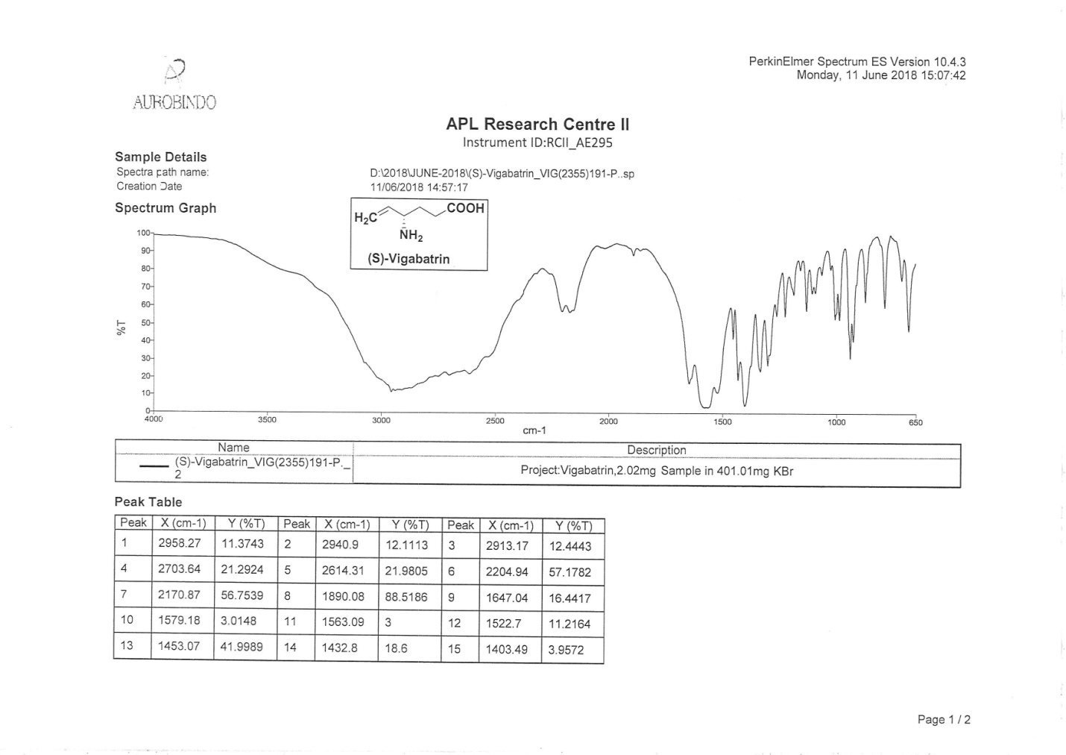
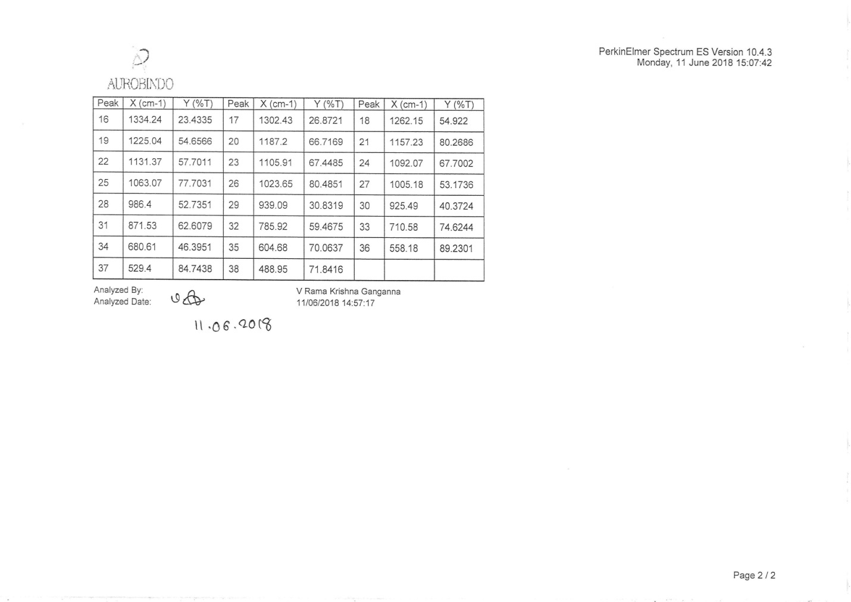
IR spectrum of compound 2

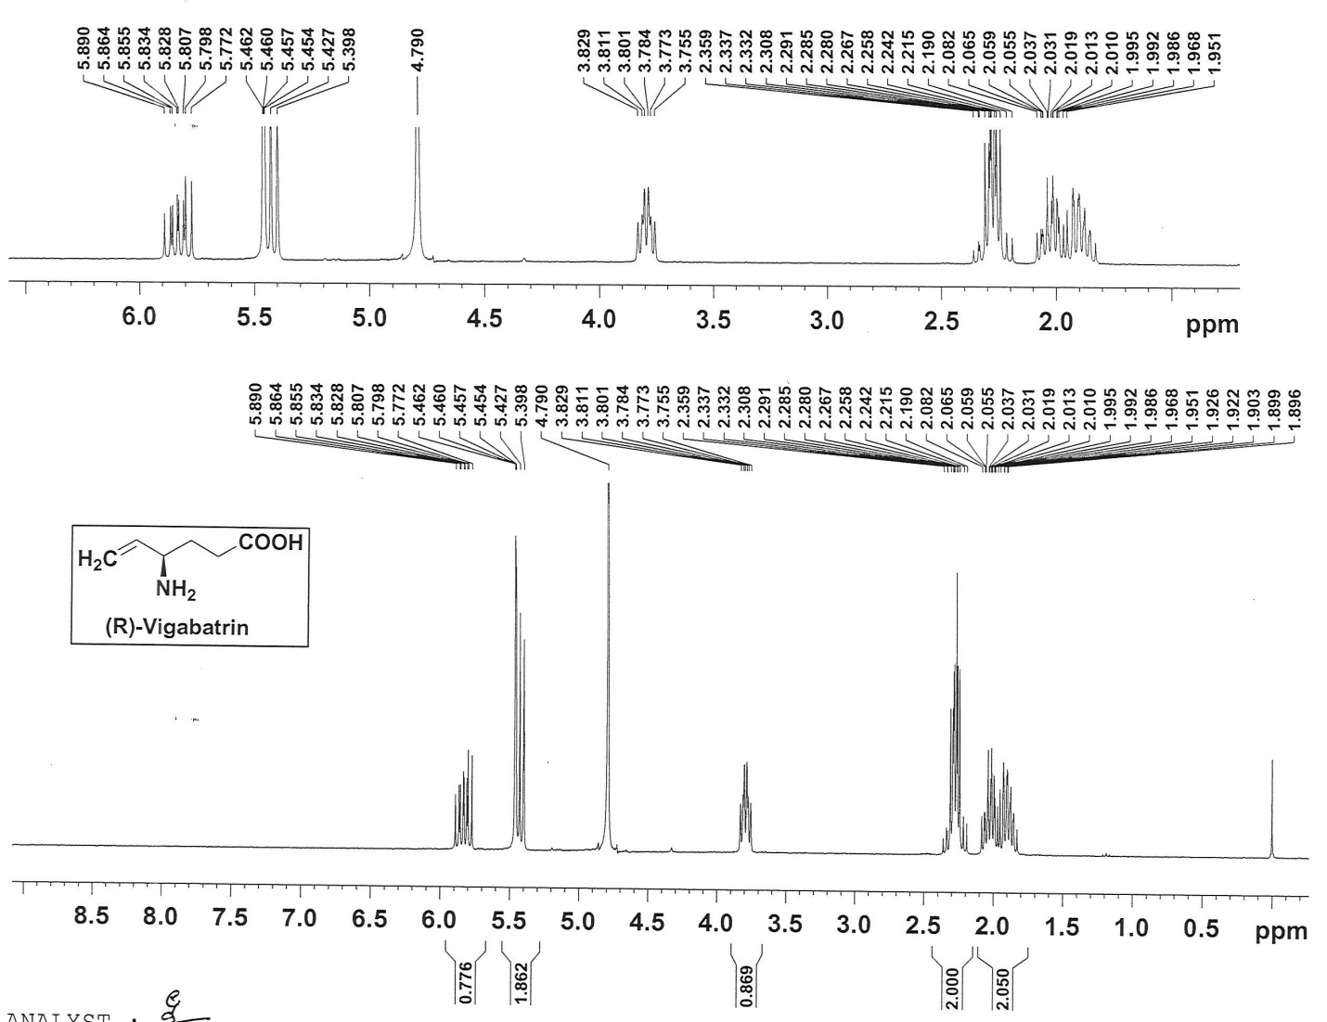
¹H NMR spectrum of compound 3

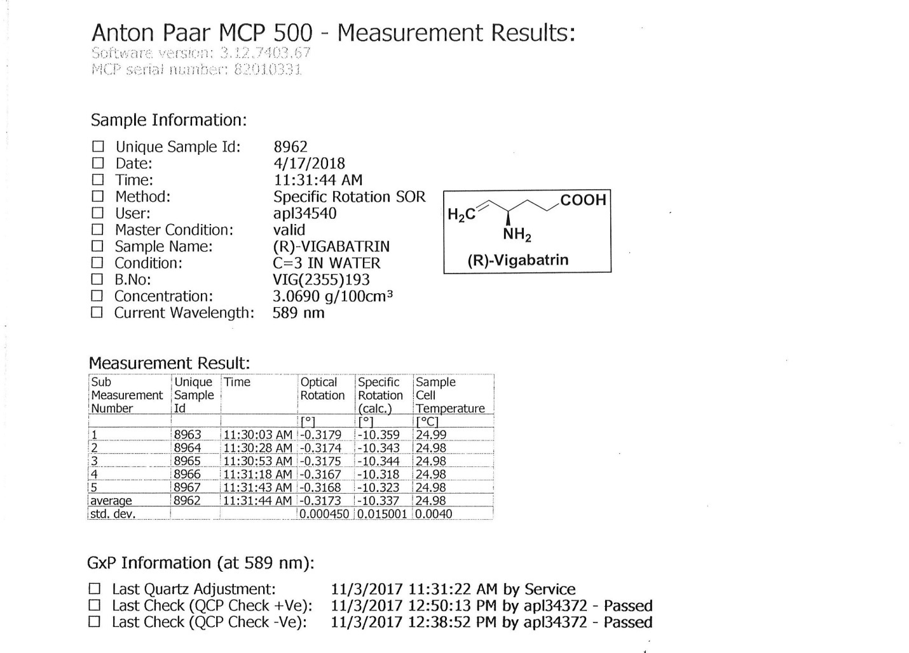
Specific Optical Rotation (SOR) of compound 3

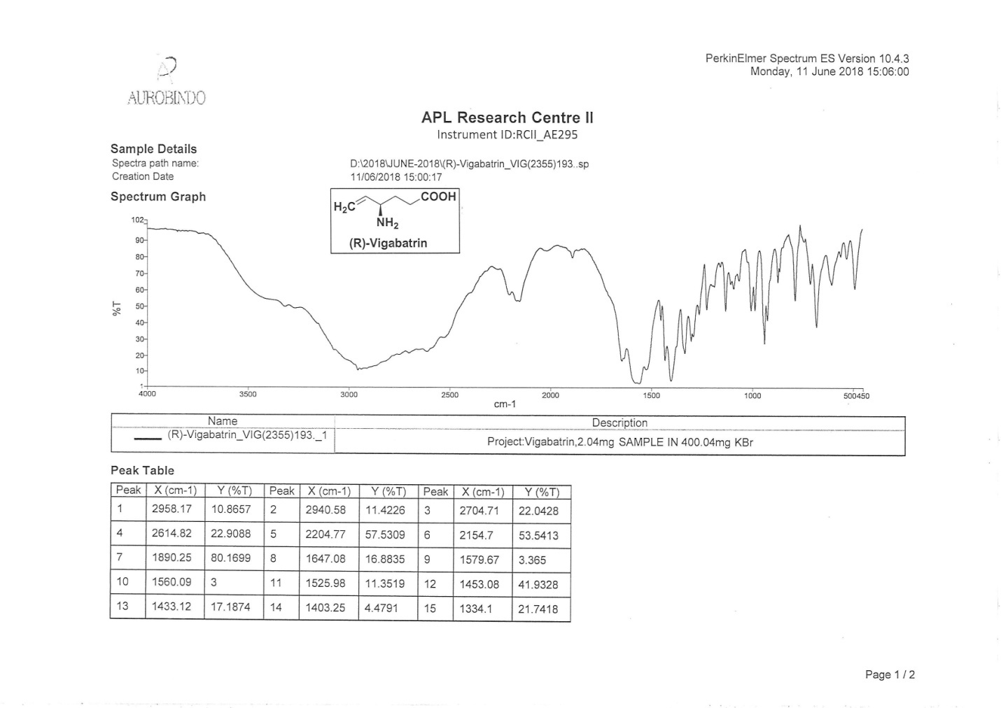
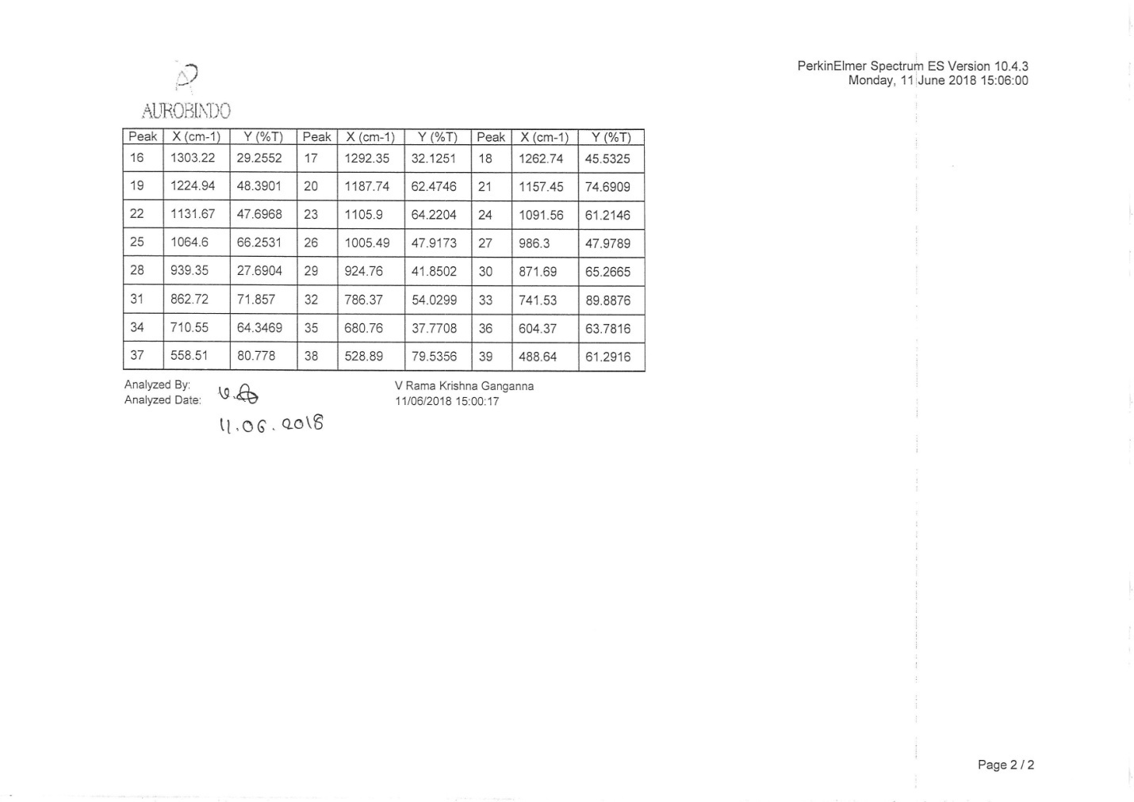

IR spectrum of compound 3
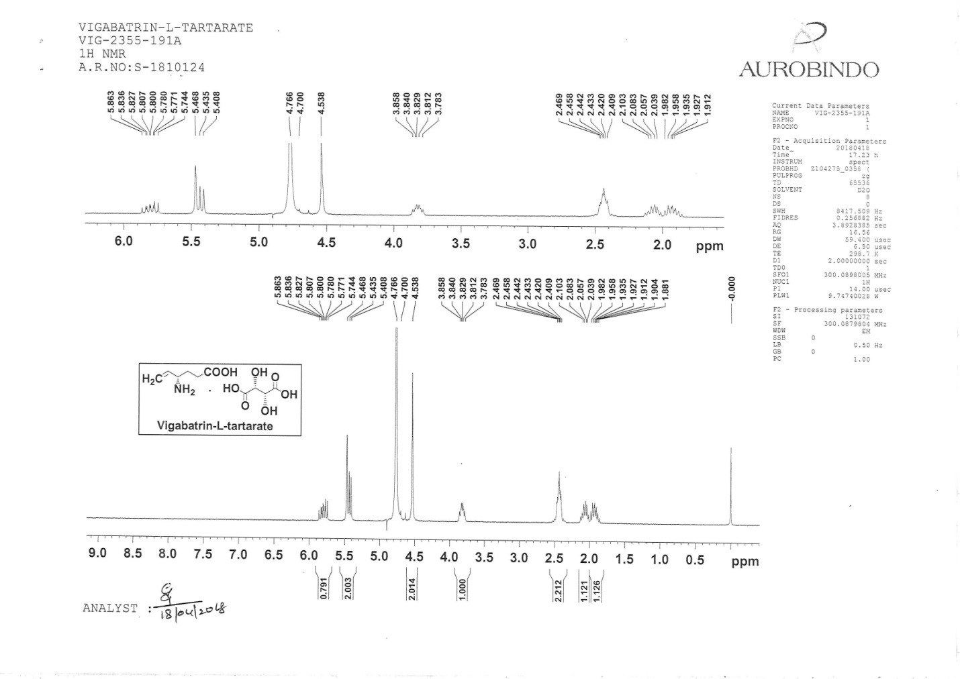
¹H NMR spectrum of compound 5
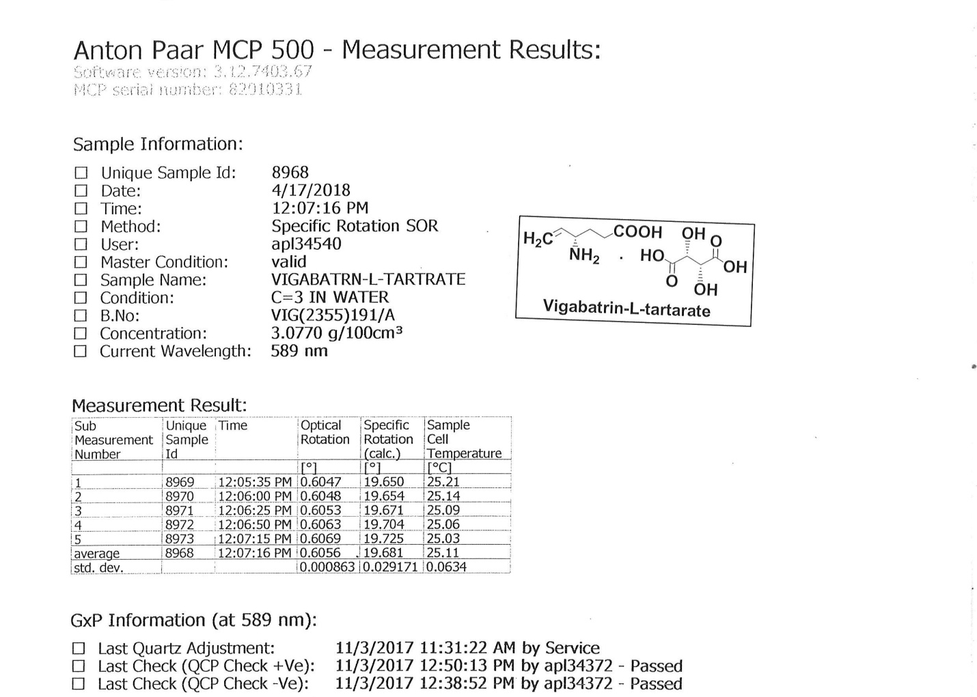
Specific Optical Rotation (SOR) of compound 5
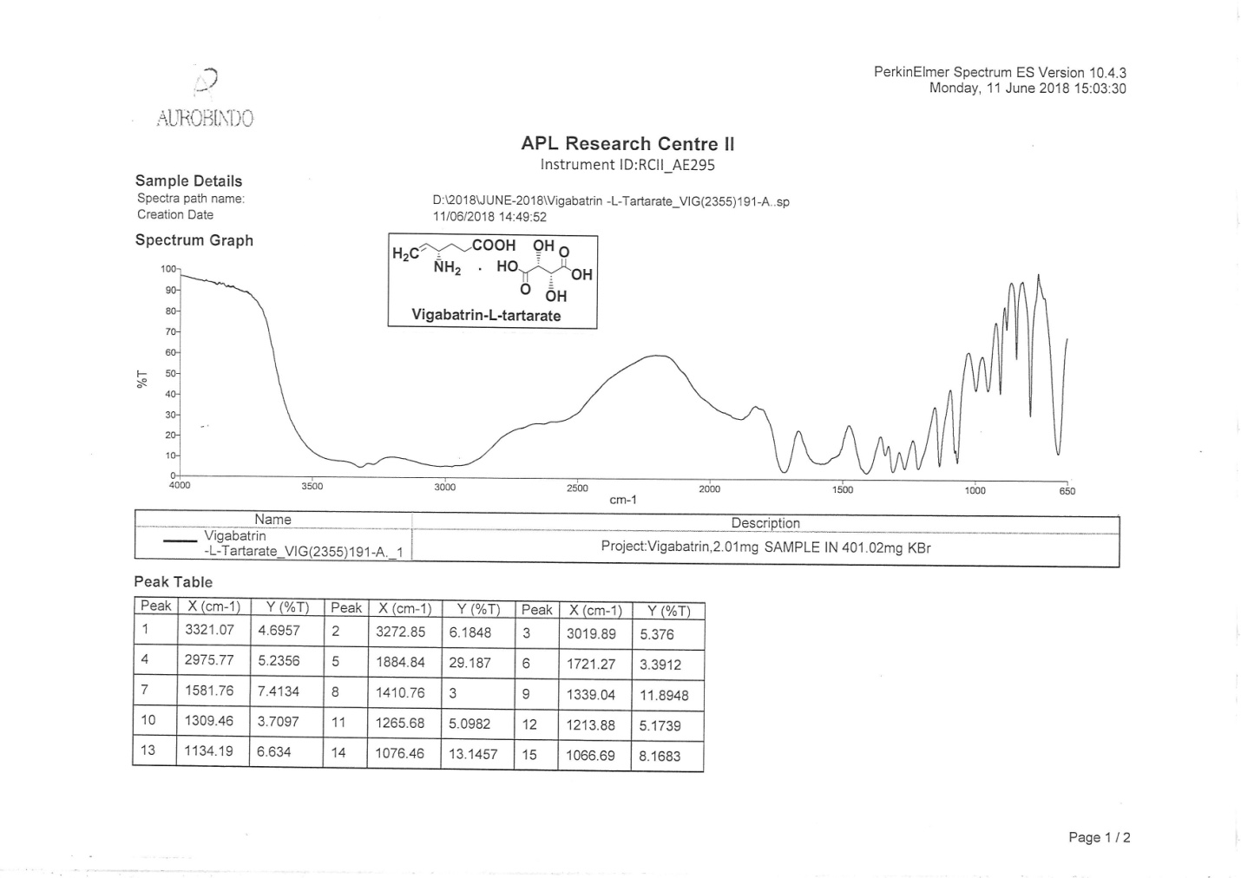
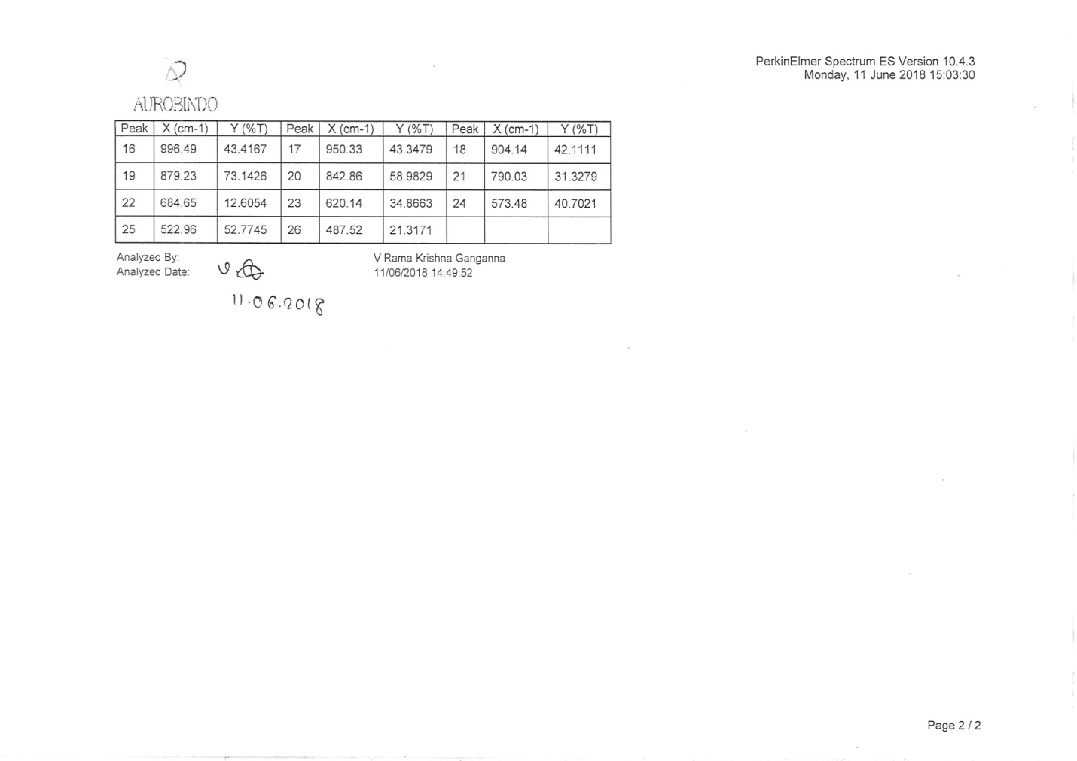
IR spectrum of compound 5

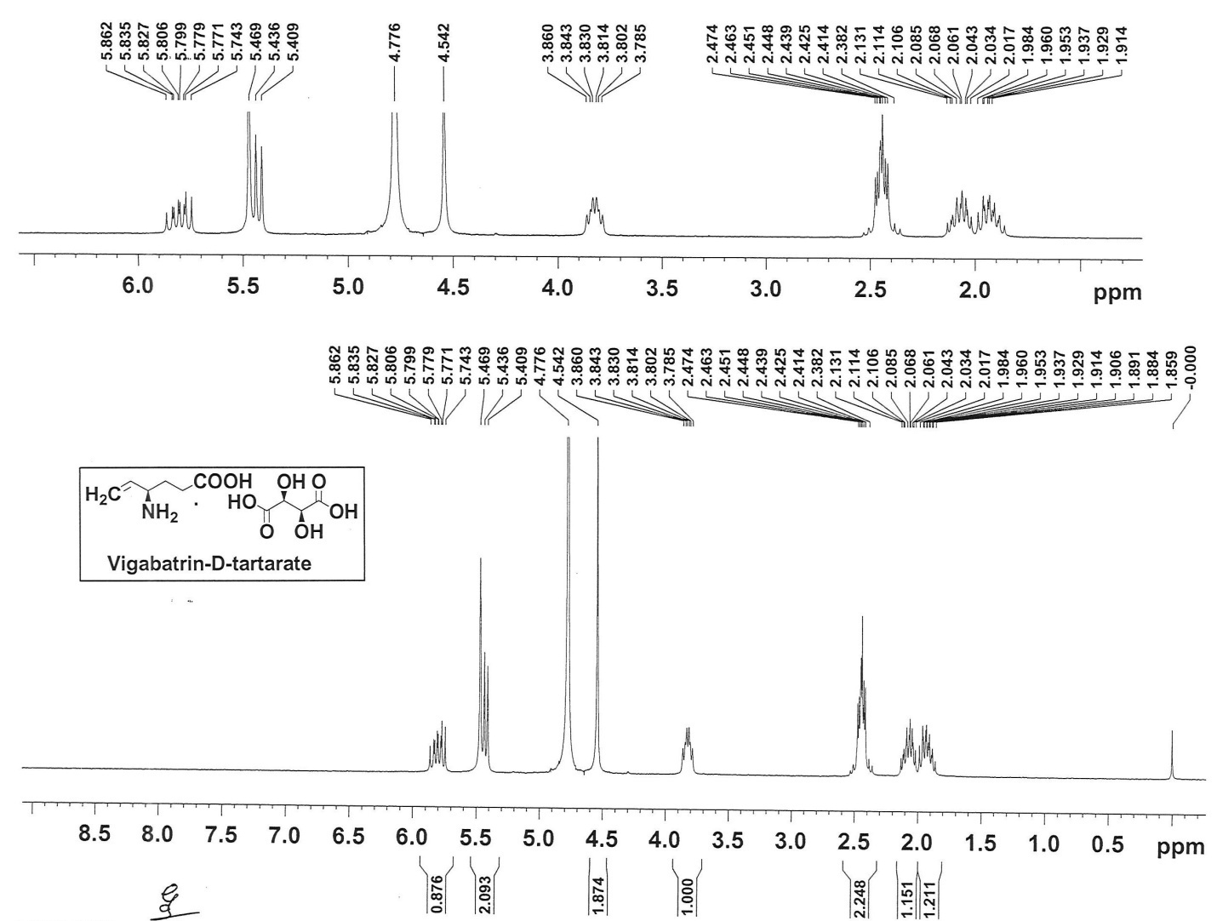
¹HNMR spectrum of compound 7

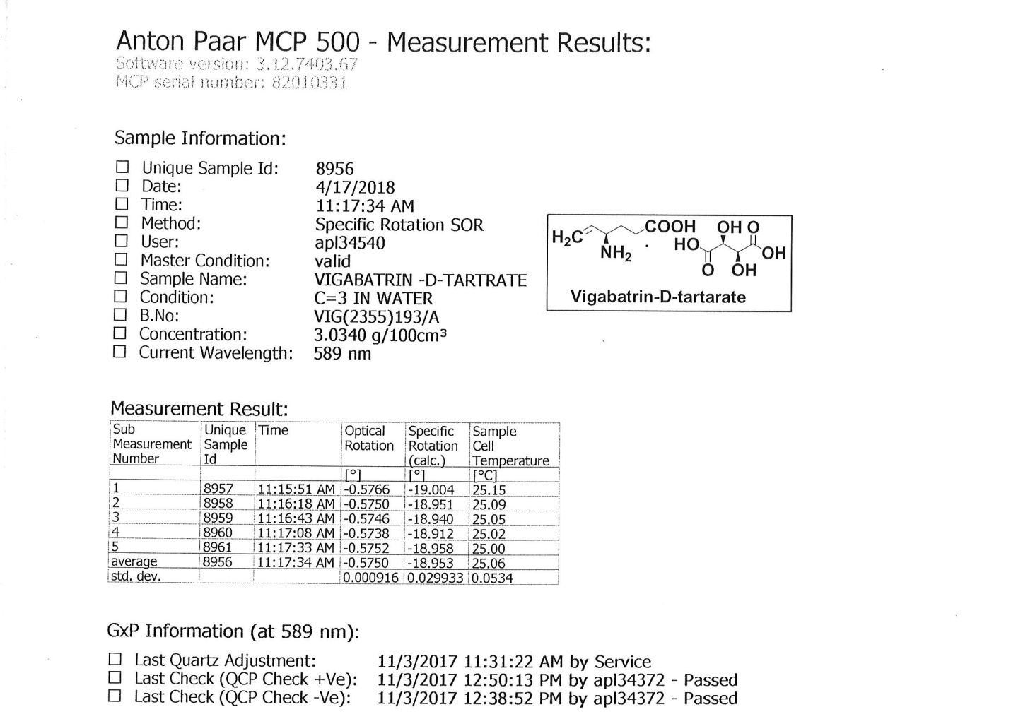
Specific Optical Rotation (SOR) of compound 7
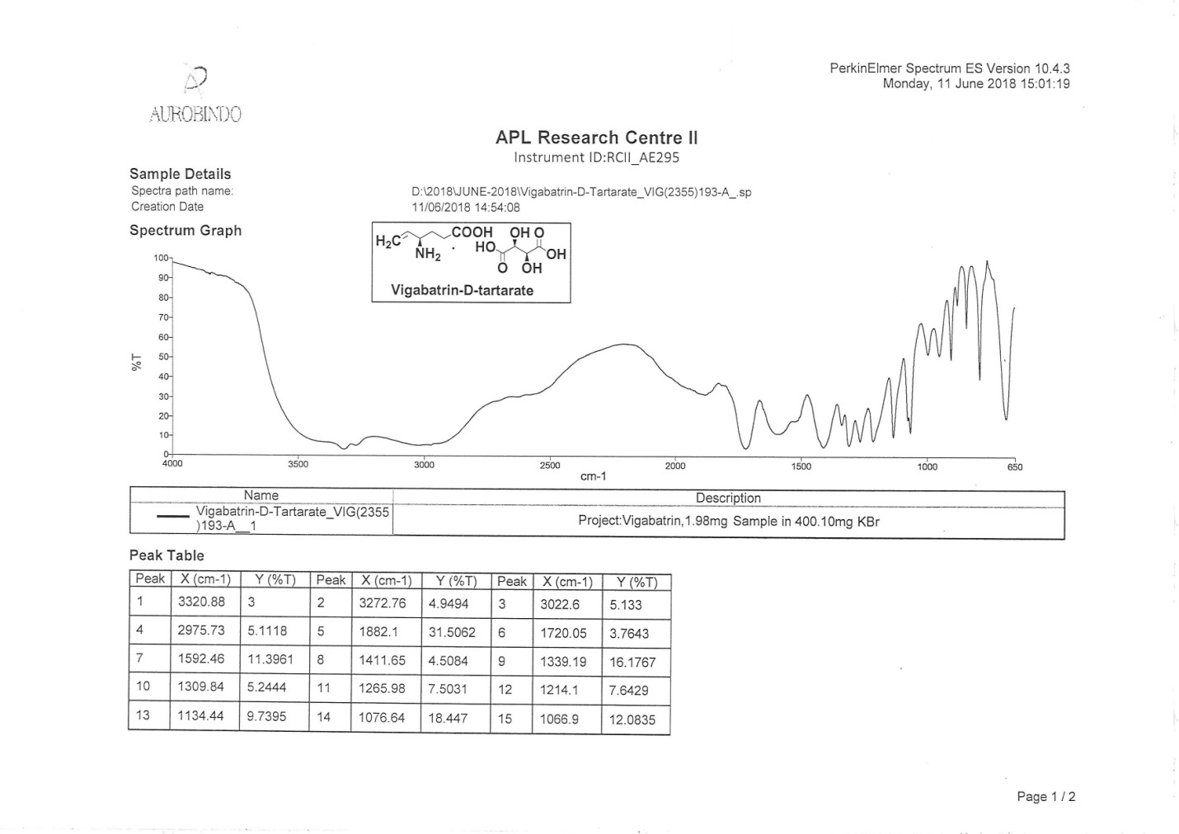
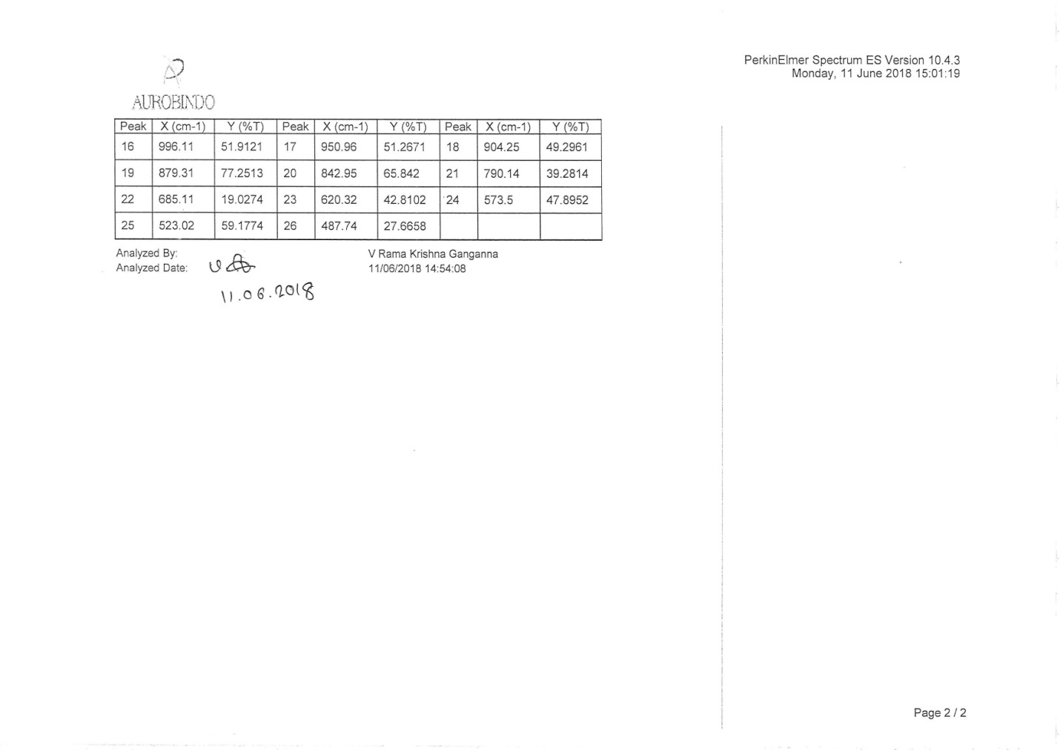

IR spectrum of compound 7

