Supporting inforamtion
Synthesis and Characterization of the Aurivillius Phase CoBi₂O₂F₄

Eleni Mitoudi Vagourdiª, Silvia Müllner^{b}, Peter Lemmens^{b}, Reinhard K. Kremer^{c},
Mats Johnsson^{a*}

a) Department of Materials and Environmental Chemistry, Stockholm University, SE-106 91 Stockholm, Sweden
b) Institute for Physics of Condensed Matter, TU Braunschweig, D-38106 Braunschweig, Germany
c) Max Planck Institute for Solid State Research, Heisenbergstrasse 1, D-70569 Stuttgart, Germany

* Corresponding author (mats.johnsson@mmk.su.se)

Table S1
Atomic coordinates and equivalent isotropic displacement parameters (Å²) for CoBi₂O₂F₄.
Atom | x | y | z | U(eq)
Bi(1) | 0.5000 | 0.5000 | 0.32714 (4) | 0.0090(2)
Co(1) | 0.0000 | 0.0000 | 0.5000 | 0.0063(6)
F(1A) | 0.091(13) | -0.088(14) | 0.381(4) | 0.010(6)
F(1B) | 0.073(14) | 0.057(19) | 0.376(4) | 0.010(6)
F(2A) | 0.069(10) | 0.494(15) | 0.537(3) | 0.014(5)
F(2B) | 0.118(10) | 0.494(11) | 0.477(2) | 0.014(5)
O(1) | 0.5000 | 0.0000 | 0.2500 | 0.006(7)
O(2) | 0.0000 | 0.5000 | 0.2500 | 0.012(8)

Table S2
Selected bond Lengths (Å) and Angles (º) for CoBi₂O₂F₄.
Bi1—O1(x2) | 2.2980(4) | Co1—F1B(x4) | 2.059(60)
Bi1—O2(x2) | 2.2980(4) | Co1—F2A(x4) | 2.011(57)
Bi1—F1A (x2) | 2.398(58) | Co1—F2A (x4) | 2.053(57)
Bi1—F1B(x2) | 2.495(55) | Co1—F2B(x4) | 1.986(44)
Co1—F1A(x4) | 2.002 (68) | Co1—F2B (x4) | 2.033(43)

Table S3
Bond valence sum (BVS) calculation results for CoBi₂O₂F₄
Atoms | Bonding Distance | Bond Valence | Atoms | Bonding Distance | Bond Valence
Bi1—O1(x2) | 2.2980(4) | 0.865 | F1A—Co1 | 2.002(68) | 0.374
Bi1—O2(x2) | 2.2980(4) | 0.865 | F1A—Bi1 | 2.398(58) | 0.331
Bi1—F1A(x2) | 2.398(58) | 0.5 |  |  | 0.70
Bi1—F1B(x2) | 2.495(55) | 0.66 | F1B—Co1 | 2.059(60) | 0.321
 |  | 3.40 | F1B—Co1 | 2.495(55) | 0.255
 |  |  |  |  | 0.58
Co—F1A(x4) | 2.002(68) | 0.375 | F2A—Co1 | 2.011(57) | 0.321
Co—F1B(x4) | 2.059(60) | 0.323 | F2A—Co1ii | 2.053(57) | 0.366
Co—F2A(x4) | 2.053(57) | 0.327 |  |  | 0.68
Co—F2A(x4) | 2.011(57) | 0.366
Co—F2B(x4) | 1.986(44) | 0.785 | F2B—Co1 | 1.986(44) | 0.388
Co—F2B(x4) | 2.033(43) | 0.345 | F2B—Co1ii | 2.033(43) | 0.348
 |  | 2.13 |  |  | 0.74
O1—Bi1 | 2.298(4) | 0.576
O1—Bi1xi | 2.298(4) | 0.576
O1—Bi1xii | 2.298(4) | 0.576
O1—Bi1xiii | 2.298(4) | 0.576
 |  | 2.30

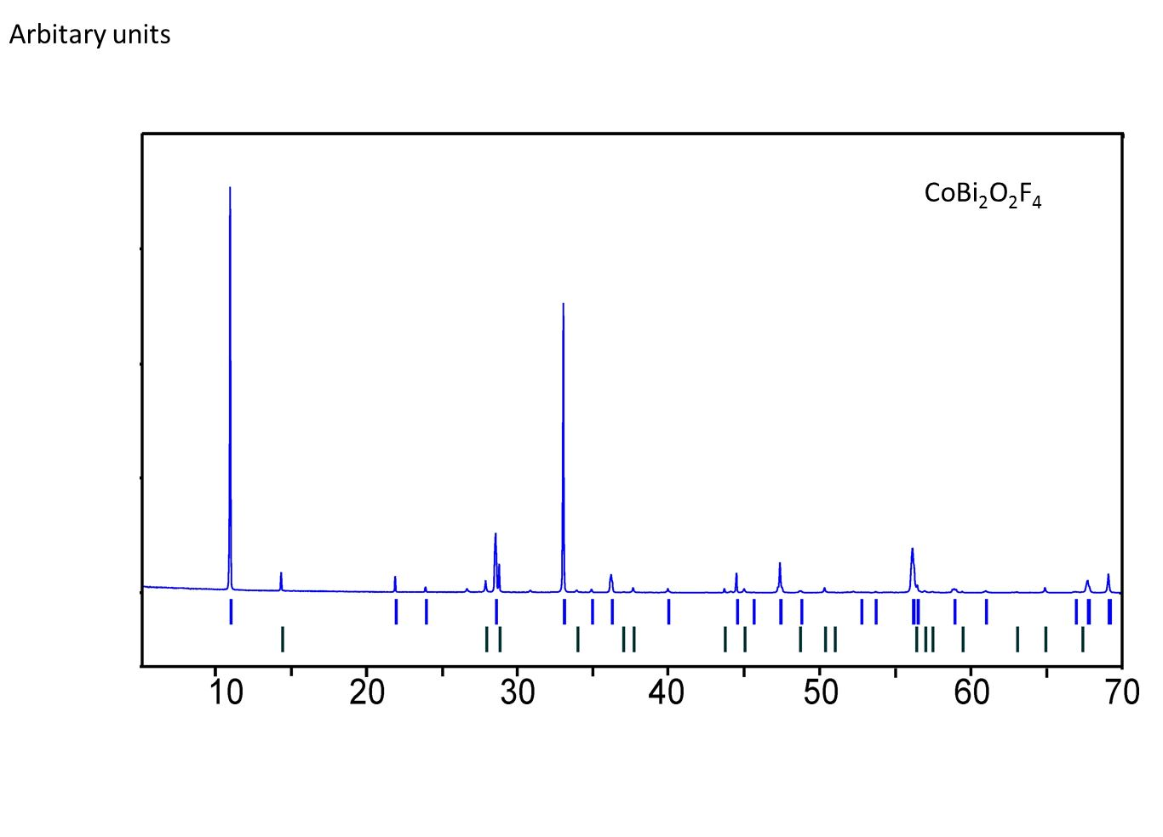
Figure S1 Experimental powder pattern of the CoBi₂O₂F₄ compound and the Bragg peak assignment for the calculated pattern. The blue lines correspond to the CoBi₂O₂F₄ phase and the green lines correspond to a minor BiOF impurity phase.

