**SUPPORTING INFORMATION for**

Mannich condensations of activated cyclic enamines

**Anna Alekszi-Kaszás,a Péter Nemes,a* Gábor Tóth,b Judit Halászc, Pál Scheibera**

aDepartment of Chemistry, University of Veterinary Medicine, H-1400 Budapest, P.O.Box 2, Hungary

bDepartment of Inorganic and Analytical Chemistry, NMR Group, Budapest University of Technology and Economics, Szt. Gellért tér 4, H-1111 Budapest, Hungary

cLaboratory of Structural Chemistry, Egis Pharmaceuticals Plc., H-1475 Budapest, P.O.B. 100, Hungary

*Corresponding author. Tel.: +36-14784176; Fax: +36-14784268; nemes.peter@univet.hu

**CONTENTS**

**General information S2**

**Experimental section S2-S13**

**NMR spectra S14-S23**

**General information**

All solvents were dried by standard procedures. To follow the reactions, TLC precoated sheets (Merck DC-Alufolien Kieselgel 60F254) were used. Melting points were determined on an Electrothermal 9100 apparatus. 1H (600 MHz) and 13C (150 MHz) NMR spectra were recorded at room temperature on a Bruker Avance III 600 MHz spectrometer equipped with Prodigy cryo-probehead, whereas the 500/125 MHz spectra were recorded on Bruker Avance II or Avance III spectrometer equipped with cryo-probehead. In the case of 300/75 MHz spectra Varian Unity 300 instrument was used. Chemical shifts are given on the δ-scale and are referenced to the solvent (dimethylsulfoxide-d6: δC = 39.5 and δH = 2.50; chloroform-d: δC = 77.0 and δH = 7.27 ppm). Pulse programs of all experiments [1H, 13C, DEPTQ, DEPT-135, sel-TOCSY (mixing time: 70–120 ms), sel-NOE (300 ms)], NOESY, edited gs-HSQC, gs-HMBC (optimized for 7 Hz), were taken from the Bruker software library. The NMR signals of the products were assigned by comprehensive one- and two-dimensional NMR methods using widely accepted strategies.13 Most 1H assignments were accomplished using general knowledge of chemical shift dispersion with the aid of the proton–proton coupling pattern (1H NMR spectra). High-resolution mass spectra (HRMS spectra) were recorded on a Bruker O-TOF MAXIS Impact mass spectrometer coupled to a Dionex Ultimate 3000 RS HPLC system with a diode array detector, and a Thermo Velos Pro Orbitrap Elite system with Xcalibur software version 2.0 (Thermo Fisher Scientific).

**1. 4-Nitro-2-phenyl-1,2,3,5,6,7-hexahydro-pyrrolo[1,2-c]pyrimidine (3a)**:

Purification of the product by column chromatography (tert-butyl methyl ether/i-propyl amine, 9:1) gave pale yellow crystals (77%); *Rf* (tert-butyl methyl ether/i-propyl amine, 9:1) 0.43; mp. 119-120 oC. 1H NMR (300 MHz, CDCl3) δ 7.30 - 6.90 (5H, m), 4.71 (2H, s, 3-H), 4.50 (2H, s, 1-H), 3.59 (2H, t, *J* = 7.5 Hz, 7-H), 3.43 (2H, t, *J* = 7.5 Hz, 5-H), 2.09 (2H, qui, *J* = 7.5 Hz, 6-H); 13C NMR (75 MHz, CDCl3) δ 160.6, 148.1, 129.5, 121.9, 118.0, 114.7, 63.9, 52.4, 47.0, 34.2, 20.3; HRMS m/z: [M+H]+ calcd for C13H16N3O2: 246.1237; found: 246.1246.

**2. 4-Nitro-2-tolyl-1,2,3,5,6,7-hexahydro-pyrrolo[1,2-c]pyrimidine (3b)**:

Upon cooling the product crystallized out from the reaction mixture; yellow crystals (63%); *Rf* (tert-butyl methyl ether/i-propyl amine, 9:1) 0.36; mp. 184 oC (EtOH). 1H NMR (300 MHz, CDCl3) δ 7.09-6.83 (4H, m, Ar-H), 4.67 (2H, s, 3-H), 4.45 (2H, s, 1-H), 3.58 (2H, t, *J* = 7.5 Hz, 7-H), 3.43 (2H, t, *J* = 7.5 Hz, 5-H), 2.27 (3H, s, Ar-CH3), 2.08 (2H, qui, *J* = 7.5 Hz, 6-H); 13C NMR (75 MHz, CDCl3) δ 160.6, 145.8, 131.5, 129.9, 118.1, 114.8, 64.2, 52.3, 47.2, 34.2, 20.3; HRMS m/z: [M+H]+ calcd for C14H18N3O2: 260.1394; found: 260.1402.

**3. 2-(4-Methoxy-phenyl)-4-nitro-1,2,3,5,6,7-hexahydro-pyrrolo[1,2-c]pyrimidine (3c)**:

Upon cooling the product crystallized from the reaction mixture; yellow crystals (72%); *Rf* (tert-butyl methyl ether/i-propyl amine, 9:1) 0.33; mp. 152-153 °C (EtOH). 1H NMR (300 MHz, CDCl3) δ 6.89-6.76 (4H, m, Ar-H), 4.60 (2H, s, 3-H), 4.37 (2H, s, 1-H), 3.73 (3H, s, O-CH3), 3.57 (2H, t, *J* = 7.5 Hz, 5-H), 3.40 (2H, t, *J* = 7.5 Hz, 7-H), 2.05 (2H, qui, *J* = 7.5 Hz, 6-H); 13C NMR (75 MHz, CDCl3) δ 161.0, 154.7, 141.6, 118.8, 113.5, 64.7, 54.7, 52.2, 47.5, 34.2, 20.1; HRMS m/z: [M+H]+ calcd for C14H18N3O3: 276.1343; found: 276.1346.

**4. 2-(2-Methoxy-phenyl)-4-nitro-1,2,3,5,6,7-hexahydro-pyrrolo[1,2-c]pyrimidine (3d)**:

Yellow crystals from EtOAc (49%); *Rf* (tert-butyl methyl ether/i-propyl amine, 9:1) 0.38; mp. 185-187 °C (EtOH). 1H NMR (300 MHz, CDCl3) δ 7.10 - 6.80 (4H, m, Ar-H), 6.78 (2H, d, *J* = 8.4 Hz, Ar-H), 4.64 (2H, s, 3-H), 4.41 (2H, s, 1-H), 3.89 (3H, s, O-CH3), 3.54 (2H, t, *J* = 7.5 Hz, 5-H), 3.46 (2H, t, *J* = 7.5 Hz, 7-H), 2.07 (2H, qui, *J* = 7.5 Hz, 6-H); 13C NMR (75 MHz, CDCl3) δ 160.6, 151.9, 137.2, 124.4, 121.0, 119.7, 114.6, 111.4, 63.9, 55.5, 52.1, 47.4, 34.3, 20.1; HRMS m/z: [M+H]+ calcd for C14H18N3O3: 276.1343; found: 276.1351.

**5. 2-Isopropyl-1,2,3,5,6,7-hexahydro-pyrrolo[1,2-c]pyrimidine-4-carboxylic acid ethyl ester (4a)**:

Colorless oil (194 mg, 82 %); *Rf* (hexane/tert-butyl methyl ether/i-propyl amine, 50:45:5) 0.40; 1H NMR (300 MHz, CDCl3) δ 4.10 (2H, q, *J* = 7.0 Hz, *CH2*CH3), 3.97 (2H, s, 1-H), 3.48 (2H, s, 3-H), 3.27 (2H, t, *J* = 7.0 Hz, 7-H), 3.01 (2H, t, *J* = 7.5 Hz, 5-H), 2.84 (1H, hept, *J* = 6.3 Hz, *CH*(CH3)2)), 1,94 (2H, m, 6-H), 1.23 (3H, t, *J* = 7.0 Hz, CH2*CH3*), 1.12 (6H, d, *J* = 6.3 Hz, CH(*CH3*)2); 13C NMR (75 MHz, CDCl3) δ 167.7, 158.8, 87.8, 63.3, 58.5, 51.3, 50.9, 45.9, 32.2, 21.2, 20.3, 15.0; HRMS m/z: [M+H+NH3]+ calcd for C13H26N3O2: 256.2020; found: 256.2019.

**6. 2-tert-Butyl-1,2,3,5,6,7-hexahydro-pyrrolo([1,2-c]pyrimidine-4-carboxylic acid ethyl ester (4b)**:

Purification of the product by column chromatography (EtOAc followed by dichloromethane/diisopropyl ether, 7:3) gave a colorless oil (153 mg, 61 %); *Rf* (hexane/tert-butyl methyl ether/i-propyl amine, 50:45:5) 0.58; 1H NMR (500 MHz, CDCl3) d 4.12 (2H, q, *J* = 7.0 Hz, O*CH2*CH3), 3.92 (2H, s, 1-H), 3.47 (2H, s, 3-H), 3.28 (2H, t, *J* = 7.0 Hz, 7-H), 3.00 (2H, t, *J* = 7.0 Hz, 5-H), 1,96 (2H, qui, *J* = 7.0 Hz, 6-H), 1.24 (3H, t, *J* = 7.0 Hz, OCH2*CH3*); 1.19 (9H, s, C(CH3)3); 13C NMR (125 MHz, CDCl3) δ 167.5 O=C-O, 158.6 C-4a, 89.0 C-4, 60.7 C-1, 58.5 OCH2, 53.5 *C*(CH3)3, 50.7 C-7, 42.8 C-3, 32.1 C-5, 26.5 C(*C*H3)3, 21.0 C-6, 14.8 OCH2*C*H3; HRMS m/z: [M+H]+ calcd for C14H25N2O2: 253.1911; found: 253.1902.

**7. 2-Benzyl-1,2,3,5,6,7-hexahydro-pyrrolo[1,2-c]pyrimidine-4-carboxylic acid ethyl ester (4c)**:

Purification of the product by column chromatography (EtOAc followed by hexane/tert-butyl methyl ether/i-propyl amine, 50:45:5) gave a colorless oil (119 mg, 42%); *Rf* (hexane/tert-butyl methyl ether/i-propyl amine, 50:45:5) 0.37; 1H NMR (300 MHz, CDCl3) δ 7.37 - 7.23 (5H, m, ArH), 4.10 (2H, q, *J* = 7.2 Hz, *CH2*CH3), 3.90 (2H, s, 3-H), 3.65 (2H, s, CH2-Ar), 3.55 (2H, s,4-H), 3.23 (2H, t, *J* = 6.9 Hz, 7-H), 3.09 (2H, t, *J* = 7.8 Hz, 5-H), 1.97 (2H, qui, *J* = 7.5, 6-H), 1.23 (3H, t, *J* = 7.2 Hz, CH3); 13C NMR (75 MHz, CDCl3) δ 167.8, 158.2, 138.3, 129.1, 128.3, 127.3, 86.3, 64.7, 58.5, 57.7, 50.8, 49.3, 32.1, 20.9, 14.73; HRMS m/z: [M+H]+ calcd for C17H23N2O2: 287.1714; found: 287.1721.

**8. 2-[2-(2-methoxy-phenyl)-ethyl]-1,2,3,5,6,7-hexahydro-pyrrolo[1,2-c]pyrimidine-4-carboxylic acid ethyl ester (4d)**:

Purification of the product by column chromatography (EtOAc, followed by hexane/tert-butyl methyl ether/i-propyl amine, 50:45:5) gave a colorless oil (210 mg, 64%); *Rf* (tert-butyl methyl ether/i-propyl amine, 50:45:5) 0.53; 1H NMR (500 MHz, CDCl3)  7.19 (1H, t, *J* = 7.7 Hz, 4’-H), 7.16 (1H, d, *J* = 7.7 Hz, 6’-H), 6.89 (1H, t, *J* = 7.7 Hz, 5’-H), 6.85 (1H, d, *J* = 7.7 Hz, 3’-H), 4.13 (2H, q, *J* = 7.0 Hz, O*CH2*CH3), 4.03 (2H, s, 1-H), 3.82 (3H, s, OCH3), 3.56 (2H, s, 3-H), 3.30 (2H, t, *J* = 7.0 Hz, 7-H), 3.06 (2H, t, *J* = 7.0 Hz, 5-H), 2.89 (2H, m, N-CH2CH2), 2.70 (2H, m, N-CH2CH2), 1,96 (2H, qui, *J* = 7.0 Hz, 6-H), 1.26 (3H, t, *J* = 7.0 Hz, CH2*CH3*); 13C NMR (125 MHz, CDCl3)  167.8 O=C-O, 158.1 C-4a, 157.5 C-2’, 130.2 C-6’, 127.4 C-4’, 120.4 C-5’, 110.3 -3’, 65.9 C-1, 58.5 OCH2, 55.2 OCH3, 53.7 NCH2CH2, 51.0 C-7, 49.0 C-3, 32.1 C-5, 29.2 NCH2CH2, 20.9 C-6, 14.8 OCH2*C*H3; HRMS m/z: [M+H]+ calcd for C19H27N2O3: 331.2016; found: 331.2034.

**9. 2-[2-(3,4-dimethoxy-phenyl)-ethyl]-1,2,3,5,6,7-hexahydro-pyrrolo[1,2-c]pyrimidine-4-carboxylic acid ethyl ester (4e)**:

Purification of the product by column chromatography (EtOAc/dichloromethane/i-propyl amine, 74:24:2) gave a colorless oil (277 mg, 77%); *Rf* (hexane/tert-butyl methyl ether/i-propyl amine, 50:45:5) 0.32; 1H NMR (300 MHz, CDCl3)  6.82 - 6.69 (3H, m, Ar-H), 4.11 (2H, q, *J* = 6.9 Hz, CH2CH3), 3.98 (2H, s 1-H), 3.86 (3H, s, OCH3), 3.84 (3H, s, OCH3), 3.54 (2H, s, 3-H), 3.26 (2H, t, *J* = 6.6 Hz, 7-H), 3.04 (2H, t, *J* = 7.8 Hz, 5-H), 2.79-2,74 (4H, m, N-CH2CH2), 1.94 (2H, qui, *J* = 7.2 Hz, 6-H), 1.25 (3H, t, *J* = 6.9 Hz, CH2CH3); 13C NMR (75 MHz, CDCl3)  167.7, 158.1, 148.9, 147.5, 132.8, 120.5, 112.1, 111.4, 86.4, 66.3, 58.5, 55.92, 55.86, 55.51, 50.9, 48.7, 34.4, 32.1, 20.9, 14.7; HRMS m/z: [M+H]+ calcd for C20H29N2O4: 361.2122; found: 361.2114.

**10. 2-(Cyclopentyl)-1,2,3,5,6,7-hexahydro-pyrrolo[1,2-c]pyrimidine-4-carboxylic acid ethyl ester (4f)**:

Colorless oil (180 mg, 68%); *Rf* (EtOAc/i-propyl amine, 20:1) 0.54. 1H NMR (300 MHz, CDCl3)  4.12 (2H, q, *J* = 6.9 Hz, *CH2*CH3), 3.98 (2H, s 1-H), 3.50 (2H, s, 3-H), 3.30 (2H, t, *J* = 6.6 Hz, 7-H), 3.06 (2H, t, *J* = 7.8 Hz, 5-H), 2.76 (1H, m,), 2.05-1.45 (10H, m), 1.25 (3H, t, *J* = 6.9 Hz, CH2*CH3*); 13C NMR (75 MHz, CDCl3)  167.7, 158.5, 86.7, 65.2, 62.3, 58.6, 51.0, 48.5, 32.1, 31.3, 24.0, 21.0, 14.8, HRMS m/z: [M+H]+ calcd for C15H25N2O2: 265.1911; found: 265.1900.

**11. 2-(Cyclohexyl)-1,2,3,5,6,7-hexahydro-pyrrolo[1,2-c]pyrimidine-4-carboxylic acid ethyl ester (4g)**:

**C**olorless oil (195 mg, 70%); *Rf* (EtOAc/i-propyl amine, 20:1) 0.57., 50:45:5) 0.32. 1H NMR (300 MHz, CDCl3)  4.12 (2H, q, *J* = 6.9 Hz, *CH2*CH3), 4.03 (2H, s 1-H), 3.55 (2H, s, 3-H), 3.28 (2H, t, *J* = 6.6 Hz, 7-H), 3.04 (2H, t, *J* = 7.8 Hz, 5-H), 2.51-2.40 (1H, m, 2.05-1.09 (12H, m), 1.25 (3H, t, *J* = 6.9 Hz, CH2*CH3*); 13C NMR (75 MHz, CDCl3)  167.6, 158.8, 87.6, 62.9, 59.6, 58.5, 50.7, 45.8, 32.1, 30.4, 26.1, 25.7, 21.0, 14.8. HRMS m/z: [M+H]+ calcd for C16H27N2O2: 279.2067; found: 279.2062.

**12. Ethyl 2-(1-benzylpiperidin-4-yl)-1,2,3,5,6,7-hexahydropyrrolo-[1,2-c]pyrimidine-4-carboxylate (4h)**:

Yellow oil (213 mg, 58%), *Rf* (EtOAc/i-propyl amine, 20:1) 0.40. 1H NMR (500 MHz, CDCl3)  7.34 - 7.24 (5H, m, ArH), 4.12 (2H, q, *J* = 7.1 Hz, *CH2*CH3), 4.04 (2H, s 1-H), 3.55 (2H, s, 3-H), 3.51 (2H, s, CH2-Ph), 3.26 (2H, t, *J* = 6.6 Hz, 7-H), 3.03 (2H, t, *J* = 7.8 Hz, 5-H), 2.93 (2H, dt, *J* = 12.0, 3.0 Hz, 2’, 6’-Hequ), 2.46 (1H, tt, *J* = 12.0, 3.0 Hz, 4’-H), 2.00 (2H, td, *J* = 12.0, 3.0 Hz, 2’,6’-Hax), 1.85 (2H, dt, *J* = 12.0, 3.0 Hz, 3’,5’-Hequ), 1.63 (2H, qd, *J* = 12.0, 3.0 Hz, 3’,5’-Hax), 1.24 (3H, t, *J* = 7.1 Hz, CH2*CH3*); 13C NMR (125 MHz, CDCl3)  167.6, 158.9, 138.5, 129.2, 128.2, 127.0, 87.4, 63.0, 62.8, 58.6, 58.0, 52.9, 50.7, 46.0, 32.1, 29.9, 21.0, 14.8. HRMS m/z: [M+H]+ calcd for C22H32N3O2: 370.2489; found: 370.2486

**13. Ethyl 2-(1-ethylpiperidin-3-yl)-1,2,3,5,6,7-hexahydropyrrolo-[1,2-c]pyrimidine-4-carboxylate (4i)**:

Yellow oil (185 mg, 60%), *Rf* (EtOAc/i-propyl amine, 20:1) 0.41. 1H NMR (300 MHz, CDCl3)  4.12 (2H, q, *J* = 6.9 Hz, O*CH2*CH3), 4.10 (2H, s 1-H), 3.60 (2H, s, 3-H), 3.29 (2H, t, *J* = 6.6 Hz, 7-H), 3.11-3.01 (1H, m, 2’-Hequ), 3.04 (2H, t, *J* = 7.8 Hz, 5-H), 2.89-2.79 (1H, m, 6’-Hequ), 2.77-2.64 (1H, m, 3’-H), 2.52-2.38 (2H, m, N*CH2*CH3), 2.02-1.42 (6-H, m, 2’,6’-Hax, 4’,5’-H), 1.26 (3H, t, *J* = 6.9 Hz, OCH2*CH3*), 1.10 (3H, t, *J* = 6.9 Hz, NCH2*CH3*), 13C NMR (75 MHz, CDCl3)  167.5, 158.8, 87.2, 63.3, 58.5, 57.6, 56.7, 53.2, 52.7, 50.8, 45.8, 32.1, 28.5, 24.5, 20.9, 14.8, 11.9; HRMS m/z: [M+H]+ calcd for C17H30N3O2: 308.2333; found: 308.2329.

**14. 2-p-Tolyl-1,2,3,5,6,7-hexahydro-pyrrolo[1,2-c]pyrimidine-4-carboxylic acid ethyl ester (4j)**:

Purification of the crude product by column chromatography (hexane/tert-butyl methyl ether/i-propyl amine 50:45:5), followed by a second chromatography (EtOAc/hexane, 1:1) gave a colorless oil (51 mg, 18%); *Rf* (hexane/tert-butyl methyl ether/i-propyl amine, 50:45:5) 0.32; 1H NMR (300 MHz, CDCl3)  7.07 (2H, , *J* = 7.5 Hz, ArH), 6.91 (2H, d, *J* = 7.5 Hz, ArH), 4.56 (2H, s, 3-H), 4.13 (2H, q, *J* = 7.2 Hz, CH2CH3), 4.09 (2H, s, 1-H), 3.34 (2H, t, *J* = 6.9 Hz, 7-H), 3.04 (2H, t, *J* = 7.8 Hz, 5-H), 2.28 (3H, s, Ph-CH3), 1,95 (2H, qui, *J* = 7.5, 6-H), 1.27 (3H, t, *J* = 7.2 Hz, CH3); 13C NMR (75 MHz, CDCl3)  168.3, 157.5, 146.3, 129.7, 128.8, 117.9, 88.0, 63.8, 58.6, 50.8, 47.3, 32.1, 20.9, 20.5, 14.8; HRMS m/z: [M+H]+ calcd for C17H23N2O2: 287.1755; found: 287.1757.

**15. 2-(4-Methoxy-phenyl)-1,2,3,5,6,7-hexahydro-pyrrolo[1,2-c]pyrimidine-4-carboxylic acid ethyl ester (4k)**:

Purification of the crude product by column chromatography (hexane/tert-butyl methyl ether/i-propyl amine 50:45:5), followed by a second chromatography (EtOAc/hexane, 1:1) gave a colorless oil (89 mg, 29%); *Rf* (hexane/tert-butyl methyl ether/i-propyl amine, 50:45:5) 0.32; 1H NMR (300 MHz, CDCl3)  6.95 (2H, d, *J* = 9.0 Hz, ArH), 6.81 (2H, d, *J* = 9.0 Hz, ArH), 4.50 (2H, s, 3-H), 4.13 (2H, q, *J* = 7.2 Hz, *CH2*CH3), 4.04 (2H, s, 1-H), 3.76 (3H, s, OCH3), 3.31 (2H, t, *J* = 6.9 Hz, 7-H), 3.04 (2H, t, *J* = 7.8 Hz, 5-H), 1,94 (2H, qui, *J* = 7.5, 6-H), 1.26 (3H, t, *J* = 7.2 Hz, CH3); 13C NMR (75 MHz, CDCl3)  167.8, 158.2, 138.3, 129.1, 128.3, 127.3, 86.3, 64.7, 58.5, 57.7, 50.8, 49.3, 32.1, 20.9, 14.73; HRMS m/z: [M+H]+ calcd for C17H23N2O3: 303.1704; found: 303.1700.

**16. Benzyl-methyl-(2-nitro-2-pyrrolidin-2-ylidene-ethyl)-amine (5a)**:

Yellow solid (226 mg, 87%) *Rf* (tert-butyl methyl ether/i-propyl amine, 9:1) 0.60; mp 112-113 °C. 1H NMR (300 MHz, CDCl3)  9.81 (1H, bs, NH), 7.28 (5H, s, Ar-H), 3.73 (2H, t, *J* = 7.2 Hz), 3.51 (2H, s, CH2), 3.50 (2H, s, CH2), 2.88 (2H, t, *J* = 7.8 Hz), 2.18 (3H, s, NCH3), 2.12 (2H, qui, *J* = 7.5 Hz, ); 13C NMR (75 MHz, CDCl3)  165.3, 139.5, 128.9, 128.1, 126.9, 116.2, 61.8, 54.3, 48.6, 42.0, 31.9, 21.5; HRMS m/z: [M+H]+ calcd for C14H20N3O2: 262.1550; found: 262.1550.

**17. 3-Benztriazol-1-yl-2-pyrrolidin-2-ylidene-propionic acid ethyl ester (7)**:

White solid, *Rf* (hexane/tert-butyl methyl ether/i-propyl amine, 50:45:5) 0.27; mp 120-121 °C. 1H NMR (500 MHz, DMSO-d6)  8.56 (1H, s, NH), 7.99 (1H, d, *J* = 8.0 Hz, 4”-H), 7.82 (1H, d, *J* = 8.0 Hz, 7”-H), 7.51 (1H, t, *J* = 8.0 Hz, 6”-H), 7.35 (1H, t, *J* = 8.0 Hz, 5”-H), 5.43 (2H, s, 3-H), 4.00 (2H, q, *J* = 7.1 Hz, OCH2), 3.50 (2H, t, *J* = 7.5 Hz, 5’-H), 3.00 (2H, t, *J* = 7.5 Hz, 3’-H), 1.95 (2H, qui, *J* = 7.5 Hz, 4’-H), 1.06 (3H, t, *J* = 7.1 Hz, CH3); 13C NMR (125 MHz, DMSO-d6)  168.1 C-2’, 168.0 C-1, 145.0 C-3a”, 132.6 C-7a”, 126.6 C-6”, 123.5 C-5”, 118.9 C-4”, 111.3 C-7”, 83.3 C-2, 58.3 OCH2, 47.8 C-5’, 31.6 C-3’, 21.1 C-4’, 14.5 CH3. HRMS m/z: [M+Na]+ calcd for C15H18N4O2Na: 309.1322; found: 309.1323.

**18. (2’S,6S)-diethyl-1’-(1-benztriazolyl-methyl)-2,3,6,7-tetrahydro-1H-spiro[indolizine-5,2’-pyrrolidine]-6,8-dicarboxylate (9)**:

White solid (376 mg, 72%), recrystallized from EtOAc, mp. 125 °C.

**9a** 1H NMR (600 MHz, DMSO-d6)  8.04 (1H, , *J* = 8.3 Hz, 4”-H), 7.87 (1H, d, *J* = 8.3 Hz, 7”-H), 7.56 (1H, t, *J* = 8.3 Hz, 6”-H), 7.40 (1H, t, *J* = 8.0 Hz, 5”-H), 5.87 (1H, d, *J* = 15.0 Hz, 1a”-Ha), 5.69 (1H, d, *J* = 15.0 Hz, 1a”-Hb), 3.99 (2H, m 8-COOCH2), 3.74 (1H, dq, *J* = 10.7, 7.1 Hz, 6-COOCH2a), 3.62 (1H, dq, *J* = 10.7, 7.1 Hz, 6-COOCH2b), 3.43 (1H, m, 5’-Ha), 3.34 (1H, m, 5’-Hb), 3.18 (1H, dd, *J* = 12.8, 5.0 Hz, H-6), 3.05 (1H, ddd, *J* = 18.0, 9.5, 1.5 Hz, 1-Hb), 2.91 (1H, td, *J* = 9.5, 7.0 Hz, 3-Ha), 2.65 (1H, dd, *J* = 15.7, 5.0 Hz, 7-Hb), 2.62 (1H, ddd, *J* = 18.0, 9.5, 1.5 Hz, 1-Ha), 2.50 (1H, td, *J* = 9.0, 1.5 Hz, 3-Hb),), 2.37 (1H, dd, *J* = 15.7 Hz, 7-Ha), 2.24 (1H, m, 3-Hb), 1.74 (1+1 H, m, 3’-Ha and 4’-Ha), 1.65 (1H, m, 4’-Hb), 1.61 (1H, m, 2’-Ha), 1.17 (3H, t, *J* = 7.1 Hz, 8-COOCH2*CH3*), 0.90 (3H, t, *J* = 7.1 Hz, 6-COOCH2*CH3*); 13C NMR (150 MHz, DMSO-d6)  171.9 6-C=O, 166.7 8-C=O, 158.8 C-9, 145.1 C-3a”, 132.8 C-7a”, 127.1 C-6”, 123.9 C-5”, 119.0 C-4”, 110.9 C-7”, 87.2 C-8, 79.0 C-5, 60.0 6-COOCH2, 59.5 C-1a”, 58.1 8-COOCH2, 52.1 C-5’, 46.7 C-3, 44.4 C-6, 33.1 C-1, 32.9 C-3’, 25.7 C-7, 22.4 C-4’, 19.9 C-2, 14.7 8-COOCH2*C*H3 13.6 6-COOCH2*C*H3.

**9b** only the well resolved, characteristic signals are listed here: 1H NMR (600 MHz, DMSO-d6)  5.83 (1H, d, *J* = 14.2 Hz, 1a”-Ha), 5.63 (1H, d, *J* = 14.2 Hz, 1a”-Hb), 0.76 (3H, t, *J* = 7.1 Hz, 6-COOCH2CH3); 13C NMR (150 MHz, DMSO-d6)  171.8 6-C=O, 143.7 C-3a”, 86.9 C-8, 59.8 6-COOCH2, 51.6 C-5’, 46.5 C-3, 45.1 C-6, 33.3 C-1, 20.3 C-2, 13.4 6-COOCH2CH3. HRMS m/z: [M]+ calcd for C24H31N5O4: 453.2376; found: 453.2337.

**19.** **(Z)-Diethyl 2-(phenylamino)-3-(pyrrolidin-2-ylidene)-succinate (10a)**:

Yellow oil, (107 mg, 32%), *Rf* (cyclohexane/EtOAc 2:1) 0.40. 1H NMR (300 MHz, CDCl3)  8.47 (1H, bs, 1’-NH), 7.14 (2H, t, *J* = 8.2 Hz, 3”,5”-H), 6.69 (1H, t, *J* = 8.2 Hz), 6.60 (2H, d, *J* = 8.2 Hz 2”,6”-H), 4.86 (1H, s, ), 4.24 – 4.06 (4H, m, 2 OCH2), 3.51 (2H, t, *J* = 7.0 Hz, 5’-H), 2.96 – 2.71 (2H, m, 3’-H), 2.07 – 1.90 (2H, m, 4’-H), 1.29, (3H, t, *J* = 6.9 Hz, CH2*CH3*), 1.25 (3H, t, *J* = 6.9 Hz, CH2*CH3*); 13C NMR (75 MHz, CDCl3)  173.3, 169.3, 166.8, 147.5, 129.3, 118.0, 114.0, 88.2, 61.2, 59.2, 56.4, 47.3, 31.5, 22.1, 14.8, 14.4. HRMS m/z: [M+H]+ calcd for C18H24N2O2: 333.1809; found: 333.1815.

**20. (Z)-Diethyl 2-(4-methoxyphenylamino)-3-(pyrrolidin-2-ylidene)-succinate (10b)**: Yellow oil (221 mg, 61%), *Rf* (cyclohexane/EtOAc 2:1) 0.41. 1H NMR (300 MHz, CDCl3)  8.47 (s, 1H, 1’-NH), 6.76 (2H, d, *J* = 8.9, 3”,5”-H) 6.62 (2H, d, *J* = 8.9 Hz, 2”,6”-H), 4.76 (1H, s, 2-H), 4.23 – 4.12 (4H, m, 2 OCH2), 3.75 (3H, s, OCH3), 3.54 (2H, t, *J* = 7.0 Hz, 5’-H), 2.98 – 2.70 (m, 2H, 3’-H), 2.06 – 1.93 (2H, m, 4’-H), 1.31 (3H, t, *J* = 7.1 Hz, CH2*CH3*), 1.23 (3H, t, *J* = 7.1 Hz, CH3). 13C NMR (75 MHz, CDCl3)  173.3, 169.1, 166.7, 152.6, 141.5, 115.9, 114.7, 88.1, 61.0, 59.1, 57.7, 55.7, 47.2, 31.3, 21.9, 14.7, 14.3. HRMS m/z: [M+H+CH3OH]+ calcd for C20H31N2O6: 395.2177; found: 395.2169.

**21. (Z)-Diethyl 2-(4-fluorophenylamino)-3-(pyrrolidin-2-ylidene)-succinate (10c)**:

Yellow oil (199 mg, 57%), *Rf* (cyclohexane/EtOAc 2:1) 0.34. 1H NMR (300 MHz, CDCl3)  8.42 (1H, s, 1’-NH), 6.80 – 6.74 (2H, m, 3”,5”-H), 6.63 – 6.46 (2H, m, 2”,6”-H), 4.72 (1H, s, 2-H), 4.11 (4H, m, 2 OCH2), 3.46 (2H, t, *J* = 7.0 Hz, 5’–H), 2.96 – 2.63 (2H, m, 3’-H), 2.02 – 1.87 (2H, m, 4’-H), 1.23 (3H, t, *J* = 7.1 Hz, CH3), 1.16 (3H, t, *J* = 7.1 Hz, CH3). 13C NMR (75 MHz, CDCl3)  173.2, 169.1, 166.8, 157.8, 154.7, 143.9, 143.9, 115.8, 115.7, 115.3, 115.2, 87.9, 61.1, 59.2, 57.3, 47.3, 31.4, 22.0, 14.8, 14.3. HRMS m/z: [M+Na]+ calcd for C18H23FN2O4Na: 373.1534; found: 373.1540.

**22. (Z)-Diethyl 2-(4-methyl-phenylamino)-3-(pyrrolidin-2-ylidene)-succinate (10d)**:

Yellow oil (125 mg, 36%), *Rf* (cyclohexane/EtOAc 2:1) 0.42. 1H NMR (300 MHz, CDCl3)  8.48 (1H s, 1’-NH), 6.96 (2H, d, *J* = 8.1, 3”,5”-H) 6.57 (2H, d, *J* = 8.1 Hz, 2”,6”-H), 4.84 (1H, s, 2-H), 4.26 – 4.10 (4H, m, 2 OCH2), 3.50 (2H, t, *J* = 7.0 Hz, 5’-H), 2.98 – 2.70 (m, 2H, 3’-H), 2.23 (3H, s, 4”-CH3,), 2.06 – 1.92 (2H, m, 4’-H2), 1.30 (3H, t, *J* = 7.1, CH3), 1.23 (3H, t, *J* = 7.1, CH3). 13C NMR (75 MHz, CDCl3)  173.4, 169.3, 166.9, 145.3, 129.9, 129.8, 114.4, 88.3, 61.1, 59.2, 56.9, 47.3, 31.5, 22.1, 20.6, 14.9, 14.4. HRMS m/z: M+ calcd for C19H26N2O4: 346.1887; found: 346.1891.

**23. (Z)-diethyl 2-(3-nitrophenylamino)-3-(pyrrolidin-2-ylidene)-succinate (10e)**:

Yellow solid, (117 mg, 31%), mp 105-106 °C, *Rf* (cyclohexane/EtOAc 2:1) 0.30. 1H NMR (300 MHz, CDCl3)  8.51 (1H, s, 1’-NH), 7.50 (1H, d, *J* = 7.8 Hz. 4”-H), 7.35 (1H, s, 2”H), 7.23 (1H, t, *J* = 8.0 Hz 5”-H), 6.88 (1H, d, *J* = 8.2 Hz, 6”-H), 4.88 (1H, s, 2-H), 4.25-4.12 (4H m, 2 OCH2), 3.55 (2H, t, *J* = 7.2 Hz, 5’-H), 2.93-2.77 (2H, m, 3’-H), 2.11-2.01 (2H, m, 4’-H), 1.28 (3H t, *J* = 7.0 Hz, CH3), 1.23 (3H t, *J* = 7.0 Hz, CH3). 13C NMR (75 MHz, CDCl3)  172.55, 169.04, 167.03, 149.59, 148.00, 129.73, 120.09, 112.32, 107.07, 86.89, 61.64, 59.47, 55.86, 47.39, 31.55, 22.15, 14.81, 14.39. HRMS m/z: M+ calcd for C18H23N3O6: 377.1581; found: 377.1588.

**24. (Z)-Diethyl 2-hydroxy-3-(pyrrolidin-2-ylidene)succinate (11)**:

White solid (720 mg, 94%), mp 85-86 °C; *Rf* (cyclohexane/EtOAc 1:1) 0.39. 1H NMR (300 MHz, CDCl3)  8.41 (1H, bs, OH), 4.69 (1H, s, 2-H), 4.18 – 4.03 (4H, m, 2 OCH2), 3.52 (2H, t, *J* = 7.6 Hz, 5’-H), 2.77 (2H, t, *J* = 7.0 Hz, 3’-H), 2.04 – 1.96 (2H, m, 4’-H), 1.20 (3H, t, *J* = 7.1, CH3), 1.17 (3H, t, *J* = 7.1, CH3). 13C NMR (75 MHz, CDCl3)  177.7, 168.9, 167.4, 89.3, 70.0, 61.5, 59.1, 47.6, 31.1, 21.9, 14.6, 14.4. HRMS m/z: [M+H]+ calcd for C12H20NO5: 258.1336; found: 258.1340.

**25. Ethyl 2-(1H-benzo[d][1,2,3]triazol-1-yl)-2-(phenylamino)acetate (12a)**,

White solid (2.95 g, 59%), mp 106-107 °C; *Rf* (cyclohexane/EtOAc 2:1) 0.57. 1H NMR (300 MHz, CDCl3)  8.06 (1H, d, *J* = 8.3 Hz, 7’-H), 7.68 (1H, d, *J* = 8.3 Hz, 4’-H), 7.45 (1H, t, *J* = 7.5 Hz, 6’-H), 7.35 (1H, t, *J* = 7.5 Hz, 5’-H), 7.15 (2H, t, *J* = 7.7 Hz, 3”,5”-H), 6.96 (1H, d, *J* = 5.9 Hz, 4”-H), 6.81 (2H, d, *J* = 7.8 Hz, 2”,6”-H), 5.67 (1H, s, 2-H), 4.25 (2H, q, *J* = 7.0 Hz, *CH2*CH3), 1.13 (3H, t, *J* = 7.0 Hz, CH2*CH3*); 13C NMR (75 MHz, CDCl3)  166.8, 146.9, 143.6, 131.5, 129.7, 128.1, 124.5, 120.5, 120.4, 114.2, 110.5, 69.9, 63.7, 14.0. HRMS m/z: [M]+ calcd for C16H16N4O2: 296.1268; found: 296.1270.

**26. Ethyl 2-(1H-benzo[d][1,2,3]triazol-1-yl)-2-(p-tolylamino)-acetate (12b)**:

White solid (3.80 g, 71%), mp 104-105 °C.; *Rf* (cyclohexane/EtOAc 2:1) 0.60. 1H NMR (300 MHz, CDCl3)  8.05 (1H, d, *J* = 8.3 Hz, 7’-H), 7.69 (1H, d, *J* = 8.3 Hz, 4’-H), 7.43 (1H, t, *J* = 7.4 Hz, 6’-H), 7.34 (1H, t, *J* = 7.5 Hz, 5’-H), 6.94 (2H, d, *J* = 8.1 Hz, 3”,5”-H), 6.72 (2H, d, *J* = 8.1 Hz, 2”,6”-H), 5.57 (1H, d, *J* = 5.6 Hz, 2-H), 4.24 (2H, m, CH2CH3), 2.17 (3H, s, CH3-Ph), 1.13 (3H, t, *J* = 7.1 Hz, CH2*CH3*); 13C NMR (75 MHz, CDCl3)  166.8, 146.8, 141.2, 130.2, 128.0, 124.5, 120.4, 114.3, 110.5, 70.2, 63.6, 20.5, 14.0. HRMS m/z: M+ calcd for C17H18N4O2: 310.1424; found: 310.1429.

**27. Ethyl 2-(1H-benzo[d][1,2,3]triazol-1-yl)-2-((4-fluorophenyl)-amino)acetate (12c)**:

White solid, (2.97 g, 75%), mp 120-121 °C; *Rf* (cyclohexane/EtOAc 2:1) 0.54. 1H NMR (300 MHz, CDCl3)  8.06 (1H, d, *J* = 8.3 Hz, 7’-H), 7.68 (1H, d, *J* = 8.3 Hz, 4’-H), 7.45 (1H, t, *J* = 7.4 Hz, 6’-H), 7.35, (1H, t, *J* = 7.5 Hz, 5’-H), 6.82, (2H, d, *J* = 8.1 Hz, 3”,5”-H), 6.75, (2H, d, *J* = 8.1 Hz, 2”,6”-H), 5.62 (1H, d, *J* = 5.8 Hz, 2-H), 4.34 – 4.14 (2H, m, *CH2*CH3), 1.11 (3H, t, *J* = 7.1 Hz, CH2*CH3*); 13C NMR (75 MHz, CDCl3)  166.7, 146.8, 139.9, 139.8, 131.4, 128.2, 124.6, 120.5, 116.4, 116.1, 115.4, 115.3, 110.4, 70.2, 63.8, 14.0. HRMS m/z: M+ calcd for C16H15FN4O2: 314.1174; found: 314.1174.

**28. Ethyl 2-(1H-benzo[d][1,2,3]triazol-1-yl)-2-((3-nitrophenyl)-amino)acetate (12d):**

White solid, (5.30 g, 92%) mp 152-153 °C; *Rf* (cyclohexane/EtOAc 2:1) 0.43. 1H NMR (300 MHz, CDCl3)  8.07 (1H, d, *J* = 8.3 Hz, 7’-H), 7.64 (1H, s, 2”-H), 7.68 (1H, d, *J* = 8.3 Hz, 4’-H), 7.59 (1H, d, *J* = 7.8 Hz. 4”-H), 7.49 (1H, t, *J* = 8.0 Hz 6’-H), 7.39, (1H, t, *J* = 7.5 Hz, 5’-H), 7.28 (1H, t, *J* = 8.2 Hz, 5”-H), 7.13 (dd, *J* = 8.2, 2.4 Hz, 1H), 7.00 (1H, d, *J* = 6.0 Hz, 6”-H), 6.14 (1H, d, *J* = 6.0 Hz, 2-H), 4.36 – 4.18 (2H, m, *CH2*CH3), 1.13 (3H, t, *J* = 7.1 Hz, CH2*CH3*); 13C NMR (75 MHz, CDCl3)  166.2, 149.4, 146.8, 144.5, 130.6, 128.6, 127.5, 124.8, 120.7, 119.3, 115.0, 110.0, 109.2, 68.8, 64.2, 14.0. HRMS m/z: [M+Na]+ calcd for C16H15N5O4: 364.1016; found: 364.1016.

NMR Spectra (for detailed structure elucidation of compounds **4b**, **4d**, **4h**, **7**, and **9)**

Compound **4b,** 1H, 500 MHz

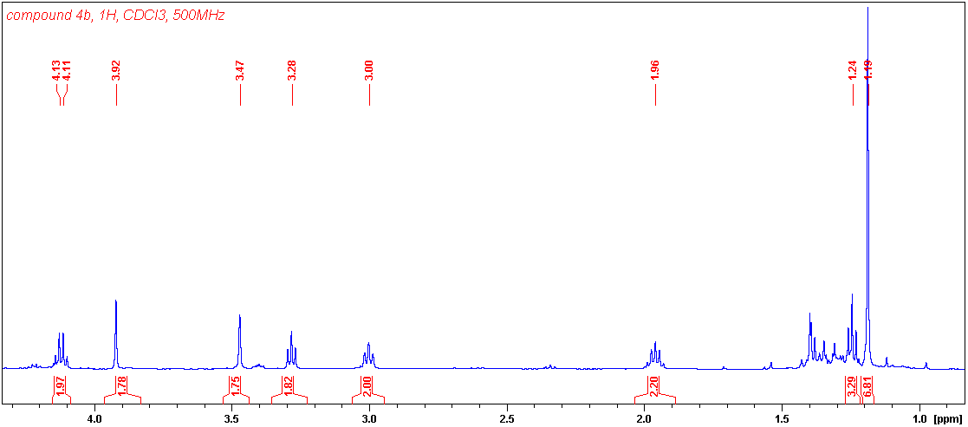

Compound **4b,** 13C, 125 MHz

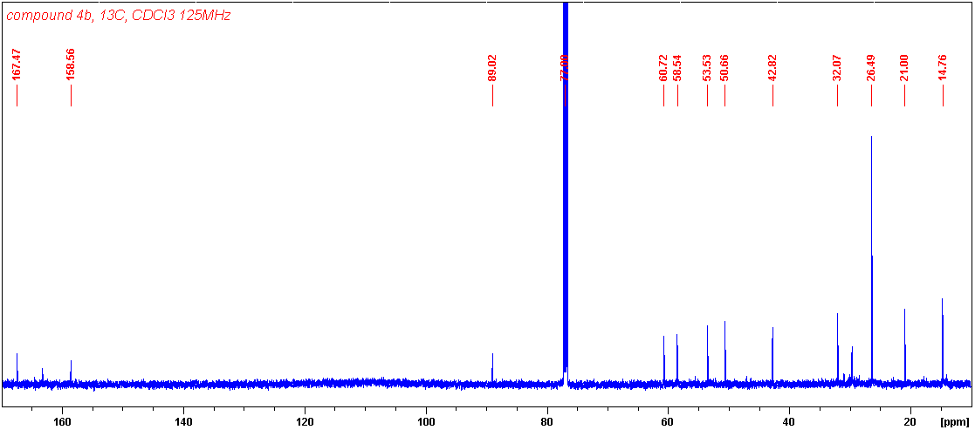

Compound **4d,** 1H, 500 MHz



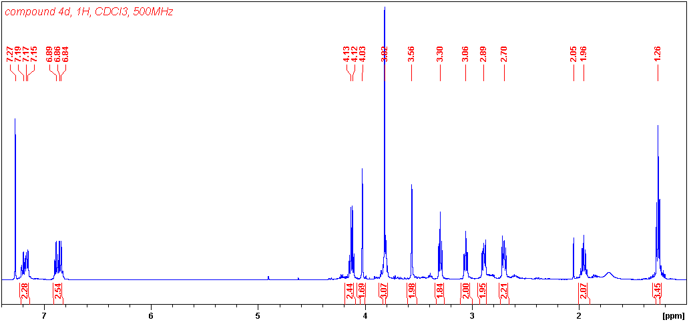

Compound **4d,** 13C, 125 MHz

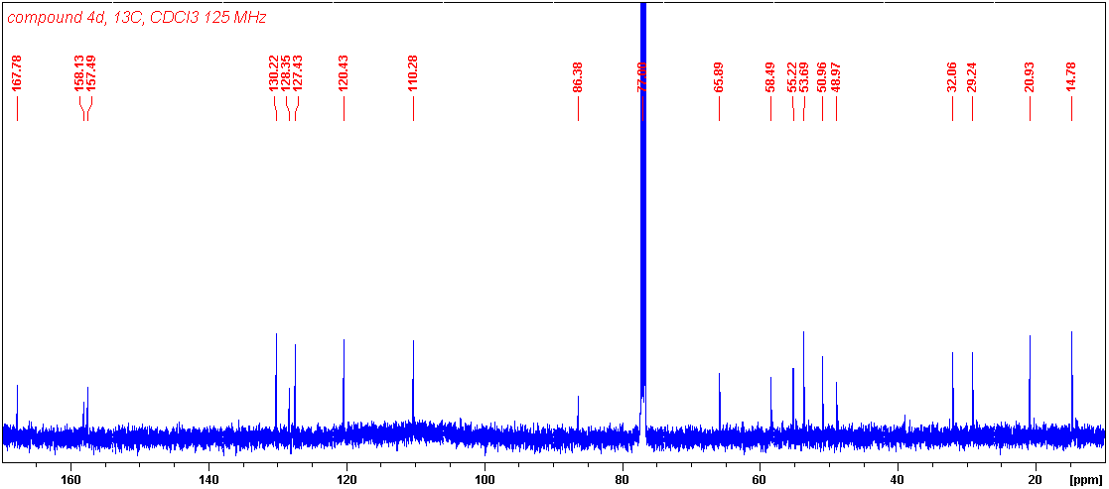

Compound **4d,** eHSQC, 500/125 MHz

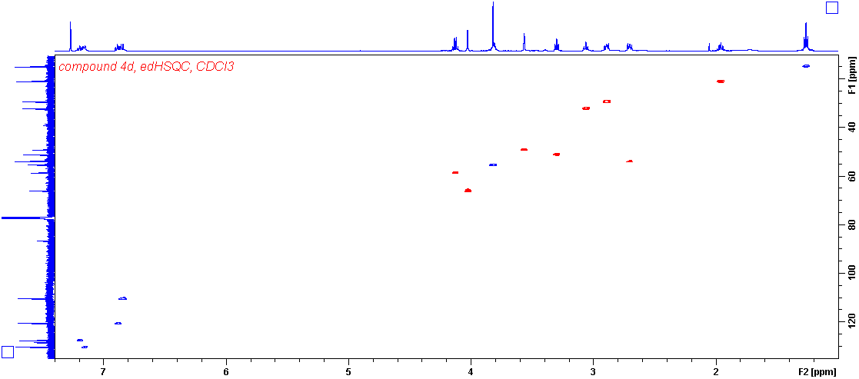

Compound **4h,** section eHSQC, 500/125 MHz



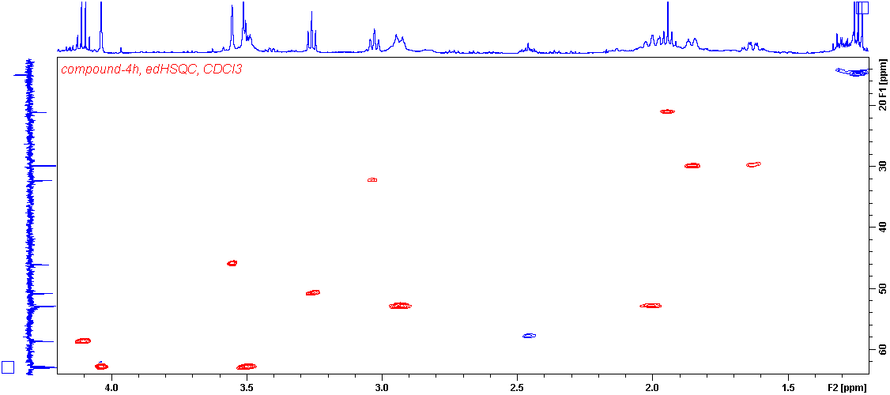

Compound **4h,** 1H, 300 MHz





Compound **4h,** 13C, 75 MHz



Compound **7,** 1H, 500 MHz

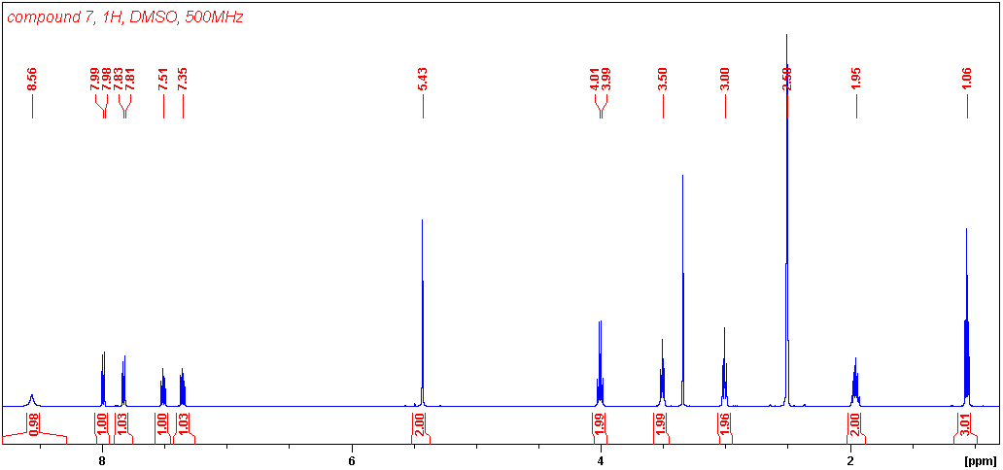

Compound **7, D**EPTQ, 125 MHz

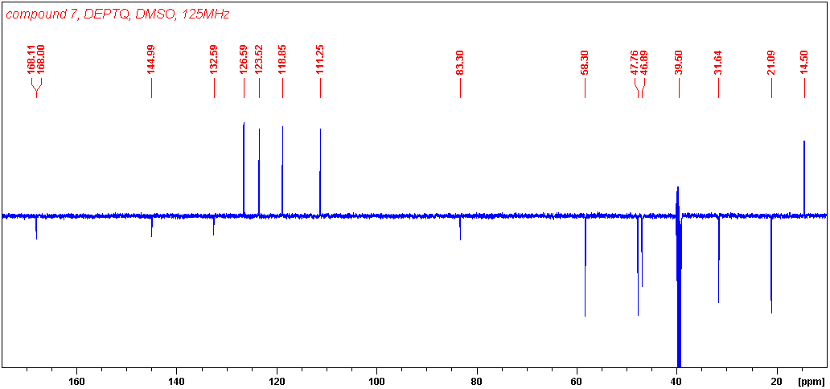

Compound **7,** HSQC, 500/125 MHz

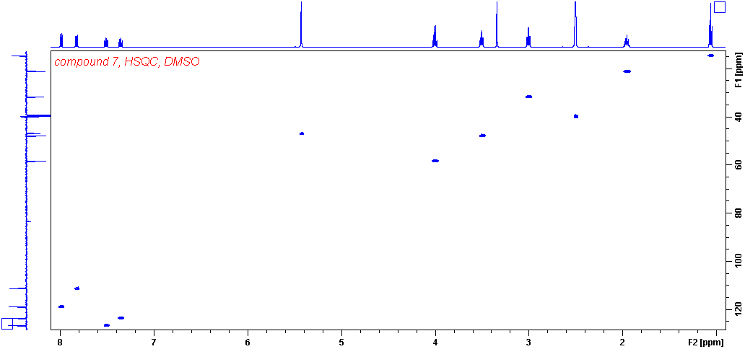

Compound **9,** 1H, 600 MHz



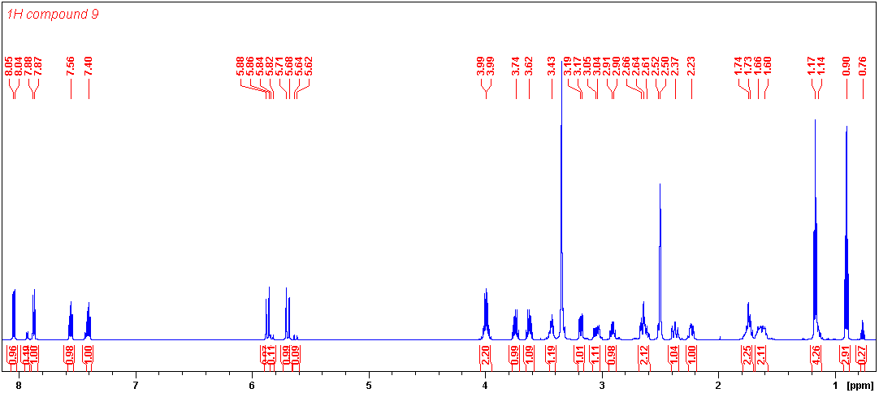

Compound **9a**, sel-NOE on Ha-1”, Hb-1” and H-6 600 MHz



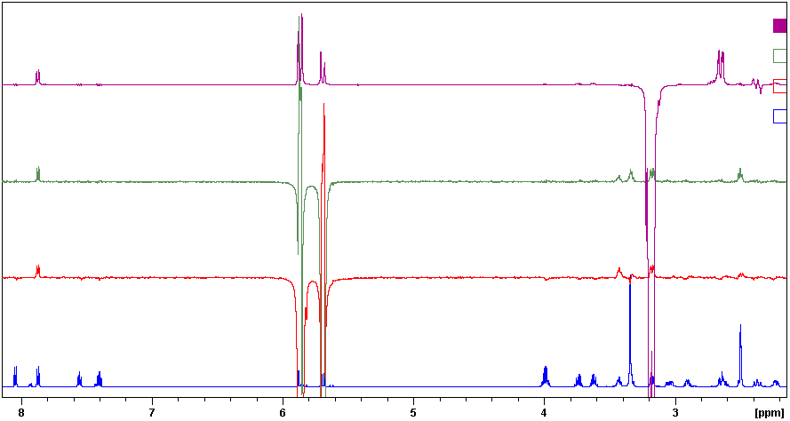

H-7” Ha-1” Hb-1” H-6 H-7

H-7” Ha-1” H-5’H-5’ H-6 H-3

H-7” Hb-1” H-5’H-5’ H-6 H-3

Compound **9a,** sel-TOCSY on H-6; H-3’ and H-3, 600 MHz

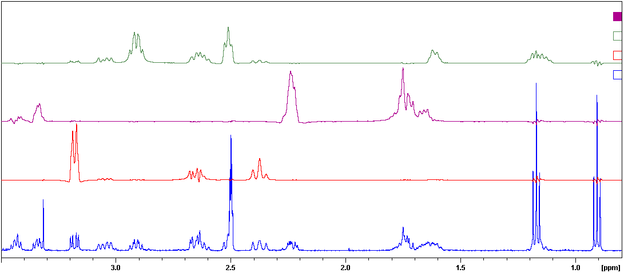

H-1 H-3 H-1 H-3 H-2 H-2

H-5’H-5’ H-3’ H-4’ H-4’

H-3’

H-6 H-7 H-7

Compound **9**, DEPTQ, 150 MHz



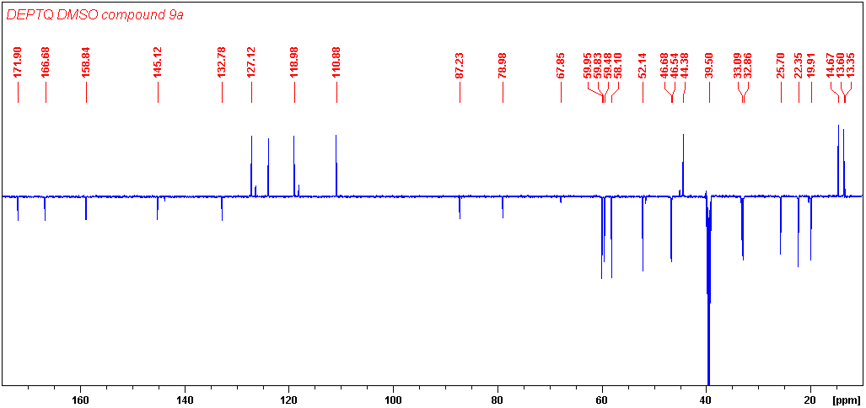

Compound **9**, edHSQC, 600/150 MHz

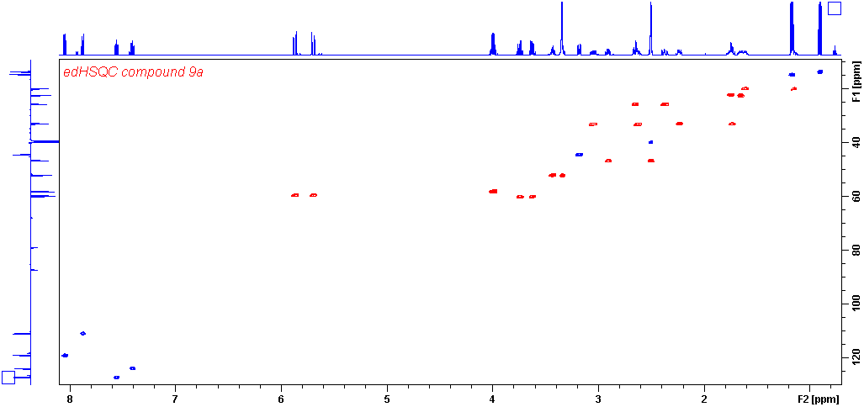

Compound **9**, edHSQC sections, 600/150 MHz

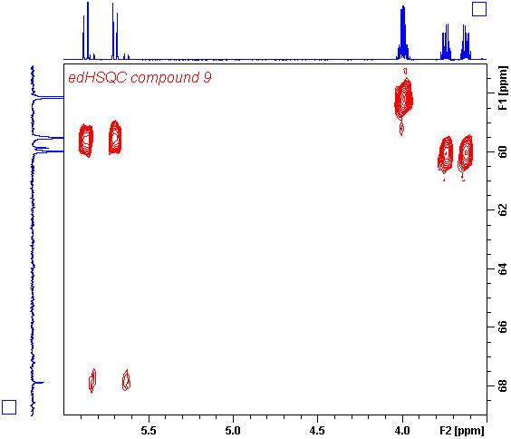

**9a** C-1a”=59.5

**9b** C-1a”=67.9

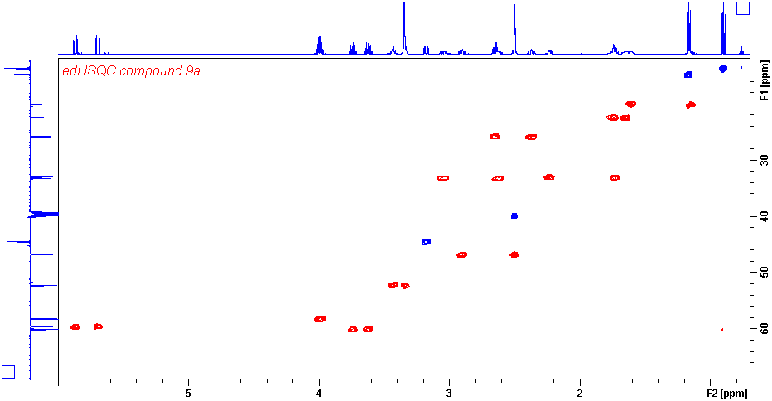

Compound **9**, HMBC, 600/150 MHz

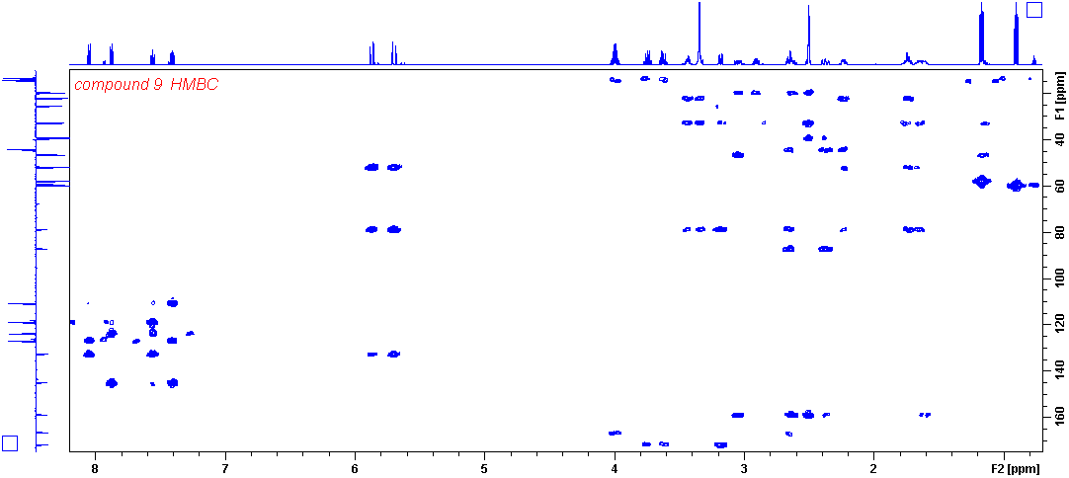

Compound **9**, HRMS

