**S1. Calculating spreading coefficients**

Figure S1 shows the configuration of a particle formed from two different phases.

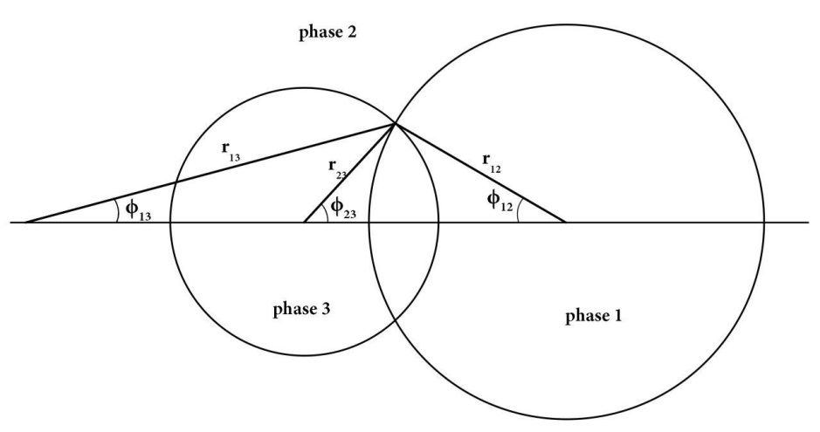

**Figure S1: Configuration of a two-phase particle showing various geometrical parameters**

*Φ*12, *Φ*13 and *Φ*23 can be extracted from FE-SEM images of Janus particles. *θ*1, *θ*2 and *θ*3 as interfacial angles are calculated using Equations (S1)-(S3):

 (S1)

 (S2)

 (S3)

Also, interfacial tensions can be obtained using Equation (S4):

 (S4)

The results obtained from FE-SEM images, Figure S1 and equations (S1)-(S4) for PMAA@PHEMA dumbbell-like Janus particles are summarized in Table S1.

**Table S1: Geometrical parameters, interfacial tensions and spreading coefficients of obtained Janus particles**

|  |  |  |
| --- | --- | --- |
| **Parameter** | **PMAA@PHEMA** | |
| **A** | **B** |
| **Φ12** | 24.4 | 34.7 |
| **Φ23** | 32.0 | 32.9 |
| **Φ13** | 14.0 | 19.3 |
| **θ1** | 169.6 | 164.6 |
| **θ2** | 56.4 | 67.6 |
| **θ3** | 134.0 | 127.8 |
| **σ12** | 16.1 | 14.8 |
| **σ13** | 18.7 | 17.3 |
| **σ23** | 4.0 | 4.9 |
| **S1** | -30.8 | -27.2 |
| **S2** | -1.4 | -2.4 |
| **S3** | -6.6 | -3.4 |

a: synthesized via one together feeding approach

b: synthesized via rest feeding approach