Choline Hydroxide: An efficient and biodegradable catalyst for the synthesis of 2-amino-3-nitro-4H-chromene derivatives in an aqueous medium
Suresh Kumar Krishnammagari, Kwon Taek Lim, Byung Gwon Cho, Yeon Tae Jeong*
Department of Image Science and Engineering, Pukyong National University, Busan 608-737, Republic of Korea
E-mail: ytjeong@pknu.ac.kr
Supplemental Materials
- Preparation of substituted 2-hydroxybenzaldehydes
- For the preparation of 4-aryloxy-2-hydroxy-benzaldehyde, we follow the procedure of Tanc et al..¹
i. Synthesis of 4-Benzyloxy-2-hydroxy-benzaldehyde (S1):
Anhydrous sodium bicarbonate (1.2 mmol) was added to a solution of 2,4-dihydroxy-benzaldehyde (1 mmol) in acetonitrile and the mixture was stirred for 1 hour at room temperature. Benzylbromide (1.1 mmol) was added and the mixture was refluxed for 24 hours. After disappearance of the reactant (TLC), the reaction was poured into ice water with vigorous stirring. A white solid precipitated was filter and purified by column chromatography (using ethyl acetate/n-hexane (1:9) as the eluent) to obtain 80 % yield as a white solid. Mp.² 80–81 °C; ¹H NMR (600 MHz, CDCl₃) δ 11.48 (s, 1H), 9.72 (s, 1H), 7.46 - 7.32 (m, 6H), 6.62 (dd, J = 8.8, 2.2 Hz, 1H), 6.52 (d, J = 2.2 Hz, 1H), 5.11 (s, 2H); ¹³C NMR (151 MHz, CDCl₃) δ 194.6, 166.0, 164.6, 135.8, 135.4, 128.9, 128.6, 127.7, 115.5, 109.1, 101.8, 70.6. Experimental data in agreement with reported data.³
ii. Synthesis of 4-(4-Nitrobenzyloxy)-2-hydroxybenzaldehyde (S2):
Following the representative procedure described above¹ the reaction of anhydrous sodium bicarbonate (1.2 mmol) was added to a solution of 2,4-dihydroxy-benzaldehyde (1 mmol) in acetonitrile and the mixture was stirred for 1 hour at room temperature. 4-Nitrobenzylbromide (1 mmol) was added and in CH₃CN on 24 h reflux yielded 4-(4-Nitrobenzyloxy)-2-hydroxybenzaldehyde in 72% after column purification with increasing amounts of EtOAc (5% to 20%) in hexanes as eluent. white solid, mp 147-149-98 ºC, ¹H NMR (600 MHz, CDCl₃) δ 11.48 (s, 1H), 9.75 (s, 1H), 8.27 (d, J = 8.7 Hz, 2H), 7.60 (d, J = 8.8 Hz, 2H), 7.48 (d, J = 8.6 Hz, 1H), 6.63 (dd, J = 8.6, 2.4 Hz, 1H), 6.49 (d, J = 2.4 Hz, 1H), 5.22 (s, 2H); ¹³C NMR (151 MHz, CDCl₃) δ 194.68, 165.15, 164.55, 147.92, 143.12, 135.64, 127.82, 124.13, 115.81, 108.82, 101.81, 69.01.
iii. Synthesis of 4-(4-Fluorobenzyloxy)-2-hydroxybenzaldehyde (S3):
Following the representative procedure described above¹ the reaction of anhydrous sodium bicarbonate (1.2 mmol) was added to a solution of 2,4-dihydroxy-benzaldehyde (1 mmol) in acetonitrile and the mixture was stirred for 1 hour at room temperature. 4-Florobenzylbromide (1 mmol) was added and in CH₃CN on 24 h reflux yielded 4-(4-Fluorobenzyloxy)-2-hydroxybenzaldehyde in 75% after column purification with increasing amounts of EtOAc (5% to 20%) in hexanes as eluent. white solid, mp 94-96 ºC, ¹H NMR (600 MHz, CDCl₃) δ 11.49 (s, 1H), 9.73 (s, 1H), 7.45 (d, J = 8.7 Hz, 1H), 7.41 – 7.38 (m, 2H), 7.11 – 7.07 (m, 2H), 6.60 (dd, J = 8.7, 2.3 Hz, 1H), 6.50 (d, J = 2.3 Hz, 1H), 5.07 (s, 1H); ¹³C NMR (151 MHz, CDCl₃) δ 194.59, 165.78, 164.57, 162.79 (d, J = 247.2 Hz), 135.47, 131.53 (d, J = 3.5 Hz), 129.59 (d, J = 8.1 Hz), 115.80 (d, J = 21.7 Hz), 115.50, 109.01, 101.69, 69.81.
iv. Synthesis of 4-((Naphthalen-1-yl)methoxy)-2-hydroxybenzaldehyde (S4):
Following the representative procedure described above¹ the reaction of anhydrous sodium bicarbonate (1.2 mmol) was added to a solution of 2,4-dihydroxy-benzaldehyde (1 mmol) in acetonitrile and the mixture was stirred for 1 hour at room temperature. 1-(bromomethyl)naphthalene (1 mmol) was added and in CH₃CN on 24 h reflux yielded 4-((Naphthalen-1-yl)methoxy)-2-hydroxybenzaldehyde in 70% after column purification with increasing amounts of EtOAc (5% to 20%) in hexanes as eluent. white solid, mp 111-113 ºC, ¹H NMR (600 MHz, CDCl₃) δ 11.52 (s, 1H), 9.74 (s, 1H), 7.99 (dd, J = 8.1, 1.1 Hz, 1H), 7.93 – 7.88 (m, 2H), 7.56 (ddt, J = 9.2, 6.9, 4.0 Hz, 3H), 7.50 – 7.45 (m, 2H), 6.67 – 6.64 (m, 2H), 5.54 (s, 1H); ¹³C NMR (151 MHz, CDCl₃) δ 194.60, 166.07, 164.63, 135.51, 133.92, 131.51, 131.08, 129.65, 128.97, 127.03, 126.85, 126.24, 125.43, 123.54, 115.52, 109.13, 101.75, 69.18.
b) For the preparation of 4-alkoxy-2-hydroxybenzaldehyde, we follow the literature procedure.^{4, 6}
i. Synthesis of 4-ethoxy-2-hydroxybenzaldehyde (S5):
To a solution of 2,4-dihydroxybenzaldehyde (0.690 g, 5.00 mmol) in acetone (20 mL), were added potassium carbonate (0.691 g, 5.00 mmol), 18- crown-6 (0.0661 g, 0.250 mmol) and 1- iodoethane (0.780 g, 5.00 mmol). The resulting mixture was heated at reflux with stirring for 48 h, under a nitrogen atmosphere. After evaporating the solvent, the brown residue was portioned between 30 mL of ethyl acetate and 20 mL of 1.0 M hydrochloric acid. The organic phase was washed with brine (2 x 10 mL), dried over anhydrous sodium sulphate and evaporated under vacuum. The oily-brown residue was purified by column chromatography (silica gel, eluent: hexane/ethyl acetate, 97 : 3) to afford a colourless oily product (35%). ¹H NMR (600 MHz, CDCl₃) δ 11.46 (s, 1H), 9.68 (s, 1H), 7.39 (d, J = 8.7 Hz, 1H), 6.50 (dd, J = 8.7, 2.4 Hz, 1H), 6.39 (d, J = 2.4 Hz, 1H), 4.06 (q, J = 7.0 Hz, 2H), 1.42 (t, J = 7.0 Hz, 3H). Experimental data in agreement with reported data.⁴
ii. Synthesis of 4-n-Butyloxysalicylaldehyde (S6)
Following the representative procedure described above.⁴ To a solution of 2,4-dihydroxybenzaldehyde (0.690 g, 5.00 mmol) in acetone (20 mL), were added potassium carbonate (0.828 g, 5.99 mmol), 18- crown-6 (0.0661 g, 0.250 mmol) and 1- bromobutane (0.752 g, 5.49 mmol). The resulting mixture was heated at reflux with stirring for 48 h, under a nitrogen atmosphere. After evaporating the solvent, the residue was portioned between 30 mL of ethyl acetate and 20 mL of 1.0 M hydrochloric acid. The organic phase was washed with brine (2 x 10 mL), dried over anhydrous sodium sulphate and evaporated under vacuum. The residue was purified by column chromatography (silica gel, eluent: hexane/ethyl acetate, 97 : 3) to afford a pale yellow oily product (30%). ¹H NMR (CDCl₃, 600 MHz) δ 11.48 (s, 1H), 9.69 (s, 1H), 7.42 (d, J = 8.7 Hz, 1H), 6.52 (d, J = 8.7 Hz, 1H), 6.41 (d, J = 2.1 Hz, 1H), 4.00 (t, J = 6.3 Hz, 2H), 1.60 (q, 2H), 1.44–1. .26 (m, 2H), 0.90 (t, J = 6.3 Hz, 3H). Experimental data in agreement with reported data.⁵
iii. Synthesis of 4-n-Octyloxysalicylaldehyde (S7)
2,4-Dihydroxybenzaldehyde (1 g, 7.24 mmol), 1- bromo-n-octane (1.66 mL, 7.5 mmol), NaHCO₃ (0.63 g, 7.5 mmol) and KI (catalytic amount) were mixed in dry acetone (25 mL) and the mixture refluxed for 48 h. It was then filtered hot to remove the insoluble solid. The warm solution was neutralised by adding dilute HCl and extracted twice with CHCl₃ (20 mL), and the combined extract dried over anhydrous sodium sulphate, concentrated and it was purified by column chromatography using silica gel, eluting with a mixture of chloroform and hexane (1:1 v/v), followed by evaporation of the solvent. The product was obtained 68% yield as a pale yellow liquid. ¹H NMR (600 MHz, CDCl₃) δ 11.49 (s, 1H), 9.70 (s, 1H), 7.41 (d, J = 8.6 Hz, 1H), 6.52 (dd, J = 8.6, 2.3 Hz, 1H), 6.41 (d, J = 2.3 Hz, 1H), 4.00 (t, J = 6.6 Hz, 2H), 1.82 – 1.75 (m, 2H), 1.47-1.42 (m, 2H), 1.38 – 1.23 (m, 8H), 0.89 (t, J = 7.0 Hz, 3H). Experimental data in agreement with reported data.⁶
- Procedure for the preparation of ChOH⁷
ChOH was synthesized according to a literature procedure. Choline chloride (7 mmol) was dissolved in methanol (15 mL), KOH (7 mmol) was added slowly at room temperature, and the mixture was heated at reflux for overnight. After mixture cooling to room temperature, the reaction mixture was filtered to remove solid KCl, concentrated to remove methanol until the weight of the residue remained constant, and used without further purification. ChOH was characterized using a mass spectrum, it is provided in the Supporting information. The massspectra showed good agreement with the reported results. The mass spectrum clearly showed the exact molecular weight of the ChOH.^{18b} MS (FAB, m/z): [M+H]⁺ calcd for C₅H₁₅NO₂, 122.11; found 122.09.
- General procedure for the synthesis of N-Methyl-4-(methylthio)-3-nitro-4H-chromen-2-amine derivatives derivatives (3a-x).
Procedure: Synthesis of N-Methyl-4-(methylthio)-3-nitro-4H-chromen-2-amine (3a)
The ChOH 10 mol% in water (3 mL) was added to a mixture of 2-hydroxybenzaldehyde (1a, 1.0 mmol) and (E)-N-methyl-1-(methylthio)-2-nitroethenamine (2, 1.0 mmol) (1 mmol) in a 10 mL reaction flask equipped with a magnetic stirrer. The resulting mixture was stirred for the appropriate time at room temperature. After completion of the reaction (confirmed by TLC, hexanes: EtOAc 1:1), the solid product was filtered and washed with water. The obtained crude product was recrystallized from ethanol to yield the pure product. The same method was adopted for the synthesis of all the targeted Products 3a-x.
5. References
- Tanc, M.; Carta, F.; Bozdag, M.; Scozzafava, A.; Supuran, C. T. Bioorganic & Medicinal Chemistry, 2013, 21, 4502-4510.
- Rahul, S. K.; Paul, W. E. Org. Lett. 2008, 10, 5007-5010.
- Murphy, G. K.; Hama, N.; Bedermann, A.; Dong, P.; Schneider, C. M.; McMahon, T. C.; Tao, R. N.; Twenter, B. M.; Spiegel, D. A.; Wood, J. L. Org. Lett. 2012, 14, 4544-4547.
- Consiglio, G.; Failla, S.; Finocchiaro, P.; Oliveri, I. P.; Di Bella, S. Dalton Trans. 2012, 41, 387-395.
- Venkatesh, G.; Kalpana, U.; Golam, M.; Rao, N.V.S. Liquid Crystals 2013, 40, 120-129.
- Rahul, K. N.; Dipika, D. S.; Shankar Rao, D. S.; Rao, N.V.S. Liquid Crystals 2012, 39, 889-902.
- Kalla, R. M. N.; Zhang, Y.; Kim, Il. New J. Chem. 2017, 41, 5373-5379.

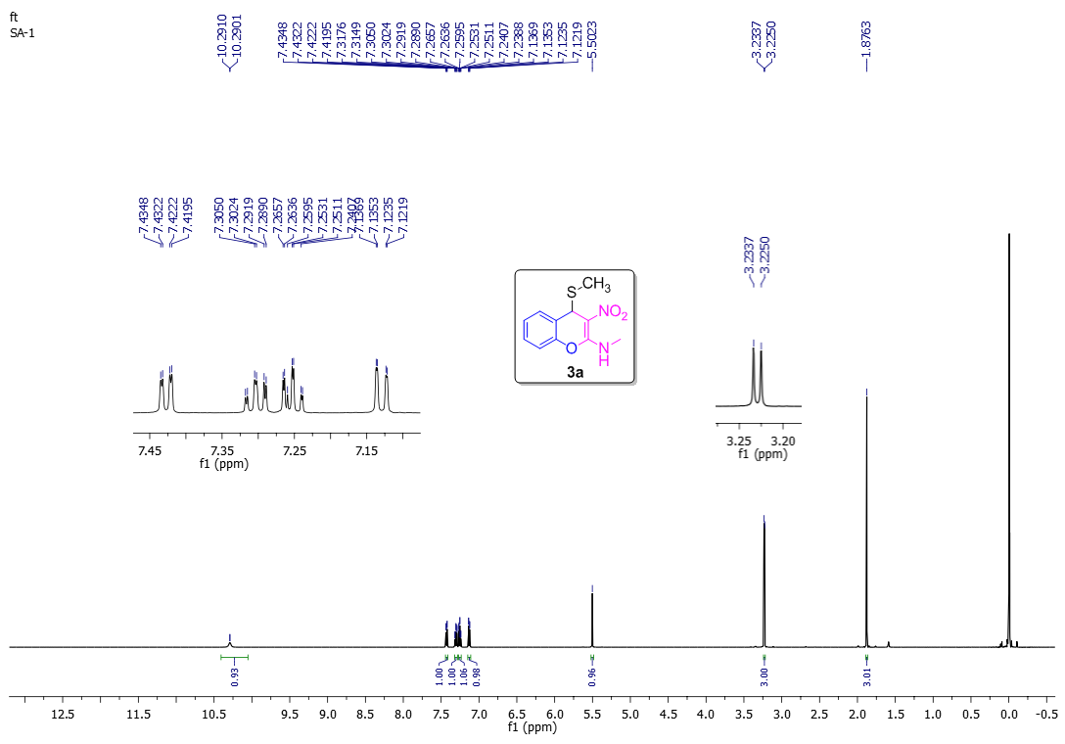
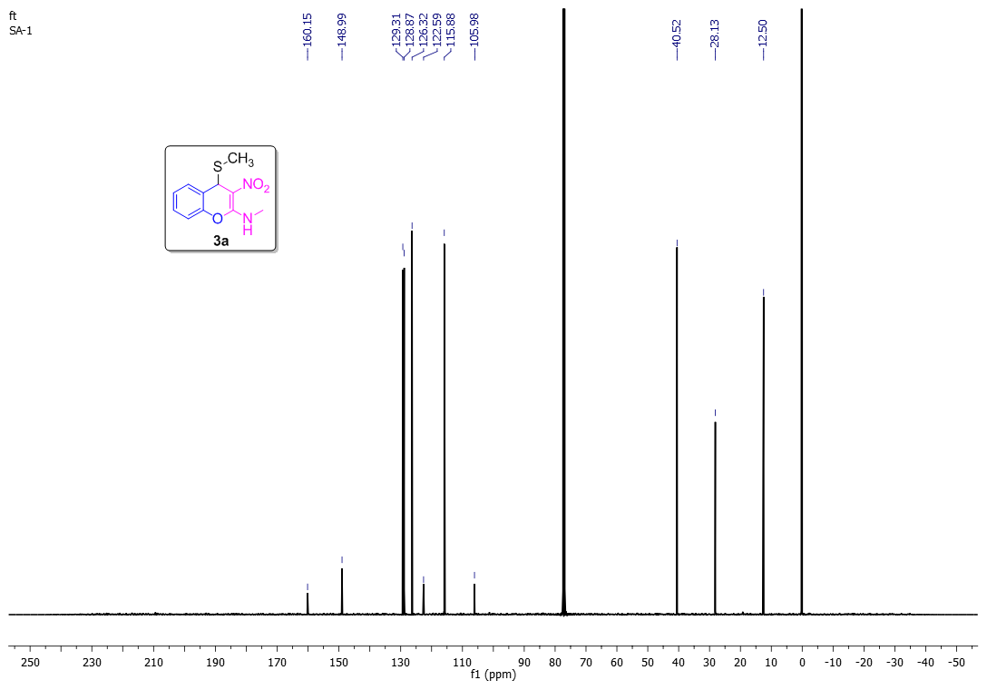
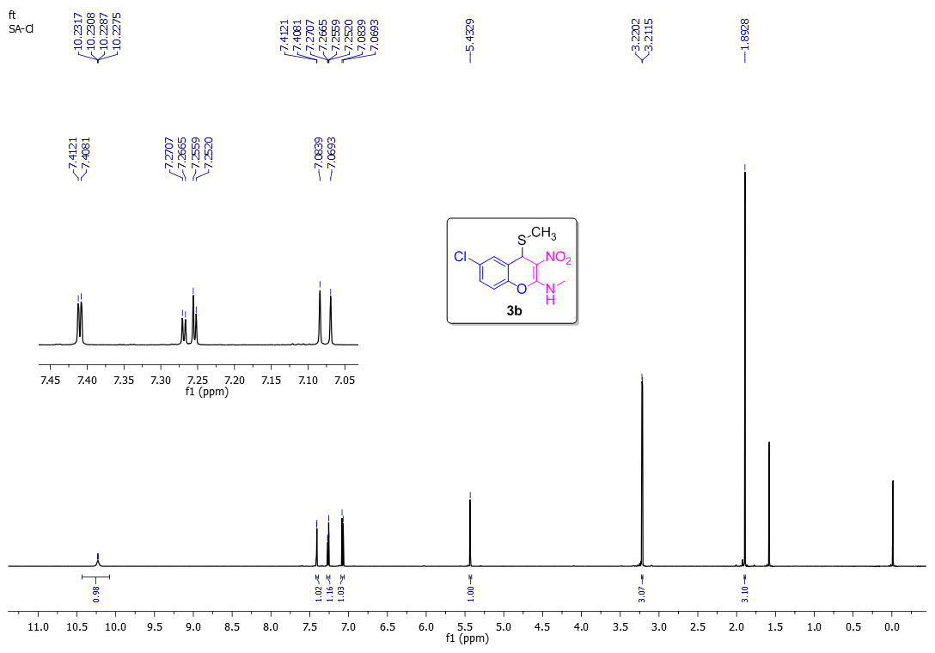
Figure S 1: ¹H NMR of 3b
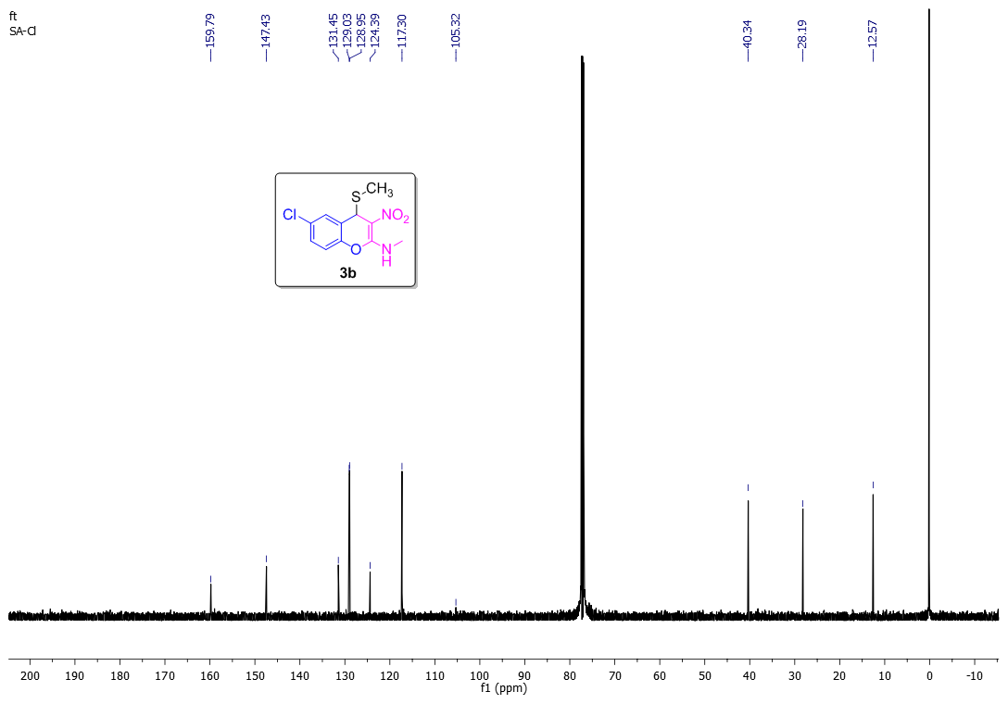
Figure S 2: ¹³C NMR of 3b
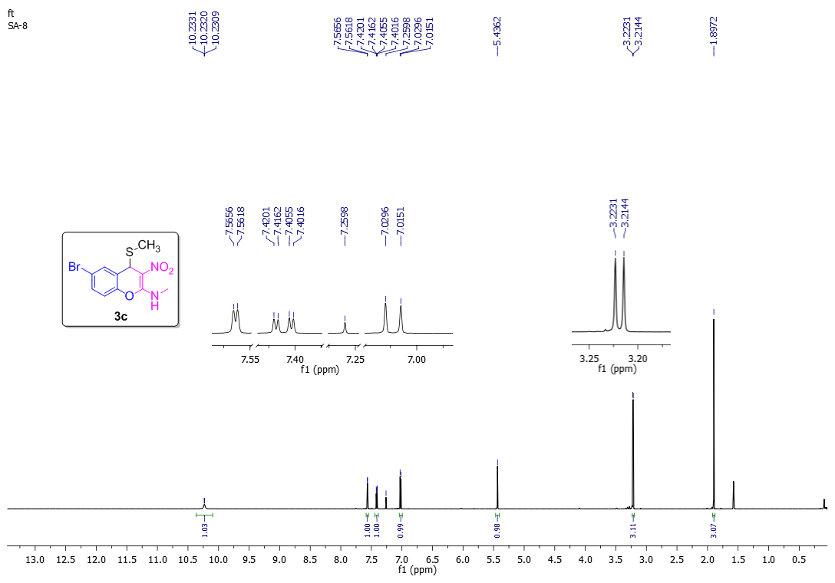
Figure S 3: ¹H NMR of 3c
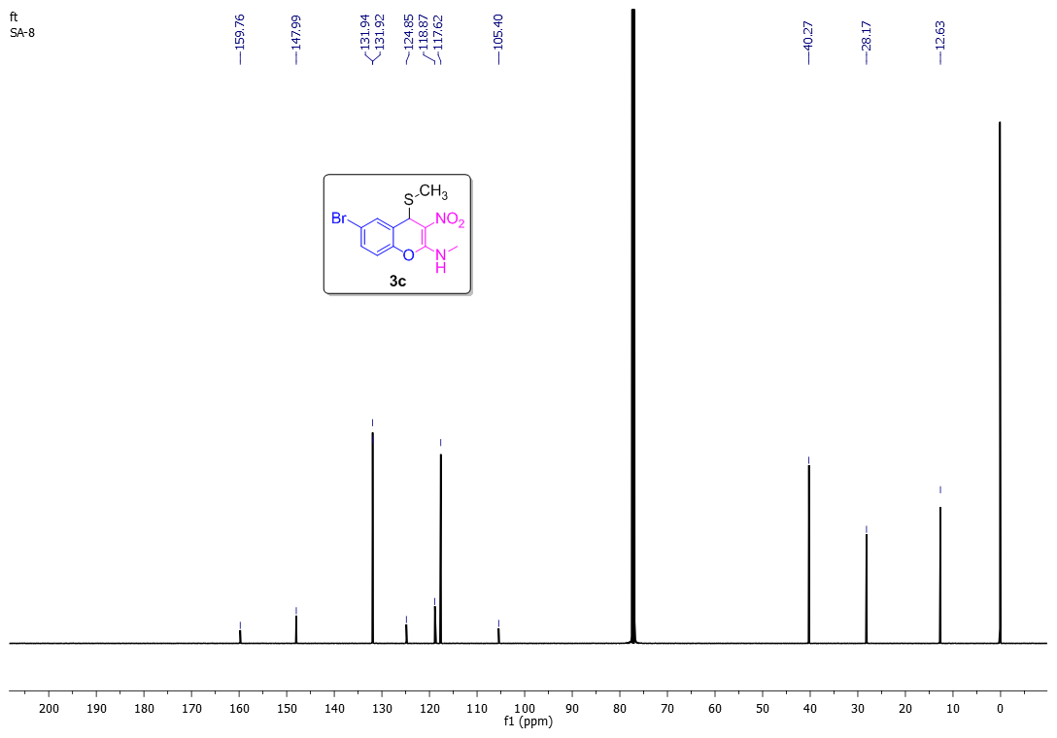
Figure S 4: ¹³C NMR of 3c
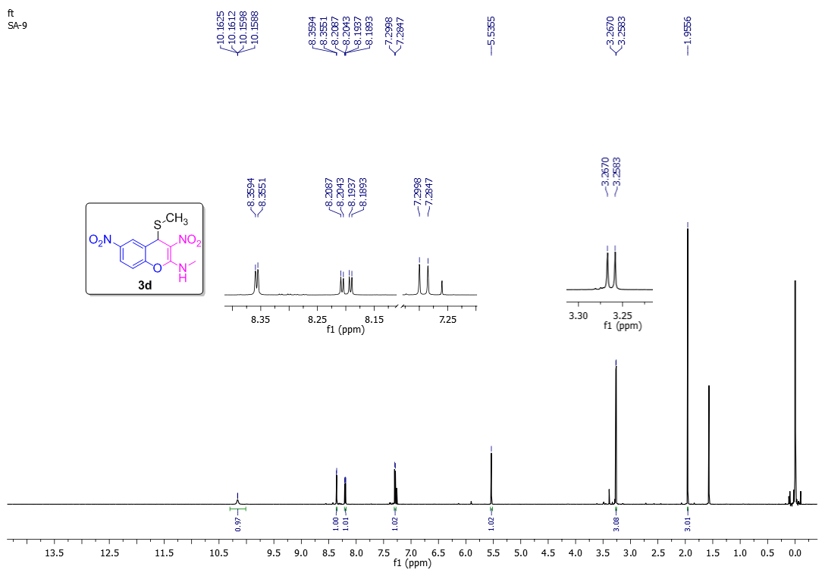

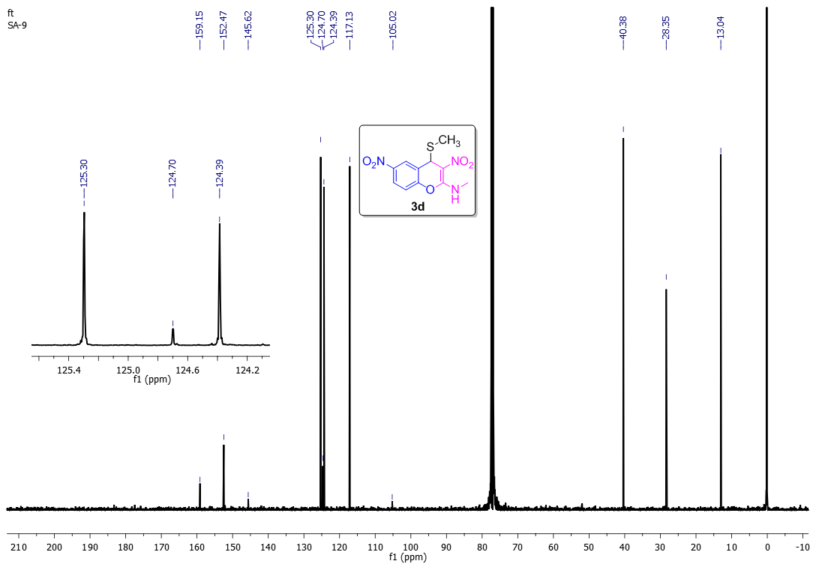
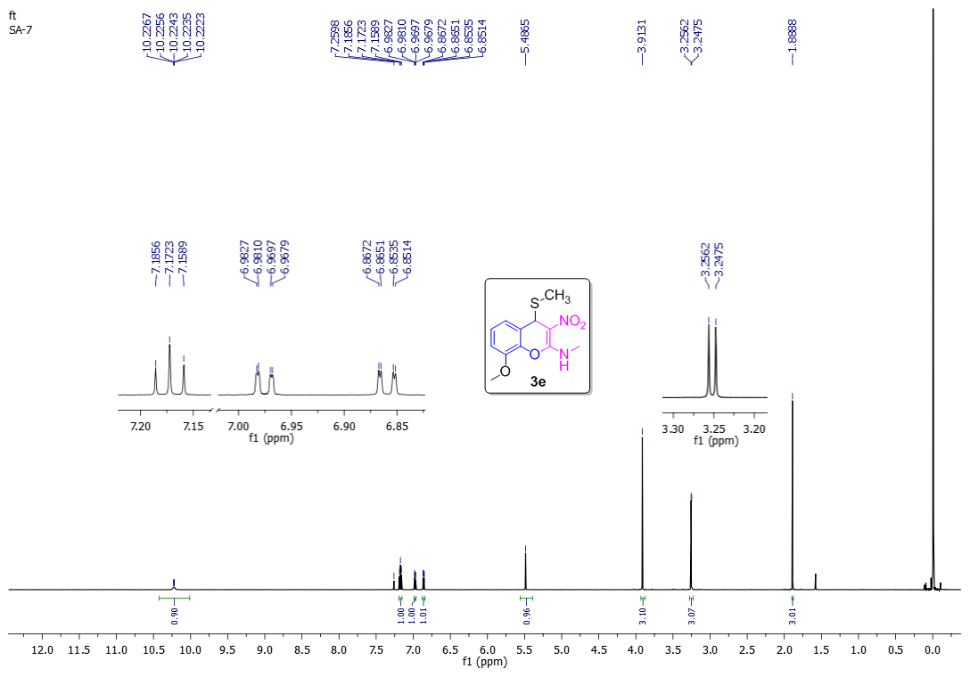

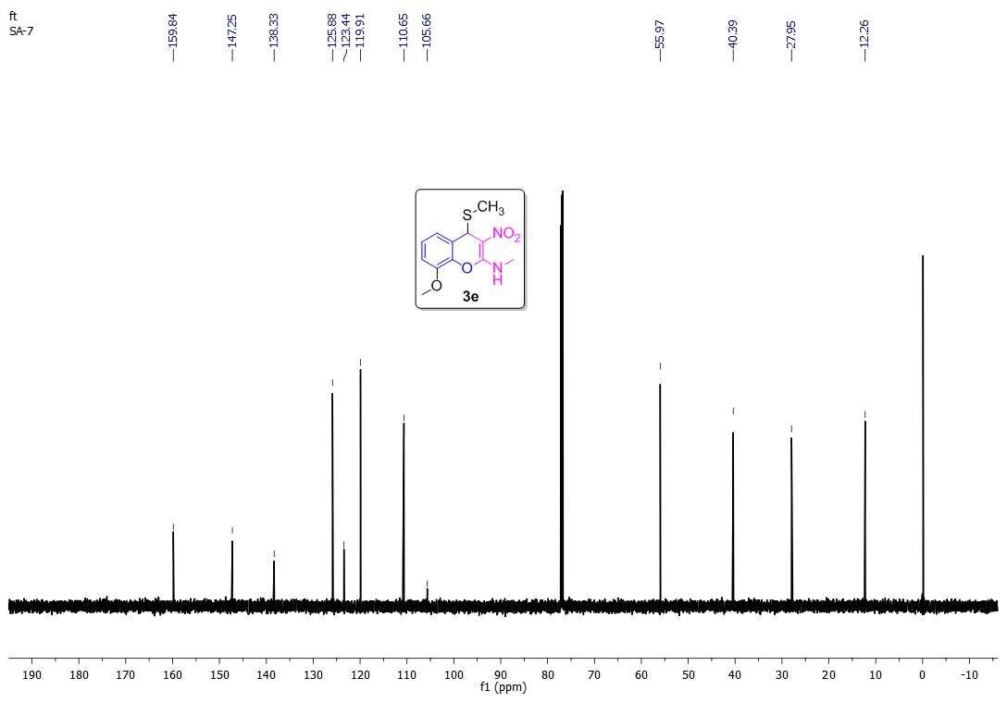
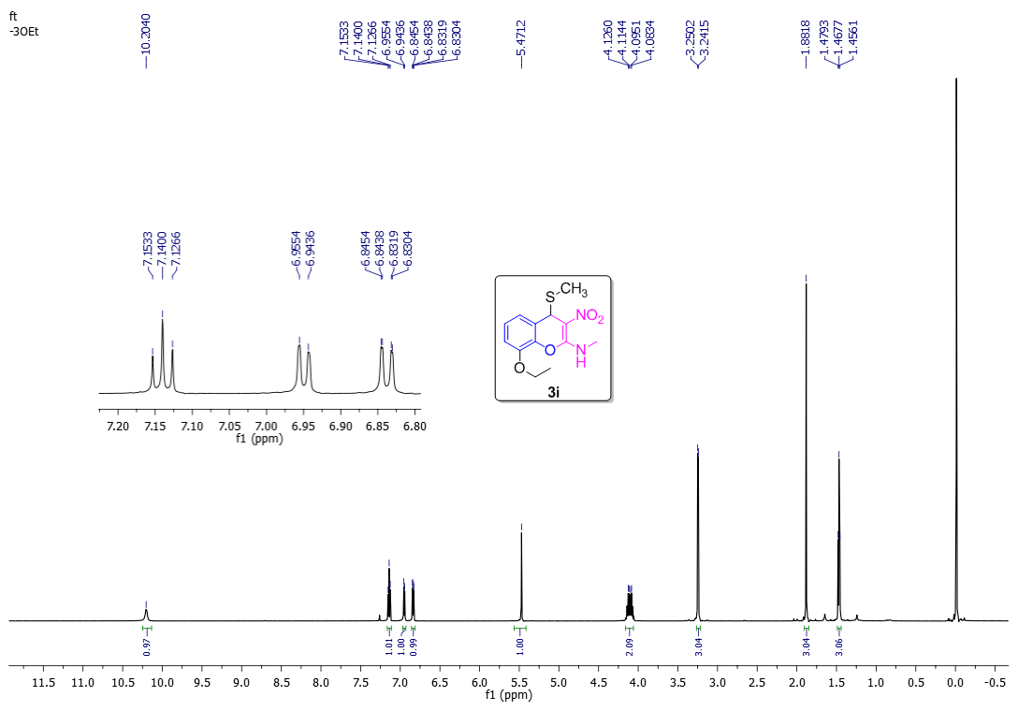

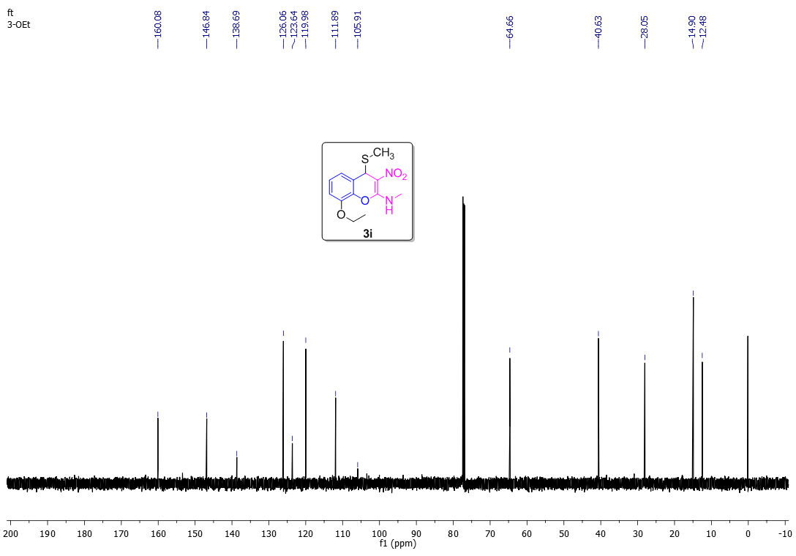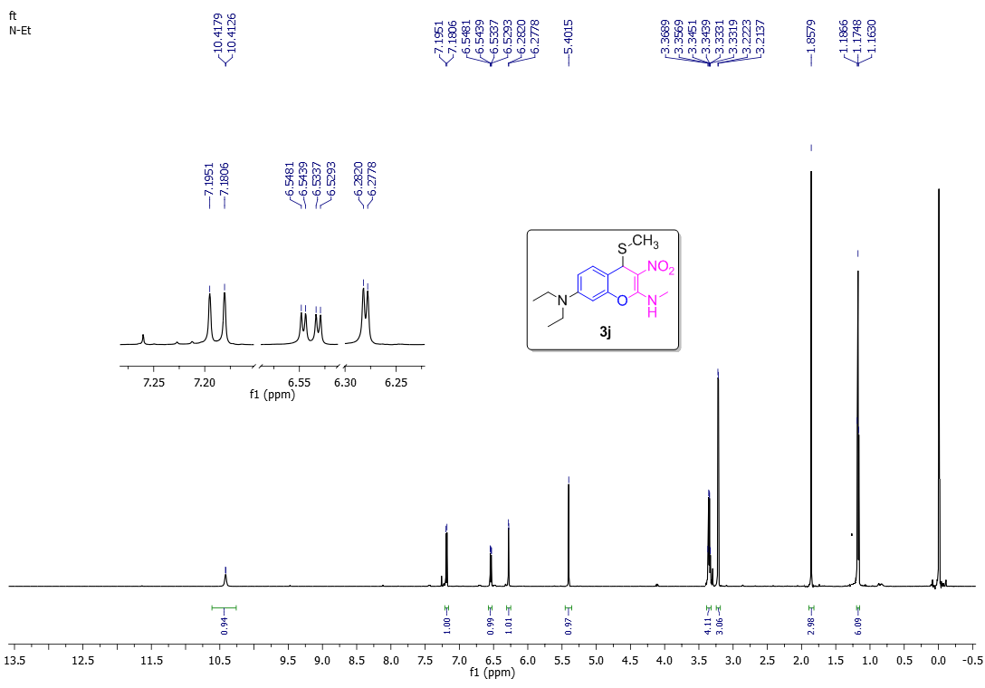

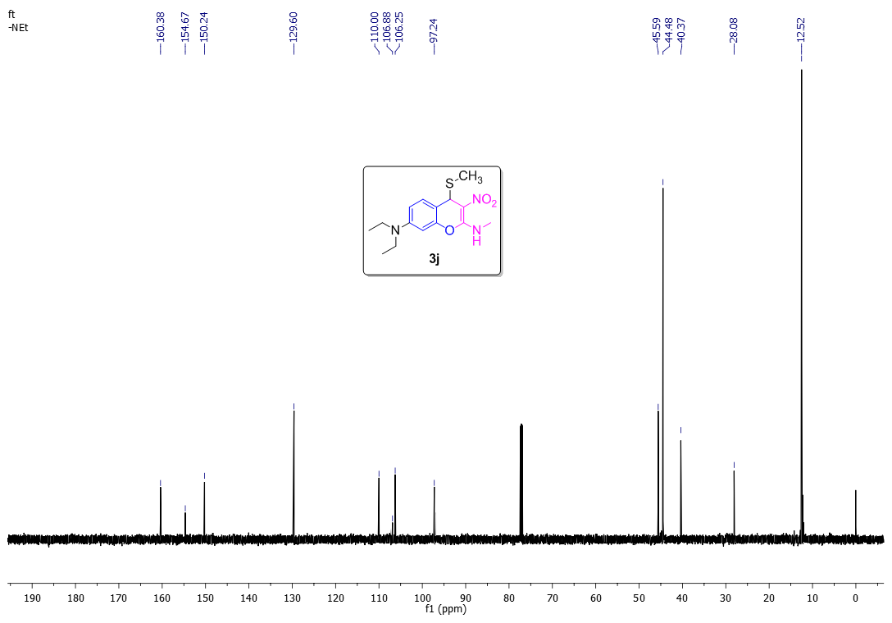
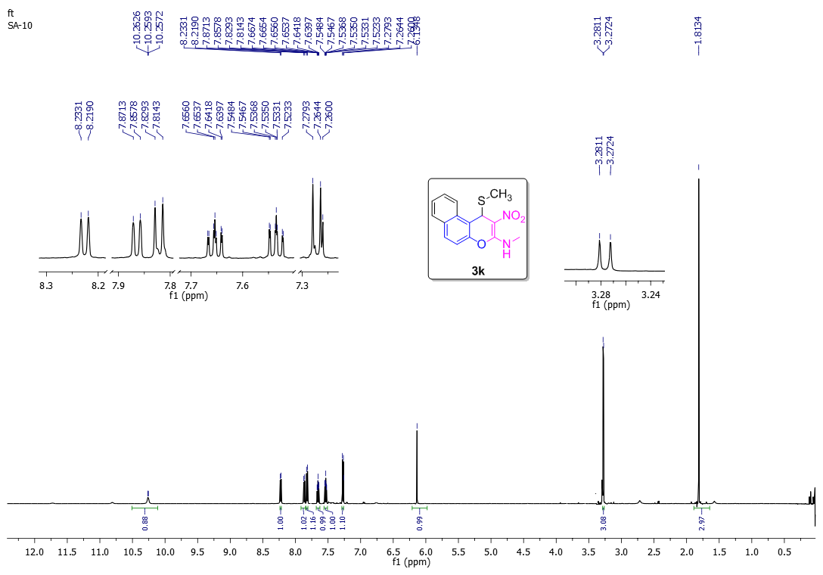

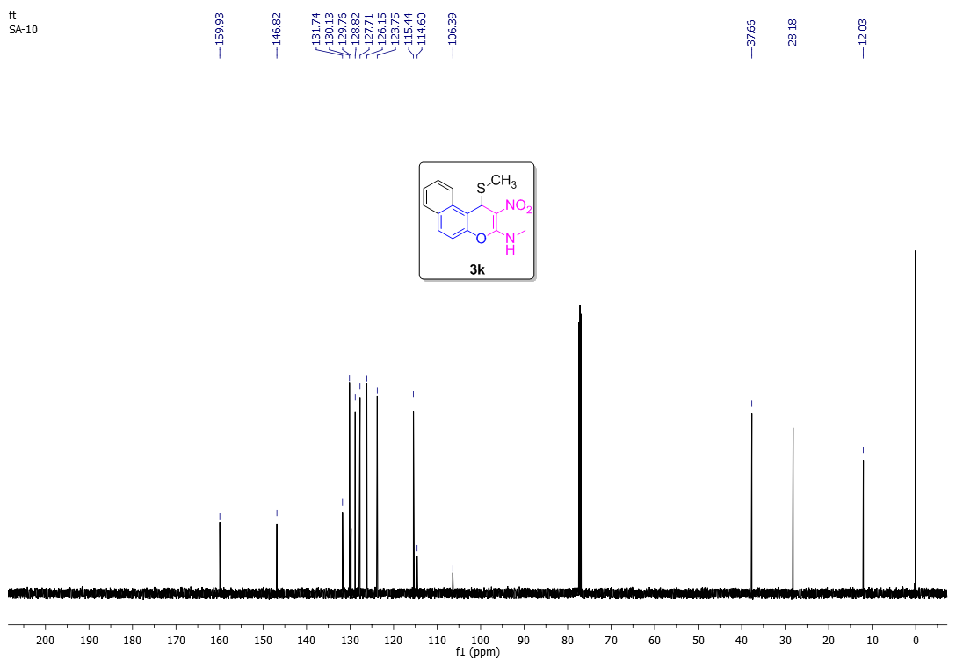
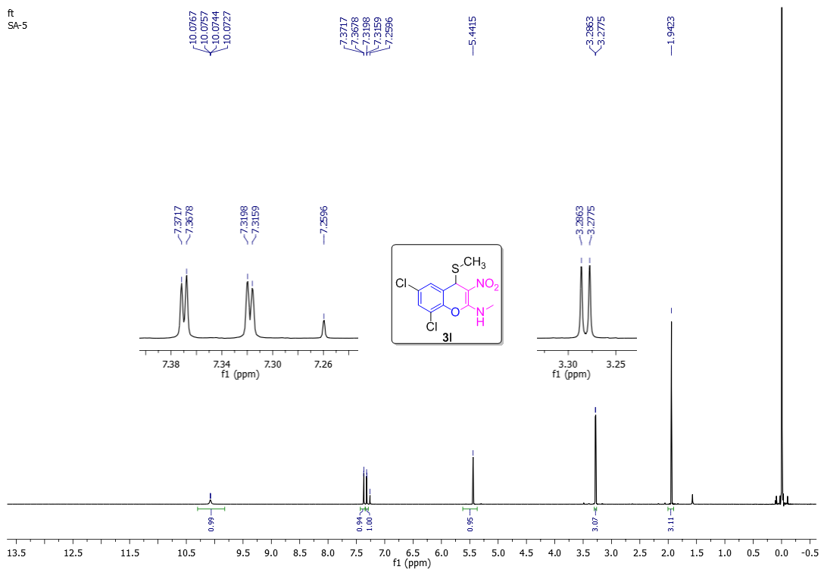

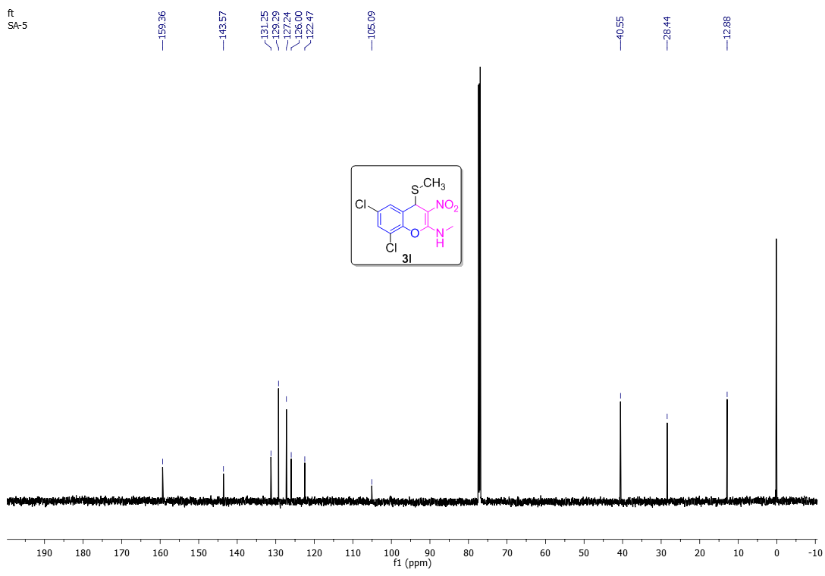
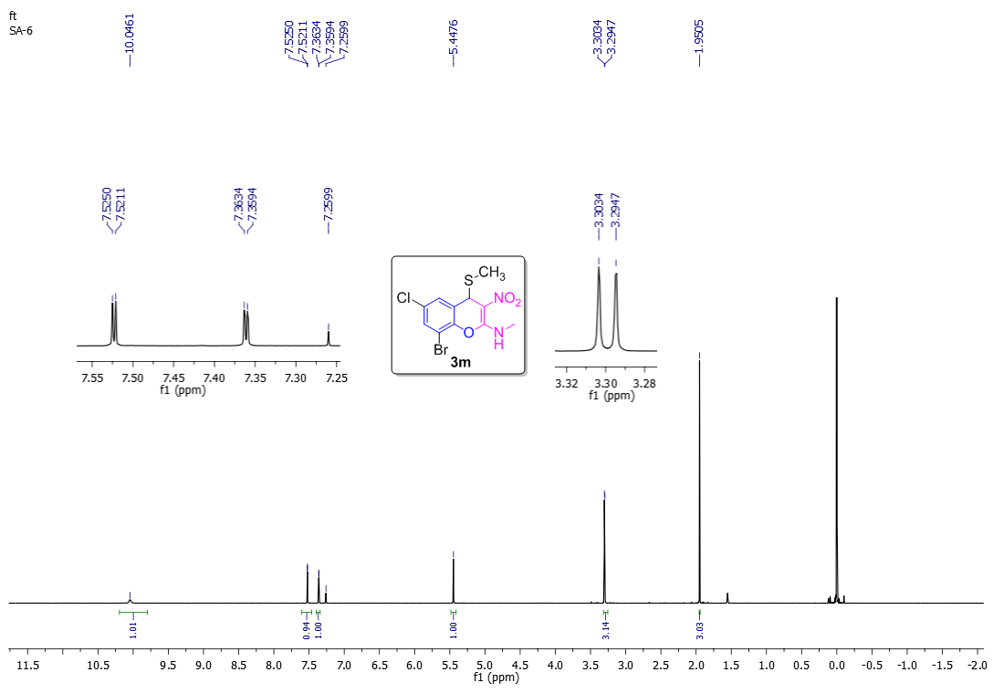

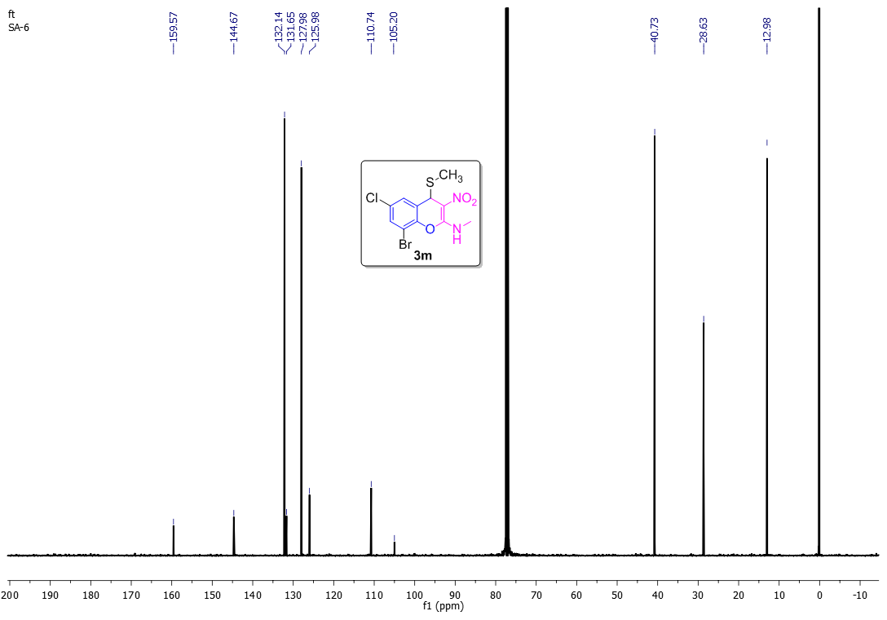
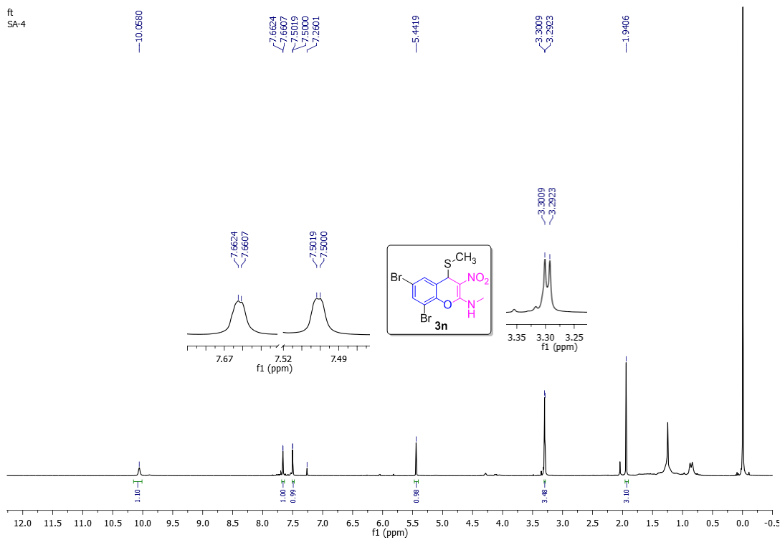

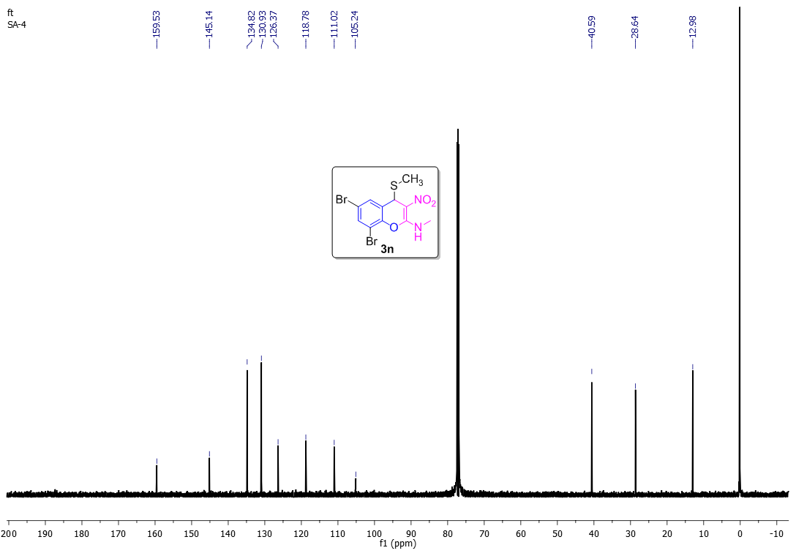
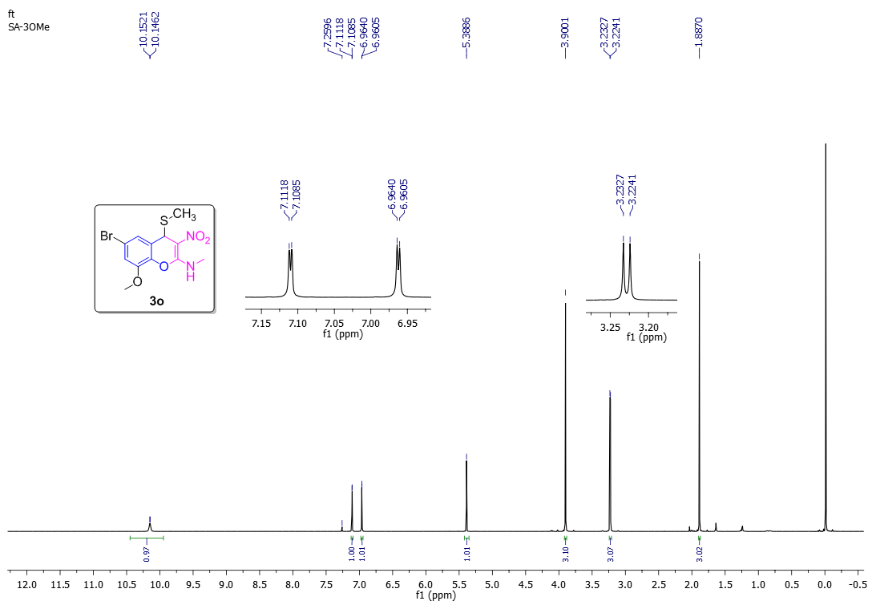

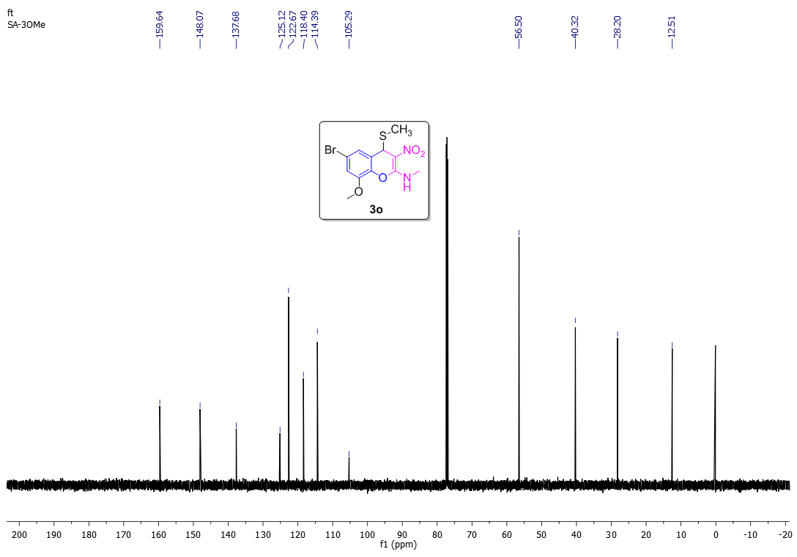
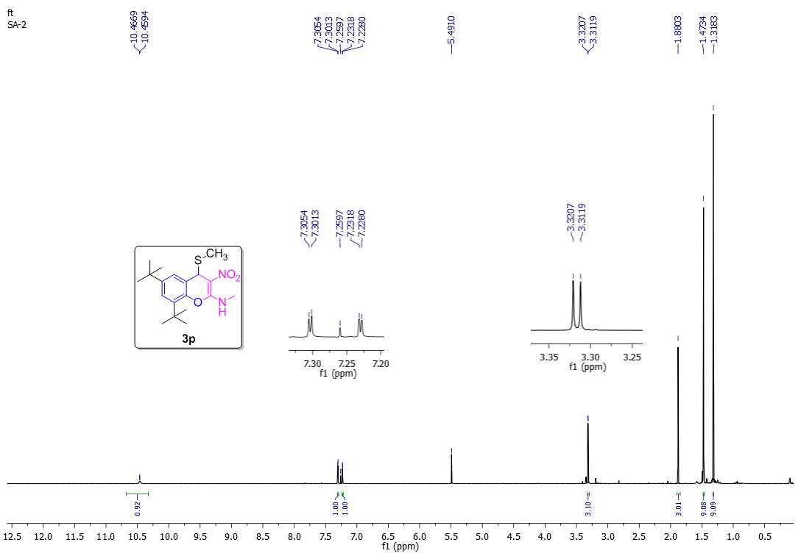

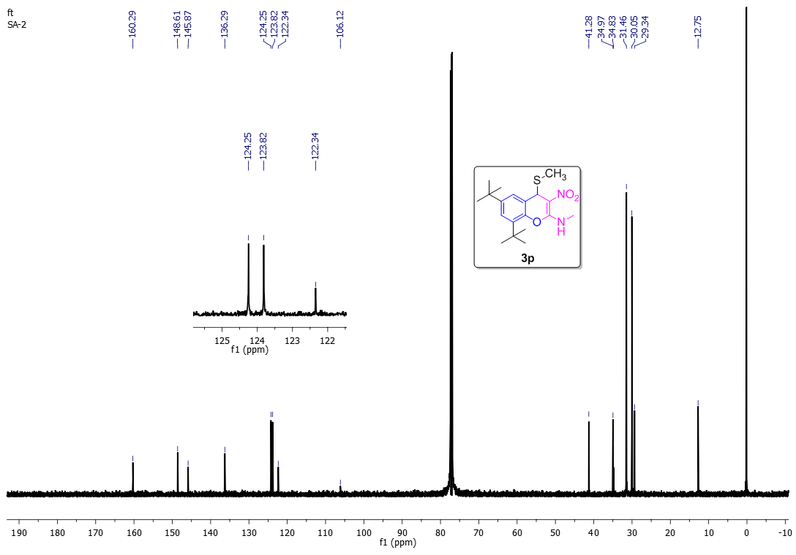
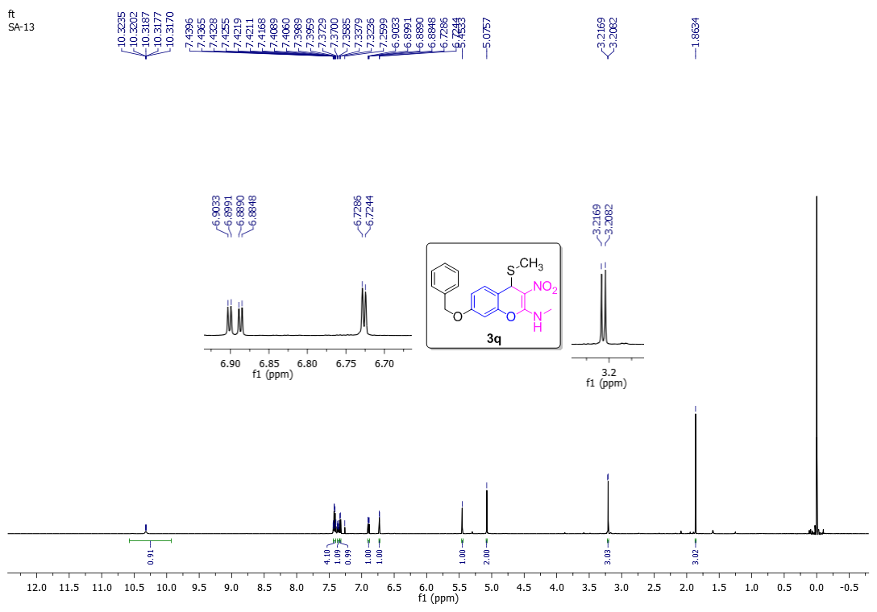

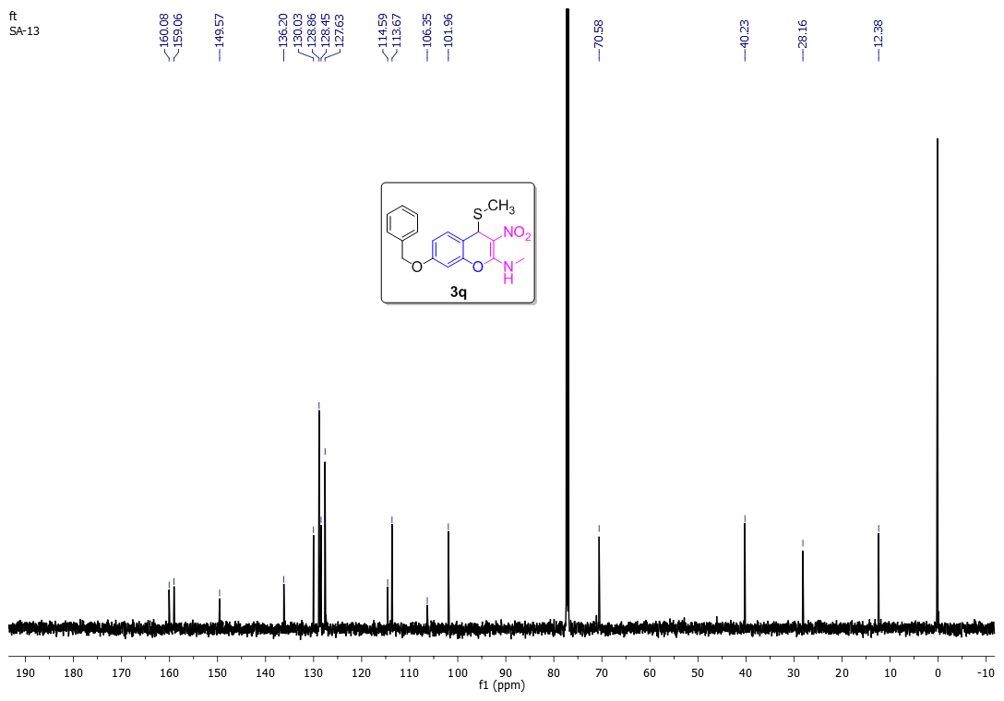
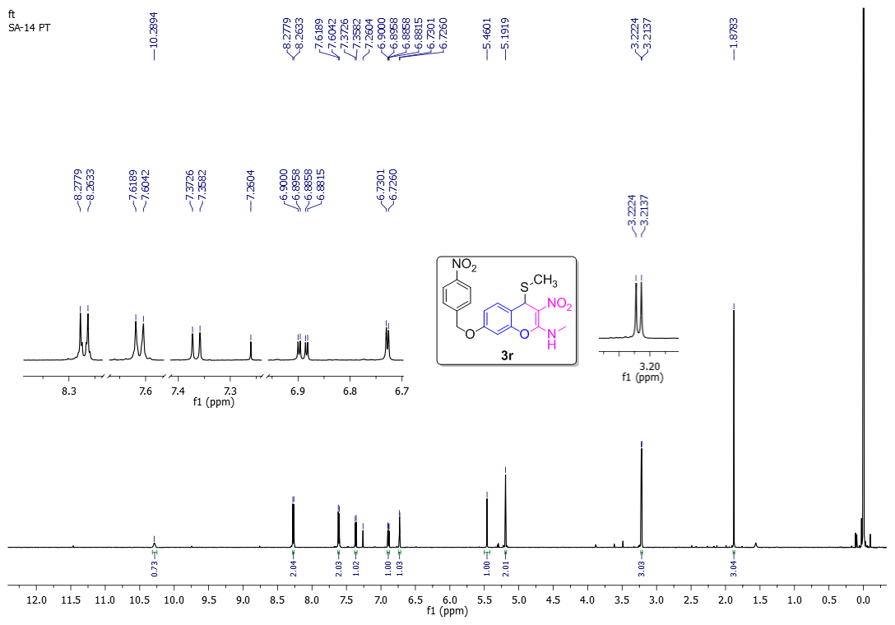

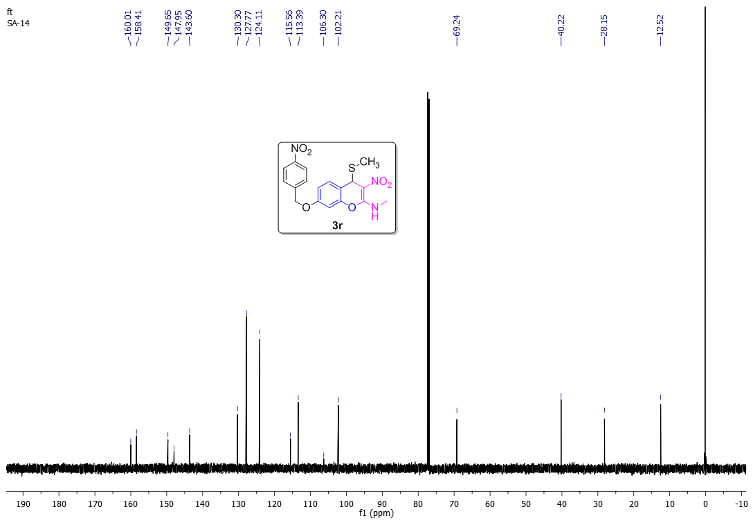
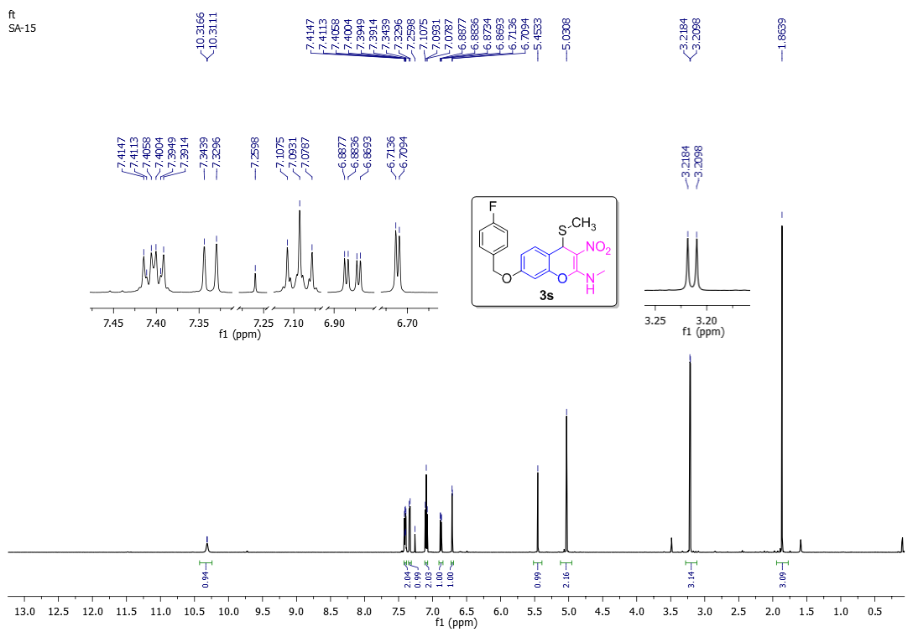

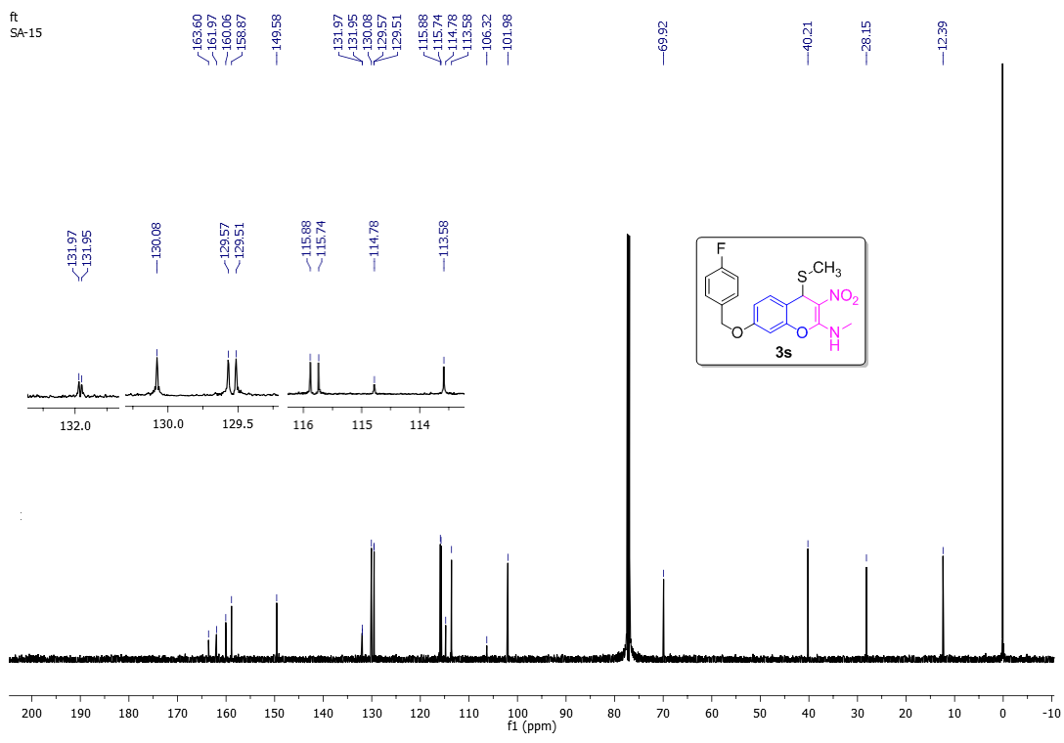
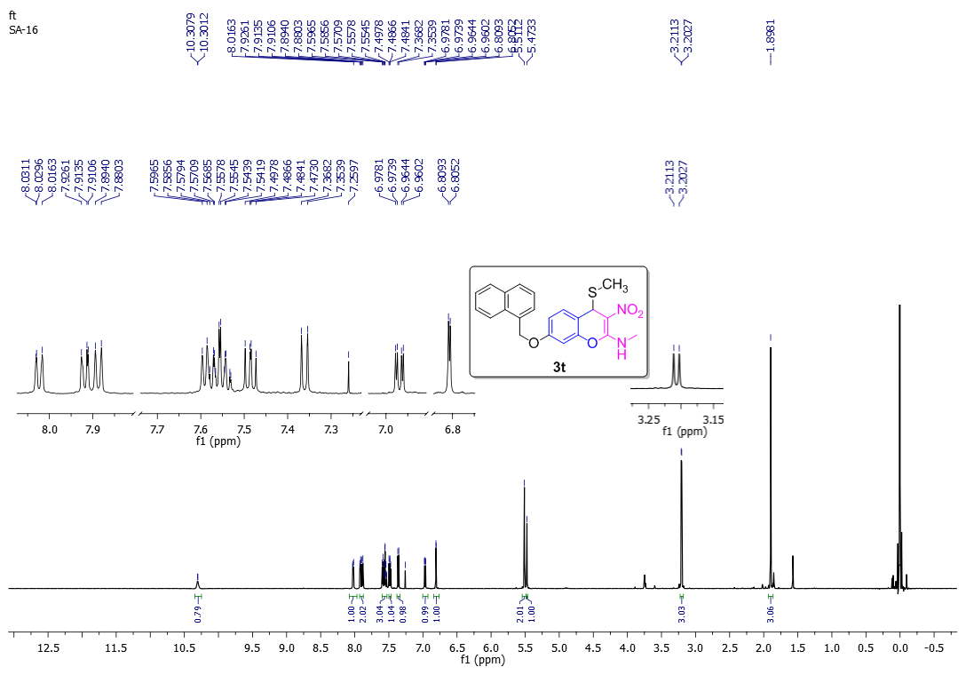

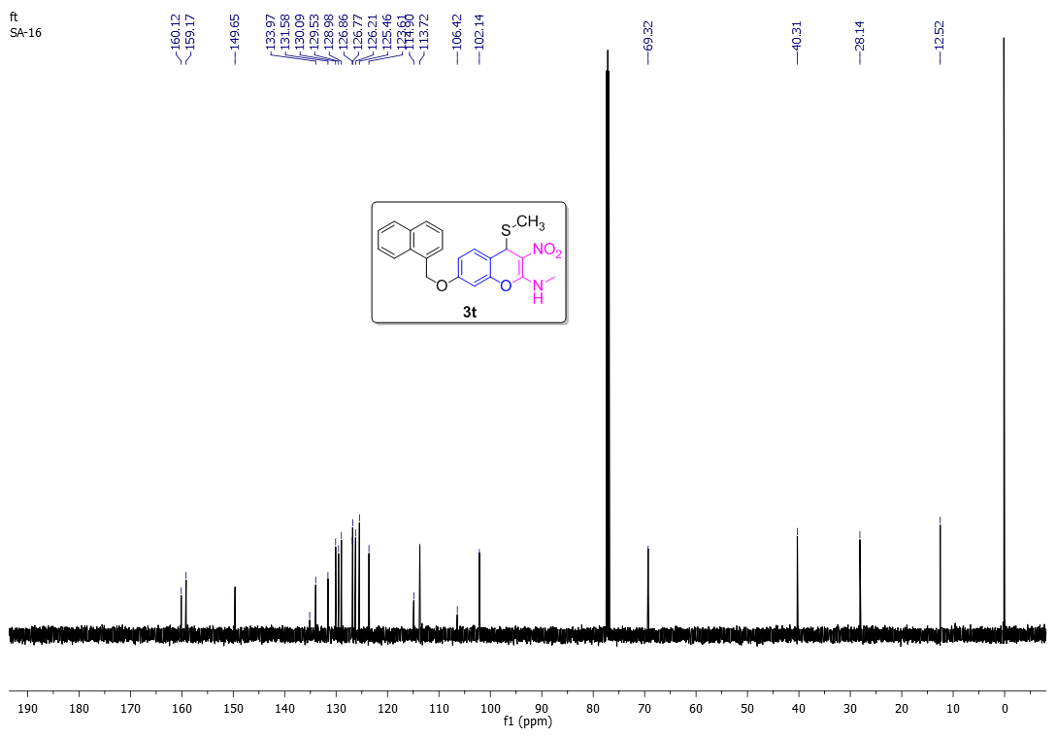
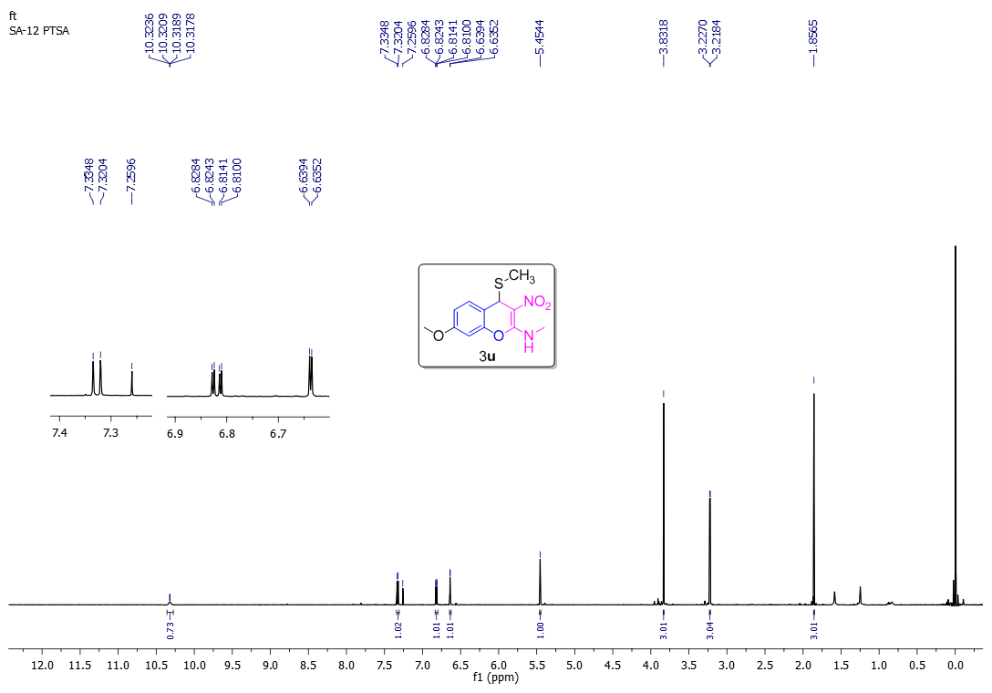
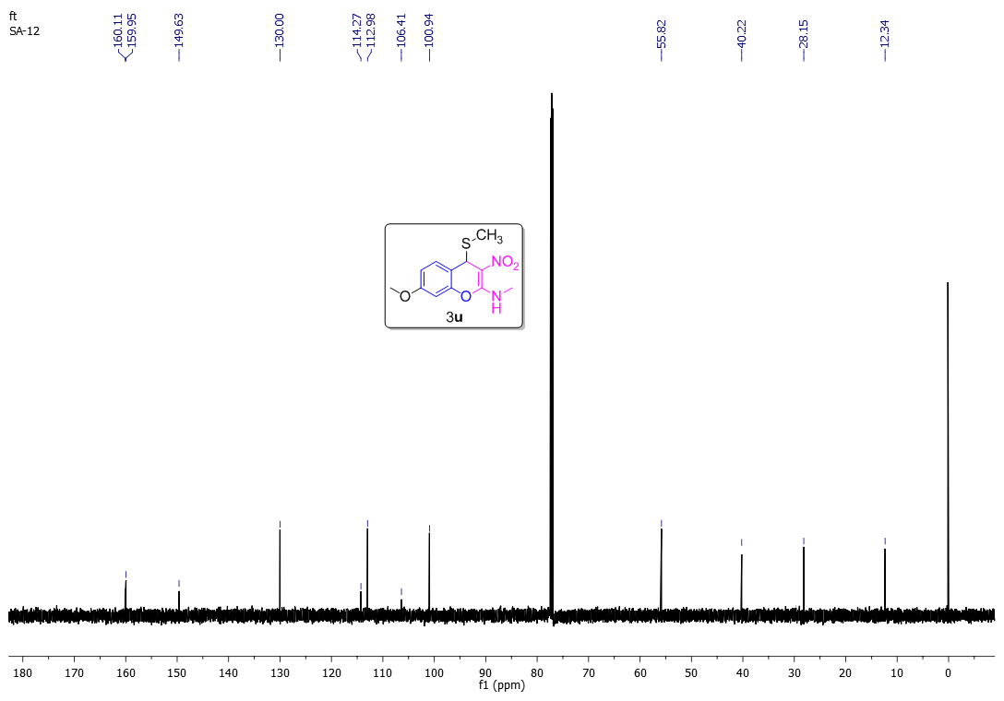
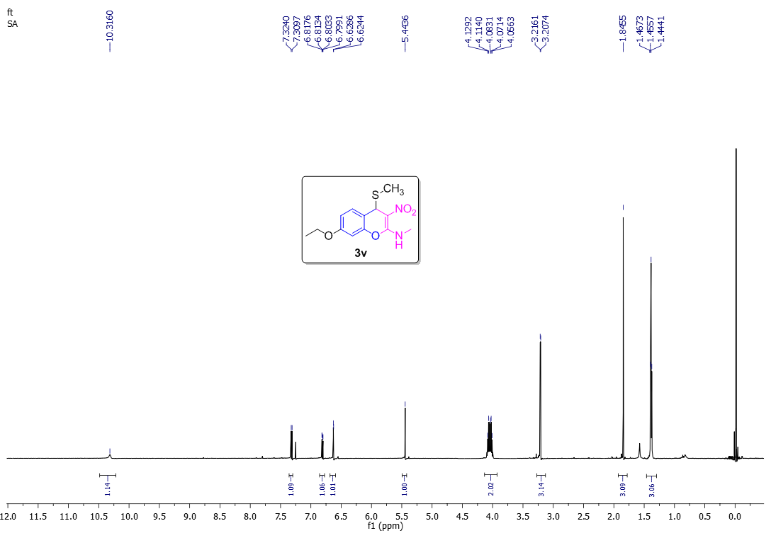

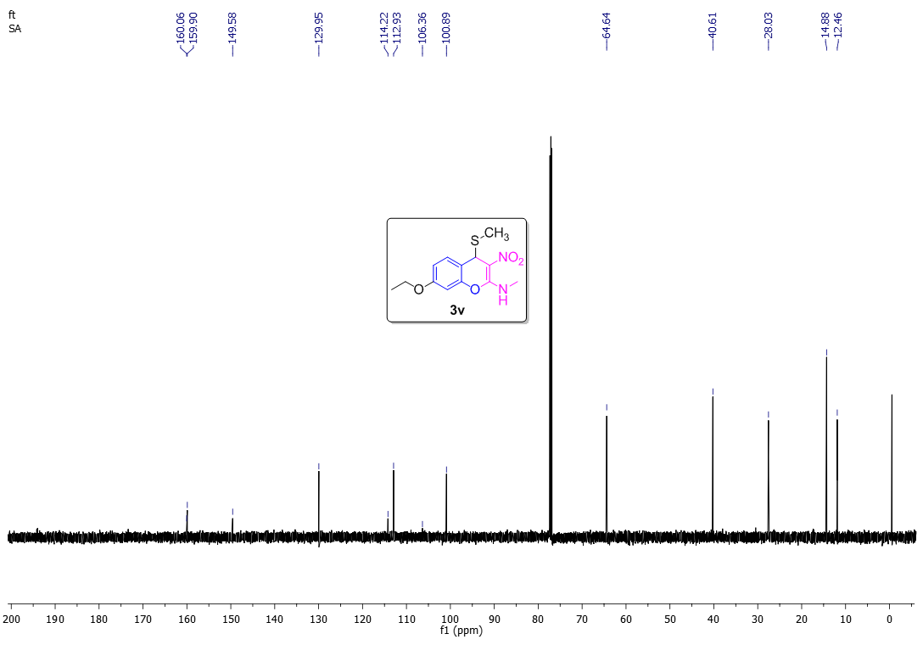
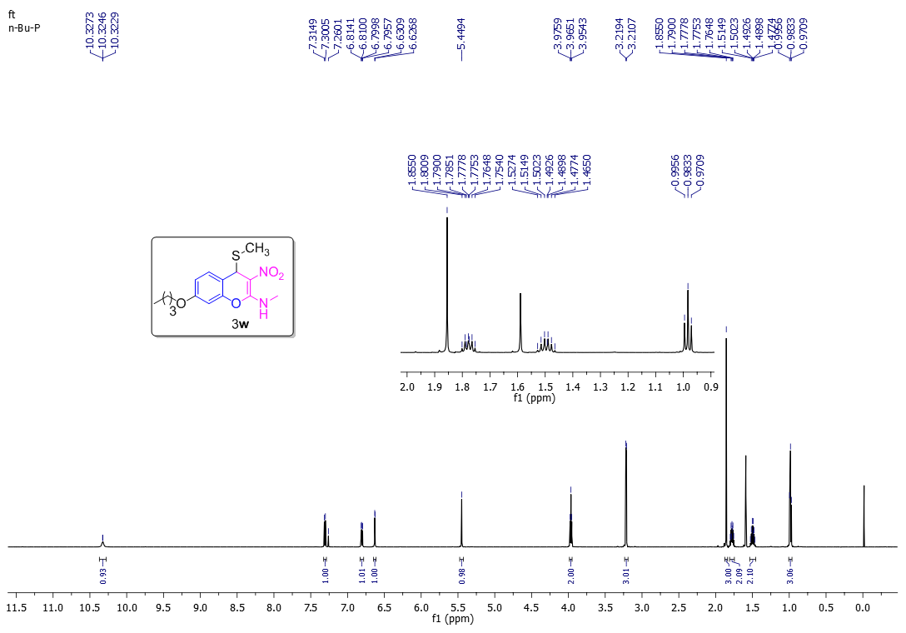

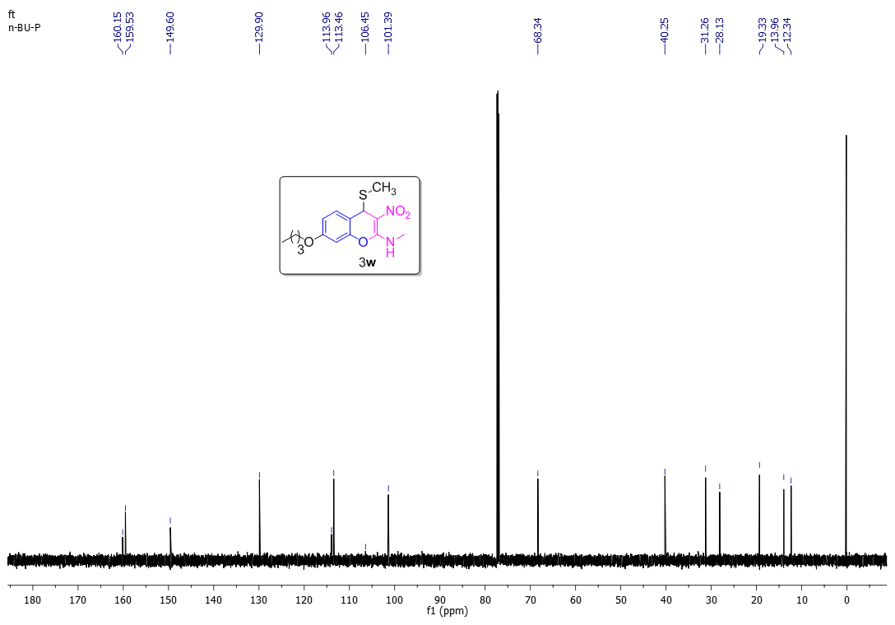
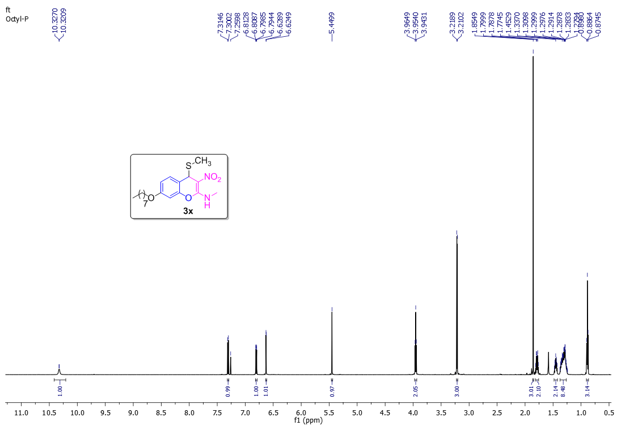
Figure S 39: ¹H NMR of 3x
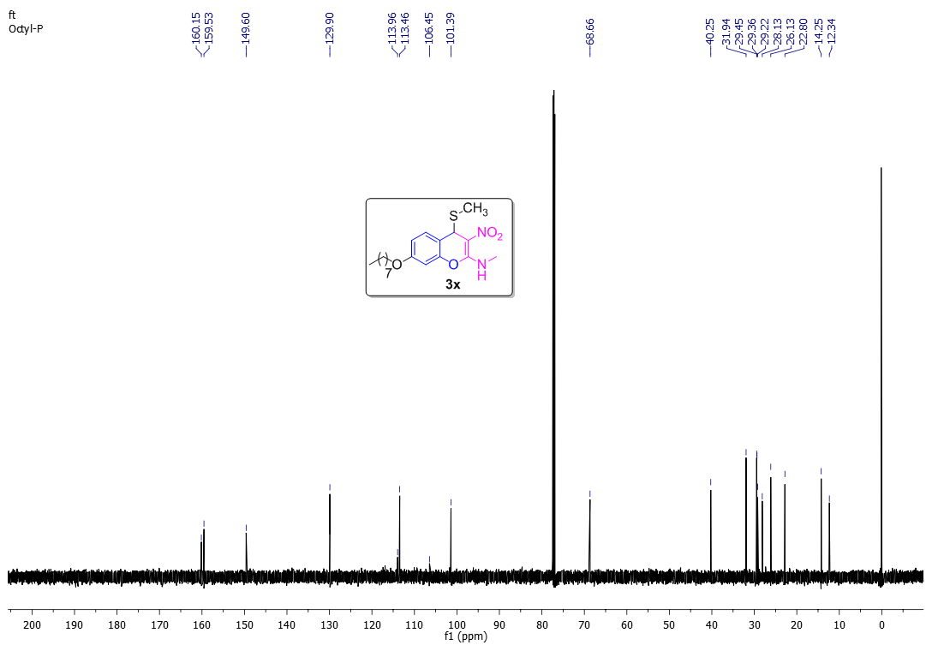
Figure S 40: ¹³C NMR of 3x

