SUPPLEMENTARY INFORMATION
Plant-Animal Worms Round Themselves up in Circular Mills on the Beach
Ana. B. Sendova-Franks, Nigel R. Franks and Alan Worley
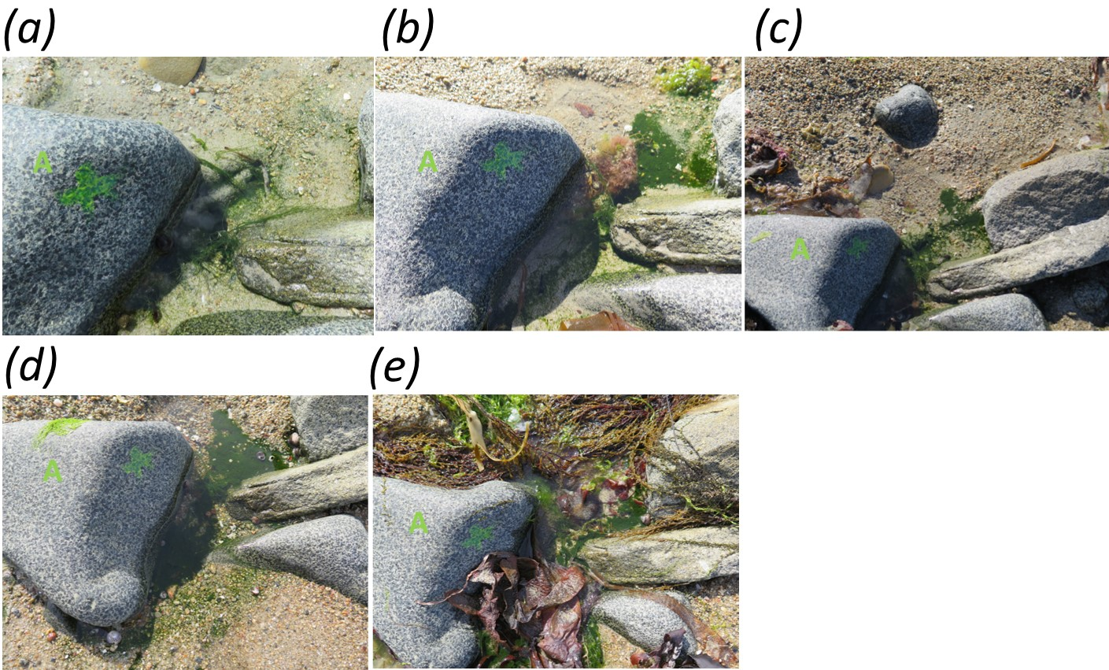
Figure S1. The five photographs of boulder A: (a) 10th June, 15:10 (60min after low tide). (b) 11th June, 17:15 (155min). (c) 12th June, 17:02 (102min). (d) 13th June, 17:19 (89min). (e) 14th June, 16:39 (19min).
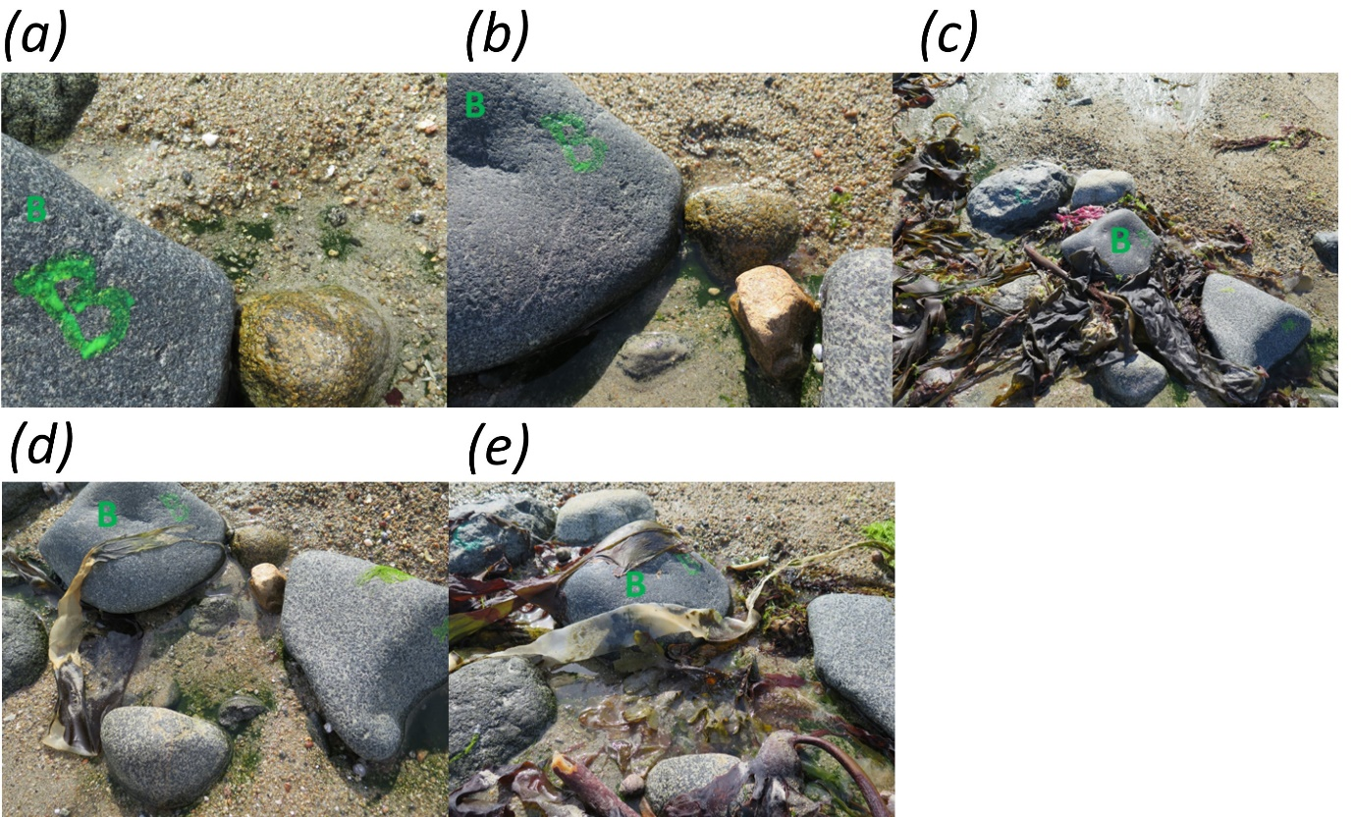Figure S2. The five photographs of boulder B: (a) 10th June, 15:12 (62min after low tide). (b) 11th June, 17:16 (156min). (c) 12th June, 17:03 (103min). (d) 13th June, 17:20 (90min). (e) 14th June, 16:39 (19min).

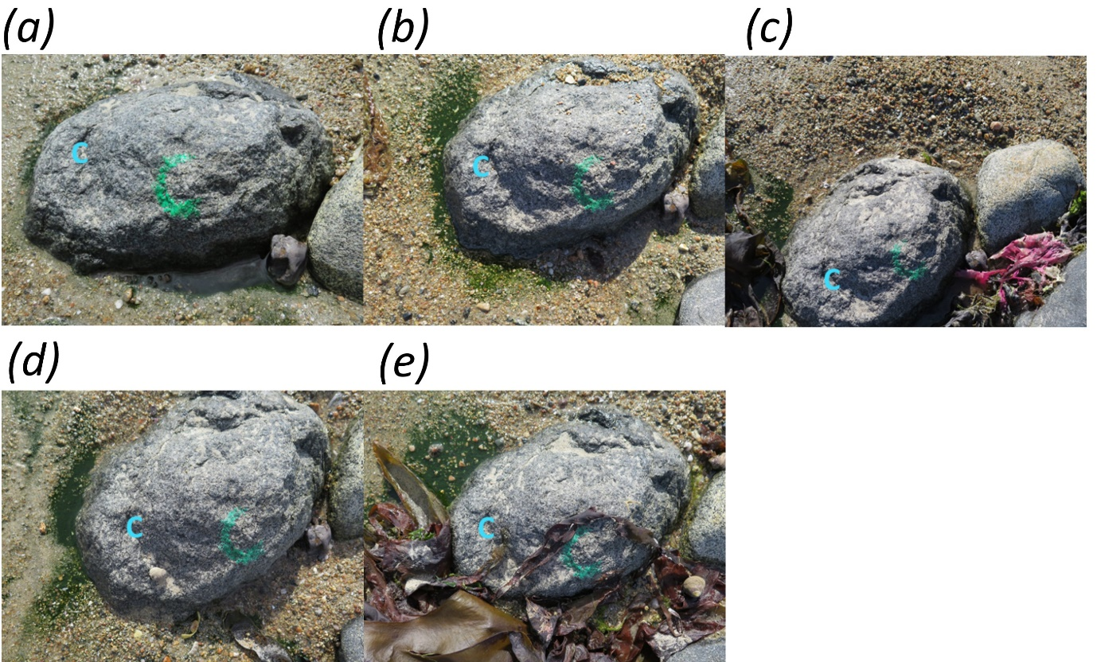
Figure S3. The five photographs of boulder C: (a) 10th June, 15:14 (64min after low tide). (b) 11th June, 17:16 (156min). (c) 12th June, 17:04 (104min). (d) 13th June, 17:21 (91min). (e) 14th June, 16:40 (20min).
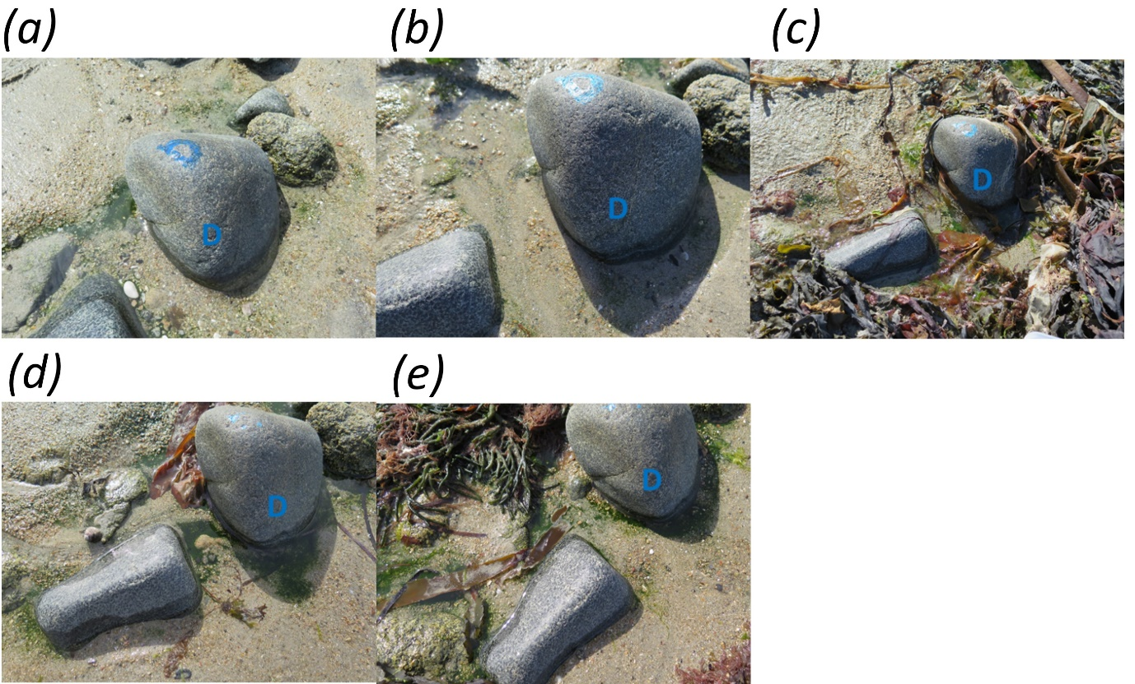
Figure S4. The five photographs of boulder D: (a) 10th June, 15:16 (66min after low tide). (b) 11th June, 17:17 (157min). (c) 12th June, 17:10 (110min). (d) 13th June, 17:21 (91min). (e) 14th June, 16:40 (20min).

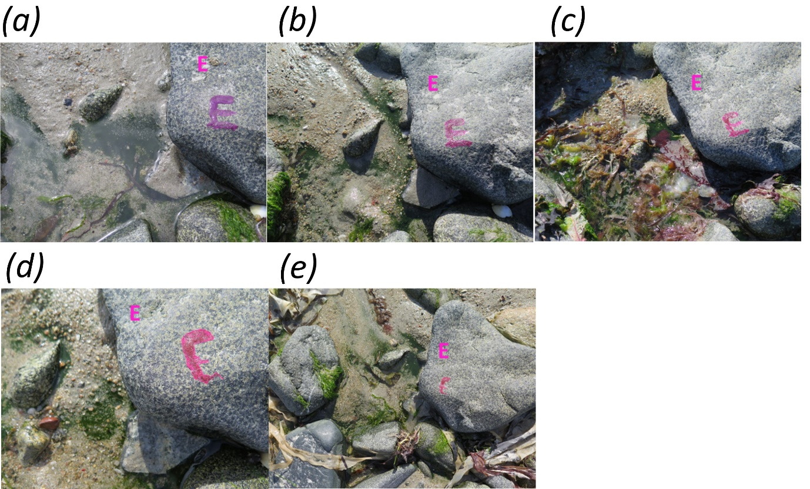
Figure S5. The five photographs of boulder E: (a) 10th June, 15:32 (82min after low tide). (b) 11th June, 17:19 (159min). (c) 12th June, 17:12 (112min). (d) 13th June, 17:25 (95min). (e) 14th June, 16:43 (23min).
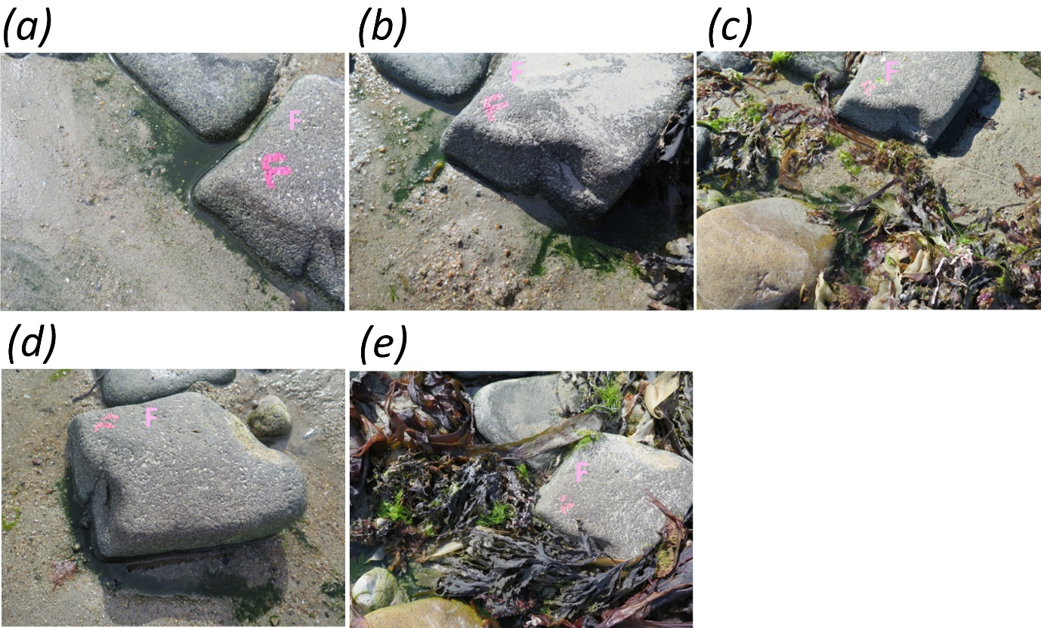
Figure S6. The five photographs of boulder F: (a) 10th June, 15:33 (83min after low tide). (b) 11th June, 17:19 (159min). (c) 12th June, 17:14 (114min). (d) 13th June, 17:26 (96min). (e) 14th June, 16:43 (23min).

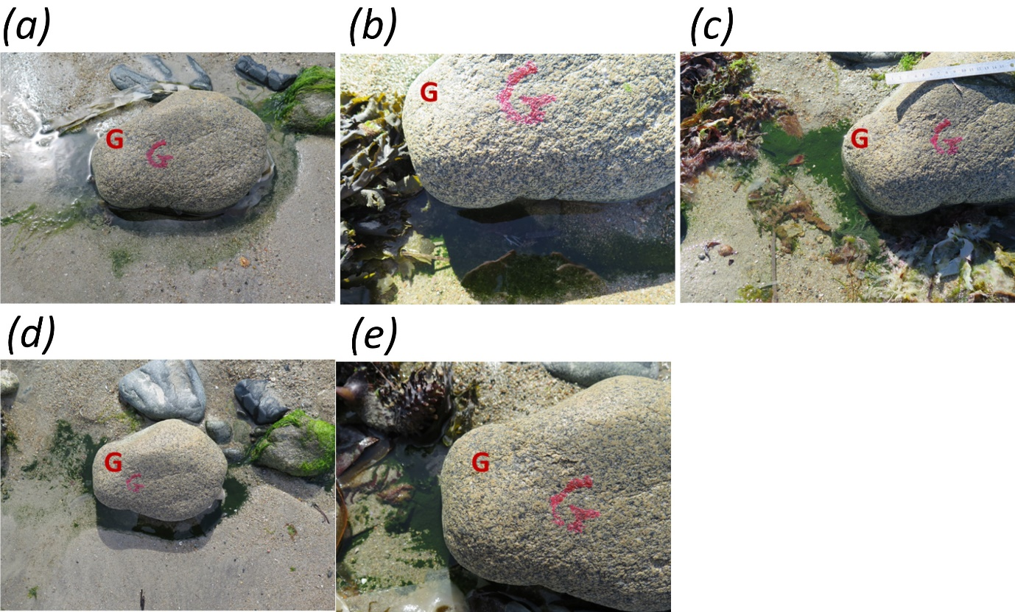
Figure S7. The five photographs of boulder G: (a) 10th June, 15:39 (89min after low tide). (b) 11th June, 17:20 (160min). (c) 12th June, 17:21 (121min). (d) 13th June, 17:27 (97min). (e) 14th June, 16:44 (24min).
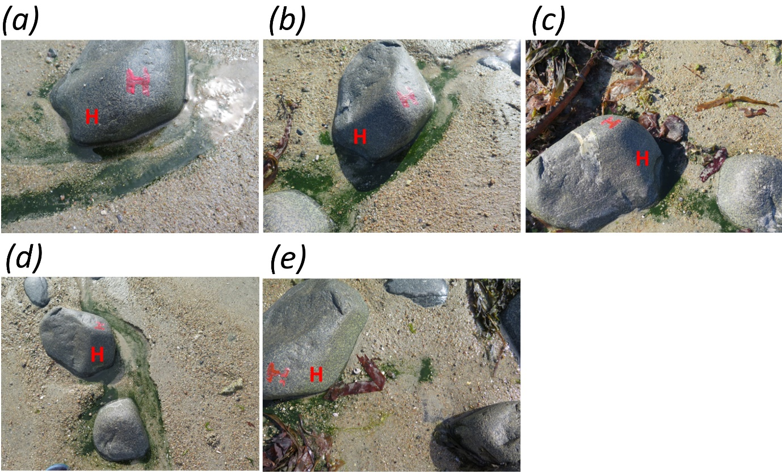
Figure S8. The five photographs of boulder H: (a) 10th June, 15:42 (92min after low tide). (b) 11th June, 17:22 (162min). (c) 12th June, 17:24 (124min). (d) 13th June, 17:27 (97min). (e) 14th June, 16:45 (25min).

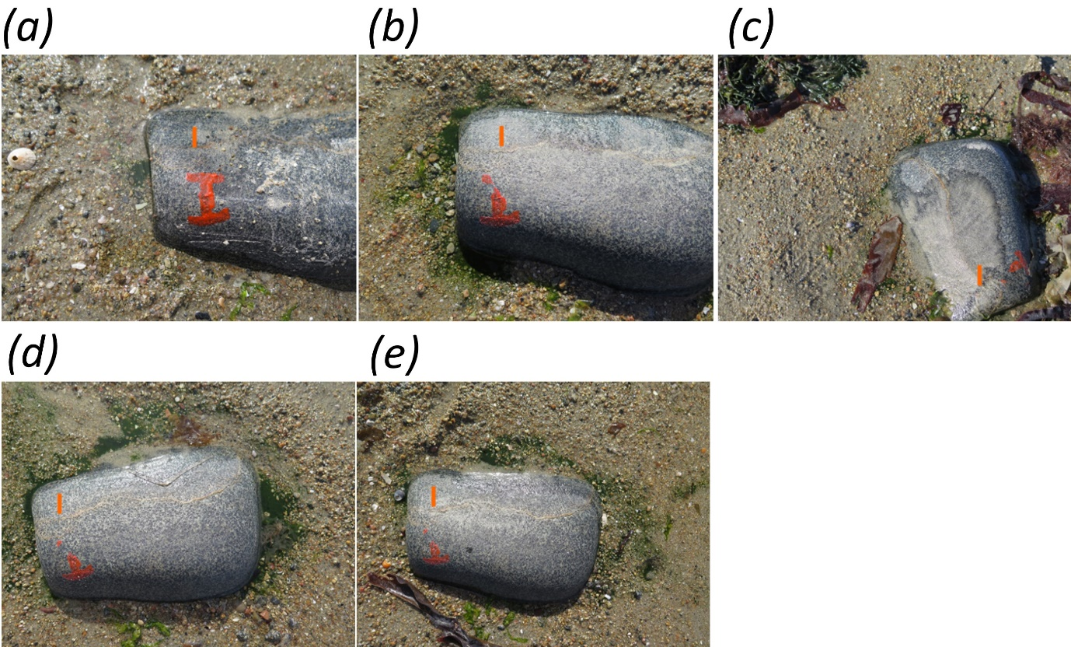
Figure S9. The five photographs of boulder I: (a) 10th June, 15:43 (93min after low tide). (b) 11th June, 17:23 (163min). (c) 12th June, 17:26 (126min). (d) 13th June, 17:28 (98min). (e) 14th June, 16:46 (26min).
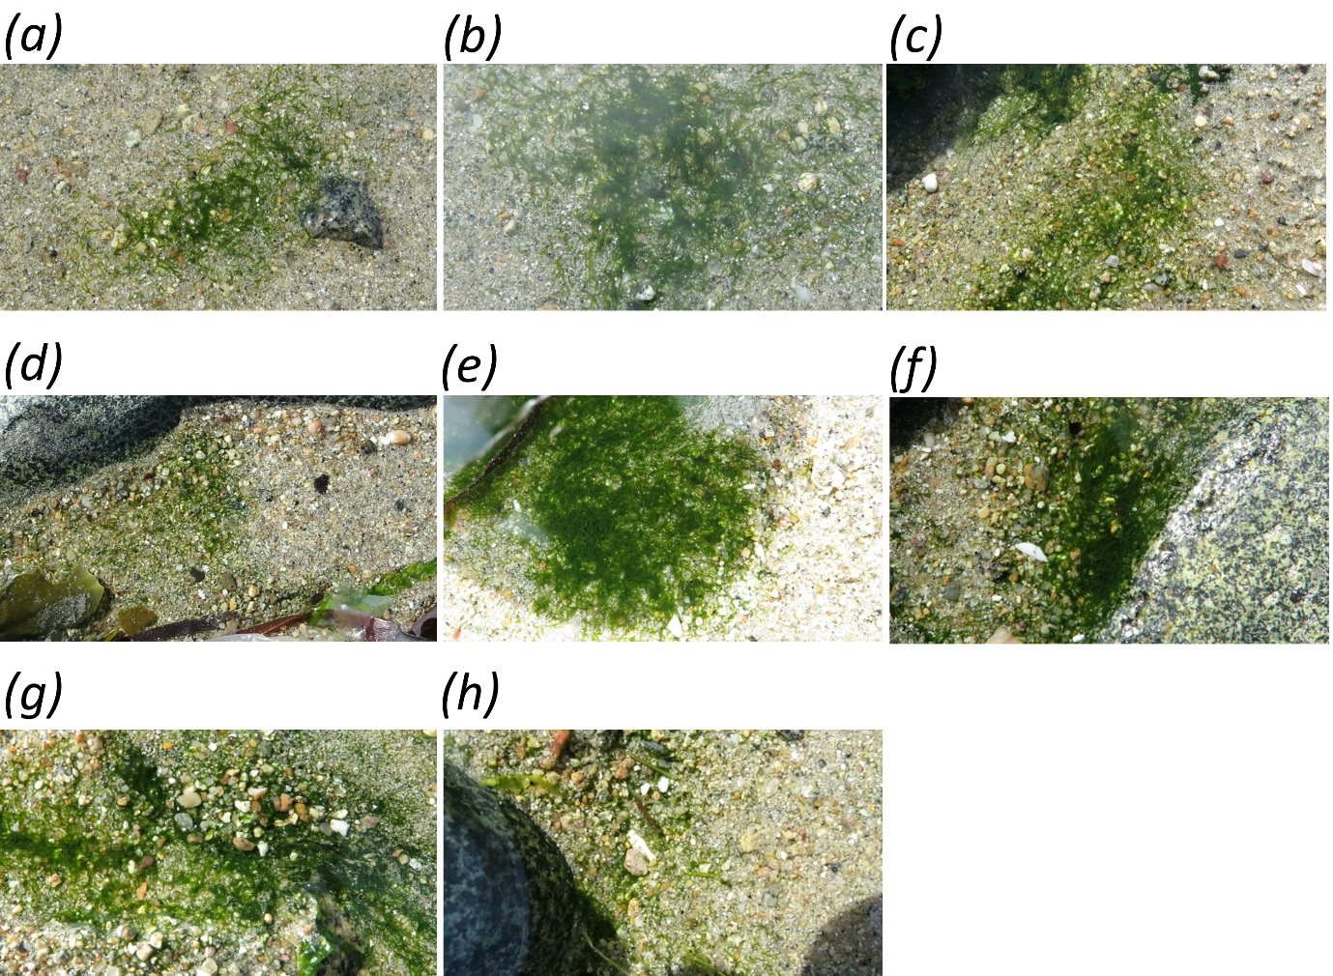
Figure S10. Movement but no circular mills: (a) 10th June, 15:16 (66min after low tide). (b) 10th June, 15:39 (89min). (c) 11th June, 17:21 (161min). (d) 12th June, 17:08 (108min). (e) 13th June, 17:23 (93min). (f) 13th June, 17:31 (101min). (g) 13th June, 17:34 (104min). (h) 14th June, 16:42 (22min).
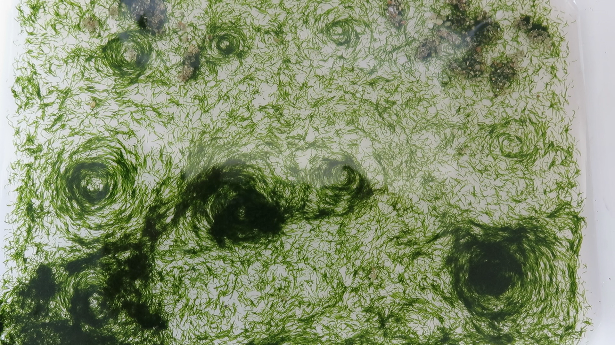
Figure S11. Nine circular mills of different density in a tub ~20 x 12cm, 14th June 2016.
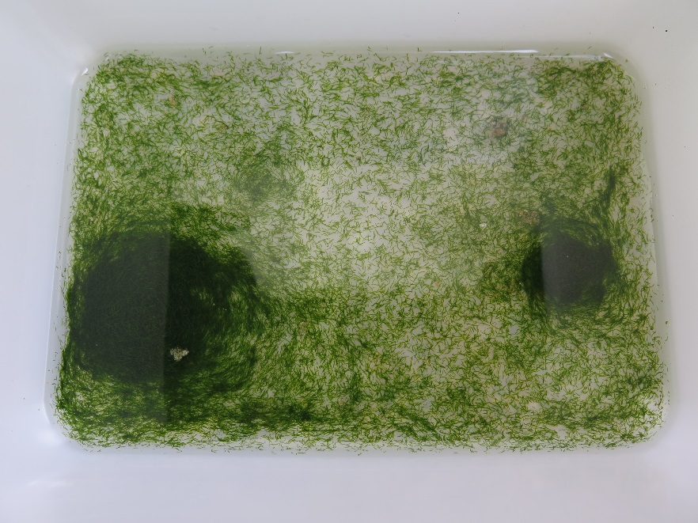
Figure S12. Two very dense circular mills in a tub ~20 x 12cm, 15th June 2016.
Video S1. Video of circular mill number 1 on the beach near boulder D (figures 2a) at 2 x normal speed.
Video S2. Video of circular mill number 2 on the beach near boulder F (figures 2b) at 2 x normal speed.
Video S3. Video of twin circular mill number 3 up the beach from boulder H (figures 2c) at 2 x normal speed.

