Supplement

NACE outcomes at different follow up durations

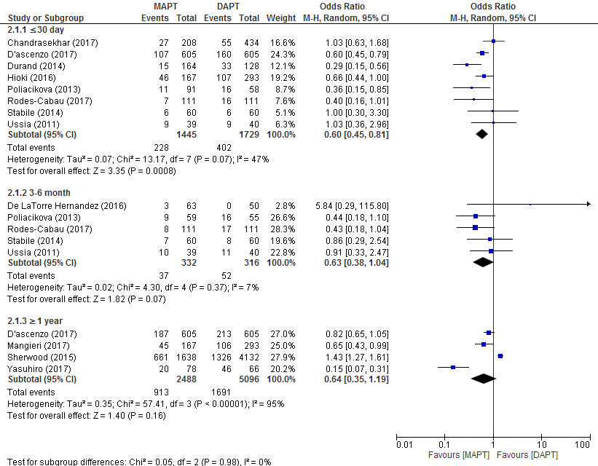

Figure S1: Forrest plot for net adverse clinical events (NACE) as a combined endpoint of major stroke, myocardial infarction (MI), all-cause mortality, and combined life-threatening and major bleeding at different follow up durations ( ≤30 days, 3-6 months and ≥ 1 year), showing pooled data from studies, with the odds ratio of the development of NACE in dual-antiplatelet therapy vs monoantiplatelet therapy.
Abbreviations: CI, confidence interval; DAPT, dual-antiplatelet therapy; MAPT, monoantiplatelet therapy.

All-cause mortality outcomes at different follow up durations

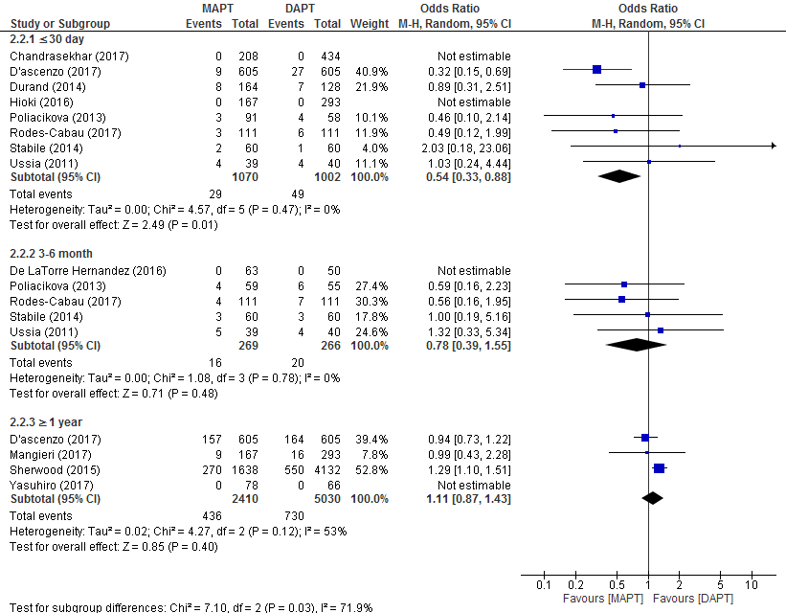

Figure S2: Forrest plot for all-cause mortality at different follow up durations ( ≤30 days, 3-6 months and ≥ 1 year), showing pooled data from studies, with the odds ratio of the development of all-cause mortality in dual-antiplatelet therapy vs monoantiplatelet therapy.
Abbreviations: CI, confidence interval; DAPT, dual-antiplatelet therapy; MAPT, monoantiplatelet therapy.

Myocardial Infarction outcomes at different follow up durations

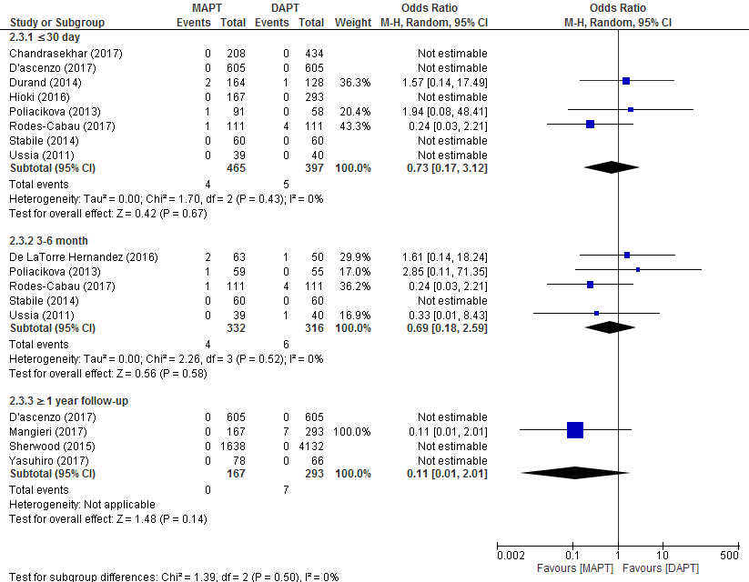

Figure S3: Forrest plot for myocardial infarction (MI) at different follow up durations (≤30 days, 3-6 months and ≥ 1 year), showing pooled data from studies, with the odds ratio of the development of spontaneous MI in dual-antiplatelet therapy vs monoantiplatelet therapy.
Abbreviations: CI,confidence interval; DAPT, dual-antiplatelet therapy; MAPT, monoantiplatelet therapy.

Stroke outcomes at different follow up durations

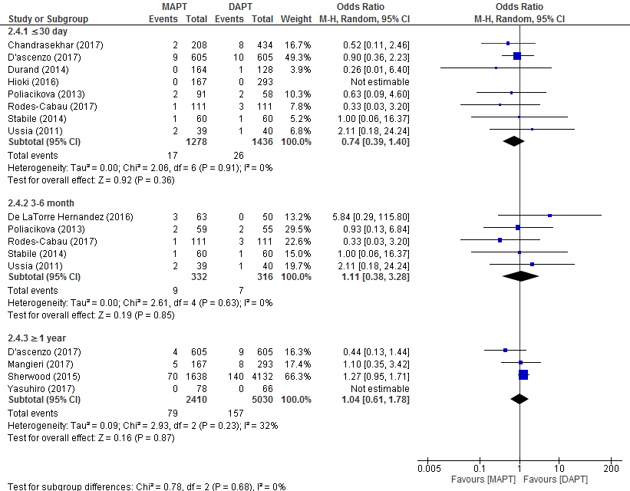

Figure S4: Forrest plot for major stroke at different follow up durations (≤30 days, 3-6 months and ≥ 1 year), showing pooled data from studies, with the odds ratio of the development of major stroke in dual-antiplatelet therapy vs monoantiplatelet therapy.
Abbreviations: CI, confidence interval; DAPT, dual-antiplatelet therapy; MAPT, monoantiplatelet therapy

Major and life-threatening bleeding at different follow up durations

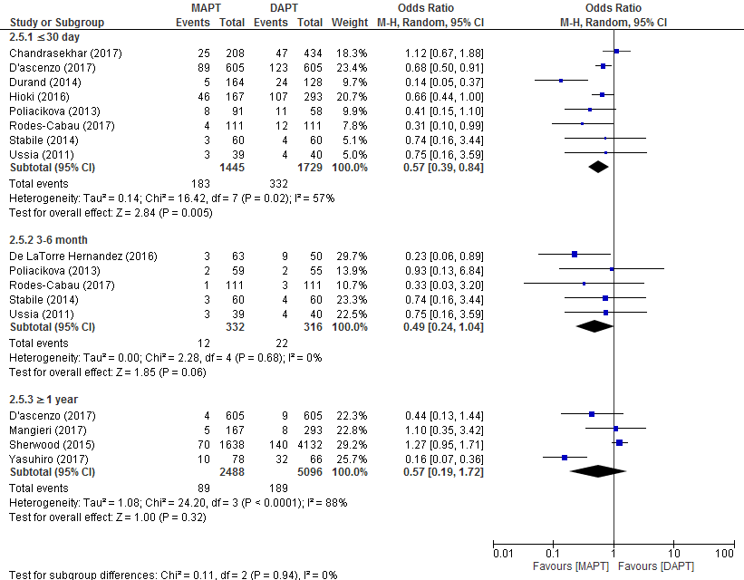

Figure S5: Forrest plot for combined major and life-threatening bleeding at different follow up durations (≤30 days, 3-6 months and ≥ 1 year), showing pooled data from studies, with the odds ratio of the development of combined major and life-threatening bleeding in dual-antiplatelet therapy vs monoantiplatelet therapy.
Abbreviations: CI, confidence interval; DAPT, dual-antiplatelet therapy; MAPT, monoantiplatelet therapy

NACE outcome analysis after excluding abstracts

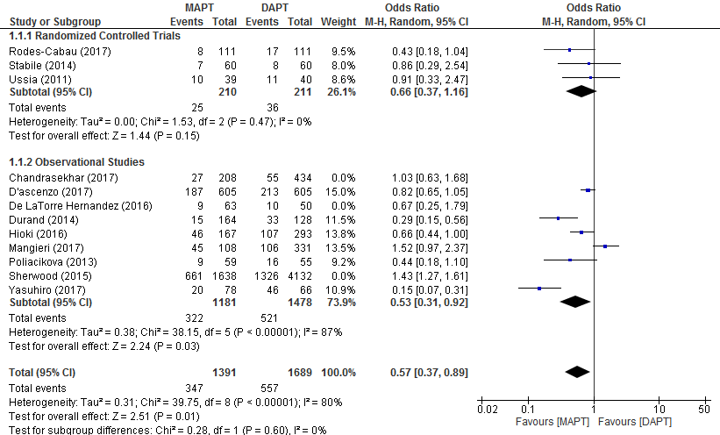

Figure S6: Forrest plot for net adverse clinical events (NACE) as a combined endpoint of major stroke, myocardial infarction (MI), all-cause mortality, and combined life-threatening and major bleeding at longest follow-up, showing pooled data from studies after excluding abstracts, with the odds ratio of the development of NACE in dual-antiplatelet therapy vs monoantiplatelet therapy.
Abbreviations: CI, confidence interval; DAPT, dual-antiplatelet therapy; MAPT, monoantiplatelet therapy.

Table S1: Definitions of outcomes as specified by each study.
Study | All-Cause Mortality | Spontaneous MI | Major Stroke | Major Bleed and Lethal Bleed | Study endpoints reported in study (not necessarily the one used in the meta-analysis)
Stabile (2014) | Cardiac and non-cardiac | MI (Q-wave and non–Q-wave). A non–Q-wave MI was defined as creatine kinase-MB enzyme elevation ≥3 times the upper limit of the normal value. When in addition to enzyme elevation there were new pathological Q waves on the electrocardiogram, the event was defined as a Q-wave MI | Repeat revascularization secondary to a stenosis >50% within the stent or within the 5-mm borders proximal or distal to the stent at the follow-up angiogram. | Repeat revascularization within the treated vessel | Primary end point not specified. Clinical end points of cardiovascular death, major vascular complications, minor  vascular complications, major stroke, minor stroke, acute MI, all-cause  mortality, life-threatening or disabling  bleeding, acute kidney injury.
Ussia (2011) | Mortality from all causes after prosthesis insertion | Creatine kinase-myocardial band >3 times the upper limit of normal | No definition | Fatal bleeding, bleeding in a critical organ (retroperitoneal, intracranial, or intraocular), deep hematoma, or overt bleeding associated with a 2 g/dL or greater decrease in hemoglobin level or leading to the transfusion of at least 2 units of packed red blood cells | Primary end point: composite of death  from any cause, MI, major stroke,  urgent or emergency conversion to  surgery, and life-threatening bleeding
Rodes-Cabau (2017) | - Cardiovascular mortality  - Non-cardiovascular mortality  - Any death in which the primary cause of death is clearly related to another condition (e.g. trauma, cancer, suicide) | Any one of the following criteria :  - Detection of rise and/or fall of cardiac biomarkers (preferably troponin) with at least one value above the 99th percentile URL, together with the evidence of myocardial ischemia with at least one of the following:  * Symptoms of ischemia  * ECG changes indicative of new ischemia [new ST-T changes or new left bundle branch block (LBBB)]  * New pathological Q-waves in at least two contiguous leads Imaging evidence of a new loss of viable myocardium or new wall  motion abnormality  - Sudden, unexpected cardiac death, involving cardiac arrest, often with symptoms suggestive of myocardial ischemia, and accompanied by presumably new ST elevation, or new LBBB, and/ or evidence of fresh thrombus by coronary angiography and/or at autopsy, but death occurring before blood samples could be obtained, or at a time before the appearance of cardiac biomarkers in the blood.  - Pathological findings of an acute myocardial infarction | - Duration of a focal or global neurological deficit >24 h; OR <24 h if available neuroimaging documents a new haemorrhage or infarct; OR the neurological deficit results in death | Major Bleeding: Overt bleeding either associated with a drop in the hemoglobin level of at least 3.0 g/dl or requiring transfusion of two or three units of whole blood/RBC, or causing hospitalization or permanent injury, or requiring surgery AND does not meet criteria of life-threatening or disabling bleeding  -Lethal Bleeding: Fatal bleeding (BARC type 5) OR  Bleeding in a critical organ, such as intracranial, intraspinal, intraocular, or pericardial necessitating pericardiocentesis, or intramuscular with compartment syndrome (BARC type 3b and 3c) OR  Bleeding causing hypovolaemic shock or severe hypotension requiring vasopressors or surgery (BARC type 3b) OR  Overt source of bleeding with drop in haemoglobin >5 g/dL or whole blood or packed red blood cells (RBCs) transfusion >4 units⁎(BARC type 3b) | Primary endpoint: Composite of death, MI, ischemic stroke or TIA, major or life threatening bleeding or death. Secondary endpoints:  Incidence of MI, ischemic stroke, major or life-threatening bleeding, and death.
Poliacikova (2013) | Includes all deaths from any cause after a valve intervention. Survival should be referenced to an age- and sex-matched sample from the representative general population being investigated whenever possible. | Any one of the following criteria :  - Detection of rise and/or fall of cardiac biomarkers (preferably troponin) with at least one value above the 99th percentile URL, together with the evidence of myocardial ischemia with at least one of the following:  * Symptoms of ischemia  * ECG changes indicative of new ischemia [new ST-T changes or new left bundle branch block (LBBB)]  * New pathological Q-waves in at least two contiguous leads Imaging evidence of a new loss of viable myocardium or new wall  motion abnormality  - Sudden, unexpected cardiac death, involving cardiac arrest, often with symptoms suggestive of myocardial ischemia, and accompanied by presumably new ST elevation, or new LBBB, and/ or evidence of fresh thrombus by coronary angiography and/or at autopsy, but death occurring before blood samples could be obtained, or at a time before the appearance of cardiac biomarkers in the blood.  - Pathological findings of an acute myocardial infarction | - Rapid onset of a focal or global neurological deficit with at least one of the following:  • Change in level of consciousness, hemiplegia, hemiparesis, numbness or sensory loss affecting one side of the body, dysphasia or aphasia, hemianopia, amaurosis fugax, or other neurological signs or symptoms consistent with stroke  • Duration of a focal or global neurological deficit ≥24 h; OR <24 h, if therapeutic intervention(s) were performed (e.g. thrombolytic therapy or intracranial angioplasty); OR available neuroimaging documents a new hemorrhage or infarct; OR the neurological deficit results in death  • No other readily identifiable nonstroke cause for the clinical presentation (e.g., brain tumor, trauma, infection, hypoglycemia, peripheral lesion, pharmacological influences)  - Confirmation of the diagnosis by at least one of the following:  • Neurology or neurosurgical specialist  • Neuroimaging procedure (MR or CT scan or cerebral angiography)  • Lumbar puncture (i.e., spinal fluid analysis diagnostic of intracranial hemorrhage) | - Life-threatening or disabling bleeding  • Fatal bleeding  • Bleeding in a critical area or organ, such as intracranial, intraspinal, intraocular, or pericardial necessitating pericardiocentesis, or intramuscular with compartment syndrome  • Bleeding causing hypovolemic shock or severe hypotension requiring vasopressors or surgery  • Overt source of bleeding with drop in hemoglobin of ≥5 g/dl or whole blood or packed red blood cells (RBCs) transfusion ≥4 U⁎  - Major bleeding  Overt bleeding either associated with a drop in the hemoglobin level of at least 3.0 g/dl or requiring transfusion of two or three units of whole blood/RBC AND  Does not meet criteria of life-threatening or disabling bleeding | Primary end point: combination mortality, major stroke, life-threatening bleeding, MI, and major vascular complications. Secondary end points: transfusion, any vascular complications, any stroke, any bleeding, acute kidney injury, and success rates.
Durand (2014) | Includes all deaths from any cause after a valve intervention. Survival should be referenced to an age- and sex-matched sample from the representative general population being investigated whenever  possible. | Any one of the following criteria :  - Detection of rise and/or fall of cardiac biomarkers (preferably troponin) with at least one value above the 99th percentile URL, together with the evidence of myocardial ischemia with at least one of the following:  * Symptoms of ischemia  * ECG changes indicative of new ischemia [new ST-T changes or new left bundle branch block (LBBB)]  * New pathological Q-waves in at least two contiguous leads Imaging evidence of a new loss of viable myocardium or new wall  motion abnormality  - Sudden, unexpected cardiac death, involving cardiac arrest, often with symptoms suggestive of myocardial ischemia, and accompanied by presumably new ST elevation, or new LBBB, and/ or evidence of fresh thrombus by coronary angiography and/or at autopsy, but death occurring before blood samples could be obtained, or at a time before the appearance of cardiac biomarkers in the blood.  - Pathological findings of an acute myocardial infarction | - Rapid onset of a focal or global neurological deficit with at least one of the following:  • Change in level of consciousness, hemiplegia, hemiparesis, numbness or sensory loss affecting one side of the body, dysphasia or aphasia, hemianopia, amaurosis fugax, or other neurological signs or symptoms consistent with stroke  • Duration of a focal or global neurological deficit ≥24 h; OR <24 h, if therapeutic intervention(s) were performed (e.g. thrombolytic therapy or intracranial angioplasty); OR available neuroimaging documents a new hemorrhage or infarct; OR the neurological deficit results in death  • No other readily identifiable nonstroke cause for the clinical presentation (e.g., brain tumor, trauma, infection, hypoglycemia, peripheral lesion, pharmacological influences)  - Confirmation of the diagnosis by at least one of the following:  • Neurology or neurosurgical specialist  • Neuroimaging procedure (MR or CT scan or cerebral angiography)  • Lumbar puncture (i.e., spinal fluid analysis diagnostic of intracranial hemorrhage) | - Life-threatening or disabling bleeding  • Fatal bleeding  • Bleeding in a critical area or organ, such as intracranial, intraspinal, intraocular, or pericardial necessitating pericardiocentesis, or intramuscular with compartment syndrome  • Bleeding causing hypovolemic shock or severe hypotension requiring vasopressors or surgery  • Overt source of bleeding with drop in hemoglobin of ≥5 g/dl or whole blood or packed red blood cells (RBCs) transfusion ≥4 U⁎  - Major bleeding  Overt bleeding either associated with a drop in the hemoglobin level of at least 3.0 g/dl or requiring transfusion of two or three units of whole blood/RBC AND  Does not meet criteria of life-threatening or disabling bleeding | Primary endpoints: Composite outcome of mortality, major stroke, life-threatening bleeding (LTB), myocardial infarction, and major vascular complications.  Secondary endpoint: transfusion, any vascular complication, any stroke, any bleeding, acute kidney injury, and success rate.
Mangieri (2017) | - Cardiovascular mortality  - Non-cardiovascular mortality  - Any death in which the primary cause of death is clearly related to another condition (e.g. trauma, cancer, suicide) | Any one of the following criteria :  - Detection of rise and/or fall of cardiac biomarkers (preferably troponin) with at least one value above the 99th percentile URL, together with the evidence of myocardial ischemia with at least one of the following:  * Symptoms of ischemia  * ECG changes indicative of new ischemia [new ST-T changes or new left bundle branch block (LBBB)]  * New pathological Q-waves in at least two contiguous leads Imaging evidence of a new loss of viable myocardium or new wall  motion abnormality  - Sudden, unexpected cardiac death, involving cardiac arrest, often with symptoms suggestive of myocardial ischemia, and accompanied by presumably new ST elevation, or new LBBB, and/ or evidence of fresh thrombus by coronary angiography and/or at autopsy, but death occurring before blood samples could be obtained, or at a time before the appearance of cardiac biomarkers in the blood.  - Pathological findings of an acute myocardial infarction | - Duration of a focal or global neurological deficit >24 h; OR <24 h if available neuroimaging documents a new haemorrhage or infarct; OR the neurological deficit results in death | Major Bleeding: Overt bleeding either associated with a drop in the hemoglobin level of at least 3.0 g/dl or requiring transfusion of two or three units of whole blood/RBC, or causing hospitalization or permanent injury, or requiring surgery AND does not meet criteria of life-threatening or disabling bleeding  -Lethal Bleeding: Fatal bleeding (BARC type 5) OR  Bleeding in a critical organ, such as intracranial, intraspinal, intraocular, or pericardial necessitating pericardiocentesis, or intramuscular with compartment syndrome (BARC type 3b and 3c) OR  Bleeding causing hypovolaemic shock or severe hypotension requiring vasopressors or surgery (BARC type 3b) OR  Overt source of bleeding with drop in haemoglobin >5 g/dL or whole blood or packed red blood cells (RBCs) transfusion >4 units⁎(BARC type 3b) | Primary endpoint: Composite of all-cause mortality, major bleeding requiring hospitalization, cerebrovascular accidents, redo-TAVR or surgical aortic valve replacement, and valve thrombosis.
Ichibori (2017) | -Cardiovascular mortality  -Non-cardiovascular mortality  -Any death in which the primary cause of death is clearly related to another condition (e.g. trauma, cancer, suicide) | Any one of the following criteria :  - Detection of rise and/or fall of cardiac biomarkers (preferably troponin) with at least one value above the 99th percentile URL, together with the evidence of myocardial ischemia with at least one of the following:  * Symptoms of ischemia  * ECG changes indicative of new ischemia [new ST-T changes or new left bundle branch block (LBBB)]  * New pathological Q-waves in at least two contiguous leads Imaging evidence of a new loss of viable myocardium or new wall  motion abnormality  - Sudden, unexpected cardiac death, involving cardiac arrest, often with symptoms suggestive of myocardial ischemia, and accompanied by presumably new ST elevation, or new LBBB, and/ or evidence of fresh thrombus by coronary angiography and/or at autopsy, but death occurring before blood samples could be obtained, or at a time before the appearance of cardiac biomarkers in the blood.  - Pathological findings of an acute myocardial infarction | duration of a focal or global neurological deficit >24 h; OR <24 h if available neuroimaging documents a new haemorrhage or infarct; OR the neurological deficit results in death | -Major Bleeding: Overt bleeding either associated with a drop in the hemoglobin level of at least 3.0 g/dl or requiring transfusion of two or three units of whole blood/RBC, or causing hospitalization or permanent injury, or requiring surgery AND does not meet criteria of life-threatening or disabling bleeding  -Lethal Bleeding: Fatal bleeding (BARC type 5) OR  Bleeding in a critical organ, such as intracranial, intraspinal, intraocular, or pericardial necessitating pericardiocentesis, or intramuscular with compartment syndrome (BARC type 3b and 3c) OR  Bleeding causing hypovolaemic shock or severe hypotension requiring vasopressors or surgery (BARC type 3b) OR  Overt source of bleeding with drop in haemoglobin >5 g/dL or whole blood or packed red blood cells (RBCs) transfusion >4 units⁎(BARC type 3b) | Primary endpoint: Composite endpoint consisting of all-cause death, nonfatal myocardial infarction, nonfatal stroke, and major or life-threatening bleeding complications.
D'ascenzo (2017) | -Cardiovascular mortality  -Non-cardiovascular mortality  -Any death in which the primary cause of death is clearly related to another condition (e.g. trauma, cancer, suicide) | Any one of the following criteria :  - Detection of rise and/or fall of cardiac biomarkers (preferably troponin) with at least one value above the 99th percentile URL, together with the evidence of myocardial ischemia with at least one of the following:  * Symptoms of ischemia  * ECG changes indicative of new ischemia [new ST-T changes or new left bundle branch block (LBBB)]  * New pathological Q-waves in at least two contiguous leads Imaging evidence of a new loss of viable myocardium or new wall  motion abnormality  - Sudden, unexpected cardiac death, involving cardiac arrest, often with symptoms suggestive of myocardial ischemia, and accompanied by presumably new ST elevation, or new LBBB, and/ or evidence of fresh thrombus by coronary angiography and/or at autopsy, but death occurring before blood samples could be obtained, or at a time before the appearance of cardiac biomarkers in the blood.  - Pathological findings of an acute myocardial infarction | Duration of a focal or global neurological deficit >24 h; OR <24 h if available neuroimaging documents a new haemorrhage or infarct; OR the neurological deficit results in death | -Major Bleeding: Overt bleeding either associated with a drop in the hemoglobin level of at least 3.0 g/dl or requiring transfusion of two or three units of whole blood/RBC, or causing hospitalization or permanent injury, or requiring surgery AND does not meet criteria of life-threatening or disabling bleeding  -Lethal Bleeding: Fatal bleeding (BARC type 5) OR  Bleeding in a critical organ, such as intracranial, intraspinal, intraocular, or pericardial necessitating pericardiocentesis, or intramuscular with compartment syndrome (BARC type 3b and 3c) OR  Bleeding causing hypovolaemic shock or severe hypotension requiring vasopressors or surgery (BARC type 3b) OR  Overt source of bleeding with drop in haemoglobin >5 g/dL or whole blood or packed red blood cells (RBCs) transfusion >4 units⁎(BARC type 3b) | Primary endpoint: Prosthetic valve dysfunction.  Secondary endpoints:  All cause death, Cardiovascular death, bleeding, vascular complications, CVA.
De La Torre Hernandez (2016) | Unavailable | Unavailable | Unavailable | Intracranial bleeding and bleeding of BARC >1 defined as any clinically overt sign of hemorrhage that is actionable and requires diagnostic studies, hospitalization, or treatment by a health care professional | Major bleeding and ischemic events at 6 months
Chandrasekhar (2017) | - Cardiovascular mortality  - Non-cardiovascular mortality  - Any death in which the primary cause of death is clearly related to another condition (e.g. trauma, cancer, suicide) | Any one of the following criteria :  - Detection of rise and/or fall of cardiac biomarkers (preferably troponin) with at least one value above the 99th percentile URL, together with the evidence of myocardial ischemia with at least one of the following:  * Symptoms of ischemia  * ECG changes indicative of new ischemia [new ST-T changes or new left bundle branch block (LBBB)]  * New pathological Q-waves in at least two contiguous leads Imaging evidence of a new loss of viable myocardium or new wall  motion abnormality  - Sudden, unexpected cardiac death, involving cardiac arrest, often with symptoms suggestive of myocardial ischemia, and accompanied by presumably new ST elevation, or new LBBB, and/ or evidence of fresh thrombus by coronary angiography and/or at autopsy, but death occurring before blood samples could be obtained, or at a time before the appearance of cardiac biomarkers in the blood.  - Pathological findings of an acute myocardial infarction | - Duration of a focal or global neurological deficit >24 h; OR <24 h if available neuroimaging documents a new haemorrhage or infarct; OR the neurological deficit results in death | Major Bleeding: Overt bleeding either associated with a drop in the hemoglobin level of at least 3.0 g/dl or requiring transfusion of two or three units of whole blood/RBC, or causing hospitalization or permanent injury, or requiring surgery AND does not meet criteria of life-threatening or disabling bleeding  -Lethal Bleeding: Fatal bleeding (BARC type 5) OR  Bleeding in a critical organ, such as intracranial, intraspinal, intraocular, or pericardial necessitating pericardiocentesis, or intramuscular with compartment syndrome (BARC type 3b and 3c) OR  Bleeding causing hypovolaemic shock or severe hypotension requiring vasopressors or surgery (BARC type 3b) OR  Overt source of bleeding with drop in haemoglobin >5 g/dL or whole blood or packed red blood cells (RBCs) transfusion >4 units⁎(BARC type 3b) | The primary endpoint was 30-day valve academic research consrotium (VARC2) composite endpoint of death, stroke, major vascular complication, life-threatining bleeding, stage 2/3 acute kidney injury, coronary obstruction or valve related re-intervention  Secondary endpoints were individual outcomes of death, major vascular complication and BARC major bleeding at 30 days.
Sherwood (2015) | Unavailable | Unavailable | Unavailable | Unavailable | Death, bleeding, and stroke at 1 year of follow up.
Hioki (2016) | -Cardiovascular mortality  -Non-cardiovascular mortality  -Any death in which the primary cause of death is clearly related to another condition (e.g. trauma, cancer, suicide) | Any one of the following criteria :  - Detection of rise and/or fall of cardiac biomarkers (preferably troponin) with at least one value above the 99th percentile URL, together with the evidence of myocardial ischemia with at least one of the following:  * Symptoms of ischemia  * ECG changes indicative of new ischemia [new ST-T changes or new left bundle branch block (LBBB)]  * New pathological Q-waves in at least two contiguous leads  -Imaging evidence of a new loss of viable myocardium or new wall  motion abnormality  - Sudden, unexpected cardiac death, involving cardiac arrest, often with symptoms suggestive of myocardial ischemia, and accompanied by presumably new ST elevation, or new LBBB, and/ or evidence of fresh thrombus by coronary angiography and/or at autopsy, but death occurring before blood samples could be obtained, or at a time before the appearance of cardiac biomarkers in the blood.  - Pathological findings of an acute myocardial infarction | Duration of a focal or global neurological deficit >24 h; OR <24 h if available neuroimaging documents a new haemorrhage or infarct; OR the neurological deficit results in death | -Major Bleeding: Overt bleeding either associated with a drop in the hemoglobin level of at least 3.0 g/dl or requiring transfusion of two or three units of whole blood/RBC, or causing hospitalization or permanent injury, or requiring surgery AND does not meet criteria of life-threatening or disabling bleeding  -Lethal Bleeding: Fatal bleeding (BARC type 5) OR  Bleeding in a critical organ, such as intracranial, intraspinal, intraocular, or pericardial necessitating pericardiocentesis, or intramuscular with compartment syndrome (BARC type 3b and 3c) OR  Bleeding causing hypovolaemic shock or severe hypotension requiring vasopressors or surgery (BARC type 3b) OR  Overt source of bleeding with drop in haemoglobin >5 g/dL or whole blood or packed red blood cells (RBCs) transfusion >4 units (BARC type 3b) | Primary endpoints: 1. Bleeding, including life-threatening, major, minor, and any bleeding, which was defined as the composite endpoint of life-threatening, major, and minor bleeding; 2. transfusion; 3. all-cause death; 4 myocardial infarction (MI); 5. stroke; and 6. valve thrombosis, during hospitalization
MI = Myocardial infarction, TIA= Transient ischemic attack, CVA= cerebrovascular accident, H= hour, VARC= valve academic research consrotium, BARC= Bleeding academic research consrotium.

Table S2a: Newcastle-Ottawa Quality Assessment Scale for Cohort Studies
 | Representativeness of the Exposed Cohort | Selection of the Nonexposed Cohort | Ascertainment of the Exposure | Outcome of study not present at start of study | Comparability | Assessment of Outcome | Adequacy of duration of Follow-up | Adequacy of completeness of Follow-up | Total Score
Acceptable * | Representative of average adult in community (age/sex/being at risk of disease) | Drawn from same community as exposed cohort | Secured records, Structured interview |  | at least age and sex  3 more additional factors | Independent blind assessment, record linkage | 6 month | Complete follow-up, or subjects lost to follow-up unlikely to introduce bias | Max= 9
Stabile (2014) | - | - | - | - | - | - | - | - | -
Ussia (2011) | - | - | - | - | - | - | - | - | -
Rodes-Cabau (2017) | - | - | - | - | - | - | - | - | -
Poliacikova (2013) | * | * | * | * | ** | - | * | * | 8
Durand (2014) | * | * | * | * | * | - | - | * | 6
Mangieri (2017) | * | * | * | * | * | * | * | * | 8
Ichibori (2017) | * | * | * | * | ** | * | * | * | 9
D'ascenzo (2017) | * | * | * | * | * | * | * | * | 8
De La Torre Hernandez (2016) | - | - | - | - | - | - | - | - | -
Chandrasekhar (2017) | - | - | - | - | - | - | - | - | -
Sherwood (2015) | - | - | - | - | - | - | - | - | -
Hioki (2016) | * | * | * | * | * | * | * | * | 8

Table S2b: Jadad Score for Randomized trials
 | Randomization | Blinding | Account of patients | Total
Stabile (2014) | 1 | 1 | 1 | 3
Ussia (2011) | 1 | 1 | 1 | 3
Rodes-Cabau (2017) | 1 | 0 | 1 | 2

Table S3a: Number of net adverse clinical events (NACE) reported for each regimen in included studies
Study | MAPT |  | DAPT
 | Positive NACE | Number of patients receiving MAPT | Positive NACE | Number of patients receiving DAPT
Randomized Controlled Trials
Rodes-Cabau (2017) | 8 | 111 | 17 | 111
Stabile (2014) | 7 | 60 | 8 | 60
Ussia (2011) | 10 | 39 | 11 | 40
Subtotal | 25 | 210 | 36 | 211
Observational Studies
Chandrasekhar (2017) | 27 | 208 | 55 | 434
D'ascenzo (2017) | 187 | 605 | 213 | 605
De LaTorre Hernandez (2016) | 9 | 63 | 10 | 50
Durand (2014) | 15 | 164 | 33 | 128
Hioki (2016) | 46 | 167 | 107 | 293
Mangieri (2017) | 45 | 108 | 106 | 331
Poliacikova (2013) | 9 | 59 | 16 | 55
Sherwood (2015) | 661 | 1638 | 1326 | 4132
Ichibori (2017) | 20 | 78 | 46 | 66
Subtotal | 1019 | 3090 | 1912 | 6094
Total (95% CI) | 1044 | 3300 | 1948 | 6305

Table S3b: Number of mortality events reported for each regimen in included studies
Study | MAPT |  | DAPT
 | Positive event | Number of patients receiving MAPT | Positive event | Number of patients receiving DAPT
Randomized Controlled Trials
Rodes-Cabau (2017) | 4 | 111 | 7 | 111
Stabile (2014) | 3 | 60 | 3 | 60
Ussia (2011) | 5 | 39 | 4 | 40
Subtotal | 12 | 210 | 14 | 211
Observational studies
Chandrasekhar (2017) | 2 | 208 | 8 | 434
D'ascenzo (2017) | 157 | 605 | 164 | 605
De LaTorre Hernandez (2016) | 1 | 63 | 0 | 50
Durand (2014) | 8 | 164 | 7 | 128
Mangieri (2017) | 9 | 108 | 16 | 331
Poliacikova (2013) | 4 | 59 | 6 | 55
Sherwood (2015) | 270 | 1638 | 550 | 4132
Subtotal | 451 | 2845 | 751 | 5735
Total | 463 | 3055 | 765 | 5946

Table S3c: Number of myocardial infarction events reported for each regimen in included studies
Study | MAPT |  | DAPT
 | Positive event | Number of patients receiving MAPT | Positive event | Number of patients receiving DAPT
Randomized Controlled Trials
Rodes-Cabau (2017) | 1 | 111 | 4 | 111
Stabile (2014) | 0 | 60 | 0 | 60
Ussia (2011) | 0 | 39 | 1 | 40
Subtotal | 1 | 210 | 5 | 211
Observational Studies
De LaTorre Hernandez (2016) | 3 | 63 | 1 | 50
Durand (2014) | 2 | 164 | 1 | 128
Mangieri (2017) | 0 | 198 | 7 | 331
Poliacikova (2013) | 0 | 59 | 1 | 55
Subtotal | 5 | 484 | 10 | 564
Total | 6 | 694 | 15 | 775

Table S3d: Number of major Stroke events reported for each regimen in included studies
Study | MAPT |  | DAPT
 | Positive event | Number of patients receiving MAPT | Positive event | Number of patients receiving DAPT
Randomized Controlled Trials
Rodes-Cabau (2017) | 1 | 111 | 4 | 111
Stabile (2014) | 1 | 60 | 1 | 60
Ussia (2011) | 2 | 39 | 1 | 40
Subtotal | 4 | 210 | 6 | 211
Observational studies
D'ascenzo (2017) | 4 | 605 | 9 | 605
De LaTorre Hernandez (2016) | 3 | 63 | 0 | 50
Durand (2014) | 0 | 164 | 1 | 128
Mangieri (2017) | 5 | 108 | 8 | 331
Poliacikova (2013) | 2 | 59 | 2 | 55
Sherwood (2015) | 70 | 1638 | 140 | 4132
Subtotal | 84 | 2637 | 160 | 5301
Total | 88 | 2847 | 166 | 5512

Table S3e: Number of major and life-threatening bleeding events reported for each regimen in included studies
Study | MAPT |  | DAPT
 | Positive event | Number of patients receiving MAPT | Positive event | Number of patients receiving DAPT
Randomized Controlled Trials
Rodes-Cabau (2017) | 4 | 111 | 12 | 111
Stabile (2014) | 3 | 60 | 4 | 60
Ussia (2011) | 3 | 39 | 4 | 40
Subtotal | 10 | 210 | 20 | 211
Observational Studies
Chandrasekhar (2017) | 25 | 208 | 47 | 434
D'ascenzo (2017) | 9 | 605 | 22 | 605
De LaTorre Hernandez (2016) | 3 | 63 | 9 | 50
Durand (2014) | 5 | 164 | 24 | 128
Hioki (2016) | 46 | 167 | 107 | 293
Mangieri (2017) | 31 | 108 | 75 | 331
Poliacikova (2013) | 5 | 59 | 10 | 55
Sherwood (2015) | 321 | 1638 | 636 | 4132
Ichibori (2017) | 10 | 78 | 32 | 66
Subtotal | 455 | 3090 | 962 | 6094
Total | 465 | 3300 | 982 | 6305

Study name | Stabile |  | Ussia |  | Rodes Cabau |  | Poliacikova |  | Durand |  | Mangieri |  | Ichibori |  | D’ascenzo |  | De La Torre Hernandez |  | Chandrasekhar |  | Sherwood |  | Hioki
 | MAPT | DAPT | MAPT | DAPT | MAPT | DAPT | MAPT | DAPT | MAPT | DAPT | MAPT | DAPT | MAPT | DAPT | MAPT | DAPT | MAPT | DAPT | MAPT | DAPT | MAPT | DAPT | MAPT | DAPT
Age(mean ± SD) | 81.1 ± 4.8 | 80.2 ± 5.7 | 81±4 | 80±6 | 79±9 | 79±9 | 82±6.9 | 81.6±6.3 | 82.7±6.3 | 84.6±5.8 | 84.3±7.1 | 82.9±8.2 | 83±6 | 84±6 | 81±4 | 81±5 | 81.6±6.7 | 81.9±4.7 | 82±6.9 | 82.6±5.5 | 84 | 84 | - | -
Female (%) | 60 | 66.7 | 59 | 50 | 46.8 | 36.9 | 53.8 | 55.2 | 45.1 | 60.9 | 57.4 | 64.6 | 64.1 | 63.6 | 63 | 62 | - | - | - | - | 53.1 | 51.6 | - | -
Diabetes (%) | 28.3 | 25 | 21 | 33 | 32.7 | 36.9 | 17.6 | 27.6 | 24.4 | 23.4 | 17.5 | 26.8 | 30.8 | 33.3 | 26 | 26 | - | - | - | - | - | - | - | -
Hypertension (%) | 95 | 95 | 80 | 88 | 79.2 | 77.5 | - | - | 70.7 | 70.3 | 84.2 | 78.5 | - | - | 82 | 77 | - | - | - | - | - | - | - | -
Hx of CAD (%) | - | - | - | - | - | - | 54.9 | 63.8 | 50 | 30.5 | - | - | 37.2 | 53 | 40 | 41 | - | - | - | - | 55.7 | 67.1 | - | -
Previous PCI (%) | 23.3 | 21.3 | 23 | 30 | - | - | 22 | 27.6 | - | - | 24.1 | 22.3 | 14.1 | 37.9 | - | - | - | - | 12 | 31 | - | - | - | -
Euroscore | 25.1 ± 12.0 | 23.34 ± 8.15 | 21±16 | 23±15 | - | - | - | - | 20±12.4 | 20.2±11.6 | 21.3±17.2 | 19.4±13 | 24.2±15.6 | 25.5±18.5 | 19±13 | 21±14 | 17.7±10.4 | 18.2±12 | 17±11.3 | 16±10.1 | - | - | - | -
STS score | 10.4 ± 6.8 | 9.7 ± 5.1 | 7±3 | 8±5 | 6.4±4.6 | 6.2±4.4 | - | - | 7.4±6.1 | 6.9±4 | 7.9±6.7 | 7.2±6.6 | 10.7±7.4 | 12.2±12.7 | 8±6 | 8±7 | - | - | 6.2±4.7 | 8.3±7.4 | 6.4 | 6.1 | - | -
EF (Mean ± SD) | 51.3 ± 11.0 | 52.4 ± 14.4 | 54±8 | 51±12 | 54±13 | 55±12 | - | - | - | - | 51.6±13.4 | 52.6±12.9 | - | - | 51±9 | 52±12 | - | - | - | - | - | - | - | -
Hx of MI (%) | - | - | 10 | 18 | 18.4 | 23.4 | - | - | - | - | 12 | 19 | - | - | 18 | 21 | - | - | - | - | - | - | - | -
Hx of CABG (%) | - | - | 10 | 5 | 38.5 | 35.1 | 20.9 | 29.3 | - | - | 18.5 | 21.1 | 15.2 | 12.8 | - | - | - | - | - | - | - | - | - | -
Hx of stroke (%) | - | - | 10 | 5 | - | - | - | - | - | - | - | - | 19.7 | 28.2 | - | - | - | - | - | - | - | - | - | -
PAD (%) | - | - | 10 | 8 | 20 | 25.2 | - | - | - | - | - | - | - | - | 37 | 36 | - | - | 3.9 | 10 | - | - | - | -
Atrial fibrillation (%) | - | - | 15 | 10 | - | - | 11 | 27.6 | - | - | 20.3 | 16.2 | - | - | 10 | 12 | - | - | - | - | - | - | - | -
Table S4: Baseline characteristics of patients included in each study

Hx= history, CAD=coronary artery disease, EF= ejection fraction, MI= myocardial infarction, CABG= coronary artery bypass surgery, PAD= peripheral arterial disease

