Supplementary Materials for Framing fast and slow
Appendix A1
Stimulus from Study 1. A congruent image-text stimulus is shown, combining an obligation image with an obligation text. Other stimuli from study 1 can be requested from the authors.

Central African Republic: UN 'may need 10,000 troops'

The UN believes at least 10,000 peacekeeping troops will be required in any force sent to end sorrow in Central African Republic, the French UN envoy says.
Ambassador Gerard Araud described the humanitarian crisis in CAR as "unbearable". Speaking to reporters, Mr Araud said the African Union force in the country, intending to reach 6,000 troops, "is considered now too low because frankly the situation is very very dire and the country is huge".
About a million people - 20% of the population - have fled their homes during months of misery, after rebels seized power in March.
“Helpless to crippling poverty and hunger”
Security Council members have been alarmed by the cycle of vengeance between sectarian groups in the Central African Republic, says Professor Patrick Larson, chair of international relations at the London School of Economics and Political Science.
“The people in CAR are living in piteous conditions, helpless to crippling poverty and hunger.” He adds, “There is concern that without an international response the situation will degenerate into a countrywide sectarian divide and misery and despair will spiral out of control.”
“Show compassion”
“There is now a real obligation for international powers to show compassion and contribute to the force. A mission to deliver peace is a realistic proposition and the international community have a responsibility to protect the population and end their grief.” Professor Larson said there is hope that intervention will curb a spreading refugee crisis in the region, providing much needed humanitarian relief and preventing famine.
France, the former colonial power, currently has 1,600 troops in CAR, working with some 4,000 from African countries.
Stimulus from Study 1. A congruent image-text stimulus is shown, combining an risk image with a risk text. Other stimuli from study 1 can be requested from the authors.

Central African Republic: UN 'may need 10,000 troops'
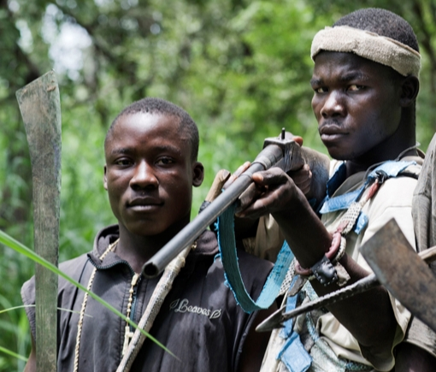

The UN believes at least 10,000 peacekeeping troops will be required in any force sent to end violence in Central African Republic, the French UN envoy says.
Ambassador Gerard Araud described the bloodshed in CAR as "uncontrollable". Speaking to reporters, Mr Araud said the African Union force in the country, intending to reach 6,000 troops, "is considered now too low because frankly the situation is very very dire and the country is huge".
About a million people - 20% of the population - have fled their homes during months of fighting, after rebels seized power in March.
“Terrorizing with the threat of violent militancy”
Security Council members have been alarmed by the cycle of vengeance between warring militia in the Central African Republic, says Professor Patrick Larson, chair of international relations at the London School of Economics and Political Science.
“The aggressors in CAR are inciting fear, terrorizing others with the threat of violent militancy.” He adds, “There is concern that without an international response the situation will degenerate into a countrywide sectarian divide and anger and violence will spiral out of control.”
“A dangerous proposition”
“There is, however, real scepticism whether international powers will take the risks and contribute to the force. A mission to deliver peace is a dangerous proposition, and the international community is reluctant to accept the hazards of a distant and perilous conflict.” Professor Larson said there is fear that intervention will threaten spreading Islamic extremism across the region, fanning the flames of hatred and violent conflict.
France, the former colonial power, currently has 1,600 troops in CAR, working with some 4,000 from African countries.
Appendix A2
Stimulus from Study 2. A congruent image-text stimulus is shown, combining a victim image with a victim text. The other stimuli from study 2 (including the Dutch versions) can be requested from the authors.

EU immigration crisis: More efforts needed to reduce the suffering in 2016

In the summer of 2015 Europe experienced the highest influx of refugees since the second world war.

Most have come from war-torn Syria where a third of the population has been displaced, and over 4 million have fled the country.

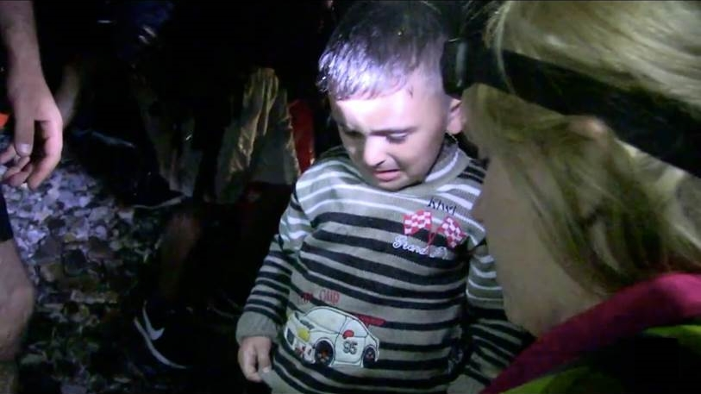

Antonio Guterres, head of the UN refugee agency, said “more efforts are needed for humanitarian assistance and to build upon clear pro-foreigner sentiments.”

“Many governments in Europe are dedicated to preventing the suffering of innocent refugees. Some will use their armed forces to protect the victims.”

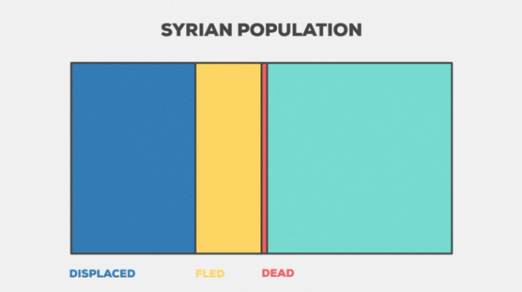
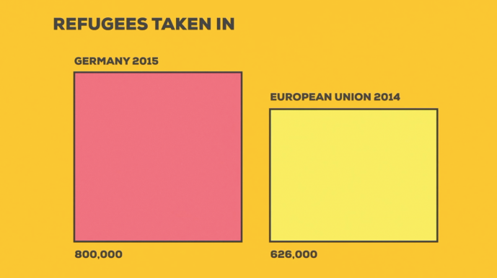
Germany took in approximately 800,000 people in 2015 – more than the entire EU in 2014 – only to later impose temporary border controls. As yet, no EU-wide solution has been found.

Stimulus from Study 2. A congruent image-text stimulus is shown, combining an intruder image with an intruder text. The other stimuli from study 2 (including the Dutch versions) can be requested from the authors.

EU immigration crisis: More efforts needed to share the burden in 2016

In the summer of 2015 Europe experienced the highest influx of refugees since the second world war.

Most have come from war-torn Syria where a third of the population has been displaced, and over 4 million have fled the country.

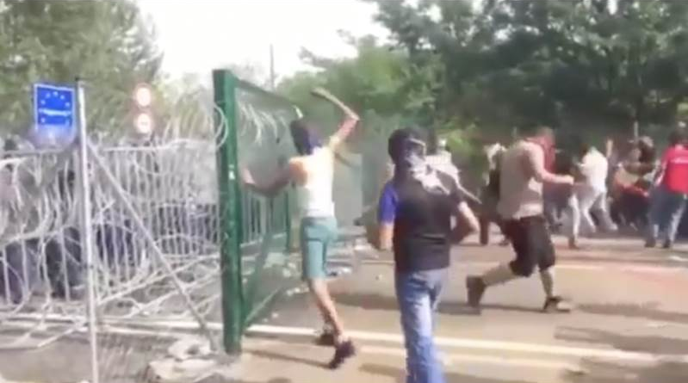

Antonio Guterres, head of the UN refugee agency, said “more efforts are needed to share the burden but there are clear anti-foreigner sentiments.”

“Many governments in Europe are rigidly interested in preventing intrusions by illegal immigrants. Some will use their armed forces to protect their borders.”

Germany took in approximately 800,000 people in 2015 – more than the entire EU in 2014 – only to later impose temporary border controls. As yet, no EU-wide solution has been found.

Appendix B
Details of the scales used in the study. Including the processing pathway manipulation check scale, and the processing style variables used for moderation analyses.
Processing pathway manipulation checks
Four items were adapted from Wolski and Nabi’s (2000) message processing depth scale, designed to assess ability, motivation and overall depth of information processing. The four items included: I was motivated to read this article; I paid close attention to each point that was made; I thought deeply about the contents; my mind wandered as I read the article (last item reversed; 1 = strongly disagree, 7 = strongly agree; α = .81). In Experiment 1, processing depth was significantly different across the processing conditions, F(2, 1241) = 157.05, p < .001, ƞ_{p}² = .20. Stimuli were processed most deeply in the controlled processing condition (M = 5.46, SD = 1.17), followed by the control condition (M = 5.28, SD = 1.28), followed by the automatic condition (M = 3.97, SD = 1.15). Post-hoc tests showed that all differences were significant (all p < .03), suggesting that our processing manipulations were successful.
The same items were used to assess the success of the processing pathway manipulations in Experiment 2. The outcome of these checks are included in the main text.
Moderator scales
This section includes details of the information processing style moderator variables used in Experiment 1 and Experiment 2. Reliability scores for these scales from both experiments are detailed in the main paper.
Need for Cognition
As detailed in the paper, the 18-item Need for Cognition scale was used in Experiment 1 (Cacioppo, Petty & Fao, 1984). A 6-item version used in previous studies (Bakker & Yelkes, 2016; Bullock, 2011) was used in Experiment 2. The 6-item version is shown in the table below. Dutch translations of these items were taken from the Longitudinal Internet Studies for the Social sciences (LISS; 2015) study panel (www.lissdata.nl/dataarchive/study_units/view/639).
6-item Need for Cognition (from Bullock, 2011)
Item | Wording | Response scale
1 | Some people prefer to solve simple problems instead of complex ones. Other people prefer to solve complex problems instead of simple ones. What is your preference? | Greatly prefer simple problems (1); greatly prefer complex problems (7).
2 | How much pleasure do you get from thinking? | None (1); a great deal (7).
3 | Some people prefer to think about small, daily projects. Other people prefer to think about big, long-term projects. What is your preference? | Greatly prefer small, daily projects (1); greatly prefer big, long-term projects (7).
4 | How much do you like or dislike thinking long and hard for hours? | Dislike a lot (1); like a lot (7).
5 | How much do you like or dislike having responsibility for handling situations that require lots of thinking? | Dislike a lot (1); like a lot (7).
6 | After finishing a task that required a lot of mental effort, do you feel more relieved than satisfied, or more satisfied than relieved? | Much more relieved than satisfied (1); much more satisfied than relieved (7).

Need for Affect
The 11-item need for affect scale (Sojka & Giese, 1997) was used in both Experiment 1 and Experiment 2. Examples of scale items include, “I am a feeling person,” “I make decisions with my heart,” and “I enjoy trying to explain my feelings – even if it’s only to myself.” (1 = Strongly disagree, 7 = Strongly agree).
Visual-Verbal Style of Processing
Preference for a visual or verbal information processing style was assessed in Experiment 1 using the 22-item Style of Processing scale (Childs, Houston & Heckler, 1985). The scale comprises a visual subscale (11 items) and a verbal subscale (11 items). These are recoded in the full scale such that low scores indicate a preference for visual processing and high scores a preference for verbal processing.
Due to time and resource restrictions in Experiment 2, we reduced the SoP scale to 12 items. We used a combination of methods to inform this decision, including content validity checking, and principal components analysis and reliability analysis using the data from Experiment 1. Principal components analysis showed that most of the items (16) loaded on two factors concerning (a) mental imagery and (b) word use/enjoyment. These factors closely matched the concept we were interested in – i.e., the mental use of words and pictures when processing information. Other items, for instance those regarding daydreaming, did not and were discarded. Reliability analysis converged on 12 items that both formed a reliable scale and met our content validity checks. These comprised six items from the visual subscale and six from the verbal subscale, striking a balance between economy of space and optimization of scale reliability and content validity (Bakker & Yelkes, 2016). The final 12-item scale is shown in the table below.
12-item Style of Processing Scale (adapted from Childers, Houston & Heckler, 1985)
Item | Wording | Visual/Verbal subscale
1 | I enjoy doing work that requires the use of words. | Verbal
2 | There are some special times in my life that I like to relive by mentally "picturing" just how everything looked. | Visual
3 | I do a lot of reading. | Verbal
4 | I think using mental images and not using words. | Visual
5 | I generally prefer to use a diagram than a written set of instructions. | Visual
6 | I like to picture how I could fix up my apartment or room if I could buy anything I wanted. | Visual
7 | I enjoy learning new words. | Verbal
8 | I find it helps to think in terms of mental pictures when doing many things. | Visual
9 | I like learning new words. | Verbal
10 | When I have forgotten something I frequently try to form a mental "picture" to remember it. | Visual
11 | I prefer to read instructions about how to do something rather than have someone show me. | Verbal
12 | I prefer activities that don't require a lot of reading. | Verbal
Note. Response scale: always false (1); usually false (2); usually true (3); always true (4).

Appendix C
Details of the pilot experiments used to generate stimuli for Experiment 2.
We took extra steps to ensure that the images and texts used to construct the stimulus articles clearly showed the victim and intruder frames, and also that they were matched on several important and potentially confounding factors. These factors included perceived arousal, salience, ambiguity, complexity, and newsworthiness, which have been shown to influence framing effects (Schuck & de Vreese, 2006), information processing (Lang, 1995), memory (Oschner, 2000) and emotional responses (Russell, 1980). By matching our frame conditions on these variables we can rule out the extraneous influence of these potential confounds, which is particularly important for visual stimuli that by nature are difficult to control in an experimental context. Therefore we can make a strong claim that the results were a product of the framing manipulation. Below we describe the steps taken to select the stimuli via two pilot experiments.
Pilot experiment 1: Image selection and thought-listing
We evaluated five images from the victim frame that clearly showed refugees as suffering victims of the crisis, and five images from the intruder frame the clearly showed refugees as burdensome and hostile intruders. N = 110 British adults were recruited via the online panel Crowdflower. Participants viewed four images – two randomly allocated from the victim frame condition and two from the intruder condition. After viewing each image they were asked to rate the extent to which the image showed Syrian refugees attempting to travel to Europe as: (1) victims and (2) intruders. Afterwards the other image appraisal measures were taken: arousal (“the image made you calm – alert”), salience (“the image was attention-grabbing”), ambiguity (“the situation conveyed in the images was ambiguous – clear”), visual complexity (“the image was visually simple – complex”), and newsworthiness (“the image was similar to other images you see in news coverage of the European refugee crisis”). All measures used a 1 – 7 Likert scale. One image was selected from each frame category that differed significantly on the victim and intruder frame rating scales (both p < .001) and that was matched on all of the control measures (all p > .05).
In addition to these measures, participants were also asked to list the thoughts and feelings they had when viewing each image. For the victim images words included sorry, sad, sympathy, desperate, pity and displaced. For the intruder images, listed words included angry, worried, violence, intruders, borders and scared. These words were then used in writing the stimulus texts – described in more detail below. This was done to maximize congruence between the visual and text stimuli.
Pilot experiment 2: Text selection
Three candidate articles were downloaded from the BBC News website. These were shortened and phrases were modified to achieve the victim and intruder framed version of each article. In addition to the words from the thought-listing output described above, reports from the websites of the UN High Commission for Refugees and the Daily Express were used to source words and phrases for the frame modifications. These included words such as protect victims, suffering, humanely, help, sorrow, tragedy and refugee in the victim condition, and protect borders, burden, hostile, violence, intruders and flood of migrants in the intruder condition. A control/balanced version of each article was also created by removing the words and phrases used to achieve the frame manipulations. The articles were then translated to Dutch using the widely accepted translation-back-translation method with the authors resolving any discrepancies. The three articles with a victim, intruder and control version of each (nine articles in total) were included in the pilot experiment. Crowdflower was used to recruit N = 93 Dutch adults who were asked to read three articles – one framed version of each article – and completed the same measures as in pilot experiment 1. Again, we aimed to select an article that best achieved the frame manipulations and was matched on the control measures. Since a control version was included for each article, we calculated a ‘frame index’ by subtracting the intruder rating from the victim rating for each participant so that positive scores indicated perception of victims and negative scores indicated perception of intruders. For the selected article, the mean frame index score for each version was as follows: victim (M = 2.65, SD = 2.88), control (M = 1.35, SD = 3.01), intruder (M = -0.50, SD = 2.87). There was a significant difference in frame rating between each version (p < .001). Moreover, each version of the article was matched on the control measures – arousal, salience, ambiguity, complexity and newsworthiness (all p < .2).
Finally, we combined the framed versions of the images and texts into the congruent and incongruent stimuli, one of which can be viewed at Appendix A2.
Manipulation checks in the main study
We also included manipulation checks in the main study to assess whether the frame conditions were detected with the images and texts combined in congruent and incongruent pairs. Note that this provides a stricter manipulation check than the pilot experiments above which tested the images and texts in isolation. To do so, the same frame rating measures were collected and a frame index score was again calculated. Stimuli with a victim image (M = 2.51, SD = 2.56) had a higher frame index score than stimuli with an intruder image (M = 1.81, SD = 2.64), F(1, 1223) = 22.40, p < .001. In addition, stimuli with a victim text (M = 2.43, SD = 2.61) had a higher frame index score than stimuli with a control text (M = 2.15, SD = 2.55) which were higher than stimuli with an intruder text (M = 1.89, SD = 2.67), F(2, 1223) = 4.43, p = .012. This confirms the results from pilot experiments 1 and 2 that the framing manipulations were effective.

