Supplemental figures

Figure S1.
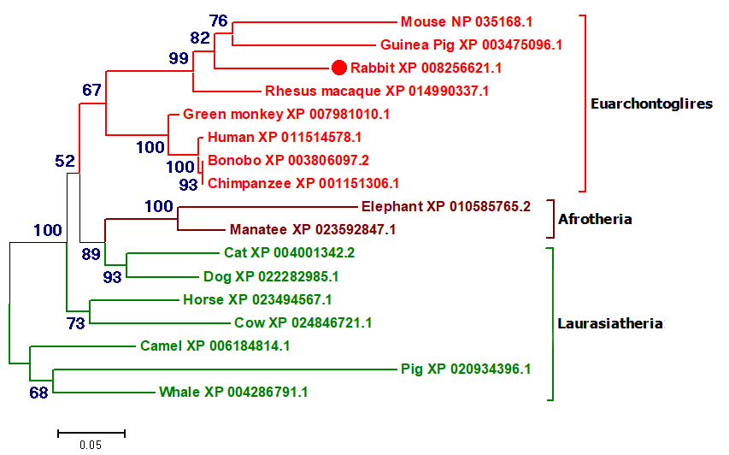

Figure S1. Evolutionary relationships of PAX4 gene in Eutheria.
The evolutionary history was inferred using the Neighbor-Joining method (Saitou and Nei 1987). &#32 The optimal tree &#32with the sum of branch length = 1.64719055 &#32is shown. &#32 The percentage of replicate trees in which the associated taxa clustered together in the bootstrap test (1000 replicates) are shown next to the branches (Felsenstein 1985). &#32 The tree is drawn to scale, with branch lengths &#32in the same units as those of the evolutionary distances used to infer the phylogenetic tree. &#32 The evolutionary distances were computed using the JTT matrix-based method (Jones et al. 1992) and are in the units of the number of amino acid substitutions per site. &#32 The rate variation among sites was modeled with a gamma distribution (shape parameter = 6). The analysis involved 17 amino acid sequences. All positions with less than 95% site coverage were eliminated. That is, fewer than 5% alignment gaps, missing data, and ambiguous bases were allowed at any position. There were a total of 329 positions in the final dataset. Evolutionary analyses were conducted in MEGA7 (Kumar et al. 2016).

Felsenstein, J., 1985 Confidence limits on phylogenies: An approach using the bootstrap. Evolution 39: 783–791.
Jones, D. T., W. R. Taylor, and J. M. Thornton, 1992 The rapid generation of mutation data matrices from protein sequences. Comput. Appl. Biosci.8: 275–282.
Kumar, S., G. Stecher, and K. Tamura, 2016 MEGA7: Molecular Evolutionary Genetics Analysis version 7.0 for bigger datasets. Mol. Biol. Evol. 33: 1870–1874.
Saitou, N., and M. Nei, 1987 The neighbor-joining method: A new method for reconstructing phylogenetic trees. Mol. Biol. Evol. 4: 406-425.
Figure S2.

Figure S2. The gene expression of PAX4 was determined by qRT-PCR.
WT, wild type control; PAX4^{+/-}, heterozygous PAX4 gene knockout rabbits; PAX4^{-/-}, homozygous PAX4 gene knockout rabbits. All experiments were repeated for three times for each gene. Data are presented as mean ± SEM, and analyzed by t-tests using Graphpad Prism software 6.0. * p < 0.05; *** p < 0.001.

Figure S3.

Figure S3. Mutation detection of 8 F0 rabbits obtained by T-cloning and Sanger sequencing.
The sequences of sgRNAs are shown in green, the PAM sites are highlighted in red; deletions (-); WT, WT control. 2-1 - 2-8 represent the 8 pups used in this study.

Supplemental tables:

Table S1. The primers of potential off-target sites (POTS) used in this study
 | Potential Off Target Site | Position | PCR Primer
s1 | CGAGGGCATCACTACCGCTCTGG | chr4:-82175741 | F: CCGTCTATAATGCAGGGTTGT  R: TACAGCTCATGGTGTTGTCC
 | CCAGGCCCTTACTACCCCACTGG | chrUN0:+6791 | F: CTGCCAGCTTCCTACTTCAG  R: TCTACCCATACTCACCCTTCTC
 | CTAGGGCATCACGACCTCACAGG | chr18:+10523100 | F: CTGCAAGAAAGCTACAGCAAAG  R: TAGATCAGAGAGTGAGGCAAGA
 | GGAGGGCGTTGCTACTGCACAGG | chr7:-90526418 | F: GAGGAGTGATGTGCTGAGACTA  R: AAAGGAGCCGAACAGGTAGA
 | CCAGGGCTTTGCTACGGCACTGG | chrUN0:+3584352 | F: CCCTTCAGCCCAATGACTT  R:GTCTCCTTTCCTATCCACACTTC
s2 | TCTGGAGTGGTCACCGGAATGGG | chr12:+75520987 | F:GGTGTAGTGAGGATGTCAGTATC  R: CTGCCTTTCCTGGACAAATG
 | AAGCCACTGGTCCCCGGAATGGG | chr3:+41677265 | F:AGCCTTGAAACACAAGTCAGATA  R: GGTCGTGGAAGAAAGAGAAAGG
 | CAGAGACAGCTCACTGGAATAGG | chr17:+28450946 | F: TATTCCCAGCTGTGGCTTAAC  R:CCAAGACTGAACCATGGAGATAC
 | CCGGGACTGAGCACCGGAAGGGG | chrUN0:+67599 | F: TCCTGTGAGGGCGAGAG  R: TAGGGAGGTGGAGCTGTG
 | CAGGCGCTGTTCACCGAAATGGG | chr4:+75062479 | F: TTCCGTCGGTGATGTTTCTC  R: TAGCTGTCCCTCCCTCATC

Table S2: Primers used for quantitative real-time RT-PCR

Name | Primers | Sequence(5’-3’) | Produce size (bp)
PAX4 | PAX4 - F  PAX4 - R | GGGCTCTTTGTGAATGGCCG  TACCTTAAGGCTCCGGGAGAT | 108
GAPDH | GAPDH - F  GAPDH - R | TTCCACGGCAGGTCAAGGC  GGGCACCAGCATCACCCCAC | 99

Table S3: Results of urinalysis

Rabbits | BLO | NIT | pH | URO | BIL | PRO (mg/dl) | GLU (mg/dl) | KET (mg/dl)
WT | Negative | Negative | 9.0 | Normal | Negative | Negative | Negative | Negative
PAX4^{+/-} | Negative | Negative | 9.0 | Normal | Negative | Negative | Negative | 2.5±3.5
PAX4^{-/-} | Negative | Negative | 5.0 | Positive | Negative | 100 | 2000 | 160

