Increased sea ice concentration worsens fledging condition and juvenile survival in a pagophilic seabird, the snow petrel

Christophe Sauser¹, Karine Delord¹, Christophe Barbraud¹
¹Centre d’Etudes Biologiques de Chizé UMR 7372, CNRS, 79360 Villiers en Bois, France

Supplementary material

Study species and monitoring
The islands of the Pointe Géologie archipelago are surrounded by sea ice during the austral winter and are generally surrounded by open water during the austral summer. However, depending on the year, the sea ice extent and concentration can vary greatly [1]. Snow petrels breed during the Antarctic summer in rocky ice free areas under boulders or within crevices [2]. Approximately 1000 breeding pairs of snow petrels breed in the archipelago [3]. During the breeding season snow petrels feed mostly on sea ice associated prey such as fish (mainly Antarctic silverfish Pleuragramma antarcticum) and krill (mainly Euphausia crystallorophias and E. superba) and occasionally on squid (mainly Psychroteuthis glacialis)[4–8].
Since 1964, three colonies of snow petrels in the Pointe Géologie archipelago have been monitored annually [9–11]. In these colonies all adult individuals were identified, ringed with a stainless steel band, measured (wing length ± 1 mm, culmen length ± 0.1 mm, tarsus length ± 0.1 mm, and bill depth ± 0.1 mm, see [12] for details), and sexed by vocalization (females have higher sound frequency than males [13]) during nests visits made just after the end of the laying period. Hatching dates were recorded by daily inspections of nest contents, and a final nest visit in mid-February was made to mark the chicks and estimate breeding success. Body size measurements (wing length, culmen length, and body mass ± 1 g) were also carried out annually since 1993 on all chicks of the three study colonies 40 days after hatching. We used this data set to investigate environmental effects on fledging body condition.
In addition to these three colonies, all nests of the archipelago were marked and their contents checked once during the second week of December to identify the breeding and non-breeding birds, and once in mid-February to mark the chicks with a stainless steel ring just before fledging. We used this data set to investigate environmental effects on juvenile survival.

Environmental variables
Sea ice contributes to a substantial proportion of the annual primary productivity in the seasonal ice zone and is important in the life cycle of krill [14] and Antarctic silverfish [15,16], both primary food resources for snow petrels. In addition, snow petrels are known to forage exclusively in the sea ice zone targeting specific sea ice concentration areas [4,17]. In the same way, sea surface temperature plays a fundamental role in net primary production [18], which may have an effect in the distribution and abundance of snow petrels’ preys. Sea ice concentration and sea surface temperature are known to affect demographic parameters in several Antarctic seabird species [19].
The SAM is the dominant mode of atmospheric variability in the Southern Hemisphere, and is characterized by the displacements of atmospheric masses between the polar regions and the mid-latitudes [20]. SAM is related to the temperature variation of the Antarctic, the temperature of the surface waters of the Southern Ocean and the distribution of sea ice around the Antarctic. A positive phase of the SAM is associated with an amplification of the surface westerlies around 60°S, and a weakening of the surface westerlies farther north. This induces Ekman drift which increases Antarctic sea ice extent and improves upwelling near the Antarctic continent [21].
Monthly SIC and SST data were obtained from http://iridl.ldeo.columbia.edu /SOURCES/.NOAA/.NCEP/.EMC/.CMB/.GLOBAL/.Reyn_SmithOIv2/. To take into account the variation in the spatio-temporal distribution of adult snow petrels [22], these two covariates where extracted during the chick-rearing period (from January to March) for the sector 66°S-67°S, 139°E-142°E corresponding to the Dumont d’Urville Sea, and during the winter period (from April to September) for the sector 66°S-67°S, 130°E-149°E when birds use a larger feeding area [23].
Annual SAM values ​​were obtained from the online database of the British Antarctic Survey [24]. Since some climate covariates were correlated to each other (table S1) we used variance inflation factors to assess which explanatory variables were collinear and should be dropped before starting the analyses [25]. A cut-off value of 3 was used to remove collinear variables.

Modelling fledging body condition
The scale mass index (SMI) adjusts the mass of all individuals to that expected if they had the same body size. We used the score of the first axis of a principal component analysis (PC1) combining wing and culmen lengths to characterize body size. PC1 accounts for 68% of the total variance and the wing and culmen length measurements are highly correlated with PC1 (r > 0.66; P < 0.001). The SMI was calculated for each individual i according to the formula:
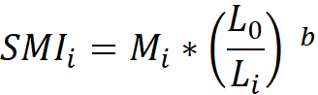
[26]
where M_{i} and L_{i} are, respectively, the body mass and the PC1 score of the individual i, L₀, is the value of PC1 for the whole studied population and b the slope estimate of the SMA (Standardized Major Axis) regression of log-transformed body mass on log-transformed PC1. We used the SMI obtained for each chick as an indicator of fledging body condition.
The interest of GAMM is the smoothing function which allows to make more flexible assumptions about the real relationship between the response variable and the predictors [27,28]. Thus, GAMM can describe complex non-linear relationships between a response variable and predictors. In addition to the three climatic covariates described above, we also considered three non-climatic covariates that could influence the SMI: the body size of the parents (Size), which affects the feeding frequency of the chicks and thus potentially the SMI [10]; the hatching date (Date), which is known to affect the body condition of chicks in birds [29,30]; and yearly breeding success of the monitored colonies (BS), which may be an indicator of trophic conditions during the breeding season [31,32]. In order to take into account the individual variability of the parents, we added a random effect for each parent in the model. Indeed, over all the years of the dataset, breeding adults can have several chicks, generating autocorrelation that can affect the results of the model. To incorporate this pattern into the model, each year was allowed to have a different variance. Therefore, our initial model was:
where E(SMI_{i}) is the expected value of the SMI as a function of the predictors, β₀ is an intercept, f_{k} ₌ _{1,... 6} are nonparametric smoothing functions, ε_{i} and δ_{i} are normally distributed random effects with mean zero and variance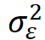 and 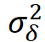 , respectively. The dataset consisted of n = 1165 chicks for which SMI was calculated. Residual normality was visually verified. We use a GAMM with a Gaussian family and identity link function. Model were fit with R 3.2.2 [33].
The use SMI has been criticized as a nonlethal measure of body condition in seabirds [34]. Therefore, in addition to the SMI, we calculated the body condition index (BCI) estimated for each individual as the residual from an ordinary least squares regression of mass on the PC1 [34]. We then ran the same GAMM model as for SMI.

Modelling juvenile survival
The snow petrel is a long-lived species with an average age of first breeding around 9-10 years [9]. Therefore, to have a sufficient number of observations to estimate juvenile survival, we considered individuals banded as chicks from 1964 to 2000 (n = 6418) and recaptured in the Pointe Géologie archipelago during the period 1964 to 2015, allowing us to know the age at recapture with precision. Chicks banded during the last 15 years (2001 to 2016) were not included in the analysis since these cohorts probably have not yet fully recruited (90% of a cohort is recruited 15 years after banding, [11]). Individuals that were never seen again after marking were taken into account to avoid an overestimation of survival. Observations at other snow petrel breeding sites outside the Pointe Géologie archipelago suggests that very few individuals (n = 2) born in the archipelago were breeding in distant colonies (25-1300 km). From the initial marking event and the successive recaptures at each breeding season we constructed a capture history for each individual coded with a "1" when the individual was observed and with a "0" when the individual was not observed. Individuals not observed may be dead, alive and absent from the recapture zone or alive and present in the recapture area but not detected.
Since our main interest was in modelling the factors affecting juvenile survival, the initial capture-mark-recapture model [35] from which model selection was performed was model (Ф_{juv.t, ad} p_{age}), where apparent survival of juvenile individuals was time dependent, survival of adult individuals was constant and recapture probability was fully age dependent with 51 age classes. Since no individual was observed on colonies before the age of 5 we constrained the probability of recapture from 1 to 4 years to 0 and survival probabilities of ages 2 to 5 to 1 in order to make the parameters identifiable [36]. Thus, juvenile survival was estimated over the first 5 years of life. Adult survival was constrained to be constant from age 6, corresponding to the minimum age at first breeding [9,11] and as suggested by a previous study [37]. From this initial model, we tested different models where age classes on recapture probability were aggregated starting from the oldest age classes. We also tested whether the recapture probability varied according to a linear or quadratic trend (on a logit scale) according to age. For body size of the parents and chick SMI only 7 years of data were available to test their effect on juvenile survival (since chick were measured only from 1993 and the cohorts born after 2000 were excluded from the survival analysis), which was insufficient. The period available for each covariate is presented in table S2.
The effects of covariates were tested using linear or quadratic (on a logit scale) relationships and using analysis of deviance (ANODEV) following [38,39]. The proportion of variance explained by covariates (R²,[40]) was calculated as:
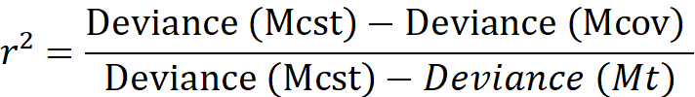
where Mcov is the covariate model, Mt is the time-dependent model and Mcst is the constant model.
Goodness-of-fit of the initial model was evaluated using the median c-hat approach (with 10 levels of c-hat and 10 replicate points at each level) available in MARK, and the estimated variance inflation factor c-hat was used to adjust standard errors and model selection criterion [41]. Model selection was performed using the corrected quasi-likelihood adjusted Akaike Information Criterion (QAICc) [42]. In practice, we consider two models as different if the difference of QAICc between these models is greater than 2. The median c-hat goodness-of-fit test indicated that the global model fit the data adequately (c-hat = 1.17, [35]). Accordingly, this model was used as a starting point for analysing the data on snow petrel survival with a c-hat value of 1.17.

Table S1. Testing for collinearity between different covariates before and after selection. VIF = variance inflation factor.
Covariate | VIF test value  before variable selection | VIF test value  after variable selection
Breeding success | 1.41 | 1.24
Adult body size | 1.05 | 1.04
Sea ice concentration in summer | 8.06 | 1.23
Anomaly of sea surface temperature in summer | 10.97 | Not selected
Sea ice concentration in winter | 25.07 | Not selected
Anomaly of sea surface temperature in winter | 28.80 | Not selected
Southern Annular Mode | 2.47 | 1.16
Laying date | 1.16 | 1.12

Table S2. Time period available for each covariate of the model.
Covariate | Years available
Southern Annular Mode | 1964 to 2000
Sea ice concentration | 1981 to 2000
Breeding success | 1964 to 2000
Body size of the parents | 1993 to 2000
Fledging SMI | 1993 to 2000

Table S3. Modelling recapture probability and juvenile survival probability of snow petrels from Pointe Géologie between 1964 and 2000. k = number of identifiable parameters.
Model number | Model structure | k | Deviance | QAICc | ΔQAICc
1 | Ф_{juv.t, ad} p₅₁ | 85 | 6861.9 | 13639.4 | 32.8
2 | Ф_{juv.t, ad} p₄₅ | 79 | 6865.6 | 13630.8 | 24.2
3 | Ф_{juv.t, ad} p₄₀ | 74 | 6875.4 | 13630.4 | 23.8
4 | Ф_{juv.t, ad} p₃₅ | 69 | 6879.8 | 13624.7 | 18.1
5 | Ф_{juv.t, ad} p₃₀ | 64 | 6884.5 | 13619.2 | 12.6
6 | Ф_{juv.t, ad} p₂₅ | 59 | 6885.9 | 13610.5 | 3.9
7 | Ф_{juv.t, ad} p₂₀ | 54 | 6900.5 | 13614.9 | 8.3
8 | Ф_{juv.t, ad} p₂₁ | 55 | 6891.9 | 13608.4 | 1.8
9 | Ф_{juv.t, ad} p₂₂ | 56 | 6890.8 | 13609.3 | 2.7
10 | Ф_{juv.t, ad} p₂₃ | 57 | 6886.1 | 13606.6 | 0
11 | Ф_{juv.t, ad} p₂₄ | 58 | 6886.1 | 13608.7 | 2.1
12 | Ф_{juv, ad} p₂₃ | 21 | 7127.9 | 13775.9 | 169.3

Table S4. Results of the GAMM model explaining fledging body condition in snow petrels as a function of environmental and intrinsic covariates. Results for Scale mass index (SMI) and Body condition index (BCI) are reported. Results using BCI suggest a positive effect, although weak, of adult body size (structurally larger parents tend to fledge chick s in better conditions) and laying dates (females that lay their egg later tend to fledge chicks in better condition).
Index | Variables | Smoother edf | F-test | P-value
SMI | Southern Annular Mode | 1.87 | 19.867 | <0.001
SMI | Sea ice concentration | 1.76 | 48.283 | <0.001
SMI | Adult body size | 1.51 | 1.929 | 0.09
SMI | Laying date | 1.00 | 0.002 | 0.96
SMI | Breeding success | 1.00 | 0.373 | 0.48
BCI | Southern Annular Mode | 1.92 | 17.98 | <0.001
BCI | Sea ice concentration | 1.93 | 28.23 | <0.001
BCI | Adult body size | 1.52 | 5.35 | 0.03
BCI | Laying date | 1.85 | 6.09 | 0.02
BCI | Breeding success | 1.00 | 1.68 | 0.19

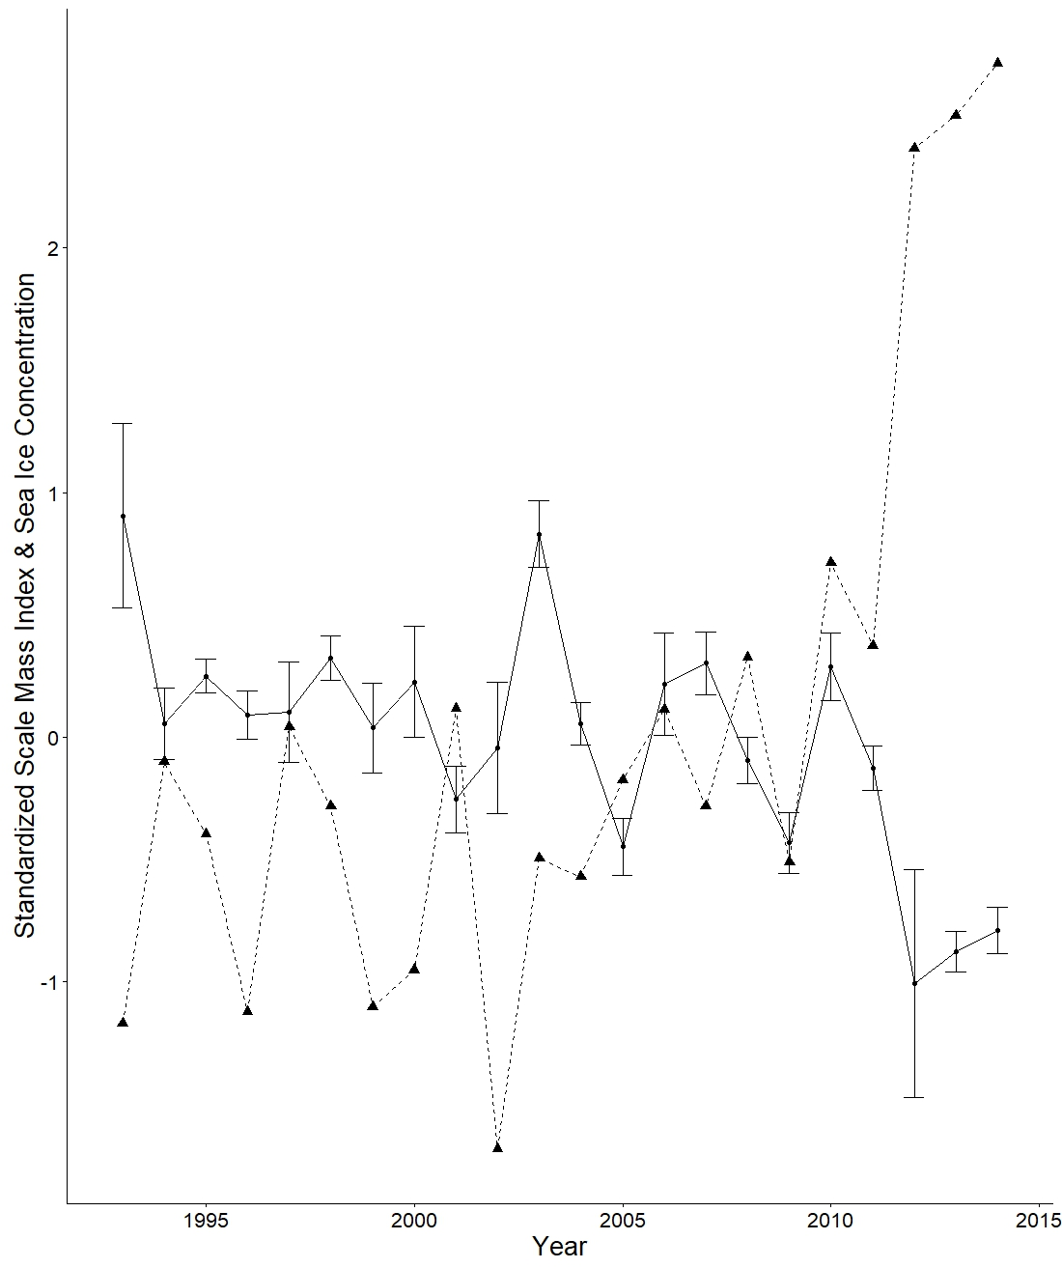
Figure S1. Standardized temporal trends of SMI (solid line, solid circles) and SIC (dashed line, triangles) from 1993 to 2014 for the January-March period. Error bars are s.e.

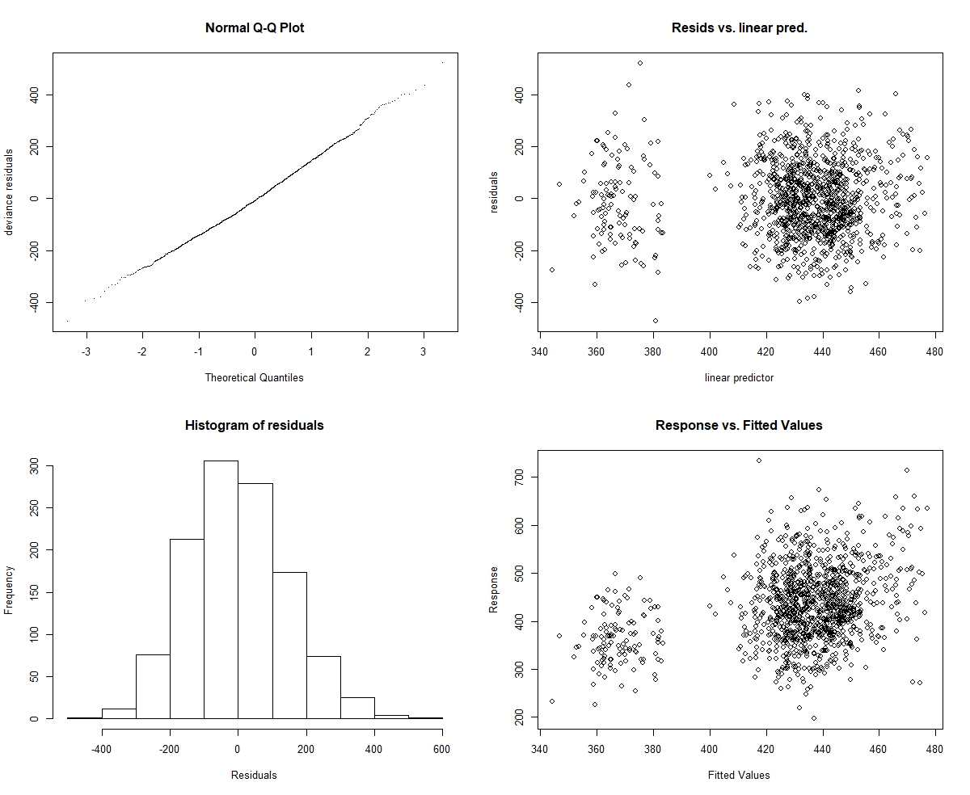
Figure S2. Standard diagnostic plots from the residuals of the model.

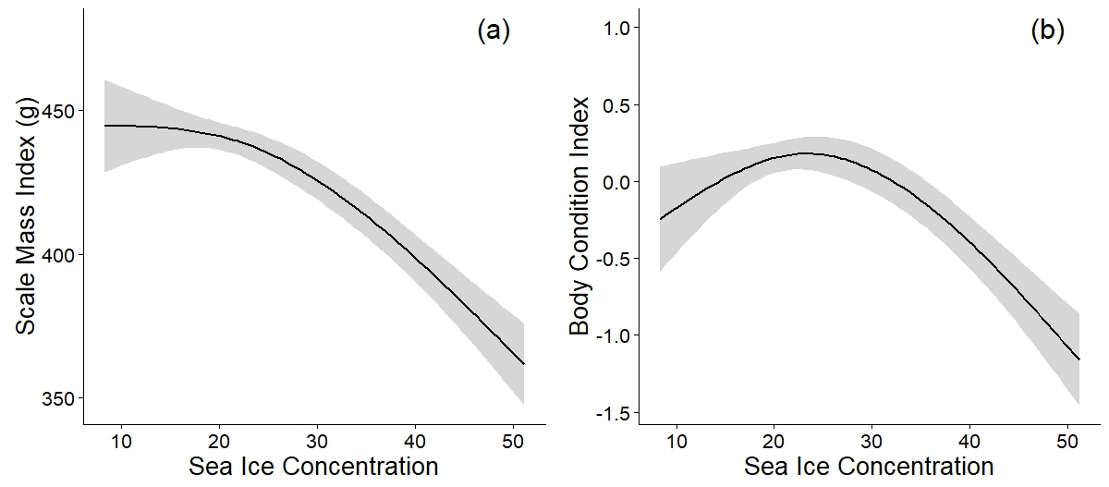
Figure S3. Estimated smoothing curves (with s.e. ) for SIC in relation with the Scale Mass Index (a) and the Body Condition Index (b).

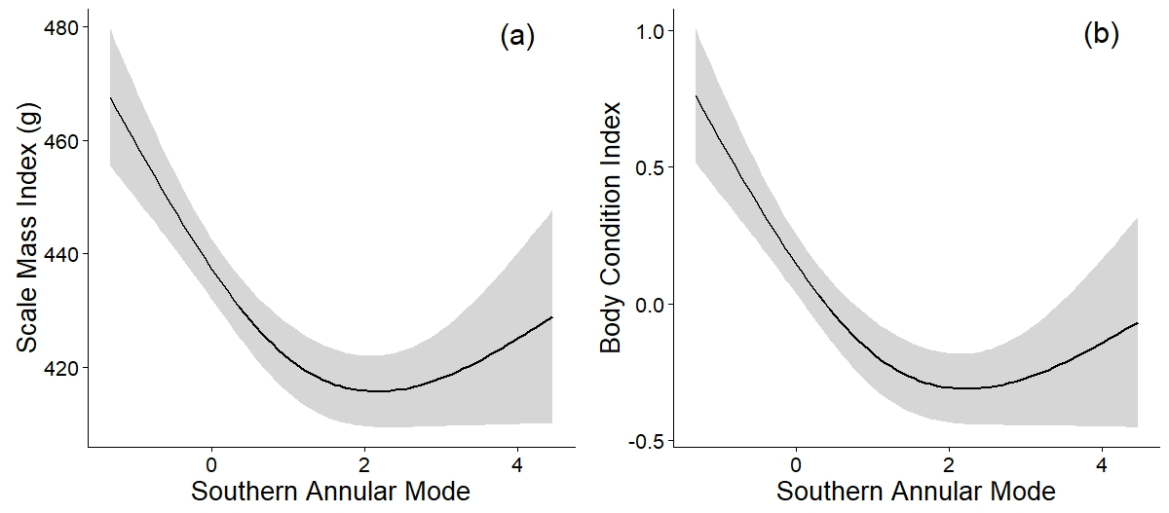
Figure S4. Estimated smoothing curves (with s.e.) for SAM in relation with the Scale Mass Index (a) and the Body Condition Index (b).

References
1. Barbraud C, Delord K, Weimerskirch H. 2015 Extreme ecological response of a seabird community to unprecedented sea ice cover. R. Soc. Open Sci. 2, 140456–140456. (doi:10.1098/rsos.140456)
2. Marchant S, Higgins PJ. 1990 Handbook of Australian, New Zealand and Antarctic birds. Vol. 1: Ratites to Ducks, Part A-Ratites to Petrels, Part B-Australian Pelican to Ducks. Oxford University Press, Melbourne.
3. Micol T, Jouventin P. 2001 Long-term population trends in seven Antarctic seabirds at Pointe Géologie (Terre Adélie) Human impact compared with environmental change. Polar Biol. 24, 175–185.
4. Ainley DG, O’Connor EF, Boekelheide RJ. 1984 The Marine Ecology of Birds in the Ross Sea, Antarctica. Ornithol. Monogr. , iii–97. (doi:10.2307/40166773)
5. Ridoux V, Offredo C. 1989 The diets of five summer breeding seabirds in Adélie Land, Antarctica. Polar Biol. 9, 137–145. (doi:10.1007/BF00297168)
6. Van Franeker JA, Williams R. 1992 Diet of fulmarine petrels in the Windmill Islands, Wilkes Land, Antarctica. Preliminary results. Circumpolar J. 7, 134–138.
7. Ainley DG, Ribic CA, Fraser WR. 1992 Does prey preference affect habitat choice in Antarctic seabirds? Mar. Ecol. Prog. Ser. , 207–221.
8. Rau GH, Ainley DG, Bengtson JL, Torres JJ, Hopkins TL. 1992 15 N/14 N and 13 C/12 C in Weddell Sea birds, seals, and fish: implications for diet and trophic structure. Mar. Ecol. Prog. Ser. , 1–8. (doi:10.3354/meps084001)
9. Chastel O, Weimerskirch H, Jouventin P. 1993 High annual variability in reproductive success and survival of an Antarctic seabird, the snow petrel Pagodroma nivea. Oecologia 94, 278–285. (doi:10.1007/BF00341328)
10. Barbraud C, Weimerskirch H, Robertson GG, Jouventin P. 1999 Size-related life history traits: insights from a study of snow petrels (Pagodroma nivea). J. Anim. Ecol. 68, 1179–1192. (doi:10.1046/j.1365-2656.1999.00361.x)
11. Jenouvrier S, Barbraud C, Weimerskirch H. 2005 Long-term contrasted responses to climate of two antarctic seabird species. Ecology 86, 2889–2903. (doi:10.1890/05-0514)
12. Barbraud C, Jouventin P. 1998 What Causes Body Size Variation in the Snow Petrel Pagodroma nivea? J. Avian Biol. 29, 161. (doi:10.2307/3677194)
13. Guillotin M, Jouventin P. 1980 Le Pétrel des neiges à Pointe Géologie.
14. Loeb V, Siegel V, Holm-Hansen O, Hewitt R, Fraser W, Trivelpiece W, Trivelpiece S. 1997 Effects of sea-ice extent and krill or salp dominance on the Antarctic food web. Nature 387, 897. (doi:10.1038/43174)
15. Koubbi P, Hulley P-A, Pruvost P, Henri P, Labat J-P, Wadley V, Hirano D, Moteki M. 2011 Size distribution of meso- and bathypelagic fish in the Dumont d’Urville Sea (East Antarctica) during the CEAMARC surveys. Polar Sci. 5, 195–210. (doi:10.1016/j.polar.2011.03.003)
16. Vacchi M, Koubbi P, Ghigliotti L, Pisano E. 2012 Sea-Ice Interactions with Polar Fish: Focus on the Antarctic Silverfish Life History. In Adaptation and Evolution in Marine Environments, Volume 1 (eds G di Prisco, C Verde), pp. 51–73. Berlin, Heidelberg: Springer Berlin Heidelberg. (doi:10.1007/978-3-642-27352-0_4)
17. Ainley DG, Ribic CA, Spear LB. 1993 Species-habitat relationships among Antarctic seabirds: a function of physical or biological factors? Condor , 806–816. (doi:10.2307/1369419)
18. Behrenfeld MJ et al. 2006 Climate-driven trends in contemporary ocean productivity. Nature 444, 752–755. (doi:10.1038/nature05317)
19. Barbraud C, Rivalan P, Inchausti P, Nevoux M, Rolland V, Weimerskirch H. 2011 Contrasted demographic responses facing future climate change in Southern Ocean seabirds: Seabird demography and climate change. J. Anim. Ecol. 80, 89–100. (doi:10.1111/j.1365-2656.2010.01752.x)
20. Marshall GJ. 2003 Trends in the Southern Annular Mode from observations and reanalyses. J. Clim. 16, 4134–4143. (doi:10.1175/1520-0442(2003)016<4134:TITSAM>2.0.CO;2)
21. Holland MM, Landrum L, Kostov Y, Marshall J. 2017 Sensitivity of Antarctic sea ice to the Southern Annular Mode in coupled climate models. Clim. Dyn. 49, 1813–1831. (doi:10.1007/s00382-016-3424-9)
22. Delord K, Pinet P, Pinaud D, Barbraud C, De Grissac S, Lewden A, Cherel Y, Weimerskirch H. 2016 Species-specific foraging strategies and segregation mechanisms of sympatric Antarctic fulmarine petrels throughout the annual cycle. Ibis 158, 569–586. (doi:10.1111/ibi.12365)
23. Delord K, Barbraud C, Bost CA, Cherel Y, Guinet C, Weimerskirch H. 2013 Atlas of top predators from French Southern Territories in the Southern Indian Ocean. CEBC-CNRS. Pp 252. DOI: 10.15474/AtlasTopPredatorsOI_CEBC.CNRS_FrenchSouthernTerritories
24. In press. British Antarctic Survey - Polar science for planet earth. See https://www.bas.ac.uk/ (accessed on 22 September 2017).
25. Zuur AF, editor. 2009 Mixed effects models and extensions in ecology with R. New York, NY: Springer.
26. Peig J, Green AJ. 2009 New perspectives for estimating body condition from mass/length data: the scaled mass index as an alternative method. Oikos 118, 1883–1891. (doi:10.1111/j.1600-0706.2009.17643.x)
27. Wood SN. 2004 Stable and Efficient Multiple Smoothing Parameter Estimation for Generalized Additive Models. J. Am. Stat. Assoc. 99, 673–686. (doi:10.1198/016214504000000980)
28. Wood SN. 2017 Generalized additive models: an introduction with R. 2nd Edition. Boca Raton, Fla.: CRC press.
29. Spear L, Nur N. 1994 Brood Size, Hatching Order and Hatching Date: Effects on Four Life-History Stages from Hatching to Recruitment in Western Gulls. J. Anim. Ecol. 63, 283. (doi:10.2307/5547)
30. Monros JS, Belda EJ, Barba E. 2002 Post-fledging survival of individual great tits: the effect of hatching date and fledging mass. Oikos 99, 481–488. (doi:10.1034/j.1600-0706.2002.11909.x)
31. Boyd H, Fox AD. 2013 Effects of climate change on the breeding success of White-fronted Geese Anser albifrons flavirostris in west Greenland. Wildfowl 58, 55–70. (doi:10.1.1.958.4070)
32. Iles DT, Rockwell RF, Matulonis P, Robertson GJ, Abraham KF, Davies JC, Koons DN. 2013 Predators, alternative prey and climate influence annual breeding success of a long-lived sea duck. J. Anim. Ecol. 82, 683–693. (doi:10.1111/1365-2656.12038)
33. Team RC. 2015 R: A language and environment for statistical computing [Internet]. Vienna, Austria: R Foundation for Statistical Computing; 2014.
34. Jacobs SR, Elliott K, Guigueno MF, Gaston AJ, Redman P, Speakman JR, Weber J-M. 2012 Determining Seabird Body Condition Using Nonlethal Measures. Physiol. Biochem. Zool. 85, 85–95. (doi:10.1086/663832)
35. Lebreton J-D, Burnham KP, Clobert J, Anderson DR. 1992 Modeling Survival and Testing Biological Hypotheses Using Marked Animals: A Unified Approach with Case Studies. Ecol. Monogr. 62, 67–118. (doi:10.2307/2937171)
36. Lebreton JD, Hines JE, Pradel R, Nichols JD, Spendelow JA. 2003 Estimation by capture-recapture of recruitment and dispersal over several sites. Oikos 101, 253–264. (doi:10.1034/j.1600-0706.2003.11848.x)
37. Péron G et al. 2016 Evidence of reduced individual heterogeneity in adult survival of long-lived species: BRIEF COMMUNICATION. Evolution 70, 2909–2914. (doi:10.1111/evo.13098)
38. Skalski J, Hoffmann A, Smith S. 1993 Testing the significance of individual- and cohort-level covariates in animal survival studies. In Marked individuals in the study of bird population (eds JD Lebreton, PM North), pp. 9–28. Basel, Switzerland: Birkhäuser: Birkhauser Verlag.
39. Grosbois V, Gimenez O, Gaillard J-M, Pradel R, Barbraud C, Clobert J, Møller AP, Weimerskirch H. 2008 Assessing the impact of climate variation on survival in vertebrate populations. Biol. Rev. 83, 357–399. (doi:10.1111/j.1469-185X.2008.00047.x)
40. Skalski JR. 1996 Regression of abundance estimates from mark–recapture surveys against environmental covariates. 53(1), 9. (doi:10.1139/f95-169)
41. Burnham KP, Anderson DR. 2004 Multimodel Inference: Understanding AIC and BIC in Model Selection. Sociol. Methods Res. 33, 261–304. (doi:10.1177/0049124104268644)
42. Anderson DR, Burnham KP. 1999 Understanding information criteria for selection among capture-recapture or ring recovery models. Bird Study 46, S14–S21. (doi:10.1080/00063659909477227)

