Appendix: Microsimulation methodology
Model prediction equations came from published clinical trials, de novo database analysis, and observational studies such as Look AHEAD,(1) UK Prospective Diabetes Study (UKPDS),(2-6) and Framingham Heart Study.(7-10) The CONQUER trial involving adults with BMI of 27-45 found that A1c declines by 0.071% for each 1kg decrease in excess body weight.(11;12) Meta-analysis of clinical trial outcomes suggests each 1kg loss in body weight reduces SBP by 1.05-mmHg.(13) We modeled disease-specific and all-cause mortality risk based on disease presence, demographics, current smoking status, and biometric data as reported in the literature and government sources.(3;14-19)
The relationship between patient characteristics and annual medical expenditures, employment probability, and work absenteeism was modeled using regression analysis with the 2009-2013 files of the Medical Expenditure Panel Survey (MEPS) (n=165,913). As described in our previous publication,(20) we used a set of zero-inflated log-ratio regressions to model the allocation of total medical expenditures across cost categories - inpatient, outpatient, emergency department, prescription drugs, and “all other” care. We estimated prediction equations separately for adults with and without obesity. Regression specifications and validation results are described elsewhere, but explanatory variables include age group, sex, race, Hispanic ethnicity, insurance status, body weight (normal weight, overweight, or obese), presence of the modeled diseases, and interaction terms for diabetes and other modeled diseases.(21) We used logistic regression to model employment probability and negative binomial regression to model annual missed work days due to illness for employed adults. All costs are presented in 2015 US dollars.
The simulation produced annual results over 15 years—beyond the 10-year window used by the Congressional Budget Office to score federal legislation—to explore whether the 10-year window adequately captured societal benefits to inform long-term policy.(22)

Reference List

1. Wing RR, Lang W, Wadden TA, Safford M, Knowler WC, Bertoni AG, Hill JO, Brancati FL, Peters A, Wagenknecht L. Benefits of modest weight loss in improving cardiovascular risk factors in overweight and obese individuals with type 2 diabetes. Diabetes care 2011 Jul;34(7):1481-6.
2. Anderson K. Cardiovascular Disease Risk Profiles. American heart journal 1991;121(1):293-8.
3. Clarke PM, Gray AM, Briggs A, Farmer AJ, Fenn P, Stevens RJ, Matthews DR, Stratton IM, Holman RR. A model to estimate the lifetime health outcomes of patients with type 2 diabetes: the United Kingdom Prospective Diabetes Study (UKPDS) Outcomes Model (UKPDS no. 68). Diabetologia 2004;47(10):1747-59.
4. Hippisley-Cox J, Coupland C. Predicting the risk of Chronic Kidney Disease in Men and Women in England and Wales: prospective derivation and external validation of the QKidney-Scores. BMC family practice 2010;11(1):49.
5. Kannel W. Prevalence, Incidence, Prognosis, and Predisposing Conditions for Atrial Fibrillation: Population-Based Estimates. The American journal of cardiology 1998;82(7).
6. Nicholas G, Reinier K, Chugh S. Independent Contribution of Diabetes to Increased Prevalence and Incidence of Atrial Fibrillation. Diabetes care 2009;32(10):1851-6.
7. Ho KK, Anderson KM, Kannel WB, Grossman W, Levy D. Survival after the onset of congestive heart failure in Framingham Heart Study subjects. Circulation 1993;88(1):107-15.
8. U.S.Department of Health and Human Services PHSNIoH. The Framingham Study: An Epidemiological Intervention of Cardiovascular Diseases: Section 34: Some Risk Factors Related to the Annual Incidence of Cardiovascular Disease and Death Using Pooled Repeated Biennial Measurements: Framingham Heart Study, 30 Year Followup. 2009.
Ref Type: Generic
9. Wilson PW, Anderson KM, Harri T, Kannel WB, Castelli WP. Determinants of change in total cholesterol and HDL-C with age: the Framingham Study. Journal of gerontology 1994;49(6):M252-M257.
10. Wilson PW, Bozeman SR, Burton TM, Hoaglin DC, Ben-Joseph R, Pashos CL. Prediction of first events of coronary heart disease and stroke with consideration of adiposity. Circulation 2008;118(2):124-30.
11. Gadde KM, Allison DB, Ryan DH, Peterson CA, Troupin B, Schwiers ML, Day WW. Effects of low-dose, controlled-release, phentermine plus topiramate combination on weight and associated comorbidities in overweight and obese adults (CONQUER): a randomised, placebo-controlled, phase 3 trial. Lancet 2011 Apr 16;377(9774):1341-52.
12. Heianza Y, Arase Y, Fujihara K, Hsieh SD, Saito K, Tsuji H, Kodama S, Yahagi N, Shimano H, Yamada N, et al. Longitudinal trajectories of HbA1c and fasting plasma glucose levels during the development of type 2 diabetes: the Toranomon Hospital Health Management Center Study 7 (TOPICS 7). Diabetes Care 2012 May;35(5):1050-2.
13. Neter JE, Stam BE, Kok FJ, Grobbee DE, Geleijnse JM. Influence of weight reduction on blood pressure a meta-analysis of randomized controlled trials. Hypertension 2003;42(5):878-84.
14. Anderson KM, Odell PM, Wilson PW, Kannel WB. Cardiovascular disease risk profiles. American heart journal 1991;121(1):293-8.
15. Schaufelberger M, Swedberg K, Koster M, Rosen M, Rosengren A. Decreasing one-year mortality and hospitalization rates for heart failure in Sweden Data from the Swedish Hospital Discharge Registry 1988 to 2000. European heart journal 2004;25(4):300-7.
16. Socialstyrelsen. Swedish Health and Welfare Statistical Databases: AMI Statistics 2013 Available from http://192.137.163.40/epcfs/FisFrameSet.asp?FHStart=ja&W=1280&H=1024.
17. Vemmos KN, Bots ML, Tsibouris PK, Zis VP, Takis CE, Grobbee DE, Stamatelopoulos S. Prognosis of stroke in the south of Greece: 1 year mortality, functional outcome and its determinants: the Arcadia Stroke Registry. Journal of Neurology, Neurosurgery & Psychiatry 2000;69(5):595-600.
18. Tonelli M, Wiebe N, Culleton B, House A, Rabbat C, Fok M, McAlister F, Garg AX. Chronic kidney disease and mortality risk: a systematic review. J Am.Soc.Nephrol. 2006 Jul;17(7):2034-47.
19. Centers for Disease Control and Prevention NCHS. Underlying Cause of Death 1999-2010 on CDC WONDER Online Database, released 2012. 2013 [cited 2013 Jul 1].
20. Chen F, Su W, Becker S, Payne M, Castro Sweet C, Peters A, Dall T. Clinical and Economic Impact of a Digital, Remotely-Delivered Intensive Behavioral Counseling Program on Medicare Beneficiariesat Risk for Diabetes and Cardiovascular Disease. PLoS ONE 2016;11(10).
21. Dall TM, Storm MV, Semilla AP, Wintfeld N, O'Grady M, Venkat Narayan KM. Value of Lifestyle Intervention to Prevent Diabetes and Sequelae. American journal of preventive medicine 2015 Mar 1;48(3):271-80.
22. Major Recurring Reports of Congressional Budget Office Congressional Budget Office. 2015.

Appendix Table 1. Overview of the NHANES population with obesity
Patient Characteristics | Total (N=100,000)
 | Weighted average | Standard Deviation
Age (years) | 48.3 | 15.5
BMI (kg/m2) | 35.6 | 5.6
SBP (mmHg) | 125.4 | 17.0
HDL-C (mg/dl) | 47.0 | 13.1
T-C (mg/dl) | 197.4 | 41.0
Hemoglobin A1c (%) | 5.8 | 1.1
Prevalence (%)
Male | 48.6
Prediabetes | 50.4
Type-2 diabetes | 20.7

Appendix Table 2. Multivariate analysis on reduction in absenteeism from work (N=412,629)
Parameter | Coefficient | Standard Error | Significance Probability | Relative Risk
Intercept | 1.215 | 0.011 | <.0001
Time span ª
10 years | 0.841 | 0.007 | <.0001 | 2.319
15 years | 1.375 | 0.01 | <.0001 | 3.955
Obesity class ª
Class II | -0.174 | 0.022 | <.0001 | 0.840
Class III | -0.136 | 0.026 | <.0001 | 0.873
Age group ª
35 to 44 | 0.089 | 0.024 | <.0001 | 1.093
45 to 54 | 0.349 | 0.027 | <.0001 | 1.418
55 to 64 | 0.438 | 0.03 | <.0001 | 1.550
65 to 74 | 0.318 | 0.036 | <.0001 | 1.374
Glucose levels ª
Prediabetes | 0.223 | 0.019 | <.0001 | 1.250
Type-2 diabetes | -0.003 | 0.03 | 0.9287 | 0.997
Hypercholesterolemia | 0.015 | 0.019 | 0.4323 | 1.015
Hypertension | 0.139 | 0.019 | <.0001 | 1.149
Male | -0.249 | 0.018 | <.0001 | 0.780
Weight loss of 12% (vs 5%) | 0.194 | 0.006 | <.0001 | 1.214
Notes: Negative binomial regression on missed work days. ª Reference categories are age 25 to 34; obesity class I; time span of 5 years; normal blood glucose levels; normal cholesterol and blood pressure levels; female; and weight loss of 5%.

Appendix Table 3. Multivariate analysis on reduction in diabetes onset (N=515,919)
 | Odds ratio (OR) | 95%  Confidence Interval |  | Significance Probability
Time span ª
10 years | 1.565 | 1.528 | 1.603 | <.0001
15 years | 1.723 | 1.683 | 1.765 | <.0001
Obesity class ª
Class II | 1.12 | 1.095 | 1.145 | <.0001
Class III | 1.251 | 1.217 | 1.285 | <.0001
Age group ª
35 to 44 | 0.71 | 0.692 | 0.729 | <.0001
45 to 54 | 0.525 | 0.511 | 0.54 | < 0.001
55 to 64 | 0.396 | 0.383 | 0.41 | <.0001
65 to 74 | 0.36 | 0.344 | 0.376 | <.0001
Prediabetes ª | 2.119 | 2.072 | 2.167 | <.0001
Hypercholesterolemia | 1.009 | 0.989 | 1.03 | 0.3817
Hypertension | 0.973 | 0.953 | 0.994 | 0.0100
Male | 1.061 | 1.04 | 1.081 | <.0001
Weight loss of 12% (vs 5%) | 1.904 | 1.868 | 1.942 | <.0001
Notes: Logistic regression with random effect on binary outcome variable. ª Reference categories are age 25 to 34; obese class I; time span of 5 years; normal blood glucose levels; normal cholesterol and blood pressure levels; female; and weight loss of 5%.

Appendix Figure 1. Projected 15-Year Cumulative Per Capita Health Expenditures
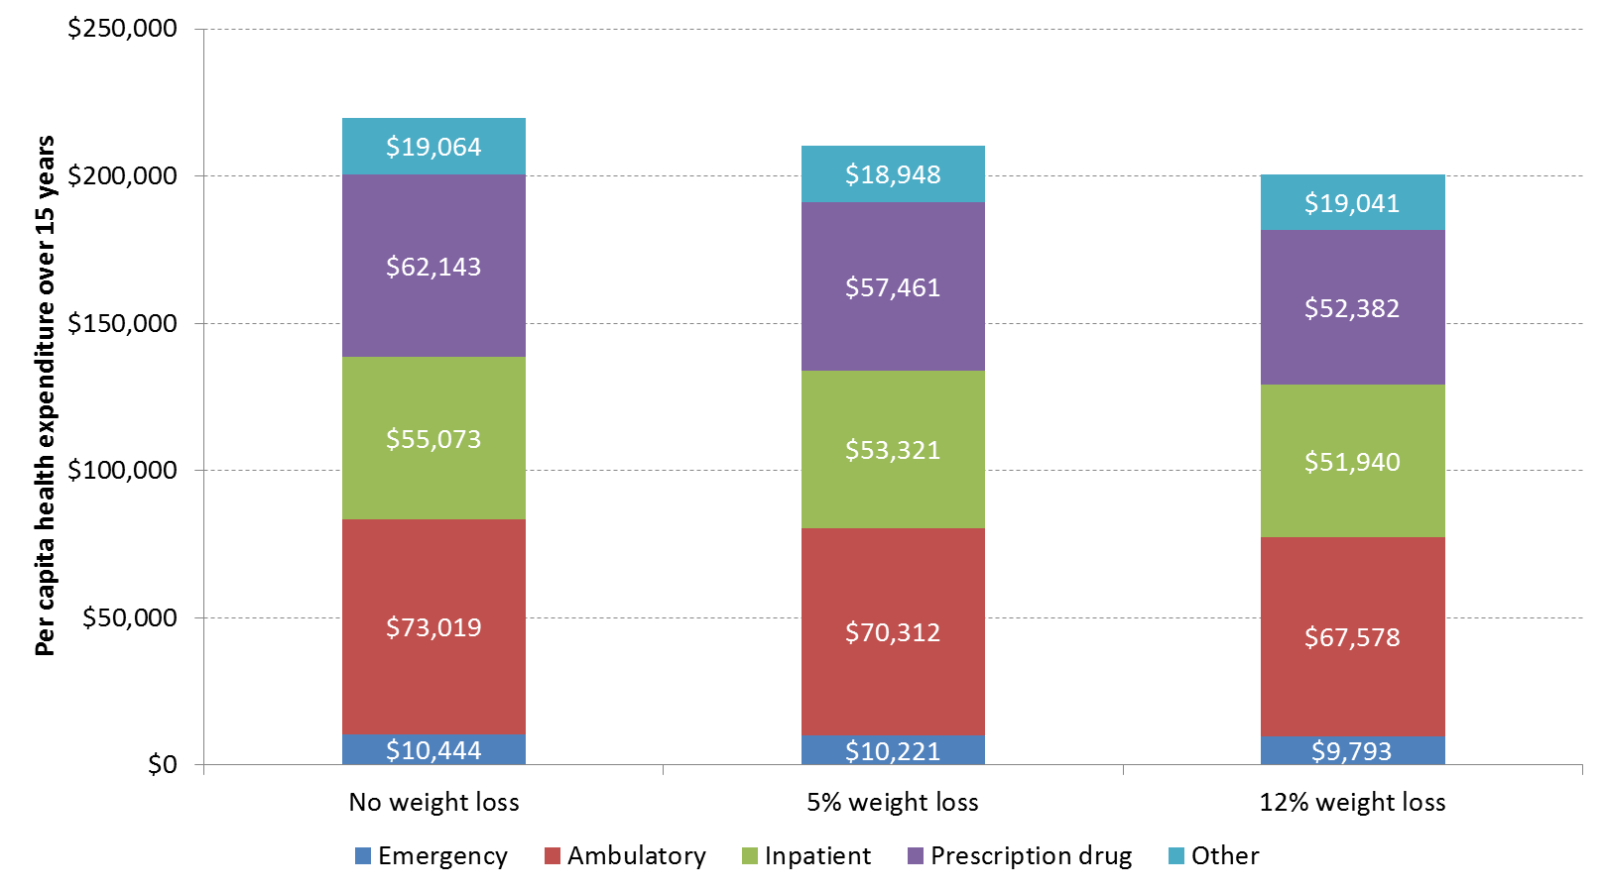

Appendix Figure 2. Distribution of cost savings from 5% weight loss
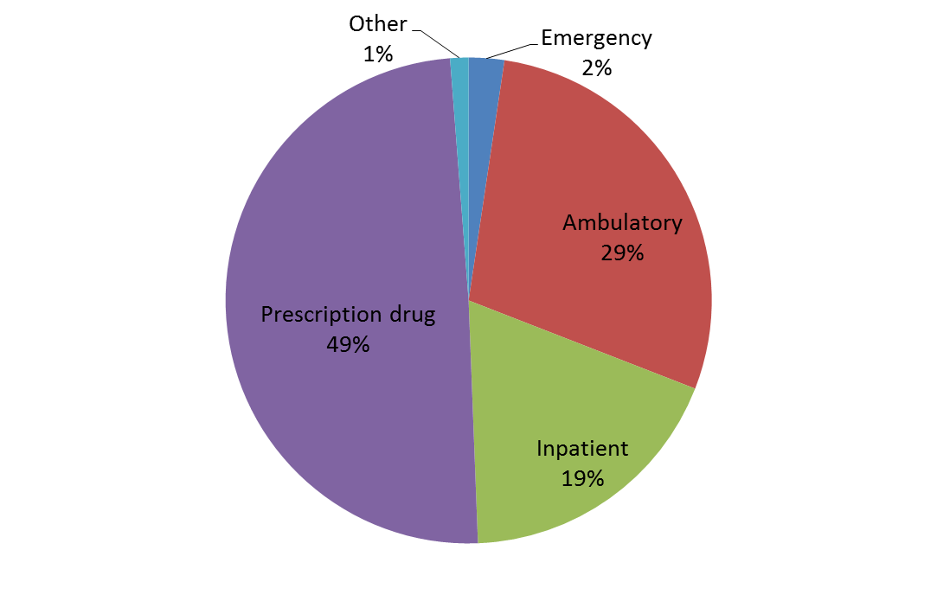

Appendix Figure 3. Distribution of cost savings from 12% weight loss
