Appendix A
Stimuli used in fMRI experiment
Words |  | Nonwords
BLUE | KNEE |  | TEG
BOOT | LAUGH |  | SUT
CAPE | LYNX |  | STET
CLAM | PEACH |  | SITH
CREW | PEAR |  | ROIN
EYE | PIE |  | NINT
FLY | SEW |  | MULP
FOOT | SHOE |  | GEAD
FRUIT | SIGHT |  | DOIL
GRAY | YACHT |  | CHUT

Supplemental Materials

Clusters | Cluster Size | MNI Coordiates  [x, y, z]
Left Angular Gyrus/Middle Occipital Cortex | 937 | [-42, -72, 22]  [-42, -76, 30]  [-40, -60, 28]
Primary Visual Cortex | 371 | [-14, -52, 16]  [-12, -52, 8]  [-6, -62, 14]
Precuneus | 188 | [0, -54, 10]  [-4, -60, 20]  [-6, -50, -16]
Right middle temporal gyrus | 144 | [50, -66, 10]  [46, -68, 24]  [50, -58, 18]
Left parahippocampal/fusiform gyrus | 132 | [-32, -42, -8]  [-28, -48, -4]  [-30, -54, -10]
Right calcarine | 93 | [8 -54, 10]  [10, -60, 20]  [22, -58, 16]
Right lingual gyrus | 91 | [20, -74, -6]  [18, -82, -8]  [10, -86, -6]
Right superior temporal/supramarginal gyrus | 88 | [60, -32, 24]  [54, -36, 28]
Right superior occipital gyrus | 67 | [18, -86, 20]
Right precuneus | 50 | [8, -58, 58]

Table S1: Significant clusters of word > pseudoword contrast collapsing across all subjects (primary p < .001, Gaussian Random Field cluster-size threshold p_{FWE} < .05), including the MNI coordinate of the peak voxel and at most two other local maxima (> 8mm distance).

Clusters | Cluster Size | MNI Coordiates  [x, y, z]
Left inferior frontal gyrus/Insula | 2706 | [-34, 16, 12]  [-56, 12, 30]  [-38, 4, 26]
Right inferior frontal gyrus/Insula | 1253 | [-34, 16, 12]  [-56, 12, 30]  [-38, 4, 26]
Superior frontal gyrus (medial) | 856 | [-4, 20, 42]  [-8, 8, 60]  [-2, 4, 66]
Left inferior parietal lobule | 364 | [-50, -40, 58]  [-56, -32, 50]  [-64, -18, 32]
Midcingulate area | 250 | [0, -14, 28]  [4, -34, 26]  [0, -24, 32]
Right Cerebellum (lobule VI and crus I) | 179 | [26, -68, -24]  [42, -68, -24]  [20, -72, -18]
Right angular gyrus | 168 | [36, -68, 50]  [36, -62, 56]  [26, -62, 46]
Left inferior parietal lobule | 113 | [-28, -46, 42]  [-34, -50, 48]  [-34, -52, 40]
Right Thalamus | 79 | [8, -6, 6]  [10, -10, 14]  [10, -8, -2]
Right middle orbital frontal gyrus | 67 | [30, 62, -2]  [36, 48, -10]  [40, 60, 0]
Right superior orbital frontal gyrus | 64 | [24, 40, -12]  [24, 50, -10]
Left caudate and putamen | 52 | [-14, 8, 6]  [-10, 0, 8]  [-20, 2, -4]

Table S2: Significant clusters of pseudoword > word contrast collapsing across all subjects (primary p < .001, Gaussian Random Field cluster-size threshold p_{FWE} < .05), including the MNI coordinate of the peak voxel and at most two other local maxima (> 8mm distance).

Figure S1. Sagittal slices of the regions that a significantly greater activation for pseudowords than words (red) or a significantly greater activation for words than pseudowords (blue) , using a primary p < .001, cluster-size threshold p_{FWE} < .05.
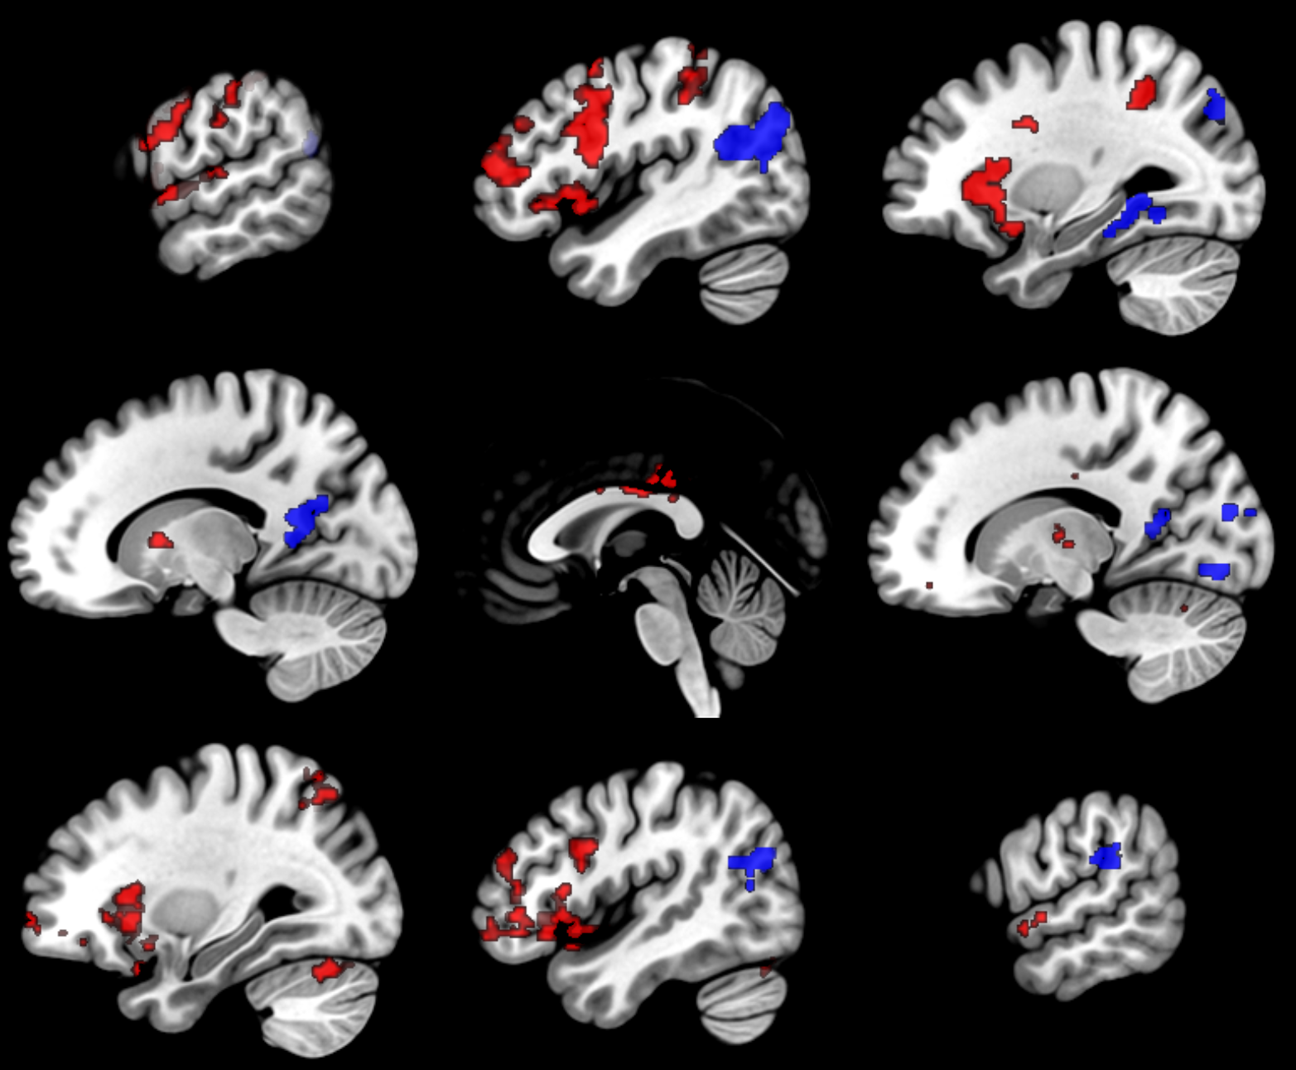
-60
-45
-30
-15
0
15
30
45
60

