Supplementary Information
Investigation of the interfacial interactions in epoxy nano-composites filled with functionalized graphene based fillers.
Souvik Chakraborty¹, Michel Barbezat^{2 *}, Eduardo Cuervo Reyes³, Amit K. Chakraborty¹ and Giovanni P. Terrasi²
- Carbon Nanotechnology Laboratory, Department of Physics, National Institute of Technology Durgapur, Mahatma Gandhi Avenue, Durgapur, India 713209.
- Laboratory for Mechanical Systems Engineering, Swiss Federal Laboratories for Material Science and Technology, Empa, Überlandstrasse 129, 8600 Dübendorf, Switzerland.
- Materials for Energy Conversion, Swiss Federal Laboratories for Material Science and Technology, Empa, Überlandstrasse 129, 8600 Dübendorf, Switzerland.
*Email of corresponding author: michel.barbezat@empa.ch (Michel Barbezat)

S1. Repeatability of the Dielectric Measurements

To discuss the repeatability of the dielectric measurements a few spectra of the nano-composites are presented in Fig. S1. With Sial T-403 the spectra after the 80ºC cure cycle is displayed because the postcure is seen to not influence the dipolar spectra. With Sial DETA cured samples the spectra at the end of the measurement (after postcure) is chosen for comparison as a down-shift of the loss spectra is observed after completion of first cure cycle. The full measurement spectra (Freq range: 0.5 – 10⁶Hz) are shown irrespective of the observed noise below 10 Hz. The sample temperature is 25ºC in all the cases. Except for the highest loading at 0.50wt% (with GO-ButA, Fig. S1c) the measurements show good repeatability independent of the epoxy matrix considered. This can be a combination of local dispersion heterogeneity as well as the filler reagglomeration tendency as has discussed in the article.

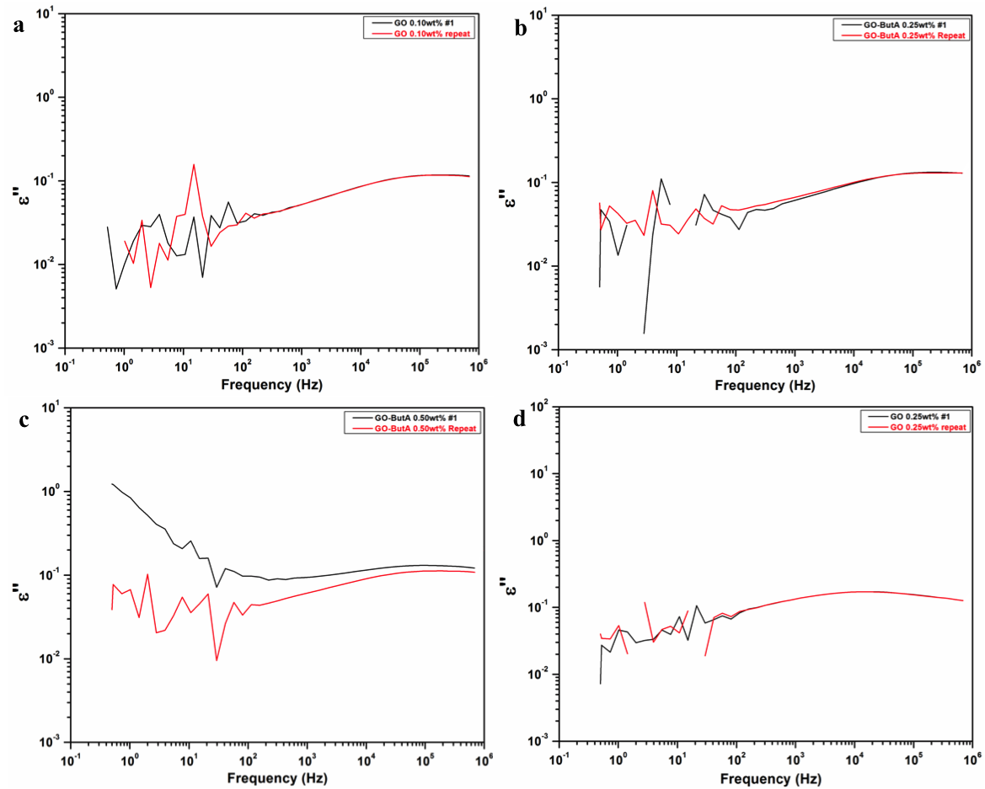
Fig. S1: Test of repeatability of the current method. a) – c) Samples cured with Sial T-403 (45.5 phr) and d) sample cured with Sial DETA. Filler types and loading is mentioned in the legends. Temperature: 25ºC.

S2. Differential thermogravimetric (DTG) plots

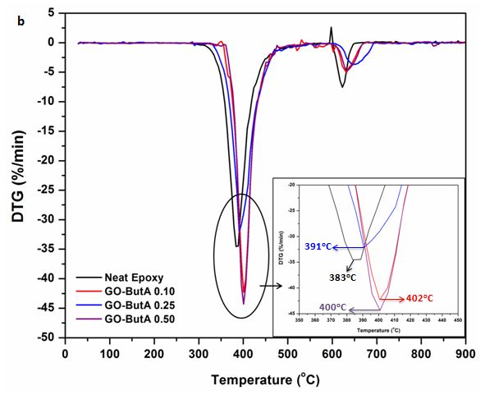

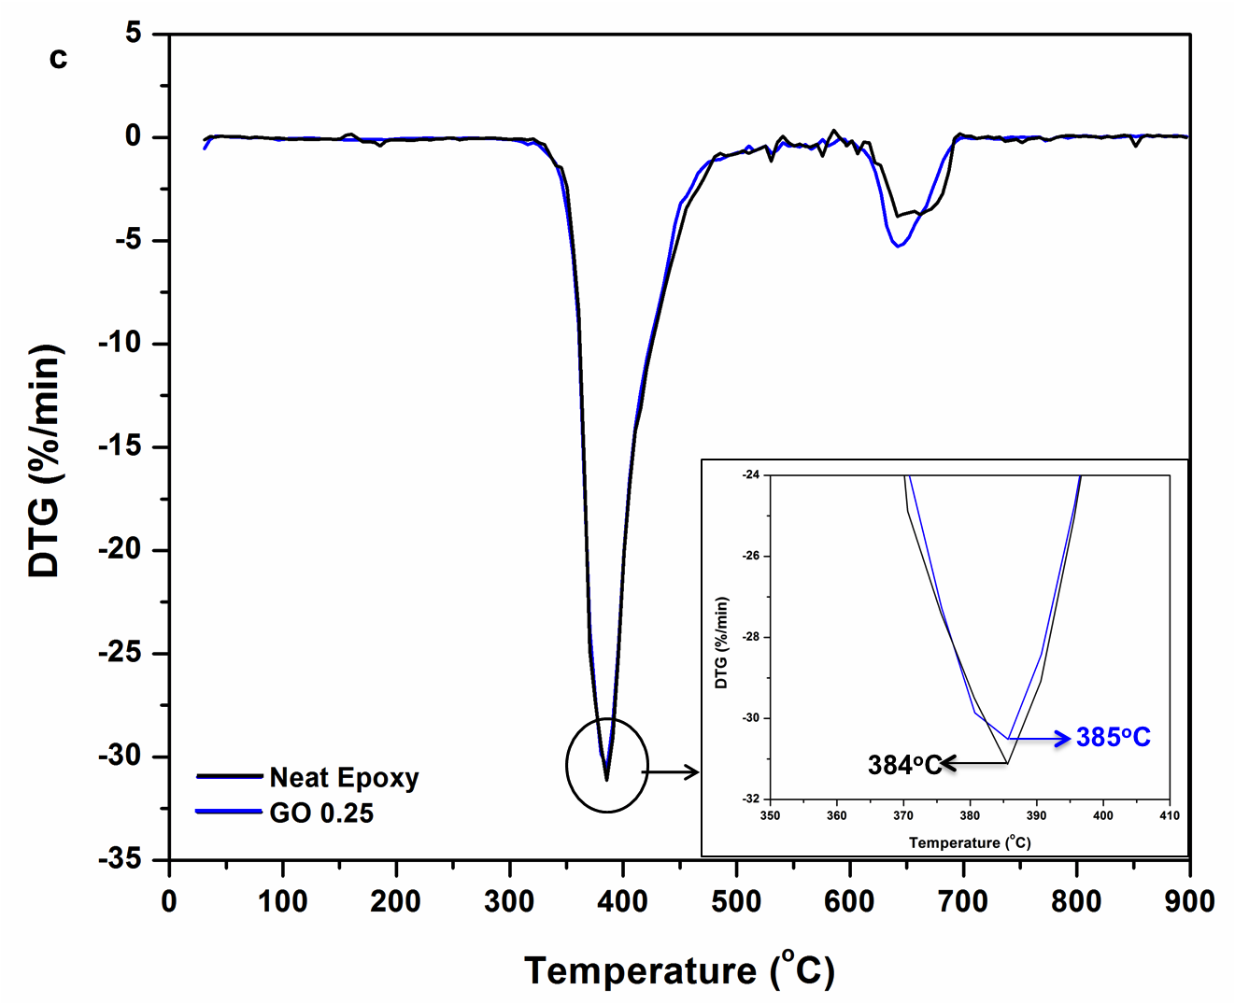

Fig. S2: The differential thermogravimetric plots (DTG) of Sial T-403 cured epoxies filled with a) GO and b) GO-ButA at different filler loadings and c) Sial DETA cured epoxies are shown. The insets show magnified DTG peaks.

