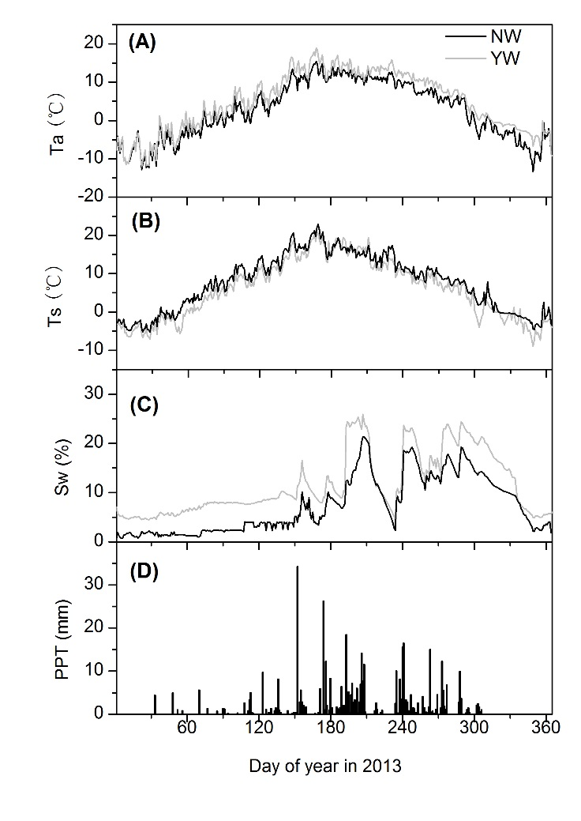
Appendix Figure 1 Effects of warming on air temperature (A), soil temperature (B) and soil water content (C) in 2013, respectively. Black and grey lines represented NW and YW treatments, respectively. D represented rainfall amount in this year.

