**ESM1**

**Table S1**

Race Speed, Median BMIs, and Number of competitors examined for each event.

|  |  |  |  |  |  |  |  |  |  |
| --- | --- | --- | --- | --- | --- | --- | --- | --- | --- |
|  | Event Distance (m) | Men's Speed (avg. m/min.) | Women's Speed (avg. m/min.) | Men's Median BMI | N (Men’s BMI) | Women's  Median BMI | N (Women’s BMI) | Men's Speed/ Women's Speed | Men's BMI/ Women's BMI |
| Runners | 100 | 597 | 552 | 23.8 | 138 | 20.7 | 137 | 1.08 | 1.15 |
| 200 | 600 | 537 | 22.8 | 51 | 20.5 | 57 | 1.12 | 1.11 |
| 400 | 537 | 480 | 22.4 | 118 | 20.3 | 120 | 1.12 | 1.10 |
| 800 | 468 | 406 | 20.7 | 54 | 19.4 | 46 | 1.15 | 1.07 |
| 1500 | 415 | 357 | 20.1 | 41 | 18.5 | 45 | 1.16 | 1.09 |
| 5000 | 363 | 328 | 19.8 | 43 | 17.6 | 39 | 1.11 | 1.12 |
| 10000 | 360 | 321 | 20.2 | 28 | 17.4 | 22 | 1.12 | 1.17 |
| 42165 | 318 | 289 | 19.8 | 103 | 18.7 | 109 | 1.10 | 1.06 |
| Swimmers | 50 | 138 | 123 | 23.2 | 55 | 20.6 | 68 | 1.13 | 1.13 |
| 100 | 125 | 112 | 23.1 | 109 | 20.7 | 94 | 1.12 | 1.12 |
| 200 | 114 | 103 | 22.9 | 97 | 20.8 | 94 | 1.10 | 1.10 |
| 400 | 106 | 98 | 22.7 | 28 | 21.0 | 32 | 1.08 | 1.08 |
| 1500M /800W | 101 | 94 | 22.6 | 30 | 20.8 | 32 | n.d. | n.d. |
| 10000 | 90 | 84 | 23.4 | 24 | 20.9 | 23 | 1.08 | 1.12 |
|  | | | | | | Average Men’s/Women’s: | | Speed  1.113 | BMI  1.109 | |  |  |  |

**Table S2**

ANOVA tables for the favored model, which are given in Table S3. In both tables, bold p. values are significant. See Figure 2 (main text) for plots.

|  |  |  |  |
| --- | --- | --- | --- |
|  |  | | |
|  | **F** | **P (>F)** | **Favored Model** |
| Men’s BMI | 12.15 | **<0.001** | Interaction |
| Men’s Height | 1.50 | 0.213 | No interaction |
| Men’s Weight | 10.36 | **<0.001** | Interaction |
| Women’s BMI | 10.76 | **<0.001** | Interaction |
| Women’s Height | 1.59 | 0.191 | No interaction |
| Women’s Weight | 11.16 | **<0.001** | Interaction |

**Table S3**

ANOVA Results

|  |  |  |  |  |  |  |  |
| --- | --- | --- | --- | --- | --- | --- | --- |
|  |  |  | **D.F.** | **Sum. Sq.** | **Mean Sq.** | **F value** | **Pr(>F)** |
| Men’s Events | BMI | Event Duration (4 Categories) | 3 | 358.4 | 119.5 | 46.15 | **0.000** |
| Event Type (Swim vs Run) | 1 | 326 | 326 | 125.93 | **0.000** |
| Interaction between Duration & Type | 3 | 94.4 | 31.5 | 12.15 | **0.000** |
| Residuals | 407 | 1053.6 | 2.6 |  |  |
| Height | Event Duration (4 Categories) | 3 | 6656 | 2219 | 37.32 | **0.000** |
| Event Type (Swim vs Run) | 1 | 5703 | 5703 | 95.92 | **0.000** |
| Residuals | 412 | 24497 | 59 |  |  |
| Weight | Event Duration (4 Categories) | 3 | 14317 | 4772 | 81.81 | **0.000** |
| Event Type (Swim vs Run) | 1 | 14900 | 14900 | 255.44 | **0.000** |
| Interaction between Duration & Type | 3 | 1813 | 604 | 10.36 | **0.000** |
| Residuals | 409 | 23858 | 58 |  |  |
| Women’s Events | BMI | Event Duration (4 Categories) | 3 | 287 | 95.66 | 42.48 | **0.000** |
| Event Type (Swim vs Run) | 1 | 211 | 210.98 | 93.69 | **0.000** |
| Interaction between Duration & Type | 3 | 72.7 | 24.24 | 10.76 | **0.000** |
| Residuals | 437 | 984 | 2.25 |  |  |
| Height | Event Duration (4 Categories) | 3 | 3919 | 1306.4 | 30.6 | **0.000** |
| Event Type (Swim vs Run) | 1 | 2133 | 2133.4 | 49.97 | **0.000** |
| Residuals | 440 | 18785 | 42.7 |  |  |
| Weight | Event Duration (4 Categories) | 3 | 7485 | 2495 | 75.5 | **0.000** |
| Event Type (Swim vs Run) | 1 | 5510 | 5510 | 166.74 | **0.000** |
| Interaction between Duration & Type | 3 | 1106 | 369 | 11.16 | **0.000** |
| Residuals | 439 | 14508 | 33 |  |  |

**Figure S1**

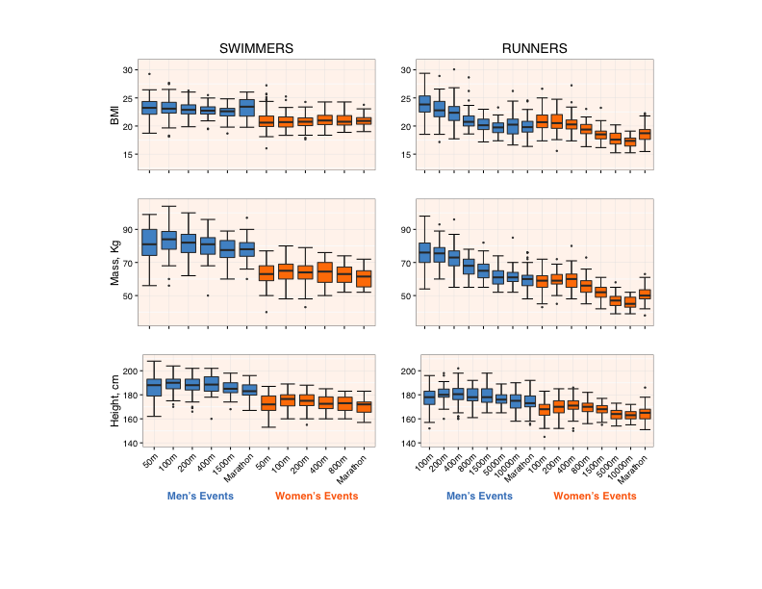

**Legend:** Boxplots of race distance and BMI, mass, and height in runners and swimmers in Men’s and Women’s events.