Supplementary Information
Electrostatic bending and outer-sphere intervalence transfer in a flexible ligand-bridged ruthenium(III)-iron(II) complex

JUAN S. AGUIRRE-ARAQUE, REGINALDO C. ROCHA and HENRIQUE E. TOMA*

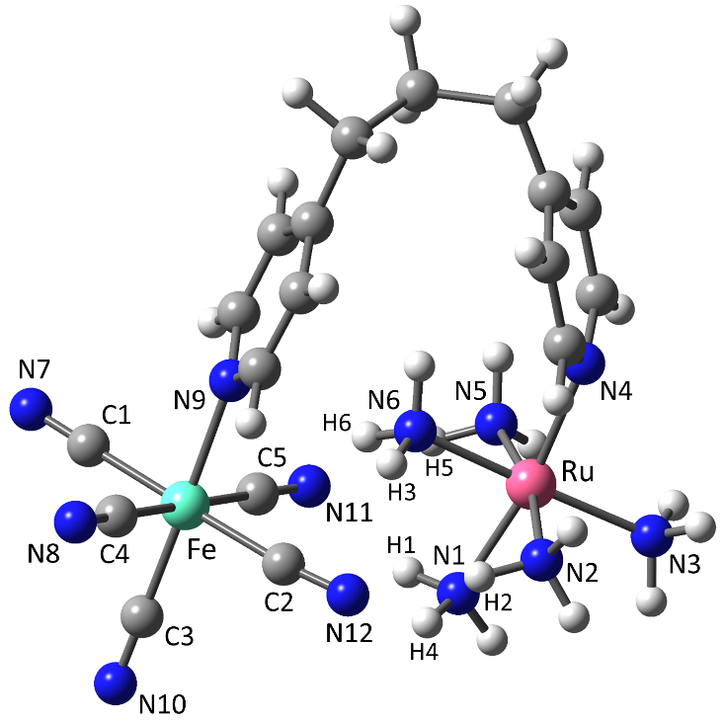
Table S1. Selected bond distances (Å) and angles (deg) for the DFT optimized molecular geometry of [Ru^{III}(NH₃)₅(μ-dpypn)Fe^{II}(CN)₅]. Experimental data from the crystal structures of [Ru^{III}(NH₃)₅(pyridine)]Cl₃ and (Et₄N)₃[Fe^{II}(CN)₅(pyridine)] are also included for comparison.
Bond/angle | Calculatedª | Experimental^{b}
 |  | [Ru(NH₃)₅(py)]Cl₃ | (Et₄N)₃[Fe(CN)₅(py)]
Ru–N1 | 2.12 | 2.08—2.12
Ru–N2 | 2.14
Ru–N3 | 2.15
Ru–N4 | 2.16
Ru–N5 | 2.15
Ru–N6 | 2.09
Fe–C1 | 1.95 |  | 1.88—1.93
Fe–C2 | 1.96
Fe–C3 | 1.93
Fe–C4 | 1.95
Fe–C5 | 1.95
Fe–N9 | 2.14 |  | 2.04
C1–N7 | 1.17 |  | 1.16 (average)
C2–N12 | 1.18
C3–N10 | 1.17
C4–N8 | 1.17
C5–N11 | 1.18
Fe–Ru | 5.36
H1···N11 | 2.07
H2···N12 | 2.04
H3···N12 | 2.15
H4···N12 | 2.26
H5···N11 | 2.04
H6···N11 | 2.14
N1–Ru–N2 | 83.3 | 88.8—92.0  177.9—179.8
N1–Ru–N3 | 93.1
N1–Ru–N4 | 170.2
N1–Ru–N5 | 85.8
N1–Ru–N6 | 88.4
N2–Ru–N3 | 91.2
N2–Ru–N4 | 97.5
N2–Ru–N5 | 168.0
N2–Ru–N6 | 89.2
N3–Ru–N4 | 96.6
N3–Ru–N5 | 94.3
N3–Ru–N6 | 178.5
N4–Ru–N5 | 92.4
N4–Ru–N6 | 81.8
N5–Ru–N6 | 85.6
C1–Fe–C2 | 178.8 |  | 88.7—91.4  178.6—179.3
C1–Fe–C3 | 90.5
C1–Fe–C4 | 90.3
C1–Fe–C5 | 91.2
C1–Fe–N9 | 88.5
C2–Fe–C3 | 90.0
C2–Fe–C4 | 90.8
C2–Fe–C5 | 87.6
C2–Fe–N9 | 91.1
C3–Fe–C4 | 90.5
C3–Fe–C5 | 90.7
C3–Fe–N9 | 178.9
C4–Fe–C5 | 178.1
C4–Fe–N9 | 89.2
C5–Fe–N9 | 89.7
ª From full geometry optimization without constraints at the at the unrestricted CAM-B3LYP//6-31G*_{(C,H,N)}/LANL2DZ_{(Fe,Ru)}//C-PCM_{(water)} level. ^{b} X-ray crystal data for the most closely related complexes that could be found in the literature: [Ru(NH₃)₅(pyridine)]Cl₃⋅1.4H₂O [Y.G.K. Shin, D.J. Szalda, B.S. Brunschwig, C. Creutz, N. Sutin, Inorg. Chem. 36 (1997) 3190] and (Et₄N)₃[Fe(CN)₅(pyridine)]⋅6H₂O [G.M. Chiarella, D.Y. Melgarejo, S.A. Koch. J. Am. Chem. Soc., 128, 1416 (2006)].

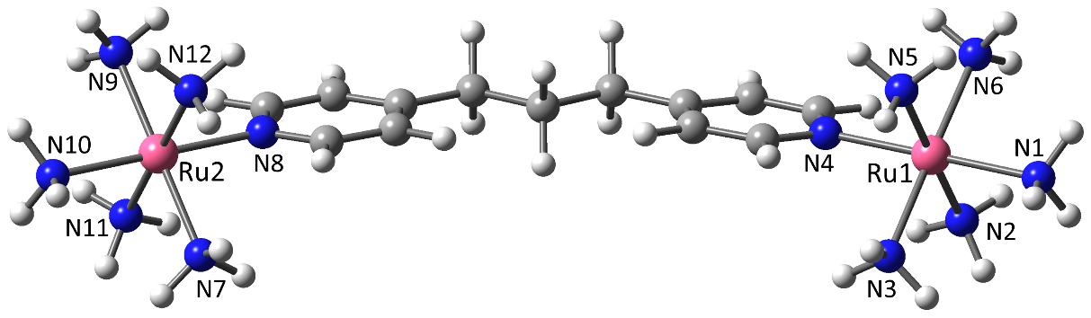

Table S2. Selected bond distances (Å) and angles (deg) for the DFT optimized molecular geometry of [Ru^{II}(NH₃)₅(μ-dpypn)Ru^{III}(NH₃)₅]⁵⁺. Experimental data from the crystal structures of [Ru^{III}(NH₃)₅(pyridine)]Cl₃ and [Ru^{II}(NH₃)₅(pyridine)](CF₃SO₃)₂ are included for comparison.
Bond/angle | Calculatedª | Experimental^{b}
 |  | [Ru(NH₃)₅(py)]Cl₃ | [Ru(NH₃)₅(py)](CF₃SO₃)₂
Ru1–N1 | 2.15 | 2.08—2.12
Ru1–N2 | 2.14
Ru1–N3 | 2.13
Ru1–N4 | 2.13
Ru1–N5 | 2.14
Ru1–N6 | 2.14
Ru2–N7 | 2.17 |  | 2.06—2.16
Ru2–N8 | 2.13
Ru2–N9 | 2.17
Ru2–N10 | 2.18
Ru2–N11 | 2.17
Ru2–N12 | 2.17
Ru1–Ru2 | 13.94
N1–Ru1–N2 | 90.1 | 88.8—92.0  177.9—179.8
N1–Ru1–N3 | 89.8
N1–Ru1–N4 | 179.9
N1–Ru1–N5 | 90.0
N1–Ru1–N6 | 90.4
N2–Ru1–N3 | 86.6
N2–Ru1–N4 | 90.0
N2–Ru1–N5 | 180.0
N2–Ru1–N6 | 93.0
N3–Ru1–N4 | 90.1
N3–Ru1–N5 | 93.4
N3–Ru1–N6 | 179.6
N4–Ru1–N5 | 89.9
N4–Ru1–N6 | 89.7
N5–Ru1–N6 | 87.0
N7–Ru2–N8 | 90.6 |  | 89.2—91.5  178.4
N7–Ru2–N9 | 179.2
N7–Ru2–N10 | 89.3
N7–Ru2–N11 | 87.9
N7–Ru2–N12 | 92.2
N8–Ru2–N9 | 90.2
N8–Ru2–N10 | 179.6
N8–Ru2–N11 | 90.4
N8–Ru2–N12 | 90.4
N9–Ru2–N10 | 89.7
N9–Ru2–N11 | 92.0
N9–Ru2–N12 | 87.8
N10–Ru2–N11 | 90.0
N10–Ru2–N12 | 89.3
N11–Ru2–N12 | 179.2
ª From full geometry optimization without constraints at the at the unrestricted CAM-B3LYP//6-31G*_{(C,H,N)}/LANL2DZ_{(Ru)}//C-PCM_{(water)} level. ^{b} X-ray crystal data for the most closely related complexes that could be found in the literature: [Ru(NH₃)₅(pyridine)]Cl₃⋅1.4H₂O and [Ru(NH₃)₅(pyridine)](CF₃SO₃)₂ [Y.G.K. Shin, D.J. Szalda, B.S. Brunschwig, C. Creutz, N. Sutin. Inorg. Chem., 36, 3190 (1997)].

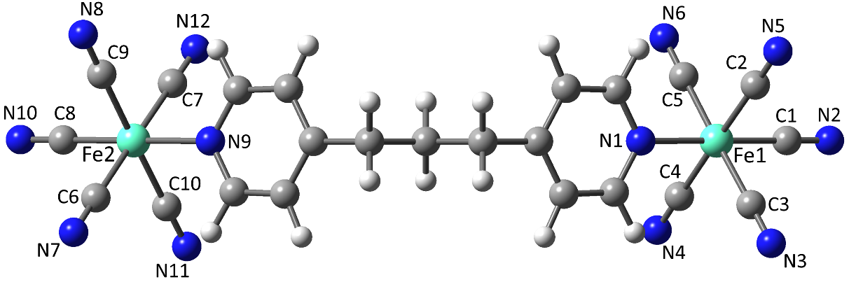

Table S3. Selected bond lengths (Å) and angles (deg) for the DFT optimized molecular geometry of [Fe^{III}(NH₃)₅(μ-dpypn)Fe^{II}(CN)₅]. Experimental data from the crystal structures of (Et₄N)₃[Fe^{II}(CN)₅(pyridine)] and (nBu₄N)₂[Fe^{III}(CN)₅(pyridine)] are included for comparison.

Bond/angle | Calculatedª | Experimental^{b}
 |  | (Et₄N)₃[Fe(CN)₅(py)] | (nBu₄N)₂[Fe(CN)₅(py)]
Fe1–C1 | 1.93 | 1.88—1.93
Fe1–C2 | 1.96
Fe1–C3 | 1.96
Fe1–C4 | 1.96
Fe1–C5 | 1.96
Fe1–N1 | 2.10 | 2.04
C1–N2 | 1.17 | 1.16 (average)
C2–N5 | 1.17
C3–N3 | 1.17
C4–N4 | 1.17
C5–N6 | 1.17
Fe2–C6 | 1.95 |  | 1.91—1.95
Fe2–C7 | 1.95
Fe2–C8 | 1.92
Fe2–C9 | 1.95
Fe2–C10 | 1.95
Fe2–N9 | 2.07 |  | 2.04
C6–N7 | 1.16 |  | 1.15 (average)
C7–N12 | 1.16
C8–N10 | 1.16
C9–N8 | 1.16
C10–N11 | 1.16
Fe1–Fe2 | 13.07
C1–Fe1–C2 | 90.6 | 88.7—91.4  178.6–179.3
C1–Fe1–C3 | 90.5
C1–Fe1–C4 | 90.5
C1–Fe1–C5 | 90.3
C1–Fe1–N1 | 179.9
C2–Fe1–C3 | 90.2
C2–Fe1–C4 | 178.9
C2–Fe1–C5 | 89.9
C2–Fe1–N1 | 89.4
C3–Fe1–C4 | 89.8
C3–Fe1–C5 | 179.2
C3–Fe1–N1 | 89.7
C4–Fe1–C5 | 90.1
C4–Fe1–N1 | 89.5
C5–Fe1–N1 | 89.5
C6–Fe2–C7 | 178.5 |  | 86.4—92.1  176.8–177.8
C6–Fe2–C8 | 89.3
C6–Fe2–C9 | 87.2
C6–Fe2–C10 | 92.8
C6–Fe2–N9 | 90.7
C7–Fe2–C8 | 89.3
C7–Fe2–C9 | 92.8
C7–Fe2–C10 | 87.2
C7–Fe2–N9 | 90.7
C8–Fe2–C9 | 89.4
C8–Fe2–C10 | 89.3
C8–Fe2–N9 | 180.0
C9–Fe2–C10 | 178.7
C9–Fe2–N9 | 90.6
C10–Fe2–N9 | 90.7
ª From full geometry optimization without constraints at the at the unrestricted CAM-B3LYP//6-31G*_{(C,H,N)}/LANL2DZ_{(Fe)}//C-PCM_{(water)} level. ^{b} X-ray crystal data for the most closely related complexes that could be found in the literature: (Et₄N)₃[Fe(CN)₅(pyridine)]⋅6H₂O and (nBu₄N)₂[Fe(CN)₅(pyridine)] [G.M. Chiarella, D.Y. Melgarejo, S.A. Koch. J. Am. Chem. Soc., 128, 1416 (2006)].

Figure S1. Cyclic voltammetry of the [Ru^{II}(NH₃)₅(dpypn)](PF₆)₂ complex 0.01 mol L⁻¹, KCl 0.1 mol L⁻¹. Glassy carbon working electrode. Ag/AgCl reference electrode. Coiled platinum wire as counter electrode.

Figure S2. Cyclic voltammetry of the [Fe^{II}(CN)₅(dpypn)]³⁻ complex, 0.01 mol L⁻¹, KCl 0.1 mol L⁻¹. Glassy carbon working electrode. Ag/AgCl reference electrode. Coiled platinum wire as counter electrode.

