“ Supporting Information”

Tuning of pnicogen and chalcogen bonds by an aerogen-bonding interaction: A comparative ab initio study
Mehdi D. Esrafili*, Parisasadat Mousavian and Fariba Mohammadian-Sabet
Laboratory of Theoretical Chemistry, Department of Chemistry, University of Maragheh, Maragheh, Iran

* Corresponding Author. Phone: (+98) 4212237955. Fax: (+98) 4212276060. P.O. Box: 5513864596. E-mail: esrafili@maragheh.ac.ir.

Figure S1. Optimized structure and the corresponding total energy (E_{tot}, au) of the binary systems
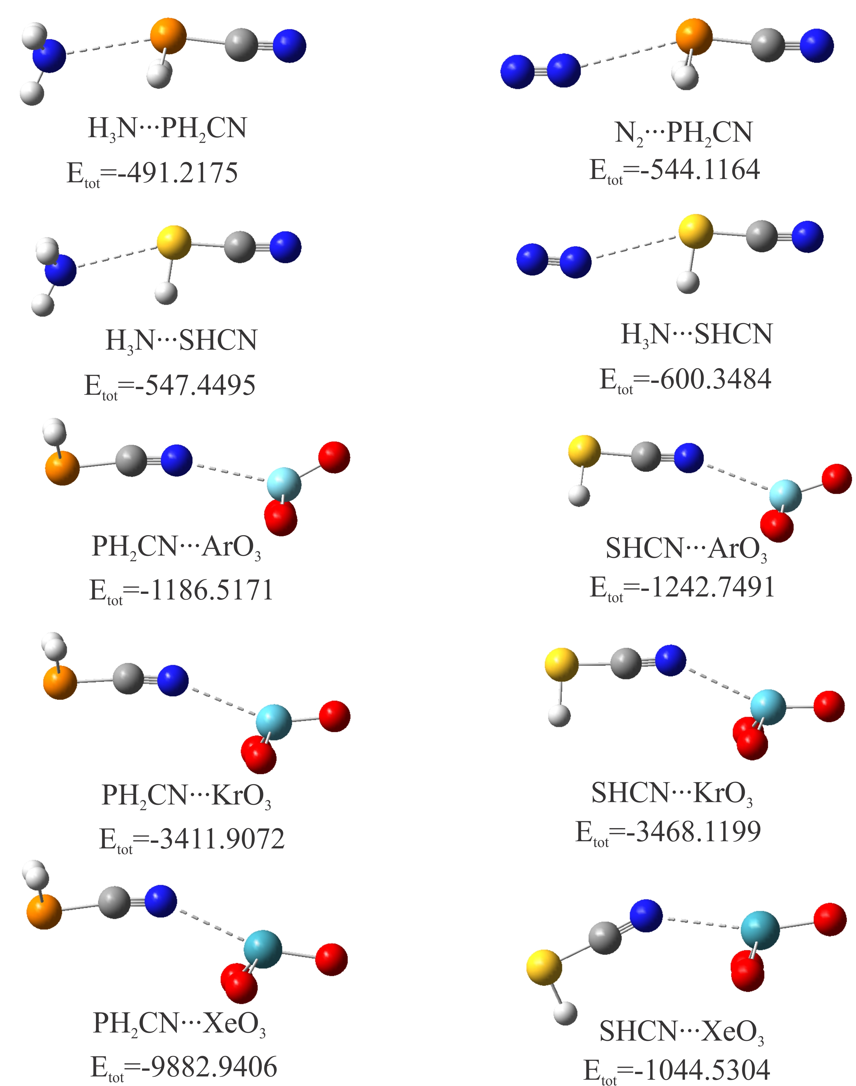

Figure S2. Optimized structure and the corresponding total energy (E_{tot}, au) of the ternary systems


