Supplementary material
PREPARATIVE BIOCHEMISTRY AND BIOTECHNOLOGY
Efficient expression of human telomerase inhibitor 1 (hPinX1) in Pichia pastoris

Fig. S1. Agarose gel electrophoresis of PCR product (M; Marker, 1:52°C, 2:53°C, 3:54°C and 4:55°C primer melting temperatures)

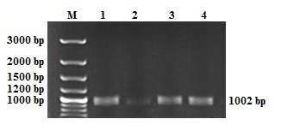

Fig. S2. Agarose gel electrophoresis of colony PCR products with gene specific primers

Fig. S3. Nucleotide BLAST analysis result of pPICZαA:hPinX1 expression cassette (sequencing with vector forward primer)

Fig. S4. Agarose gel electrophoresis of yeast colony PCR products with gene specific primers,

