Supplementary material.
Optimization of the position and number of landmarks.

Position of standard landmarks (lm)
For all species, type-I landmarks were placed at either apex of the diatom valve (lm 1 and 2), and two additional landmarks were positioned on the cell outline along the transapical axis (lm 3 and 4).
To reach our objective of finely characterizing the degree of deformity of each valve, complementary landmarks were placed on the cell outline to specifically describe the intensity of the morphological malformation. As the location and type of deformity differed between the species studied, the positioning of landmarks was adapted for each.

Gomphonema gracile
Position of specific landmarks
Gomphonema gracile always exhibited a “boomerang shaped” teratology, resulting from the combination of more or less pronounced curvature and marked invagination. Thus, the strategy for placing additional landmarks was to select stable inflexion points (type-II landmarks) on the most severely affected side. The invagination formed a bowl-shape indentation from lm 3 with ca. 2-µm long sides, and landmarks were placed on either side (lm 5 and 6). To describe the curvature, landmarks were evenly distributed between lm 1 and lm 5 (=lm 7), and lm 2 and lm 6 (=lm 8). Proportionality relationships were applied to symmetrically position the landmarks along the apical axis on the other side. On normal specimens, the landmarks were similarly distributed. Lm 9 and lm 10 were the reflection of lm 5 and lm 6, respectively, and lm 11 and lm 12 those of lm 7 and lm 8.
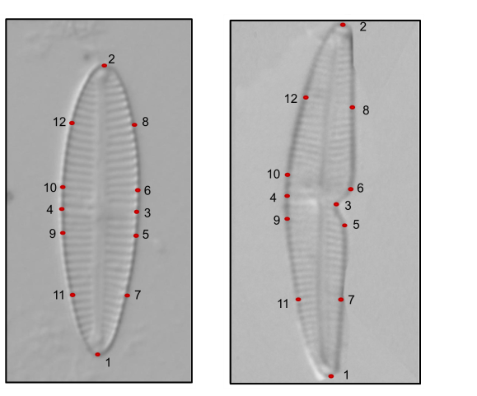
Location of the highest number of landmarks tested for Gomphonema gracile (12 landmarks). Left: GGRA, right:
GGRT. Note that lm 4 was always positioned on the side
of the stigma (opposite the invagination).
Establishing the optimal number of landmarks
The analysis performed with 12 landmarks allowed for a perfect description of overall specimen shape, with a very precise assessment of contours. The TPS successfully discriminated between normal and deformed individuals, with RW1 accounting for 76.7 % of the variability, and RW2 for 7.5 %. However, the average time to process 10 individuals was 49 min. Reducing landmarks by half, to 6 (lm 1 to 6), did not result in a loss of discrimination power; the TPS analysis also did well in separating morphotypes, with slightly higher variability explained (RWI=82.1 %, RW2=7.0 %) due to unchanging location and aspect of the deformity, and to a reduced number of coordinates computed in the analysis. With this simplified approach, 10 individuals were processed in ca. 12 min, using a lower number of landmarks and simpler positioning (no calculation of distance required, in contrast to lm 7-8 and 11-12).

Nitzschia palea
Position of specific landmarks
Contrary to G. gracile, the deformity in Nitzschia palea was characterized by a bump in the outline, located in the median area of the longitudinal axis, but variable in location and size (spreading up to 3 µm). To account for this variability, lm 5 and 6 were spaced at 2 µm from lm 3, and, symmetrically, lm 7 and 8 at 2 µm from lm 4. Lm 9 and 10 were positioned at equal distance between lm 3 and lm 1 and lm 2 (the apices), respectively. Similarly, lm 11 and 12 were placed at equal distance between lm 4 and lm 1 and lm 2, respectively. To increase precision (especially in cases where the bump shifted from the transapical axis), 4 other landmarks were added between lm 5 and lm 9 (lm 13), lm 6 and lm 10 (lm 14), lm 7 and lm 11 (lm 15) and lm 8 and lm 12 (lm 16).
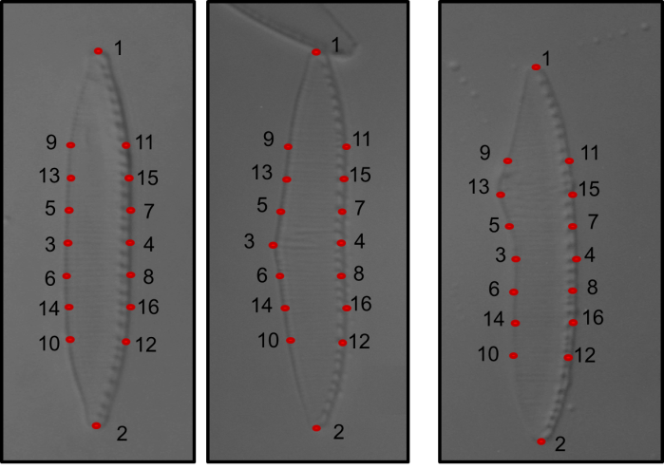
Location of the highest number of landmarks tested for Nitzschia palea (16 landmarks). Left: NPAL, middle and right: NPTR.
Note that lm 4 was always positioned on the side of the fibulae.
Establishing the optimal number of landmarks
The number of landmarks influenced the percentage of variability explained by the TPS: RW1 and RW2 accounted for 97 % of the variability for 6 landmarks (lm 1 to 6), 58 % for 12 landmarks (lm 1 to 12), and 65 % for 16 landmarks (lm 1 to 16). However, only the TPS based on 16 landmarks was able to distinguish between normal and deformed specimens. The fact that the TPS did not allow for the discrimination between NPAL and NPTR with 12 landmarks may be due to the variability in location and spread of the bump.

Achnanthidium minutissimum
Position of specific landmarks
As was the case with G. gracile, the deformity in Achnanthidium minutissimum was always located in the same area (curvature of the apex). This teratology (cymbelliclinum-like) was always curved on the opposite of the central area with lower striae density (lm 3). The strategy used to position the landmarks was thus similar to that applied for G. gracile. Lm 5 was placed between lm 2 and lm 4 in the invagination (for ADMT), which corresponds to the inner inflexion point of the rostrum in ADMI, while lm 6 and lm 7 were placed at the outer inflexion points circumscribing the invagination (ADMT) or the rostrum (ADMI).
In this study, 11 individuals (out of 335) presented a double teratology. As this number was too low to provide appropriate statistical power (it would have been possible by increasing the number of landmarks if more specimens had been available), only one of the two teratologies was accounted for in this circumstance.
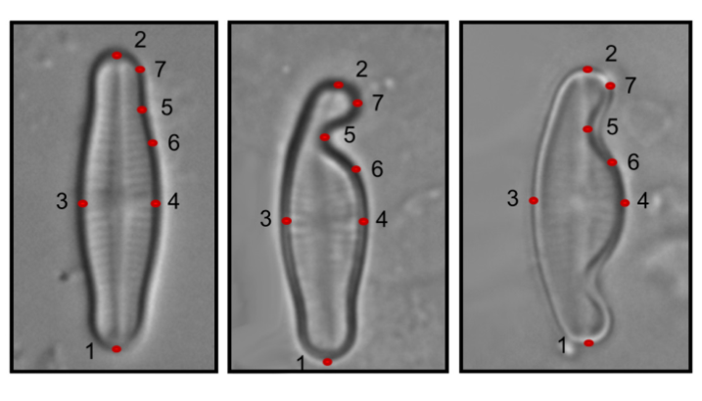
Location of the highest number of landmarks tested for Achnanthidium minutissimum (7 landmarks). Left: ADMI, middle and right: ADMT (single and double teratology, respectively).

Establishing the optimal number of landmarks
The TPS using 7 landmarks performed well in discriminating normal from deformed diatoms. The two first axes explained 66% and separated the morphotypes along RW 2. The presence and intensity of the deformity were well described using only three landmarks (lm 5 to 7) along the first axis of the TPS (explaining 81 % of the variability). However, with 7 landmarks, complementary information about the morphology of the populations (length-to-width ratio) was obtained, which was useful to better understand and assess changes between sites and years.

