Supplementary Material
A penetrating metal−organic framework based on N-heterocyclic carboxylic acid with sensing properties towards Cr(VI)/Fe(III) and nitrobenzene

ZIAO ZONG, YUHUA FAN, CUNGANG XU, SHANSHAN ZUO, FEI YAN, XIANGMIN MENG, XIA ZHANG and CAIFENG BI*

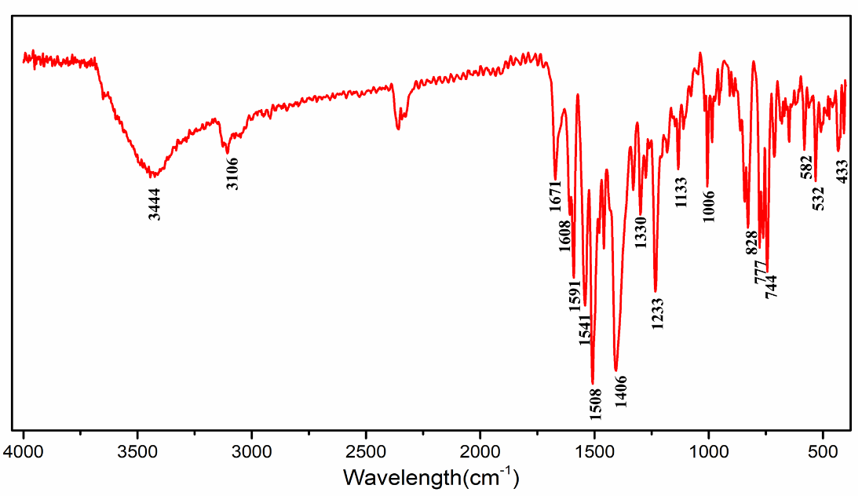
Figure S1. IR spectra of complex 1.

Table S1. Selected bond lengths [Å] and angles [°] for complex 1.
Cd(1)-O(1) | 2.358(5) | Cd(1)-N(1) | 2.252(5)
Cd(1)-O(2) | 2.328(5) | Cd(1)-N(4) | 2.277(6)
Cd(1)-O(4) | 2.326(6) | Cd(1)-O(3) | 2.407(7)
N(1)-Cd(1)-O(1) | 101.2(2) | O(4)-Cd(1)-O(1) | 94.2(2)
N(1)-Cd(1)-O(2) | 115.2(2) | O(4)-Cd(1)-O(2) | 101.8(3)
N(1)-Cd(1)-N(4) | 99.1(2) | O(4)-Cd(1)-N(4) | 89.4(2)
O(4)-Cd(1)-N(1) | 142.3(3) | N(4)-Cd(1)-O(1) | 141.29(19)
N(4)-Cd(1)-O(2) | 86.14(19) | O(1)-Cd(1)-O(2) | 55.39(19)
Symmetry codes: (i) x, -y+2, z-1/2; (ii) x+1/2, y-1/2, z; (iii) x, -y+2, z+1/2; (iv) x-1/2, y+1/2, z.

Figure S2. TG curve of complex 1.

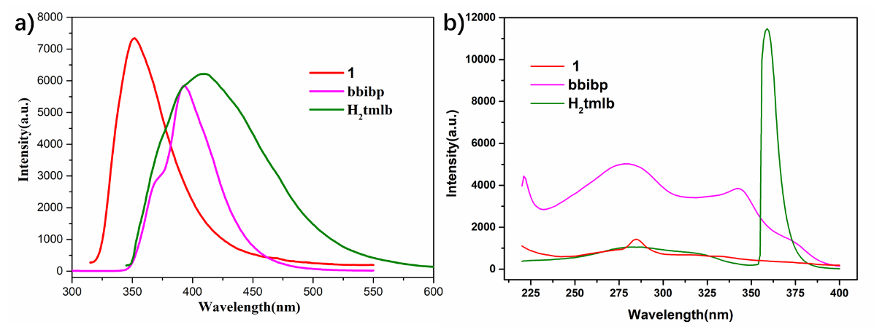
Figure S3. Emission spectra (a) and excitation spectra (b) of complex 1 at room temperature in the solid state.

Figure S4. Powder XRD pattern of complex 1.

Figure S5. Emission spectra of complex 1 in the suspension of ligand + DMF + NB.

