Supplemental Information

Copper-zinc particles with zinc-enriched surfaces generated via spray pyrolysis

Ryan Felixª, Joseph Repacª, Yujia Liangª, Afshan Uroojª, Howard Glicksman^{b}, Sheryl Ehrman^{a,c,}*

ªDepartment of Chemical and Biomolecular Engineering, University of Maryland, College Park, Maryland, USA; ^{b}DuPont Electronic Technologies, Research Triangle Park, North Carolina, USA; ^{c}Charles W. Davidson College of Engineering, San Jose State University, San Jose, CA 95192, USA
*Corresponding Author, sheryl.ehrman@sjsu.edu, 408-924-3800

Contents
- Spray pyrolysis background
- Particle densification calculation
- Surface enrichment process
- 45% zinc fabrication route
- Zinc diammine chloride from a spray route

1. Spray pyrolysis background
In spray pyrolysis, liquid precursor solutions of dissolved salts and co-solvents are atomized into micron-sized droplets that are transported via a carrier gas into a heated furnace. Within the furnace the droplets undergo solvent evaporation, nucleation, and growth, and finally reaction and densification. Detailed analysis of the spray pyrolysis process and methods for avoiding the formation of unfavorable particles (i.e. hollow or broken) are given in reports by Gurav et al. 1993 and Okuyama et al. 2003 [1-5].

2. Particle densification calculation
Equation S1 [6] is used to calculate the theoretical diameter of a fully dense particle. The diameters for the 10 at% zinc precursors at both temperature conditions lie within this range which suggest the particles underwent full densification at temperatures as low as 825°C. The range of ± 0.30 µm in the value of theoretical particle diameter is derived from the uncertainty associated with the previously measured droplet diameter of 5 ± 2 µm [7].
$D_{p}=D_{d}{\left(\frac{C*MW}{1000ρ}\right)}^{1/3}$ Equation S1
Where D_{p} is the fully dense particle diameter, D_{d} is the diameter of the aerosolized droplets, C is the concentration of metal salt in the precursor, MW is the molecular weight of the metal, and ρ is the density of the bulk metal.

3. Surface enrichment process
In the furnace conditions of the reactor, copper nitrate is reduced to metallic copper and is believed to be in the solid state as evident from its melting point of 1085°C, and low vapor pressure. However, zinc should melt at 420°C, vaporize and ultimately boil at 911°C [8]. From the phase diagram, the eutectic melting temperature of a mixture of 10% zinc and 90% copper is approximately 1040°C [9]. At its melting point of 1083°C, the surface tension of copper is 1285 nN/m [8] The surface tension of zinc decreases linearly with increasing temperature, from 782 mN/m at 420°C to 713 mN/m at 825°C and 683 mN/m at 1000°C [8]. This falls in line with the hypothesis that the melting of zinc and the decreasing surface tension during heating would improve wetting on the surface of copper, and is further supported by the interfacial tension effects between metal phases. In addition to the melting of zinc, the good solid state solubility of copper and zinc, as evidenced by the Hume-Rothery rules, is a previously researched factor that should improve the wetting of liquid zinc on the surface of copper [10, 11]. A possible explanation for why surface enrichment with zinc is observed at the 1000°C temperature condition but not the 825°C temperature condition may be because at 825°C the zinc has insufficient time at a high enough temperature to reduce the surface tension for adequate wetting and surface coverage. As the Biot numbers of the droplets and particles within the reactor are sufficiently small (Bi << 1), the particles can be modeled as having a uniform temperature that matches the profile of the reactor. From the furnace temperature profile it can be calculated that the particles fabricated at 825°C spend ~58% of their residence time above the melting point of zinc, whereas the 1000°C particles spend 73% of their residence time above the melting point of zinc, while also reaching a higher temperature.

4. 45% zinc fabrication route
Analysis of particles yielded results that suggested powders fabricated from precursors of high (45%) zinc content undergo a formation route unlike that of particles fabricated from low (10%) zinc content precursors. Low zinc content precursors fabricated at high temperatures produce powders with surfaces enriched in zinc, while high zinc content precursors at all fabrication temperatures tested do not. Exploring this further, ZnCl₂ and metallic zinc have relatively high vapor pressures; both are effectively atmospheric pressure at the 1000°C furnace temperatures, however, the vapor pressure of zinc is approximately one third of atmospheric pressure at the 825°C condition [12]. Vapor zinc species that do not condense may bypass the filter and nucleated zinc particles in the reactor may experience thermophoretic forces that allow them to adhere to the cool surface of the tube at the furnace outlet. Vaporization and thermophoretic deposition provide two potential mechanisms for losses of zinc observed in EDX. Significant adhesion of zinc to tube walls in spray pyrolysis during the production of zinc has been previously documented [13]. This volatilization and thermophoretic force hypothesis is supported by an attempt to fabricate particles from precursors of pure zinc at 825°C and 3 L/min; we were unable to collect significant powders at long run times, and found significant deposition on the inner glass tube surface and at the furnace outlet of a black powder that could potentially be zinc oxide (images not shown). Furthermore, this theory may be supported by the apparent formation of the non-spherical, platelet morphologies (Fig. 1e,f) because typically the products of droplets are spherical in nature. EDX mapping of the powders determined that regions of platelet morphologies were primarily composed of zinc and largely lacked copper, suggesting they are the products of a volatilization and condensation process (Fig. S6). Experiments at lower furnace temperatures that attempt to confirm a volatilization and condensation process are contraindicated by incomplete organic pyrolysis, shifted residence times, and significant changes in particle morphology related to the absence of densification.

5. Zinc diammine chloride from a spray route
In the spray pyrolysis process, typically unstable intermediates degrade with increase in temperature or residence time [5]. The ZDC complex not only remained present despite the increase in temperature, but also was still produced when the residence time was increased to approximately 7 seconds under the 1000°C furnace condition (Fig. S4). The significant stability of this ZDC complex in the spray pyrolysis process is one reason why it is of interest. Another reason ZDC is of interest is that it requires the formation of an amine ligand, though it is not clear whether ammonia gas is being formed or whether the ligand formation is catalyzed while complexed to zinc. High-resolution XPS scans of the nitrogen in powders showed maxima narrowly clustered around ~400 eV (Table S1). This binding energy suggests that most if not all of the nitrogen remaining in the powders is bound to hydrogen [14]. The presence of free amine in the powders was confirmed through a ninhydrin assay (Fig S5).
The stability of ZDC is consistent with previous research, though it was initially unclear if the complex could be stable at reactor conditions [15]. The reported decomposition temperature of ZDC is a mere 271°C, suggesting the full ZDC complex cannot form in the center of the furnace but rather after the introduction of quench N₂ gas at the outlet or on the collection filter [16]. ZDC is reported to thermally decompose by driving off ammonia to form ZnCl₂, which is stable at elevated temperatures [17]. It may be that ZnCl₂ vaporizes in the reactor and condenses after quenching near the furnace outlet or on the filter. The stability of ZnCl₂ in the vapor phase is in support of this proposed process [18]. Though the ZDC complex is unlikely to form within the center of the reactor, the same is not necessarily true for the conversion of nitrate to the amine ligand. Review of previous literature has shown that it is possible to thermally reduce nitrate to amine under conditions similar to those within the reactor [19]. However, the highest recoveries are obtained when the reaction is catalyzed by what is now known as Devarda’s alloy, a mixture of copper and zinc [20-22]. This alloy is not entirely specific to the catalysis, as many other transition metal mixtures and compositions have been shown to obtain high efficiency conversion of nitrate to amine, including pure zinc [23-26]. It is clear that nitrate within the system undergoes reduction to amine, and though previous literature suggests reactor conditions are suitable for nitrate reduction, it is not immediately clear where in the reactor this conversion occurs. The reduction of nitrate may occur either inside of droplets within the reactor, or later on the powder collection filter.
It is also unclear whether the reduction of nitrate to amine occurs while coupled to zinc, and if so, where this would occur. Powder fabrication at high zinc concentrations is believed to include significant vaporization and gas to particle conversions, as evident from losses in zinc (of which the probable cause is thermophoretic forces), as well as the fabrication of non-spherical platelet morphologies (typically contents of droplets form spherical particles rather than the observed platelets). The actual complex formation may be a direct result of the condensation process. The observed platelet morphology, which is not believed to form from droplets, contains high concentrations of zinc, chlorine, and nitrogen suggesting that these regions are rich in ZDC (Fig. S6). If the reduction of nitrate to ammine does occur while coupled to zinc, there exist three options for the location and time at which this occurs: 1) in the liquid phase, while coupling to zinc inside droplets, 2) nitrate may reduce to NOx and vaporize, followed by H₂-facilitated reduction in the vapor phase, 3) the nitrate may couple to a solid zinc species at the furnace outlet and be reduce at this point. Fabrication of ZDC has been definitively confirmed in this study, and review of literature has shown that the reactor conditions can support the formation of the complex amine ligand, and that the furnace outlet has conditions mild enough to support the complex. Yet, the exact chemistry and mechanism behind the formation remains to be elucidated and further studies are required to fully understand the process.
The complex appeared robust, being stable at a high reactor temperature of 1000°C and long residence times of approximately 7 seconds. The synthesis of the complex within the spray pyrolysis reactor was investigated and a vaporization-condensation scheme was proposed wherein zinc and zinc chloride vaporize and condense to yield platelet morphologies rich in zinc, chlorine, and nitrogen, indicative of zinc diammine chloride localization. However, the specifics of zinc diammine chloride fabrication in the spray pyrolysis process have yet to be elucidated and require further study.

References
[1] A. Gurav, T. Kodas, T. Pluym, Y. Xiong, Aerosol processing of materials, Aerosol Science and Technology, 19 (1993) 411-452.
[2] K. Okuyama, I.W. Lenggoro, Preparation of nanoparticles via spray route, Chemical Engineering Science, 58 (2003) 537-547.
[3] D.S. Jung, S.B. Park, Y.C. Kang, Design of particles by spray pyrolysis and recent progress in its application, Korean Journal of Chemical Engineering, 27 (2010) 1621-1645.
[4] H.D. Glicksman, S. Ehrman, A. Langrock, L.P.V. George, K. Zhong, Method of making non-hollow, non-fragmented spherical metal or metal alloy particles, E I du Pont de Nemours and Company (Wilmington, DE), University of Maryland (College Park, MD), United States of America, 2014.
[5] K. Zhong, G. Peabody, H. Glicksman, S. Ehrman, Particle generation by cosolvent spray pyrolysis: effects of ethanol and ethylene glycol, Journal of Materials Research, 27 (2012) 2540-2550.
[6] R.N. Berglund, B.Y. Liu, Generation of monodisperse aerosol standards, Environmental Science & Technology, 7 (1973) 147-153.
[7] K. Zhong, G. Peabody, E. Blankenhorn, H. Glicksman, S. Ehrman, A spray pyrolysis approach for the generation of patchy particles, Aerosol Science and Technology, 47 (2013) i-v.
[8] W.F. Gale, T.C. Totemeier, Smithells metals reference book, Butterworth-Heinemann2003.
[9] T.B. Massalski, H. Okamoto, P. Subramanian, L. Kacprzak, W.W. Scott, Binary alloy phase diagrams, American Society for Metals1986.
[10] W. Hume-Rothery, G.W. Mabbott, K.C. Evans, The freezing points, melting points, and solid solubility limits of the alloys of silver, and copper with the elements of the B sub-groups, Philosophical Transactions of the Royal Society of London. Series A, Containing Papers of a Mathematical or Physical Character, (1934) 1-97.
[11] G. Bailey, H. Watkins, The flow of liquid metals on solid metal surfaces and its relation to soldering, brazing, and hot-dip coating, The Journal of the Institute of Metals, 80 (1951) 57-76.
[12] C.L. Yaws, Handbook of vapor pressure: Volume 4: Inorganic compounds and elements, Gulf Professional Publishing1995.
[13] Y.J. Jang, C. Simer, T. Ohm, Comparison of zinc oxide nanoparticles and its nano-crystalline particles on the photocatalytic degradation of methylene blue, Materials Research Bulletin, 41 (2006) 67-77.
[14] J. Chastain, R.C. King, J. Moulder, Handbook of X-ray photoelectron spectroscopy: a reference book of standard spectra for identification and interpretation of XPS data, Physical Electronics Division, Perkin-Elmer Corporation Eden Prairie, Minnesota1992.
[15] F. Basolo, R.G. Pearson, D.D. Williams, Mechanisms of inorganic reactions: A study of metal complexes in solution, Journal of The Electrochemical Society, 106 (1959) 272C-272C.
[16] C. Hammond, CRC handbook of chemistry and physics, Lide, DR, Ed, 4 (1997).
[17] D.W. Lohry, D.E. Meeker, Method of producing zinc diammine chloride and uses for same, Nulex, Inc., United States, 2002.
[18] C.W. Zielke, W.A. Rosenhoover, R.T. Struck, Regeneration of" spent" product catalyst from the hydrocracking of subbituminous coal, Industrial & Engineering Chemistry Process Design and Development, 21 (1982) 61-66.
[19] J.C. Fanning, The chemical reduction of nitrate in aqueous solution, Coordination Chemistry Reviews, 199 (2000) 159-179.
[20] A. de Varda, Ueber die directe bestimmung des stickstoffs im saltpeter, Chem Zeit, 16 (1892) 1952.
[21] J. Mertens, P. Van den Winkel, D. Massart, Determination of nitrate in water with an ammonia probe, Analytical Chemistry, 47 (1975) 522-526.
[22] E. Hansen, J. Růžička, N. Larsen, Determination of total inorganic nitrogen by means of the air-gap electrode, Analytica Chimica Acta, 79 (1975) 1-7.
[23] J. Lingane, R. Pecsok, Volumetric determination of nirate ion by reduction with chromous ion, Analytical Chemistry, 21 (1949) 622-625.
[24] M. Litchfield, The automated analysis of nitrite and nitrate in blood, Analyst, 92 (1967) 132-136.
[25] R.M. Carlson, Continuous flow reduction of nitrate to ammonia with granular zinc, Analytical Chemistry, 58 (1986) 1590-1591.
[26] T.J. Chow, M. Johnstone, Determination of nitrate in sea water, Analytica Chimica Acta, 27 (1962) 441-446.

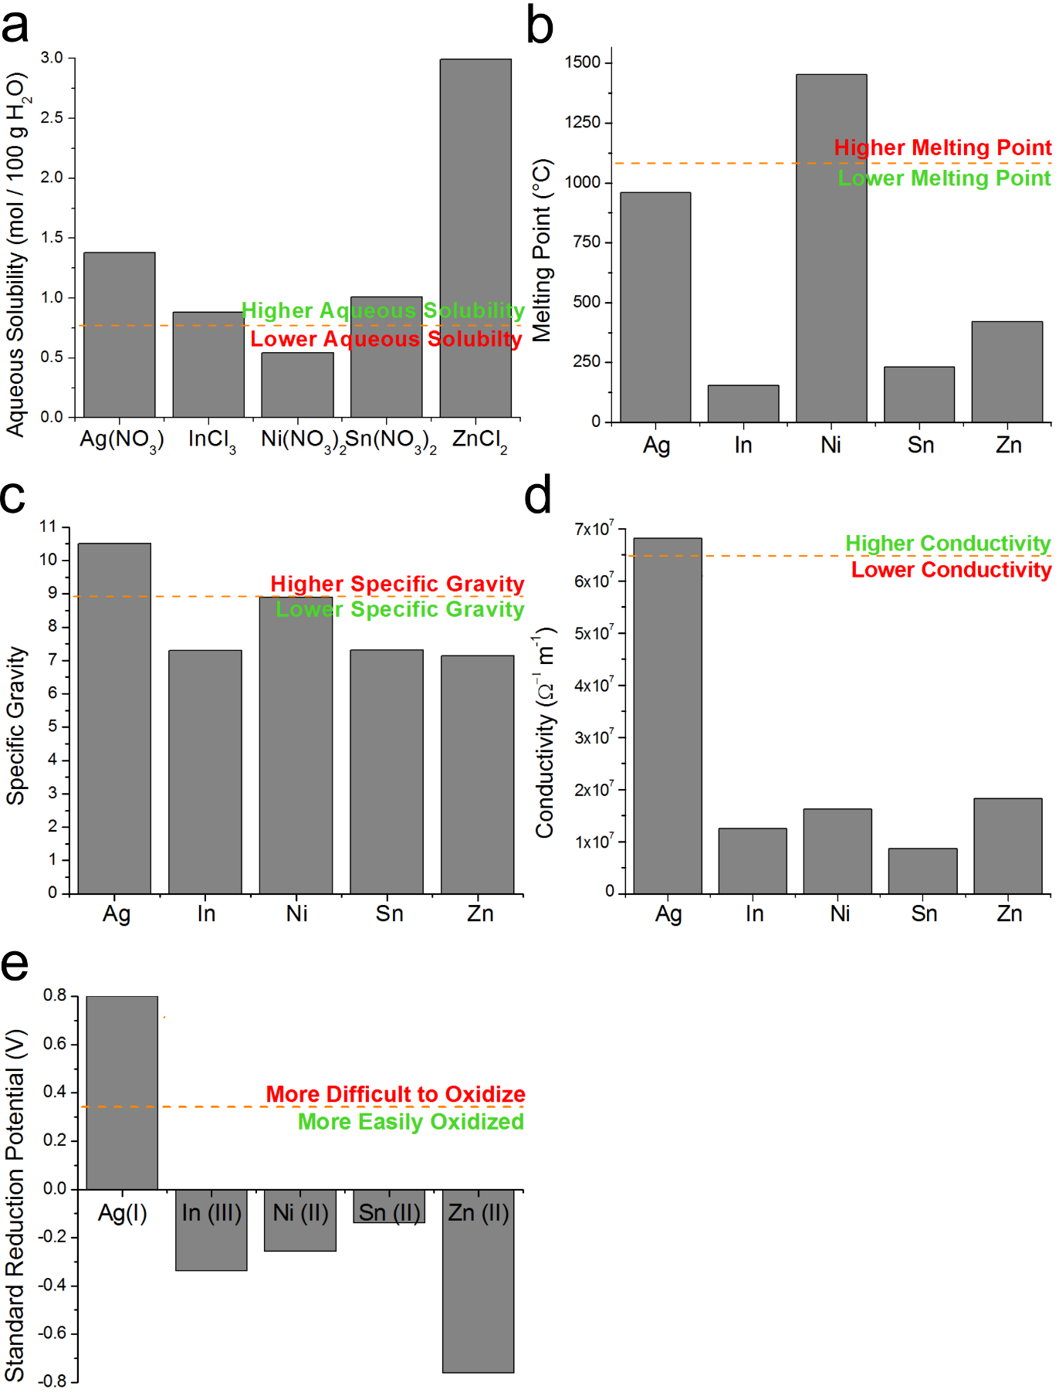
Figure S1: Physical characteristics for deciding system parameters. Orange dashed lines represent copper species: a) Cu(NO₃)₂, b-d) Cu, e) Cu(II).
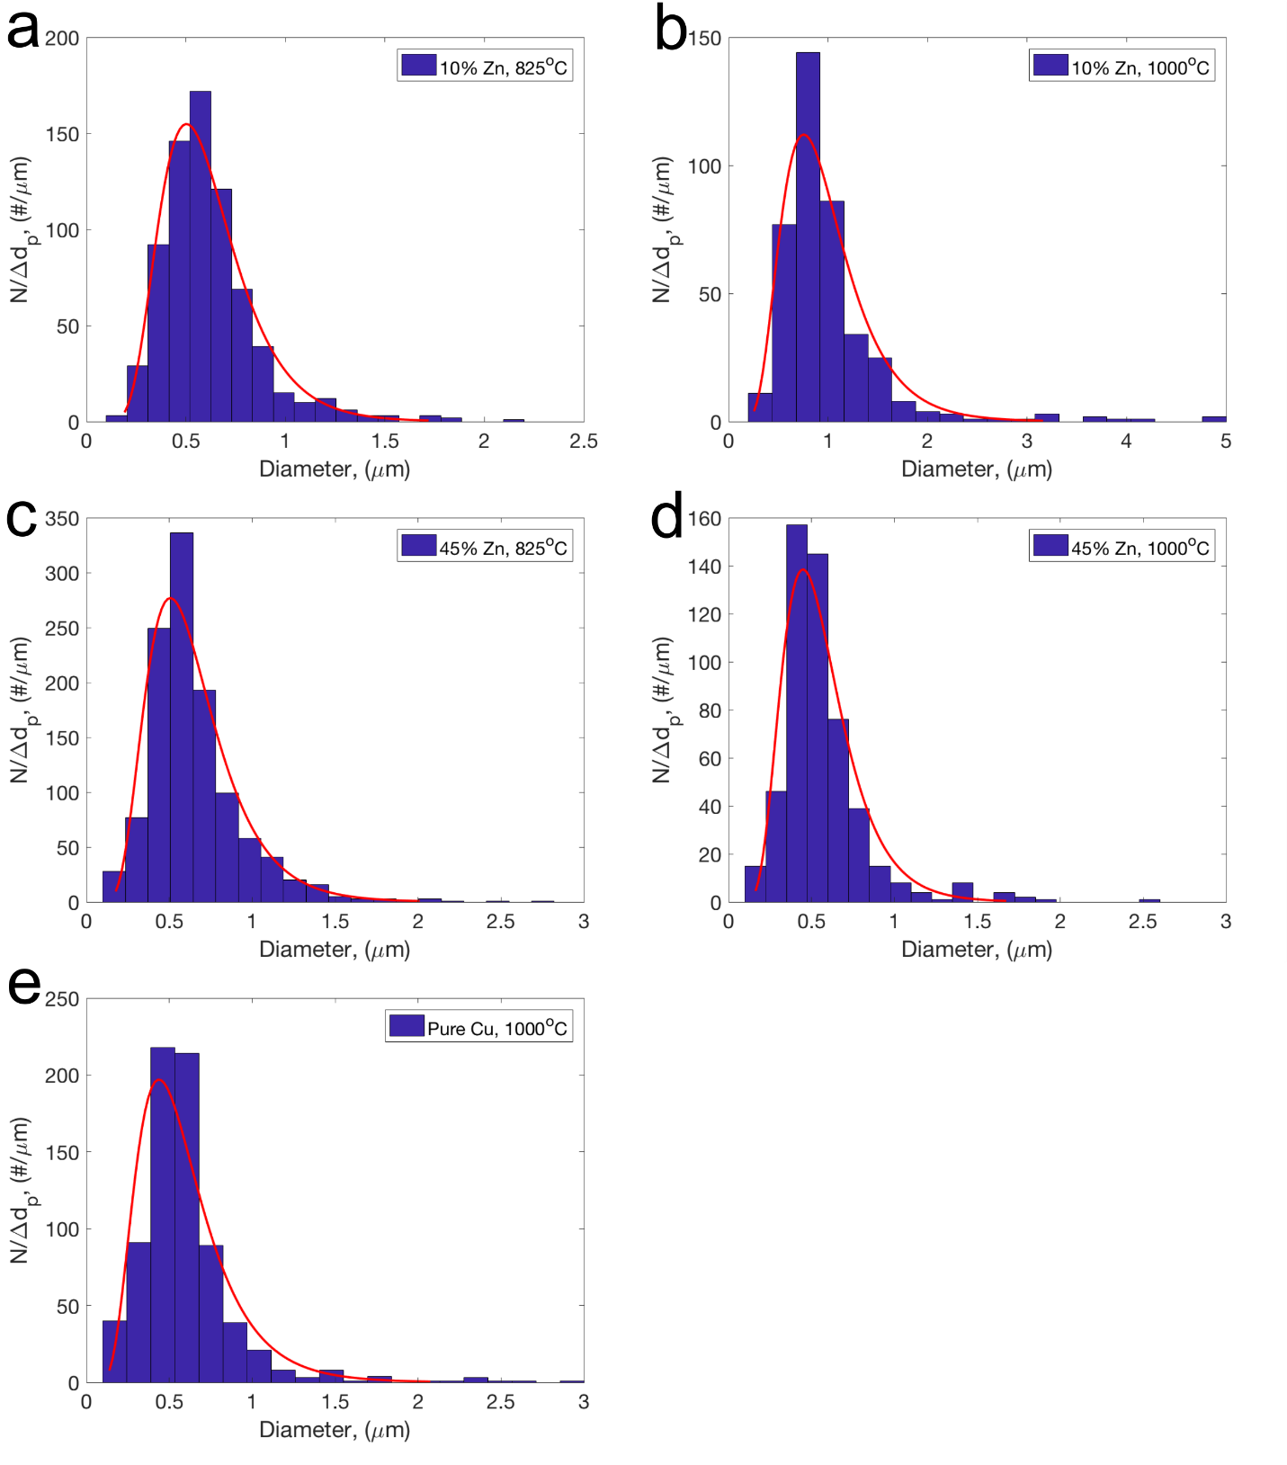
Figure S2: Histograms of particle volume diameters taken from representative SEM images. The volume diameters were calculated from tracings of the particle diameters made in ImageJ software.

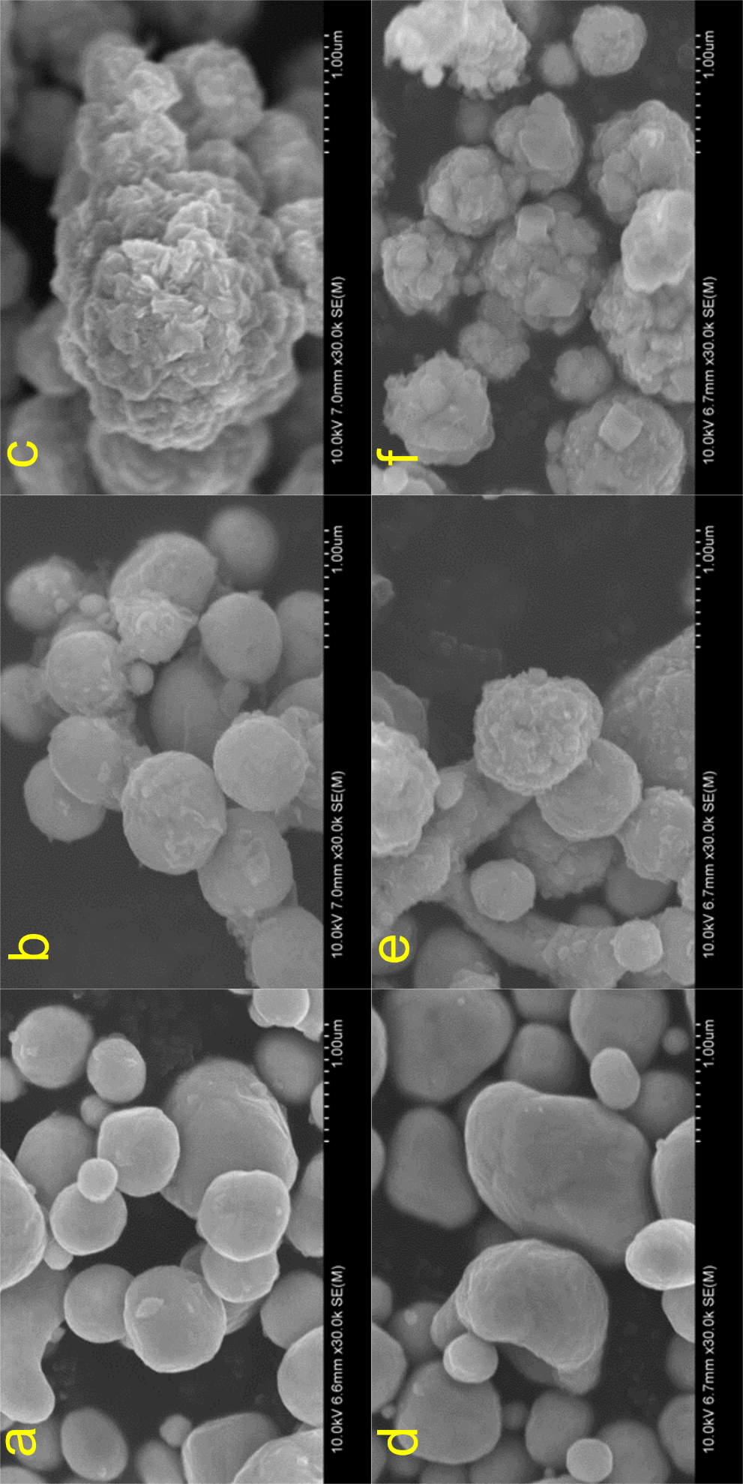
.

Figure S3: SEM image of particles generated from three different precursor zinc concentrations: a) and d) are 0 at% zinc, b) and e) are 5 at% zinc, c) and f) are 10 at% zinc. The ethylene glycol concentration was varied between precursors: a, b, c) are 20 vol% ethylene glycol, while d, e, f) are 33 vol% ethylene glycol. There appears to be no change in morphology with variance in ethylene glycol concentration.

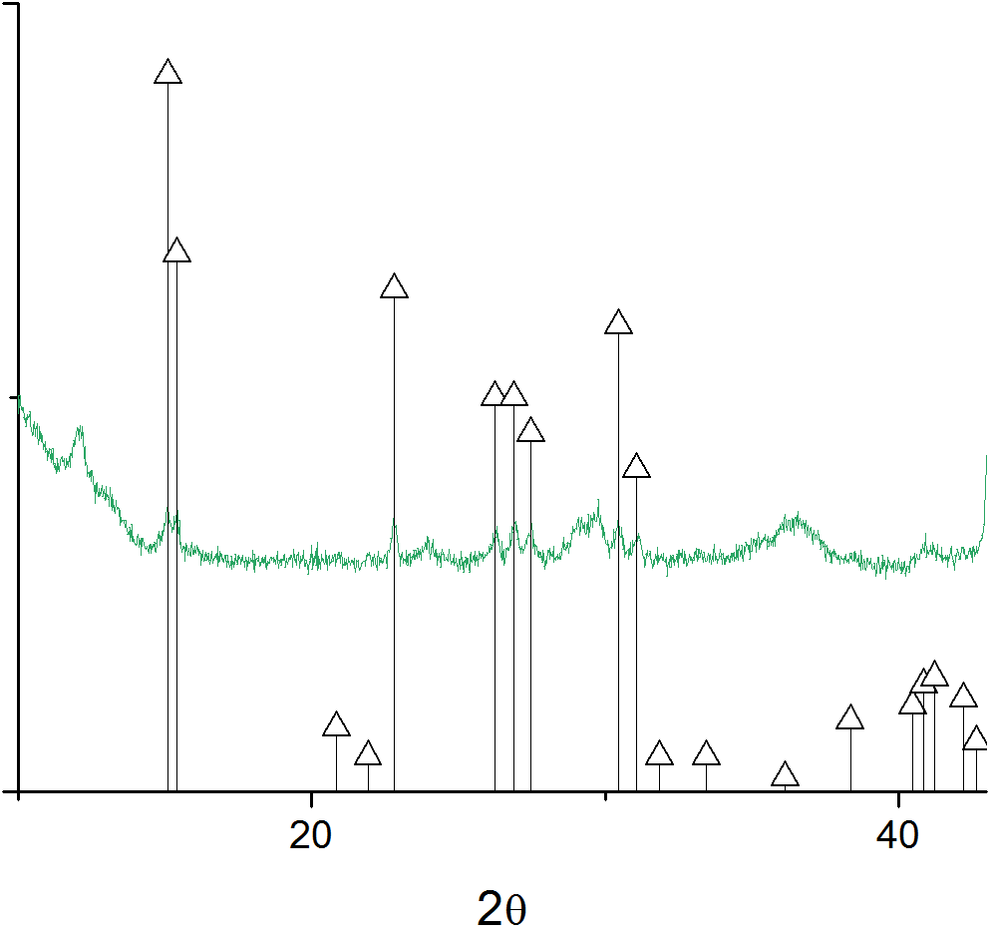
Figure S4: Long residence time experiment (1L/min flow rate) of 45 at% zinc precursor fabricated at 1000ºC. The presence of Zn(NH₃)₂Cl₂ remains evident and is labeled by the (∆) reference peaks, PDF #00-024-1435.

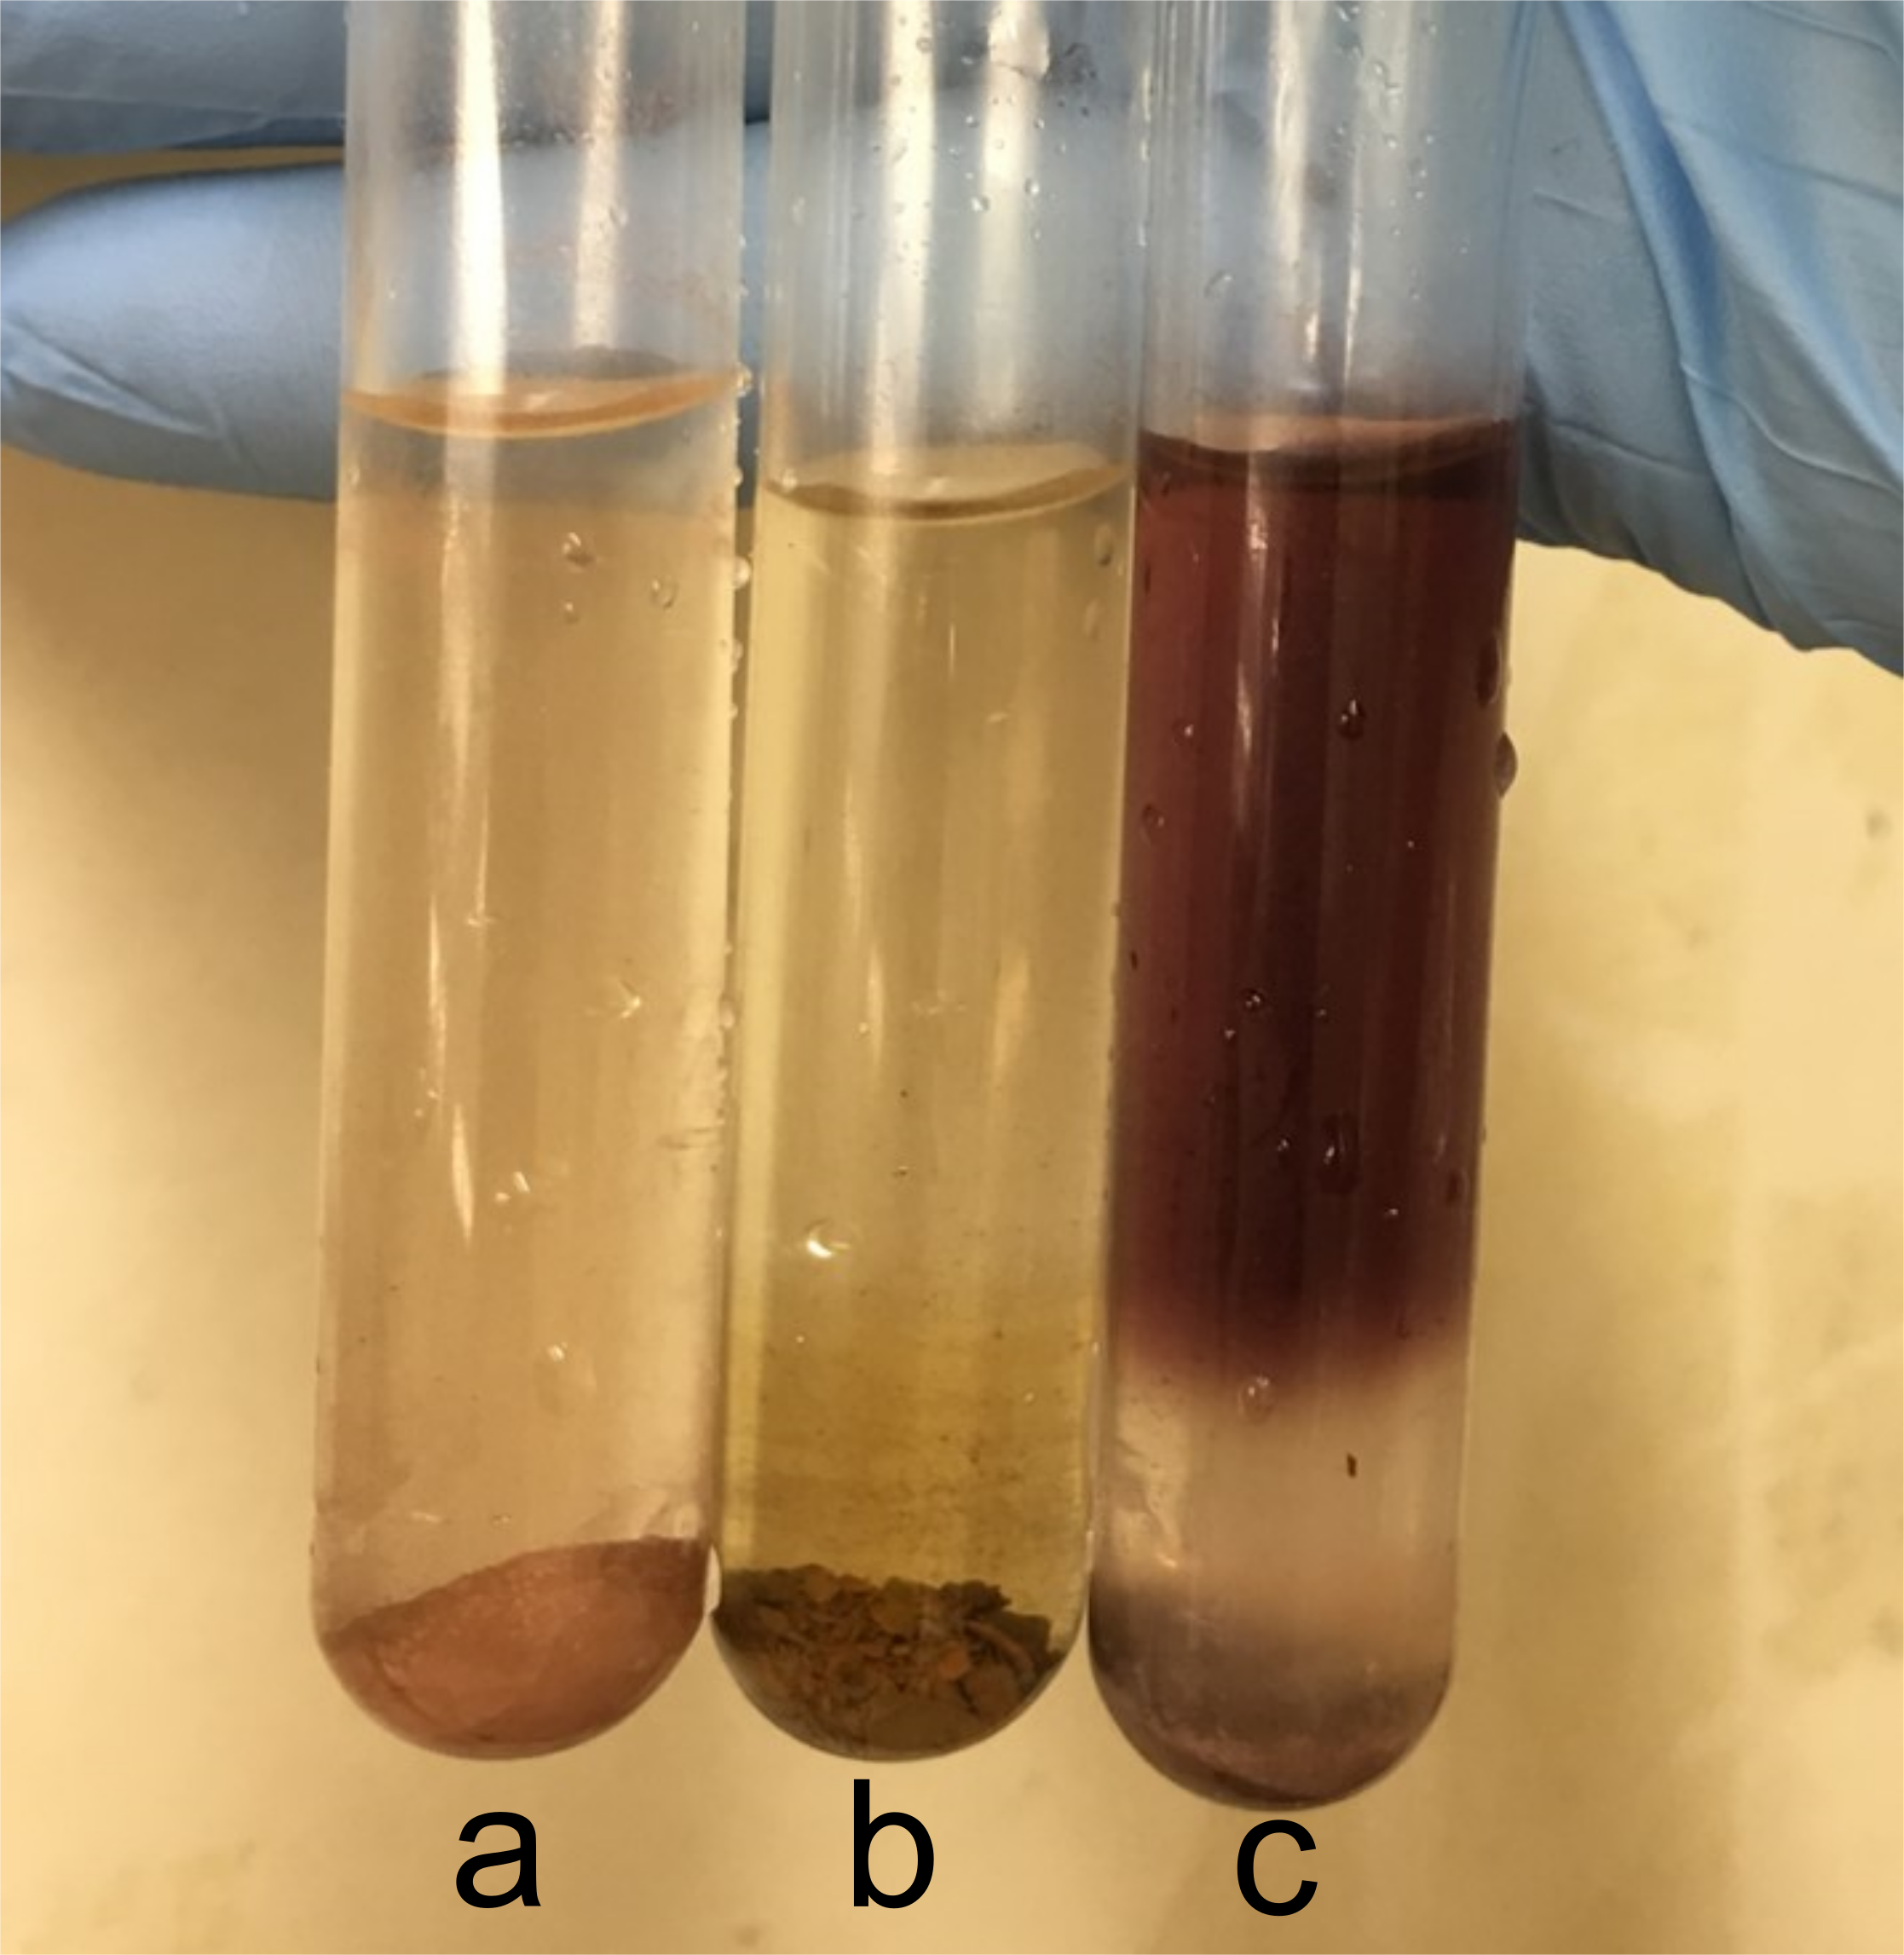
Figure S5: Ninhydrin assay of powders generated. a) Pure copper at 1000ºC, negative; b) 10% Zn at 1000ºC, negative; c) 45% Zn at 1000ºC, positive (Ruhemann’s purple).

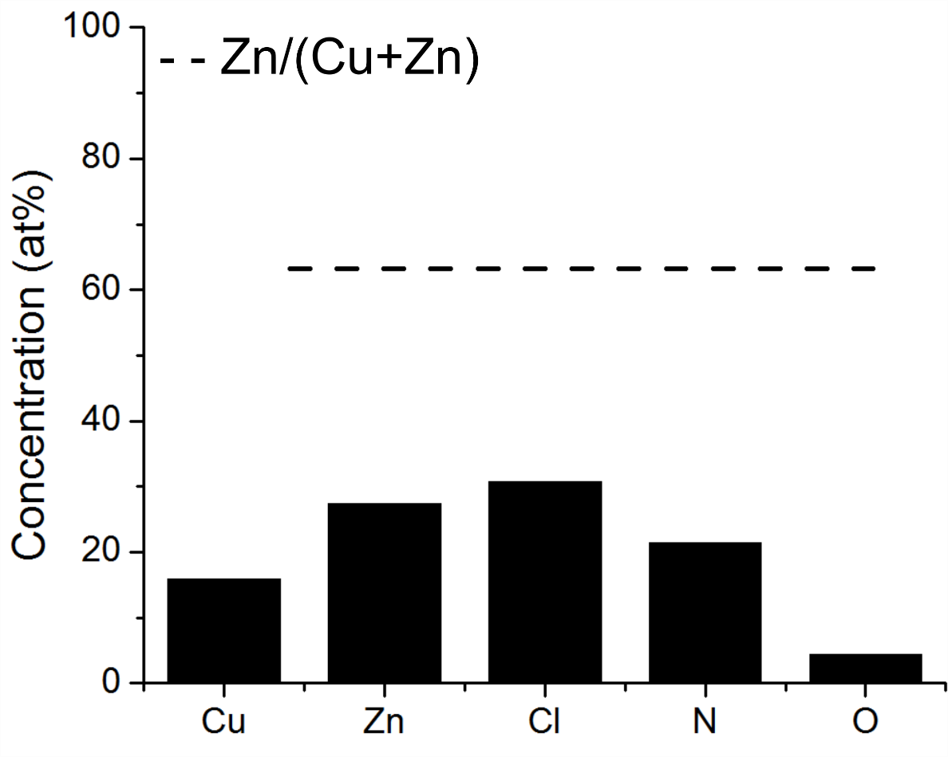
Figure S6: EDX point scans of platelet morphologies in powders generated from 45% zinc precursors at 1000ºC show enrichment in zinc, chlorine, and nitrogen, and a high relative composition of zinc to copper.

Table S1: Binding energies (eV) of nitrogen peaks from high resolution XPS scans of powders.
Sample | XPS High Resolution Nitrogen Peak Location
10% zinc, 825°C | 400.3
10% zinc, 1000°C | 400.4
45% zinc, 825°C | 400.1
45% zinc, 1000°C | 400.7

