Supplementary Information
(A) Full experimental and Spectroscopic data of the synthesized compounds 2-12:
Synthesis of 2,3-diphenyl-2-oxido-2,3-dihydro-1,3,4,2-benzoxadiazaphosphepine (2).
A solution of phenylphosphonic dichloride (0.35 ml, 2.5 mmol) in toluene (5 ml), was added dropwise to a solution of compound 1 (0.53 g, 2.5 mmol) in toluene (30 ml) in presence of a catalytic amount of triethylamine (0.35 ml, 5 mmol) at 5−10 ºC for 30 minutes. The mixture was heated under reflux for 10 hours. The formed solid was filtered off, washed with water several times and recrystallized from diluted dioxane to give pale green solid in 78% yield; mp 236−238 ºC. IR (KBr), (ν_{max}, cm⁻¹): 3098 (C–H_{arom}), 1609 (C=N), 1530 (C=C), 1199 (P=O), 1089 (O–C). ¹H-NMR (400 MHz, DMSO-d₆): 7.52–7.59 (m, 4H, Ph–H), 7.74 (d, 3H, J=5.2 Hz, Ph–H), 7.85–7.90 (m, 3H, Ph–H), 8.12–8.21 (m, 4H, Ph–H), 8.91 (s, 1H, CH=N). ¹³C-NMR (100 MHz, DMSO-d₆): 116.7 (C–2`,6`), 118.2 (C–9), 119.4 (C–5a), 120.4 (C–4`), 121.8 (C–7), 124.0 (C–3``,5``), 127.8 (C–2``,6``), 129.6 (C–3`,5`), 130.9 (C–6), 132.3 (C–4``), 136.8 (C–8), 140.0 (d, J_{PC}=125 Hz, C–1``), 142.3 (C–1`), 147.0 (C–5), 159.6 (C–9a). ³¹P-NMR (162 MHz, DMSO-d₆): 35.7 ppm. MS (EI, m/z): 334 (M⁺, 6%). Anal. calcd. for C₁₉H₁₅N₂O₂P (334.32): C, 68.26; H, 4.52; N, 8.38%. Found: C, 67.91; H, 4.25; N, 8.02%.
General procedure for reaction of compound 1 with phosphorus oxychloride and phosphorus tribromide: Sythesis of products 3 and 4.
A solution of phosphorus oxychloride or phosphorus tribromide (2.5 mmol) in toluene (5 ml), was added dropwise to a solution of compound 1 (0.53 g, 5 mmol) in toluene (60 ml) in presence of a catalytic amount of triethylamine (0.7 ml, 10 mmol) at 5−10 ºC for 30 minutes. The mixtures were heated under reflux for 10 hours. The reaction mixtures were concentrated into their third volume and left to cool. The obtained oily products were dissolved in distilled water (15 ml). The formed solids were filtered off and crystallized from methanol to give pale green solids 3 and 4, respectively.
3-Phenyl-2-hydroxy-2-oxido-2,3-dihydro-1,3,4,2-benzoxadiazaphosphepine (3): 60% yield; mp >300 ºC. IR (KBr), (ν_{max}, cm⁻¹): 3227 (br, OH), 1604 (C=N), 1581, 1510 (C=C), 1220 (P=O). ¹H-NMR (400 MHz, DMSO-d₆): 3.55 (s, 1H, OH exchangeable with D₂O), 6.92–7.02 (m, 4H, Ph–H), 7.36–7.54 (m, 4H, Ph–H), 7.67 (d, 1H, J=7.6 Hz, Ph–H), 8.96 (s, 1H, CH=N). ¹³C-NMR (100 MHz, DMSO-d₆): 112.2 (C–2`,6`), 115.1 (C–9), 117.9 (C–5a), 121.4 (C–4`), 122.9 (C–7), 129.7 (C–3`,5`), 130.2 (C–6), 133.3 (C–8), 142.0 (C–1`), 146.5 (C–5), 158.1 (C–9a). MS (EI, m/z): 274 (M⁺, 9%). Anal. calcd. for C₁₃H₁₁N₂O₃P (274.22): C, 56.94; H, 4.04; N, 10.22%. Found: C, 56.65; H, 3.76; N, 9.86%.
3-Phenyl-2,3-dihydro-1,3,4,2-benzoxadiazaphosphepine 2-oxide (4): 73% yield; mp 215−217 ºC. IR (KBr), (ν_{max}, cm⁻¹): 3030 (C–H_{arom}), 1603 (C=N), 1513 (C=C), 1228 (P=O). ¹H-NMR (400 MHz, DMSO-d₆): 7.20 (t, 1H, J=7.6 Hz, Ph–H), 7.37 (t, 2H, J=8.4 Hz, Ph–H), 7.53 (d, 2H, J=7.6 Hz, Ph–H), 7.74 (d, 1H, J=667 Hz, P–H), 7.79 (d, 1H, J=8.8 Hz, Ph–H), 7.88 (d, 1H, J=8.0 Hz, Ph–H), 8.03 (d, 1H, J=2.8 Hz, Ph-H), 8.24 (d, 1H, J=7.6 Hz, Ph–H), 9.35 (s, 1H, CH=N). ³¹P-NMR (162 MHz, DMSO-d₆): 7.8 ppm.MS (EI, m/z): 258 (M⁺, 2%). Anal. calcd. for C₁₃H₁₁N₂O₂P (258.22): C, 60.47; H, 4.29; N, 10.85%. Found: C, 60.11; H, 4.03; N, 10.53%.
Synthesis of 3-phenyl-2-sulfanyl-2-sulfido-2,3-dihydro-1,3,4,2-benzoxadiazaphosphepine (5).
A mixture of phosphorus decasulfide (1.11 g, 2.5 mmol) and compound 1 (0.53 g, 2.5 mmol) in toluene (40 ml), was heated under reflux for 5 hours. The formed solid on heating was filtered off and recrystallized from ethanol to give orange solid in 63% yield; mp 95−97 ºC. IR (KBr), (ν_{max}, cm⁻¹): 3058 (C–H_{arom}), 2610 (SH), 1600 (C=N), 1544, 1503 (C=C), 1059 (O–C), 691 (P=S). ¹H-NMR (400 MHz, DMSO-d₆): 3.33 (br, 1H, SH exchangeable with D₂O), 6.66–6.89 (m, 1H, Ph–H), 7.16–8.00 (m, 8H, Ph–H), 8.95 (s, 1H, CH=N). MS (EI, m/z): 306 (M^{+,} 69%). Anal. calcd. for C₁₃H₁₁N₂OPS₂ (306.35): C, 50.97; H, 3.62; N, 9.14; S, 20.93%. Found: C, 50.72; H, 3.11; N, 8.95; S, 20.59%.
Synthesis of 2-ethoxy-3-phenyl-2-sulfido-2,3-dihydro-1,3,4,2-benzoxadiazaphosphepine (6).
A solution of phosphorus decasulfide (2.22 g, 5 mmol) in ethanol (30 ml) was heated under reflux for 1 hour to give O,O-diethyldithiophosphoric acid in situ. Compound 1 (0.53 g, 2.5 mmol) was added to the previous ethanolic solution. The mixture was heated under reflux for 8 hours. The reaction mixture was concentrated into its half volume and left to cool. The formed solid after adding some water, was filtered off and recrystallized from diluted ethanol to give yellow solid in 55% yield; mp 178−180 ºC. IR (KBr), (ν_{max}, cm⁻¹): 3030 (C–H_{arom}), 2927 (C–H_{aliph}), 1602 (C=N), 1565 (C=C), 1067 (P–O–C), 693 (P=S). ¹H-NMR (400 MHz, DMSO-d₆): 1.03 (t, 3H, J=6.8 Hz, CH₃), 4.01 (q, 2H, J=6.8 Hz, OCH₂), 7.35–7.41(m, 3H, Ph–H), 7.49–7.55 (m, 4H, Ph–H), 7.79 (t, 1H, J=7.2 Hz, Ph–H), 7.97 (d, 1H, J=8.0 Hz, Ph–H), 9.62 (s, 1H, CH=N).¹³C-NMR (100 MHz, DMSO-d₆): 14.3 (CH₃), 59.6 (CH₂), 115.1 (C–2`,6`), 116.7 (C–9), 118.8 (C–5a), 120.1 (C–4`), 122.3 (C–7), 129.6 (C–3`,5`), 130.8 (C–6), 138.5 (C–8), 141.5 (C–1`), 145.9 (C–5), 160.4 (C–9a). MS (EI, m/z): 318 (M⁺,27%). Anal. calcd. for C₁₅H₁₅N₂O₂PS (318.34): C, 56.60; H, 4.75; N, 8.80; S, 10.07%. Found: C, 56.28; H, 3.61; N, 8.59; S, 9.69%.
Synthesis of 2-(4-methoxyphenyl)-3-phenyl-2-sulfido-2,3-dihydro-1,3,4,2-benzoxadiaza-phosphepine (7).
Lawesson's reagent (0.5 g, 1.25 mmol) was added to a solution of compound 1 (0.26 g, 1.25 mmol) in toluene (30 ml). The mixture was heated under reflux for 8 hours. The solution was concentrated to its half volume and left to cool. The obtained solid was filtered off and recrystallized from toluene to give canary yellow solid in 75% yield; mp 184−186 ºC. IR (KBr), (ν_{max}, cm⁻¹): 3079 (C–H_{arom}), 2981 (C–H_{aliph}), 1617 (C=N), 1514 (C=C), 1044 (O–C), 765 (P=S). ¹H-NMR (400 MHz, DMSO-d₆): 3.74 (s, 3H, OCH₃), 7.30 (d, 1H, J=6.8 Hz, Ar–H), 7.39 (t, 2H, J=7.2 Hz, Ph–H and Ar–H), 7.45–7.49 (m, 2H, Ph–H), 7.65–7.76 (m, 5H, Ph–H), 7.92 (d, 1H, J=8.0 Hz, Ph–H), 8.07 (d, 2H, J=8.0 Hz, Ar–H), 9.00 (s, 1H, CH=N). ¹³C-NMR (100 MHz, DMSO-d₆): 55.6 (OCH₃), 116.2 (C–9), 116.6 (C–2`,6`), 119.1 (C–5a), 120.3 (C–3``,5``), 121.3 (C–4`), 122.0 (C–7), 128.2 (C–2``,6``), 129.1 (C–3`,5`), 130.7 (d, J_{PC}=105 Hz, C–1``), 134.6 (C–6`), 135.5 (C–8), 146.4 (C–1`), 147.9 (C–5), 157.1 (C–4``), 157.8 (C–9a). ³¹P-NMR (162 MHz, DMSO-d₆): 57.2 ppm. MS (EI, m/z): 380 (M⁺, 67%). Anal. calcd. for C₂₀H₁₇N₂O₂PS (380.41): C, 63.15; H, 4.50; N, 7.36; S, 8.43%. Found: C, 62.95; H, 4.19; N, 7.02; S, 8.07%.
Synthesis of 2-ethoxy-3-phenyl-2-oxido-2,3-dihydro-1,3,4,2-benzoxadiazaphosphepine (8).
A mixture of triethyl phosphate (0.85 ml, 5 mmol) and compound 1 (0.53 g, 2.5 mmol) in the presence of a few drops of DBU, was fused on water bath for 10 hours. The oily product was dissolved in hot methanol and left to cool. The formed solid was filtered off and dried to give pale brown solid in 53% yield; mp 146−148 ºC. IR (KBr), (ν_{max}, cm⁻¹): 3050 (C–H_{arom}), 2976 (C–H_{aliph}), 1600 (C=N), 1560, 1510 (C=C), 1202 (P=O), 1047 (P–O–C). ¹H-NMR (400 MHz, DMSO-d₆): 1.03 (t, 3H, J=6.8 Hz, CH₃), 3.41 (q, 2H, J=6.8 Hz, OCH₂), 7.21 (d, 1H, J=8.4 Hz, Ph–H), 7.51–7.58 (m, 4H, Ph–H), 7.82 (t, 2H, J=8.0 Hz, Ph–H), 8.01 (d, 2H, J=8.0 Hz, Ph–H), 8.72 (s, 1H, CH=N). ¹³C-NMR (100 MHz, DMSO-d₆): 16.5 (CH₃), 61.1 (CH₂), 112.2 (C–2`,6`), 117.3 (C–9), 119.2 (C–5a), 120.2 (C–4`), 121.5 (C–7), 129.1 (C–3`,5`), 130.8 (C–6), 136.6 (C– 8), 141.4 (C–1`), 145.9 (C–5), 159.3 (C–9a). MS (EI, m/z): 302 (M⁺, 24%). Anal. calcd. for C₁₅H₁₅N₂O₃P (302.27): C, 59.60; H, 5.00; N, 9.27%. Found: C, 59.31; H, 4.72; N, 8.97%.

Synthesis of 1-(2-ethoxy-2-oxido-2,3-dihydro-1,2-benzoxaphosphol-3-yl)-2-phenylhydrazine (9).
A mixture of diethyl phosphite (0.7 ml, 5 mmol) and compound 1 (0.53 g, 2.5 mmol) in the presence of a few drops of DBU, was fused on water bath for 6 hours. The oily product was dissolved in hot diluted ethanol and left to cool. The formed solid was filtered off and dried to give yellow solid in 69% yield; mp 101−103 ºC. IR (KBr), (ν_{max}, cm⁻¹): 3415, 3162 (2 NH), 3049 (C–H_{arom}), 2950, 2886 (C–H_{aliph}), 1614, 1573 (C=C), 1230 (P=O), 1083 (P–O–C). ¹H-NMR (400 MHz, DMSO-d₆): 0.77 (t, 3H, J=6.8 Hz, CH₃), 3.95 (q, 2H, J=6.8 Hz, OCH₂), 4.68 (s, 1H, NH exchangeable with D₂O), 5.32 (d, 1H, J=15.2 Hz, P–CH), 6.77 (t, 1H, J=7.2 Hz, Ph–H), 6.86–6.89 (m, 2H, Ph–H), 7.04 (d, 1H, J=8.0 Hz, Ph–H), 7.17 (d, 1H, J=7.6 Hz, Ph–H), 7.22–7.24 (m, 3H, Ph–H), 7.28–7.31 (m, 1H, Ph–H), 9.08 (brs, 1H, NH exchangeable with D₂O). ¹³C-NMR (100 MHz, DMSO-d₆): 17.2 (CH₃), 59.6 (CH₂), 48.5 (d, J_{PC}=148 Hz), 116.9 (C–2`,6`), 117.7 (C–7), 118.7 (C–3a), 119.7 (C–4`), 121.45 (C–5), 129.2 (C–3`,5`), 131.6 (C–4), 134.1 (C–6), 139.6 (C–1`), 157.2 (C–7a). ³¹P-NMR (162 MHz, DMSO-d₆): 19.7 ppm. MS (EI, m/z): 304 (M⁺, 35%). Anal. calcd. for C₁₅H₁₇N₂O₃P (304.29): C, 59.21; H, 5.63; N, 9.21%. Found: C, 58.91; H, 5.39; N, 9.01%.
Synthesis of 2,3-dihydro[1,2]benzoxaphospholo[2,3-b][1,4,2]oxazaphosphinine 5-oxide (10).
A mixture of tris(2-chloroethyl)phosphite (0.7 mL, 3 mmol) and compound 1 (0.53 g, 2.5 mmol) in presence of a few drops of DBU as a catalyst, were allowed to react on a water bath for 10 h (0.15 mL of distilled water added after 3 h). The reaction mixture was treated with cold water to give the solid which was filtered off and recrystallized from dilute ethanol to yield a beige solid in 48% yield; mp 228−230°C (dec.). IR (KBr), (ν_{max}, cm⁻¹): 3064 (C–H_{arom}), 2974, 2922(C–H_{aliph}), 1628 (C=N), 1600 (C=C), 1291 (P=O), 1044 (P–O–C). ¹H-NMR (400 MHz, DMSO-d₆): 3.80 (s, 2H, NCH₂), 4.17 (s, 2H, OCH₂), 6.81–6.97 (m, 2H, Ph–H), 7.38 (t, 1H, J=8.4 Hz, Ph–H), 7.68 (d, 1H, J=8.0 Hz, Ph–H). ¹³C-NMR (100 MHz, DMSO-d₆): 55.7 (NCH₂), 60.6 (OCH₂), 117.9 (C–7), 119.4 (C–10a), 121.1 (C–9), 125.6 (C–10), 135.3 (C–8), 146.1 (d, J_{PC}=94 Hz, C–10b), 157.1 (C–6a). MS (EI, m/z): 209 (M⁺, 3%). Anal. calcd. for C₉H₈NO₃P (209.14): C, 51.69; H, 3.86; N, 6.70%. Found: C, 51.31; H, 3.52; N, 6.43%.
Synthesis of 3-ethoxy-3-oxido-2-phenyl-2,3-dihydrochromeno[3,4-d][1,2,3]diazaphosphol-4(1H)-one (12).
A mixture of compound 1 (0.53 g, 2.5 mmol) and diethyl ethoxycarbonyl phosphonate (0.56 ml, 2.5 mmol) in ethanol containg a few drops of DBU, was heated under reflux for 10 hours. The solid formed was filtered off, washed with water then cooled ethanol and crystallized from DMF/EtOH to give pale brown solid in 72% yield; mp >300 ºC. IR (KBr), (ν_{max}, cm⁻¹): 3270 (NH), 3030 (C–H_{arom}), 1733 (C=O), 1622, 1601 (C=C), 1250 (P=O), 1032 (O–C). ¹H-NMR (400 MHz, DMSO-d₆): 1.29 (t, 3H, J=6.8 Hz, CH₃), 4.34 (q, 2H, J=6.8 Hz, OCH₂), 7.36 (t, 1H, J=6.8 Hz, Ph–H), 7.59–7.63 (m, 3H, Ph–H), 7.68–7.75 (m, 3H, Ph–H), 7.89 (d, 2H, J=7.0 Hz, Ph–H), 9.21 (s, 1H, NH exchangeable with D₂O). ¹³C-NMR (100 MHz, DMSO-d₆): 15.8 (CH₃), 60.0 (OCH₂), 116.9 (C–2`,6`), 117.8 (C–6), 118.1 (C–9a), 120.8 (C–4`), 122.9 (C–8), 125.9 (d, J_{PC}=86 Hz, C–3a), 127.9 (C–9), 130.0 (C–3`,5`), 135.2 (C–7), 141.0 (C–9b), 143.7 (C–1`), 156.5 (C–5a), 175.1 (C–4). ³¹P-NMR (162 MHz, DMSO-d₆): 25.3 ppm. MS (EI, m/z): 342 (M⁺,13 %). Anal. calcd. for C₁₇H₁₅N₂O₄P (342.29): C, 59.65; H, 4.42; N, 8.18. Found: C, 59.29; H, 4.03; N, 7.89%.

(B) Copies of some IR, MS, ¹H- ¹³C- and ³¹P-NMR spectral data for the synthesized compounds:
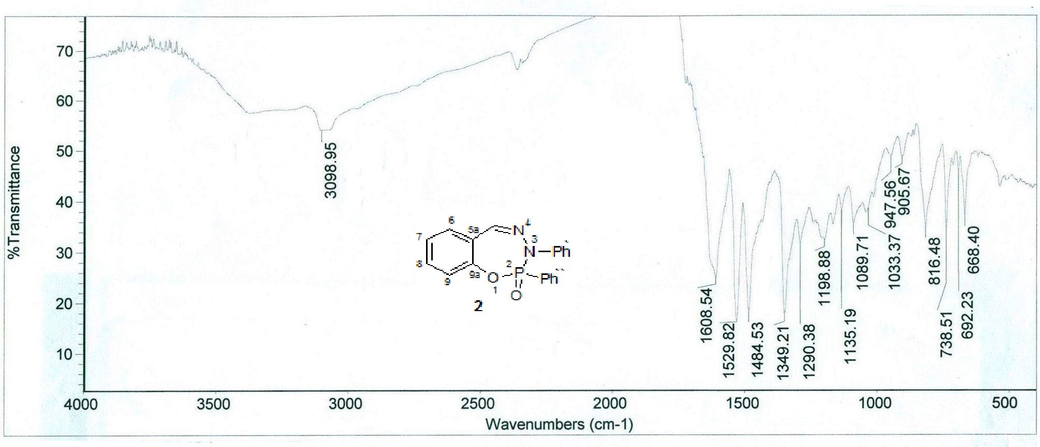
Figure 1: The IR spectrum of compound 2.

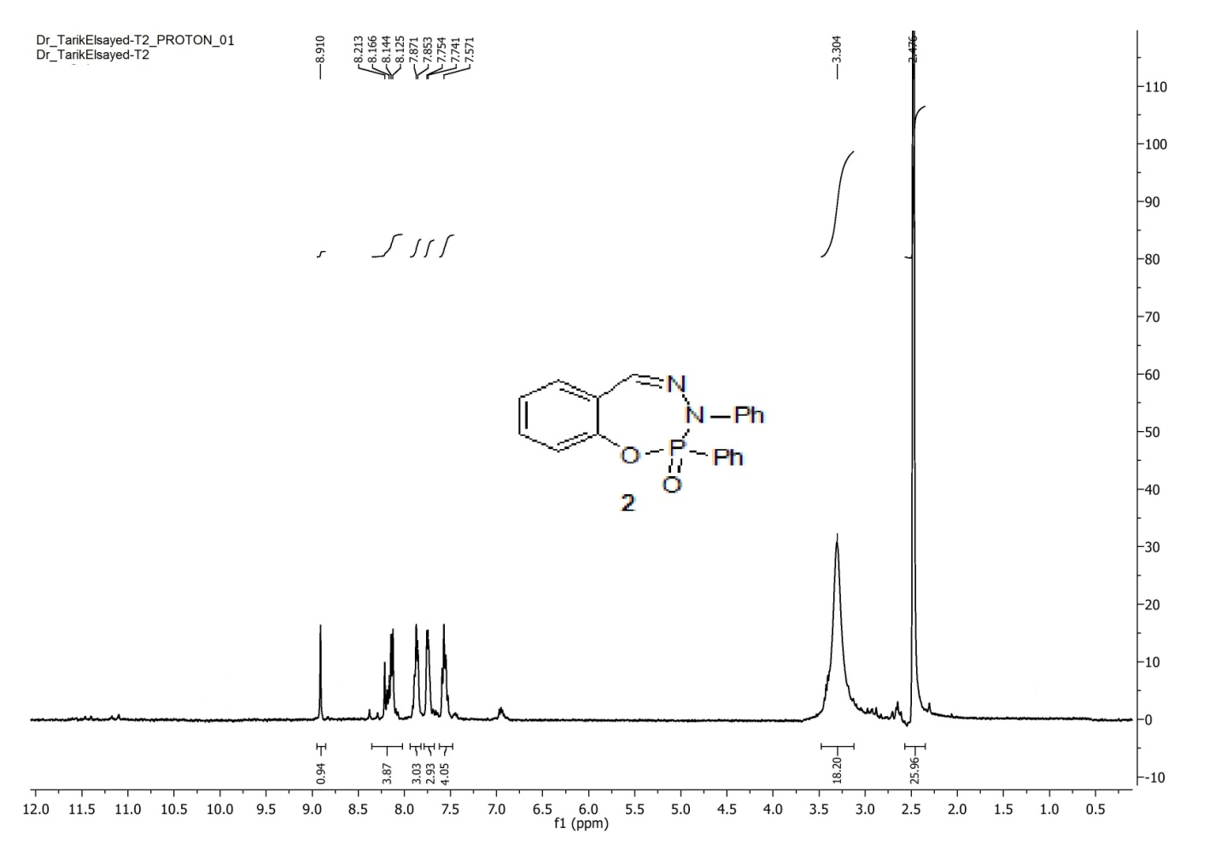
Figure 2: The ¹H-NMR spectrum of compound 2.
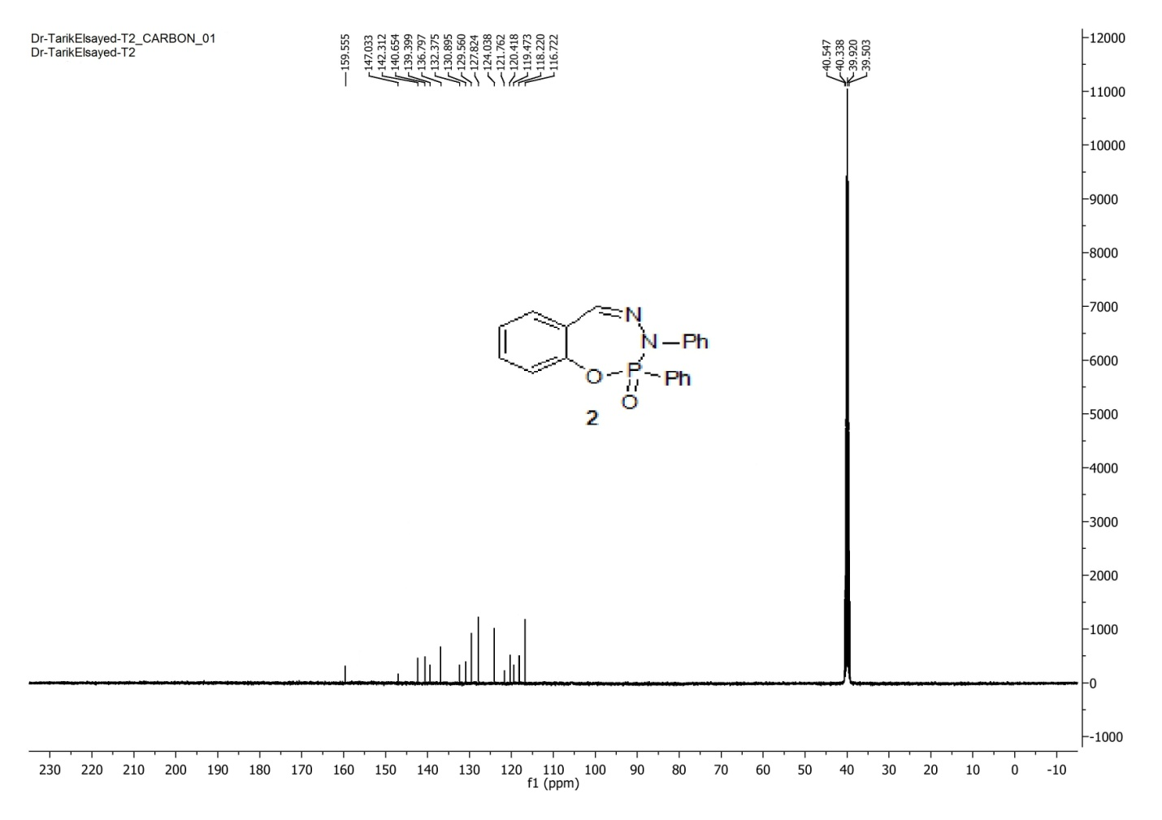
Figure 3: The ¹³C-NMR spectrum of compound 2.
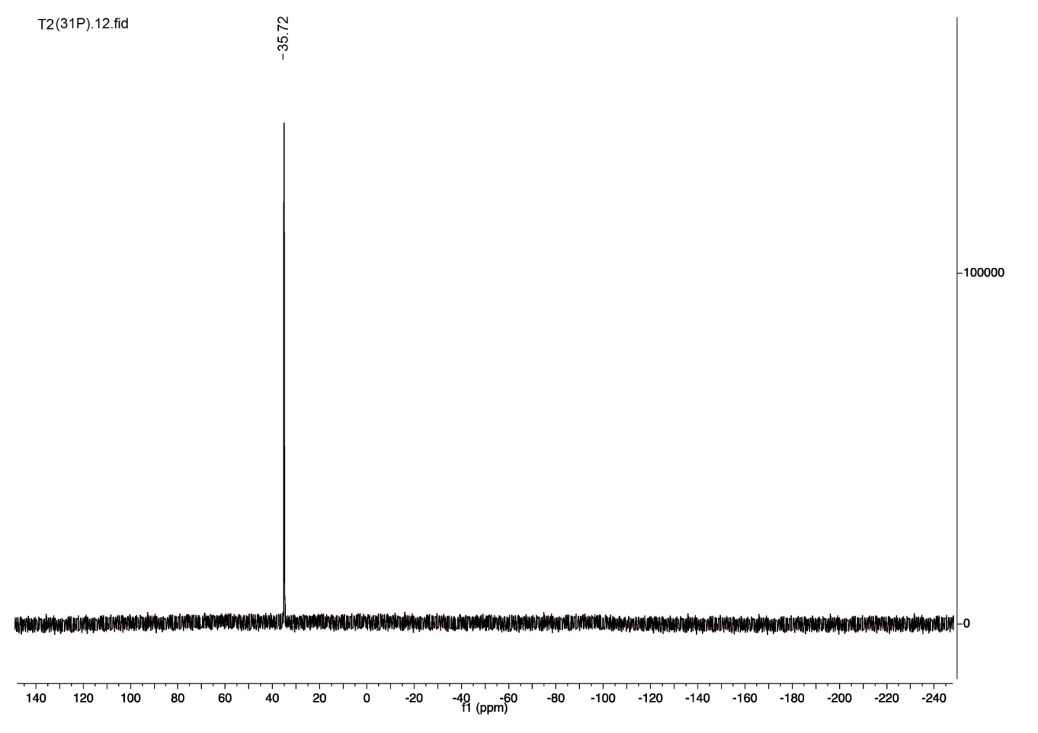
Figure 4: The ³¹P-NMR spectrum compound 2.
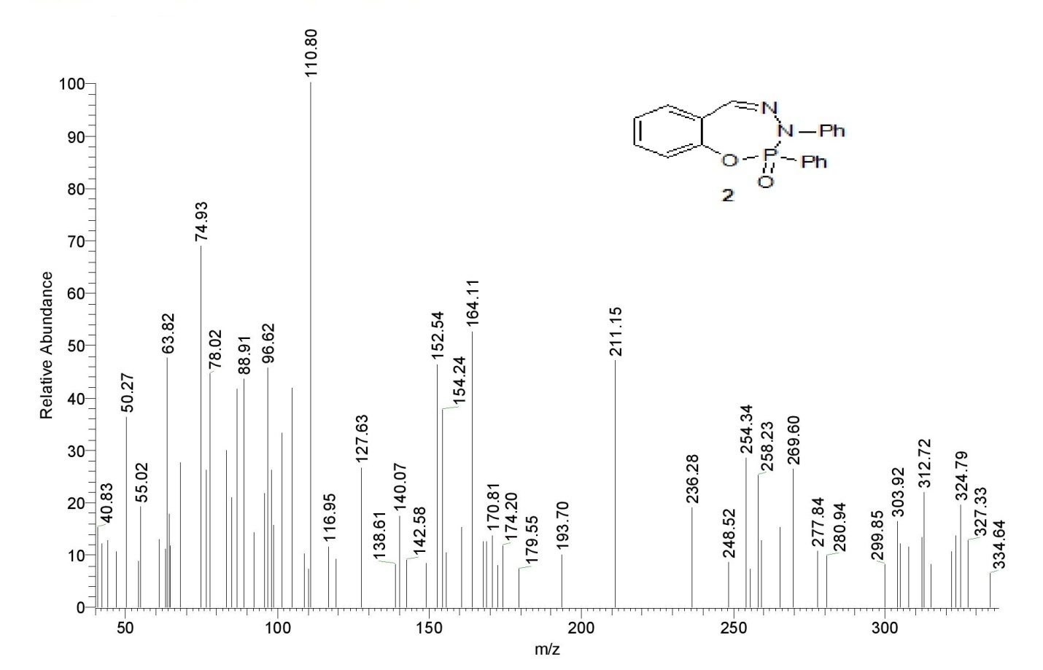
Figure 5: The mass spectrum of compound 2.

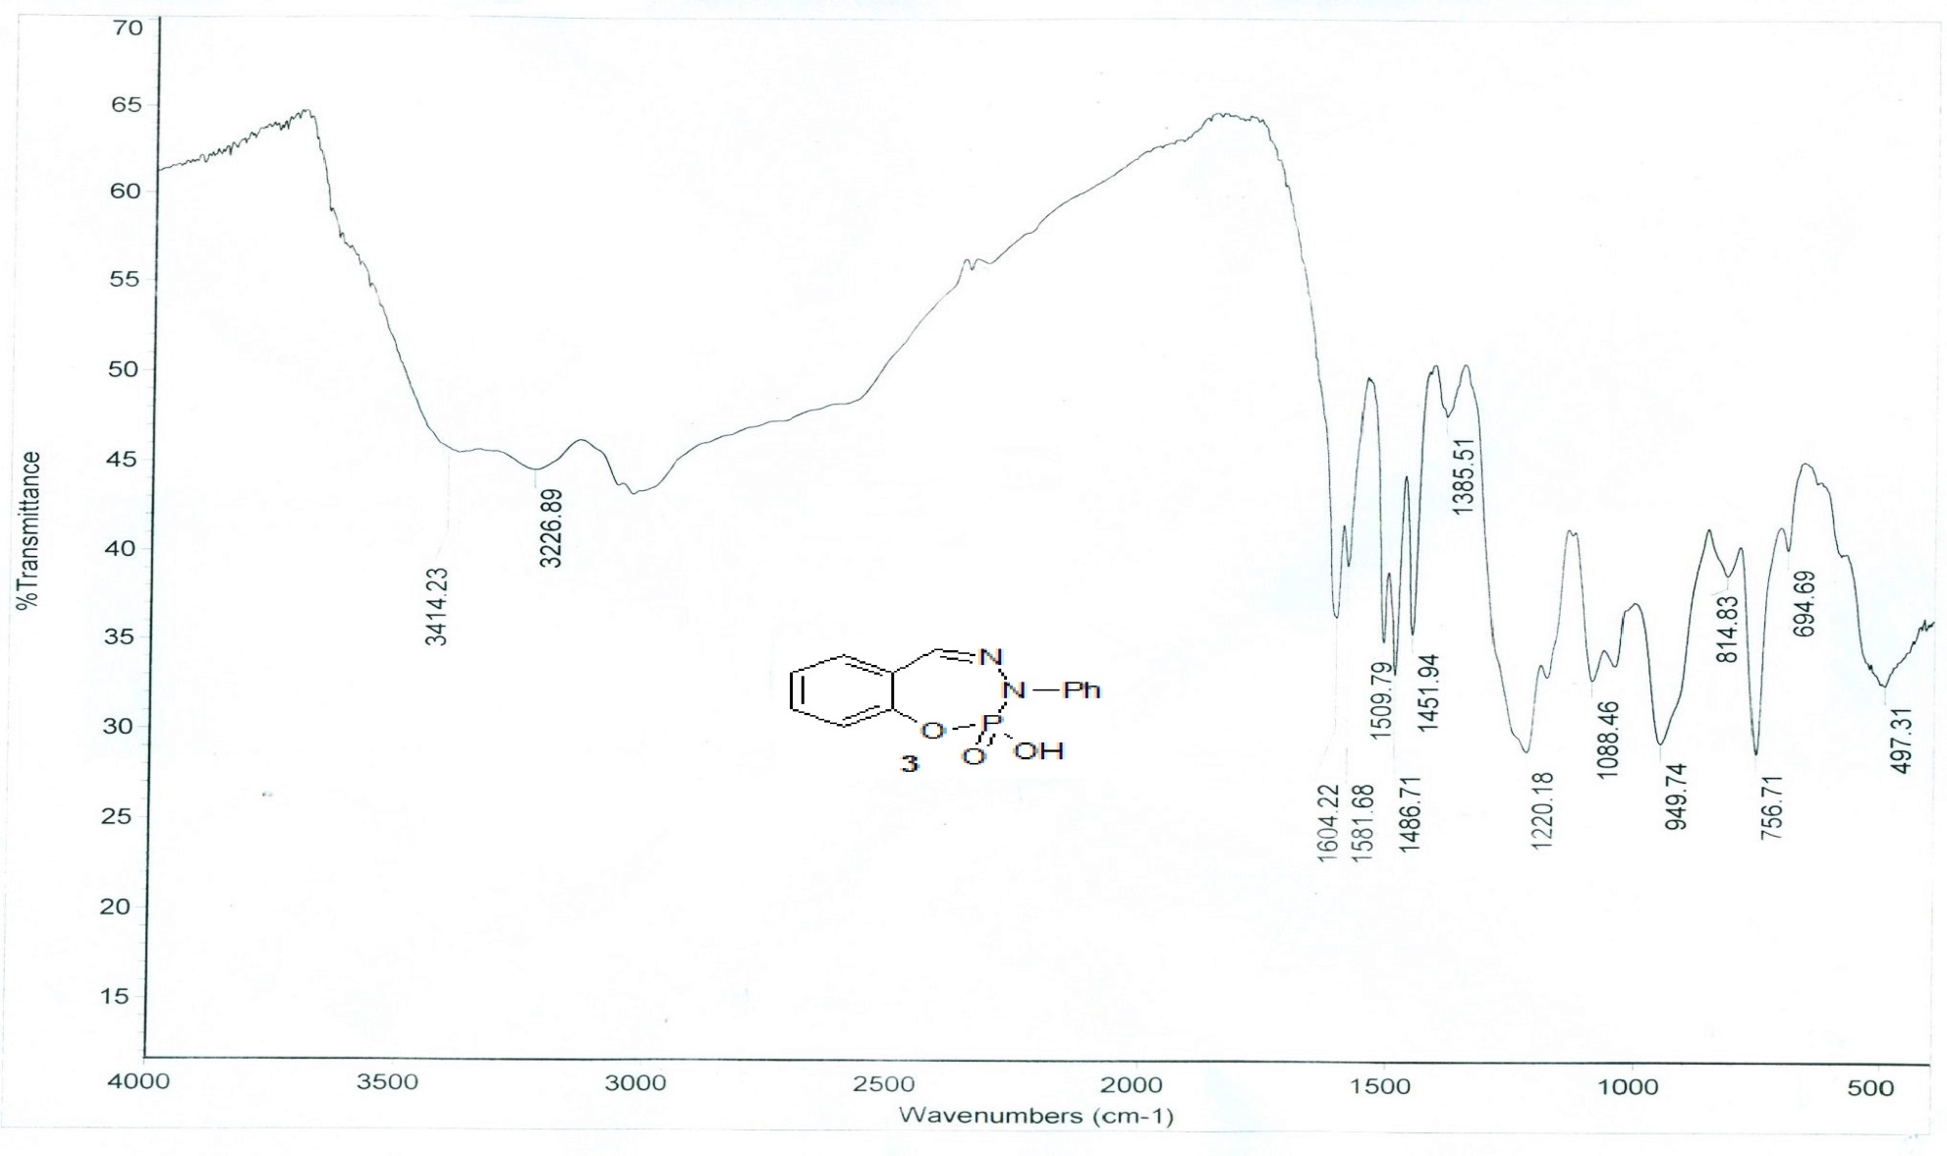
Figure 6: The IR spectrum of compound 3.
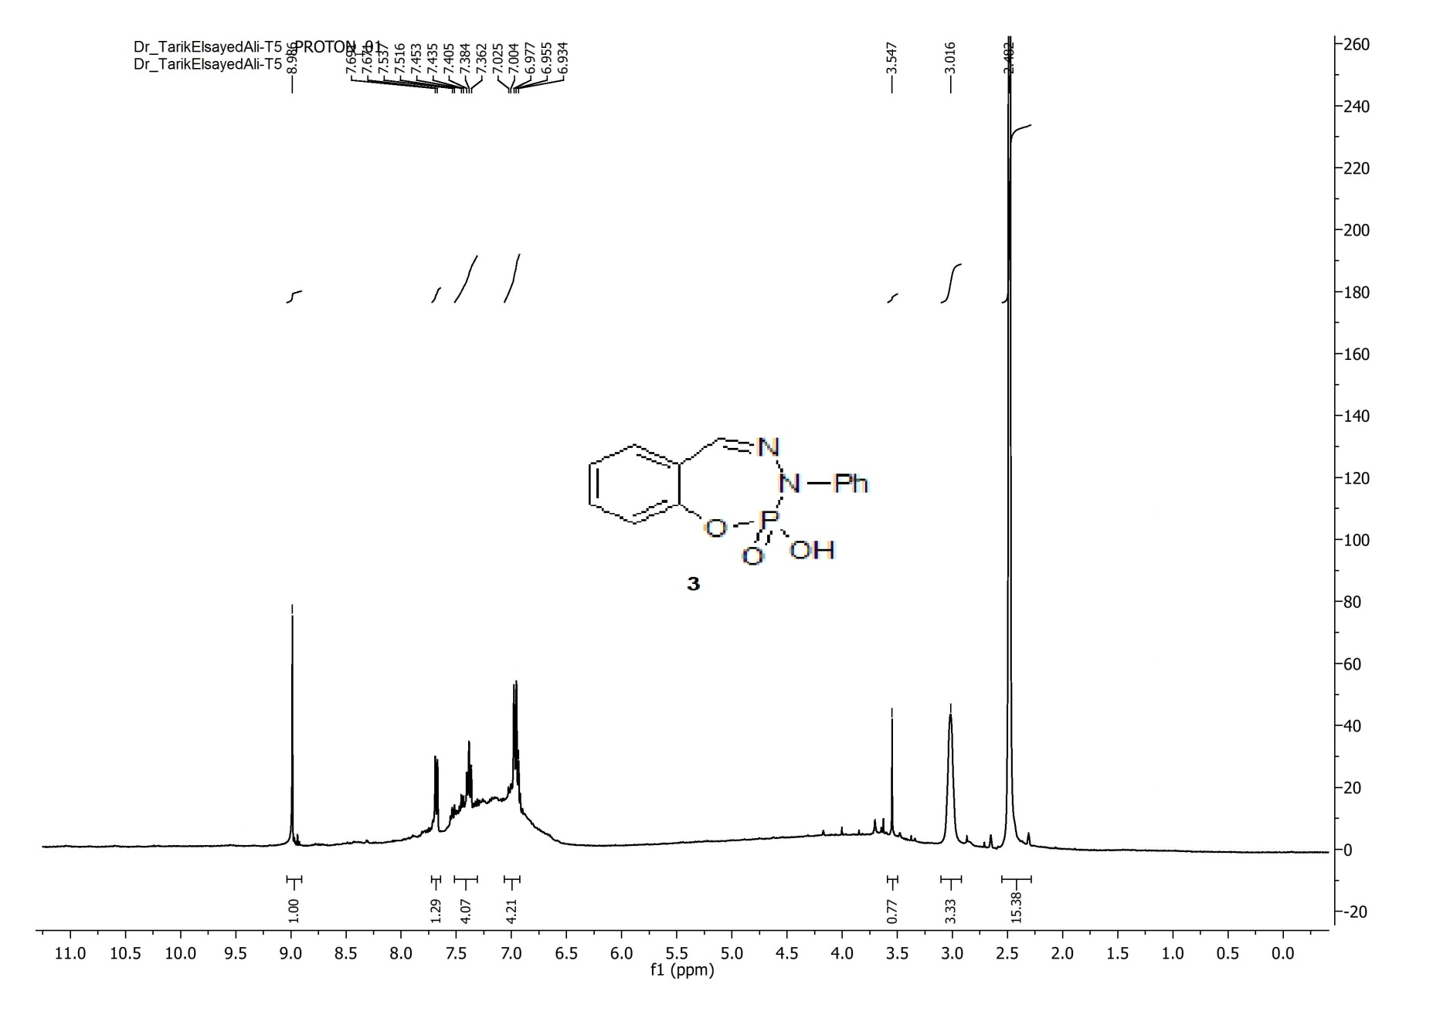
Figure 7: The ¹H-NMR spectrum of compound 3.

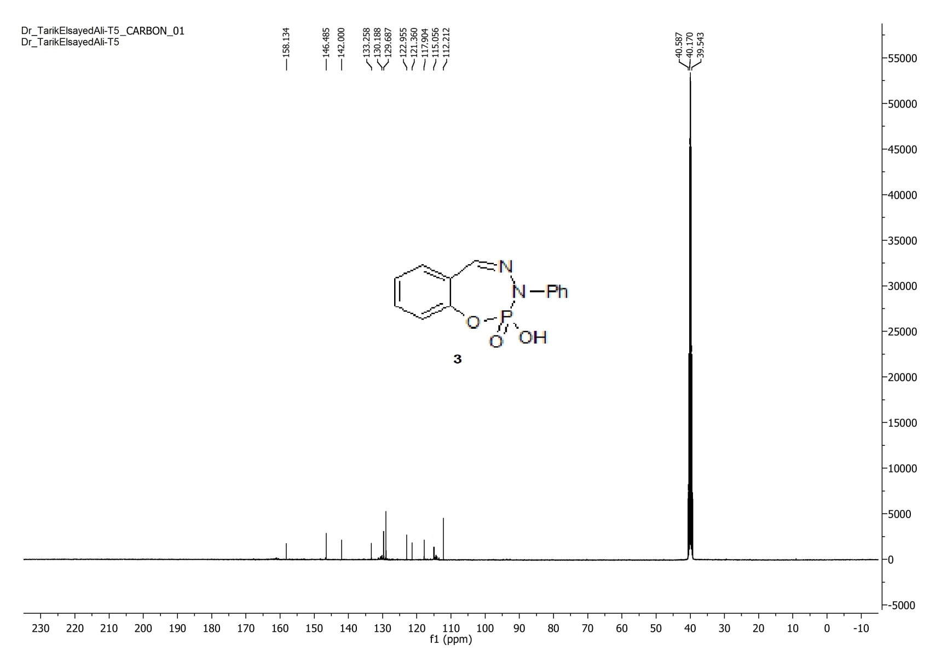
Figure 8: The ¹³C-NMR spectrum of compound 3.

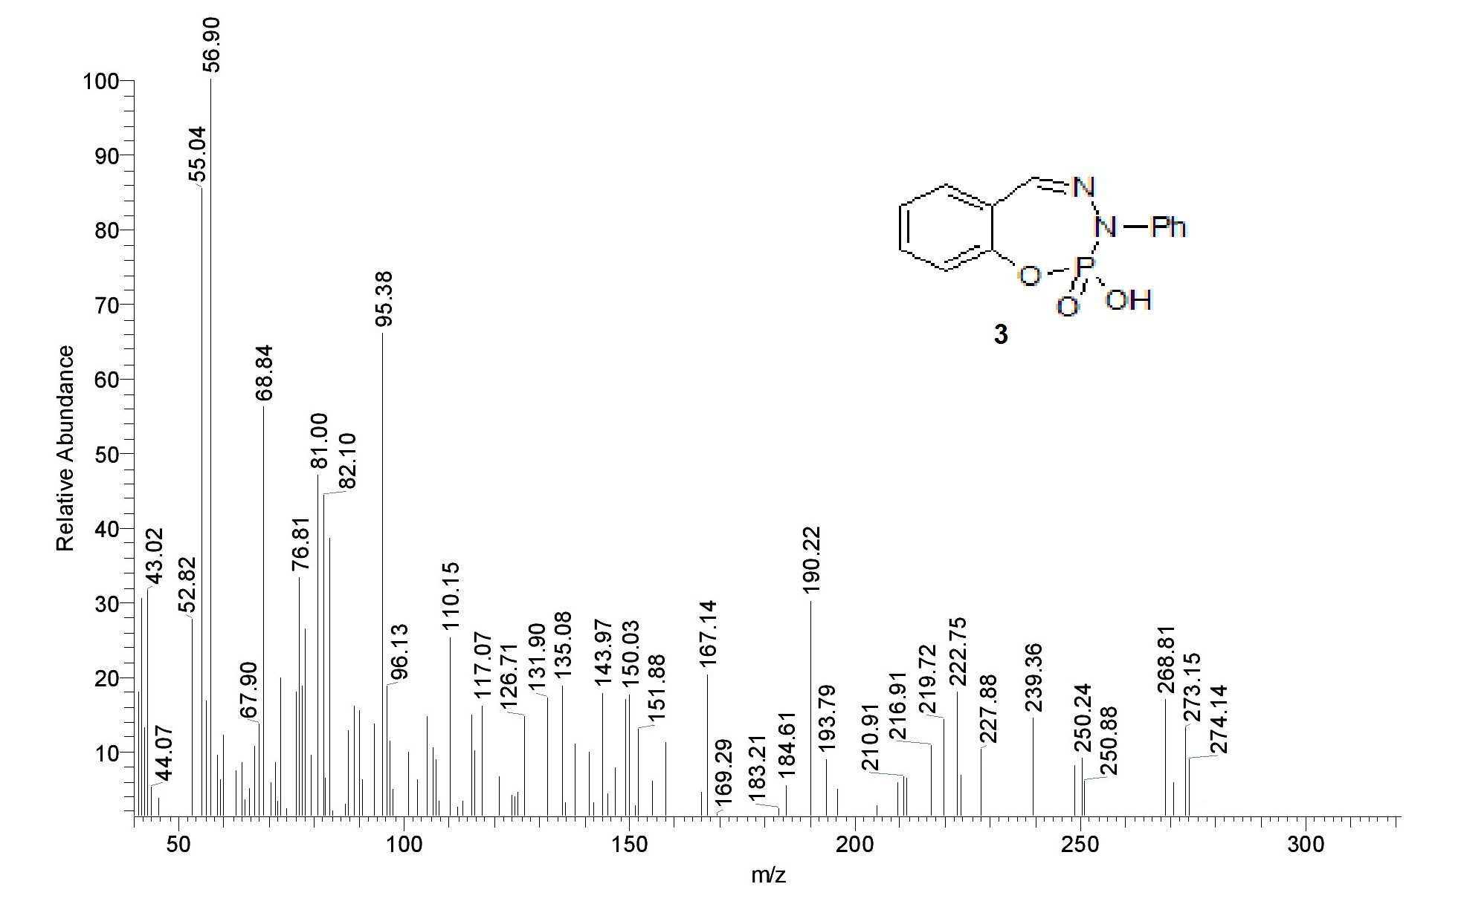
Figure 9: The mass spectrum of compound 3.
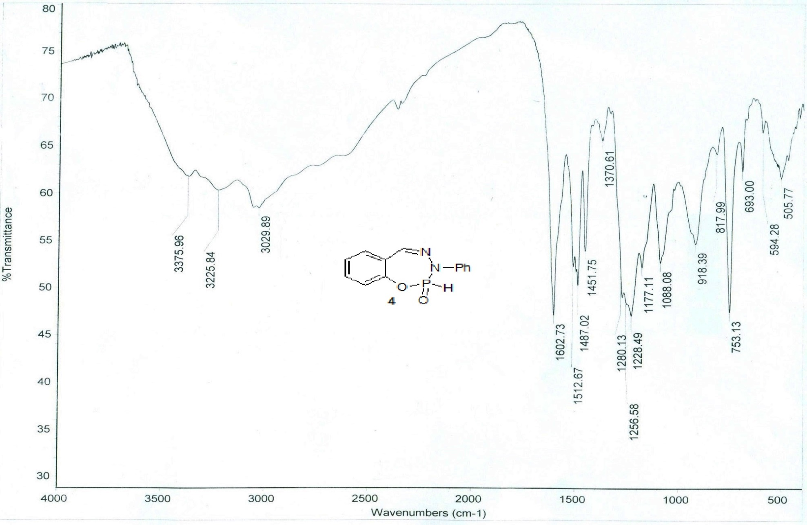
Figure 10: The IR spectrum of compound 4.
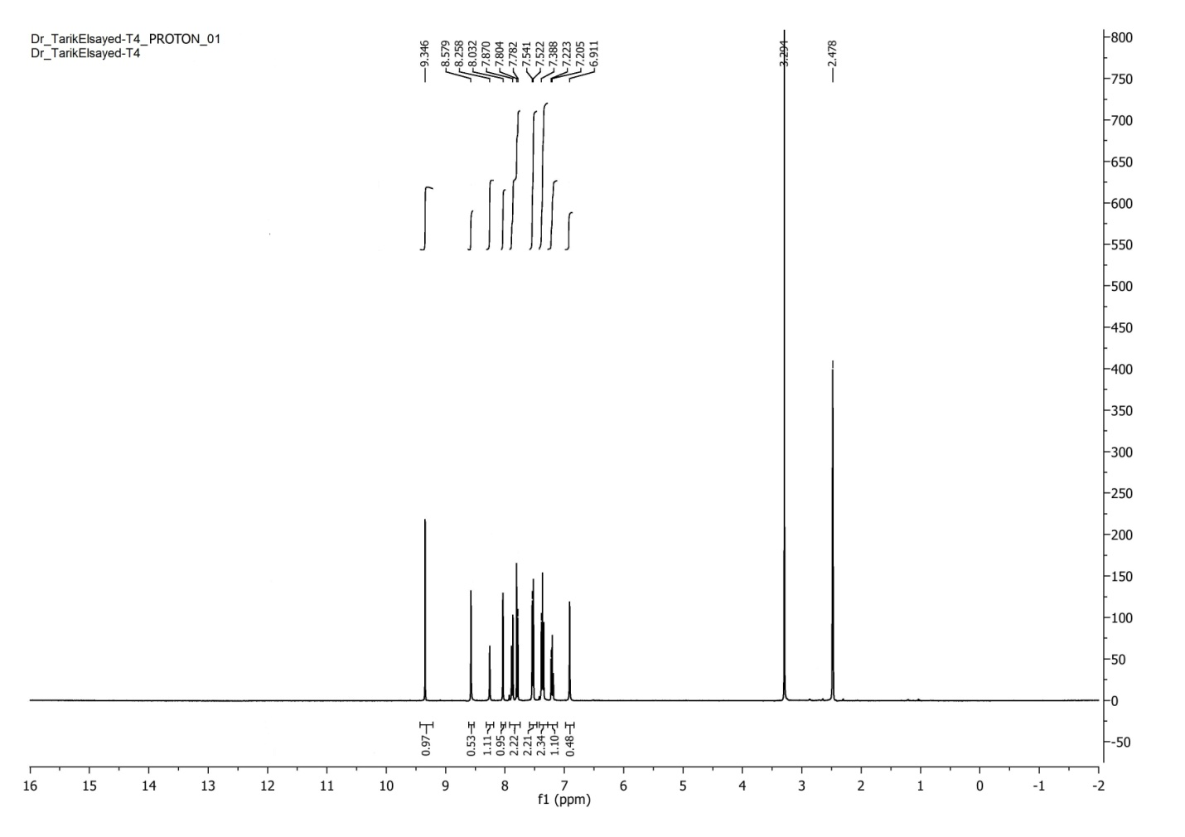
Figure 11: The ¹H-NMR spectrum of compound 4.
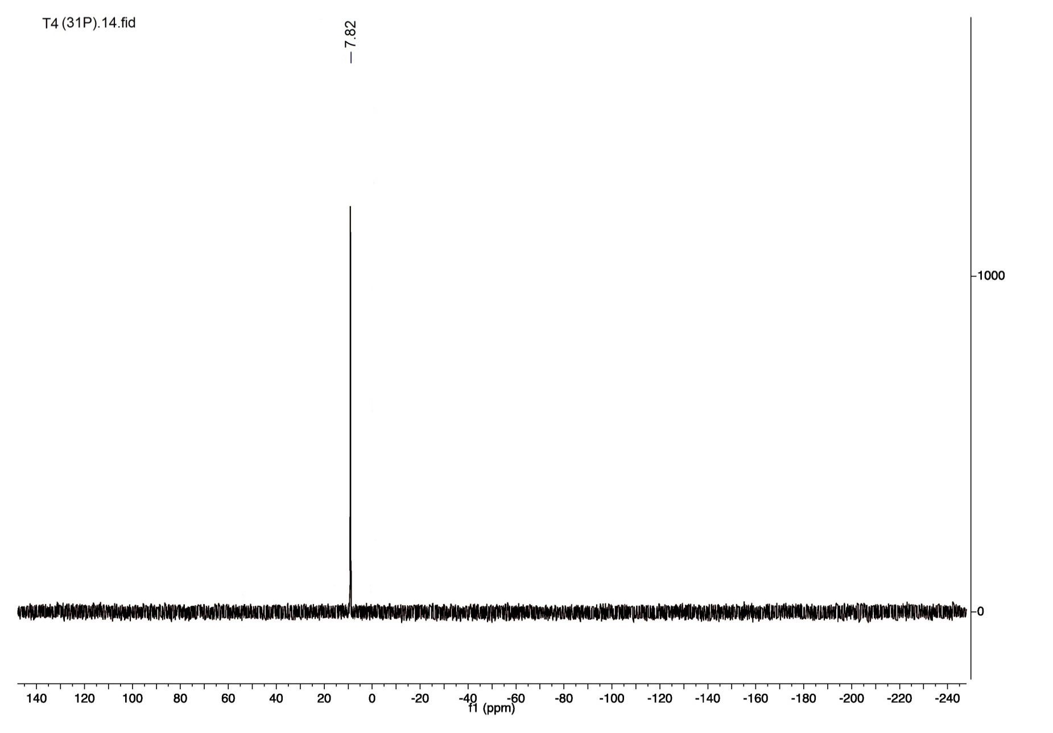
Figure 12: The ³¹P-NMR spectrum compound 4.

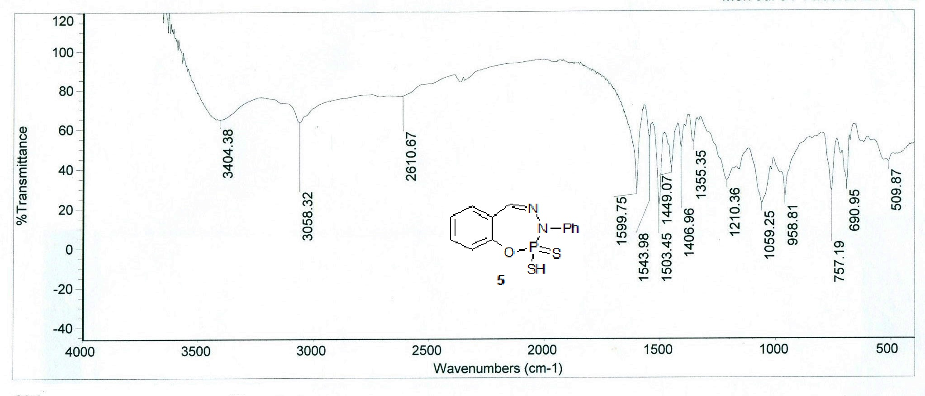
Figure 13: The IR spectrum of compound 5.
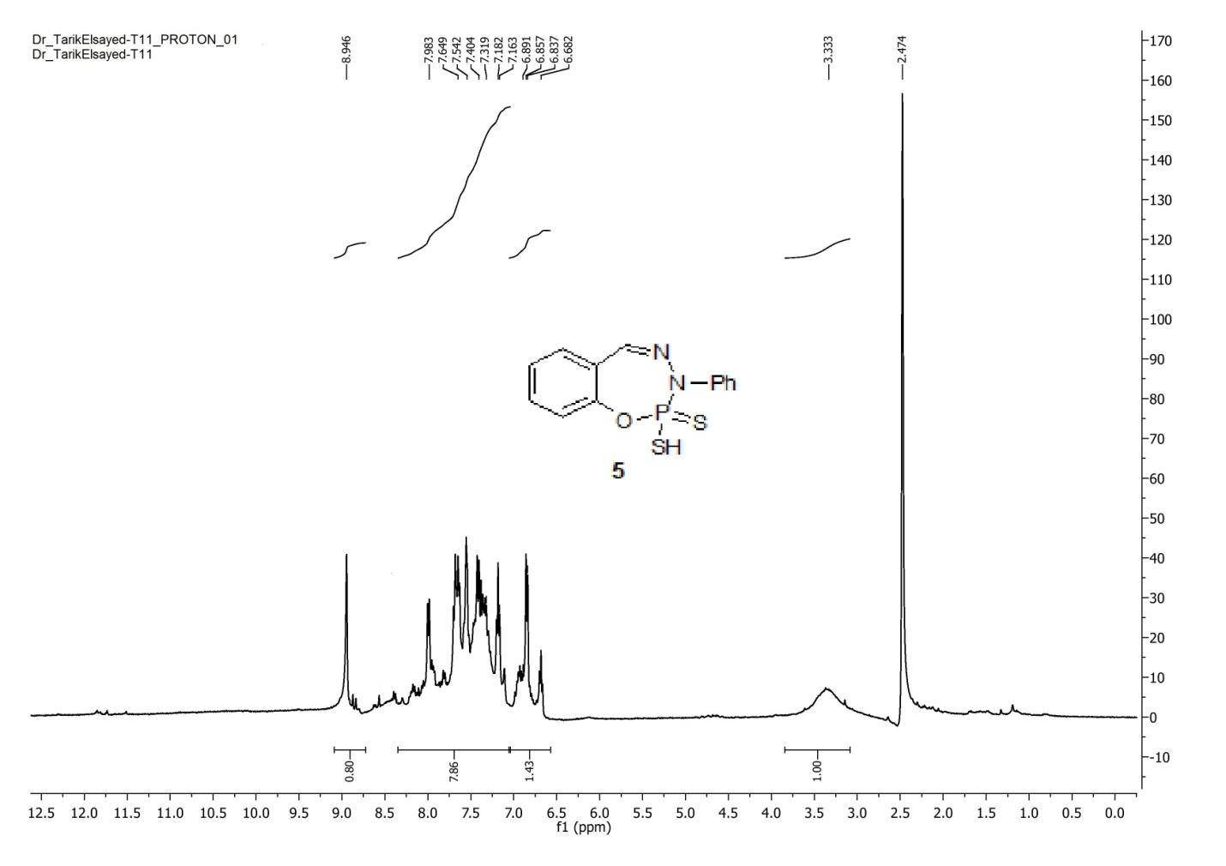
Figure 14: The ¹H-NMR spectrum of compound 5.

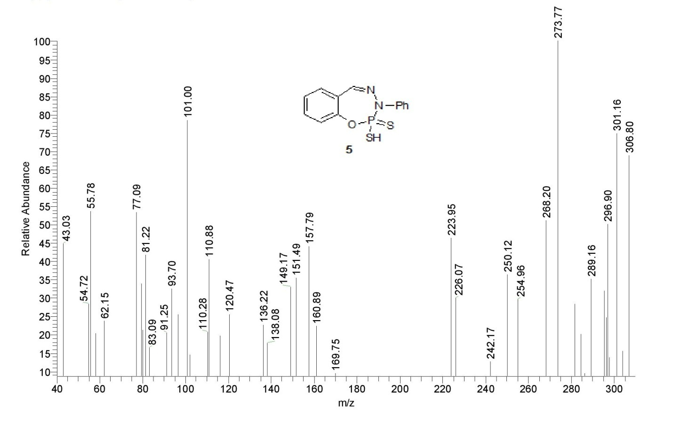
Figure 15: The mass spectrum of compound 5.

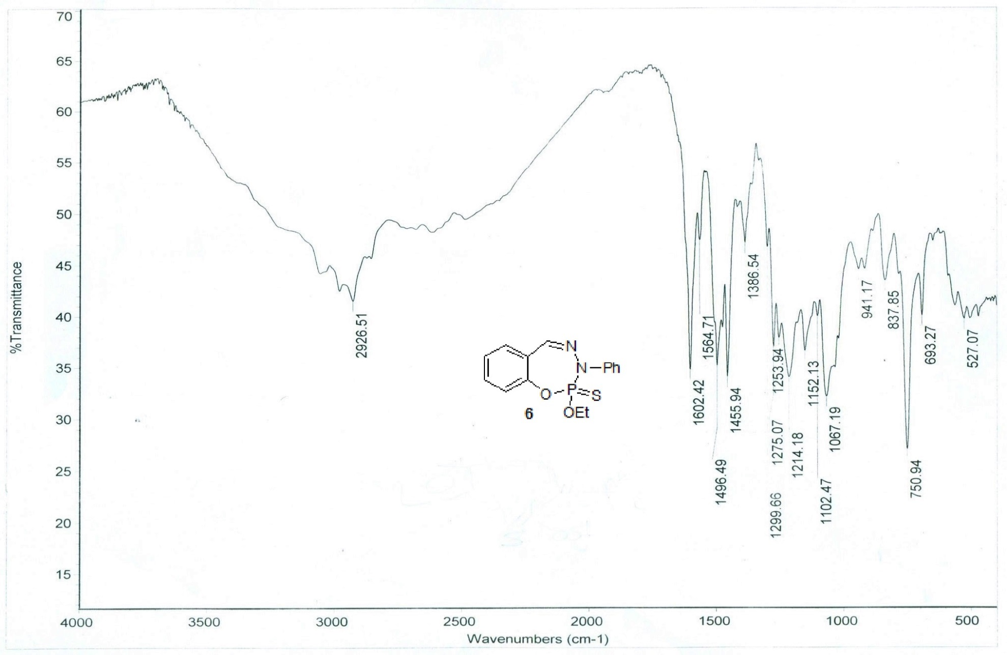
Figure 16: The IR spectrum of compound 6.
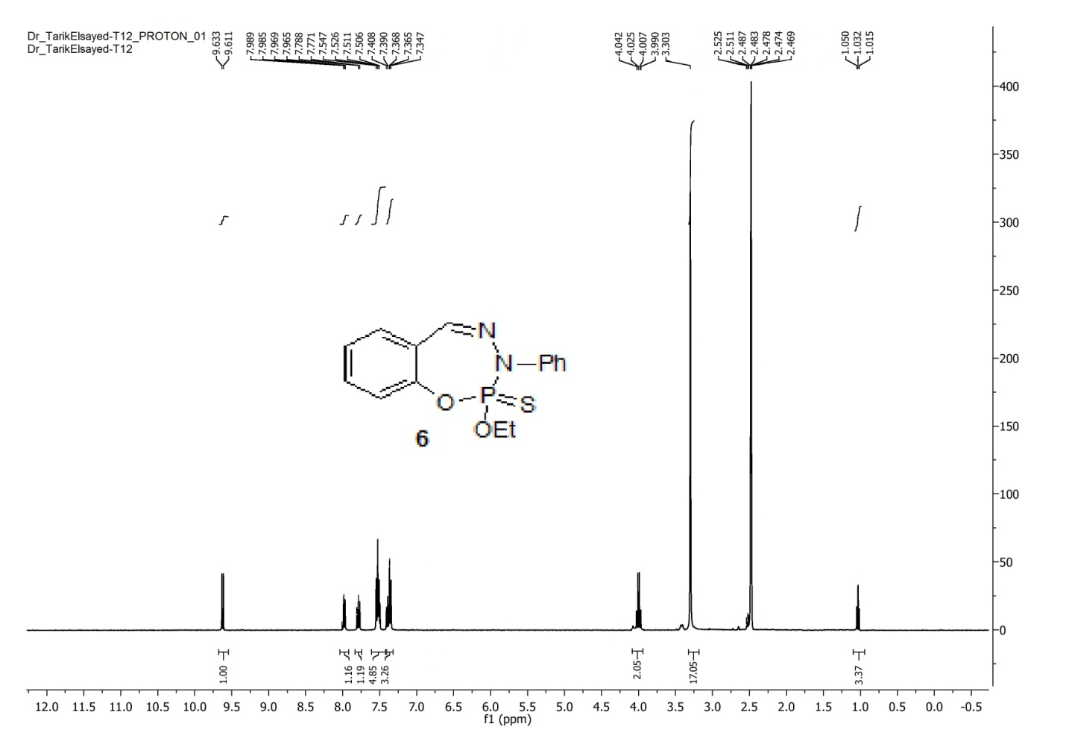
Figure 17: The ¹H-NMR spectrum of compound 6.
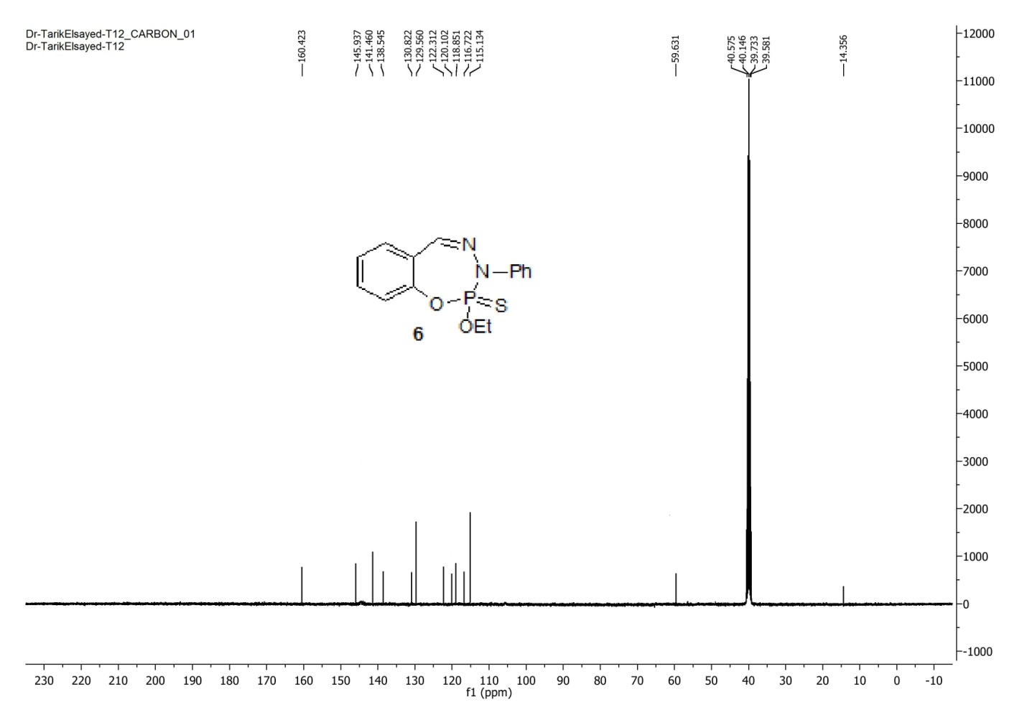
Figure 18: The ¹³C-NMR spectrum of compound 6.

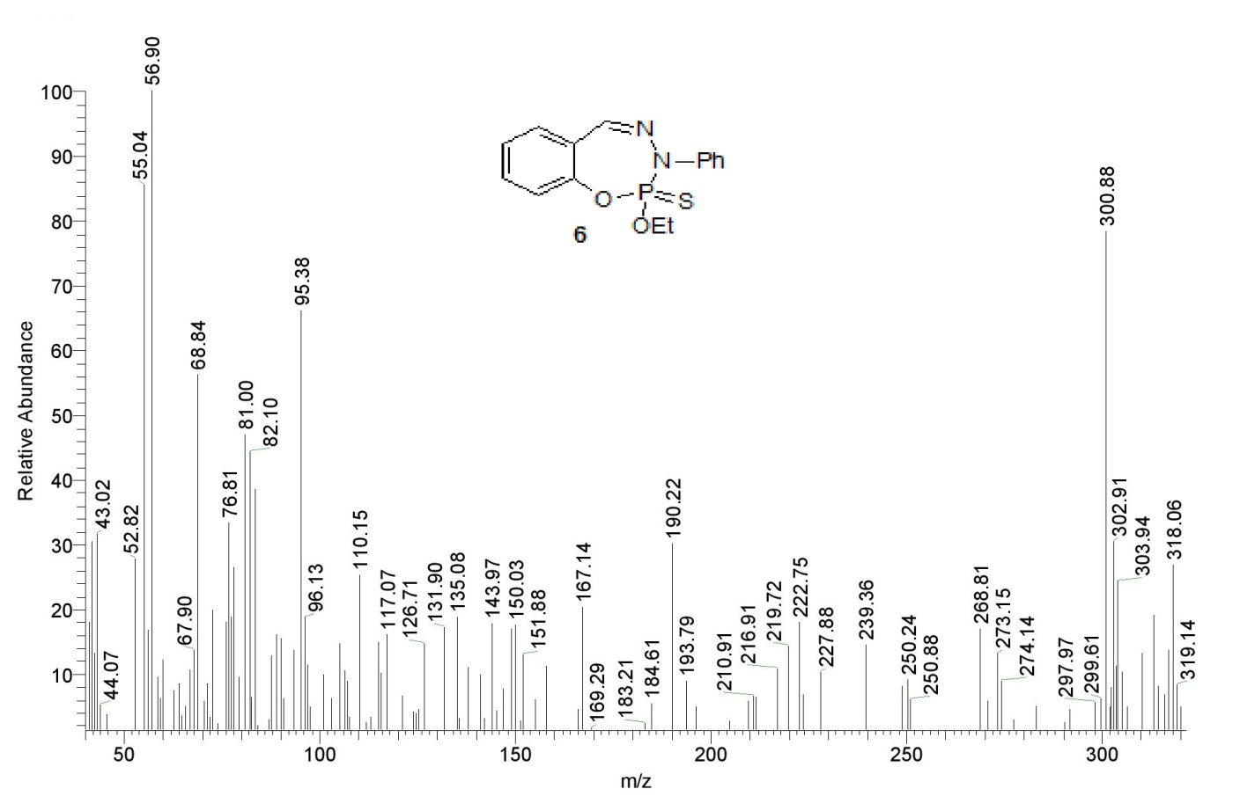
Figure 19: The mass spectrum of compound 6.

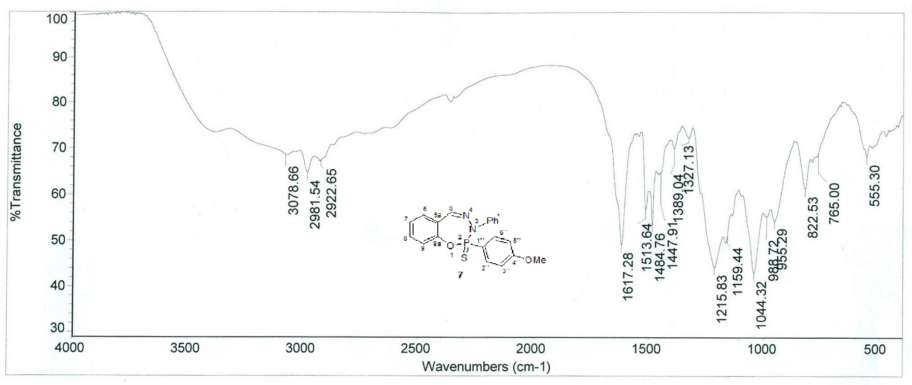
Figure 20: The IR spectrum of compound 7.
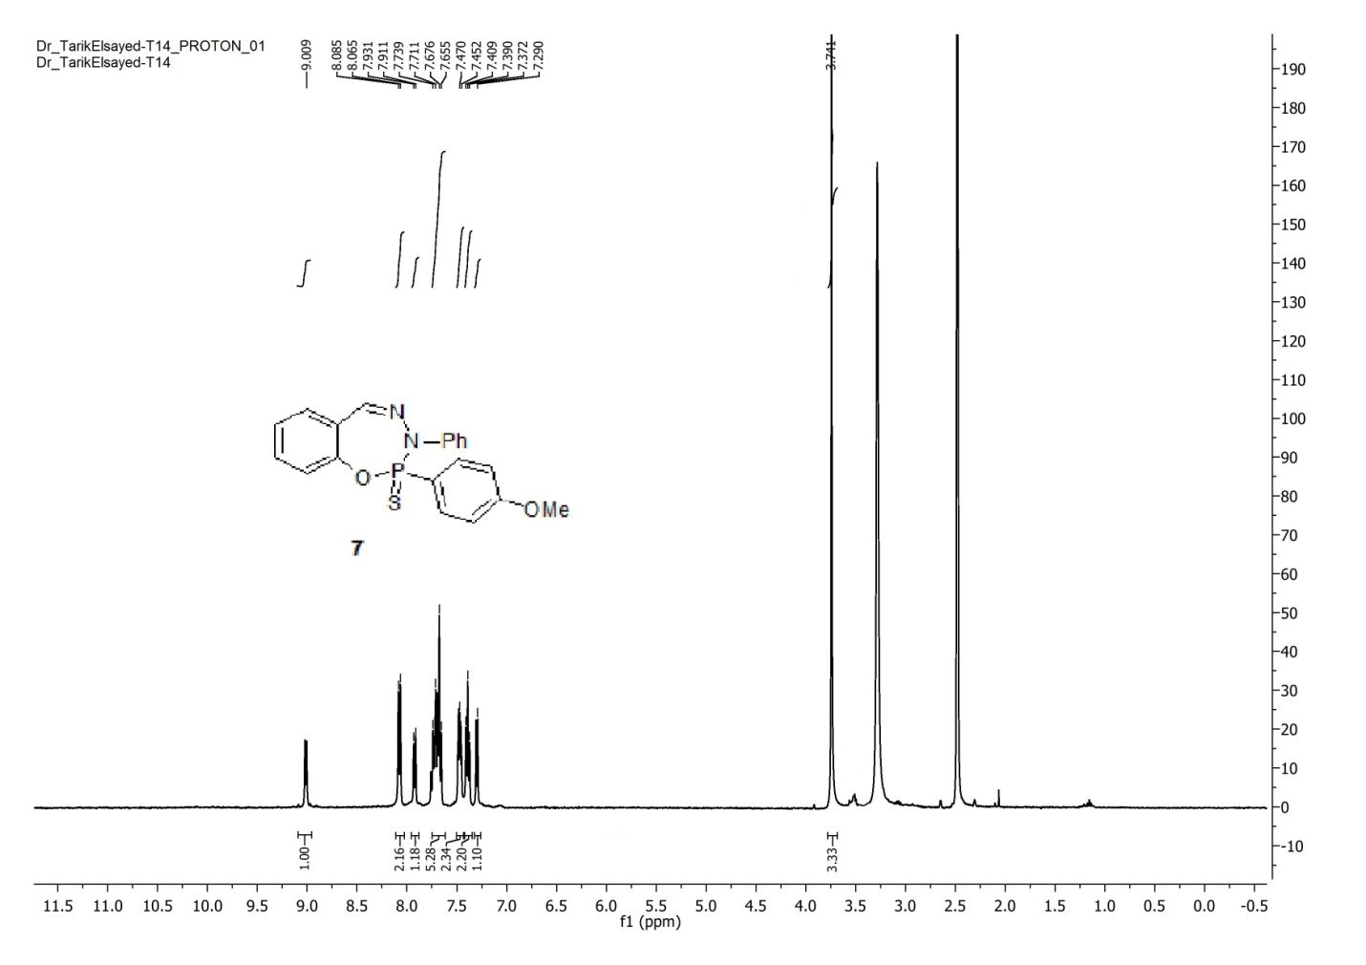
Figure 21: The ¹H-NMR spectrum of compound 7.

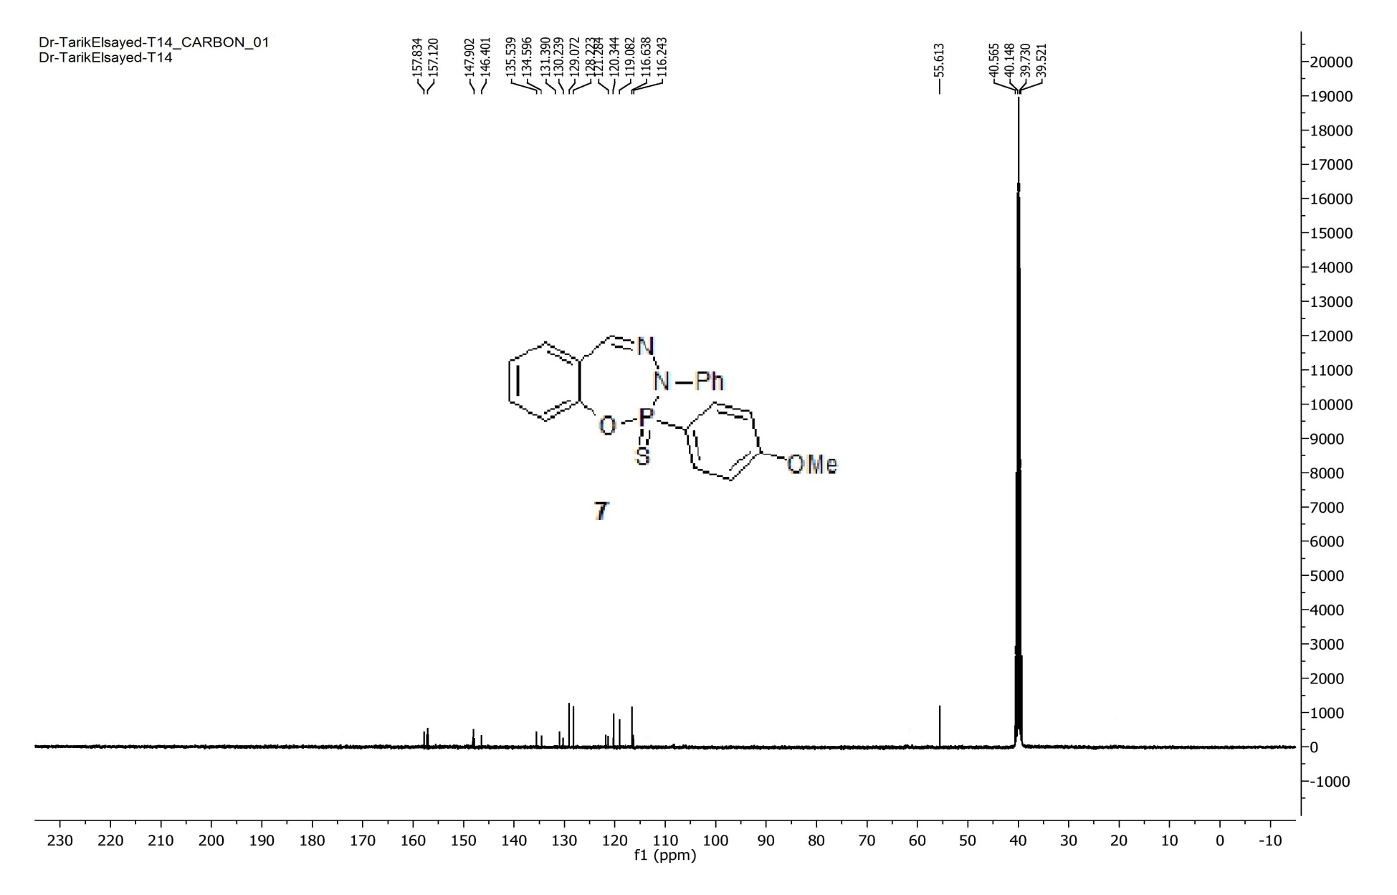
Figure 22: The ¹³C-NMR spectrum of compound 7.
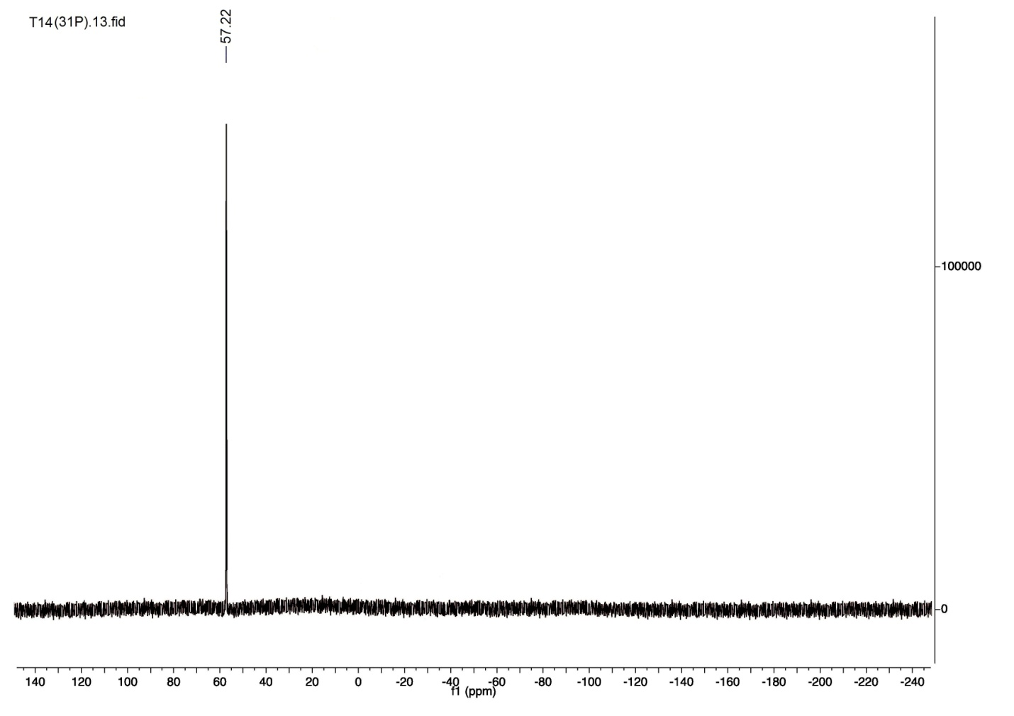
Figure 23: The ³¹P-NMR spectrum compound 7.

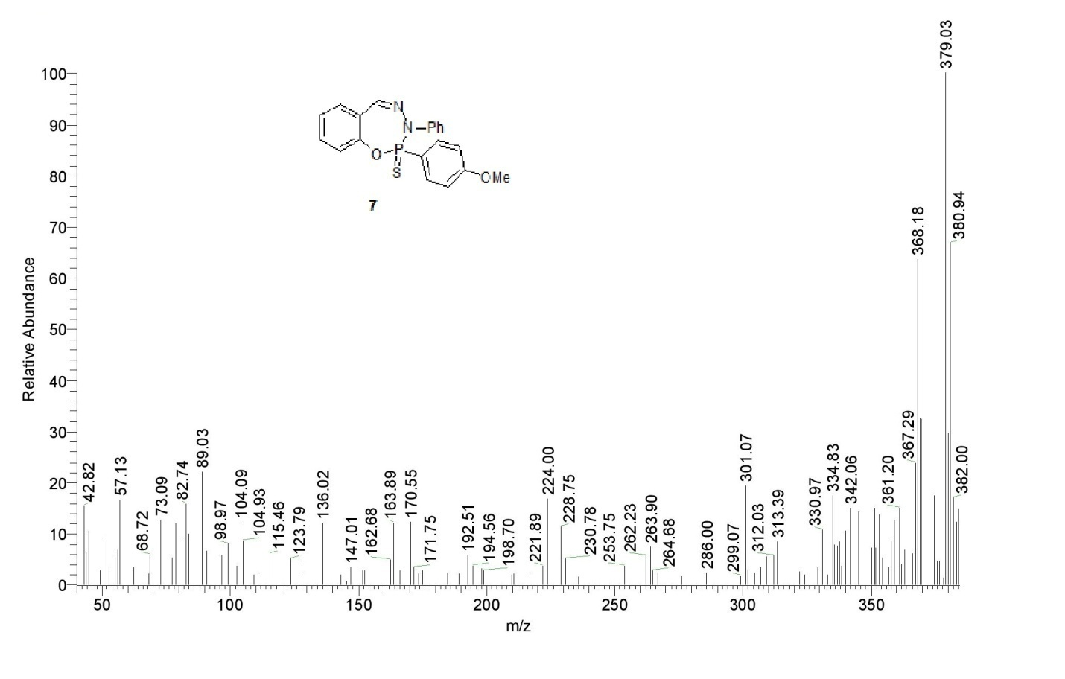
Figure 24: The mass spectrum of compound 7.

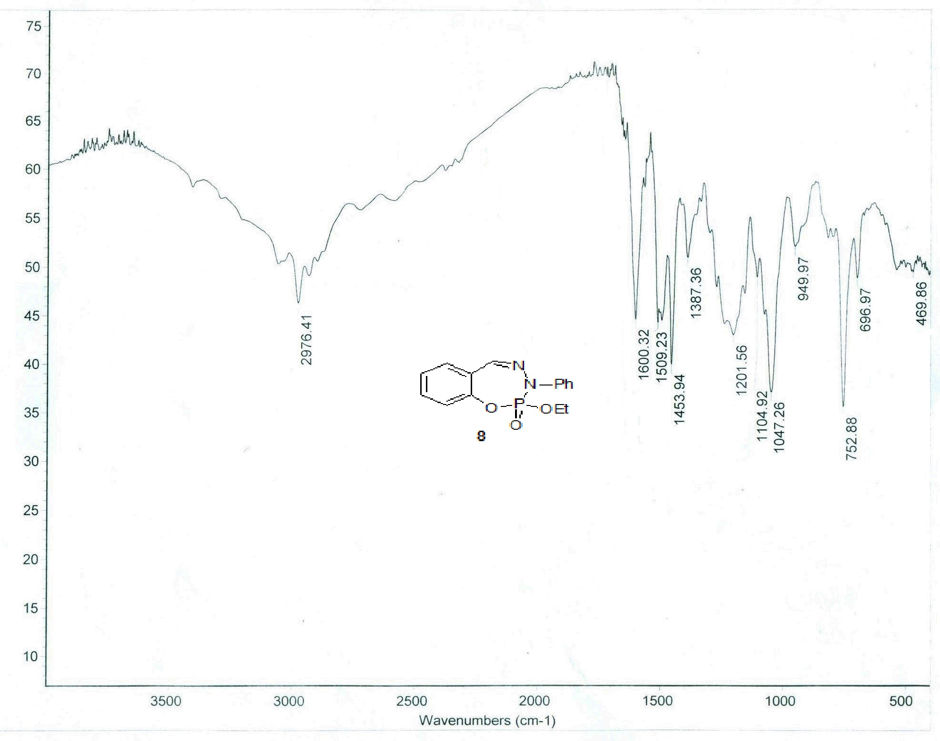
Figure 25: The IR spectrum of compound 8.
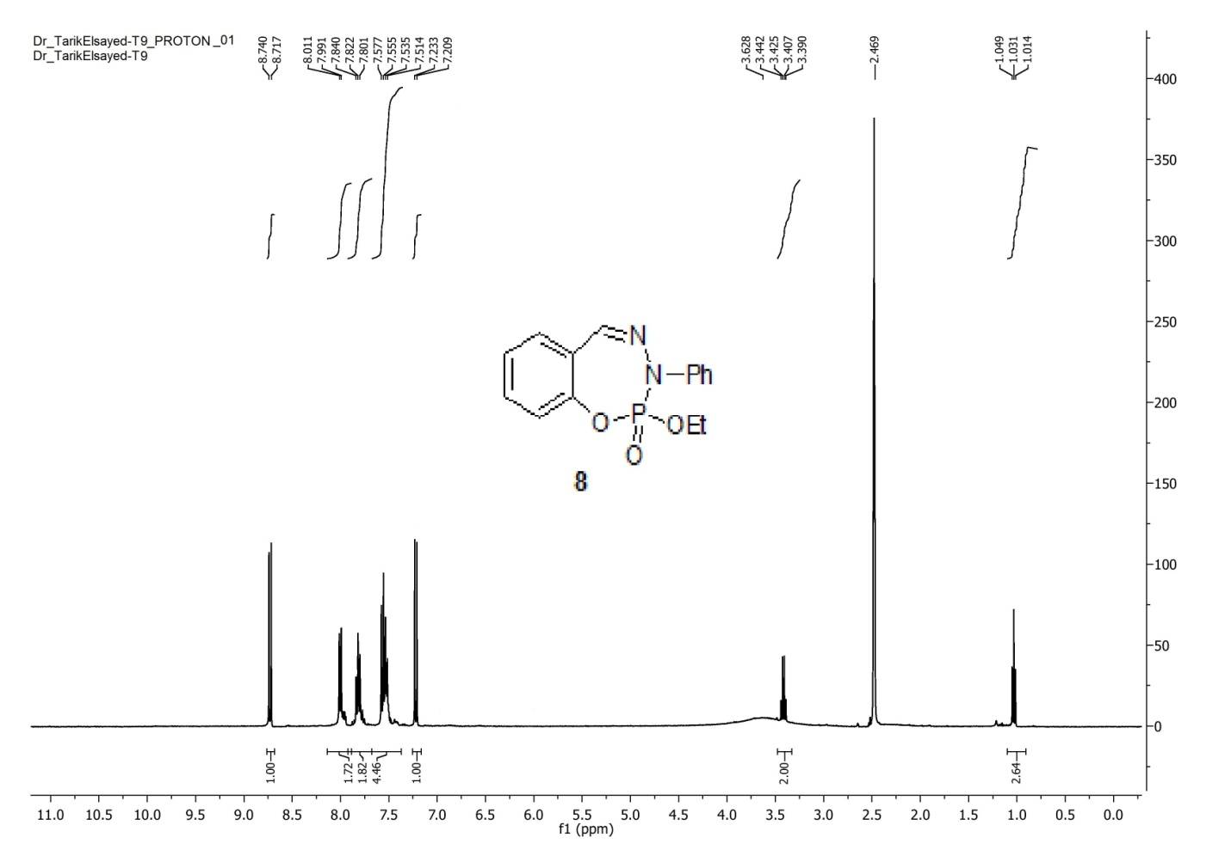Figure 26: The ¹H-NMR spectrum of compound 8.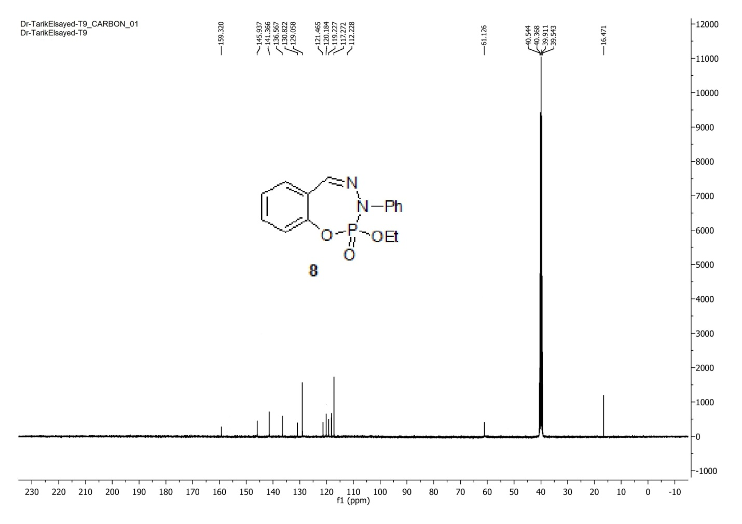
Figure 27: The ¹³C-NMR spectrum of compound 8.
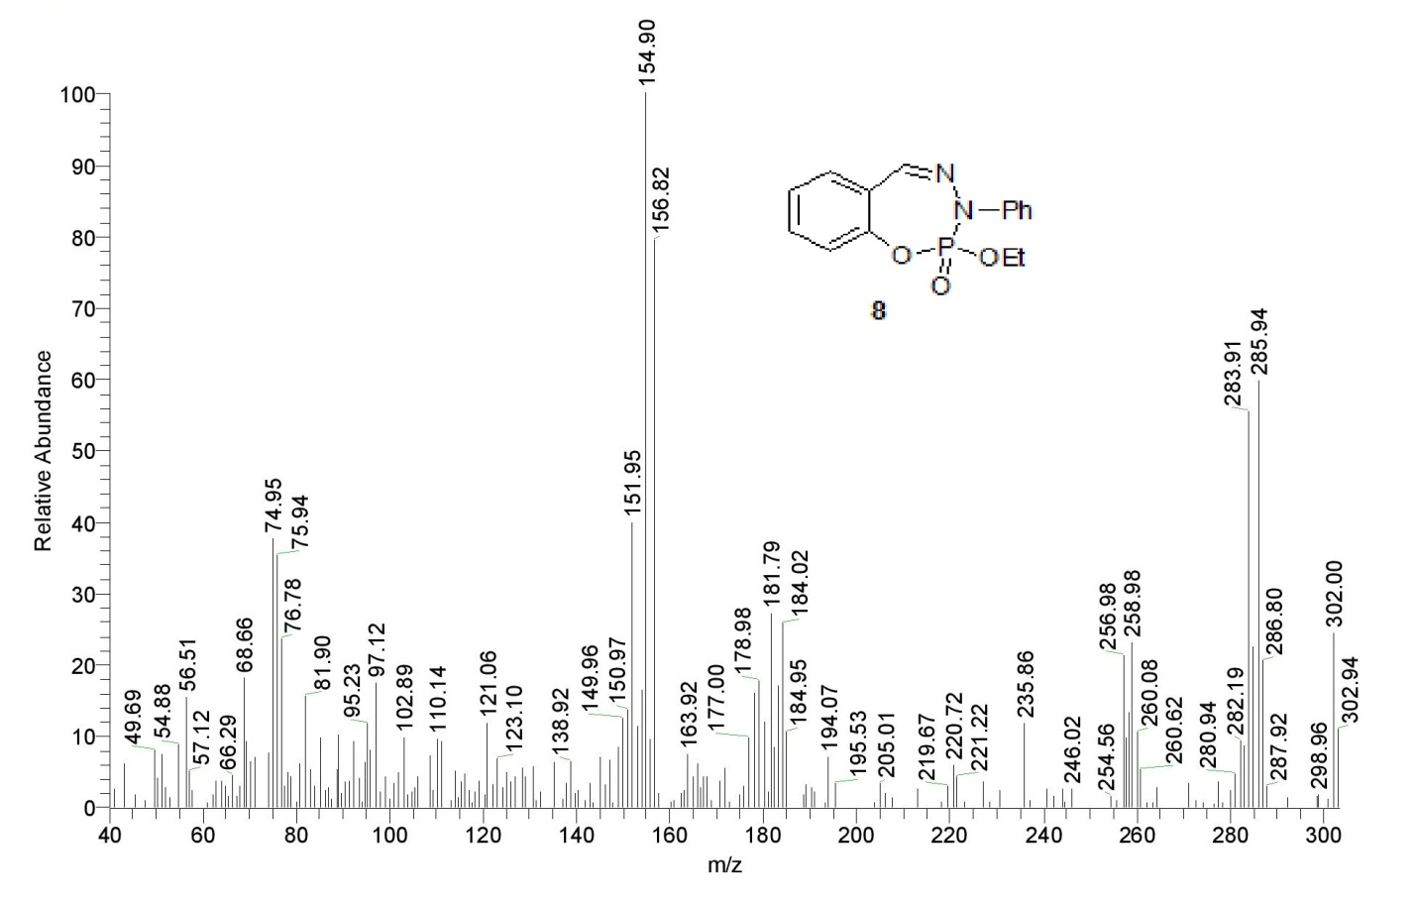
Figure 28: The mass spectrum of compound 8.

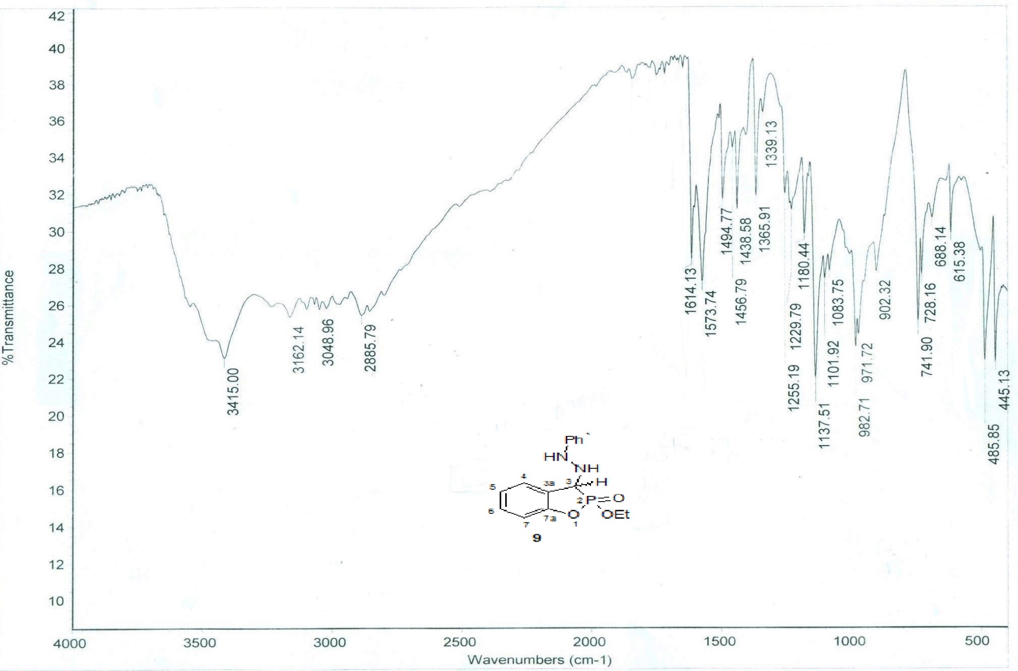
Figure 29: The IR spectrum of compound 9.
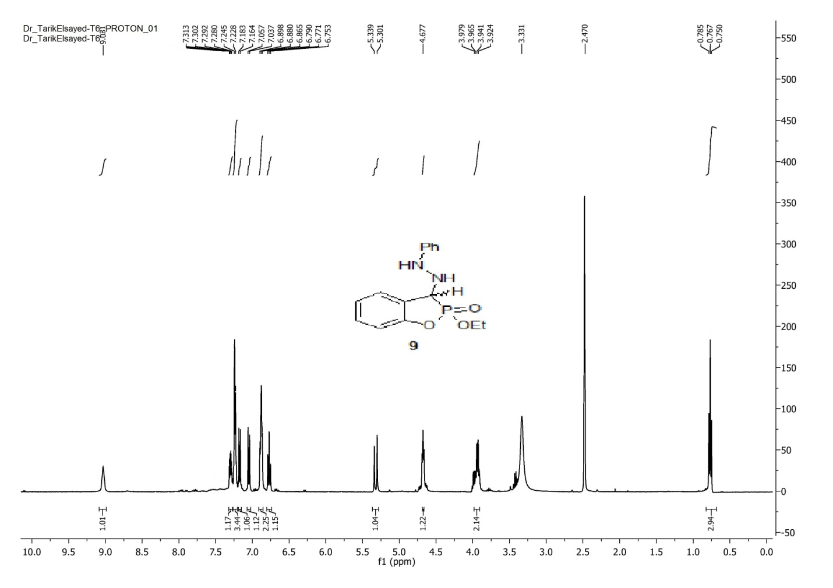
Figure 30: The ¹H-NMR spectrum of compound 9.
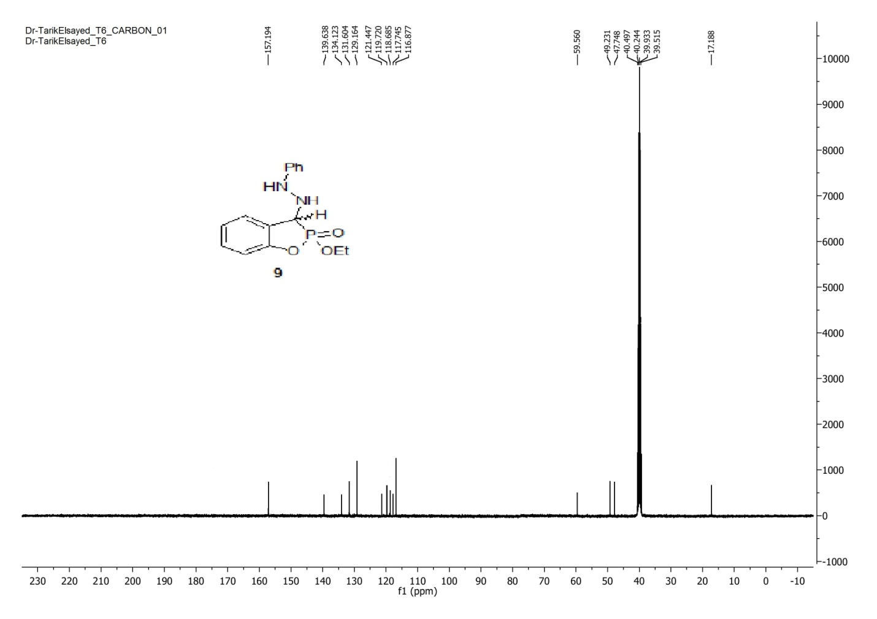
Figure 31: The ¹³C-NMR spectrum of compound 9.
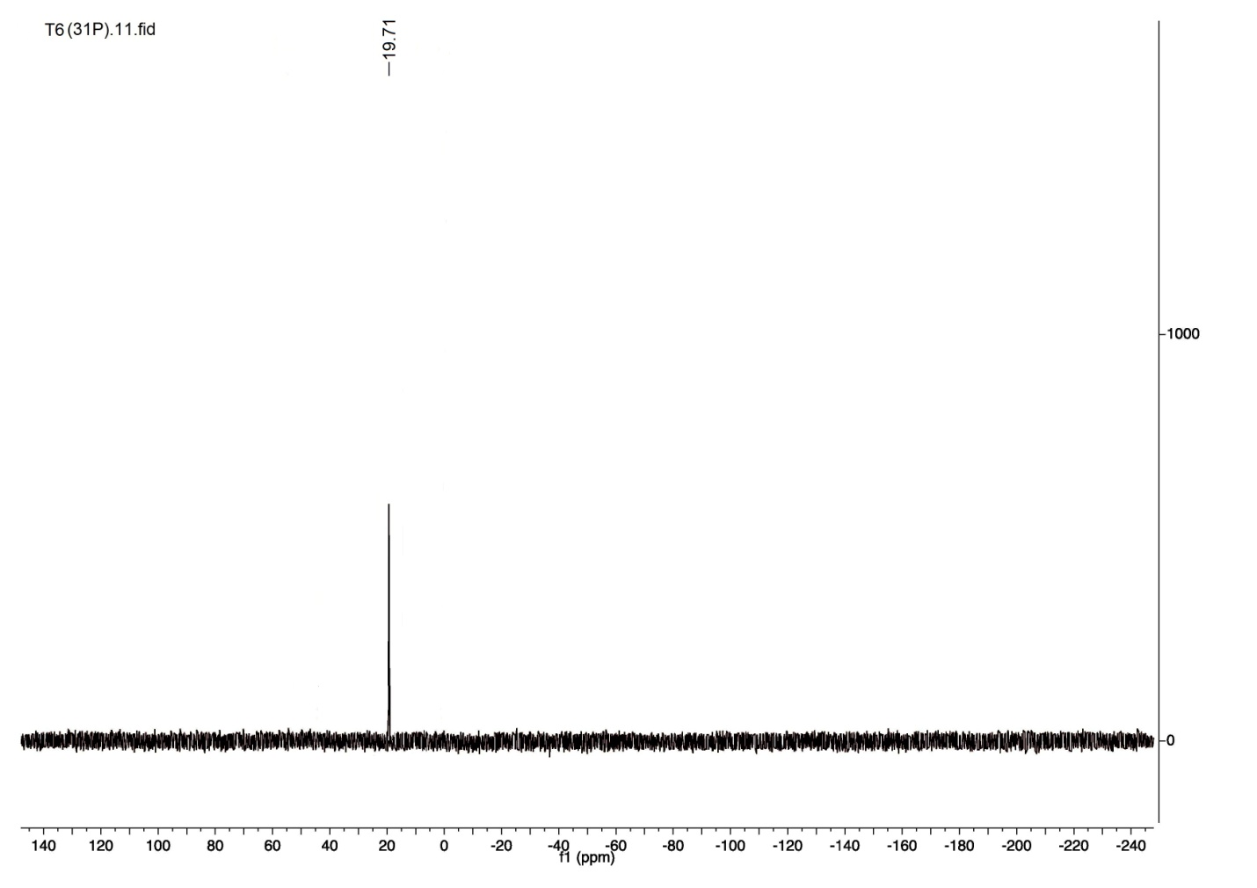
Figure 32: The ³¹P-NMR spectrum compound 9.
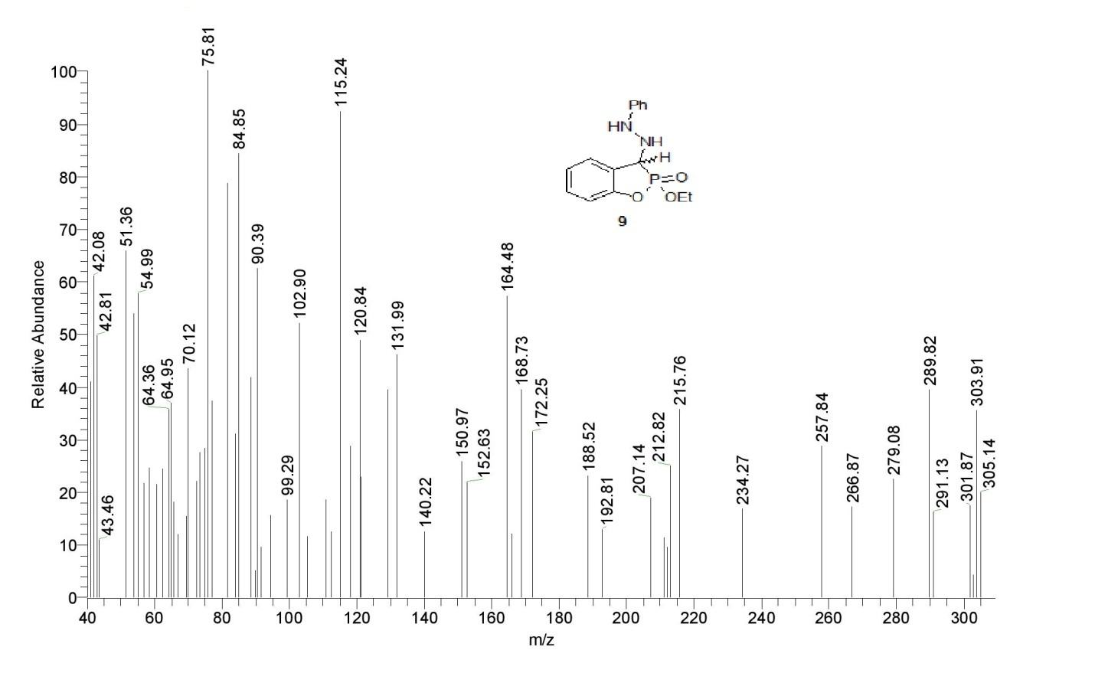Figure 33: The mass spectrum of compound 9.
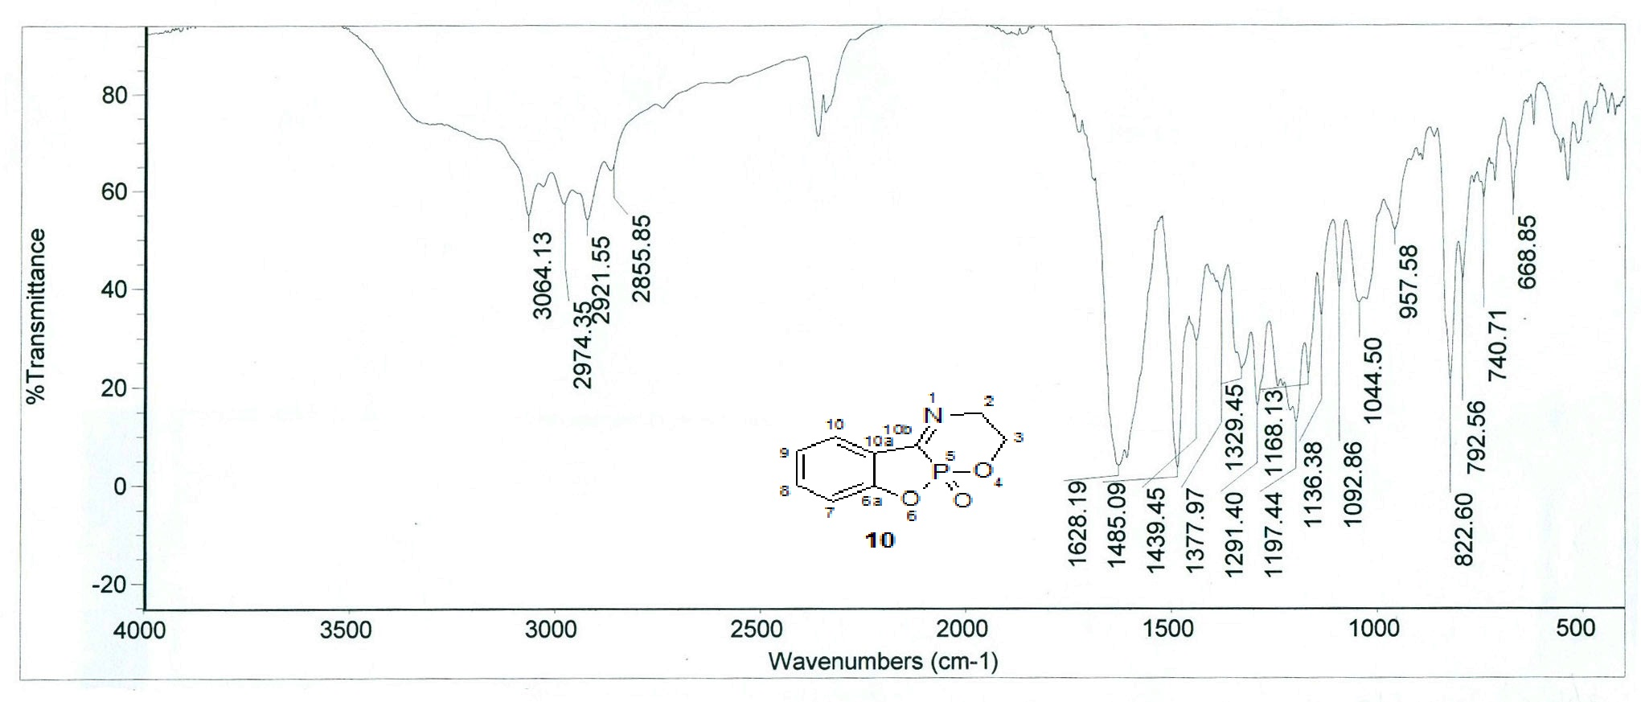
Figure 34: The IR spectrum of compound 10.
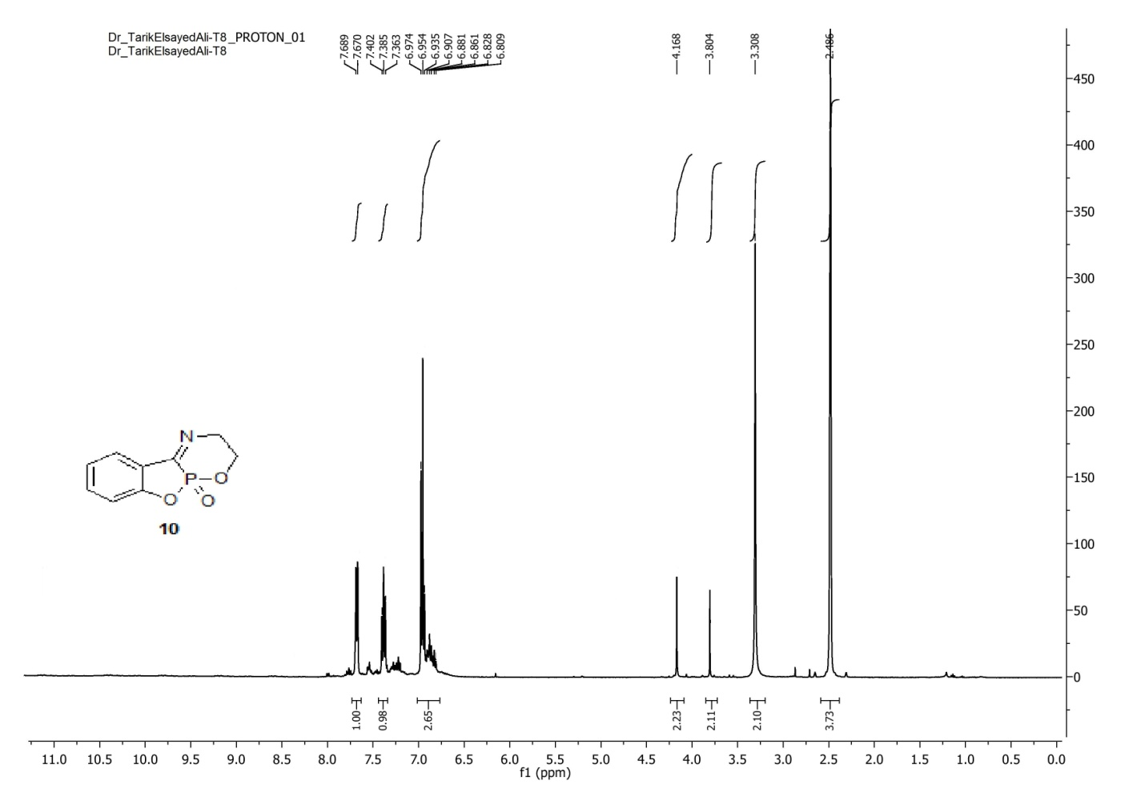
Figure 35: The ¹H-NMR spectrum of compound 10.
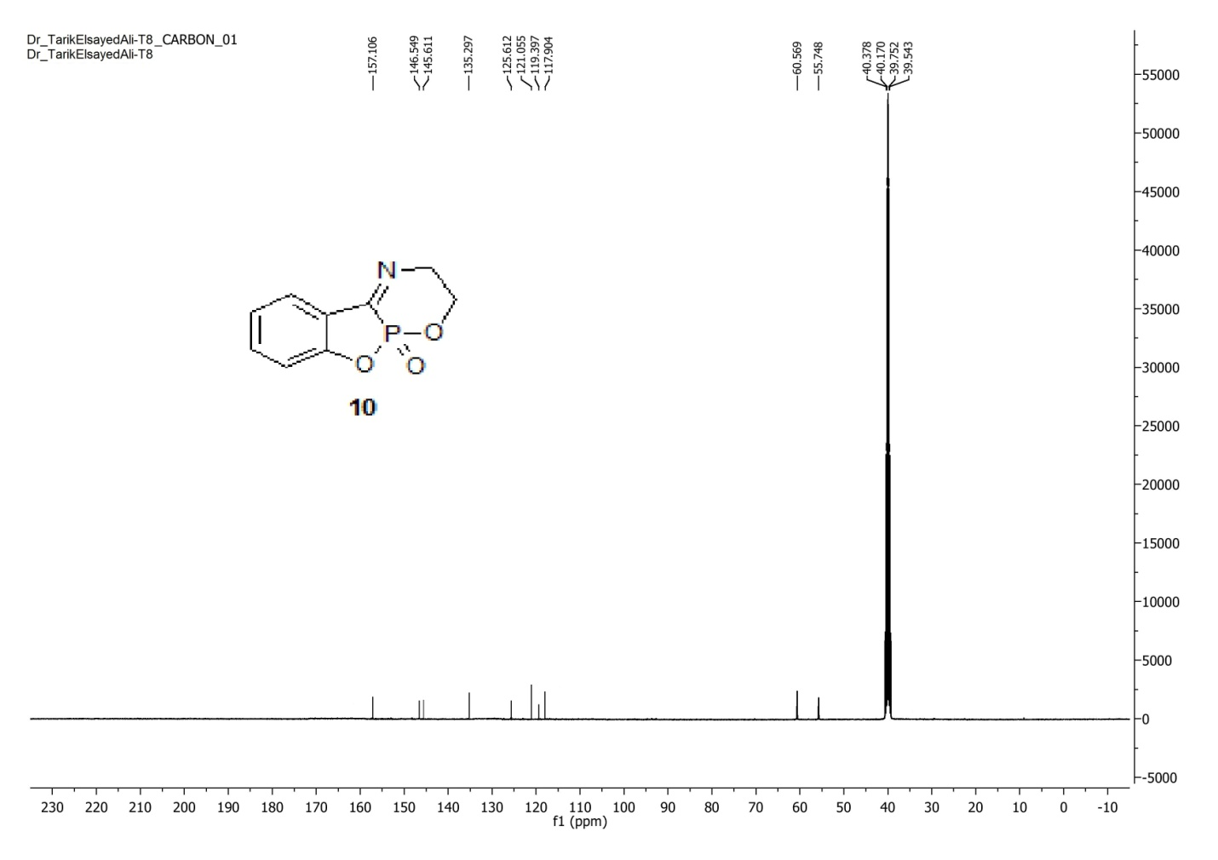
Figure 36: The ¹³C-NMR spectrum of compound 10.
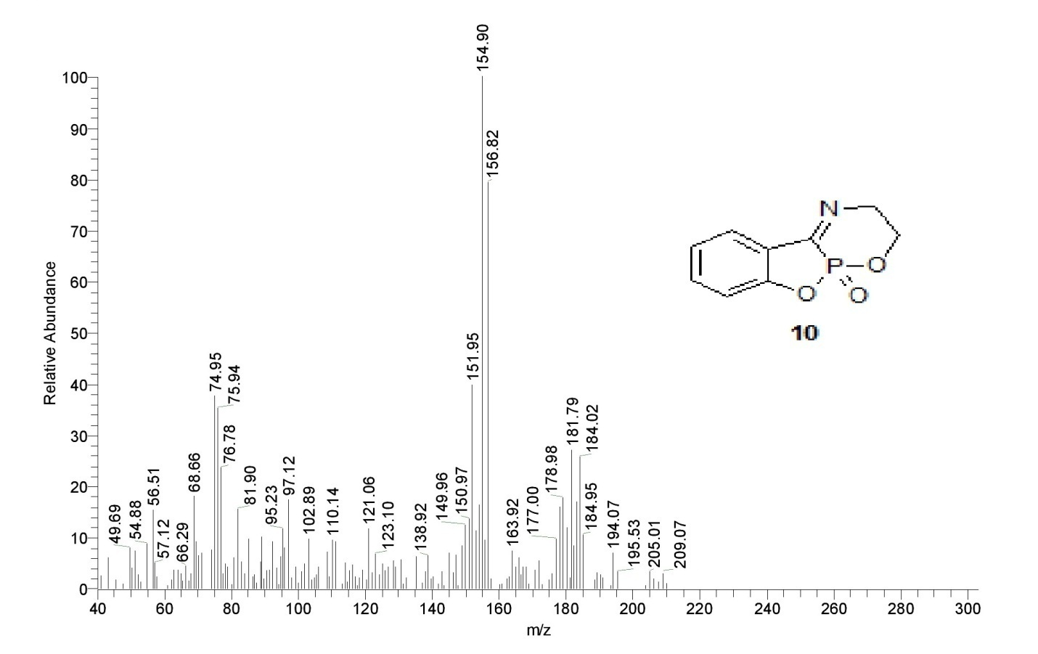
Figure 37: The mass spectrum of compound 10.
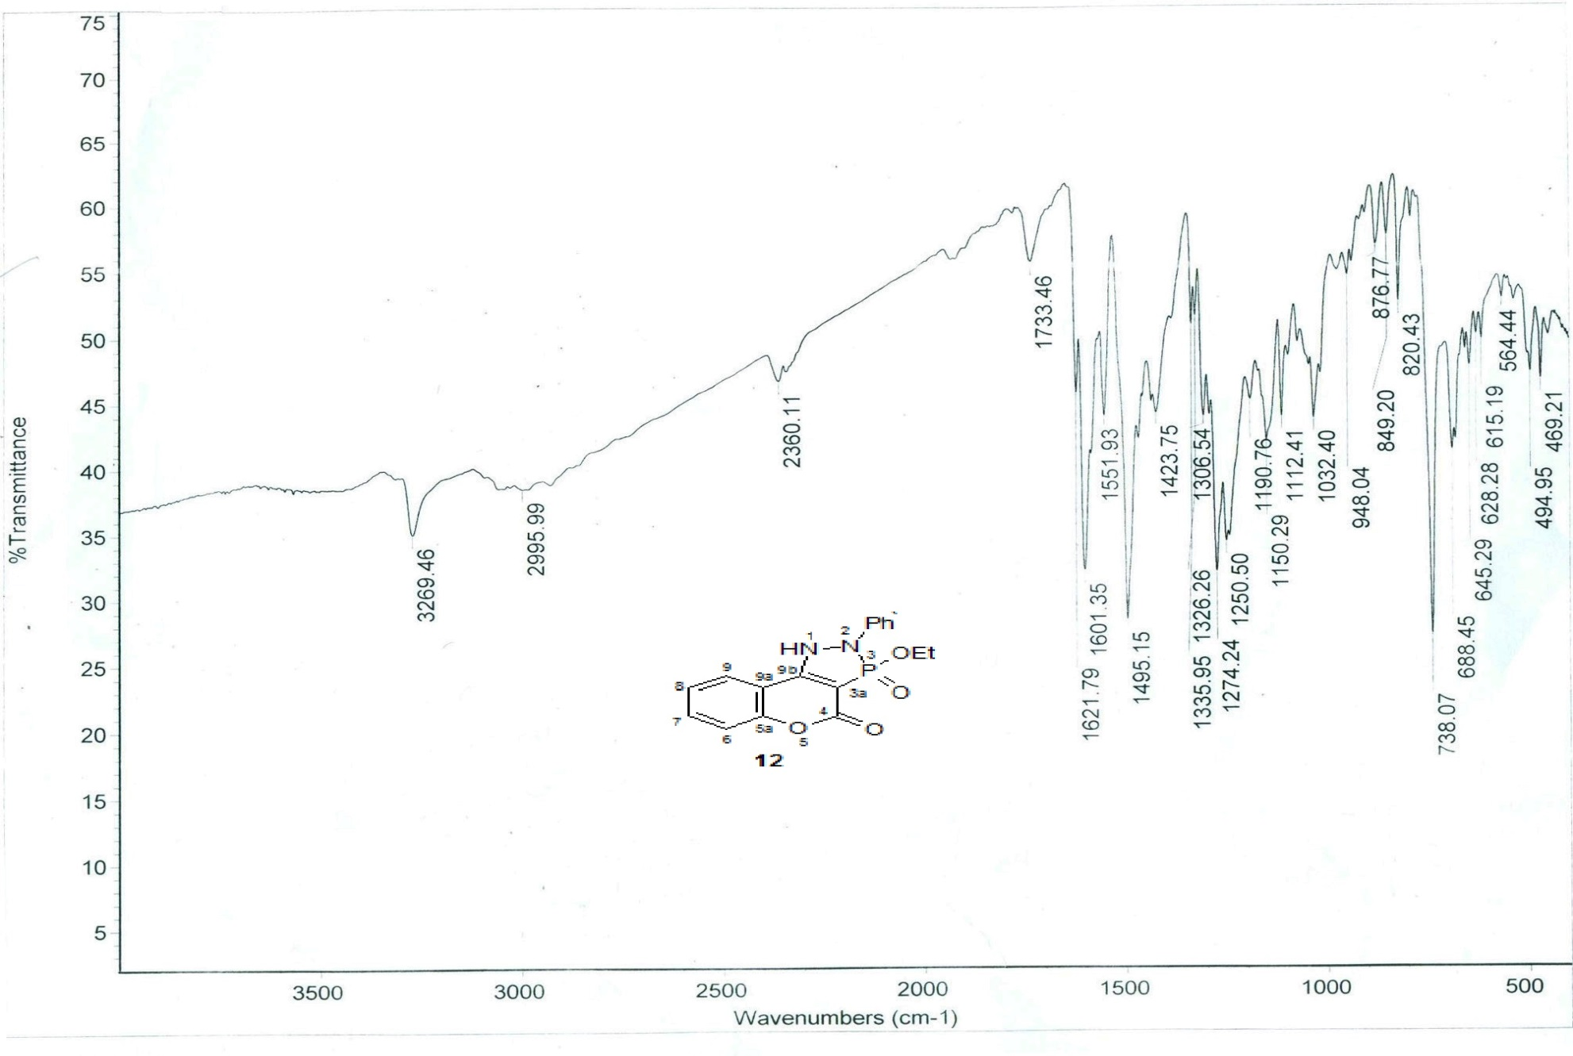
Figure 38: The IR spectrum of compound 12.
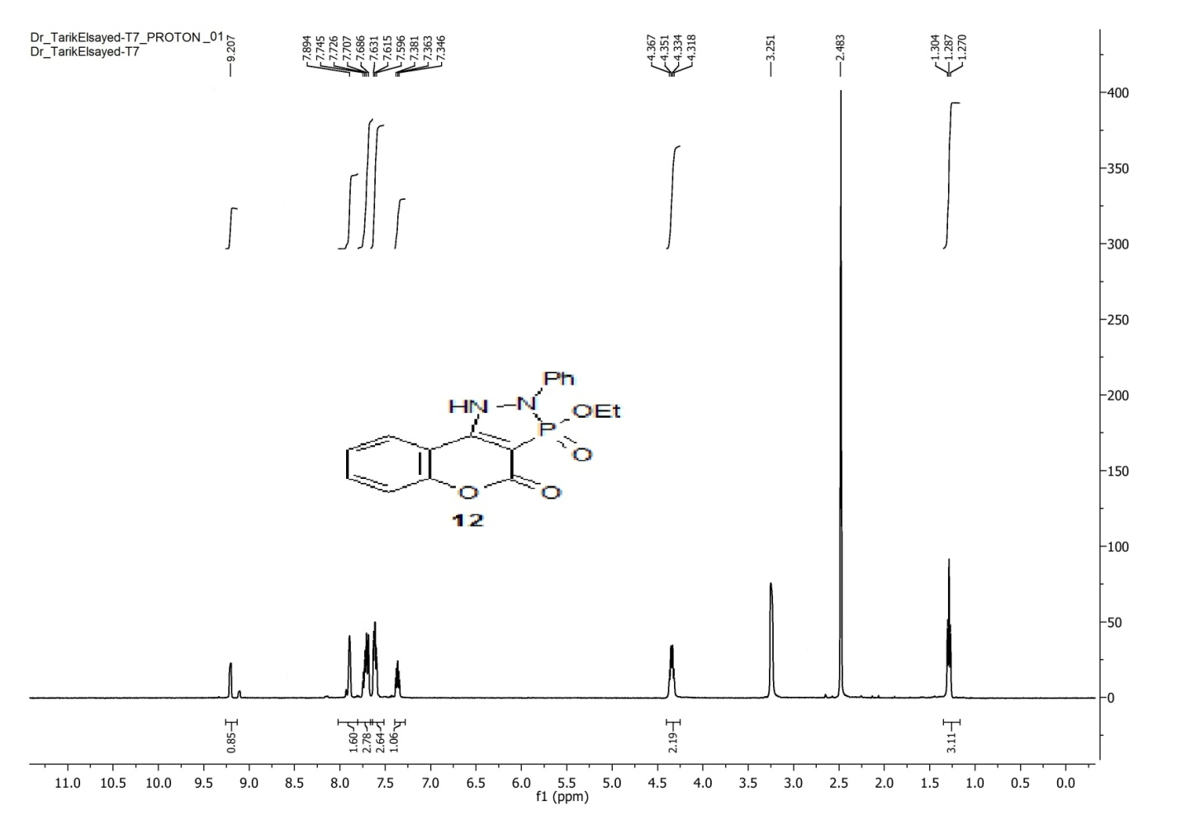
Figure 39: The ¹H-NMR spectrum of compound 12.
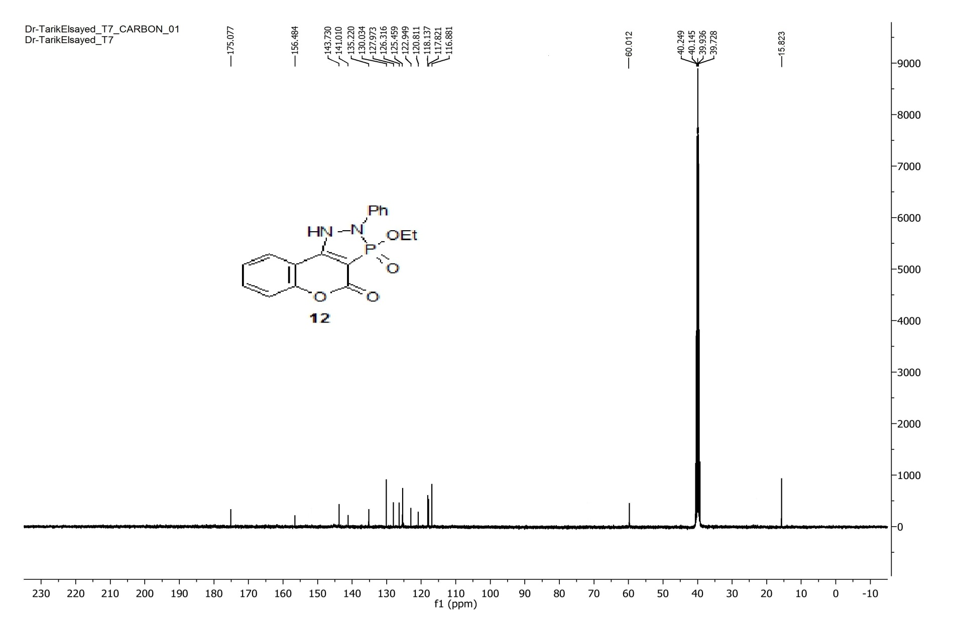
Figure 40: The ¹³C-NMR spectrum of compound 12.

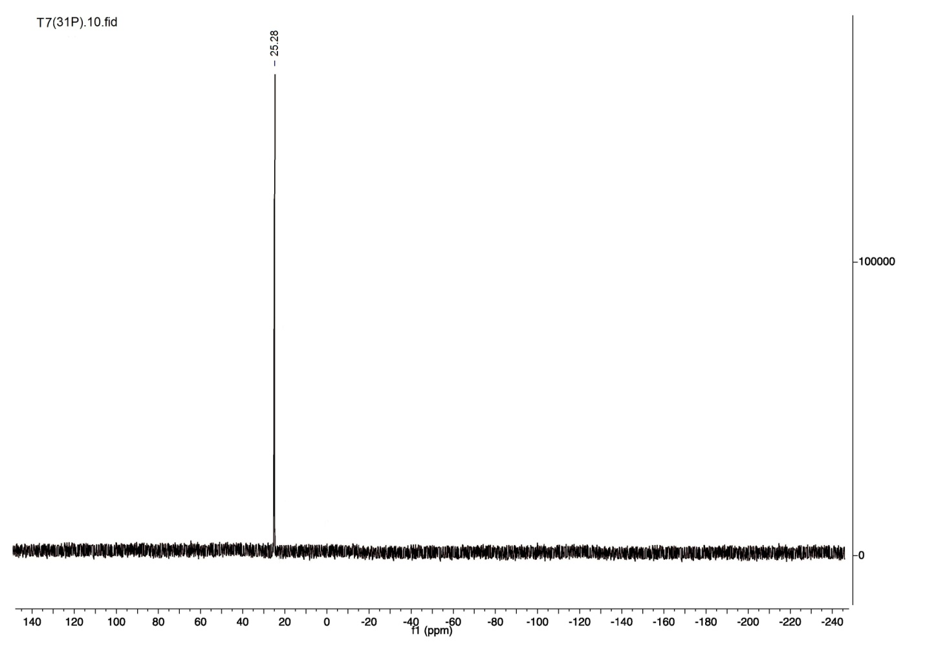
Figure 41: The ³¹P-NMR spectrum compound 12.
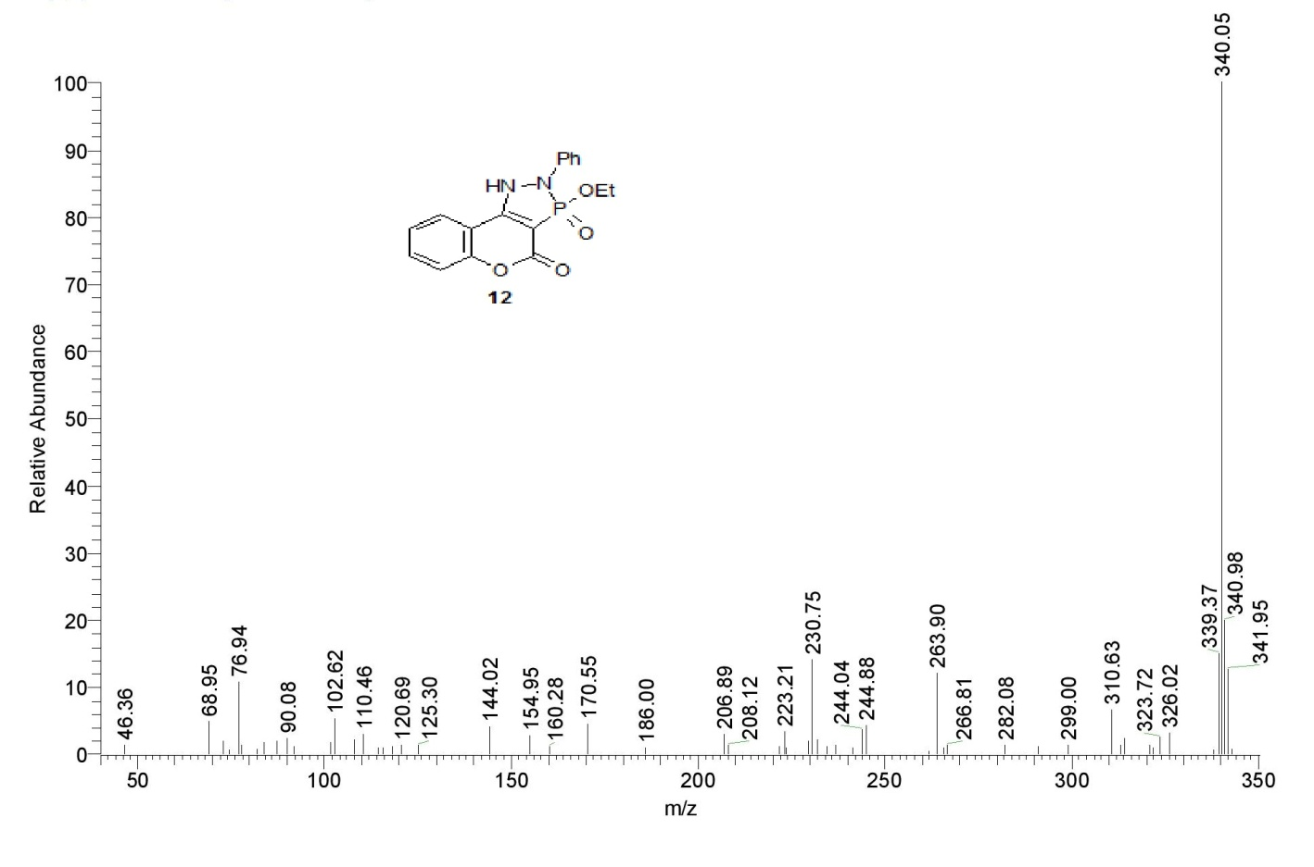
Figure 42: The mass spectrum of compound 12.

