Appendix to:

Development of an iso-toxic decision support system for the placement of a rectum spacer, integrating genetic markers of toxicity

- Appendix I: Patient characteristics

- Appendix II: Treatment planning dose restraints

- Appendix III: Iso-toxic model equations

- Appendix IV: Including SNPs into the NTCP model

- Appendix V: V80% in the bladder

- Appendix VI: Patient specific NTCP outcomes

- Appendix VII: Variation of NTCP limit

- Appendix VIII: Results of all published SNP odds ratios for late rectal bleeding

- Appendix IX: Sensitivity analyses of SNP odds ratios

Appendix I: Patient characteristics
Characteristic | Subgroup | Number of patients (%)
Risk group | Low | 2 (12.5%)
 | Intermediate | 7 (43.75%)
 | High | 7 (43.75%)
IRS | Balloon | 8 (50%)
 | Hydrogel | 8 (50%)
IRS: Implantable rectum Spacer

Appendix II: Treatment planning dose restraints
An overview of the constraints set during treatment planning (given dose)
Structures | Constraints
Planning Target Volume | V70 > 95% | V77 < 3%
Rectum Volume | V70 = 0%
Anal Canal Volume | V74 = 0% | Mean dose < 40 Gy
Anorectum Volume | V54 < 50% | V65 <20%
Bladder Volume | V70 = 0%
Gy: Gray, Vxx: percentage of volume receiving more than xx Gy
Appendix III: Iso-toxic model equations
NTCP model
The NTCP model used is a Lyman-Kutcher-Burman (LKB) model that was reviewed by the QUANTEC group (quantitative analysis of normal tissue effects in the clinic). This model is described by the equations (1-3) shown below:
$NTCP=\frac{1}{\sqrt{2π}}\int_{-∞}^{t}{e^{-\frac{x^{2}}{2}}dx}$ (1)
$t=\frac{gEUD-TD50}{m∙TD50}$ (2)
$gEUD={\left(\sum_{i}{v_{i}d_{i}^{1/n}}\right)}^{n}$ (3)
where $gEUD$ stands for generalized equivalent uniform dose, $i$ is the number of the DVH bin, $v_{i}$is the volume of the bin and $d_{i}$is the dose. The QUANTEC-recommended parameters are $TD50$ = 76.9, $n$ = 0.09 and $m$ = 0.13 for grade>=2 late rectal toxicity.
TCP model
The TCP model utilizes realistic radio biologically input parameters and works for a wide range of treatment strategies [19]. The model is described using equation (4):
$TCP= \left(\frac{1}{k}\right)\sum_{i=1}^{k}{\left(exp\left(-N_{0}{S\left(D\right)}_{i}\right)\right)}$ (4)
where $k$ represents groups of patients with separate radiosensitivity, $N_{0}$ is the initial clonogen sum and $S\left(D\right)$ is the surviving fraction of a population of cells irradiated by a total uniform dose $D$.

Appendix IV: Including SNPs into the NTCP model
In order to incorporate a single nucleotide polymorphisms (SNP) into the Ly Lyman-Kutcher-Burman (LKB) model, the dose response curve was split into two different dose response curves: one for the population with the SNP and one without. The dosimetric factor used by the LKB is the generalized equivalent univorm dose (gEUD), and the parameters which determine the shape of the dose response curve are the TD50, which is the gEUD needed for a 50% response, and m, which is inversely proportional to the gradient at TD50. In order to split the LKB curve into two, we need to determine the new TD50 and the new m for both curves. For this, we need to know the relationship of the response of the curve without SNP and with SNP, p₀ and p₁ respectively, to the original curve p.
The prevalence factor of the SNP can be calculated using the minor allele frequency as shown in equation (5):
$s=2∙MAF+{MAF}^{2} ≈2∙MAF$ (5)
Where s is the prevalence. Because the total probability of toxicity needs to remain the same over the whole populations, the relationship of the two new curves to the original can be described as shown in equation (6):
$p=s{∙p}_{1}+\left(1-s\right)p_{0}$ (6)
The odds ratio (OR) can be described as function of p₀ and p₁ as shown in equation (7):
$OR= {\frac{p_{1}}{1-p_{1}}}/{\frac{p_{0}}{1-p_{0}}}$ (7)
Which allows us to describe equation (6) as shown in equation (8)
$p=s\frac{OR∙p_{0}}{p_{0}\left(OR-1\right)+1}+\left(1-s\right)p_{0}$ (8)
Since the OR of each SNP is reported, as well as the MAF, we can now use the method reported in Appelt&Vogelius (2012) to find the correct values for TD50 and m corresponding to the low and high risk curves.

Appendix V: V80% in the bladder
Currently the genitourinary toxicity is not taken into account when maximising the dose in the target planning volume, while controlling the rectal toxicity. To prevent the dose from escalating too much in the bladder, we limited the bladder dose in agreement with published contraints. The percentage of the volume receiving more than 80 Gy (V80%), should be no more than 15%, the V75% no more than 25%, the V70% no more than 35%, and the V65 no more than 50%. This is shown in the figure below. 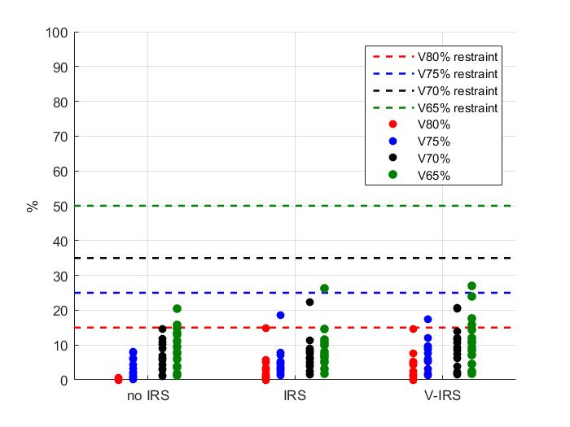
The figure shows the V80%, V75%, V70% and V65% for each of the patients included in the study after the dose was optimised by the iso-toxic model. It can be noted that the dose in the bladder is higher for the patients with implantable rectum spacer (IRS) and V-IRS, which is because the dose given to the planning target volume (PTV) can be increased more in patients with an IRS without exceeding the constraints on the rectum toxicity. It can also be noted that the bladder dose remains within the given limits.

Appendix VI: Patient specific NTCP outcomes
The figure below shows the normal tissue complication probability (NTCP) predictions as function of the fraction dose for each individual patient before and after the placement of an implantable rectum spacer (IRS). The first 8 patients received a rectum balloon implant (RBI) and the second 8 received a hydrogel spacer.
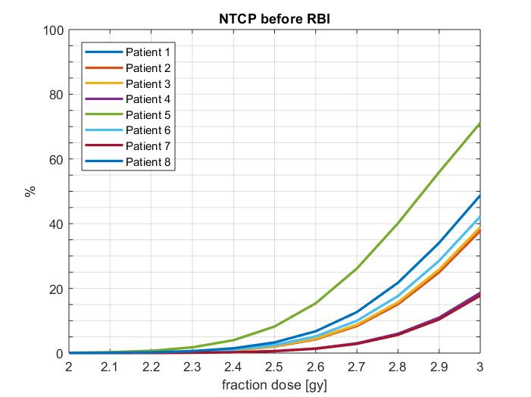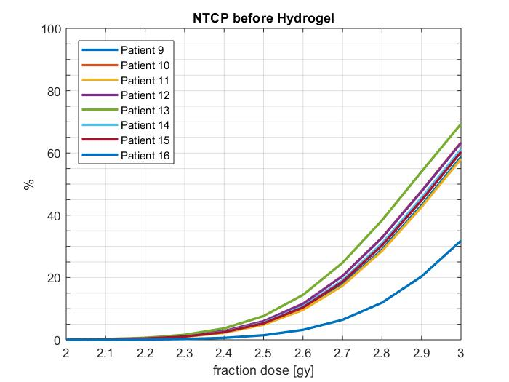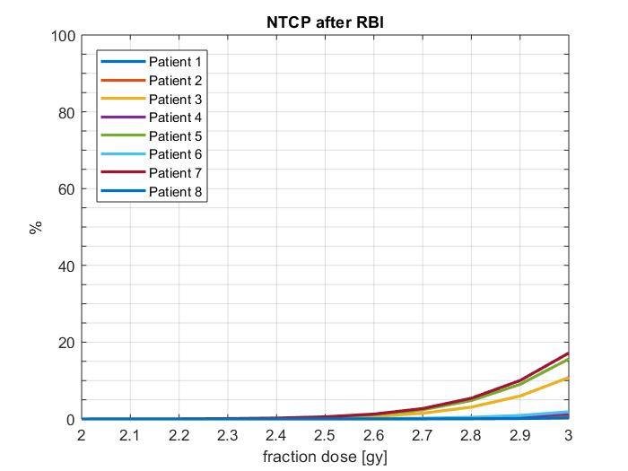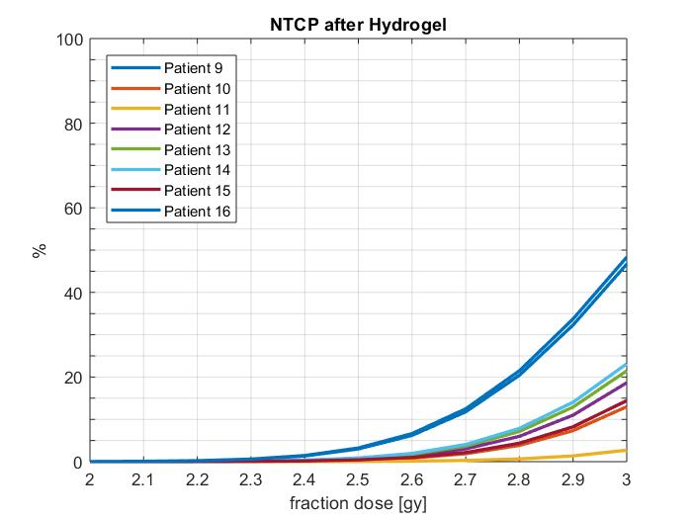

Appendix VII: Variation of NTCP limit
The figure below shows the median tumour control probability (TCP) and range, as well as the median normal tissue complication probability (NTCP) and range, for the patients without implantable rectum spacer (IRS), with IRS and with the virtual IRS (V-IRS). Per group, the NTCP limit of the iso-toxic model is set to be 2.5, 5 and 10%.
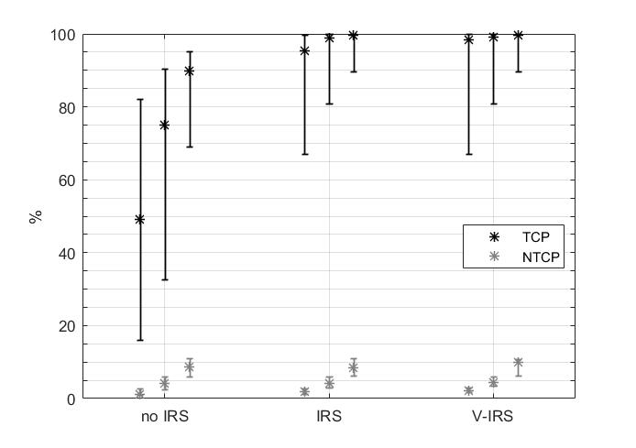
It can be observed that even when the NTCP limit is 2.5%, the patients with spacers perform well regarding the TCP, with median values of 95% and 99% for the actual IRS and the V-IRS respectively. When the NTCP limit is 10%, the improvement found by the IRS has less impact (90% to 99%). The V-IRS performs reasonably well for different ranges, though with the tight NTCP limit of 2.5%, the real IRS predicts a lower median TCP than the V-IRS (95% as opposed to 99%).
Appendix VIII: Results of all published SNP odds ratios for late rectal bleeding
The SNP’s shown in the paper are the two SNP’s that had the most effect on the NTCP, but six close to significant SNP’s for late rectal bleeding were found. The results from these SNP’s without implantable rectum spacer (IRS) are shown in the figure below.
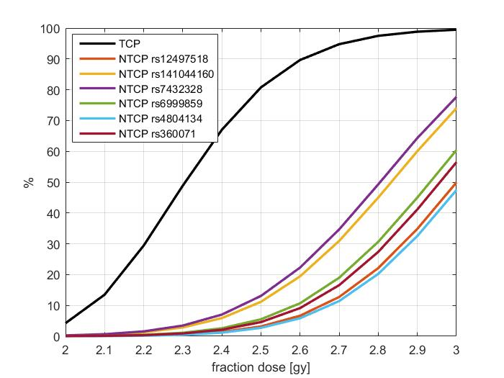
In the figure below, the results are shown with IRS. Only the SNP’s with rsID rs141044160 and rs7432328 were used in the paper. Note that rs4804134 and rs12497518 had odds ratios of 0.6, and thus lowered the risk of late rectal bleeding. Also note that though they had the same odds ratio, the curves differ. This is due to the difference in minor allele frequency (0.31 and 0.47 respectively).
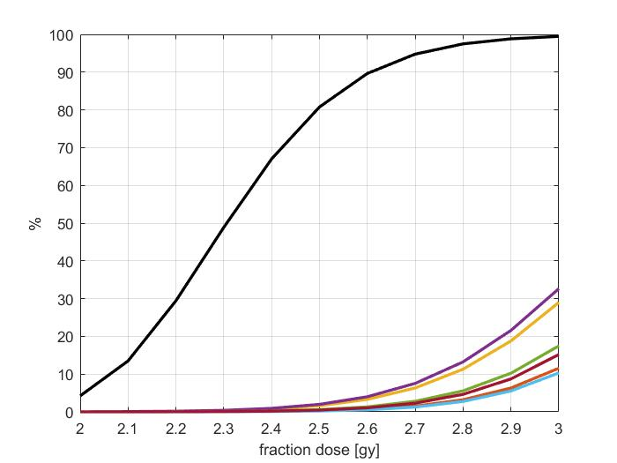

Appendix IX: Sensitivity analyses of SNP odds ratios
To demonstrate the effect of the odds ratios (ORs) single nucleotide polymorphisms (SNPs), the OR’s of the SNPs were artificially varied between 0.5 and 10, and the resulting normal tissue complication probability (NTCP) was calculated for the different fraction doses. Since the tumour control probability (TCP) is not effected by the SNPs, this remains the same. The figure below shows the results without implantable rectum spacer (IRS). The Minor Allele Frequency for all these ORs was assumed to be 0.05.
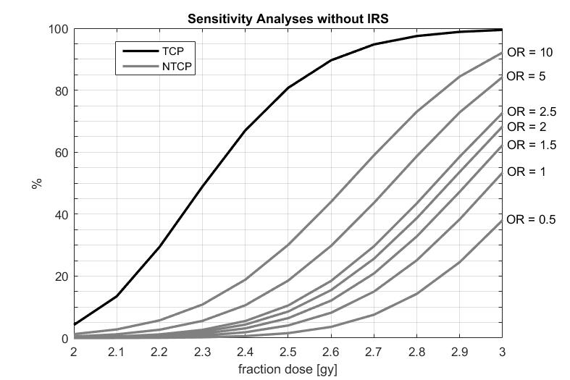
In the figure below the results are shown for the patients with IRS.
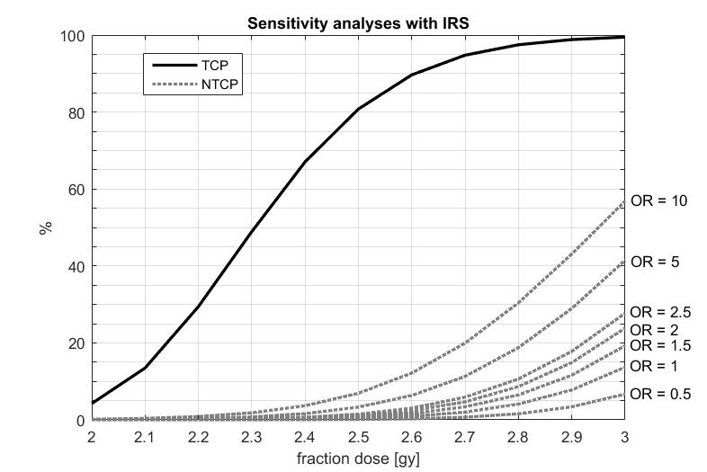
SNPs with an OR lower than 1 have a protective effect on the rectum. Patients with these SNPs have a lower risk of late rectal toxicity, and can safely be considered for more dose escalation.

